ABT4650
RouteScan / AGI2

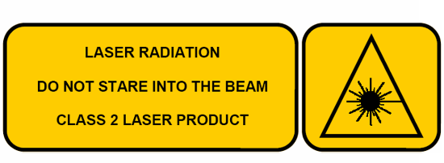

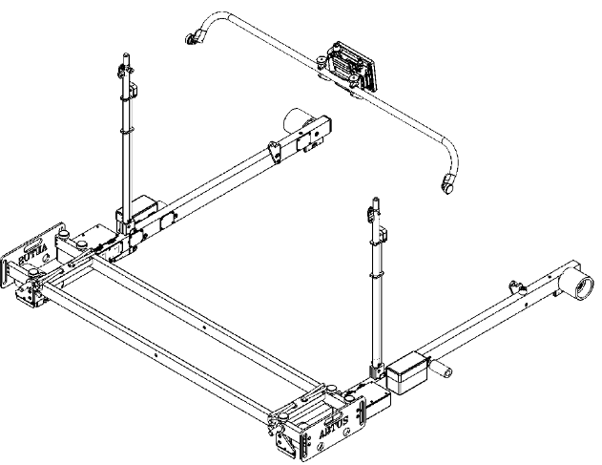
Instruction Manual

Index
0
1.0 Index 1
2.0 Item List 2
3.0 Specification 2
4.0 Getting Started 3
4.1 Overview 3
4.2 Assembly 4
5.0 Software Features 4
5.1 Switching On 4
5.2 Single Point Check 9
5.3 Recording Data 10
5.4 Settings 15
5.5 View Results 17
5.6 File types and recorded data. 19
6.0 Target Pole 19
7.0 Maintenance 20
7.1 Before Each Use 20
7.2 Every 3 Months 21
7.3 Annually 21
8.0 Measurement Characteristics 22
8.1 Point Co-ordinates 22
8.2 Gauge 22
8.3 Super-Elevation 22
9.0 Trouble shooter 23
9.1 Tips for Good Recording 23
9.2 No Power 23
9.3 Cannot Connect 23
9.4 Bluetooth Connection 23
9.5 Pairing 25
9.6 Measurement Takes a Long Time 26
9.7 Refresh radio list 26
9.8 Restore data 26
9.9 Restore ID 27
9.10 Save Calibration DATA 28
9.11 Disconnected warning message 28

Item List

- RouteScan
- Control Unit
- Carry Case
- Instruction Manual
- RouteScan Charger
- Control Unit Charger
- Optical Cleaning Kit
- Target Pole (if purchased separately)

Specification

Weight | -  -- | On track(RouteScan)  (Control Unit)  In Box | 11kg  0.5kg  25kg
Physical Dimensions | -  - | On Track(RouteScan)  In Box | 1655 x 315 x265 mm  Length:1755 mm  Height:373 mm  Width:385 mm
Operating Temperature | - |  | -10°C to + 50°C (-4°F to 122°F)
Environmental Rating | - |  | IP54
Battery Life | -  - | RouteScan  Control Unit | Up to 6 hours  Up to 6 hours
Operating System | - |  | 
PC Connectivity | - |  | USB  Bluetooth  Wireless LAN

Getting Started

Overview
The RouteScan has been developed to provide quick, accurate structure clearance measurements relative to the Permanent Way. With the RouteScan in position on the track, the operator is able to control the measurement laser from a position of safety using the Control Unit, via a Bluetooth connection.

The unit is lightweight (11kg) and is provided with a protective box for easy transportation to and from site. All data is displayed on a colour screen. The files can be opened and viewed in MS Excel.

The use of wireless technology in the RouteScan means that there are two separate batteries in the ABT4650:
- RouteScan
- Control Unit

The unit has been designed to be user-friendly with only limited training required.

RouteScan is approved for use in the UK in areas of 3rd rail. The following guidelines should be adhered to when using RouteScan in an area of live 3rd rail:
- Never touch any part of RouteScan against the electrified 3rd rail
- When carrying RouteScan on the track, take extra care to avoid tripping. Carry RouteScan on the opposite side of your body to the 3rd rail
- When lifting RouteScan on or off the rail, ensure you have a firm footing and that you are standing between the running rails
- When pointing the laser dot at a specific point, never place yourself or others in a position of danger. Wherever possible, control the position of the laser dot using the control unit from a safe position

Before Use:
Make sure there are no stains or marks on the optical window and that the optical window is NEVER touched directly.
For cleaning instructions see Section 7.1
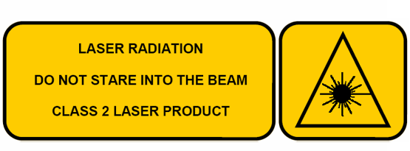
RouteScan produces a visible (635nm wavelength) laser beam which emerges from the Laser Housing.

It is a Class II laser product in accordance with:
- IEC60825-1 (2001) “Radiation safety of laser products”
- EN60825-1 (2001) “Radiation safety of laser products”
- FDA 21 CFR 1040.10 and 1040.11 (US department of health and human service, Code of federal Regulations)

Laser Class II products:
Do not stare into the laser beam or direct it towards other people unnecessarily.

Eye protection is normally afforded by aversion responses including the blink reflex.

CAUTION
Looking into the laser beam may be hazardous to the eyes.

Laser may turn on without warning.

Do not allow water droplets to fall on the lens of the laser housing as this may compromise accuracy. If water does drop on the lens, carefully blot away using the lens tissue provided. Follow the instructions in Section 7.1 to clean the lens if necessary.

Please review Section 9.1 prior to using your ABT4650 for the first time.

Assembly
Upon receipt of your ABT4650 no assembly is required.

Software Features

Switching On
- Ensure that the gauge is powered by pressing the Power Button – the Power Button should now display a green light (Figure 1). Figure 2 shows the individual parts of the Routescan.
- Within the first 5 seconds of switching on, the Routescan shows you the Battery level status by the Battery Led indicator:
- Green: 100-to 70%
- Orange: 70-to 30%
- Red: 30-to 5%
- Blinking Red less than 5%. In this stage the Routescan is not operative.
You can check the battery level at any time (not when the scan is in process or the spindle in movement) by pressing the Battery indicator button.
N.B. Once the Power Button has been pressed, RouteScan goes through a start-up period – it is not possible to turn off RouteScan until start-up is complete. During start-up the Laser Housing will rotate as part of a self-calibration routine; do not interfere with it during this period.
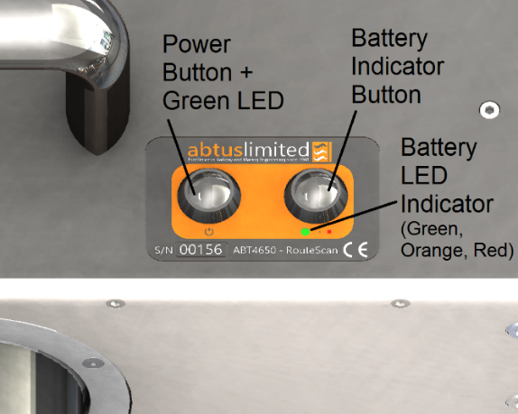
Figure 1

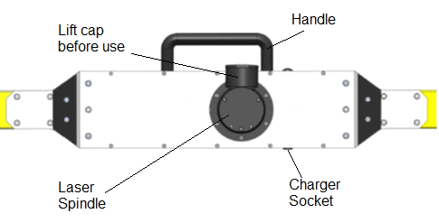
Figure 2
- Rotate the black lens cover to reveal the optical lens before attempting to take any readings (Figure 3)
Figure 3

- Turn on the Control Unit (Please refer to manufacturers own operating manual for details of operation as Control Unit models may vary) – wait until the Windows operating system has fully loaded
- Load the Abtus Gauge Interface 2 software (AGI2) from the Desktop (Figure 4) – the software launches directly to the welcome screen.

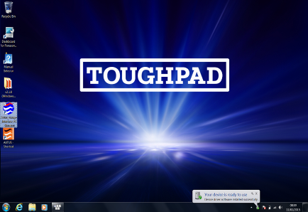
Figure 4 Double click Abuts Gauge Interface 2 icon (AGI2)

The user is given two options by the welcome screen.(Figure 5)
Trackside has full functionality including a Bluetooth connection with the Routescan.
Office mode does not provide a Bluetooth connection. It is used only for management and viewing of data already stored.
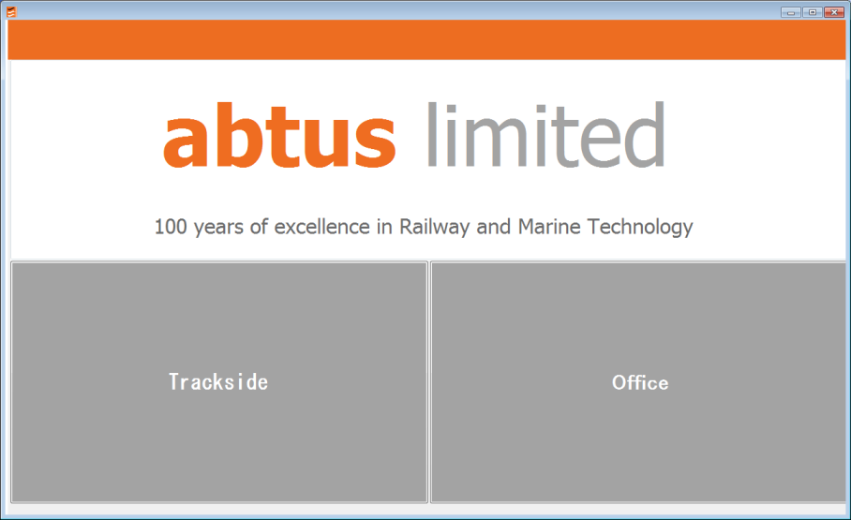
Figure 5
- Click on ‘trackside’ or ‘office’ as appropriate.
For trackside work, the software ‘starts’ in the Bluetooth Connect ‘page’ (Figure 6)
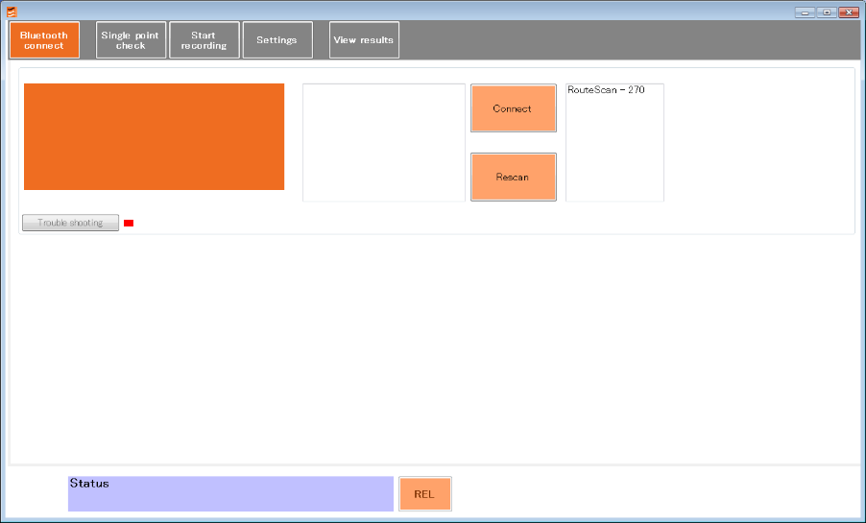
Figure 6
- Select your device by clicking on it from the right list box. And click on ‘Connect’
- Please be patient while the Control Unit makes the connection.
Once connected the screen shown in (Figure 7) will be displayed and you will then be ready to start using the RouteScan.

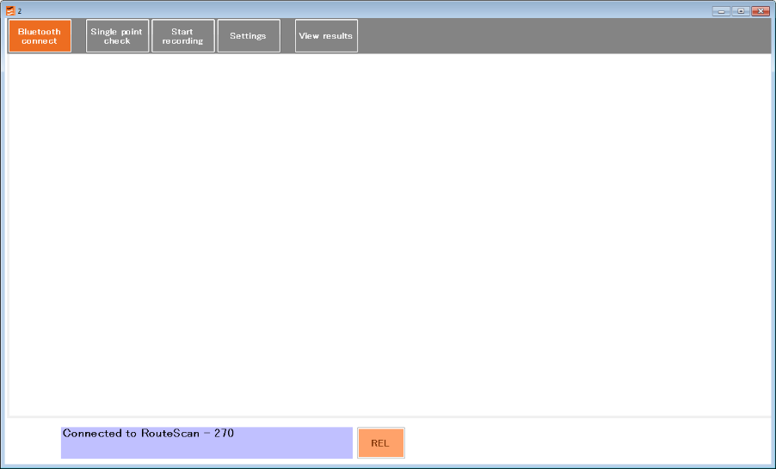
Figure 7
If you go back to the Bluetooth Connect ‘page’ (Figure 8) you can double check the device is connected on the orange box and a green indicator next to the ‘trouble shooting’ button means that your Bluetooth communication is established properly.
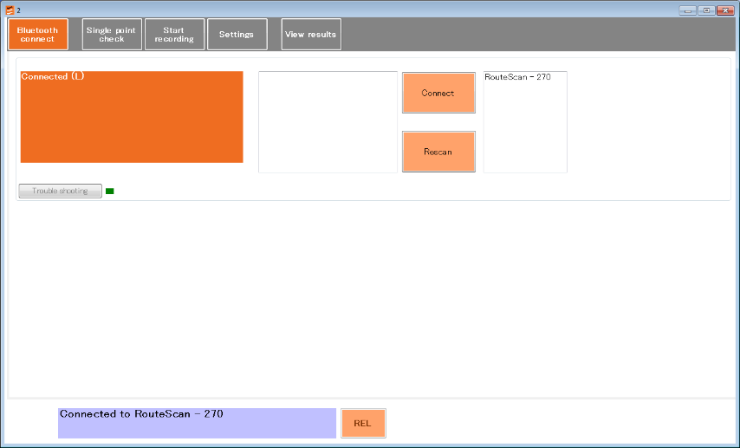
Figure 8
If the device is not displayed in the right hand list, please click the ‘Rescan’ button. It will once again scan for Abtus devices that are turned on. The communication uses 'Bluetooth' technology. Look for the 'Discovering...' message.
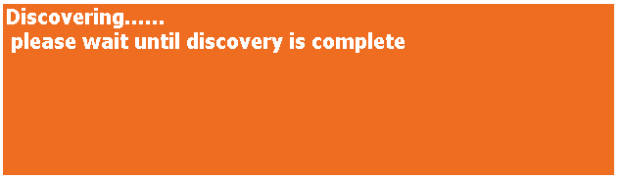
You must wait until this process is over and you see...

Look for your Abtus product in the device found right box list and click on it there.
Only paired devices will be listed in this box.
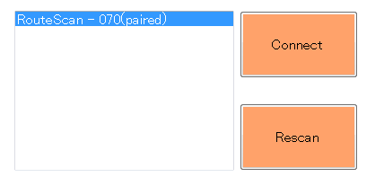
Click on the ‘Connect’ button.
If all is well, after a few seconds, the software will connect to the Routescan and you get through to the previous screen and be ready to start work with the Routescan.
If there is a problem with the connection - see the following 'Bluetooth connection' section of this manual.

Single Point Check
The Abtus Gauge Interface 2 software provides a user interface/screen to check single points.
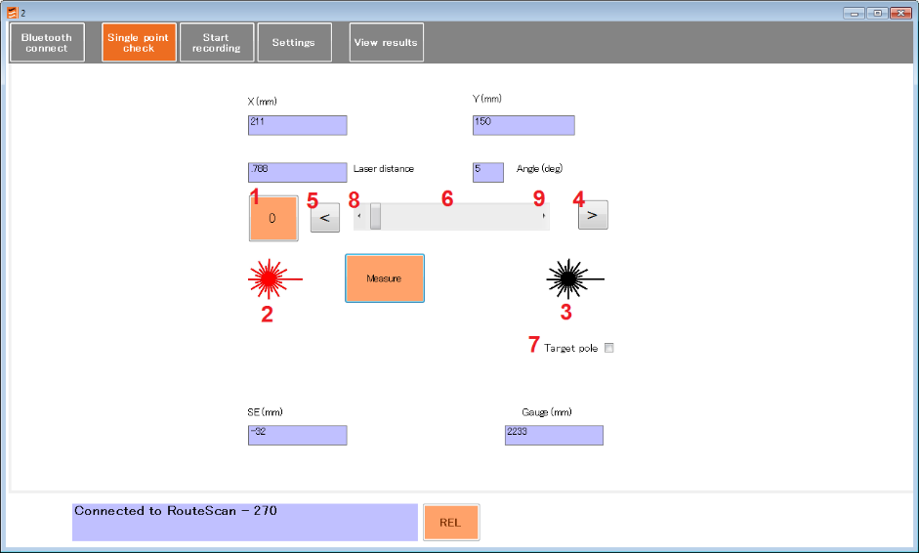
The position of the laser beam can now be controlled either by rotating the laser housing by hand or by the buttons 4, 5, 6, 8, and 9
The user has the following input options:
- Zero position button. It takes the Routescan to 0deg
- Laser ON
- Laser OFF
- Move the spindle +20deg
- Move the spindle -20deg
- Move the spindle from 0 to 180deg
- Target pole option. That option adds 300mm to Y axis to compensate the Target pole.
- Move the spindle -1deg
- Move the spindle +1deg
The Measure button gives an instant measurement. The purple boxes show the measurement results for the single point:
  - X & Y position in mm
  - Laser distance in mm
  - Angle in degrees
  - Super elevation in mm
  - Gauge in mm
Note – it is not possible to send commands from the Control Unit when the Laser Housing is rotating. Ensure that the Laser Housing is stationary before clicking any buttons

Recording Data
The Abtus Gauge Interface 2 software provides a versatile framework in which to record and analyse data. This section will only describe the steps necessary to start a recording.
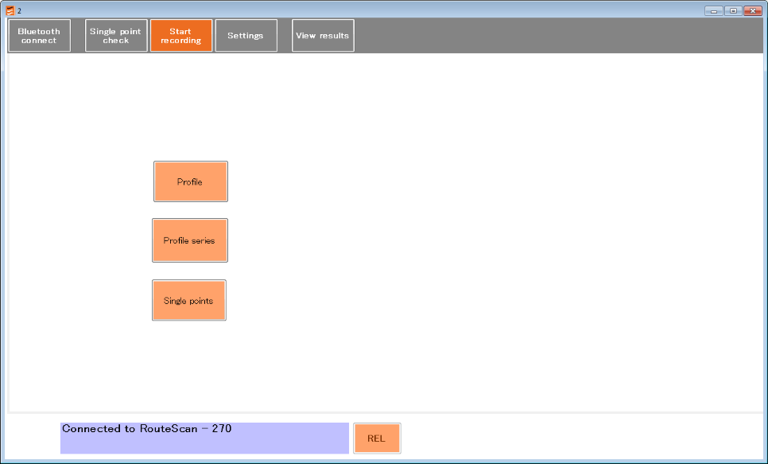

The user can choose from Three options.
- Profile: Record a profile.
- Profile series: Record a series of profiles. The user sets the chainage distance (start distance point) and the increment distance between each recording. The same profile is recorded at a series of positions separated by the same interval. Each new profile is saved in a separate file with the file name automatically appended with the distance at which that profile was recorded from the first profile.
- Single points: Record a set of single points.

If the user chooses Profile, Profile series or Single points, the next window is common to all three options. The user is able to fill in fields for ‘File name’, ‘Description’, ‘User name’ and ‘Track code/location’. The only mandatory field is ‘File name’. You can store and use later predefined fields right to each field.

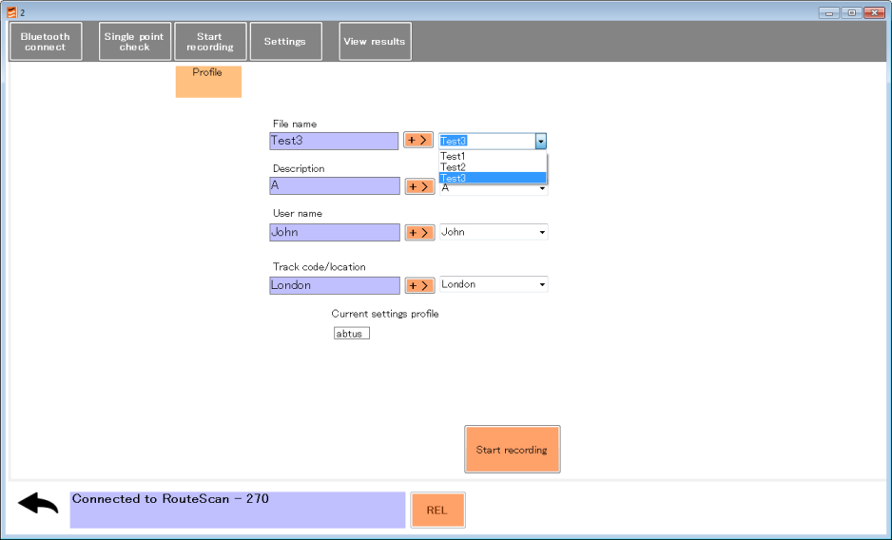
If the user chooses Profile series, the next window is:
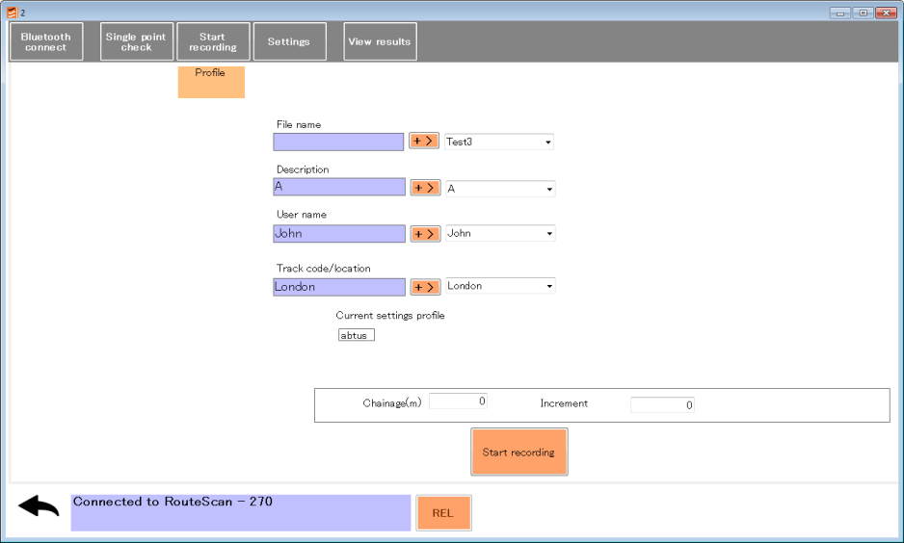
Where the user is given the two additional fields ‘Chainage’ and ‘Increment.

After Clicking on Start recording button, the scan will start. The scan is automatically broken up into sections. Scanned data is displayed on the Control Unit after each section has been scanned.
During the scan you can see the following screen. Scan progress is displayed at the bottom of the screen in %.
The user has the following options while the scan is in progress and before it is saved:
- Zoom in/out
- Centre, drag and drop the result scan
- Delete button. You can delete any point at the end of the scan before save. This button is only available when the scan is over.
- Move selected points along the scan profile.
- Stop the scan. The scan will stop after it has completed the current section
- End scan allows you to collect all the data at any time during the scan and finish it.
- Single point. This function allows to you add single points at the end of the scan before you save it. This button is only available when the scan is over.
- Save the data into a file. This button is only available when the scan is over. If the scan stops suddenly and it is not over, please click on End scan button and then save the scan.

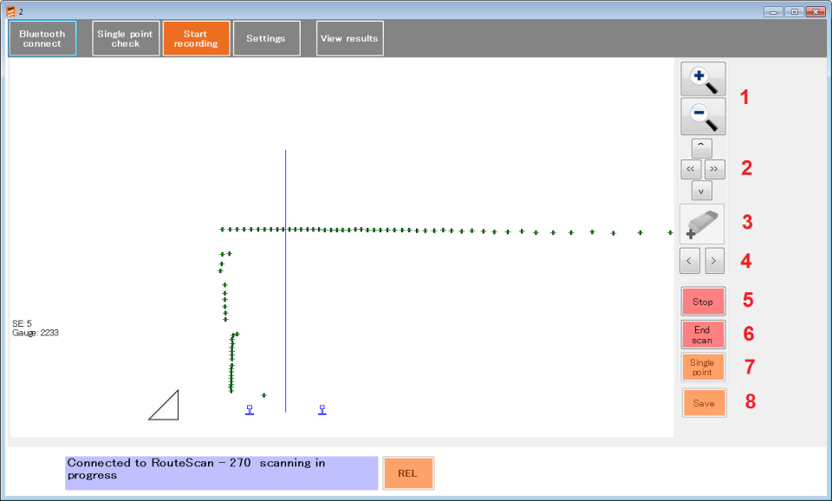

You can also see in this screen the following information about the scan:
- Current SE and Gauge in mm
- Coordinates X & Y of each point of the scan from the left hand rail (LHR)
- Graphical indication of the SE
- Real position of the rails according to current gauge.
- Centre of the track according to nominal gauge.
- Relative or absolute mode. Relative mode does not take in account the current SE during the scan, all the points are relative to the rails. Absolute mode generates the points taking in to account the SE relative to the ground.

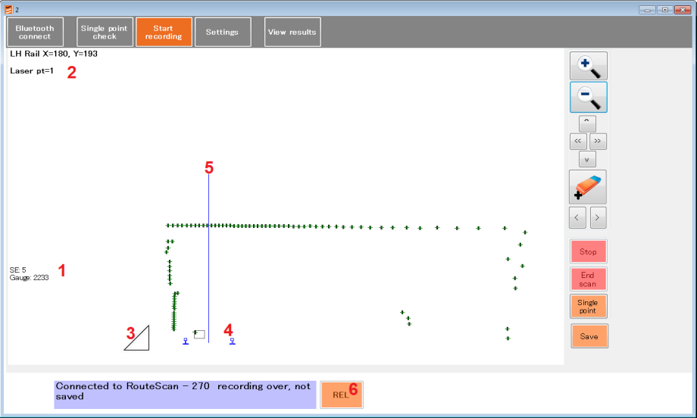

You can see in the following screen how to add a single point into a scan. In addition to the single point check options you have two more options:
- Once you has measured your point you can add it into the scan.
- You can also add a note. Which you will able to see in the results.
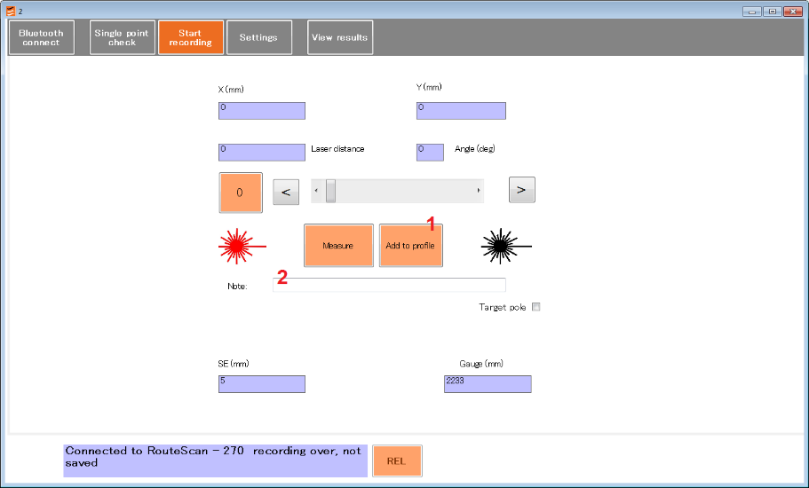

Profile data structure in the *.csv file
Single point data structure in the *.csv file

Settings
The settings screen tab is where the scan recording parameters are defined.
- Start Angle, [degrees]
- End Angle, [degrees]
- Increment (Resolution) [degrees].
- Absolute/Relative
In the settings tab, the mode can be changed between ‘ABS’ and ‘REL’ by clicking on the button at the bottom of the screen.
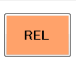
In absolute mode, super elevation is taken into account. In relative mode, the measurement are relative to the rails.
Up to three settings can be defined allowing up to three segments with different start and end angles and increments to be recorded in a single scan and saved in one file.
:

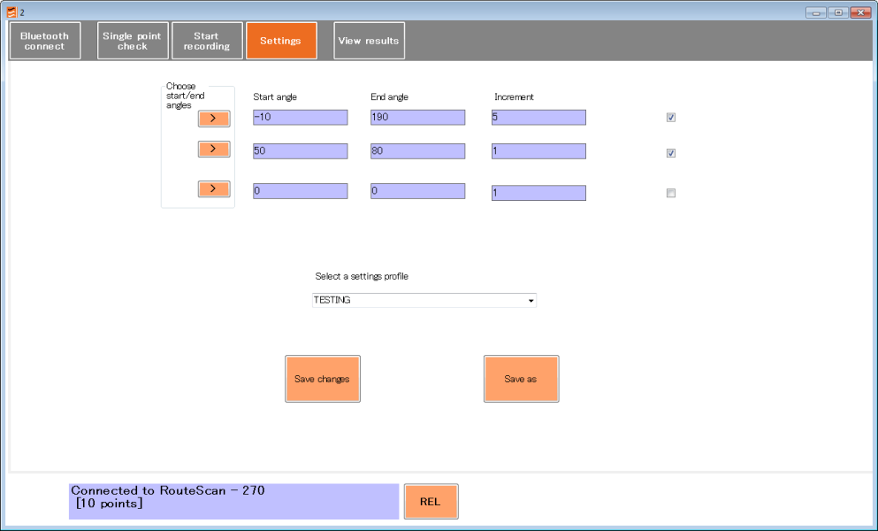
Figure . Settings screen

- A number of settings can be saved to suit different measurement conditions.
- Only in Trackside Mode (when the Routescan is connected), the start and end angles can also be changed by clicking on the “Choose start/end angle” at the left. This takes the user to the single point check tab. Here the user can make test measurements to find the required start and end angles for the scan. When both start and end angles are chosen, the user should click in the back arrow to return to the settings tab.
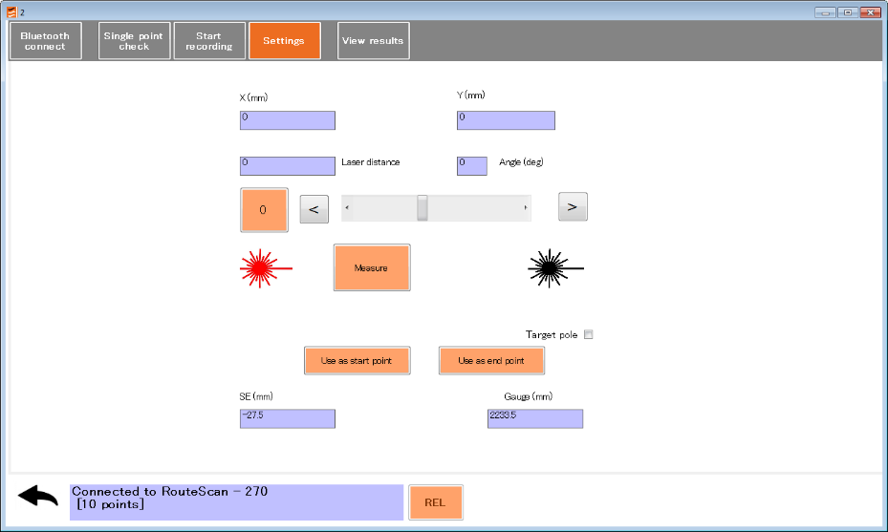

View Results
To review saved Data Files tap the ‘View Results’ tab. You can see graphical and numerical results. Results cannot be modified in this page.

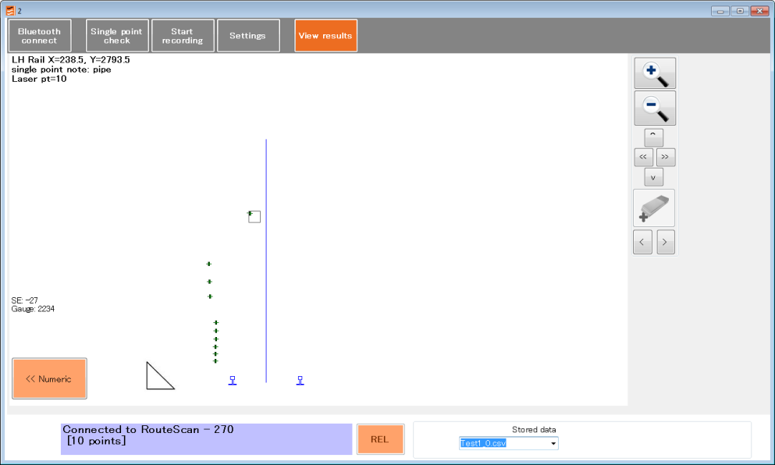
Figure . Scan Profile graphical view
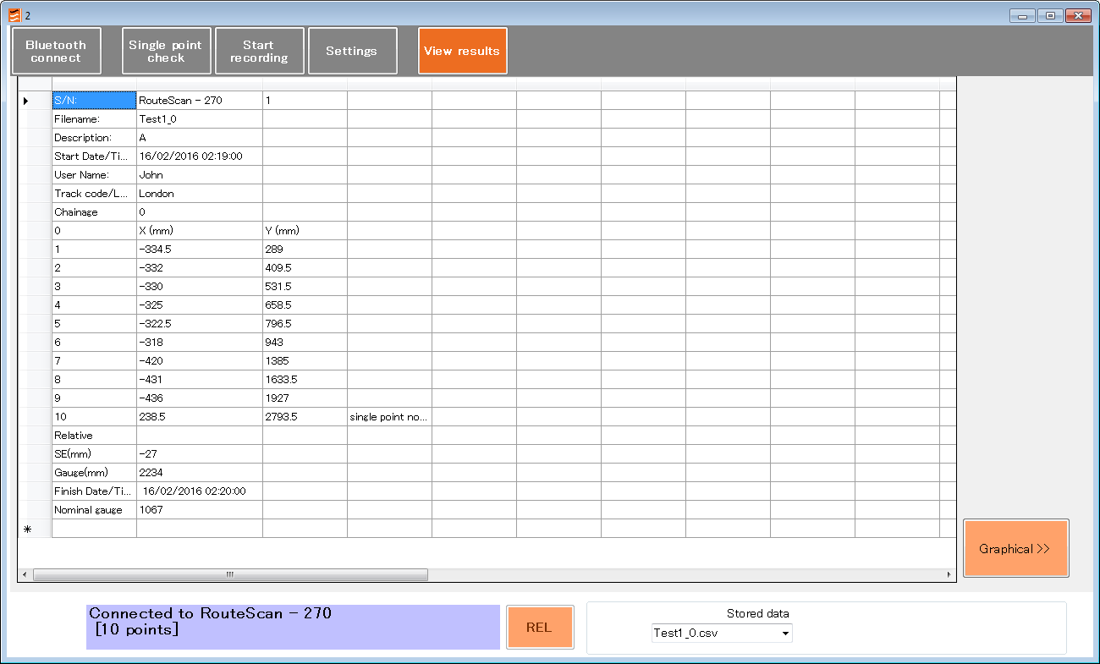
Figure . Scan Profile numeric view
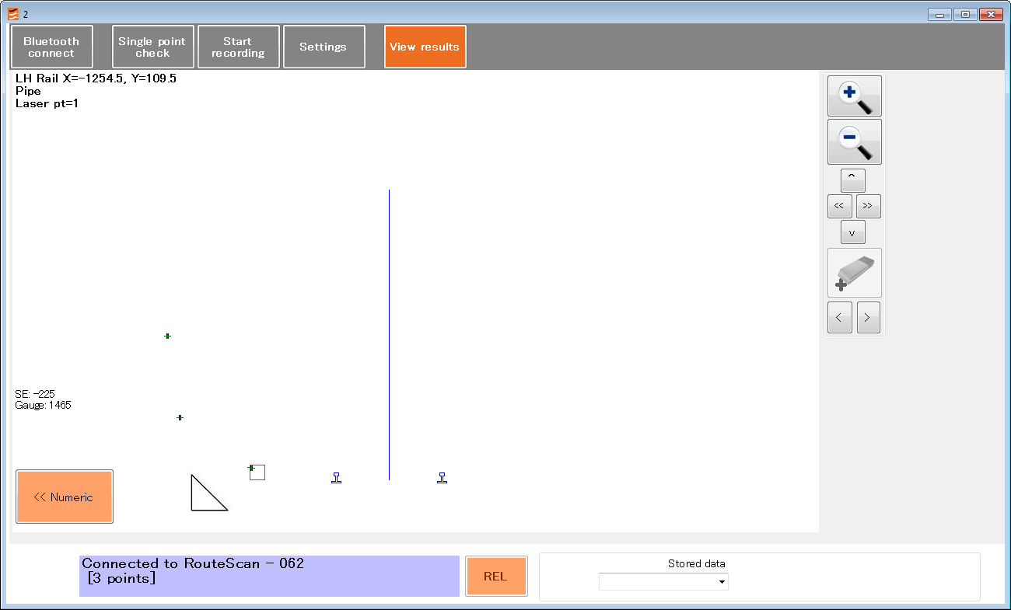
Figure . Single Point Scan graphical view
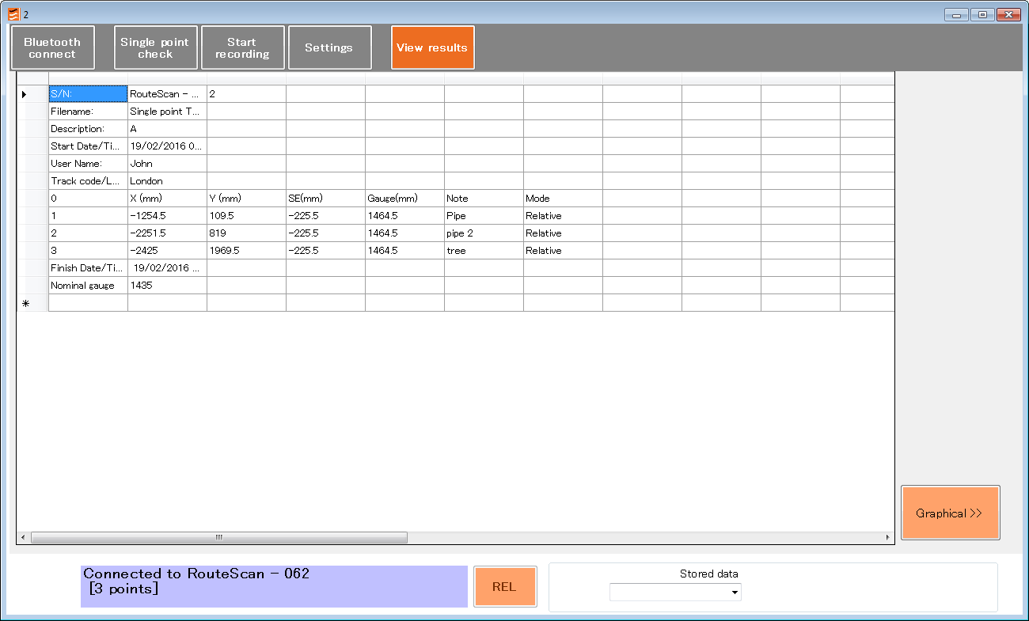
Figure . Single Point Scan numeric view

File types and recorded data.
The Software automatically saves *.csv files for each recording.

The CSV file is in a standard format which will open in almost any software package (e.g. Excel, Word, Notepad etc). This file contains all the Start and Finish information along with all the recorded data in an easy to read layout.

Recorded Data is stored in:
C:\abtus\recorded data\ROUTESCAN

Target Pole
The target pole is an optional accessory for RouteScan. It allows the measurement of points that cannot be ‘seen’ directly by the laser, such as the gauge corner of the rail on an adjacent track.

It is comprised of:
- Target Pole
- Rail Pole
- Pointed Foot
- Rounded Foot

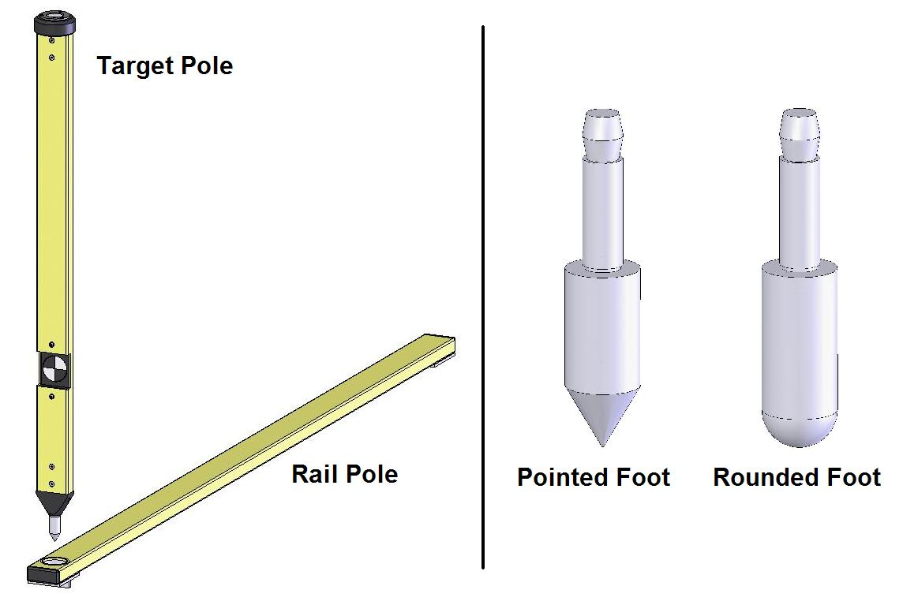
Figure 1

To measure a point using the target pole, load the Single Point screen and tick the ‘Target Pole’ tick box. The software will automatically adjust the measurement by the vertical height of the target.

When measuring to the Target Pole:
- Ensure that the target surface is ‘square’ to the laser
- Check that it is held vertically by using the bubble embedded in the top of the pole – a 1mm offset of the bubble from the centre of the vial translates approximately to a 0.5mm error in the X-Y measurement

The Pointed Foot and Rounded Foot click into the bottom of the Target Pole and are interchangeable. When using the Target Pole on its own, it is advisable to use the Rounded Foot to minimise wear to the Pointed Foot (refer to Section 7.2).

When using the Target Pole with the Rail Pole, the Pointed Foot must be fitted. When measuring the location of an adjacent track, the Rail Pole allows the Pointed Foot to be located accurately on the gauge corner of the rail.

- Place the Rail Pole on the track to be measured
- Ensure that the Rail Pole is located ‘squarely’ across the track and that it is firmly located against the rail being measured
- Locate the Pointed Foot in the socket in the Rail Pole

Maintenance

Before Each Use
Make sure there are no stains, marks or dirt on the lens. After blowing off dirt and dust, the drag method can be used to remove fingerprints or other contaminants

The lens is of an extremely high grade and is coated with a proprietary compound. Unlike many other optical coatings of this grade, this compound is tough enough to be cleaned using the lens tissues and cleaning solution provided. However, each clean detracts from the life time of the coating and so direct contact cleaning should be kept to a minimum.

NEVER touch the lens with anything other than the lens tissues provided

NEVER use high pressure air to remove dirt/dust from the lens

NEVER use a circular motion to clean the lens

Every 3 Months
Visually inspect the ABT4650 for signs of damage. If necessary, contact your local distributor for help.

If using the Target Pole accessory, check the Pointed Foot and Rounded Foot for wear by measuring the length as shown in the figure below. The foot should be replaced if it has worn by more than 1mm.

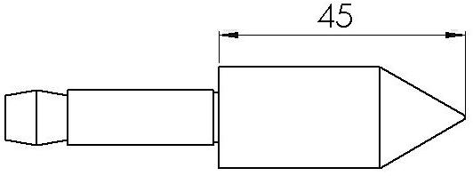
Figure

Annually
The ABT4650 is approved for use in the UK in areas of 3rd rail. An annual electrical insulation test should be carried out.

The ABT4650 must be returned to Abtus Ltd annually for re-calibration to ensure measurements are within specification. The ABT4650 will also be tested for electrical insulation compliance at the same time. If using the Target Pole accessory, this should be re-calibrated at the same time.

The condition of all components will be checked at this time and replaced as required.

Measurement Characteristics

Point Co-ordinates
Range | 0.2-30m
Accuracy | ±3mm @ 4.0m  ±6mm @ 8.0m
Resolution | 1mm

Gauge
Range | -15/+25mm (on nominal)
Accuracy | ±0.5mm
Resolution | 0.1mm

Super-Elevation
Range | ±200mm
Accuracy | ±1.2mm
Resolution | 0.1mm

Super Elevation (SE) is measured across the running rails and is displayed as height differential between the high and low rail in millimetres
The default sign convention is:
- ive SE is the right rail lower than the left rail
+ ive SE is the right rail higher than the left rail
(Ask to Abtus for setting a different one if you have different sign convention)

NB. The left end is the fixed end of the gauge

Trouble shooter

Tips for Good Recording
The ABT4650 is a very accurate piece of equipment – many of the parameters that it measures rely on extremely sensitive sensors. While every reasonable effort has been made to make it ‘railway proof’, users should treat it with extreme care.

No Power
Check that all the batteries are fully charged. The RouteScan takes approximately 4hours to charge and the Control Unit takes approximately 2hours.

Cannot Connect
The connection between the Control Unit and the RouteScan is via Bluetooth. Obstacles such as metal and water (the human body is mostly water!) can degrade wireless signals – ensure that nothing is restricting the signal.

Ensure that all batteries are fully charged (see Section 4.1 for more information on the batteries).

Ensure that the internal Bluetooth device is ON and there is only one stuck active.

Bluetooth Connection
Before recording can start, a Bluetooth connection must be made between the Control Unit and the ABT4650 Routescan.

Your Abtus device and associated tablet computer will already be set up in the factory with the Bluetooth communications established.

In the event of connecting to another gauge or tablet, the Bluetooth communication may need some configuration before it connects automatically.

If you follow the instructions in the Switching on section', but the gauge does not connect, click on 'Trouble shooting' button.

An extra control ‘panel’ appears
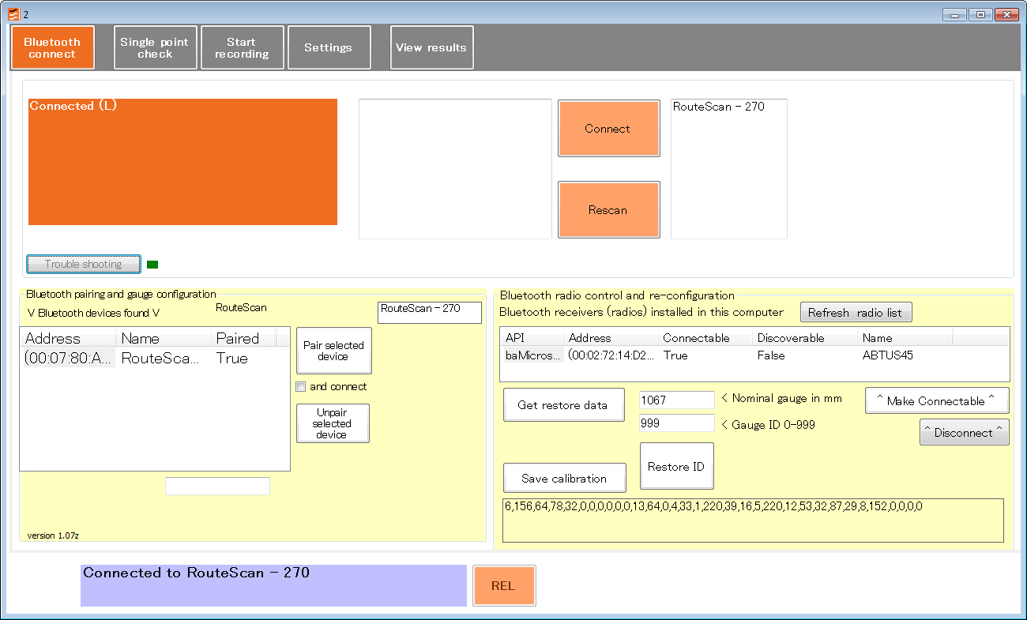
The list of ‘Bluetooth devices found’ shows those devices which the tablet can see.
It DOES NOT mean that they are all in operation.
Click on ‘Rescan’ button
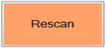
And wait for the list to re-fill.

Pairing
If the Routescan is shown as not paired (Paired = false), highlight the device in the list and click on ‘Pair selected device’. Once paired, click on 'Rescan' so that the device will appear in the device found box list, then connect to the device.
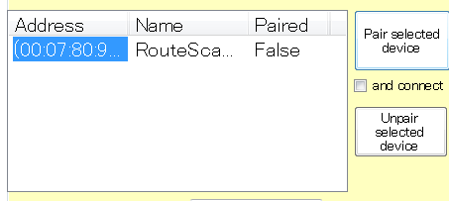
If a connection cannot be made. Unpair the selected device. Then try to pair with the device again with the option “and connect” on.
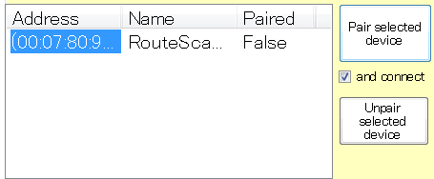

Measurement Takes a Long Time
The time taken to perform a point measurement is dependent on surface quality. Surfaces that are too shiny or too dull will affect the measurement time. On standard brickwork or masonry, RouteScan can complete up to 240 measurements per second.

RouteScan has been benchmarked on the same calibration surface as is used for calibrating the Structure Gauging Train in the UK and has been proven to work reliably.

When using RouteScan to measure Gauge and SE in Single Point mode; ensure that the laser is pointing at a near-by surface to minimise measurement time.

Refresh radio list
Bluetooth receivers (radio) installed have to appear in the list with the value ‘true’. If this value is ‘false’ you have to refresh the radio list. Click on ‘Refresh radio list’ button, select the radio (API) and press ‘Make Connectable’ button.

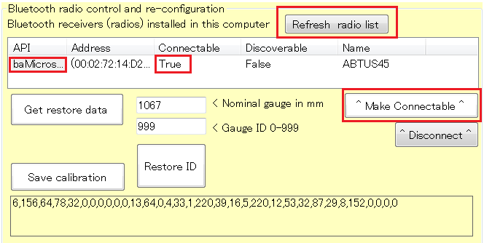

Restore data
The restore data process is a very sensitive one. Please ensure you understand it before do it. Don’t hesitate ask the manufacturer if in any doubt.

If the Routescan’s calibration file fails then the Routescan will produce incorrect results.
Press the ‘Get restore data’ button, choose the calibration file for the device and press open.
C:\abtus\system\Calibration Files
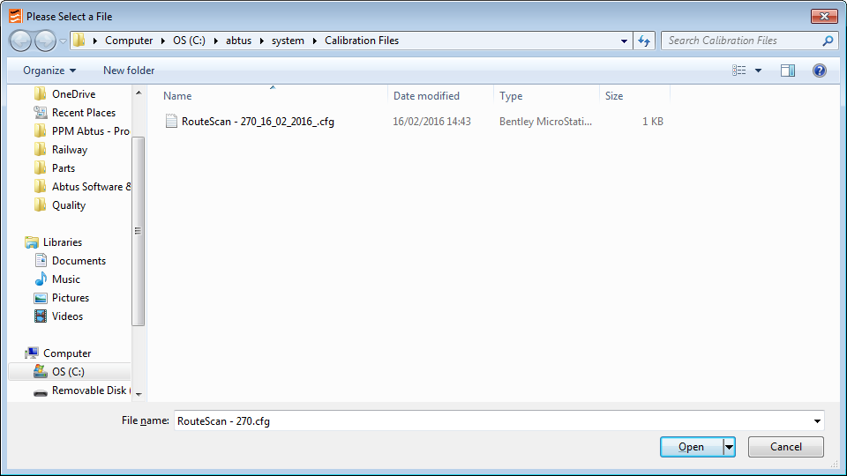

New values will now appear at the bottom of the screen and the ‘Restore calibration’ button will be shown. Press ‘Restore calibration’ to program the gauge with those values.
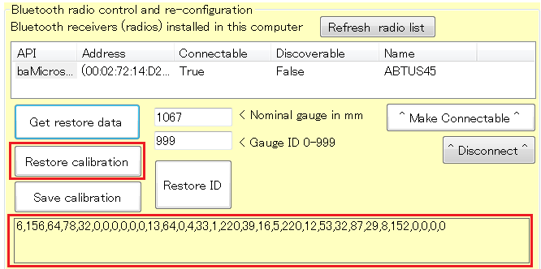

Restore ID
The restore ID process is a very sensitive one. Please ensure you understand it before do it. Don’t hesitate ask the manufacturer if in any doubt.

A device’s ID is the serial number of the gauge, and the nominal width of the gauge. Sometimes the device appears in the device list with the incorrect ID due to a corruption in the register storing the device’s ID. The gauge’s ID can be restored.

- Make sure that the gauge is paired and connected to the computer/tablet.
- Put the nominal gauge in mm and the gauge ID (serial number).
- Select ‘Left or only device’.
- Press the ‘Restore ID’ button.
- Press ‘Unpair selected device’ to unpair the Routescan
- Restart both the computer/tablet and the Routescan. The Routescan will now appear with its restored ID in the list of devices found.
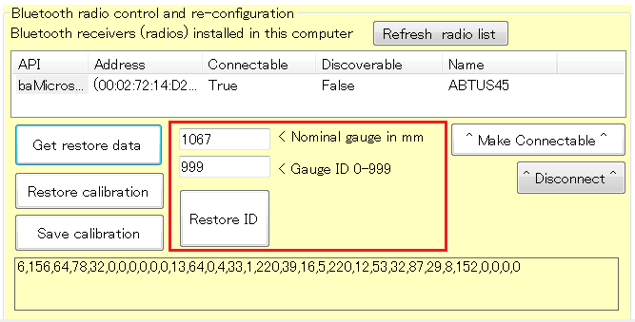

Save Calibration DATA
If you wish save the calibration data from the gauge, press ‘Save calibration’ button. It will be stored in C:\abtus\system\Calibration Files with the current date.

Disconnected warning message
This message means that the control unit has lost the Bluetooth connection with the Routescan. It can be caused by:
- Low Voltage Battery. You will see the battery led indicator blinking in red in that case or you won’t able to switch it on again because the battery is totally discharged.
