

USER GUIDE
FOR
AFASOs
&
HQ ADMINISTRATORs

Version 2
November 2011

Developed by:
BAM Technologies, LLC.
2001 Jefferson Davis Highway, Suite 610
Arlington, VA 22202
Phone: 703.778.9187
www.bamtech.net

User Guide for AFASOs and HQ Administrators

Welcome to B4B!
B4B is a web application used by the Air Force Aid Society for inventory management of its Bundles for Babies program. It enables AFASOs to log the distribution of inventory as well as request new inventory. It enables HQ Administrators to approve/disapprove requests for new inventory and generate order forms which may be sent to vendors. This guide provides instructions for both AFASO and HQ Administrator.

Table of Contents
Table of Contents 3
Accessing the System 4
AFASO 4
Viewing Alerts 4
Receiving Shipments 5
Requesting New Inventory / Adjusting Existing Inventory 7
Distributing Inventory and Logging Recipient Information 9
HQ Administrator 13
Accepting/Rejecting Requests for New Inventory 13
Approving/Declining Requests for Manual Adjustments 14
Placing Orders 15
Setting Thresholds 17
Assigning Products 19
Assigning Vendors 20
Viewing Inventories 22

Accessing the System
Users enter B4B via the Applications Page on the AFAS Portal. The functionality the user experiences depends on whether the user is an AFASO or an HQ Administrator.

AFASO
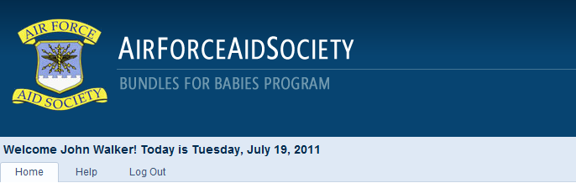
From the Home page the AFASO manages his section’s inventory. To help him, B4B displays alerts and contains tables from which he can receive new inventory, request new inventory, request manual adjustments to his current inventory, and log the distribution of inventory to class participants. The alerts and each table are described below.

Viewing Alerts
At the top of the AFASO’s Home page he may see a yellow box containing alerts which advise him of issues involving his inventory.
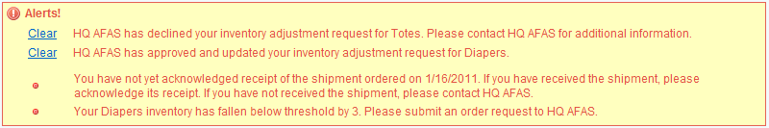
Note: The yellow box does not appear if there are no alerts.
Alerts appear when the following conditions are met:
- HQ AFAS approves the AFASO’s request for a manual adjustment to his inventory.
- HQ AFAS declines the AFASO’s request for a manual adjustment to his inventory.
- The AFASO’s acknowledgement of receipt of a shipment from a vendor is overdue (more than 30 days since the order was submitted by HQ AFAS).
- The AFASO’s inventory for a product falls below the HQ-mandated threshold.
Clearing Alerts
The AFASO clears the alerts regarding manual inventory adjustments by clicking on the Clear link. However, the remaining alerts are cleared only when other actions are taken by the AFASO. The overdue alert clears only when the AFASO receives the shipment by clicking on the Receive link in the ORDERS table. And the threshold alert clears only when the inventory is adjusted upward either by requesting new inventory or requesting a manual adjustment by clicking on the Order or Adjust links, respectively, in the INVENTORY table.

Receiving Shipments
On the AFASO’s Home page he sees a table labeled ORDERS, which shows the status of any requests for new inventory he submitted to HQ AFAS.
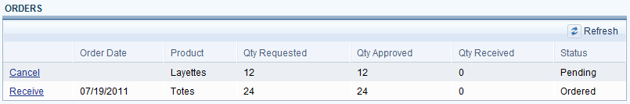
The table contains the following columns:
- Cancel or Receive. These links enable the AFASO to cancel an order which is still in Pending status or to acknowledge receipt of a shipment.
- Order Date. When HQ AFAS submits an order containing a shipment bound for his section, the AFASO sees the date on which HQ AFAS submitted the order. While an order is still in Pending status, the date is blank.
- Product. Self-explanatory.
- Qty Requested. This field shows the number of products the AFASO requested be sent to his section.
- Qty Approved. This field shows the number of products HQ AFAS actually ordered on behalf of the section. Since the HQ Administrator may adjust the quantity, this value could be different than what the AFASO requested.
- Qty Received. This field shows the number of items received in a shipment. A single shipment may not contain the entire quantity, so this column shows the number received to date.
- Status. This field shows the AFASO whether the request has been submitted to a vendor (“Ordered”) or whether HQ AFAS is still working on the order (“Pending”).
Cancelling Requests
When an AFASO requests new inventory, that does not necessarily mean that an order is placed right away. Before placing an order with a vendor the HQ Administrator may wait until requests from several sections arrive, thereby placing one larger order instead of several smaller ones. Until the order is actually placed with the vendor an AFASO may cancel his request by hitting the Cancel link in the ORDERS table. This action removes the line from the ORDERS table and removes the request on the HQ AFAS end.
Receiving Shipments
When the HQ Administrator places an order with a vendor, the vendor ships directly to the section, so HQ AFAS does not actually know when an order arrives at a section. When the order is placed the AFASO sees a Receive link in the ORDERS table which he uses to record receipt of a shipment once it arrives.
When the AFASO clicks on Receive a window appears in which he records the receipt.
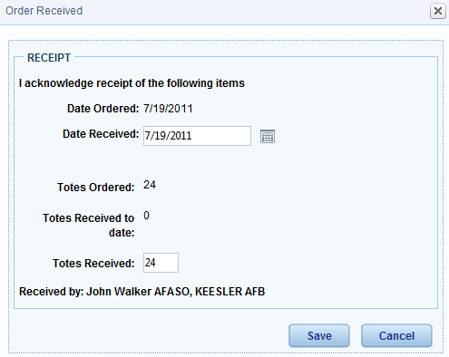
In the window the AFASO records the date the shipment was received. He sees the quantity that was ordered by HQ AFAS for his section and the number of items in the order that has already been received. Finally, he enters in the field labeled [Product] Received the number of items in the current shipment. He then hits the Save button to record the receipt. This also updates his inventory displayed in the INVENTORY table.
Incremental Receipt
Products do not always arrive in a single shipment. Let’s assume that for the order shown above, the totes were shipped in two separate shipments, one containing 18 totes and one containing the remaining 6.
When the first shipment is received the AFASO clicks on Receive, enters 18 in Totes Received, and hits Save.
The ORDERS table updates to show that 18 totes have been received so far.
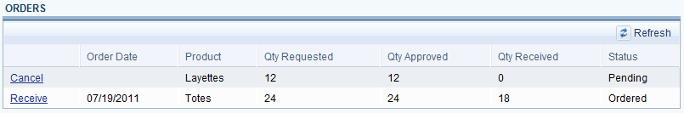
When the second shipment arrives the AFASO again clicks on Receive. The window now shows 18 Totes Received to date and automatically shows the balance in the Totes Received field.
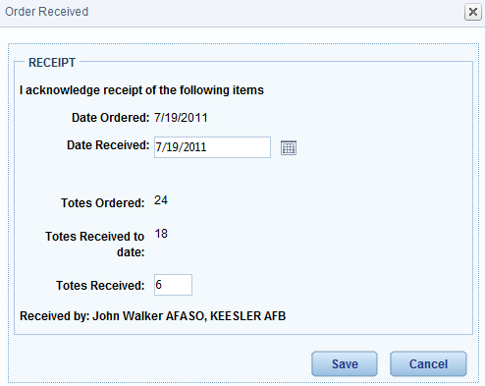
The AFASO leaves the remaining 6 in Totes Received and hits Save. Since the entire order of totes has now been received, the line for totes in the ORDERS table disappears.
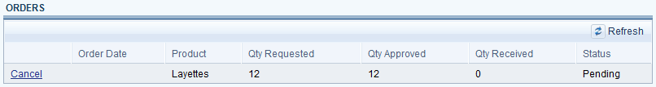

Requesting New Inventory / Adjusting Existing Inventory
On the AFASO’s Home page he sees a table labeled INVENTORY, which shows his current inventory for each of the active products in the Bundles program.
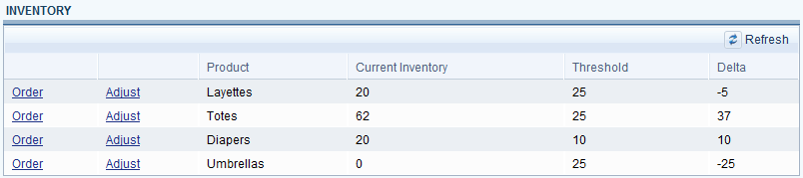
The table contains the following columns:
- Order or Adjust. These links enable the AFASO to request new inventory or to request a manual adjustment to the inventory.
- Product. Self-explanatory.
- Current Inventory. This value is the number of the product that the AFASO has on-hand. This value adjusts as new inventory is received and as products are distributed in classes.
- Threshold. This value is set by the HQ Administrator and is used by B4B to trigger an alert that a product may need to be ordered.
- Delta. The difference between Current Inventory and Threshold.
Requesting New Inventory
An AFASO may be prompted by B4B that his inventory for a particular product has fallen below the threshold, or he may compare his existing inventory with his upcoming class schedule and decide that it is time to request new inventory. To request new inventory the AFASO clicks on the Order link, which opens a window in which he requests a number of products and provides optional comments which will be seen by the HQ Administrator.
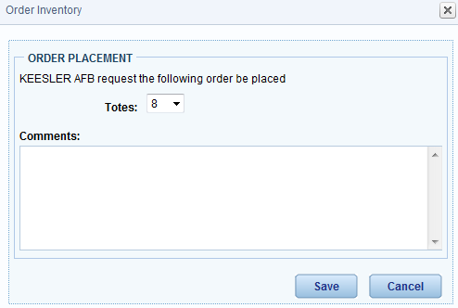
The AFASO uses a drop-down menu to select the number of products he would like HQ AFAS to order for his section. The values in the drop-down menu are increments based on the order increment defined by the HQ Administrator. That is, if the increment is 8, then the values of the drop-down menu are 8, 16, 24, etc.
Comments are optional, but may be used to convey to the HQ Administrator the rationale for requesting products at this time, especially if the section is not currently below threshold.
After selecting the number and possibly providing comments the AFASO hits the Save button to transmit the request to HQ AFAS. Once submitted, the request appears in the ORDERS table with Pending status.
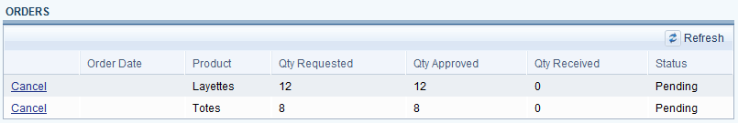
Adjusting Existing Inventory
In B4B there are three ways in which a section’s inventory may be adjusted: (1) by receiving a shipment, which increases inventory; (2) by distributing products in a class, which decreases inventory; or (3) by requesting a manual adjustment to the existing inventory, which may increase or decrease inventory. This section discusses the third option.
The option to manually adjust the existing inventory enables the AFASO to correct mistakes or to simply update the inventory when an atypical action occurs. For example, suppose that a recipient returns a layette to the section. Without the option of manually adjusting the inventory, the AFASO has no way to increase his inventory by one.
Let’s suppose that a recipient returned a layette, meaning that the section now has 21 layettes in the current inventory instead of 20. To manually adjust the inventory the AFASO clicks on the Adjust link, which opens a window in which the AFASO indicates the adjustment, provides the rationale for the adjustment, and hits Save.
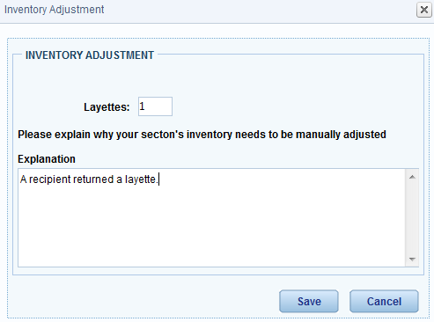
Note: The AFASO is requesting that an inventory adjustment be made, but the adjustment only takes effect when the HQ Administrator approves it.

Distributing Inventory and Logging Recipient Information
One of the key functions the AFASO performs in B4B is logging the distribution of inventory during classes. In addition to stating the number of products distributed, which keeps the inventory accurate in the database, the AFASO must also record information about each recipient.
On the AFASO’s Home page he sees a table labeled CLASSES AND DISTRIBUTION, which shows the classes that have been recorded.
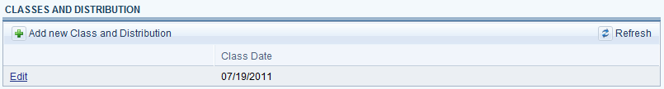
To add a new class the AFASO hits either the “add” icon ( ) or hits the Add new Class and Distribution link, either of which opens a New Class and Distribution window in which the AFASO records the information about the class and the distribution of products.
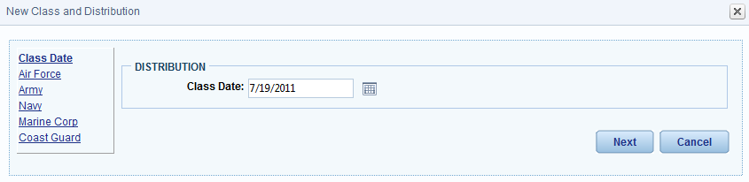
After entering the class date, either by typing the date directly or by using the calendar function, the AFASO hits the Next button to begin entering data about the products and the recipients. The AFASO must record information about each recipient, grouped according to service. B4B defaults to Air Force as the first service.
Note: By entering a class date and hitting Next, B4B adds the class to the CLASSES AND DISTRIBUTION table.
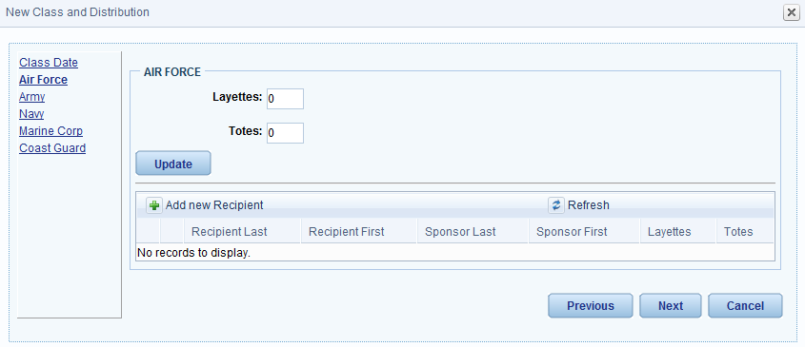
To add a new recipient the AFASO hits either the “add” icon ( ) or hits the Add new Recipient link, either of which opens a New Recipient and Sponsor Information window in which the AFASO records the number of products distributed to the recipient, information about the recipient, and information about the recipient’s sponsor.
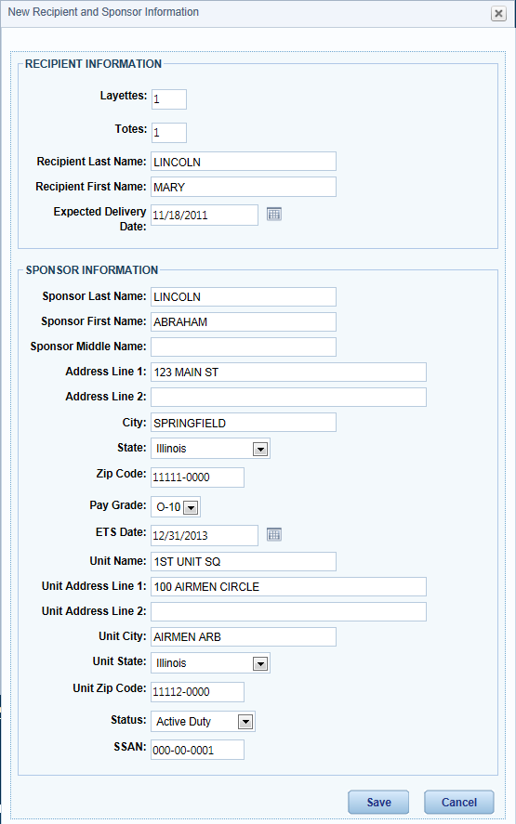
Note: Fields are available for only active products in the Bundles program. If a recipient receives items for multiple products, the entire distribution should be recorded once. For example, in the example above the recipient received both a layette and a tote, and both are recorded in this one window.
When all of the distribution information is entered the AFASO hits the Save button to record it.
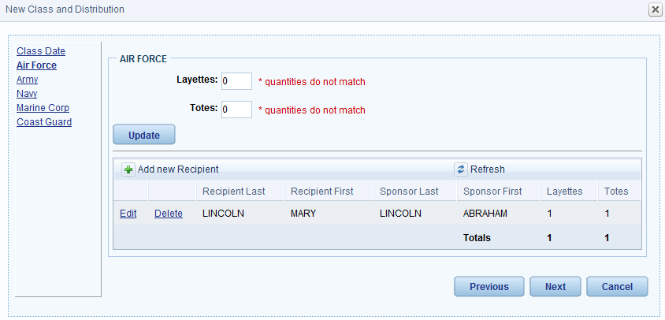
In addition to recording individual distributions the AFASO must also record the number of products distributed to each service. B4B does NOT automatically sum the individual distributions to get the group total. Instead, the AFASO must enter the totals in the fields provided for each product and then hit the Update button. Having the AFASO enter individual and group totals provides a mechanism for confirming that the totals are correct.
Note: If the totals entered by the AFASO do not match the sums of the individual distributions, the AFASO is prompted with an alert that the quantities do not match.
The AFASO enters the distribution data for each service. He may click on a service’s link or he may hit the Previous or Next buttons to navigate. If the AFASO is not yet ready to finalize the class, he may hit the Cancel button. On the final tab, for the Coast Guard, the AFASO sees a button labeled Finish. When he hits this button B4B finalizes the class.
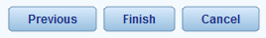
Class data is gathered by HQ AFAS for billing purposes, so once a class distribution is finalized it cannot be edited. In the CLASSES AND DISTRIBUTION table a class may appear with either a View link or an Edit link. If a class has the View link, then its data has been finalized and cannot be changed. If a class has the Edit link, then an AFASO may still edit the information.
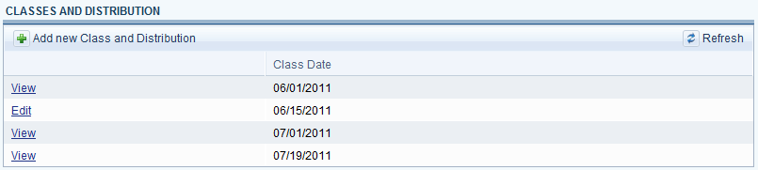

HQ Administrator
The HQ Administrator manages the program via six pages, each of which is discussed separately below. The six pages are Home, Orders, Thresholds, Products, Vendors, and Inventories.
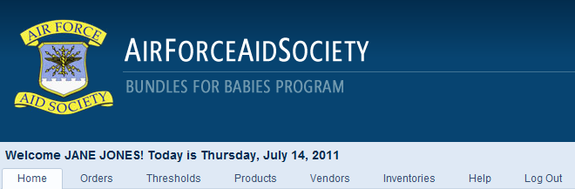

Accepting/Rejecting Requests for New Inventory
From the Home page the administrator manages sections’ requests for inventory adjustments, which could be requests for new inventory or requests for a manual adjustment to the inventory.
When an AFASO requests an increase to his section’s inventory the request appears in the REQUESTS table on the administrator’s Home page.
The REQUESTS table displays the section, the product being requested, the quantity being requested, the section’s threshold for the product, the section’s current inventory of the product, and any comments from the AFASO.
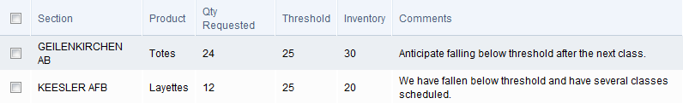
The administrator has two options: (1) accept the request, which means that an order for some quantity will be placed with the vendor on the section’s behalf or (2) reject the request, which means that no such order will be placed. He chooses the option first checking the checkbox by the request and then by hitting one of the buttons that appear above the table.
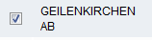
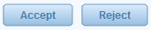
As in the example above, the administrator may see multiple requests. He may accept or reject each individually, or he may accept or reject a group by checking multiple checkboxes, including the topmost checkbox which, when checked, automatically selects all the sections’ requests.
Once accepted or rejected, the request clears from the table.

Approving/Declining Requests for Manual Adjustments
An AFASO may discover that his actual on-hand inventory does not match the inventory found in B4B. He may request that HQ adjust his B4B inventory, and the administrator uses the INVENTORY ADJUSTMENTS table to approve or decline the request.
The INVENTORY ADJUSTMENTS table displays the request date, section, the product whose inventory needs to be adjusted, the amount of the adjustment, and the section’s current inventory of the product.
The administrator views more details about the request by clicking on the Edit link, which opens a window in which the administrator sees the AFASO’s explanation, records optional comments about the decision, and makes the decision to approve or decline the request.
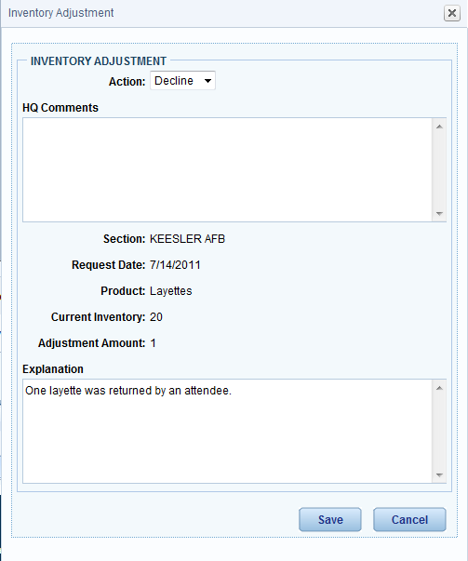
To approve or decline the request the administrator chooses the option from the drop-down menu labeled Action and then hits the Save button.
If approved, B4B updates the section’s inventory accordingly.
Once approved or declined, the request clears from the table.

Placing Orders
The Orders page contains a table which displays all pending and completed orders to vendors. The table displays the date the order was placed, the status of the order, the product being ordered, the vendor from whom the product is being ordered, comments entered by the administrator and, for completed orders, an order form which may be printed.
Pending Orders
As the administrator accepts requests for new inventory on the Home page, B4B automatically builds an order (or orders) on the Orders page. For example, in the Home page section above we saw requests from the sections at Geilenkirchen AB and Keesler AFB for totes and layettes, respectively. When the administrator accepted the requests BRB created an order for each product, as illustrated below.
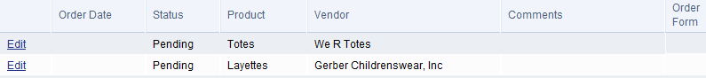
Note: An order not yet placed has no Order Date or Order Form, and its status is Pending.
The administrator may view a pending order by clicking on the Edit link, which opens a window displaying details of the order.
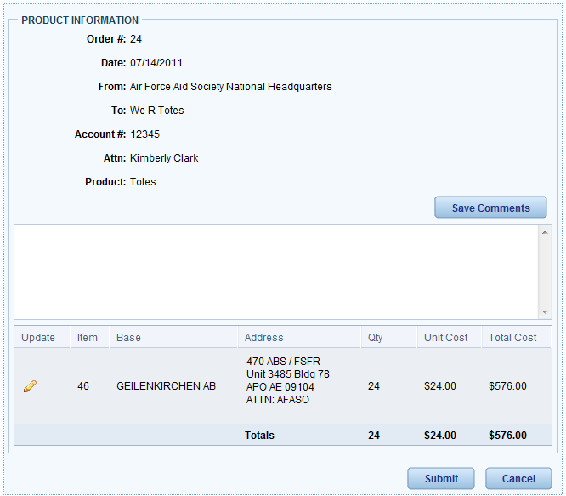
Information about the vendor and the product is drawn directly from the data contained on the Products and Vendors pages, which will be discussed later.
Each section’s shipping address automatically populates on the form.
The administrator has the opportunity to provide comments to the point-of-contact by entering the comments and hitting the button Save Comments.
The administrator may also edit the quantities being ordered. For example, in the order shown above the section requested 24 totes. The administrator may adjust that amount by hitting the edit icon (), which opens the quantity field for editing.
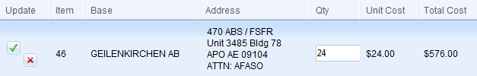
After adjusting the quantity the administrator may save the change by hitting the Save Changes icon () or may abandon the changes by hitting the Cancel Changes icon ().
As the administrator accepts new requests the order form updates accordingly. For example, suppose that after the order form was created, but before it is submitted, the section at Keesler AFB requests new totes. When the administrator accepts the request B4B automatically adds the item for Keesler to the form and updates the totals.
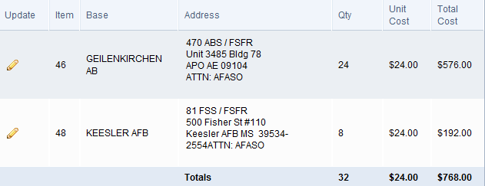
When the administrator is ready to submit the order he hits the Submit button, which changes the order’s status from Pending to Ordered.
Note: Submitting an order does NOT transmit any data electronically to the vendor. Instead, this action triggers alerts to the AFASO and creates a PDF of the order form which may be e-mailed or faxed to the vendor.
Completed Orders
When an administrator submits an order, the order’s status changes from Pending to Ordered in the ORDERS table. Since a submitted order cannot be edited, the action link available to the administrator changed from Edit to View.
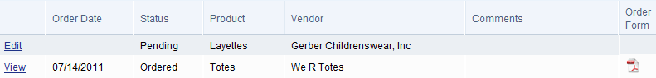
By clicking on the View link, the administrator may view the details of the order. Notice that the edit icon () for each line item disappeared.
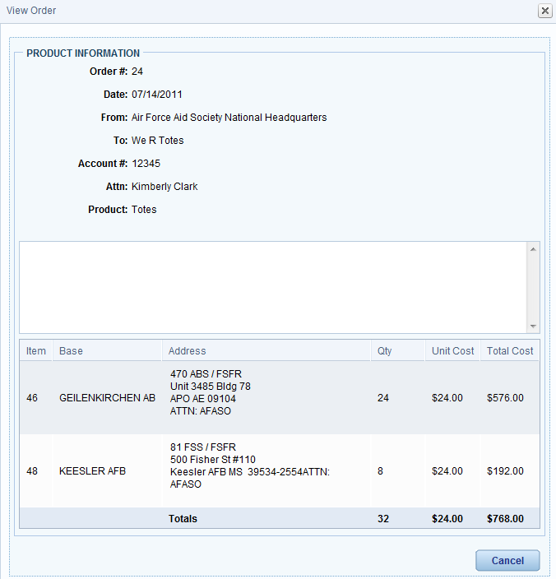

Setting Thresholds
The Thresholds page displays a table which contains each section’s threshold for the active products available in the Bundles for Babies program. If a section’s inventory falls below the thresholds listed here, then the AFASO receives an alert from B4B, advising him to request new inventory.
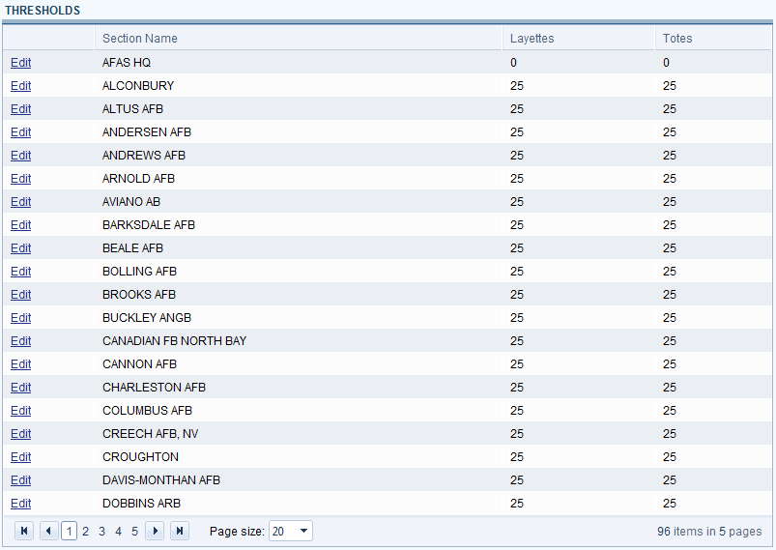
In the example above all the sections have the same thresholds for the products listed, but the administrator may adjust each section’s thresholds to better reflect actual usage. To edit a section’s thresholds, the administrator clicks on the Edit link, which opens a window, changes the values, and hits the Save button.
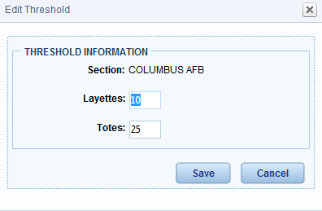
The new threshold(s) is then displayed in the table.
The table displays all the sections, and the administrator may scroll through the pages to locate a particular section, but B4B provides the administrator the ability to search for and then display the thresholds for a single section. By entering a section’s name in the Filter field and then hitting the Filter button, the administrator sees just that section’s thresholds.
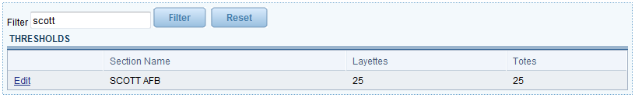

Assigning Products
The Products page displays a table which lists all of the products available in the Bundles for Babies program. The table identifies whether the product is active (discussed below), the name of the product, the product’s vendor, its unit cost, its default threshold (discussed below), and the order increment (discussed below).
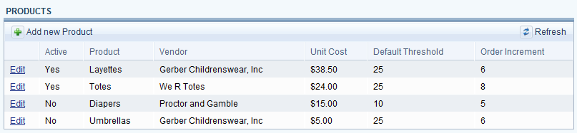
The current Bundles for Babies program contains two products, layettes and totes, but B4B is designed to allow more products to be added as necessary, such as diapers and umbrellas as shown in the sample table above. To add a product the administrator either hits the “add” icon ( ) or hits the Add new Product link, either of which opens a PRODUCT INFORMATION window in which the administrator assigns the product’s parameters.
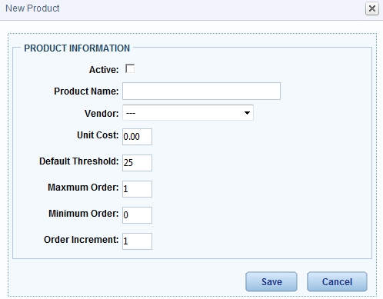
A product’s parameters include:
- An Active checkbox. If a product is marked as “active”, i.e. the box is checked, then it is a product currently available in the Bundles program. Consequently, the product appears to the AFASO on his screens, and it appears on the Thresholds and Inventories pages.
- Product Name. This is the name product as it will be displayed throughout B4B (including capitalization).
- Vendor. From a drop-down menu the administrator associates the product with one of the vendors contained in the database. Hence, a vendor must be created prior to a product being associated with it.
- Unit Cost. The cost per item.
- Default Threshold. The default appears for every section on the Thresholds page until the section’s individual thresholds are changed there by the administrator.
- Maximum Order. It may be that a vendor can only ship up to a certain maximum in a single order.
- Minimum Order. It may be that a vendor will ship no fewer than this minimum in a single order.
- Order Increment. Vendors may require that orders be placed in particular increments, e.g. in groups of 6.
After creating a product the administrator may edit its parameters at any time by clicking on the Edit link, which opens the PRODUCT INFORMATION window.
Note: If the product’s parameters are changed while an order for the product is in Pending status, then the changes automatically update on the order form.

Assigning Vendors
The Vendors page is very similar to the Products page. It displays a table which lists all of the vendors participating in the Bundles for Babies program. The table identifies the name of the vendor, an account number, a POC, the vendor’s mailing address, and the vendor’s telephone number.

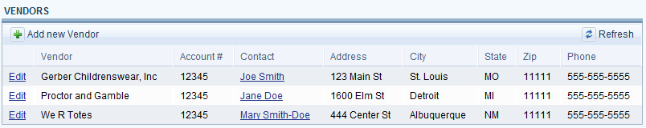
The current Bundles for Babies program contains two products, layettes and totes, and thus two vendors, but B4B is designed to allow more vendors to be added as necessary. To add a vendor the administrator either hits the “add” icon ( ) or hits the Add new Vendor link, either of which opens a VENDOR INFORMATION window in which the administrator assigns the vendor’s parameters.
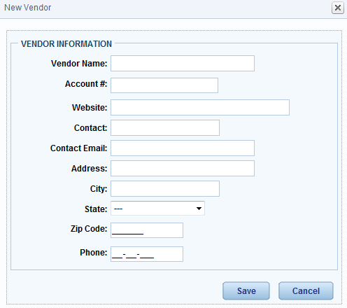
A vendor’s parameters include:
- Vendor Name. This is the name of the vendor as it will be displayed throughout B4B (including capitalization).
- Account#. The account number appears on the order form.
- Website. The administrator may add the vendor’s website information here as a reference.
- Contact. This field contains the name of a POC at the vendor.
- Contact Email. This field contains the POC’s e-mail address.
- Address, City, State, and ZIP. The vendor’s mailing address.
- Phone. The POC’s telephone number.
After creating a vendor the administrator may edit its parameters at any time by clicking on the Edit link, which opens the VENDOR INFORMATION window.
Note: If the vendor’s parameters are changed while an order for its product is in Pending status, then the changes automatically update on the order form.

Viewing Inventories
The Inventories page is very similar to the Thresholds page. It displays a table which contains each section’s actual inventory for the active products available in the Bundles for Babies program.
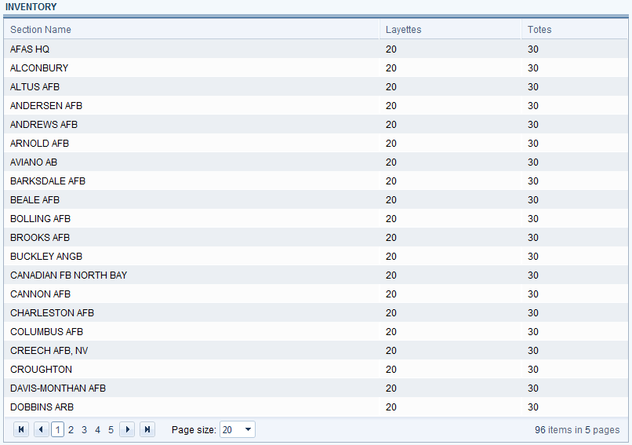
The table displays all the sections, and the administrator may scroll through the pages to locate a particular section, but B4B provides the administrator the ability to search for and then display the inventories for a single section. By entering a section’s name in the Filter field and then hitting the Filter button, the administrator shall see just that section’s inventories.
