TT3
IR Infrared Remote Control Repeater Emitter Extender Adapter
Does your entertainment system have wooden doors or would you like to mount your components in a closet? Put all of your AV gear in a closet or in a chest, or even in another room, totally out of view and control it with your IR remote controls.
Feature:
- High sensitivity
Remote control signal receiving real-time response to fast forward without delay
- CFL friendly
This unit can be installed in an area with compact fluorescent lighting, and will Work in most lighting environments
- IR Status LED
Blue IR LED confirms the signal is being transmitted
- Wide Band IR
Wide Band IR receives infrared signal from many types of remotes
- Compact size
With the small size of the connecting block, you can mount it near audio equipment with nearly no visibility
- Low power consumption
12VDC, 30mA max

Compatible:
DVD, IPTV, Fans, Air-conditioner, Satellites Receive Equipment, which’s receiving and transmitting frequency range are available.
Specification:
Receive Frequency Range | 34 KHZ to 60KHZ
Transmit Frequencies | 38 KHZ & 56KHZ
Receive Range | 8 Meter
Emitter Range | 5-10CM
Power | 12VDC,30mA MAX
Dimensions (IR Receiver)  (IR Emitters)  (IR Connecting Block) | 31(L)×17(W)×13(H)mm  13L)×8(W)×5.5(H)mm  90(L)×55(W)×26(H)mm
Cord Length (IR Receiver)  (IR Emitters) | 1.5 Meter  3 Meter
Connector Type | 3.5mm mini plug
Weight (IR Receiver)  (IR Emitters)  (IR Connecting Block) | 0.03Kg  0.03Kg  0.15Kg

Package Include:
1 x IR Distribution Block
1 x IR Receiver
4 x IR Emitter
1 x DC 12V Adapter
1 x Operation Manual

Note:
Before bid, please make sure receiving and transmitting frequency range are compatible. The receive range is about 8 meter, please make sure it’s enough for your house.

How to Use:
Note: Careful consideration must be taken when placing the IR Receiver near a Plasma Display!
Plasma Displays emit IR frequencies during use and may cause interference. Put the IR emitter as far as possible from the plasma display screen.
The Connected Remote Control Repeater is shown in the picture below:
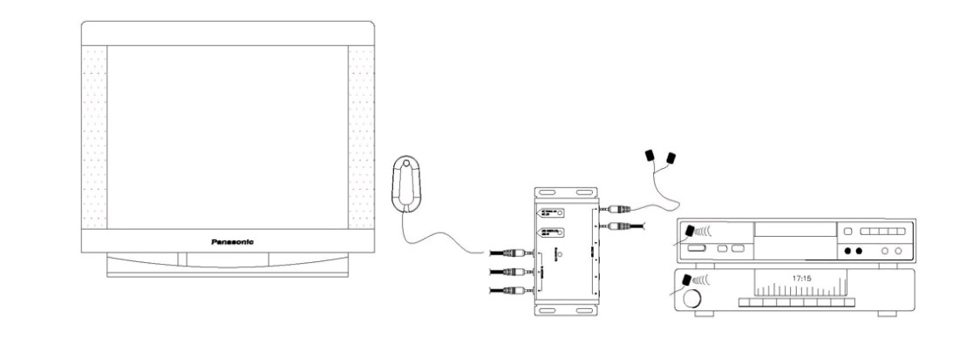

- Take the Mini IR Receiver (up to three) and connect it to the IR Receiver input jacks labeled 1-3 on the IR Connecting Block.
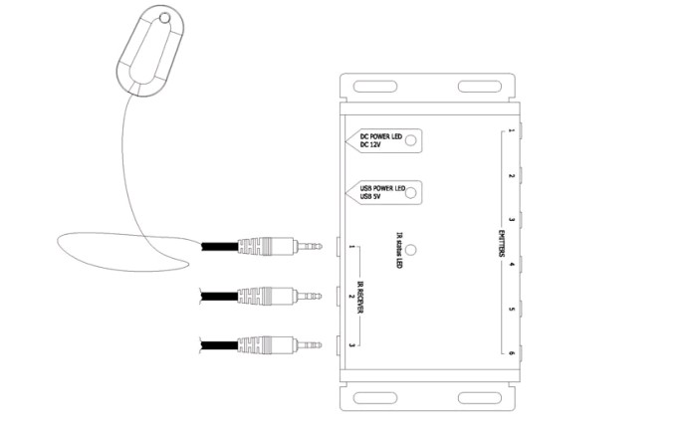

- Connect the emitters (up to six) to the emitter jacks labeled 1-6 on the IR Connecting Block.
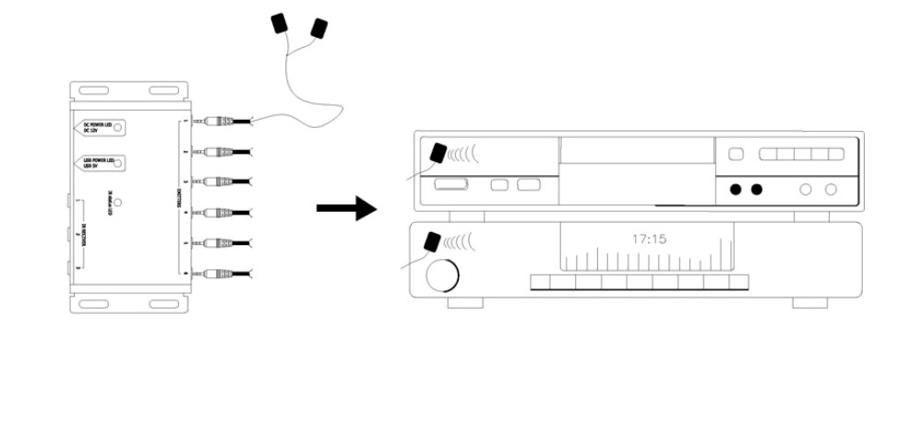
- Place the emitters on the source equipment.
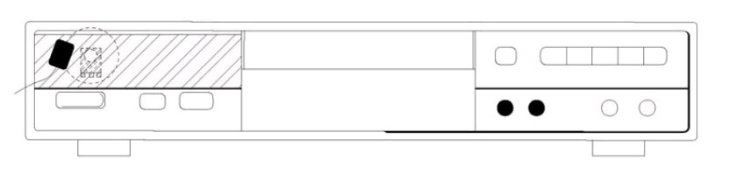

- Connect the 12VDC/ 5V USB Power Supply to the power jack on the IR Connecting Block and plug the Power Supply in the wall outlet. The LED will illuminate with a red light letting you know power is connected.
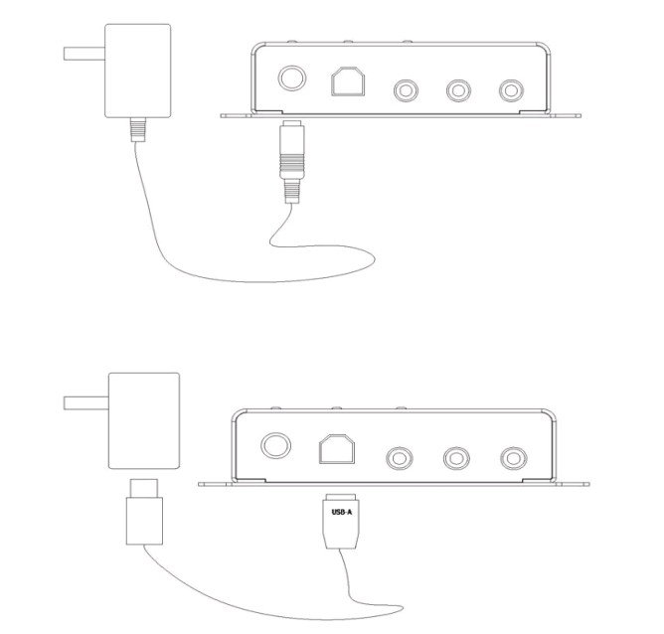

5. When the LED is green, it means that the power has been connected successfully .When an IR signal is received, the IR confirmation red LED will flash.
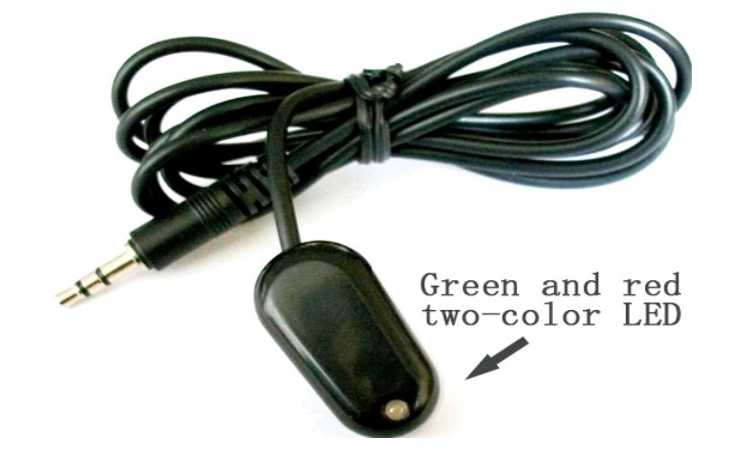

描述：红外遥控转发器

注意问题：等离子显示器可能干扰使用。

参考Keyword: IR Remote Control repeater
参考链接：http://www.ebay.com/itm/IR-Infrared-Remote-Control-Repeater-Emitter-Extender-/180478446511?clk_rvr_id=263192499448

