Ameyo User MAnual

This document contains step to step guide to Ameyo.

Contents
Introduction 1
Ameyo Feature Guide 1

Introduction
Functional validation determines if the solution is behaving according to specifications. This document is aimed to capture the functional requirements of your system. Functional requirements define what the system is supposed to do and what it will provide to the end-user. It describes the functionality or behavior of the system.

Ameyo Feature Guide

- Click on the drop down and select Customer Service Hub.
- 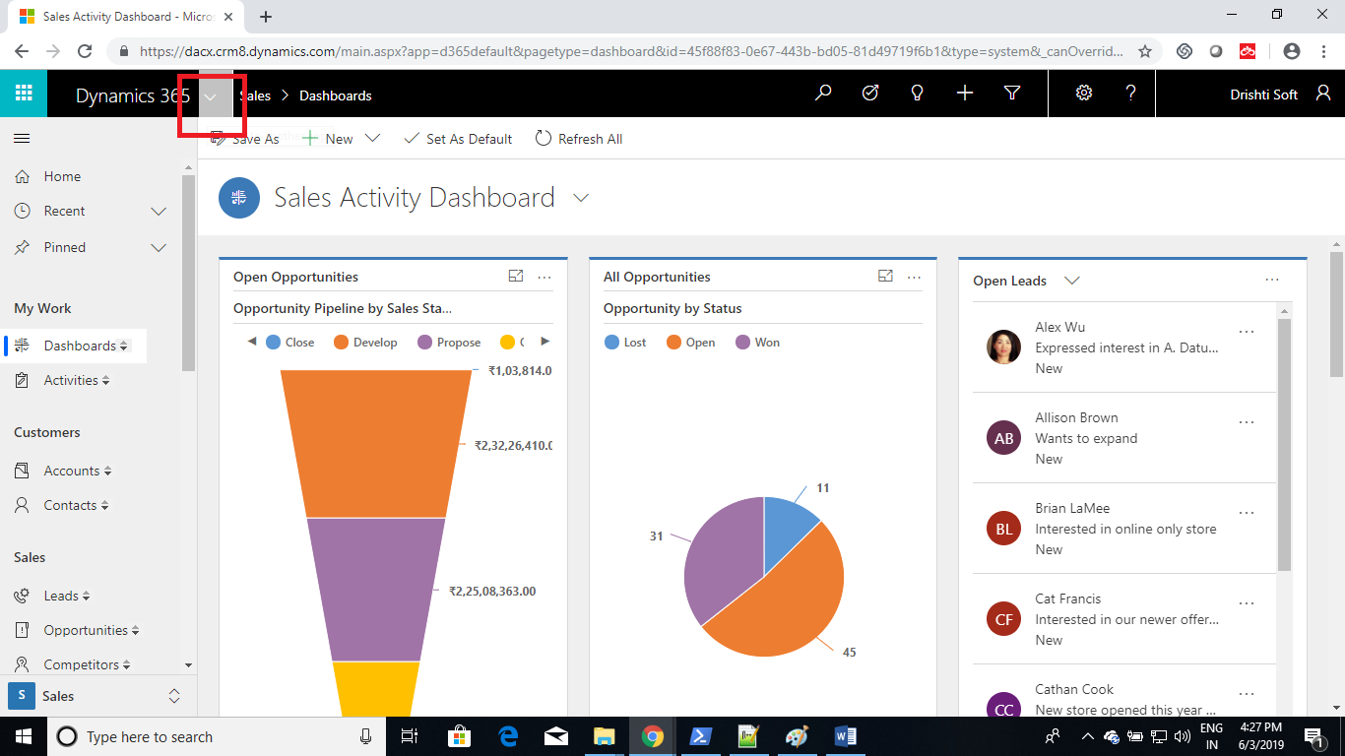
- 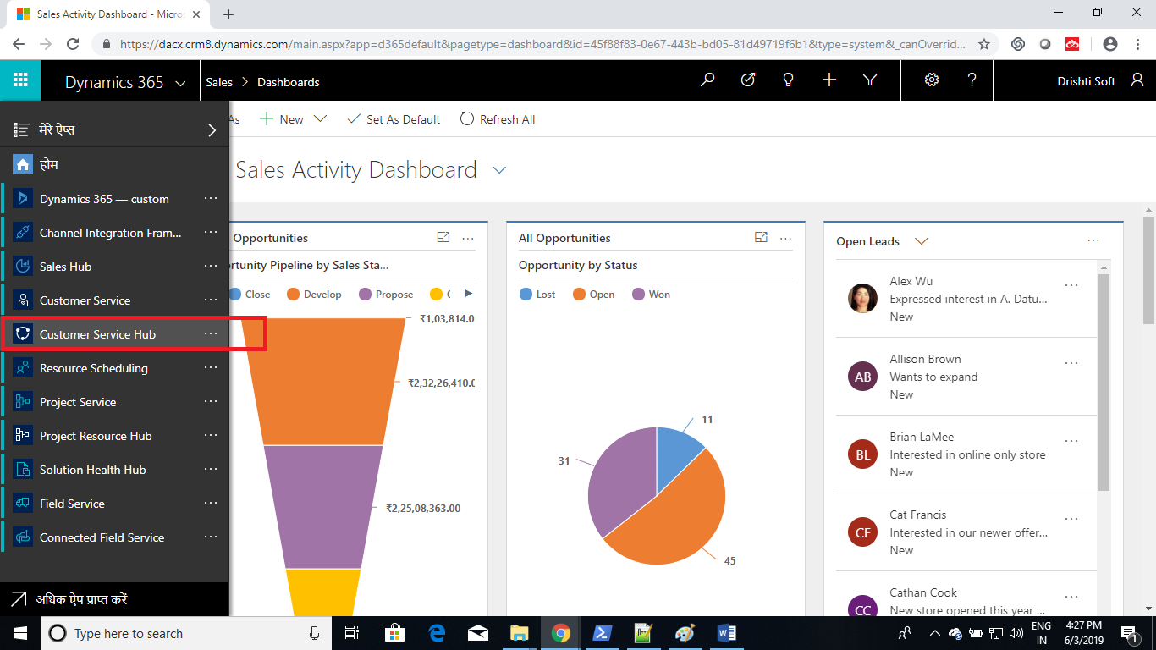
- Click on the arrow icon, it will open the Ameyo.
- 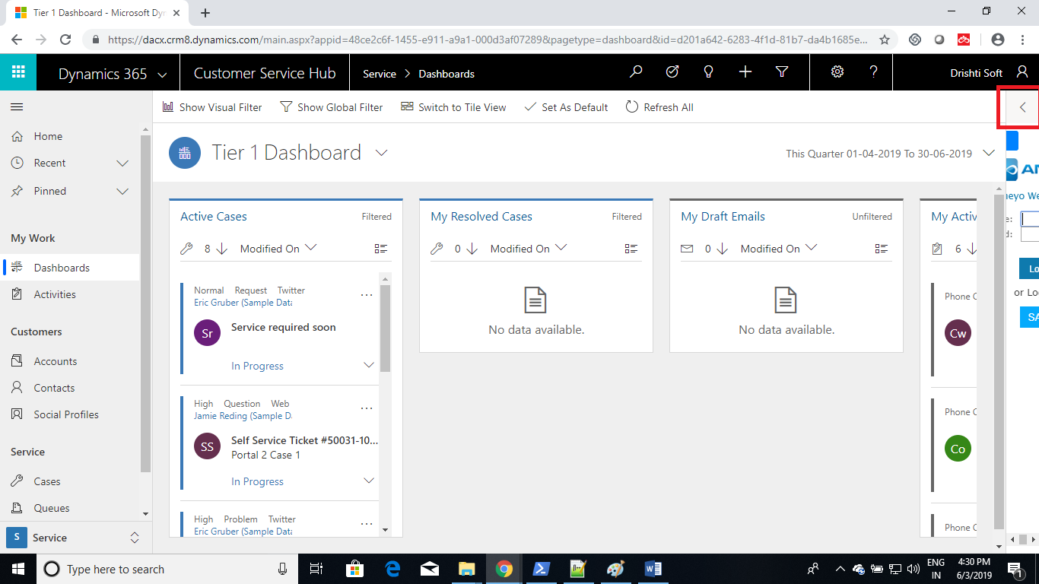
- 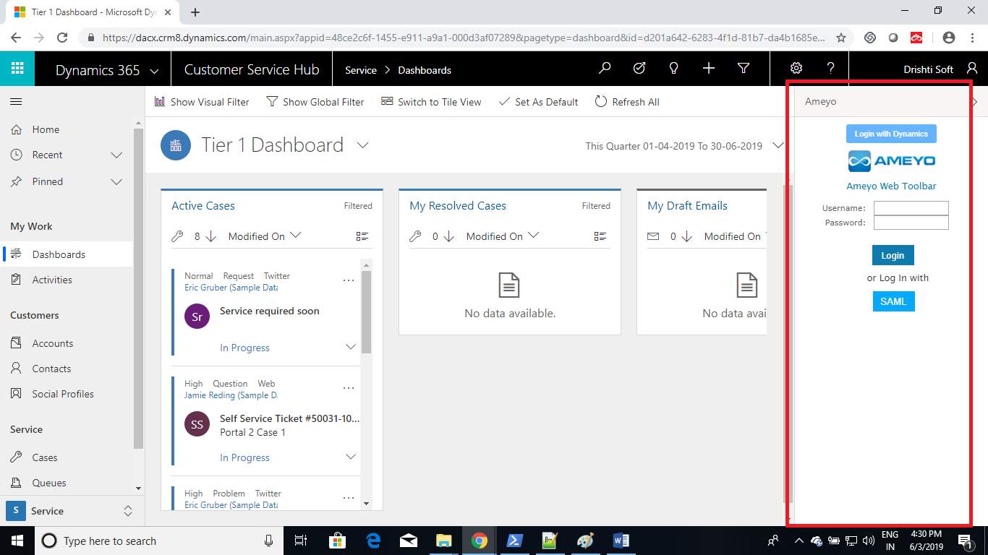
- To Login Click on the Login with Dynamics Button.
- 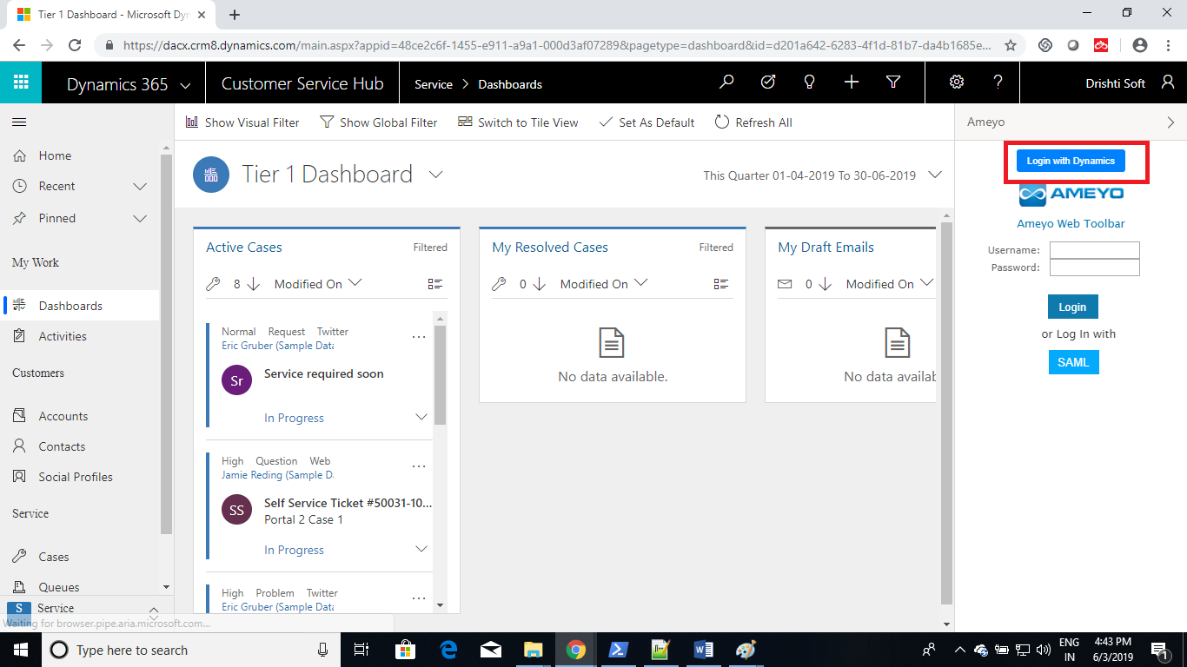
- On Successful Login you will be taken to the Ameyo Toolbar.
- 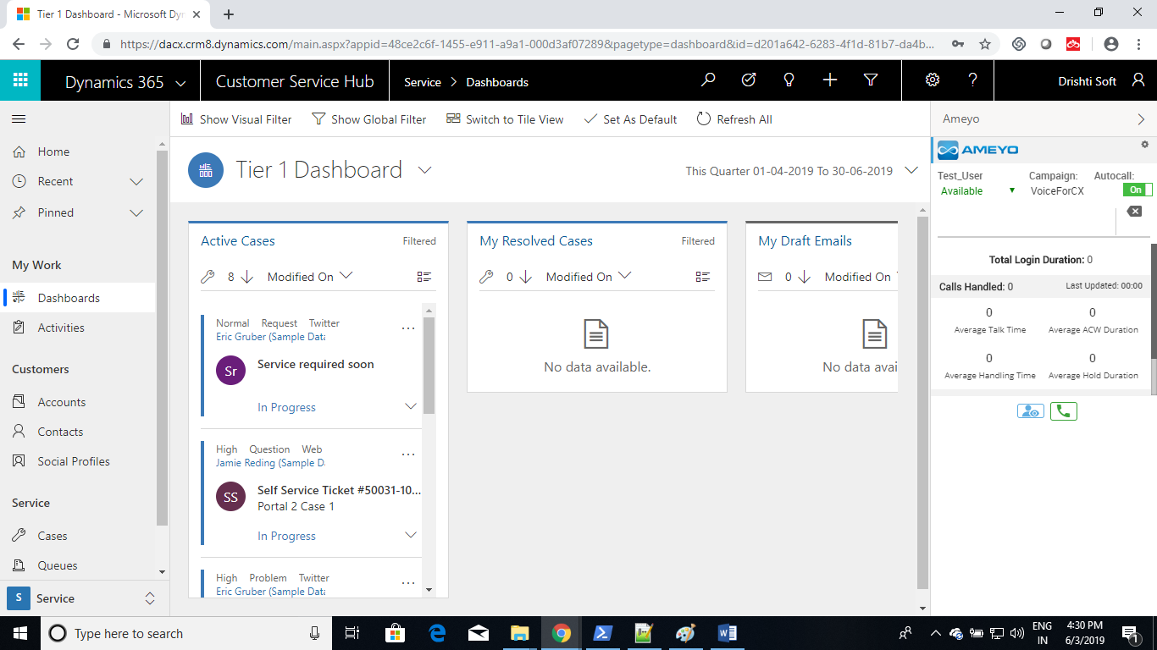
- Now we will perform search based on the mobile number. For this Test Drive, we have configured search to be perform on Contact entity and on telephone1 field. Entity and search field are configurable.
- Now we will make a call from Ameyo by entering a phone number in the text box. And Click on the phone icon.
- 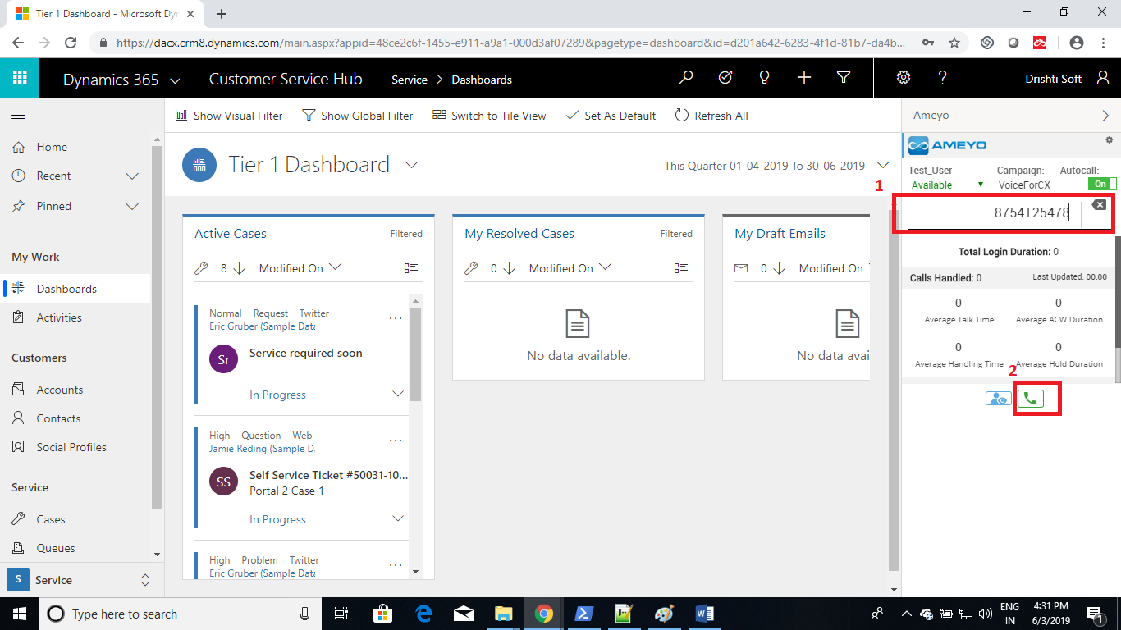
- A call will get initiated and if a contact is not found in MSD, a new contact record with name as Unknown will get created for that phone number.
- 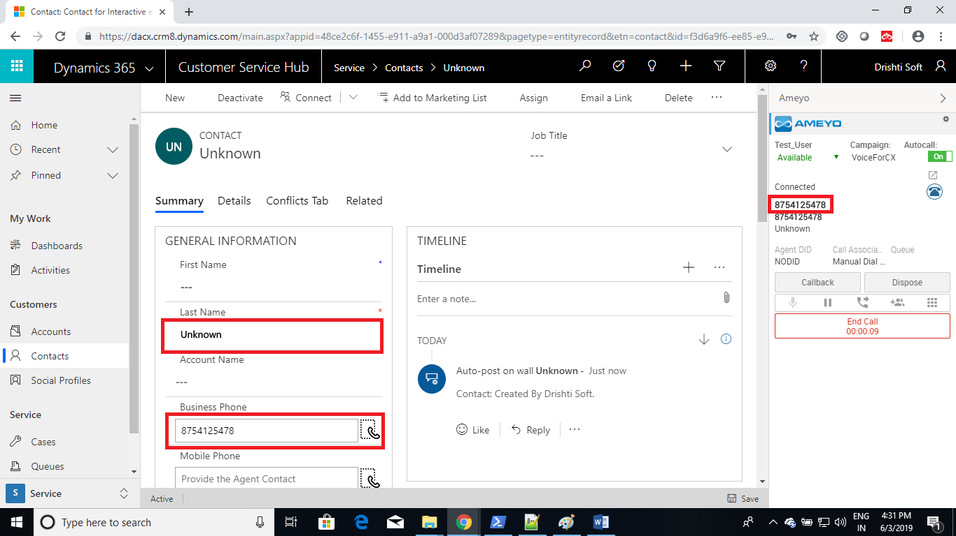
- Now you can dispose the call by clicking on dispose button. It will ask you dispositions, select them and click on Done button.
- 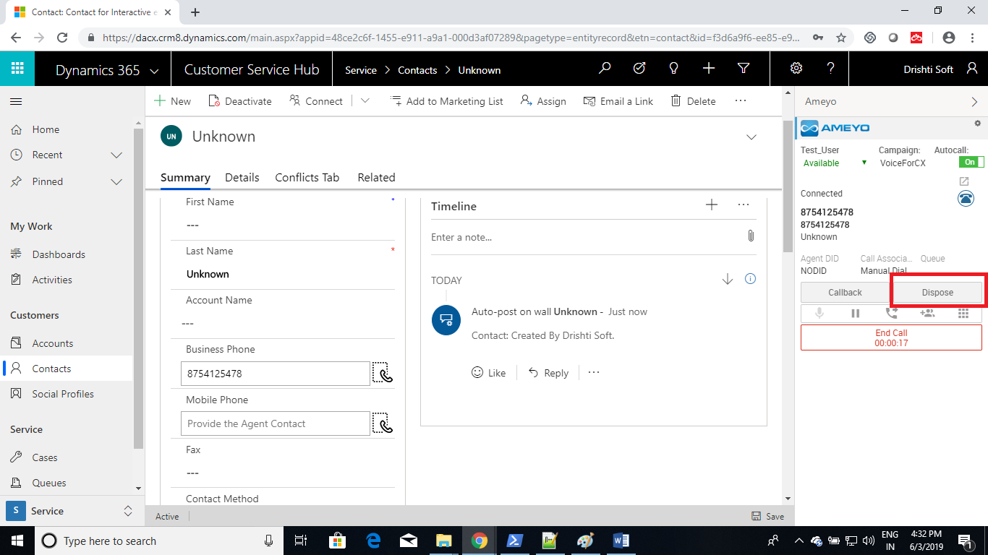
- 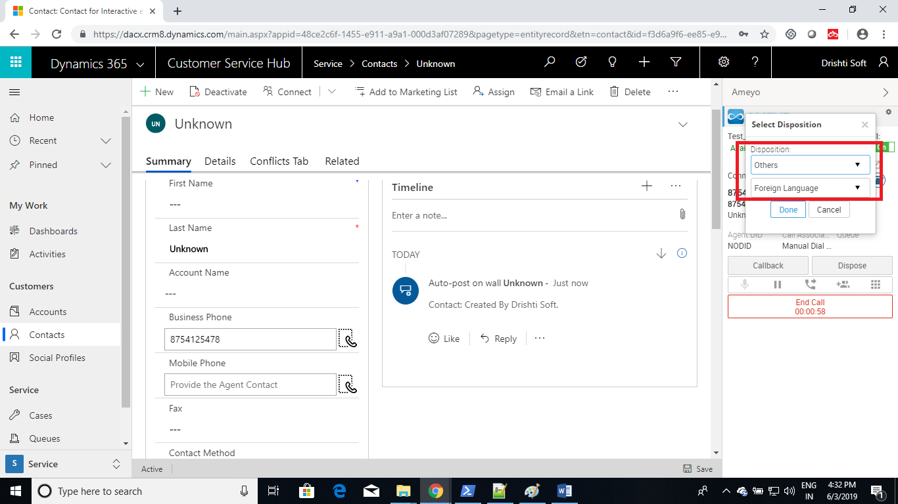
- 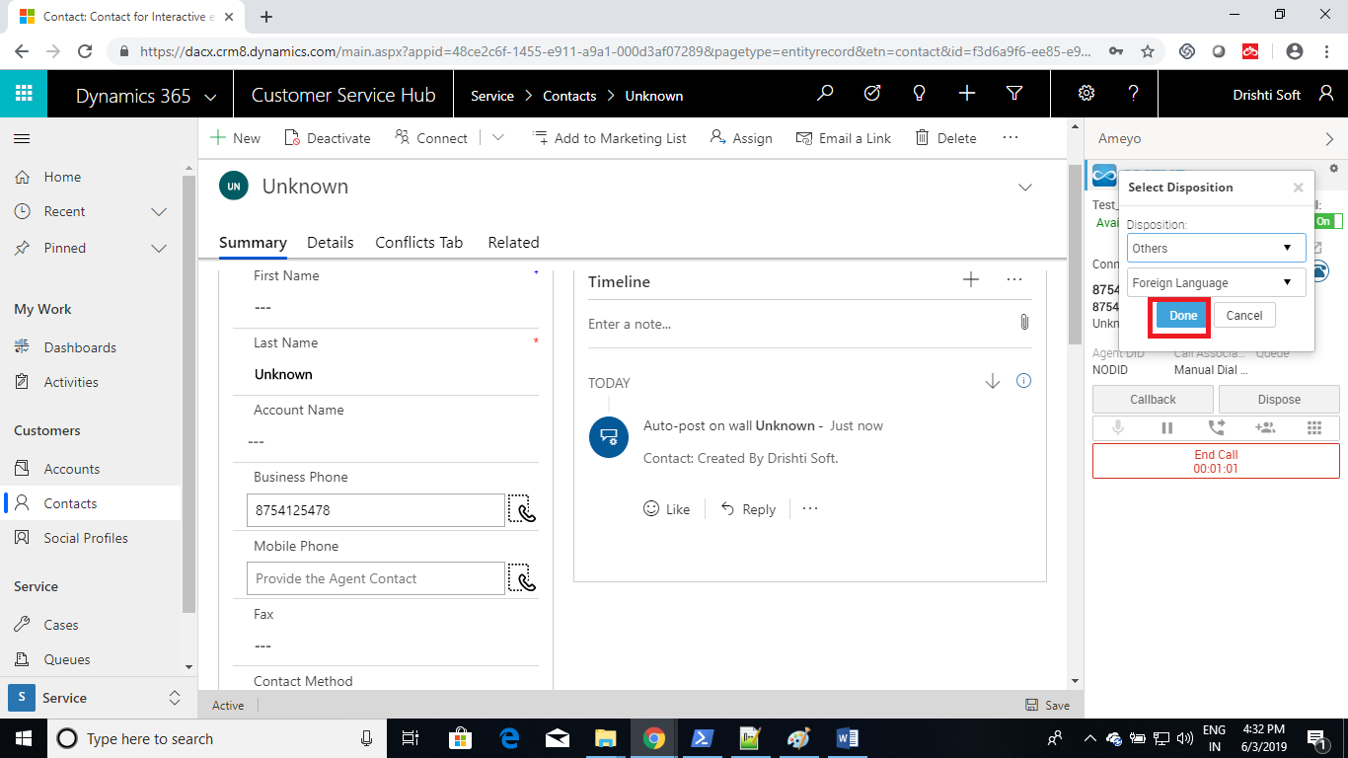
- On successful dispose, a phone call activity will get created, where call related data is dumped.
- Refresh the page, and you can see newly created phone call activity for that contact.
- 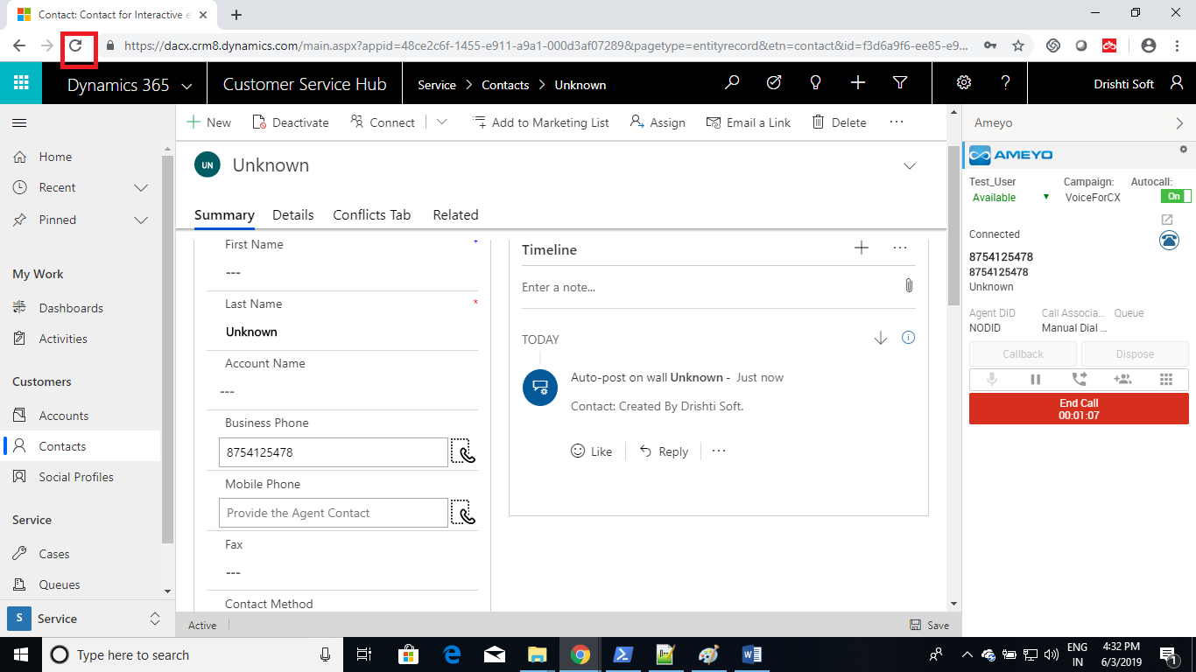
- 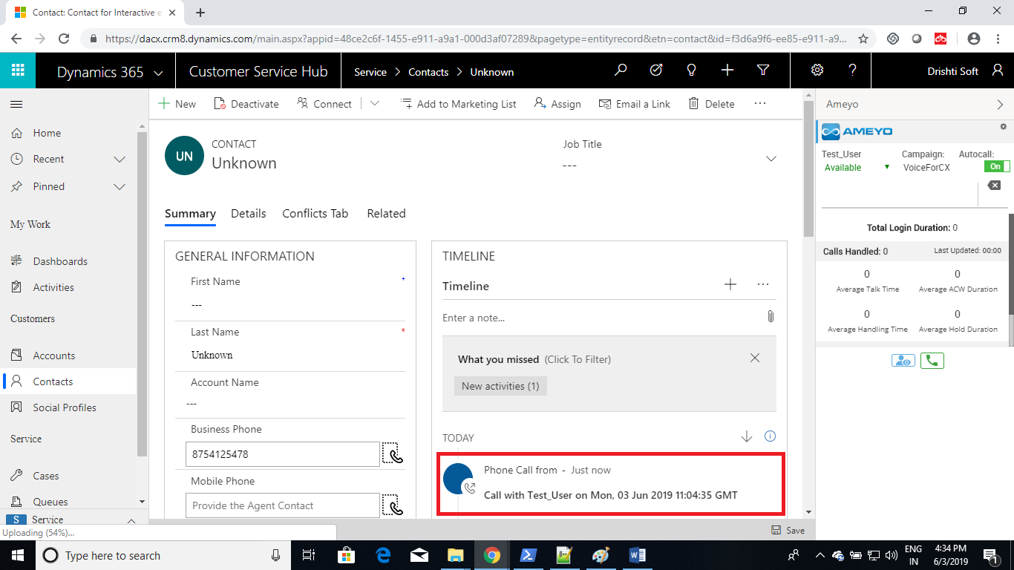
- Open the phone call activity by clicking it.
- Call related data is dumped in the following fields:
  - Subject
  - Phone Number
  - Direction
  - Regarding
  - Agent
  - Association
  - Disposition
  - Sub Disposition
  - Recording Link
- 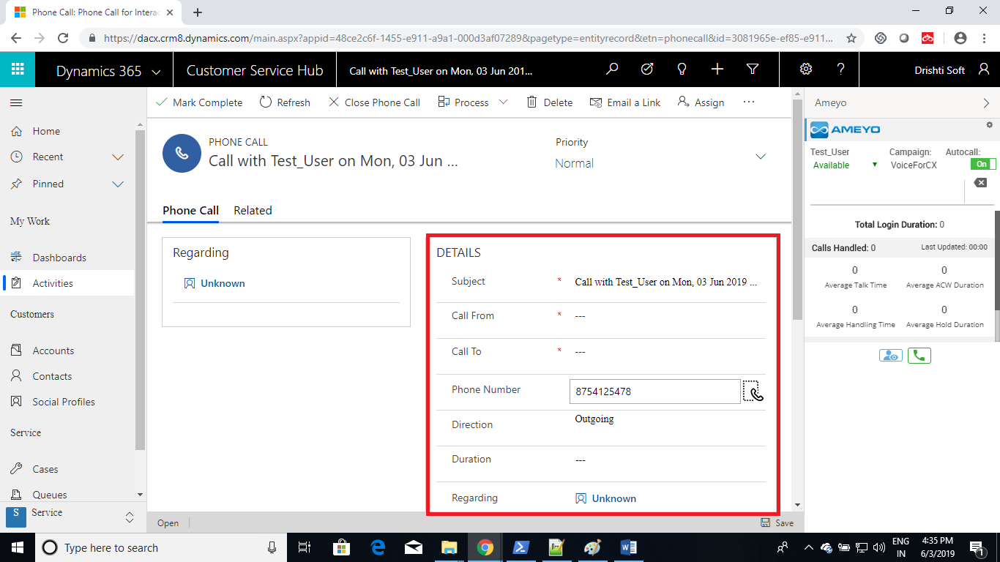
- 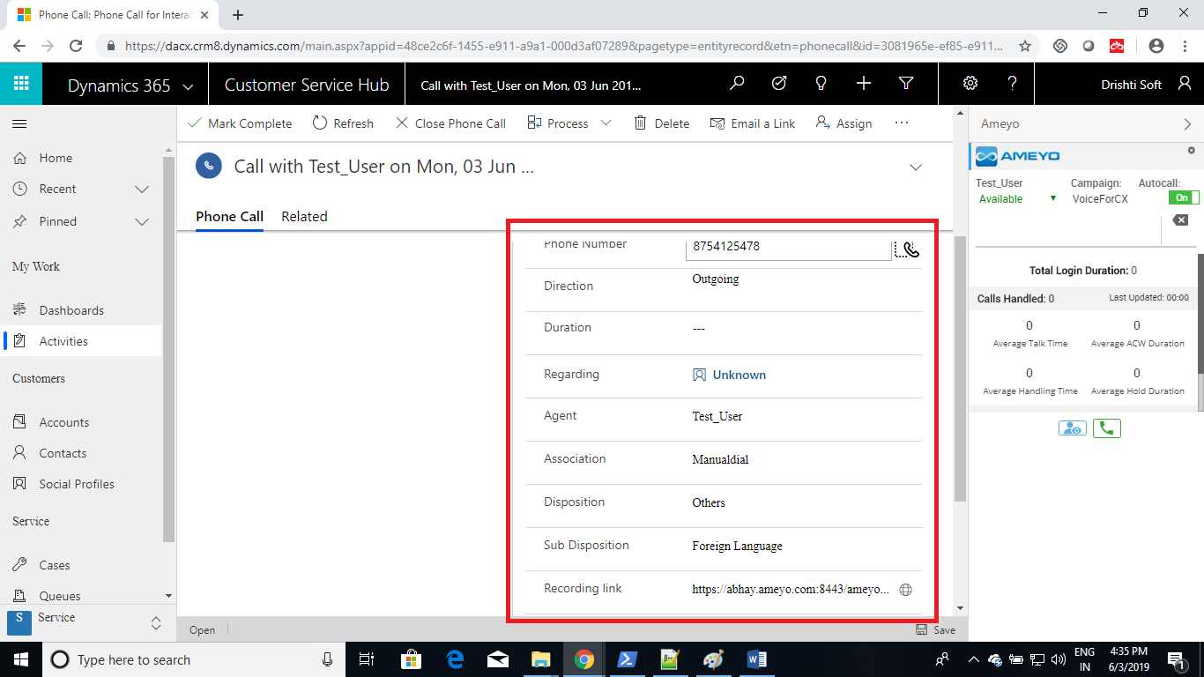
- Now make another call, for an existing contact.
- 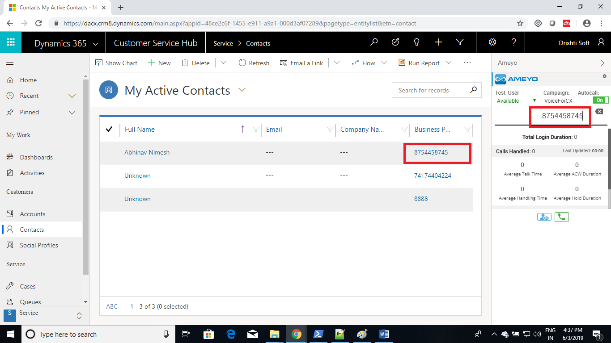
- Found contact will get open.
- 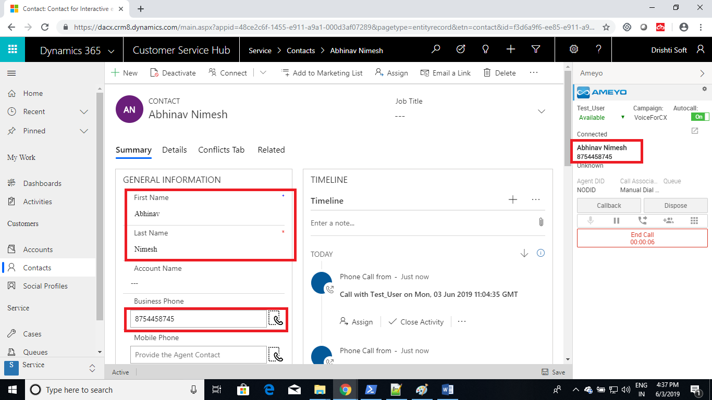
- Dispose the call.
- If there exists more than one contact, than you can select the contact from a drop down in Ameyo.
- 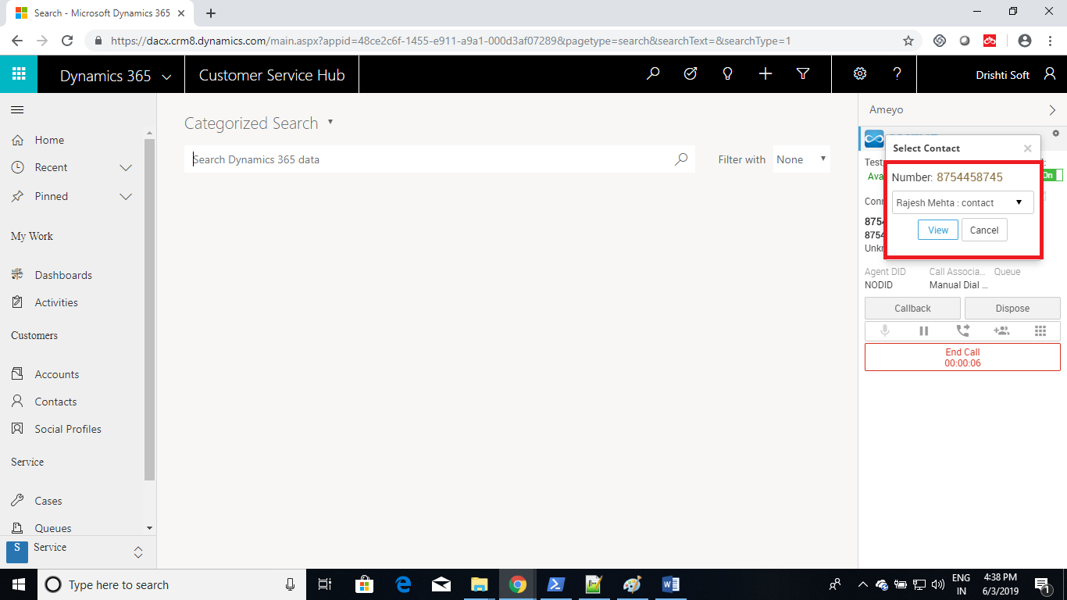
- 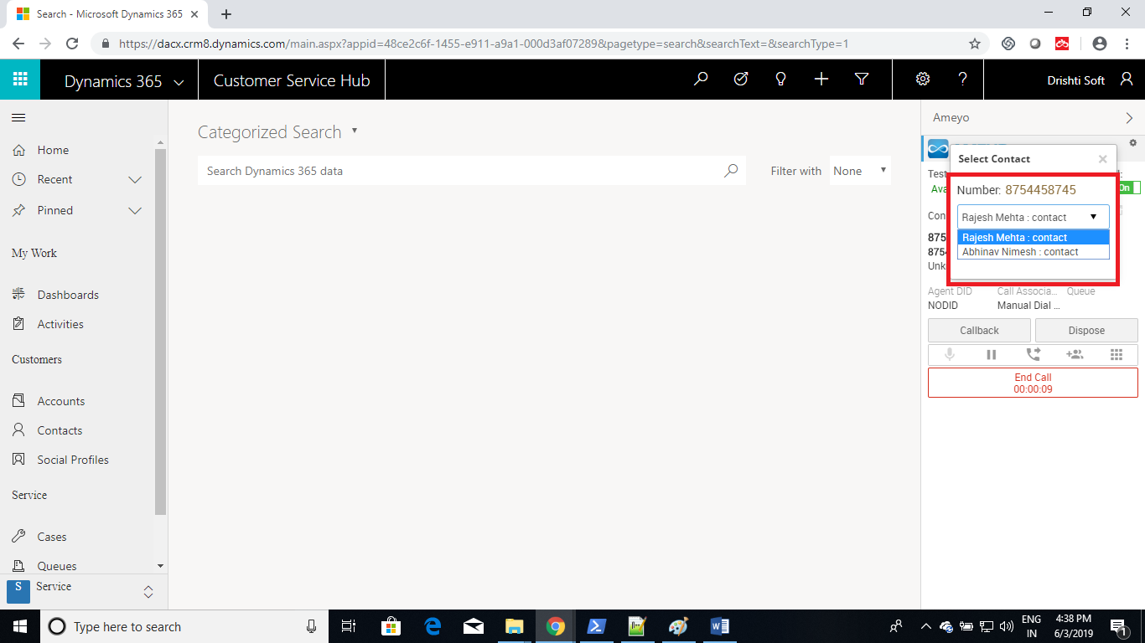
- Click on view button to open the selected contact.
- 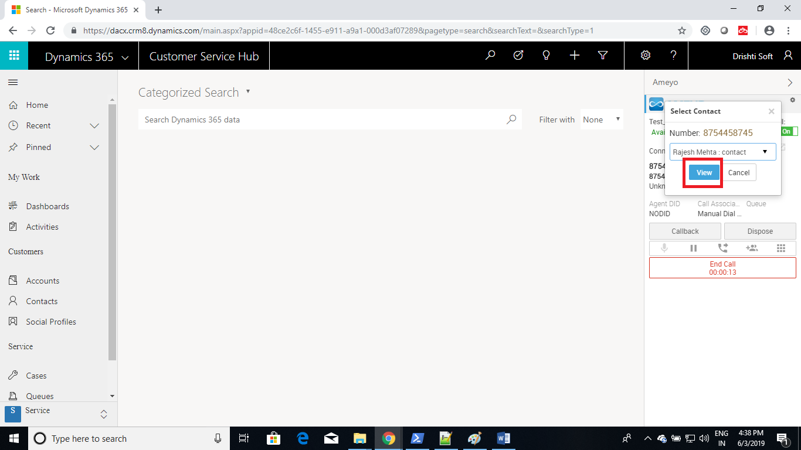
- 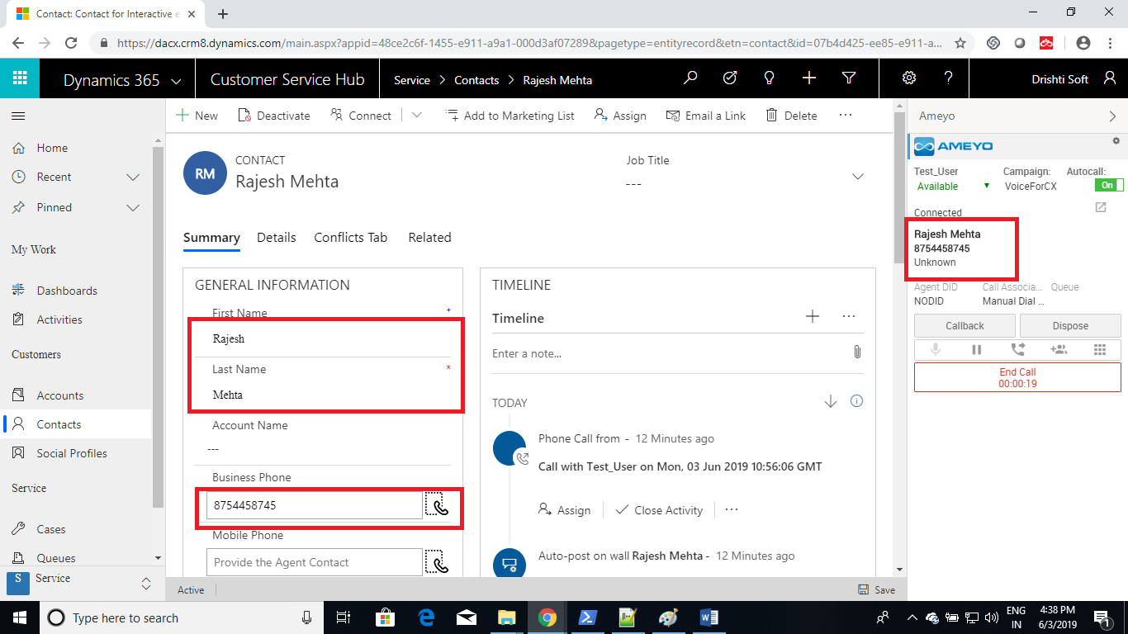
- You can also make a call by clicking the phone icon in MSD. (Click to Call)
- 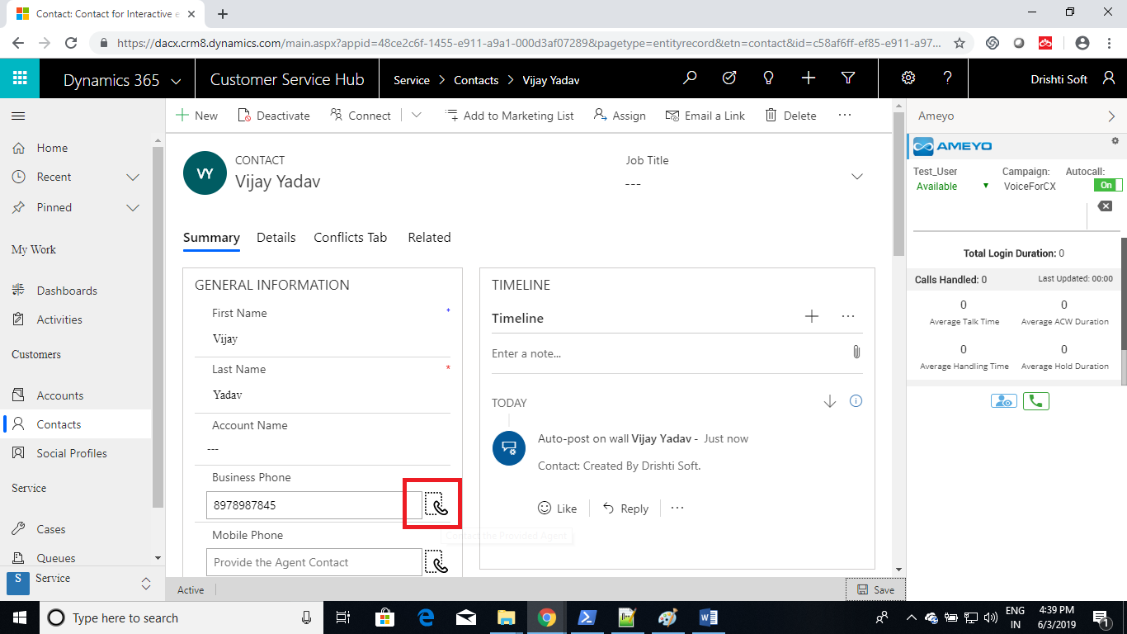
- A call will get initiated for the click contact number.
- 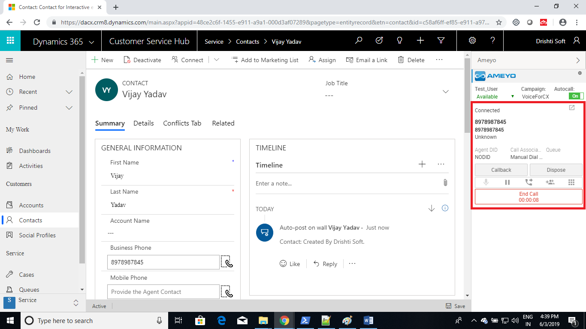
- Dispose the call.
- If during a call you are navigated to some other tab,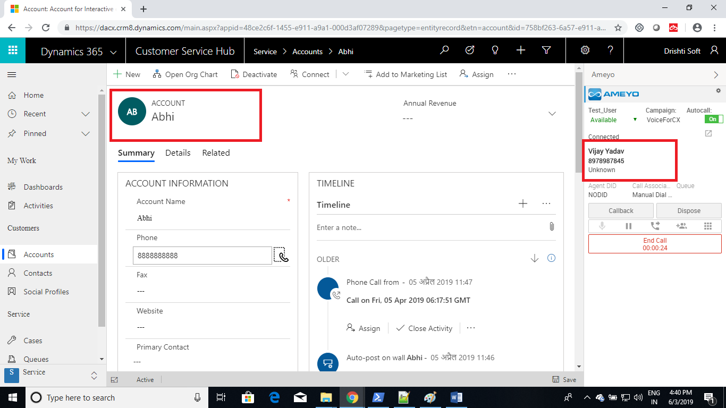
- and you want to open the searched contact, you can click on the hyperlink icon on the right side as shown in the below image.
- 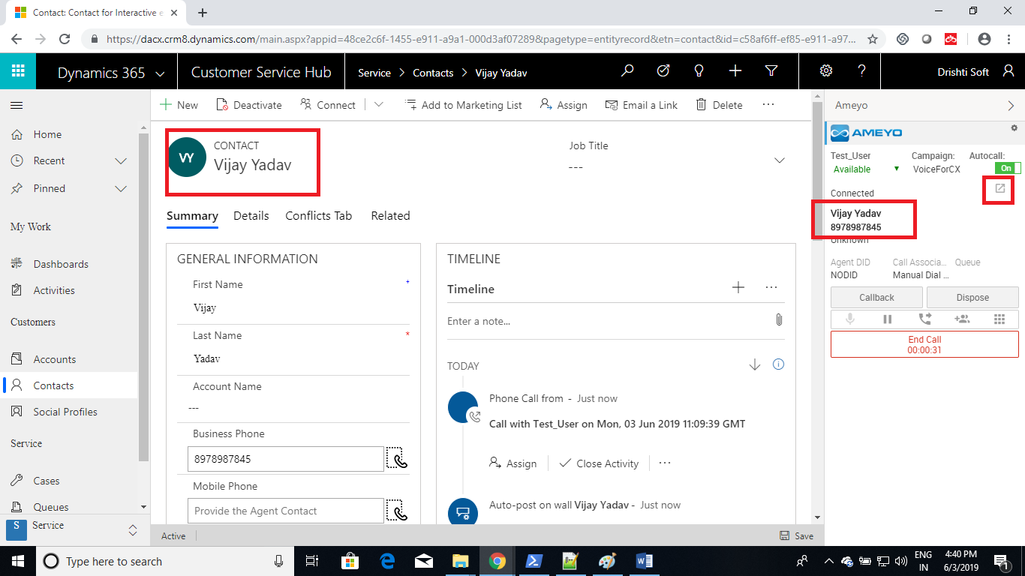
- To Logout user click on the setting button in Ameyo, select logout option.
- 
 