

cryoICE BOX

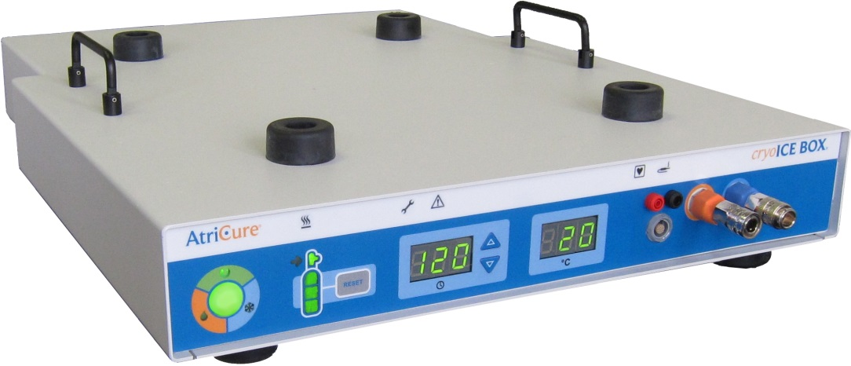
Version 6
USER’s manual
Model cryoICE BOX1 – 115 VAC
Model cryoICE BOX2 – 230 VAC


AtriCure, Inc.
7555 Innovation Way
Mason, Ohio 45040
USA
P001207 Rev A

Table of Contents
Foreword iv
Patent Information iv
Warnings and Precautions v
WARNINGS v
PRECAUTIONS v
Meanings of Symbols on cryoICE BOX vi
Meanings of Symbols on cryoICE Probe viii
Safety CSA Mark Information viii
1. System Overview 1
cryoICE BOX Front and Rear Panels – Illustrations and Nomenclature 2
Operating Modes 3
• READY Mode 3
• FREEZE Mode 3
• DEFROST Mode 3
• FAULT Condition 3
2. Technical Specifications 4
Mechanical Specifications 4
Environmental Specifications 4
Electrical Specifications 4
Mains Fuses 4
Footswitch Specifications 4
Equipment Type / Classification 4
3. cryoICE BOX and Accessories 5
4. cryoICE BOX Set-Up and Preparation 6
N₂O Cylinder Installation 6
Exhaust tubing 8
Heater Band Installation 8
Turning On the cryoICE BOX 9
Resetting the N₂O Gas Gauge 10
• Meaning of gas gauge indicators seen in Figure 12 11
System Check 11
5. DEVICE USE 11
Install cryoICE Probe 11
Set Ablation Time 13
START Ablation 13
6. Special Cases 14
Abort FREEZE 14
Change Ablation Time during Ablation 14
Emergency Stop 14
Set Default Ablation Time 14
Operate without temperature reading 14
7. System Disassembly After Use 15
Disconnecting the cryoICE Probe 15
N₂O Cylinder Removal 15
8. Preventive Maintenance and Cleaning of the cryoICE BOX 16
Cleaning and Disinfecting Instructions 16
Preventive Maintenance 16
Replacement of AC Line Fuses 17
Tank Hose Accessory – Alternate (Replacement of Gas Line Desiccant Filter) 20
Other Replacement Components 22
Disposal 22
9. TROUBLESHOOTING 23
cryoICE BOX Error Codes 27
10. ELECTROMAGNETIC COMPATABILITY TABLES 27
Electromagnetic Emissions 27
Electromagnetic Immunity 28
EMC Guidance and Manufacturer’s Declaration 29
Recommended Separation Distance 30
Warranties 31

Foreword

This manual and the equipment it describes are for use only by qualified medical professionals trained in the particular technique and surgical procedure to be performed. The cryoICE BOX also referred to as the ACM or AtriCure Cryo Module

Caution: Federal (USA) law restricts this device to sale by or on the order of a physician.

Please read all information carefully. Failure to properly follow the instructions may lead to serious surgical consequences including patient and caregiver harm.

Important: This manual is designed to provide instructions for use of the cryoICE BOX with the AtriCure cryoICE Probes (CRYO2), CRYO3, CRYOF and AtriCure Accessory Devices (CMF1, CMH15, CMH22). This manual is not a reference to surgical technique.

Indications for Use:
The AtriCure Cryo Module is a non-sterile, reusable device which delivers cryogenic energy, namely nitrous oxide, to AtriCure’s cryo-ablation probes.

The cryoICE BOX unit is an electro-mechanical cryogenic surgical unit that delivers a cryogenic Nitrous Oxide (N₂O) energy source to a cryoICE Probe to create lines of ablation through tissue. The cryoICE BOX is part of a system which includes the N₂O gas cylinder, N₂O gas line hose, N₂O exhaust hose, cylinder heater band, an optional footswitch, and single-use cryoICE Probe. The system provides controlled lesion forming temperatures below -40°C, with typical operating ranges between -50°C to -70°C.

The cryoICE BOX is designed to operate only with AtriCure designed and developed cryoICE Probes. For the user’s convenience, the AtriCure Cryo Module will be referred to in this User’s Manual as the “cryoICE BOX”. The AtriCure cryoICE Probe will be referred in this User’s Manual as the “cryoICE Probe”.

This User’s Manual provides a description of the cryoICE BOX, its controls, displays, indicators, and a sequence for its operation with the cryoICE Probe. This User’s Manual also supplies other information of importance to the user. This manual is intended as a User’s Manual only. Please refer to the cryoICE Probe instructions for use. Do not operate the cryoICE BOX before thoroughly reading this manual.

Patent Information
May be covered by one or more patents.

Warnings and Precautions
The safe and effective use of the cryo device and equipment is highly dependent upon factors under the control of the operator. There is no substitute for a properly trained operating room staff. It is important that the operating instructions supplied with the cryoICE BOX unit be read, understood, and followed before use.


WARNINGS
Note: Do not operate the cryoICE BOX unit before thoroughly reading this manual.
Note: Do not use cryo surgical equipment unless properly trained in the specific procedure being undertaken. This manual and the equipment it describes are for use only by qualified medical professionals trained in the particular technique and surgical procedure to be performed.
- Fire Hazard: Do not use extension cords.
- Trip Hazard: Standard care should be used to reduce the risk of tripping on the Footswitch cable, as well as the N₂O exhaust hose.
- No modification of this equipment is allowed.
The voltage selector is factory set and should not be changed by the user. The voltage setting and the fuse rating must be appropriate as identified to prevent cryoICE BOX malfunction and potential instrument damage.


Electric Shock Hazard: Connect the cryoICE BOX Power Cord to a properly grounded receptacle. Do not use power plug adapters.
Electric Shock Hazard: Do not connect wet accessories to the generator.

Electric Shock Hazard: Ensure that the cryoICE Probe is correctly connected to the cryoICE BOX and that no thermocouple wires are exposed from the cable, connector, or the cryoICE Probe.

PRECAUTIONS
- Use only with the AtriCure cryoICE Probes intended for use with the cryoICE BOX.
- Do not transition into FREEZE mode until the cryoICE Probe is properly positioned at the ablation site.
- The system status indicators and displays are important safety features. Do not obstruct either the ablation or the system status indicators.
- Do not remove the cryoICE BOX cover as there is a potential for electrical shock. Refer to authorized personnel for service.
- The Power Cord of the cryoICE BOX must be connected to a properly grounded receptacle. Extension cords and/or adapter plugs must not be used.
- Do not contact AtriCure cryoICE Probes with a RF device.
- Compressed Air Hazard: Do not operate N₂O cylinders with a pressure greater than 1000 PSIG (6900 kPa).
- Nitrous Oxide connections should only be unplugged when the ACM is in the ready mode and properly vented.

Meanings of Symbols on cryoICE BOX

Attention: consult accompanying documents
Dangerous Voltage
Power OFF
Alternating Current
Equipotential Terminal | 
Type CF Applied Part | 
READY | 
FREEZE | 
DEFROST | 
N₂O Gas Gauge | 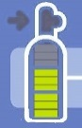
Timer | 
Timer Increase Button | 
Timer Decrease Button | 
cryoICE Probe Temperature | 
Thermocouple/Probe | 
Cylinder Valve On/Off | 
N₂O Gas Gauge Reset | 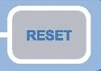
Gas Exhaust | 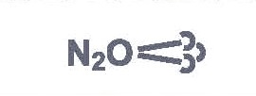
Maintenance Needed | 
Cylinder Heater Band | 
Footswitch | 
Maximum Pressure
Gas Inlet | 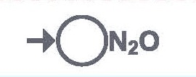
Gas Outlet | 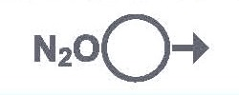
Humidity and Temperature Storage Limits  (located on corrugated cardboard packaging) | 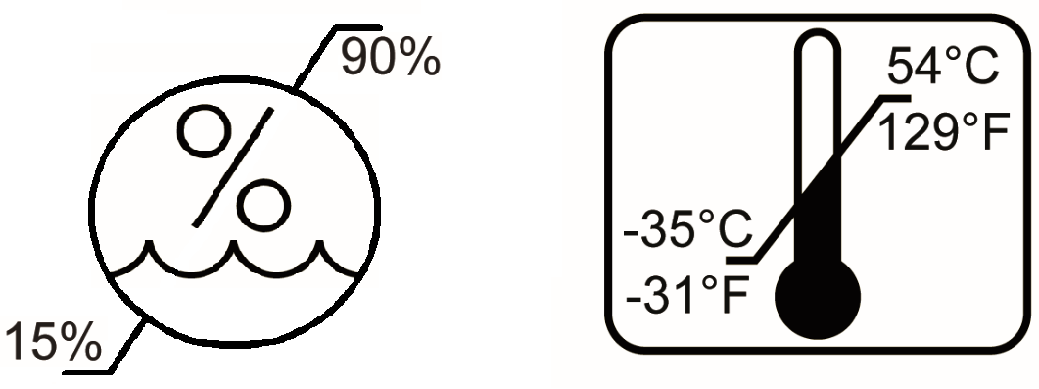

Meanings of Symbols on cryoICE Probe
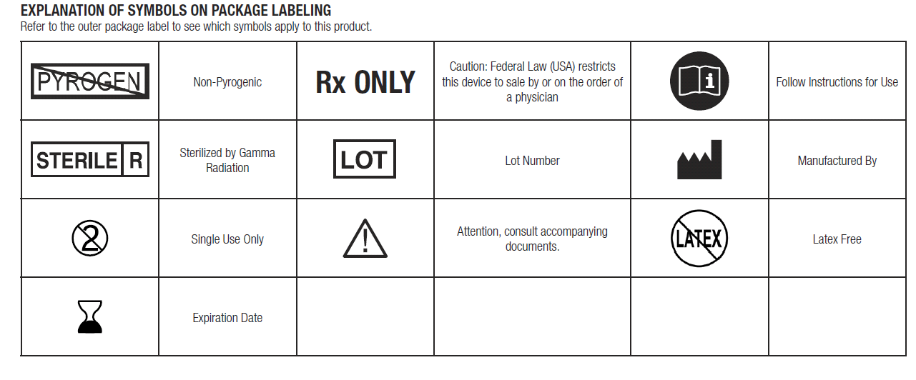
Classification in accordance with EN 60601-1

Safety CSA Mark Information



CLASS 8750 01 - MEDICAL ELECTRICAL EQUIPMENT/SYSTEMS
CLASS 8750 81 - MEDICAL ELECTRICAL EQUIPMENT/SYSTEMS - Certified to US
Standards
Cryogenic Ablation Device, Model AtriCure Cryo Module, ACM1 & ACM2, cord connected/ appliance coupler / transportable, rated: 115/230Vac, 4/2A, 50/60Hz.
1. Type of protection against electric shock: Class I
2. Degree of protection against electric shock: Type CF
3. Degree of protection against ingress of water: IPX0
4. Equipment not suitable for use in the presence of a flammable anesthetic mixture with air or with oxygen or nitrous oxide.
5. Mode of operation: Continuous
Environmental Conditions: Normal: 10-40°C, 15-90% rH, 980-1050mb

System Overview
The cryoICE BOX
This section provides a detailed description of the cryoICE BOX including its function and operating features.
- The cryoICE BOX unit is an electro-mechanical cryogenic surgical unit that delivers a Nitrous Oxide (N₂O) cryogenic energy source to a cryoICE Probe to create lines of ablation through tissue. The cryoICE BOX is part of a system which includes the N₂O cylinder, N₂O gas line hose, N₂O exhaust hose, cylinder heater band, an optional footswitch, and single-use cryoICE Probe. The system provides controlled lesion forming temperature that is below -40°C, with typical operating ranges between -50°C to -70°C.
- Along with the Activation Button on the front panel of the cryoICE BOX, an optional Footswitch can also be used to activate and terminate the cryo ablation cycle.
- The cryoICE BOX is designed to operate only with AtriCure cryoICE Probes. Please refer to the cryoICE Probe Instructions for Use P0001031 with CRYO2, P000678 with CRYO3, or P001060 with CRYOFORM.
- Refer to the cryoICE Probe Instruction for Use for complete description and indications for use of these devices.

cryoICE BOX Front and Rear Panels – Illustrations and Nomenclature
Illustrations of the cryoICE BOX front panel (Figure 1) and rear panel (Figure 2) are shown below.
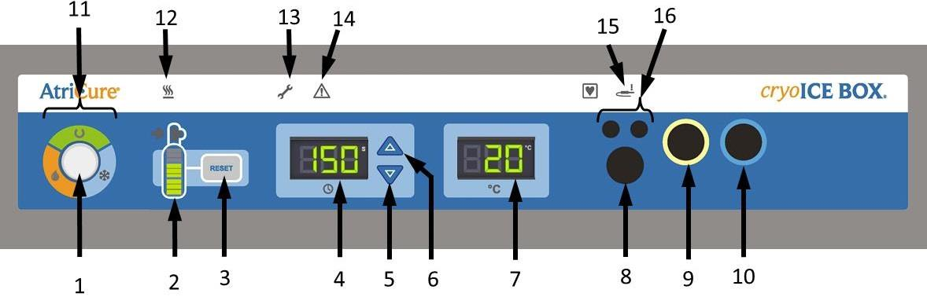
Figure 1: cryoICE BOX Front Panel
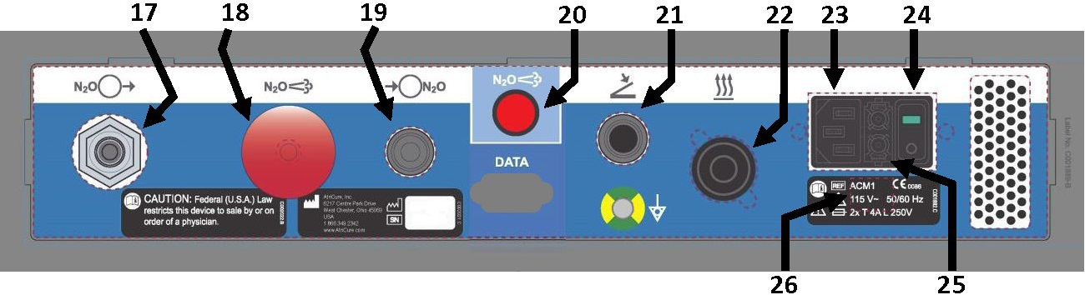
27
28
Figure 2: cryoICE BOX Rear Panel

1. Activation Button | 15. Thermocouple Open Indicator
2. Nitrous Oxide (N₂O) Gas Gauge Display | 16. cryoICE Probe Thermocouple Ports
3. Nitrous Oxide (N₂O) Gas Gauge Reset | 17. N₂O Exhaust Port
4. Ablation Timer Display | 18. N₂O Manual Exhaust Knob
5. Ablation Timer Decrement | 19. N₂O Inlet Port
6. Ablation Timer Increment | 20. N₂O Exhaust Switch
7. cryoICE Probe Temperature | 21. Activation Footswitch Connection Port
8. Future Probe Connection | 22. Heater Band Cord Receptacle
9. cryoICE Probe Gas Outlet Port | 23. Power Plug Receptacle
10. cryoICE Probe Gas Inlet Port | 24. Power Switch
11. Ablation Status Indicator | 25. Mains Fuse Location
12. Cylinder Heater Band Indicator | 26. cryoICE BOX Rating Label
13. Maintenance Needed Indicator | 27. Equipotential Terminal
14. System Fault Indicator | 28. RS232 Data Connection

Operating Modes
The cryoICE BOX operates in one of three modes: READY, FREEZE, and DEFROST. These modes are identified by the system status indicator LEDs and the ablation status indicator LEDs located on the front of the cryoICE BOX unit.

READY Mode
This mode is entered automatically upon successful execution of Power-on-self -test when the unit is first turned on, or following DEFROST Mode upon the cryoICE Probe reaching approximately 5°C and automatically venting. This indicates that the system is ready for the next cryo ablation run.
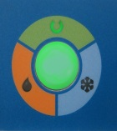



FREEZE Mode
This Mode is entered from the READY Mode when the user initiates the cryo ablation cycle by pressing and releasing the Activation Switch or the Footswitch. In this mode, the N₂O gas is permitted to cycle through the cryoICE Probe causing a temperature drop to take place at the cryoICE Probe.

DEFROST Mode
This Mode is entered automatically from FREEZE Mode upon expiration of the ablation timer, or manually by the operator when the Activation Switch or the Footswitch is actuated while in the FREEZE Mode. In this mode, the cryoICE Probe temperature is actively forced towards the ambient temperature.
Once the cryoICE Probe temperature is above approximately 5°C, the cryoICE BOX unit will transition back to the READY Mode.

NOTE: cryoICE BOX does allow early transition out from the DEFROST Mode into either the READY Mode or the FREEZE Mode by pressing the Activation Button.
NOTE: cryoICE Probe temperature may drop temporarily upon transition from Defrost to Ready state.

FAULT Condition


This is entered upon detection of any unrecoverable error condition during any Mode. The system is inoperable in this Mode until the unit is first power cycled, and only if the fault condition no longer exists or has been remedied.

Technical Specifications

Mechanical Specifications
Size: | 17.5 in (44.5 cm) - (W) × 27.0 in (68.6 cm) - (D) × 4.5 in (11.4 cm) - (H) maximum
Weight: | 45 lb. (20.4 kg) absolute maximum.

Environmental Specifications
 | Temperature | Humidity | Atmospheric pressure
Operational temperature | +10°C to +40°C | 15 to 90% relative humidity | 980mb to 1050mb
Storage | –35°C to +54°C | 15 to 90% relative humidity | 980mb to 1050mb
Transit | –35°C to +54°C | 15 to 90% relative humidity | 980mb to 1050mb

Electrical Specifications
cryoICE BOX1: 100-120VAC, (115 VAC nominal), 50/60 Hz
cryoICE BOX2: 220-240VAC, (230 VAC nominal), 50/60 Hz

Mains Fuses
cryoICE BOX1 (100 -120VAC, 50 / 60 Hz,): Replace fuses as marked:
4.0A/250V, T-lag, 5 × 20 mm, UL Recognized, IEC Approved
cryoICE BOX2 (220-240VAC, 50 / 60 Hz,): Replace fuses as marked:
2.0A/250V, T-lag, 5 × 20 mm, UL Recognized, IEC Approved

Footswitch Specifications
Moisture protection rating: IPX8

Equipment Type / Classification
Class 1 Equipment

cryoICE BOX and Accessories
As shown in Figure 3, the system is comprised of the following:
A: AtriCure Cryo Module Cylinder Heater Band (CMH15 or CMH22)
B: cryoICE BOX N2O Gas Line Hose Module, standard
C: cryoICE BOX N₂O Exhaust Hose
D: cryoICE BOX N₂O Gas Line Hose Module, with filter canister set (Optional)
E: cryoICE BOX
F: cryoICE BOX Footswitch (Optional – not shown)
G: cryoICE BOX Power Cord (not shown)
H: AtriCure cryoICE Probe with integral tube set (not shown)
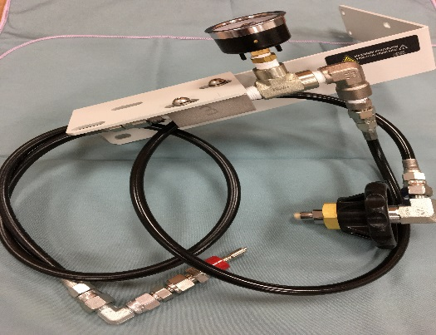
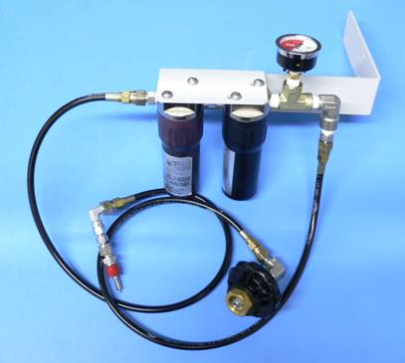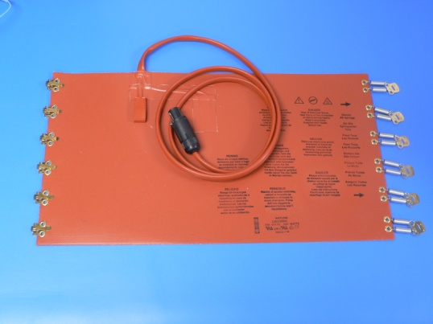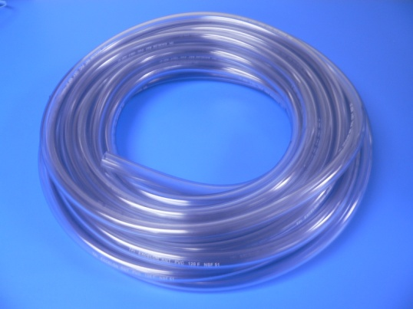
A
E
D
C
B
Figure 3: cryoICE BOX Accessories

cryoICE BOX Set-Up and Preparation
This section will outline the preliminary set-up for the cryoICE BOX, including cylinder installation, heater band installation, turning on the cryoICE BOX, and resetting the cylinder gauge on the cryoICE BOX user interface.
NOTE: The cryoICE BOX should be set up at least 15-minutes prior to the procedure to allow time for the heater to warm the N₂O cylinder to operating temperature.

N₂O Cylinder Installation
- Use only nitrous oxide gas with a water content not exceeding 3 ppm. Automotive grade nitrous oxide should not be used due to the inclusion of hydrogen sulfide.
- The cryoICE BOX is designed to use 20-pound (9-kg) cylinders.
- Always install a completely full cylinder so the cylinder volume can be indicated correctly.
- To install a new N₂O cylinder, first find the N₂O gas line receptacle on the rear panel and connect this end into the corresponding end of the N₂O gas line. Insert and push in the connector until you hear it “click” in place and the connection is fully seated and secured from unlatching as seen below in Figure 4.
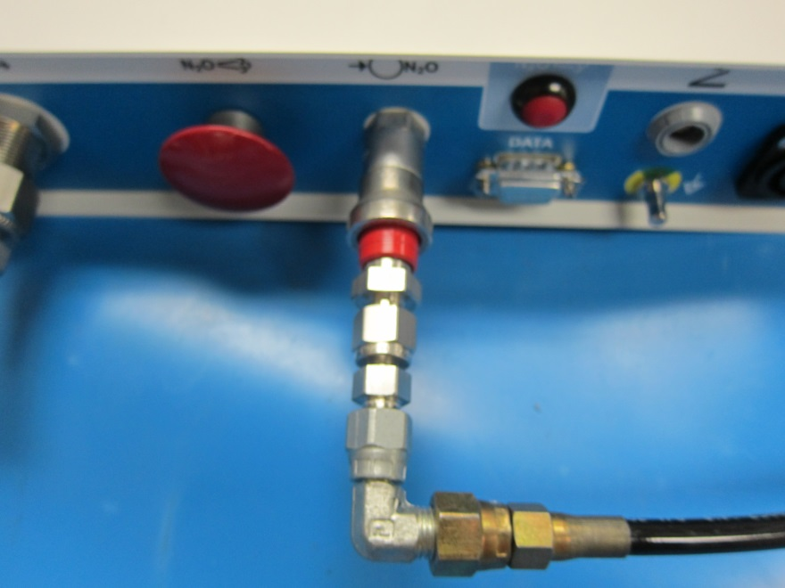
Figure 4: N₂O Inlet Connection
- Next, match the opposite black knob end of the N₂O gas line with the threaded connection port of a new N₂O gas cylinder.
- Screw the cryoICE BOX gas line into place by hand tightening the knob as shown in Figure 5. Over tightening this fitting with a wrench may cause damage, allowing N₂O gas to leak.
- To open gas cylinder valve, slowly turn the knob on the top of the cylinder counter-clockwise as seen in Figure 6.
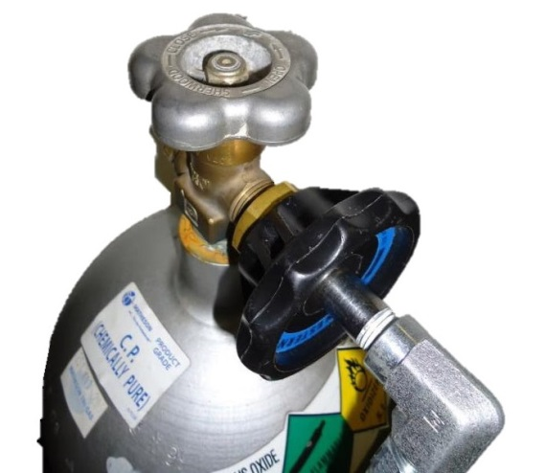
Figure 5: Attach Black Knob to Threaded Connection

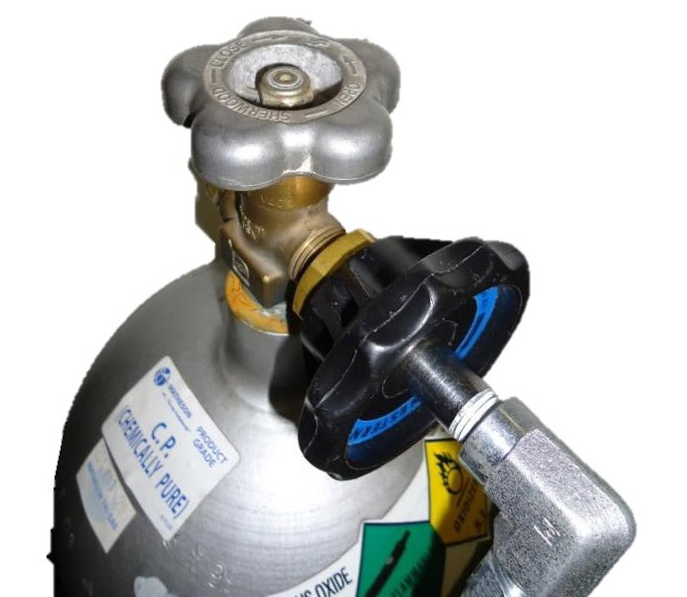
Figure 6: Turn Valve Counter-Clockwise to Open

- Listen for leaks. If a leak is detected, tighten the black knob with a wrench if needed.
- If the Low-Pressure indicator, as seen in Figure 7, illuminate’s amber this indicates that the cryoICE BOX is not detecting proper pressure. Check to ensure that the gas cylinder valve is open fully and that the cylinder you have attached is not empty.

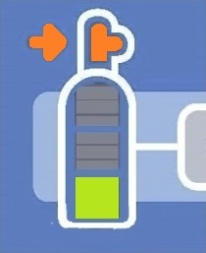
Figure 7: Low Pressure Indicator

Exhaust tubing
- NOTE: Ensure the Exhaust tubing (hose) is firmly attached to the cryoICE BOX N2O exhaust port, see Figure 2 item 17.
- Be sure to route the N₂O vent tubing to a safe area prior to use.
- If a scavenger system is used, it must be able to accommodate a continuous flow of 60-liters per minute.

Heater Band Installation
- Ensure the cryoICE BOX is properly connected to an N₂O gas cylinder
- Place heater band with the cord facing upward.
- Secure all tensioning spring retainers around the gas cylinder, starting with the very bottom and very top retainers and then proceed to secure the middle retainers as shown in Figure 8.
- The Heater band must be positioned less than 2-inches (5-cm) from bottom of the cylinder to ensure that the N₂O is heated efficiently.
- Plug heater band cord into the appropriate indicated receptacle located on the rear panel of the cryoICE BOX unit as shown in Figure 9.
- Verify that the Cylinder Heater Band Icon on the front of the unit is not illuminated.

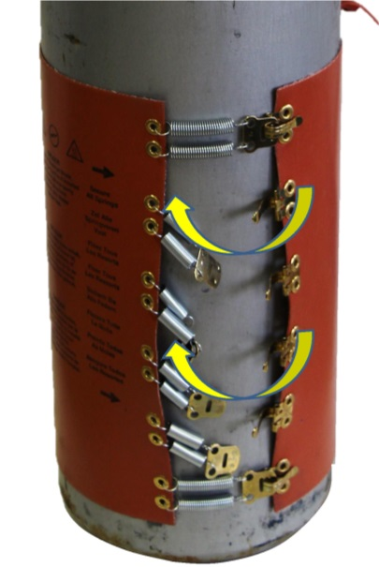
Figure 8: Secure All Tensioning Spring Retainers

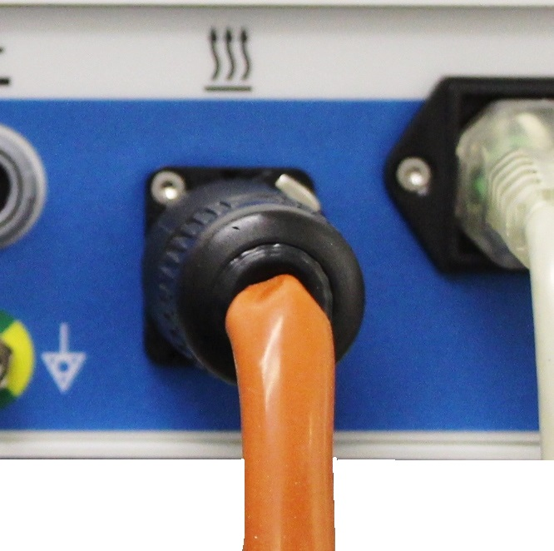
Figure 9: Plug Heater Band Cord into Receptacle

Turning On the cryoICE BOX
- Plug in the cryoICE BOX unit into an approved hospital outlet.
- Turn on the cryoICE BOX unit with the switch located on the back as seen in Figure 10.
- After powering up, the Activation Button on the front of the cryoICE BOX interface will be illuminated. If no light is observed, check for proper power cord connection and switch position.
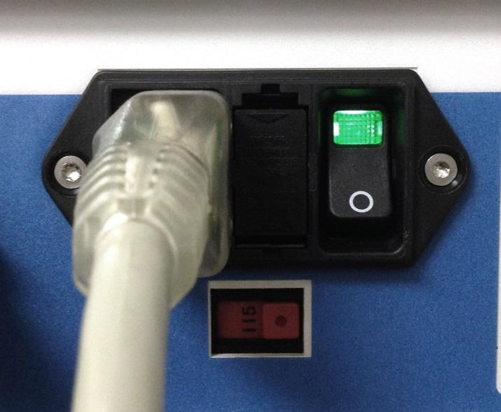
Figure 10: Turn on cryoICE BOX with Switch

Resetting the N₂O Gas Gauge
- Only reset the gauge when a new full cylinder has been installed
- Ensure cryoICE BOX is powered on
- Ensure the unit is in “READY” mode
- Find the gas cylinder display on the front of the cryoICE BOX and note the “RESET” button to the right of this display, see Figure 11.
- Press and hold the “RESET” button for one second.
- Caution- Replace the N₂O cylinder with a full cylinder only. The N₂O remaining volume is calculated from the expected cylinder full volume.
- The gauge can only be reset to full after a system power cycle or following a cylinder swap out. If “Reset” button is pressed following usage the gauge will reset to the estimated cylinder volume.

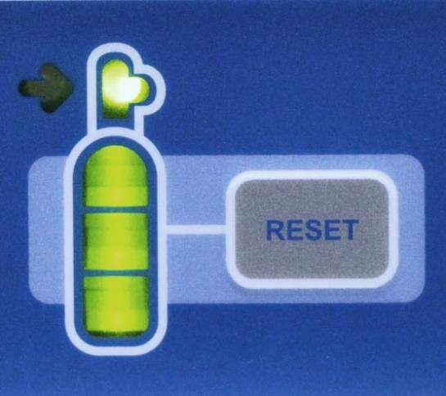
Figure 11: N₂O Gas Gauge RESET Button

Meaning of gas gauge indicators seen in Figure 12
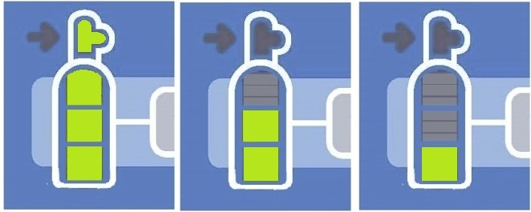
Figure 12: N₂O Gauge Indicators

- 3-segments on = approximately 40 minutes remaining
- 2-Segments on = approximately 30 minutes remaining
- 1-segment on = approximately 20 minutes remaining
- 1-segment Flashing = approximately 10 minutes remaining

System Check
- Verify neither the Maintenance Needed or System Fault icons are illuminated.

DEVICE USE

Install cryoICE Probe
- Ensure cryoICE BOX is properly connected to a N₂O gas cylinder.
- The cryoICE Probe may be connected before the cryoICE BOX has been turned on, while the cryoICE BOX is being turned on, or when the cryoICE BOX unit is on and in “READY” mode.
- Insert the corresponding connections on the pneumatic connectors as shown below in Figure 13. The sliding ring will need to be manually pushed-in on the orange connector.
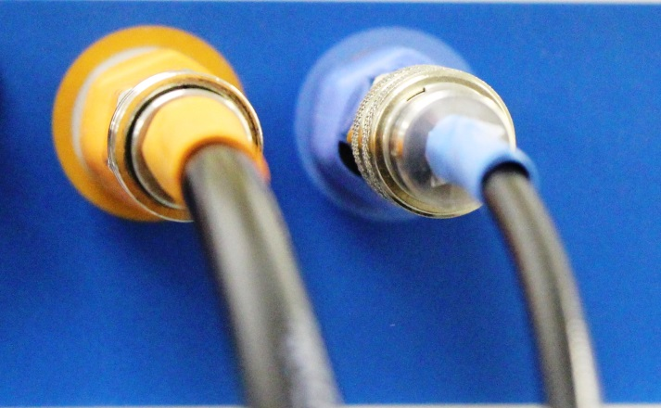
Figure 13: Color Coded Pneumatic Connectors
- Ensure each pneumatic connection is fully seated by listening for an audible “click” as each connector engages its receptacle. Gently tug on each tube to ensure proper engagement with connector.
- Insert the corresponding red and black colored connections into the thermocouple connectors, see Figure 15.
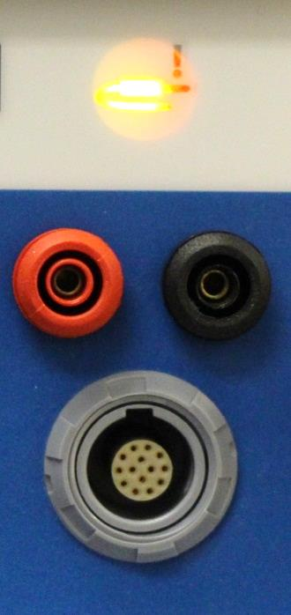  Figure 14 | 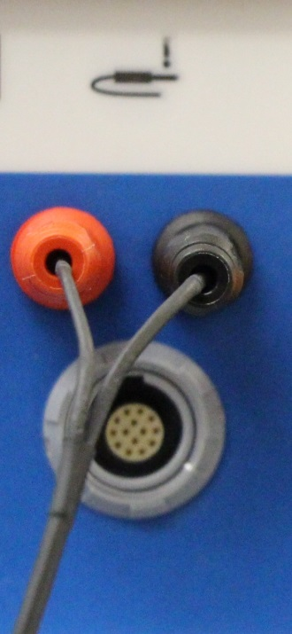  Figure 15

- The cryoICE Probe icon, seen above in Figure 14, will extinguish if the cryoICE Probe is functioning properly and the approximate room temperature will be displayed on the temperature display (typically 10 to 25° C). An example of this is shown in Figure 16.

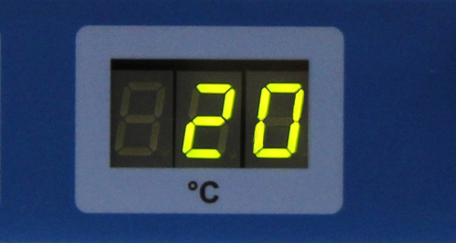
Figure 16: Probe Temperature Display
- A test run is advised to ensure the cryoICE Probe and system is working properly prior to the case.
- Pneumatic connectors should only be unplugged when the ACM is in the ready mode.

Set Ablation Time
- The time of ablation is displayed in the middle of the interface of the cryoICE BOX and is indicated by a clock underneath the display. The display shows the time of ablation in seconds, see Figure 17.
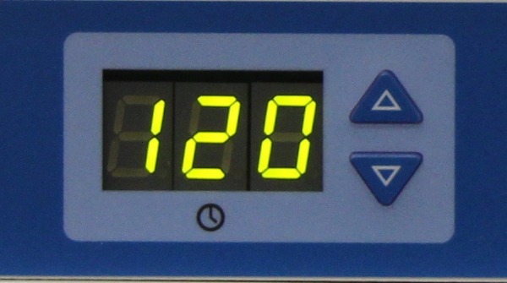
Figure 17: Ablation Time Display
- To change the duration of the ablation, press either of the up or down arrows to the right of the time display. The display will change in increments of ten seconds. The timer will reset to the default setting after a single cycle has been run.

START Ablation
- Ensure cryoICE BOX is powered on and the cryoICE Probe and N₂O is connected properly.
- Check that desired ablation time is displayed, change if needed.
- Press and release the Activation Button at the left of the device to begin the ablation.
- The temperature display on the front panel displays the cryoICE Probe temperature. A double-beep will indicate that the therapeutic temperature has been reached (typically -40°C), and the ablation timer will begin to count down. A short beep will sound every 30 seconds. A series of beeps will indicate the last 5-seconds of the Ablation cycle.
- At the conclusion of the Ablation cycle, the cryoICE BOX will automatically transition into the DEFROST mode. The DEFROST indicator will illuminate indicating probe warming until it has reached the transition temperature which ends defrost, then the unit will automatically transition into READY and vent the probe.

Special Cases

Abort FREEZE
To stop ablation during a FREEZE cycle, press and release the Activation Button during the ablation. The system will then transition into DEFROST mode.

Change Ablation Time during Ablation
To change the current ablation time, the up and down arrows can be used to add or decrease time in 10 second increments.

Emergency Stop
To stop ablation and depressurize the cryoICE Probe during a FREEZE or DEFROST push the Activation Button to vent cryoICE Probe until the cryoICE BOX system has sequenced into “READY” mode.
The unit can also be stopped by turning off power in the back of the unit or unplugging it from the AC power outlet. The flow of N₂O will stop, however gas will be trapped within the cryoICE Probe and the cryoICE BOX. This gas will be vented the next time the cryoICE BOX is powered on.

Set Default Ablation Time
- Ensure cryoICE BOX is powered on.
- Press and hold both up and down arrows simultaneously for one second to initiate the mode that allows a change to the default ablation time.
- The time display will flash and the default time can now be changed by using the up or down arrows. The time will change in increments of 10 seconds. The time cannot be set lower than 10 seconds, nor higher than 300 seconds.
- To save the set default time, the display will stop flashing after 5 seconds and the new default will be set.

Operate without temperature reading
If the cryoICE BOX does not display a temperature and the cryoICE Probe is properly plugged in (red and black connectors) the cryoICE Probe should not be used. If the Activation Button is pressed with this condition, the cryoICE BOX will flash and beep for 5-seconds. If the Activation Button is pressed again within 5-seconds, the cryoICE BOX will sequence into FREEZE mode and the counter will start the countdown immediately. This should only be done at the discretion of a physician as there will not be temperature feedback.

System Disassembly After Use
Check to see that the service icon is not illuminated. If so, notify AtriCure service to correct the problem.

Disconnecting the cryoICE Probe
- The cryoICE Probe can only be removed in the READY mode.
- Remove the cryoICE Probes pneumatic connections by pushing in the sliding ring on the receptacle while pulling out the cryoICE Probe side of the connector.
- Remove the black and red connections for the thermocouples.

N₂O Cylinder Removal
- Turn off the N₂O cylinder by turning the knob clockwise.
- Purge the N₂O from the system by pressing and holding the N₂O Exhaust Switch in the back of the unit. Watch the pressure gage on the cylinder to see that all the pressure has been released. If the cryoICE BOX is powered off, pull and hold the N₂O Manual Exhaust Knob until the pressure is relieved.
- Disconnect the gas cylinder inlet fitting on the back of the cryoICE BOX by sliding the collar back.
- Disconnect the hose from the N₂O cylinder by unscrewing the black knob.
- Turn off power and unplug the cryoICE BOX.

Preventive Maintenance and Cleaning of the cryoICE BOX

Cleaning and Disinfecting Instructions
A mild detergent or standard hospital alcohol solution and clean soft cloth may be used to clean the cryoICE BOX enclosure, front and rear panels, N₂O exhaust tube, N₂O gas line hose, power cable, Footswitch and cord as well as the cylinder heater band.
- Do not spray or pour liquids directly on the unit or allow fluids to enter the cryoICE BOX enclosure.
- Do not allow fluids to enter the Footswitch chassis. Take care not to wet the electrical connector on the cable. The Footswitch cannot be sterilized.
- Take care not to wet the electrical connector on the Cylinder Heater Band cable. The Cylinder Heater Band and its device cable cannot be sterilized.
- Do not use caustic, corrosive, or abrasive cleaning materials to clean any of the equipment

Preventive Maintenance
AtriCure service representatives or the hospital biomed personnel shall conduct annual preventative maintenance procedures to ensure all cryoICE BOX components are functioning as defined within this manual. Pay particular attention to operational and safety features, including but not limited to:
- Electrical power cords for fraying, damage, and proper grounding
- AC power switch
- Any front panel display damage including switches, numeric displays and indicator lights.
- cryoICE Probe electronic interface connector damage, cracking or inability to insert and latch cryoICE Probe connector.
- cryoICE Probe pneumatic interface connector damage or inability to insert and latch cryoICE Probe pneumatic connector.
- Carrying handle damage or inability to fold.
- Rubber feet damage, cracking or inability for the cryoICE BOX to remain stable on a flat surface.
- Rubber alignment cup damage, cracking or inability for the ASB/ASU to remain stable atop cryoICE BOX and within the alignment cup.
- Listen for leaks when pressurized.
- Other medical equipment that may be used simultaneously with the cryoICE BOX should also be inspected for damage. Specifically, check for insulation damage of electrical cables and associated connectors.

The cryoICE BOX does not have any customer serviceable parts aside from mains fuses and gas line desiccant filter for cryoICE BOX consoles so equipped. For servicing issues, contact AtriCure, Inc. at:

www.atricure.com
7555 Innovation Way
Mason, Ohio 45040
USA

Customer Service/ Product Inquiries
Telephone: 513-755-4100
866-349-2342 Toll Free
Fax: 513-755-4567

Replacement of AC Line Fuses
Tools and Parts
• Needle Nose Pliers
• Fuses:
cryoICE BOX Model | Fuse Type | Manufacturer | Part Number
ACM1 | T 4A L 250V | Schurter | 0034.5049
ACM2 | T 2A L 250V | Schurter | 0034.5046

The cryoICE BOX unit has been pre-set at the factory to either 110V – 120V (ACM1) or 220V – 240V (ACM2). The Rating Label below the Power Entry Module on the back panel of the cryoICE BOX indicates the selected Input Voltage for this unit. This setting should only be adjusted by the manufacturer or by an authorized AtriCure technical service representative.
NOTE: cryoICE BOX unit should be powered off and unplugged before continuing with the fuse replacement procedure.

Procedure to replace AC Mains Fuses
1. Determine the fuse type by looking at the cryoICE BOX Model Number or the cryoICE BOX Rating Label.
2. Using the needle nose pliers, carefully extract the fuse box from the power entry module by squeezing down on the fuse box tabs in the slots as shown in Figure 18.
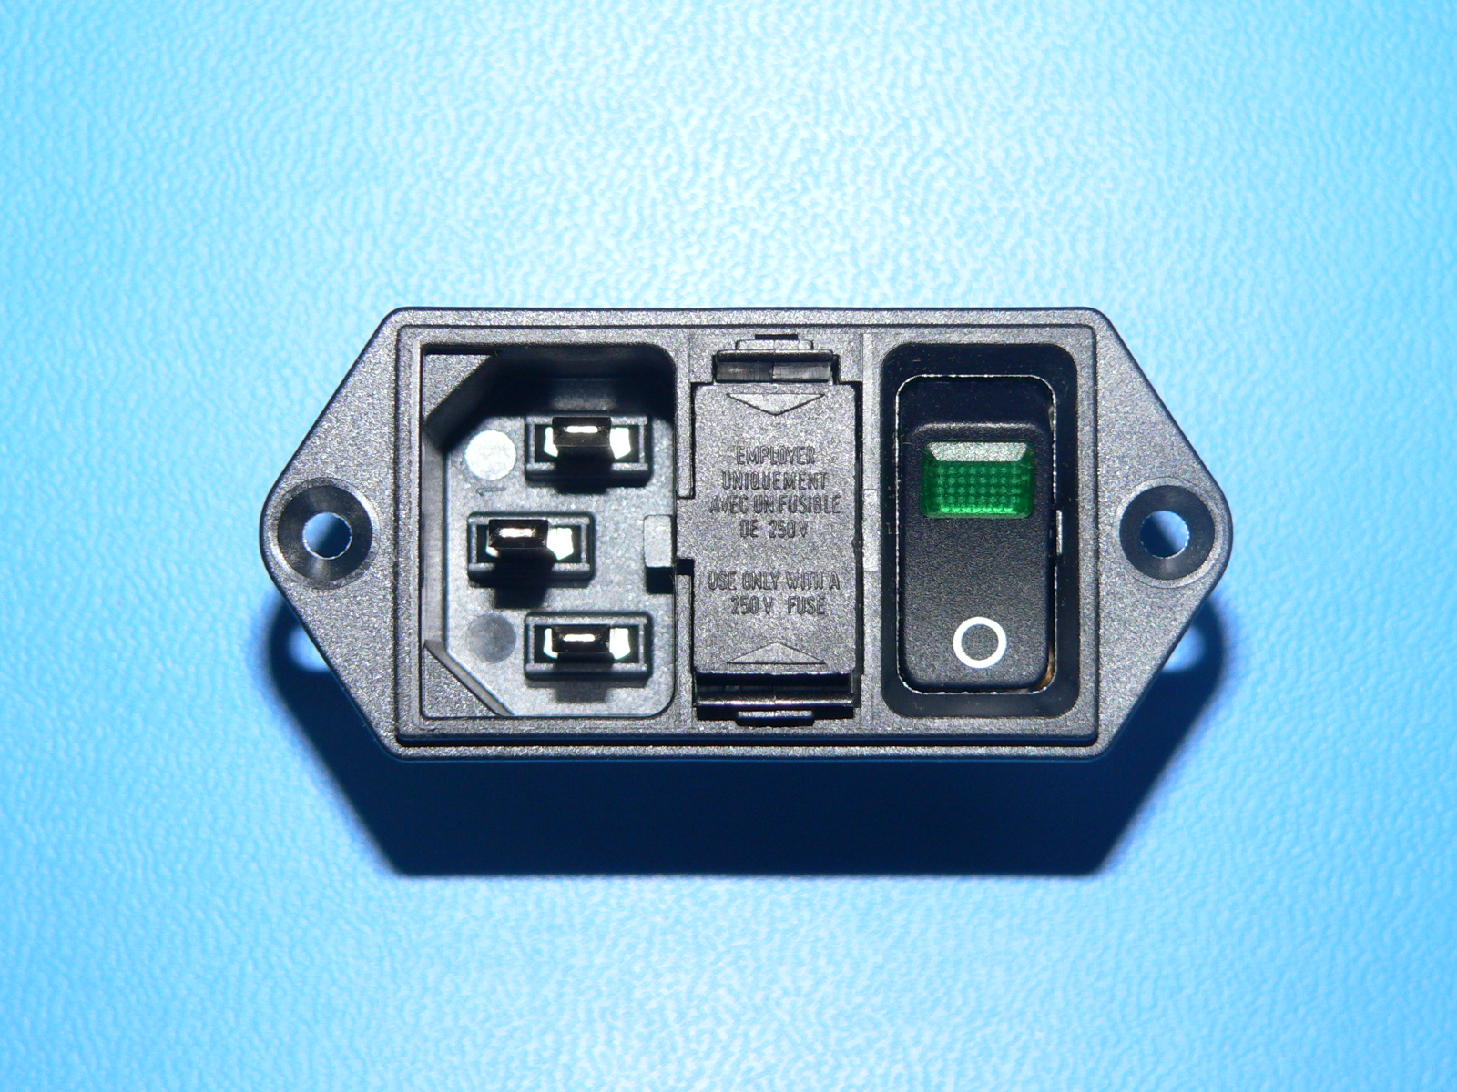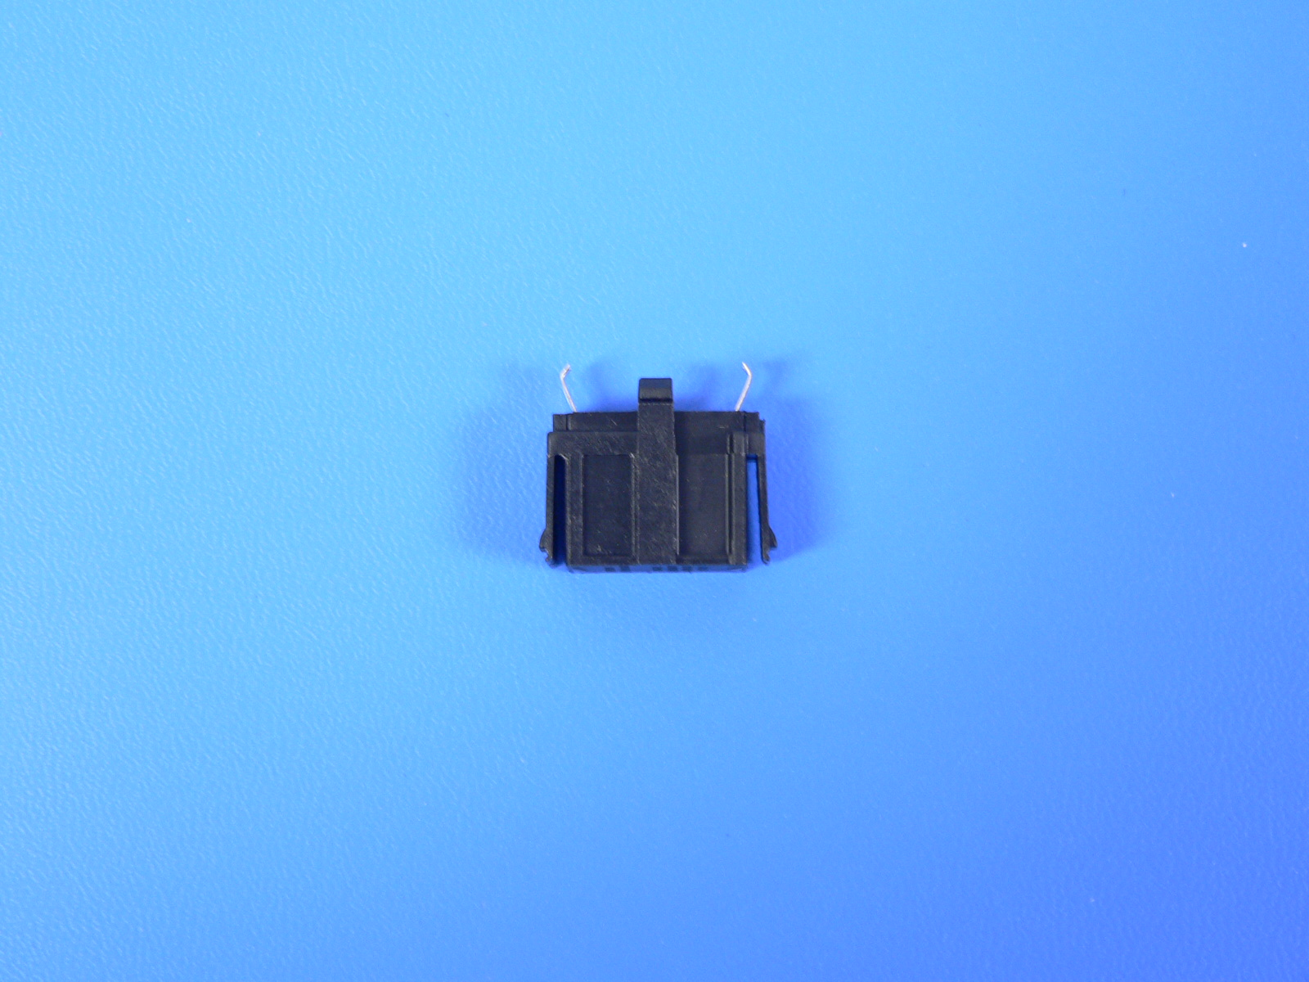
Figure 18: Fuse Box Tabs

3. Replace the (2) two fuses located in the fuse box. Make sure the fuses are aligned properly as shown in Figure 19.

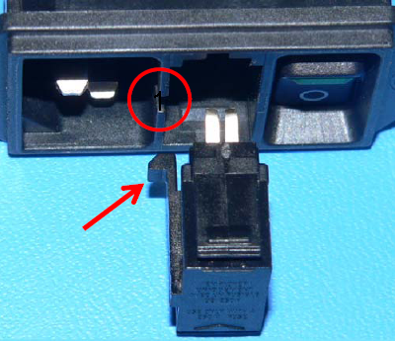
Figure 19: Guide Tab Location

4. Align the fuse cartridge so the guide tab is towards the power entry side.
5. Return the fuse box to the power entry module and push in firmly.
6. Confirm operational status by plugging in the cryoICE BOX and turning power on. Ensure that the self-test is completed without errors.

Tank Hose Accessory – Standard

New ACM Installation
A001053 | Packaged, ACM Accessories - Domestic

Existing ACM Upgrade
A001056 | Packaged, Tank Hose Assembly - Domestic

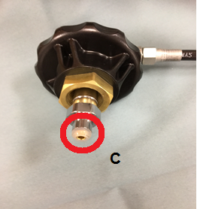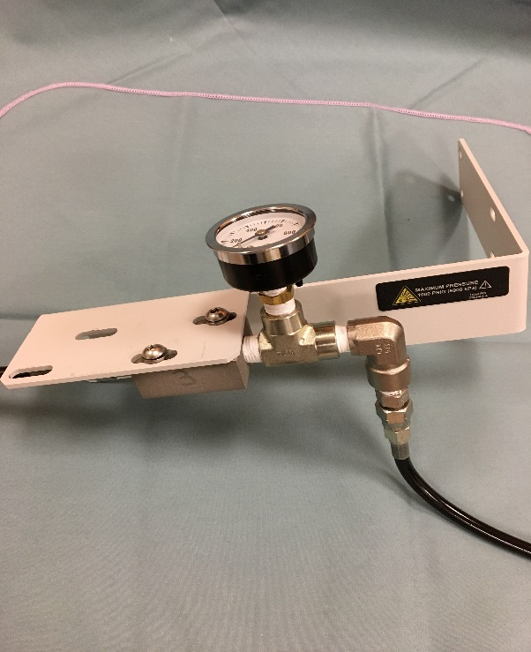
N2O Cylinder Interface ACM Tank Hose Accessory

Replacement Part
Component “C” | Tip Washer | AtriCure | F021837

Tank Hose Accessory – Alternate (Replacement of Gas Line Desiccant Filter)
This section only applies to cryoICE Box Systems equipped with the Tank Hose Accessory which contains the canister set. Refer to Figure 20.

Replacement Parts
Item | Supplied By | Part Number
Filter Cartridge | AtriCure | F021720
Filter O-ring | AtriCure | F010924
Tip Washer | AtriCure | F021837
O-Ring Lubricant | AtriCure | C002502

D
Figure 20: Gas Line Components

A. Filter Cartridge (Desiccant)
B. Filter Housing
C. Tip Washer
D. Filter O-Ring

Procedure
- Unscrew the filter cartridge housing by rotating it counter-clockwise. Refer to Figure 21 below.
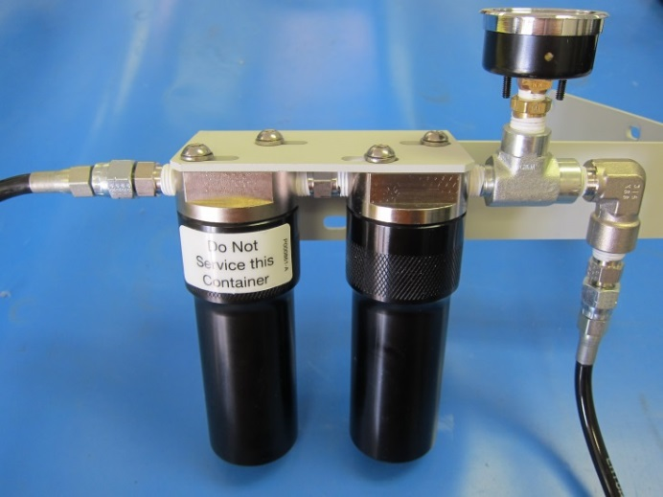
Figure 21: Filter Housing Removal

- Remove the desiccant filter cartridge by rotating it counter-clockwise using hand force only. Refer to Figure 22 below.
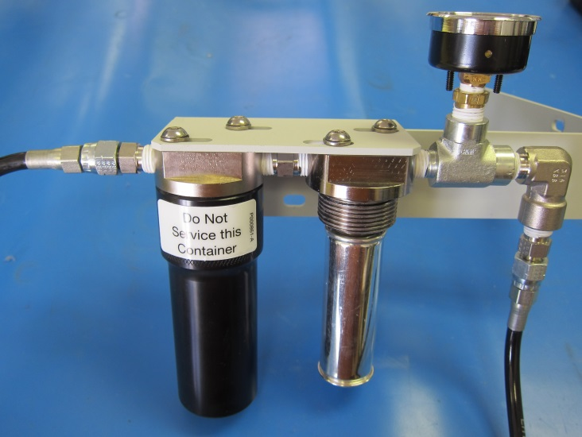
Figure 22: Desiccant Filter Cartridge Removal

- Remove the old black O-ring from the top of the filter housing fixture.
- Slide the new O-ring onto the filter housing fixture, making sure that it is fully seated in the groove at the top.
- Apply a thin film of O-Ring Lubricant around the new O-Ring.
- Replace the desiccant filter cartridge with the new cartridge.
- Replace the filter housing by screwing on clockwise using hand force only.
- Remove the old Tip Washer and replace it with the new washer.

Other Replacement Components
Item | Supplied By | USA Part Number | International Part Number
ACM Footswitch | AtriCure | A000708 | A000708
N2O Gas Line Assembly | AtriCure | A000837 | A000838
Heater Band Extension Springs (Qty. 6) | AtriCure | A000836 | A000836
N2O Exhaust Hose | AtriCure | C002051 | C002051
Cylinder Heater Band (CMH15) | AtriCure | A000728 | A000728
Cylinder Heater Band (CMH22) | AtriCure | A000727 | A000727
AC Power Cord – (10ft /3.3m) | AtriCure | C000262 | C002090

Disposal
The cryoICE BOX does not contain hazardous substances. Follow local governing ordinances and recycling plans regarding disposal or recycling of device components. The used cryoICE probe is considered bio-hazardous. Follow facility procedures for disposal.

TROUBLESHOOTING

Problem | Possible Cause | Action
Front displays not lit | - No power | - Check power switch on back of cryoICE BOX  - Check plug connection on back of cryoICE BOX  - Check AC plug in wall socket  - Ensure power is available at wall socket
Front displays not lit | - cryoICE BOX electrical failure | - Call AtriCure Service
Cylinder Heater Band Icon Illuminated  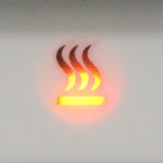 | - Heater not plugged in | - Check connection on back of unit
 | - N₂O cylinder valve closed | - Ensure N₂O valve is open
 | - Empty N₂O cylinder | - Replace N₂O cylinder
 | - Extremely cold N₂O cylinder | - Allow 15 minutes to warm up
 | - Heater not attached to N₂O cylinder | - Attach Heater Band to cylinder
 | - Heater malfunctioning | - Call AtriCure Service
Temperature Not Displayed  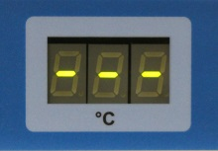 | - cryoICE Probe not plugged in | - Ensure cryoICE Probe thermocouple leads are firmly seated within their receptacles
 | - Malfunctioning cryoICE Probe | - Replace cryoICE Probe
 | - cryoICE BOX malfunctioning | - Call AtriCure Service
cryoICE BOX has power but will not go into FREEZE mode | - cryoICE Probe not plugged in | - Plug in cryoICE Probe
cryoICE BOX has power but will not go into FREEZE mode | - N₂O cylinder empty | - Replace N₂O Cylinder
cryoICE BOX has power but will not go into FREEZE mode | - N₂O cylinder valve closed | - Open cylinder valve
cryoICE BOX has power but will not go into FREEZE mode | - Inlet Gas Connection not secure | - Ensure Inlet Gas Connection is completely seated

Problem | Possible Cause | Action
cryoICE Probe not getting cold enough | - Heater Band not properly installed | - Check heater installation and heater icon
cryoICE Probe not getting cold enough | - N₂O cylinder low or out of gas  - Exhaust filter is clogged | - Replace N₂O cylinder  - Exhaust connector (orange) is frosting/ freezing ice (liquid condensate is not uncommon) call AtriCure Service.
Temperature Display indicates incorrect values | - cryoICE Probe plugged in incorrectly | - Ensure cryoICE Probe black and red plugs are in correct receptacles
Temperature Display indicates incorrect values | - Malfunctioning cryoICE Probe | - Replace cryoICE Probe
Temperature Display indicates incorrect values | - cryoICE BOX malfunctioning | - Call AtriCure Service
Bottom segment on N₂O icon flasing  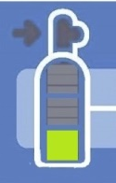 | - N₂O cylinder empty | - Replace with full cylinder
 | - N₂O cylinder cold | - Make sure heater blanket is installed and working. Allow time for the cylinder to warm up if it is cold
 | - Indicator not reset when cylinder was replaced | - Press Reset when cylinder is replaced
N₂O Gas Gauge flashing.  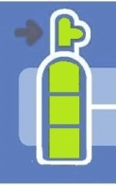 | - N₂O cylinder pressure is below 650psi. | - Make sure heater blanket is installed and working. Allow time for the cylinder to warm up if it is cold
 | - N₂O cylinder empty | - Replace with full cylinder

Problem | Possible Cause | Action
Amber Low Pressure Indicator on N₂O icon flashing  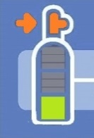 | - N₂O cylinder not turned on | - Ensure the N₂O cylinder is fully turned on
Difficulty connecting a Cryo Probe to the ACM  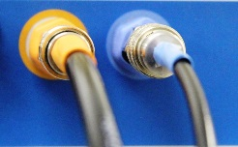 | - Trapped N2O within the system  - Quick connector out of sequence, sleeve on blue connector is forward  - Quick connector O-ring dried out and/or swelling | - Power-On the ACM which clears trapped gas exerting pressure on the connector  - Push the sleeve toward the ACM until it locks back toward ACM (usually clicks)  - Lubricate the connector inside with silicon based O-ring lubrication such as AtriCure Part No. C002502.
Wrench Icon flashing and clicking heard inside ACM, may also include display flashing | - Heater band over temperature due to empty N2O Cylinder  - Heater band over temperature due to loose fit on N2O cylinder | - Unplug heater band if clicking stops and/ or display flashing stops, check if tank is warm to the touch – If so, tank is likely empty, replace tank with full tank. Power-off, then Power-on ACM to reset wrench Icon.  - Heater band is to be tight and positioned at bottom of tank, cord at top edge.  If problem is not corrected by above two actions, return ACM and heater band to AtriCure

Problem | Possible Cause | Action
CRYO Probe getting colder than -75C and not defrosting | - The ACM and Probe system is flooded with liquid N2O.  - The N2O quality is not adequate to be used as a refrigerant.  - N2O cylinder contains a siphon tube or a dip tube. | - If Probe does not reach desired Defrost temperature, apply warm sterile saline to the tissue and probe area as necessary  Replace the tank hose accessory which has canister set with tank hose accessory without canister set.  A001056 – Domestic Accessory  A001055 – International Accessory  Power-On ACM within a few minutes of Cryo Probe use to minimize N2O condensing in system.  - Medical grade nitrous oxide, 3ppm water maximum, is preferred for use with AtriCure cryogenic Devices.  - Verify the N2O cylinder does not contain a siphon tube or dip tube. Cylinder valve body should be blank (no mark of: S, DT, or D).

cryoICE BOX Error Codes
If an error condition should occur, the Maintenance Needed Indicator or the System Fault Indicator will illuminate. The Probe Temperature display on the front panel will temporarily display one of the following error codes during the power-up sequence. Contact AtriCure Service if one of these conditions occurs.
Error ID | Error | Likely Cause
001 | No 24 VDC | Fuse (F2)
002 | Cylinder over temperature | Heater blanket
003 | Probe overpressure | Pressure regulator
004 | Unwanted Probe pressure | Leaky inlet valve
005 | No 230 VAC | Fuse (F1)
008 | Cylinder over pressure/temperature | Overheated Cylinder
PPP | Power On Self-Test Error | Activation Button/Footswitch Pressed during power up

ELECTROMAGNETIC COMPATABILITY TABLES

Electromagnetic Emissions
Guidance and manufacturer’s declaration – electromagnetic emissions
The cryoICE BOX is intended for use in the electromagnetic environment specified below. The customer or the user of the cryoICE BOX unit should assure that it is used in such an environment.
Emissions test | Compliance | Electromagnetic environment – guidance
RF emissions CISPR 11 | Group 1 | The cryoICE BOX unit uses RF energy only for its internal function. Therefore, its RF emissions are very low and are not likely to cause any interference in nearby electronic equipment.
RF emissions
CISPR 11 | Class A | The cryoICE BOX unit is suitable for use in all establishments other than domestic and those directly connected to the public low-voltage power supply network that supplies buildings used for domestic purposes.
Harmonic emissions IEC 61000-3-2 | Class A
Voltage fluctuations/ flicker emissions IEC 61000-3-3 | Complies

Electromagnetic Immunity
Guidance and manufacturer’s declaration – electromagnetic immunity
The cryoICE BOX is intended for use in the electromagnetic environment specified below. The customer or the user of the cryoICE BOX unit should assure that it is used in such an environment.
IMMUNITY test |  | IEC 60601 test level | Compliance level | Electromagnetic environment – guidance
Electrostatic discharge (ESD) IEC 61000-4-2 |  | ± 6 kV contact  ± 8 kV air | ± 6 kV contact  ± 8 kV air | Floors should be wood, concrete, or ceramic tile. If floors are covered with synthetic material, the relative humidity should be at least 30 %.
Electrical fast transient/burst  IEC 61000-4-4 |  | ± 2 kV for power supply lines  ± 1 kV for input/output lines | ± 2 kV for power supply  Lines  ± 1 kV for input/output  lines | Mains power quality should be that of a typical commercial or hospital environment.
Surge  IEC 61000-4-5 |  | ± 1 kV line(s) to line(s)  ± 2 kV line(s) to earth | ± 1 kV differential mode  ± 2 kV common mode | Mains power quality should be that of a typical commercial or hospital environment.
Voltage dips, short interruptions and voltage variations on power supply input lines  IEC 61000-4-11 |  | <5 % U_{T}  (>95 % dip in UT)  for 0,5 cycle  40 % U_{T}  (60 % dip in UT)  for 5 cycles  70 % U_{T}  (30 % dip in UT)  for 25 cycles  <5 % U_{T}  (>95 % dip in UT)  for 5 s | <5 % U_{T}  (>95 % dip in UT)  for 0,5 cycle  40 % U_{T}  (60 % dip in UT)  for 5 cycles  70 % U_{T}  (30 % dip in UT)  for 25 cycles  <5 % U_{T}  (>95 % dip in UT)  for 5 s | Mains power quality should be that of a typical commercial or hospital environment. If the user of the cryoICE BOX unit requires continued operation during power mains interruptions, it is recommended that the cryoICE BOX unit be powered from an uninterruptible power supply or a battery.
Power frequency (50/60 Hz) magnetic field  IEC 61000-4-8 |  | 3 A/m | 3 A/m | Power frequency magnetic fields should be at levels characteristic of a typical location in a typical commercial or hospital environment.
NOTE: | U_{T} is the a.c. mains voltage prior to application of the test level.

EMC Guidance and Manufacturer’s Declaration
Guidance and manufacturer’s declaration – electromagnetic immunity
The cryoICE BOX is intended for use in the electromagnetic environment specified below. The customer or the user of the cryoICE BOX should assure that it is used in such an environment.
IMMUNITY test | IEC 60601 TEST LEVEL | Compliance level | Electromagnetic environment – guidance
Conducted RF  IEC 61000-4-6 | 3 Vrms  150 kHz to 80 MHz | 3 Vrms | Portable and mobile RF communications equipment should be used no closer to any part of the cryoICE BOX, including cables, than the recommended separation distance calculated from the equation applicable to the frequency of the transmitter.  Recommended separation distance  d = 1.2 √P
Radiated RF IEC 61000-4-3 | 3 V/m  80 MHz to 2.5 GHz | 3 V/m | d = 1.2 √P 80 MHz to 800 MHz  d = 2.3 √P 800 MHz to 2.5 GHz  where P is the maximum output power rating of the transmitter in watts (W) according to the transmitter manufacturer and d is the recommended separation distance in meters (m).  Field strengths from fixed RF transmitters, as determined by an electromagnetic site survey,ª should be less than the compliance level in each frequency range.^{b}  Interference may occur in the vicinity of equipment marked with the following symbol:
NOTE 1: At 80 MHz and 800 MHz, the higher frequency range applies.

NOTE 2: These guidelines may not apply in all situations. Electromagnetic propagation is affected by absorption and reflection from structures, objects, and people.
a Field strengths from fixed transmitters, such as base stations for radio (cellular/cordless) telephones and land mobile radios, amateur radio, AM and FM radio broadcast and TV broadcast cannot be predicted theoretically with accuracy. To assess the electromagnetic environment due to fixed RF transmitters, an electromagnetic site survey should be considered. If the measured field strength in the location in which the cryoICE BOX is used exceeds the applicable RF compliance level above, the cryoICE BOX should be observed to verify normal operation. If abnormal performance is observed, additional measures may be necessary, such as re-orienting or relocating the cryoICE BOX.

b Over the frequency range 150 kHz to 80 MHz, field strengths should be less than 3 V/m.

Recommended Separation Distance
Recommended separation distances between portable and mobile RF communications equipment and the AtriCure Cryo Module
The cryoICE BOX is intended for use in an electromagnetic environment in which radiated RF disturbances are controlled. The customer or the user of the cryoICE BOX can help prevent electromagnetic interference by maintaining a minimum distance between portable and mobile RF communications equipment (transmitters) and the cryoICE BOX as recommended below, according to the maximum output power of the communications equipment.
Rated maximum output power of transmitter W | Separation distance according to frequency of transmitter m
Rated maximum output power of transmitter W | 150 kHz to 80 MHz  d = 1.2 √P | 80 MHz to 800 MHz  d = 1.2 √P | 800 MHz to 2.5 GHz  d = 2.3 √P
0.01 | 0.12 | 0.12 | 0.23
0.1 | 0.38 | 0.38 | 0.73
1 | 1.2 | 1.2 | 2.3
10 | 3.8 | 3.8 | 7.3
100 | 12 | 12 | 23
For transmitters rated at a maximum output power not listed above, the recommended separation distance d in meters (m) can be estimated using the equation applicable to the frequency of the transmitter, where P is the maximum output power rating of the transmitter in watts (W) according to the transmitter manufacturer.

NOTE 1: At 80 MHz and 800 MHz, the separation distance for the higher frequency range applies.

NOTE 2: These guidelines may not apply in all situations. Electromagnetic propagation is affected by absorption and reflection from structures, objects, and people.

Warranties
Limitation on Liability

This warranty and the rights and obligations hereunder shall be construed under and governed by the laws of the State of Ohio, U.S.A.

AtriCure, Inc. warrants this product to be free from defects in material and workmanship under normal use and preventive maintenance for the respective warranty period shown below. AtriCure’s obligation under this warranty is limited to the repair or replacement, at its option, of any product, or part thereof, which has been returned to AtriCure, Inc. or its Distributor within the applicable time period shown below and which examination disclosed, to AtriCure’s satisfaction, to be defective. This warranty does not apply to any product, or part thereof, that has been: (1) adversely affected due to use with devices manufactured or distributed by parties not authorized by AtriCure, Inc. (2) repaired or altered outside AtriCure’s factory in a way so as to, in AtriCure’s judgment, affect its stability or reliability, (3) subjected to improper use, negligence or accident, or (4) used other than in accordance with the design and use parameters, instructions and guidelines for the product or with functional, operational or environmental standards for similar products generally accepted in the industry. AtriCure has no control over the operation, inspection, maintenance or use of its products after sale, lease or transfer, and has no control of the selection of Customer’s patients.

AtriCure’s products are warranted for the following periods after shipment to the original purchaser:

AtriCure Cryo Module Unit One (1) Year
AtriCure Cylinder Heater Band One (1) Year
AtriCure Gas Line Hose Assembly……………………………………………… One (1) Year
Grounded Electrical Cord One (1) Year
AtriCure Cryo Footswitch One (1) Year

THIS WARRANTY IS IN LIEU OF ALL OTHER WARRANTIES, EXPRESS OR IMPLIED, INCLUDING THE WARRANTIES OR MERCHANTABILITY AND FITNESS FOR A PARTICULAR PURPOSE, AND OF ALL OTHER OBLIGATIONS OR LIABILITIES ON THE PART OF ATRICURE, INC. AND IS A PURCHASER’S EXCLUSIVE REMEDY. IN NO EVENT SHALL ATRICURE, INC. BE LIABLE FOR SPECIAL, INCIDENTAL OR CONSEQUENTIAL DAMAGES INCLUDING, WITHOUT LIMITATION, DAMAGES RESULTING FROM LOSS OF USE, PROFITS, BUSINESS OR GOODWILL.

AtriCure, Inc. neither assumes nor authorizes any other person to assume for it any other liability in connection with the sale or use of any of AtriCure Inc. products. There are no warranties that extend beyond the terms presented unless an extended warranty is purchased before the original warranty expires. No agent, employee or representative of AtriCure has any authority to change any of the foregoing or assume or bind AtriCure to any additional liability or responsibility. AtriCure, Inc. reserves the right to make changes to products built and/or sold by them at any time without incurring any obligation to make the same or similar changes on products previously built and/or sold by them.

