Braille Me User Guide V 2.3

INNOVISION

(Inceptor Technologies Pvt. Ltd.)
Last updated on: 29/04/2019
Firmware version: M02.38S01.06H09.20

Table of Contents
1. Introduction 2
1.1. Features of braille Me 3
1.2. Document Conventions 3
1.3. Inside the box 4
2. Specifications 4
3. Orientation 5
4. Powering the device 8
4.1. Powering On/Off 8
4.2. Charging 8
5. Menu system 9
6. Basic Concepts 9
6.1. Panning Keys 9
6.2. Edit box 10
6.3. Cursor 10
7. File manager 11
7.1. Supported Files 11
7.2. Folder option 12
7.3. Search 13
7.4. Read, Edit, Rename and Delete 13
7.5. New file/folder 14
7.6. Editor 15
7.7. Braille Translation in Braille Me 21
8. Bluetooth 21
8.1. Connecting to an Android device 22
8.2. Connecting to an IOS device 23
9. USB 24
9.1. Connecting with NVDA 24
9.2. Connecting with VoiceOver 26
9.3. Connecting as mass storage 26
10. Settings 26
10.1. Language setting 26
10.2. Date and time 26
10.3.Auto scroll time 27
10.4. Standby time 27
10.5. Word Wrap 27
10.6. Turn off buzzer 28
10.7. Hide paragraph indicator 28
10.8. Switch pan keys 28
10.9. Braille Test 29
10.10. Factory reset 29
10.11. Software version 29
11. Battery level 29
12. Command Guide 30
13. System Shutdown 30
14. List of all commands 30
14.1. Standalone commands 30
14.2. Braille Back commands 32
14.3. NVDA commands 33
14.4. VoiceOver commands 36
15. List of system notifications and errors 40
16. Firmware upgrade 43
17. Appendices 45
17.1. Warranty information 45
18. Contact us 47

1. Introduction
Braille Me is a sleek, portable and lightweight smart braille display. It is a competent device specially designed for visually impaired students and professionals.
With its revolutionary Braille cell technology, Braille Me is highly compact and cost-effective. At Innovision, we understand the challenges faced daily by students and professionals, and keeping their recommendations in mind, we have built Braille Me.
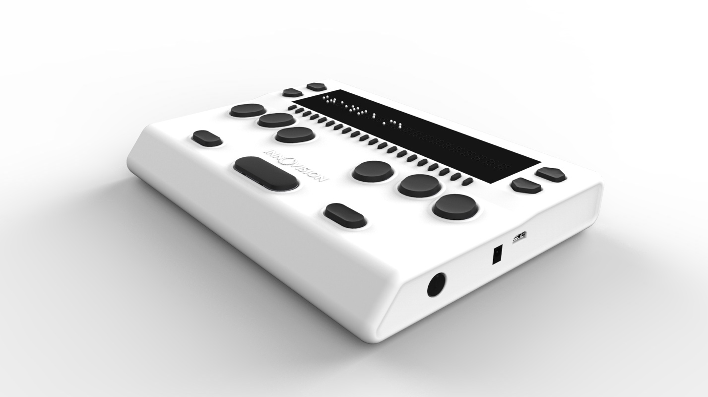
Image of Braille Me in isometric view
Braille Me is a compact smart braille display with the following capabilities:
• 20 braille cells representing any six-dot braille code, in any language.
• Capable of reading the contents of files from an SD card under Stand-Alone mode in both text and braille formats
• Connectivity to PCs and mobile devices via Bluetooth and USB
• Basic note-taking feature with internal braille translation
It operates in 2 ways – Standalone mode and remote mode.
Standalone mode:
In this mode, Braille Me displays the content of files stored on the inserted SD card. Braille Me allows you to browse, read, edit, rename and delete files. Braille Me has a built-in text to braille translator to support grade 1 and grade 2 translation and multi-language braille.
Remote mode:
You can connect the device to a computer/smartphone/tablet using either Bluetooth or USB. Once connected, you can navigate, read and edit the content present on the connected device through Braille Me seamlessly. You can also read books on your smartphone from Kindle, iBooks, Bookshare, etc.

1.1. Notepad with several editing and navigation functions
- Six - dot 20 braille cells with paper like feel
- 6 key Perkins style keypad for typing
- Removable battery lasting for 10 hours on continuous usage
- Upto 32 GB storage through captive SD card
- Support for 40+ languages
- Remote connectivity to PCs and Smartphones through Bluetooth and USB
- Notepad with several editing and navigation functions

Along with box:
- Carrying case

1.2. Document Conventions
Throughout the document, Braille keys are indicated by numbers. For example, a button corresponding to Dot 1 is indicated by the phrase – Dot 1. If multiple braille keys are required, it is indicated by the numbers separated by a space e.g. Dots 1 5.
When key combinations are used, a plus (+) sign is inserted between the keys e.g., Space + Dot 1. In such cases, all the combination keys have to be pressed together.
When any key combination is pressed, note that the command is executed only when all the keys are pressed and released together, i.e., If a user presses Space + Dots 2 3 to execute a particular command then until all the keys - Space, Dot 2 and Dot 3 are released the command will remain on the waiting list and as soon as they are released the command will be executed.
On a braille keyboard, Space is often used as a modifier to alter the effect of the input keys.
Messages, menu items or errors are displayed on the braille screen.
There are 2 types of messages in the software – notifications and errors denoted in the document.
Errors occur when there is a difference in the expected user input or any of the internal systems have failed. Notifications are messages which are intended to inform of any changes to the system.

1.3. Inside the box
Braille Me comes in a box along with the peripheral devices which are to be used along with Braille Me.
The box contains the following items:
- Braille Me
- Braille User guide (Pre-loaded onto the SD card)
- Standard –A to Micro-B USB cable
- AC charger
- 8 GB SD card pre inserted in your Braille Me (expandable upto 32GB)

2. Specifications
Specification | Braille Me
Braille Display | Six-dot 20 Braille cells with cursor routing keys
Keyboard Type | 6 key Perkins-style
Ports | Micro USB, SD card slot, DC jack
Interface | USB v2.0, Bluetooth smart v4.2, SD card upto 32GB
Language | Supports 40+ languages
Supported File Formats | .TXT, .BRL and .BRF
Screen readers | Android: BrailleBack 0.95.1 +  iOS 11.3+: Voiceover  MacOS High Sierra: Voiceover  Windows 7+ : NVDA 2017.2+
Battery | 10 hours, 1.5 hours to charge(AC adapter)
Electrical parameters | Charging: 19V/1A  Charger AC socket: AC 100-240V, 50-60Hz, 1.0A
Size & Weight | 18.8 cm x 13.8 cm x 2.9 cm (W x D x H), 580g
Certification | CE certified  FCC under process  FCC ID: Z64-2564N  IC ID: 451I-2564N
Warranty | One-year limited parts and labor warranty

3. Orientation
To begin exploration of Braille Me, place the device on a flat surface in front of you with the row of braille cells farther away from you and the sloping edge nearer to you. This is the proper operational orientation.
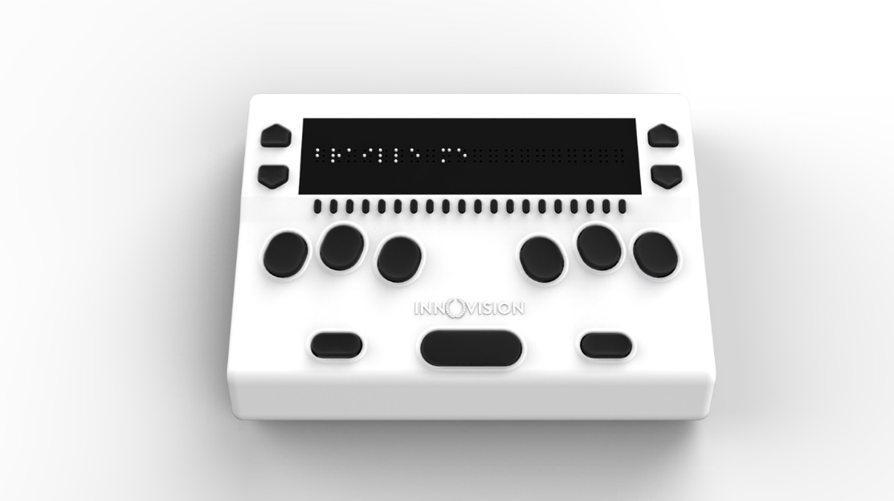
Image of braille Me in top view
Henceforth the guide will refer to this orientation to indicate the position of keys and slots.
On the left face there is a slot for inserting an SD card. When you receive the device, it would already have an 8GB SD card inserted. It is expandable upto 32 GB.
The SD card slot is a standard slot with spring feedback. The SD card is inserted with the card connector fingers facing upwards by pushing the card into slot till it clicks into place. To release the card, press in and remove your finger to allow the card to pop out.
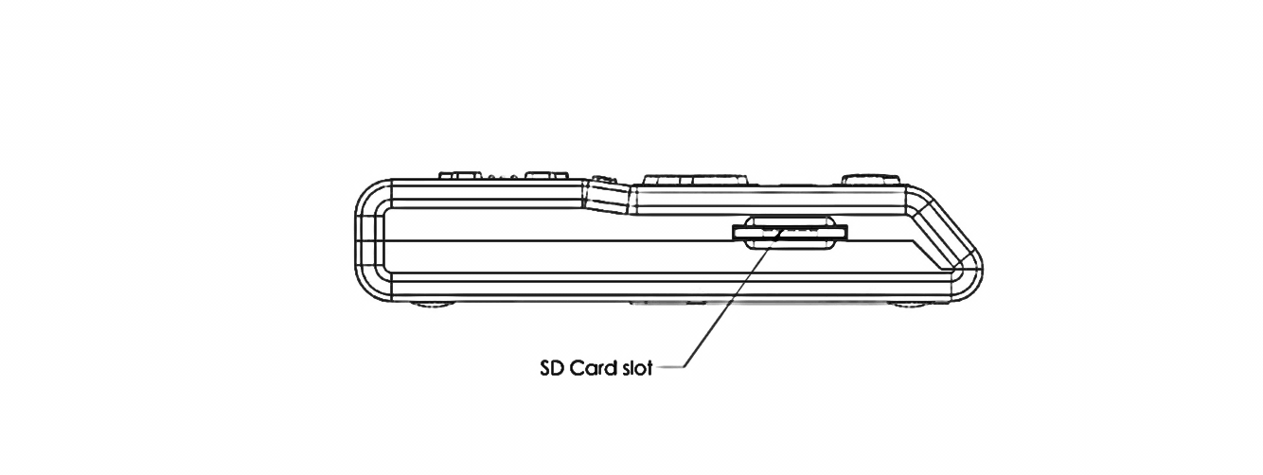
Drawing of left face of Braille Me

On the right face of the device, you would find a circular button closest to you. This is a toggle button to power On/Off Braille Me. Going forwards on the right face we will find two ports – A DC jack for charger and a USB slot.
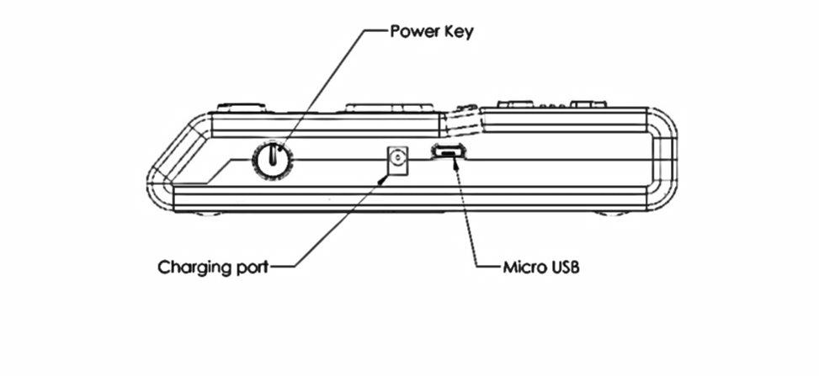
Drawing of the right face of Braille Me
The DC jack is used to insert the power cord from the charger and is positioned just beside the power button. The USB slot is farthest from you and is used to connect to PCs via a Standard-A to Micro-B USB cable.
Moving on to the top face, you will find a braille display of 20 cells farthest away from you. The texture of the braille display area is smoother compared to the body, and it will have many holes with the braille pins. It is accompanied by a line of 20 cursor routing buttons below each braille cell. The 1st cursor routing button also acts as a firmware upgrade button when the device is off.
On both the sides of the braille display, we have a couple of keys used for navigation. On the right side we have the panning keys named Right-1(Up) and Right-2(Down) and on the left side the previous item button named Left-1 (Up) and the next item button named Left-2 (Down).
As we move towards the lower section from the braille display we have a Perkins style keypad which has 6 keys ergonomically arranged representing the six dots of braille. Dots 3 2 1 on the left and Dots 4 5 6 on the right. It is accompanied by a space bar which is located below these 6 keys in the middle where the thumb rests.
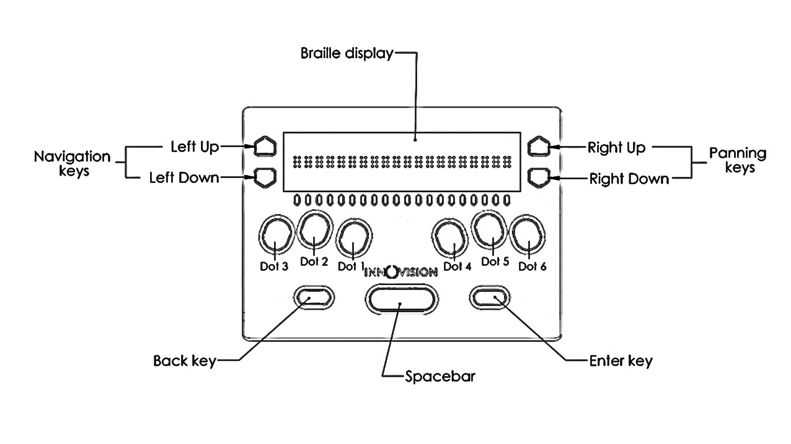
Drawing of top face of Braille Me
On the right side of the Space bar we have the Enter key and on the left side Backspace key. This concludes our top face.
On the bottom of the device a battery compartment is present which is secured with a set of 4 screws.
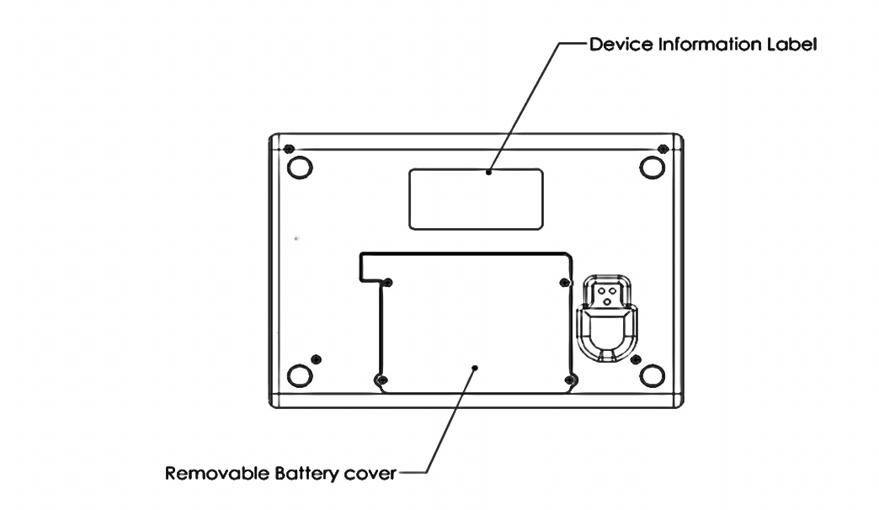
Drawing of bottom face of Braille Me
Type of button or port | Function | Placing
Display | Braille dots | Upper most part on the top face
Ports | SD card slot | Left face
Ports | Micro-USB slot | Right face
Ports | DC jack | Right face
Ports | Battery compartment | Bottom face
Buttons | Dot 1 to 6 | Six keys in the middle of the top face  Dot 3-2-1 on the left side and Dot 4-5-6 on the right side
Buttons | Space | Lower middle part of Top face
Buttons | Enter | Lower right part of the top face
Buttons | Backspace | Lower left part of the top face
Buttons | 20 Routing keys | Placed below braille display on Top face
Buttons | 2 Panning keys: Right-1 and Right-2 | On the Right side of braille display
Buttons | 2 Navigation keys: Left-1 and Left-2 | On the Left side of the braille display
Buttons | Power button | Right face
Buttons | Firmware upgrade button | 1st Cursor button

4. Powering the device
This section explains how to charge, turn the device on and off and charging the device. Refer to the following sections for additional support.

4.1. Powering On/Off
To turn on the device just press the power button for 1 sec and instantly the device will boot and you would hear an audio notification – a short beep. Along with this beep, the braille display will get activated, and all dots will toggle up and down. Post this toggling the braille display will show “file manager”, which is the first option of the device menu. As soon as “file manager” is displayed, you can start your work. This entire process should take less than four seconds.
There are two ways of shutting down the device. One way is to long press the power button for three seconds and the second is by using the shutdown option in the device menu. In both cases a long beep is given indicating the shutting down of the device. After the beeps all the dots will move down. Note: no beeps will be given once the buzzer is turned off. Sometimes, when you press the power button to turn on the device, the device does not start and only gives a very short beep. It indicates that the battery level is very low, and the device needs immediate charge. Plug the charger and wait for 10-15 minutes till the device has some minimum battery to get started. Another scenario can be when the device starts and shuts down immediately. It means the device has some battery to get started, but it is not sufficient enough to start working. This should also get resolved after 5-10 minutes of charging.

4.2. Charging
When you receive Braille Me, it may already have some charge; however, we recommend charging it fully before or during first use. You can use the device and charge it at the same time, so this does not hinder your reading time.
When the battery of Braille Me gets to 15% and 7%, you will receive a notification indicating that battery is low. At 2% charge, the device shuts down without notification. During shutting down Braille Me gives a long beep, and all the braille dots will move down.
Note: No beeps will be given if the buzzer is turned off.
To charge the device, use the AC adapter provided. Insert the 2- pin end into the AC socket of your house and the circular end into the device. Make sure the 2-pin end is firmly held in the AC socket. The circular single pin end remains slightly out of the device but it is nothing to worry about. The device will still get charged and you need not force it in. If the device is powered on, you could check the charging status under battery level in the device menu. Once the charger is plugged, it takes a few seconds to detect. Also, in power ON state when the charging is complete a notification will appear indicating battery level full. If the charger is not right or damaged, the device will notify with the message “charger not supported”. Please use only the charger supplied with the device. If the device is powered off, no charging indication will be displayed.
Please note USB charging is not supported and any attempts to do so might damage the device.
If you have charged the device for 1 or more hours, and it doesn't turn on, contact the organization from where you purchased the device or contact Innovision’s Customer Care at
Phone: +91-82-91-406811
Email: customercare@innovisiontech.co

5. Menu system
An informative yet straightforward menu system is implemented which will help you explore all the functions and settings. At a time only one menu item is displayed. To use the device, Braille Me has a set of universal commands which work throughout the menu system and in its different applications.
Action | Universal command
To go inside/ select a menu item | Enter key
To go 1 step back in the menu hierarchy | Backspace + Space key
Navigate to the next/ previous menu item | Left-1/ Left-2
To Pan back/ forward | Right-1/ Right-2
Apart from the above-listed commands, you may also need to use the cursor routing buttons and Braille input keys to edit content. For easy navigation, the menu system is made cyclical, which means that if we press left 2 key while at the last menu option, we will be redirected to the first menu option in cyclical rotation.

6. Basic Concepts

6.1. Panning Keys
The Panning keys are keys found on the top right side of the braille display. These keys control how you read the content in a single line of text. A line might have more than 20 letters hence all the letters cannot be to read at once on the 20 cell braille display. So, to read the contents of the line beyond the 20 characters; you will require moving back and forth using the panning keys. To read the subsequent 20 characters (panning forward), press downward pointing key also named Right-2. To read the prior 20 characters (panning backward), press the upward pointing key also named Right-1.

6.2. Edit box
Braille Me presents a text dialog/ Input field called an Edit Box when you trigger functions like
- find the keyword,
- rename a file,
- rename a folder
Whenever an edit box appears, it will show a message asking you "enter the name/keyword." This message is temporary and will vanish when you start typing. Enter the text using the braille dot keys. Once you are done typing, press the Enter key to proceed forward. The Edit Box permits only 40 characters of text as input.

6.3. Cursor
Whenever you are editing content in Braille Me, by default a cursor will be displayed. The cursor marks the position where the editing takes place. So, when the cursor is on a character, and if you type a new character, the cursor along with the old character will both shift forward by 1 cell and insert the new character. If you execute backspace then the character prior to the cursor will be removed and cursor will shift backward by 1 cell. In case you execute the delete command Space + Enter then the character with the cursor will be deleted and cursor position will remain the same. In order to show the cursor on a six-dot system we offer two different ways:
- mode-1: blink curser
- mode-2: show only cursor

6.3.1. Mode 1
In this mode, the cursor is shown by blinking dots which are not part of the braille character. For example, on the braille display the text “welcome braillist” is displayed. The cursor is positioned on ‘b’ so the Dots 1 and 2 will remain steady and in up position since they make up the letter b, while the Dots 3, 4, 5 and 6 will toggle up and down indicating the cursor. So at a time the braille cell will contain both the information of the character and the cursor. This is the default representation.

6.3.2. Mode 2
Another way to display the cursor is to show the cursor only when triggered by the user. In this mode, when the user presses the combination – Left-1 + Left-2 the braille display will remove all the characters and only show the cell with the cursor by raising all six dots. Here, all keys except the cursor routing keys and the Backspace + Space key combination are frozen. Upon pressing the same combination Left-1 + Left-2 again, it will bring back all the characters and all keys will become functional. So the combination Left-1 + Left-2 will toggle between the text and the cursor.
The cursor blinking mode (mode 1) can be switched on/off by pressing the combination right-1 + right-2.
Irrespective of the cursor blinking mode turned on or off, you can use the left-1 + left-2 combination to check the cursor in the mode two formats. Both the cursor modes work in the editor, edit boxes and also with the screen reader.
To move the cursor from one position to another you can use the cursor routing buttons. Let say the cursor is on the 10th braille cell and you want to move it to the 2nd braille cell. Then you would have to simply press the cursor routing button below the 2nd braille cell, and the cursor will route to the same.

7. File manager
File manager is the first option under menu. As soon as the device is turned on, the first option that we see on the display is “file manager”. This is an application which manages the files and folders on the SD card facilitating browsing, reading and editing the files. To enter the menu item – “file manager,” press the Enter key. Once we press Enter, we are inside file manager. Here, a list of all files and folders saved on the SD card appears. To navigate between the list items, press left 1/left 2 keys. This list is numbered for easy navigation. Folders are indicated by letter F, Dots 1 2 4 before its name, and the files have their individual indicators depending on the file format. Refer to section 7.1. Supported Files for detailed information about the file/folder indicators. Besides navigating between the list items inside file manager, one can perform different functions using different key combinations. For example, Space + Dots 1 3 5 to see rename and delete options, Space + Dots 1 3 4 5 to create new file or folder etc. Also, after pressing Enter on different files shown in the list, you will see two options, “read file” and “edit file”. Then you can open the file as per your requirement in either of the two modes. Note: txt files have both read file and edit file options, BRL files only have edit file option, and BRF files only have read file option. Hence, if you press Enter on a file in BRF format, instead of read file and edit file options, there will be only read file option. Similarly, if the file is a BRL file, there will only be “edit file” option.

7.1. Supported Files
Braille Me has certain criteria for files which are as follows. It supports mainly three formats – BRF, BRL and TXT, all other file types are masked and not shown in the browse list. Also, take care that files with filenames more than 40 characters will not be shown. If in the file name there are characters of a language apart from the one selected as system language then that file name will not be shown.
While opening a file in edit mode, if its size exceeds – 100kB then the device will give an error “exceeds file size limit” and if the encoding is not ASCII (ANSI) or UTF-8, then braille Me will show an error “file not supported”.
The list of files is numbered but unsorted and shown one at a time. If the file format is TXT then a dot pattern of all 6 dots is preceded to the file name. If the file is a BRL file then the dots 1 3 4 6 are preceded. And if it is BRF then a pattern of dots 1 2 3 are preceded. Folder is indicated by dots 1 2 4.
If the SD card is empty or does not have any files/folder then an error message will be displayed – “no content found”. Also, if the SD card format is not FATfs then it will show “file not supported”.

7.2. Folder option
Besides files, you can also create folders on the SD card. Once inside file manager, simply press Space + Dots 1 3 4 5. The first option that you see is new folder. Press Enter on it, and a message will appear, “type folder name”. Here, you have to type the name of the folder and press Enter. If the operation is successful a message appears - “folder created”. Exit this message by pressing Space + Backspace, and you will be redirected to the list of files/folders in the file manager with the braille display showing the folder you just created.
In order to see the files inside a particular folder, press Enter after navigating to the folder of interest. Next, you will see the list of files and folders inside that particular folder. The device also allows creating folders inside folders. However, a maximum of three levels of folders can be accessed due to memory constraints, meaning the contents of the third folder would not be accessible. Yet, the third folder can be renamed/deleted.
If you want to rename/delete a folder, press Space + Dots 1 3 5 after seeing the name of the folder. That gives you rename/delete options. If you press Enter on a rename option, then an edit box appears, asking you to type new folder name. After typing the folder name, if you press Enter, then the message appears, “rename successful”.
If you press Enter on the delete option, then it asks you to confirm the delete confirm, “delete yes or no?” You can press Backspace + Dot 3 for yes or Enter + Dot 6 for no. Note: we can’t rename/delete any folder in search list. In order to rename/delete a folder, we have to find that folder in root folder or through browsing inside folder in which that folder is created. There are a few constraints on folders.
  - A maximum of 50 files per folder is supported.
  - Cut, copy paste is not supported for files or folders.
  - A folder name can have maximum 40 characters, else it will not be not shown in the list.
  - Search command restriction inside folder: While performing a search command, if we are inside a folder, then search results matching with our keyword will only consist of the files/folder existing inside that particular folder and the files/folders outside folder are not shown. For example, if you have created a folder named Braille Me. Inside this folder, there are different files like user guide, key commands etc. In such case, if you perform the search command while inside the Braille Me folder, then it will provide you with search results of the files that are inside the Braille Me folder and the files outside the Braille Me folder will not be displayed. Suppose you searched with the keyword “user” while inside Braille Me folder. Then only the file “User guide” will be shown. There can be other files saved in the root folder or in some other folders which are matching with the search keyword. But such files will not be shown once the search command is performed inside a particular folder.

7.3. Search
This function allows you to scroll through the files and folders on the SD card. Once inside file manager, a user can simply press Space + Dots 1 2 4 to search for files/folders on the SD card. Upon pressing Space + Dots 1 2 4, the message appears, “type file name or folder name”. Enter the first few characters of the file/folder name and press Enter key. Suppose you have a file named “Braille” on the SD card. In that case, if you just type Br, you will be able to find the file. Note: in order to search for any file, you should at least type two letters from the file name, single letter search is not supported. Upon pressing Enter after typing few initial letters from the file name, a list of files/folders will appear which is numbered but unsorted. The keyword inserted can be either complete matches or can be the initials of the file/folder name. For example, if I search with the keyword “harry” then among the files “harry potter”, “the harry potter”, “harry’s” and “harry”, only “harry potter”, “harry’s” and “harry” will be enlisted.
Also, the search is case sensitive so when you enter the keyword, enter in upper case if the file name is in upper case and vice versa. If in any circumstance, there is no match found an error will show up – “no content found”. As mentioned earlier, from the list of matching search results, we can only open the file in read/write mode. The options delete and rename are not available while we are on any file/folder in search. Also, if search command is executed inside any folder, then only files/folders inside that folder will be shown in search result, and not files from the root folder. For example, if I have a file called “class notes” in the root folder of the file manager. Then I create a folder called “my notes” and create a file with same name inside it “class notes”. Now, while being inside my notes folder, if I perform the search command for class notes file, only the one which is saved inside the my notes folder will be shown and not the one saved in the root folder.

7.4. Read, Edit, Rename and Delete
Once inside file manager, to open any of the files press Enter when the file name is displayed on the braille display. This will take you to two options: Read file and edit file. For BRF files there will not be any edit option and for BRL files there will not be any read option.

7.4.1. Read
In this mode, files with BRF and TXT both can be opened. There is no limit on the file size. Files with BRF format do not get translated according to the system language and will be shown as it is on the braille display. Files with TXT format are translated as described in section 7.7. Braille Translation in Braille Me. Typing and cursor routing functions are automatically turned off while in read mode. Also, in a BRF file, which is a read-only file, word wrap does not work. You can still use the navigation commands, keyword search and auto-scroll feature to read quickly. While reading a TXT file, you can switch between grade 1 and grade 2 using a toggle key – Space + Dots 1 2 4 5.

7.4.2. Edit
When you enter the “write” option, it will take you to the editor which is covered in the next section. Before the editor, Braille Me can throw errors in cases where the file is not appropriate like file size more than 100kB or encoding is not ASCII/ UTF-8 or file is corrupt. Refer to section 7.1. Supported Files for details on supported files.

7.4.3. Rename
You can also rename a file. When the file name is shown on the display, press Space + Dots 1 3 5. It will provide you with two options, and the first option is rename file. Here, upon selecting this option, an edit box will open asking you to type new file name. If successful, it will give a notification – “rename successful”. Press Backspace + Space key and now you are on the file list with the renamed file shown on the braille display. Similar is the process while renaming a folder. Once the name of the folder is shown on the display, press Space + Dots 1 3 5 and press Enter on the rename folder option.

7.4.4. Delete
After pressing Space + Dots 1 3 5 on the file name, the second option after rename is “delete”. This allows you to permanently remove the file/folder from the SD card. When we press Enter on the delete option, it asks to confirm the delete request. A message comes, “delete yes/no”. Yes command is executed by pressing Backspace + Dot 3, and the no command is executed by pressing Enter + Dot 6. It will show a message – “delete successful” if the file/folder was removed. After deleting when you go back to the file manager list, it will show the next item.

7.5. New file/folder
You can use this function to create files and folders on the SD card. While you are inside file manager, by pressing Space + Dots 1 3 4 5, you can open new file/folder option. It provides you with following three options:
- new folder,
- new txt file,
- new BRL file.
If you press Enter on new folder option, a message appears, “type folder name”. In case of new txt and BRL file options, the message that appears is “type file name”. After entering the folder name and pressing Enter, the message appears: “folder created. Upon pressing Space + Backspace, you will be redirected to the list of files and folders in file manager. The device allows you to create folders at three levels. That means, there can be folder inside folder, and again a folder inside that second folder. In case of new txt/BRL file, after entering the filename, you will be directed to the editor. Note, the filename is restricted to 40 characters. In the editor, you will be shown a message – “Start typing.” After that you can start taking your notes.

7.6. Editor
This is one of the most important aspects of Braille Me. It is a simple and easy to use notepad application which allows you to navigate, read documents and also edit them. Let us learn about the editor through following sections.

7.6.1. Navigation
Inside editor, you can navigate line-wise using the default left1/left2 keys. Additionally, default right1/right2 keys or the panning keys can help you pan left and pan right respectively. To go to the start of file, press the shortcut command Space + Dots 1 2 3, and to get to the end of file, press Space + Dots 4 5 6. In order to go to the next/previous paragraph, press Enter + Dot 4 and Backspace + Dot 1 respectively. Lastly, one can also pan left 50 times and pan right 50 times using the command Space + Dots 1 4 5 6 and Space + Dots 3 4 5 6 respectively.

7.6.2. Autoscroll
Braille Me also offers an automatic scrolling feature – Autoscroll which can be activated by pressing Space + Dots 2 3 6. On pressing Space + Dots 2 3 6, “auto scroll on” message will pop up. Now press the Backspace + Space combination to exit notification. Also when you again press the same key then “auto scroll off” message will be displayed. Auto scroll time can be modified from the configuration settings. User can vary the auto-scroll time from 1sec to 9 sec. Once activated, the braille display will pan after a set time period going forward. During this time, all other keys except the Backspace + Space combination will be frozen. You can deactivate it by again pressing Space + Dots 2 3 6.

7.6.3. Typing
As soon as you enter the editor if it’s a new file you will be shown a message – “start typing” else you will be shown the contents of the file. In order to type inside any file, use the 6 Braille keys provided on the Braille Me device. The keys are arranged as 3 2 1 from the left, and 6 5 4 from the right. If you open a file that you had been working on earlier, then as soon as the file is opened, you see the line where you had stopped working last time. This is the bookmark function.
When you open TXT or BRL files, all editor commands and functions are active. If you only want to read the document, you can freeze the typing keys, ensuring unwanted characters are not entered while reading. By default, typing will be on, to toggle press Space + Dots 1 2 3 4 5 6. While toggling, Braille Me will show a message – “typing on/off,” use the Backspace + Space key to go back to the file.
While typing, a paragraph is shown by a specific symbol with two adjoining cells where first cell has dots 1 2 4 6 and second cell with dots 1 2 3 4 in up position. To insert a paragraph, use the Enter key. Note, when you insert a paragraph, the symbol for paragraph is only inserted and your subsequent characters will continue on the same line. However, when you see this on your desktop, it will show as a normal paragraph with the subsequent characters starting in a new line.
Paragraph indicator can be manually enabled or disabled. From the settings sub-menu, one can use the “Hide paragraph indicator” option to hide the paragraph indicator. Once the paragraph indicator is removed, instead of two adjoining cells with dots combination, there will be two blank cells. Now it can again be enabled by going to the settings.

7.6.4. Word Wrap
While working inside a file, word wrap feature becomes very useful. It can be turned on from the settings. When word wrap is turned on, it makes typing/reading easier as words are not broken at the 20th cell. If any word is not able to fit into the first twenty cells, then such word automatically shifts to the next line.

7.6.5. Grade1 and Grade2 Braille
The editor supports both grade 1 and grade 2 braille and dynamic switching between them. Whenever you open a file, by default it will start in grade 1 braille (contractions off). To switch to grade 2 braille you can simply press the hot key – Space + Dots 1 2 4 5 to toggle contractions. For large files the system can take a couple of seconds to convert and in the meanwhile it will show a message switching to grade 1 or 2.

7.6.6. English typing
The editor also supports multi-lingual typing inside the file. For example, when the system language is set to any other language than English, the user can still type in English inside the same file. To enable English typing, the user simply needs to press the hotkey, Space + Dots 1 5. For example, when the system language is set to Hindi, the user can create a new file and start typing in Hindi. At the same time, if he/she wants to insert English letters inside the same file with Hindi content, by pressing Space + Dots 1 5, English typing can be turned on. After pressing Space + Dots 1 5, a message appears, “English typing is on”. By pressing the same hotkey again, the English typing can be turned off.

7.6.7. Keyword search
In cases where the files are large navigation by keyword search would be the best option. Whenever you want to search a keyword, simply press its shortcut command - Space + Dots 1 2 4. This will open an edit box asking you – “type keyword”. Type out the initials of the keyword or the entire keyword. Note, the entered keyword must contain more than one character. Upon pressing Enter, an enumerated list of sentences with the keyword will be displayed. The list will have all the sentences from top to bottom of the file even if you are currently positioned in the middle. And the first sentence with the keyword in the file will be numbered 1. However, when the list comes up, it will first show the sentence with the keyword just after your current position with its number. To go to the previous sentence, use the left-1 key which is for the previous item and left-2 to go to the next sentence. Each sentence that appears in the list will have a total of 40 characters so you can use the pan keys to read it completely. To go to any of the listed sentences press the Enter key.

7.6.8. Saving the content
To save documents, you can press Space + Dots 2 3 4. While in the editor, it will give you a notification “File saved”. You can save a TXT file as TXT as well as BRL. The advantage in saving a TXT file as BRL is that it will not be back translated and stored as braille characters. In some languages the braille back translation might not be perfect and lead to erroneous data, so it is preferred to store it as a BRL file. The name of BRL file will be the same as the TXT file. If there is a BRL file with the same name then it will overwrite it. Also, saving as a TXT file or a BRL file is independent of each other so you can save in both the formats.
If you have made any changes in the file and then pressed the Backspace + Space key for exit, then Braille Me will prompt you with the message “Save: yes or no?”. You can either input Yes by pressing Backspace key + Dot 3 or No by pressing Enter key + Dot 6. You could also press the Backspace + Space key combination to remain in the file. On selecting Yes, your file will be saved and closed. If you select No, then the file will be closed without saving your edited content. If the File is not modified, then by pressing Backspace + Space combination for exit it will prompt “Close: Yes or No?”

7.6.9. Auto bookmark
Whenever you exit a file, the last position is stored and bookmarked. So, whenever you open that file again, it starts from where you had left. This reduces a lot of hassle while reading long documents over a period. Such auto Bookmark for the last 10 files are stored. Note: sometimes the auto bookmark shifts to the next line from where you had stopped reading. This is because of small discrepancy in braille conversion.

7.6.10. Manual bookmark setting
Besides the auto bookmark option, Braille Me also supports manual bookmarks. It works both in read and edit mode. If you are reading a document and have already finished reading first few paragraphs, if you close the file now, there will be auto bookmark for the current point reached in the document. But, sometimes, you might want to set bookmarks for various sections in the document to be referred back later. In that case, manually setting bookmarks can be the best option. So, what the user needs to do is just move to the line where he or she wants the bookmark to be set and press Space + Dots 1 2. Then the message appears, “bookmark is set”. Likewise, one can set multiple bookmarks at different points in the same document. Upon pressing Enter + Dots 1 2, a list of all set bookmarks appears. This list is numbered, however, the nearest set bookmark and its corresponding number appears first as soon as Enter + Dots 1 2 is pressed. You can navigate on this list using left 1 and left 2 keys. If you press Enter on any of the bookmarks set, you will be directed to that section of the document. The user can also manually delete the already set bookmarks. Once the list of set bookmarks appears, the user has to press Space + Dots 1 4 5, which is the command for delete. If the delete command was successful, then the set bookmark is removed and the previous bookmark is shown on the display. If there are no bookmarks set and you press Enter + Dots 1 2, then the message appears, “bookmark not found”.

Inside editor there are several options and shortcut keys as given in table below:

Function | Command
Previous | Left1
Next | Left2
PAN left | Right1
PAN right | Right2
Go to start of File | Space + Dots 1 2 3
Go to end of File | Space + Dots 4 5 6
Delete | Space + Enter
Activate the Return key | Enter
Contraction switching | Space + Dots 1 2 4 5
Previous paragraph of file | Backspace + Dot 1
Next paragraph of file | Enter + Dot 4
Backspace | Backspace
Space | Space
Keyword Search | Space + Dots 1 2 4
Save file contents | Space + Dots 2 3 4
Save as BRL | Enter + Dots 2 3 4
Auto-Scroll toggle | Space + Dots 2 3 6
Typing on/off | Space + Dots 1 2 3 4 5 6
Cursor blink ON/OFF | Right1 + Right2
Cursor mode 2 toggle | Left1 + Left2
Display time | Left1 + Right1
Display date | Left2 + Right2
Display battery level | Left1 + Left2 + Right1 + Right2
Back (exit) | Space + Backspace
No | Enter + Dot 6
Yes | Backspace + Dot 3
Activating marker 1 | Backspace + Cursor routing button
Activating marker 2 | Enter + Cursor routing button
Cut | Space + Dots 1 3 4 6
Copy | Space + Dots 1 4
Paste | Space + Dots 1 2 3 6
Undo | Space + Dots 1 3 5 6
Delete block | Space + Dots 1 4 5
English typing on/off | Space + Dots 1 5
Pan left 50 times | Space + Dots 3 4 5 6
Pan right 50 times | Space + Dots 1 4 5 6

7.6.11. Cut, copy and other options
Besides the basic navigation, bookmark and autoscroll option for quick reading, Braille Me also allows you to cut, copy and paste data inside any file. The size limit for cut/copy is 5 KB. Cut, copy and paste options work only in write mode. The process is very simple and is very much similar to the copying/cutting data on a computer.
Various shortcut commands are provided for cut, copy, paste and undo. For example, Space + Dots 1 4 to copy, Space + Dots 1 3 4 6 to cut etc. But before copying/cutting any data, it is required to be selected. For that, marker positioning is important. So, let us first understand the concept of markers.

7.6.12. Marker positioning
Before performing any commands for cut, copy or delete, we need to select the data region that we want to cut/copy/delete. For this purpose, Braille Me has two markers. Marker 1 is the starting point of the data being selected whereas marker 2 is the point where the selection ends. For example, if I want to select the data from cell number 1 to cell number 12, then I will have to put marker 1 at cell number 1 and marker 2 at cell 12. In order to put markers, we have couple of hotkeys. In this case, since I want to put marker 1 at cell number 1, I will press Backspace + Curser routing button below first cell, and press Enter + Cursor routing button below 12th cell. This way my marker 1 and marker 2 are positioned. Marker is indicated by all 6 dots blinking at the selected cell. Once the markers are placed, the data gets selected and is ready to be copied/cut/deleted. Note: these markers are inter-changeable. Meaning, Backspace + Cursor routing button can be first as well as second marker, if Enter + Cursor routing button is used as marker one.
Marker settings can fail in following scenarios:
- If the block is selected, and after that any editing takes place in the same block, then the markers get removed.
- Also, if you press any cursor keys after the data is selected but not yet pasted, then in such case the markers get removed.
- Also, once the data is cut/copied, and is pasted in the file, then also the markers get removed.
However, navigating inside the file does not affect the marker position. Note: while using cut, copy and paste options, we have to keep in mind the upper limit of the file size in write mode. If the file is of 100 KB already, and if you try copying some data inside file, in such case, it will allow you to copy the data, but at the time of pasting, it will throw an error, “exceeds file size limit”. But it will allow you to use the cut/paste options regardless. If any of the markers is removed and you try copying/pasting data, then it throws an error “marker settings are not valid”. Also, it is important to know that the block that we can cut/copy also has a limit of 5KB. If the data region that you have selected is more than 5 KB, then it will throw an error, “block size exceeds 5kb limit”. Note: cut, copy, paste options currently work only inside file. It is not supported across files. One can’t copy data from file A and paste it in file c. Also, while pasting the data, overwriting does not take place. Besides cut, copy and paste, one can also delete the selected block. Once both marker 1 and 2 are positioned, press Space + Dots 1 4 5 to delete the selected block. Undo command can be executed by pressing Space + Dots 1 3 5 6. Note: undo works only at single level. For example, if you have copied some data and pasted it at some other point in the file. Now, if you press Space + Dots 1 3 5 6, only the command for paste will be undone and not that of copying.

7.7. Braille Translation in Braille Me
Braille Me is equipped with language to Braille translation and vice versa. At a time Braille Me supports 17+ languages. A file with multiple languages cannot be translated. The language used for translation is one selected in the language setting under configuration.
Whenever you open a TXT file, by default it is converted into grade 1 braille. The translation is generally perfect but at times there can be discrepancies. There are 3 commonly found issues:
- Missing characters: If the TXT file consists of characters from a different language or certain special symbols then they will not be converted into braille and will be replaced by spaces.
- Incorrect convention: It has been noticed that Braille standards in many languages have changed over time and different age groups have learnt different standards. At Innovision we constantly try to keep pace with the changing standards and try to implement the standards mentioned in the white paper – World Braille Usage published by a group of global Organizations for the Blind.
- Insertion of random characters: while back translating (Braille to language) there may be instances where the braille combination does not match any character in the language. In such cases an ASCII character is inserted.

7.7.1. Switching between Grade 1 and Grade 2
To switch contractions, you can use the toggle contractions hot key – Space + Dots 1 2 4 5. While the system is processing the conversion a message will be displayed – Switching to grade 1 or 2. Note, at any point in time input (typing) and output (braille) will be in the same grade. So, if you have contractions off then the input will also be in grade 1 and while contractions are on, your input will also be in grade 2.
Even while using the keyword search function, make sure you input the keyword in the grade currently selected.
The Braille translation relies on translation tables stored in a folder called tables in the SD card provided with the device. Please do not tamper with the files inside this folder nor delete them. If those files are corrupted or deleted somehow you can find them on our website. Braille Me uses these files for translation of file names and contents of the file.

8. Bluetooth
This function allows you to connect Braille Me to IOS and Android smartphones. Once we press Enter on the Bluetooth option, we are provided with two options:
- BrailleBack
- Voiceover
BrailleBack is used to connect Braille Me to an Android smartphone whereas voiceover is used while connecting Braille Me to I-phone or Mac OS.

8.1. Connecting to an Android device
Upon pressing Enter on the Bluetooth, the first option is BrailleBack. Press Enter on this option to connect Braille Me to your Android smartphone. Then the display shows the message, “Waiting for connection”.
Now, on your smartphone, turn on Bluetooth. Within few seconds, Braille Me should be visible in the list of available devices as “smartbeetle”. Double tap on it. Sometimes the smartphone might ask to confirm the paring request. Double tap on the “pair” button.
If the pairing was successful, then “smartbeetle” should be appearing in the list of paired devices on the smartphone, and the message on the Braille Me display must change to “Paired, waiting for connection”.
Now on your smartphone, navigate to the settings option. Inside settings, open accessibility settings. There, the default options for Talkback and BrailleBack will be shown as off. Turn on TalkBack and BrailleBack. The smartphone asks whether you want to turn on BrailleBack. Hit the okay button and in just a couple of seconds Braille Me should get connected with text from the smartphone being displayed on Braille Me device. If they do not get connected, then try to lock and unlock the smartphone. Note, while connecting to BrailleBack, you also need talkback turned on while trying to connect. Once connected with BrailleBack, you can navigate the entire smartphone using the Braille Me keypad. Also, you can type using the six-key Brailler keypad provided on Braille Me device.
To input text with your braille keyboard, first, enable the keyboard in your Android settings under Language and Input. If you try to use the keyboard before completing this step, you will receive a prompt to change your settings.
To edit a text field, focus and activate the text field. You can then use the left1/left2 keys to move in the text field. When editing text, BrailleBack switches to eight-dot braille known as Computer Braille. Currently, BrailleBack does not support any other braille as input. To change the braille output to 6 dots follow the procedure below:
By default, Android is set to display English Computer Braille.
Change the language in BrailleBack to display 6-dot braille, follow the steps below:
- On your smartphone, go to open the Home screen.
- Navigate and select Apps>Settings>Accessibility>BrailleBack>Settings.
- Navigate through this screen of items to "Braille type" and select.
- Android generates a dialog screen which indicates the type of braille being displayed and provides two choices: Literary braille or Computer Braille.
- Computer Braille is checked by default. Select "Literary braille" by checking this item.
- When you check "Literary braille," you are returned to the BrailleBack Settings screen.
- Navigate to the "Literary braille table" and select. Another dialog screen opens with a selection of output translation tables.
- Select your preferred language and grade. After that, you are returned to the BrailleBack Settings screen.
Refer to the BrailleBack commands in section 14.2. Braille Back commands while in BrailleBack, you can turn on/off typing and also use the two cursor modes with the commands mentioned in the table. To close the connection with your smartphone simply press Backspace + Space key combination and it asks you to confirm. Press yes by the key combination – Backspace + Dot 3.
There are a few cases where the connection can break abruptly between the smartphone and Braille Me which are listed below. If any of the cases occur a “connection lost” message will be displayed.
- When the device goes out of the Bluetooth range: if the smartphone and Braille Me device are not in the Bluetooth range, then the Bluetooth connection can fail. The connection will get established automatically as soon as the device comes back in the Bluetooth range.
- Secondly, if while using Braille Me with your smartphone, either TalkBack or BrailleBack is turned off then the connection can fail. The connection gets re-established as soon as you turn on TalkBack or BrailleBack.
- The smartphone’s screen goes off as the device goes on sleep mode. However, if you turn on the screen, the Bluetooth connection gets established automatically.
Additionally, there are some secondary possible ways in which we can connect Braille Me with our smartphone.
- Instead of first navigating to the Bluetooth option on Braille Me and pressing Enter, we can also first turn on Bluetooth from the smartphone and then open the Bluetooth option on Braille Me.
- Once the device is paired, in BrailleBack application, there is a settings option. Inside BrailleBack settings, there is an option called status. By default this option will be shown as “not connected”. If you double tap on this option, it will initiate a connection with Braille Me.

8.2. Connecting to an IOS device
- On Braille Me, inside Bluetooth, the second option after BrailleBack will be “Voiceover”. Press Enter on that option. The display will show the message, “waiting for connection”.
- Now on your I-phone, search for Bluetooth inside system preferences. Select Bluetooth icon. Turn the Bluetooth on if it is off.
- Then, navigate to settings, general, and accessibility. Enter the voiceover option.
- Inside voiceover, navigate to Braille option. Then, on the extreme bottom, there will be an option called “Choose a Braille display”. Double tap on this option and “BrailleMe” should appear in the list of available Braille displays.
- Select “BrailleMe” and your IOS device will get connected
On your Mac computer, from System preferences search for Accessibility option. Enter into Accessibility and select VoiceOver option. Select “Enable VoiceOver” and then select "Open VoiceOver utility..." option. On the VoiceOver Utility window select "Braille" option from the left side panel. Now on the right side panel select the "Displays" option. Now select the (+) Plus sign to select the braille display which you want to connect with. From the list of Bluetooth devices select your braille display and press the Select button at the bottom of the window. Once you press the select button your device should start showing the strings from the Mac-laptop. If not then try by pressing the select button once again.
If it still not get connected then you might need to turn off and turn on the Bluetooth on the Mac side OR you need to exit and enter into "Connect to device" mode Option on the braille display.
To edit a text field, focus and activate the text field. You can then use the left1/left2 keys to move in the text field. When editing text, VoiceOver has two settings – 6 dot and 8 dot. Select 6 dot for the best experience with Braille Me.
Once connected with VoiceOver, you can navigate the entire smartphone using the Braille Me keypad. Also, you can type using the six-key Brailler keypad provided on Braille Me device.
To edit a text field, focus and activate the text field. You can then use the left1/left2 keys to move in the text field. When editing text, VoiceOver has two settings – 6 dot and 8 dot. Select 6 dot for the best experience with Braille Me.
Refer to the VoiceOver commands in section 14.4. VoiceOver commands while in Voiceover, you can turn on/off typing and also use the two cursor modes with the commands mentioned in the table.

9. USB
Braille Me allows you to connect to your Windows computer over USB. With Braille Me, a standard micro-USB cable has been provided. Insert the small end of the cable in Braille Me and the larger end into your computer’s USB slot. Under this menu, if you try to select any option without inserting the USB cable or it is not inserted properly into the computer socket then it will give an error “USB connection not found”

9.1. Connecting with NVDA
To connect with NVDA, you would require adding our braille display driver. To install our driver and NVDA add-on, follow the following steps.
- Execute the NVDA screen reader
- On Braille Me Navigate to Menu -> USB Connection -> Connect to NVDA. Press Enter key and Braille me should respond with the message “waiting for connection".
- If your Windows OS version is Windows 7 then you need to first install the Braille Me driver which is an executable file with the name “Braille MeUsbDriver-64bit.exe”. If it is Windows 8 or 10 then you do not require to install the driver.
- You can check whether the driver is properly installed by going to device manager and checking if Braille Me is listed under USB peripherals. Note, if the Braille Me is not connected via USB and you have not entered the Connect to NVDA option on Braille Me, it will not show up in this list.
- Now on your PC execute the application with the name “Braille Me-v0.7.nvda-addon” to install the Add-on for Braille Me in NVDA. As soon as the add-on installation is complete you are ready for connecting with NVDA.
- Now go to NVDA settings -> Preferences -> Braille Settings
- In the Braille Settings window Select the braille display as" Braille Me" and click on OK button.
- On Braille Me navigate to the USB menu and under it – connect to NVDA. This will show a message – “waiting for connection.” Now your Braille Me is set to get connected to NVDA.
- Switch on NVDA on the computer, go to preferences and braille settings and under braille display select Braille Me. Also, select the Output table as your preferred language and grade. If a six-dot table is present for your language, prefer it over other tables since it will perfectly match with Braille Me. As soon as you press OK, you will be connected to NVDA.
To exit simply press Backspace + Space key combination and Braille Me will ask you to confirm closing the connection. Press the shortcut key Backspace + Dot 3 for Yes to exit. All the commands for navigation and editing are listed in the section – 14.3. NVDA commands
Troubleshooting with NVDA:
- Once we press Enter on “connect to NVDA” option, there is an audio beep on the computer, indicating that the Braille Me is detected and open to be connected.
- If the audio beep is given on the computer, and yet the Braille Me does not connect to the computer, then go to the Device Manager option on the computer and see if Braille Me is displayed in the list of connected devices.
- Sometimes, while using with NVDA, suddenly Braille Me shows the message, “USB connection not found. This is due to defective USB cable or if the cable is not properly connected to the computer or into the Braille Me USB port.
- While using with NVDA, there can be “connection lost message”. This happens if NVDA is turned off, or if the computer has gone to the sleep mode. In such situation, if you take the computer out of the sleep mode, or restart the NVDA, the connection must get established automatically.
- The connection will be unsuccessful if you try connecting Braille Me with NVDA without installing our NVDA Add-on.
In all the above failure cases, just check through the following things:
- USB cable is properly inserted and held in the computer’s US B port as well as into Braille Me’s USB port.
- NVDA screen reader is installed on the computer.
- If using with windows 7, make sure that the NVDA driver is installed (separate from the Add-on).
- NVDA Braille Me Add-on is installed.
- NVDA is turned on.
- Braille Me is displayed in the Device Manager option on the computer.

9.2. Connecting with VoiceOver
To connect to VoiceOver, you do not require any driver installation. Simply navigate to the USB menu on Braille Me and select – connect to VoiceOver. Thereafter on VoiceOver go to VoiceOver utility> Braille > Displays> select Braille Me from the list. Subsequently the Braille Me should instantly connect to VoiceOver.

9.3. Connecting as mass storage
Braille Me also provides a utility to transfer files from the inserted SD card to a computer through a USB cable. It shows up as a mass storage device like a pen drive on the computer. This utility is present under the USB menu in Braille Me. To activate, connect the USB cable to the computer and enter this utility. Within 10-15 seconds Braille Me will show up on your computer as a mass storage device. Meanwhile, Braille Me will show a message – “connected as mass storage device.” Till the time the Braille Me is shown on your computer, avoid pressing the back command (Space + Backspace), or else the device might get hanged. If the SD card is not inserted in Braille Me then it will give an error – “SD card not found.”

10. Settings
This menu item lists all the settings available on the device. Foremost is language setting.

10.1. Language setting
The default setting for language is UEB grade 1. The device supports around 40+ languages. You can switch between them using the set language utility. Here you will find a list of all the languages in grade 1. All menu systems and file name operations are translated using grade 1. If the language is changed, then it will change the entire menu system, notifications, errors, etc. to that language.

10.2. Date and time
Braille Me also maintains date and time, which can be set in the settings menu. The format for time is: (HH: MM AM/PM/H24), and for Date, it is: (DD: MM: YY day name). While editing the date, the day is not shown. You can check the time by using a shortcut – Left-1 + Right-1 and date by pressing Left-2 + Right-2. Date and time are not reset through the factory reset option.
To edit the time and hours use the left-1 and left-2 keys, positioned on the left side of the display. Suppose the time is 12.00 PM and you want to change it to 12.10 PM. Then, you will go to settings and find set time option. After pressing Enter on it, the currently set time will be displayed (in our example, 12.00 PM). It will be displayed as 12/00 PM. Now, since you want to change the minute’s field from minutes 00 to minutes 10, firstly you will press the cursor routing button below first 0 (below 7th cell). You will see that the cursor is shifted to that cell. Now by using left 1 and left 2 keys, you can change it. Left 1 key will change it to 1, 2, 3, etc. Whereas left 2 key will change it to 12, 11, 10 etc. Once you have changed it, press Enter. Then, the display will show a message, “time saved”.
Similar is the process to change date. You have to go to set date option under settings and press Enter. After that the currently set date is displayed. The format of showing the date is as follows. Date, month and year. For example, if the date is 01/01/2018, the first 01 represents the date whereas the second 01 represents the month field. After year, the day is displayed (Monday, Tuesday etc.). Supposing that the date is 01/01/2018, and you want to change it to 02/01/2018. What you need to do is press the cursor routing button below number 1 in the date field. Once the cursor has shifted to that cell, press left 1 key to make it 2. Once finished, press Enter. The display will show a message, “date saved”.

10.3. Auto scroll time
Auto scroll is a feature which continuously refreshes the braille display after a specific time and keeps showing the next 20 characters. Here you can set time after which it refreshes. It can vary from 1 to 9 sec. To change time, use left-1 and left-2 keys.

10.4. Standby time
This option allows the user to change the time before which the device goes in sleep mode. This helps to save battery. The user can change the value from 1 to 9 with the unit being minutes. The default Standby time is 5 minutes.

10.5. Word Wrap
This option allows the user to toggle between on and off. By default, word wrap is off. So the option is shown as “enable word wrap”. To turn it on, press Enter. Then press Backspace + Space to exit the notification. The option for word wrap is now shown as disable word wrap since it is already enabled. This is a very useful feature to make sure that words are not broken at the end of 20th cell. When turned on, it automatically moves a word that is on the edge of the 20 cell display to the beginning of the next line. It is available for both read and edit. Word wrap works in TXT and BRL files. It also works with messages, menu system, notification and errors. When the device is being used in remote mode, that is to say, either with Bluetooth or NVDA, word wrap function depends on the settings of the smartphone/screen reader. However, it works until the connection is established. For example, word wrap function will work when the Bluetooth is paired but not yet connected to BrailleBack/voiceover. To explain it with help of an example, suppose you are typing the following sentence. “India is a developing country”. Once you have finished typing, if you read on the display, you will see that the word “developing” is broken at letter “i” and the text after that (ng country.) is on the next line. When word wrap is turned on, what happens is that since the word “developing” is not able to fit into the first twenty cells, it will shift to the next line as a whole word and will not be broken. So, when word wrap is on, the same sentence will appear as follows. On first line of twenty cells, you will see, “India is a”, and “developing country” will shift to the next line.

10.6. Turn off buzzer
As mentioned earlier, the device gives audio notification along with the Braille message at various instances. For example, when the device gets turned on, the device gives one short beep. Similarly, while powering off the device also, the device gives a long beep. When the battery level reaches to 15%, the device gives 2 beeps, at 7%, the device gives 3 beeps, and at 2% battery level, the device gives 4 beeps. These audio buzzer beeps can be disturbing in formal gatherings such as office meetings and presentations. Hence, the turn off buzzer option in the settings gives a choice to the user to manually select whether the beeps should be on or off. Depending on the requirements of place and time, the user can turn the buzzer on/off. By default, the buzzer beeps are on, to turn it off, go to settings. Find the turn off buzzer option, and press Enter. Then the message appears, “buzzer beep is off”. Press Space + Backspace to exit this message. Now in the settings submenu, the option for buzzer beep on/off will show as “turn on buzzer”. Note: once the buzzer beep is turned off, there will be no beeps at any point, including low battery notification. Also, the factory reset option will change the buzzer settings back to the default.

10.7. Hide paragraph indicator
Paragraph indicator, represented by 2 adjoining cells with first cell having dots 1 2 4 6, and the second cell with dots 1 2 3 4 in up position, can be removed by using this option. By default, paragraph indicator is on. By pressing Enter on this option, the message appears, “paragraph indicator is hidden”. To exit this message, press Space + Backspace. Now, since the paragraph indicator is hidden, the option under settings is displayed as “show paragraph indicator”. When paragraph indicator is hidden, instead of 2 adjoining cells with dot pattern, there will be 2 blank cells.

10.8. Switch pan keys
By default, pan keys are on the right and next/previous item keys are on the left of the display. But now, considering the user requirement of left-handed users, we have incorporated switch pan keys option under settings. By pressing Enter on this option, the message appears, “pan keys are switched to the left”. Now, right 1 and right 2 keys work as next/previous item keys, whereas left 1 and left 2 keys act as panning keys. By pressing Enter again on the switch pan keys option, the pan keys can be again set to the right. This switching also affects the functions while using it in remote mode.

10.9. Braille Test
This utility is made for testing the braille dots. When you enter it, all braille dots will toggle up and down. Here you should check if any dots are stuck and either is not coming up or going down. If there is any discrepancy, then it is certain that the braille displays needs cleaning, and please contact customer care in this regard.

10.10. Factory reset
This utility is used to remove all bookmarks and Bluetooth paired devices. It also resets time for Standby, auto scroll and resets the language to the default language which is UEB (Unified English Braille) Grade-1.

10.11. Software version
It shows the current version of the software in Braille Me. You can check if you have the most updated version by comparing your current software number with that on the website. This version number would also be required while contacting customer care.

11. Battery level
In this utility, you can check the amount of charge in the battery and also the status of charging. The battery level is a graphical representation with each cell representing 10% charge. So, if the battery is 45% charged then all dots from the 1st to the 4th cell are embossed and also the 5th cell with the dots 1 2 3 embossed. After the 10 cells of battery level, you will also find a message indicating if the charger is connected or not.
You can also see this battery level by simply pressing all navigation and panning keys left-1 + Left-2 + right-1 + right-2 from anywhere in the device. If the battery level drops to 15% or 7%, a notification will pop up informing you the battery level and an audio indicator with two beeps for 15% or three beeps for 7%. And after 2%, the device will shut itself down after giving four beeps plus a long beep.
Braille Me is designed to charge within 1-2 hours using the charger provided. In case it does not charge in the stipulated time, it can be because the charger has been damaged or the cable is loose. If the charger has been damaged or you have inserted a different charger, then Braille Me will show a message “charger not supported.”

12. Command Guide
While using Braille Me, the user has to use various commands to perform different actions. We have already mentioned a few of the shortcut commands that the user will need to use. For example, Space + Backspace for exit command, Backspace + Dot 3 for yes, and Enter + Dot 6 for no command. Now, for easy and quick reference to the useful shortcut commands of Braille Me, there is an option in the menu options called command guide. User can refer to this section to understand various commands for different actions.
In order to read the command guide, use the left1/left2 keys to navigate between the menu options, and find the command guide option and find the command guide option. Press Enter on it, and you will have commands for different modes. So, inside the command guide, the commands are divided into
- stand-alone mode commands,
- NVDA screen reader commands,
- BrailleBack commands
- Voiceover iOS commands
- Voiceover MAC commands
Depending on the type of commands that the user wants to refer to, he or she has to select the topic. Upon pressing Enter on either of these options, the command list for that particular topic will open. Then the user can read the entire command list usingleft1/left2 keys. Once finished reading, press Space + Backspace, and you will be redirected to the list of command guides available for different modes.

13. System Shutdown
To shut down the device there are two modes of action. One way is to long (3 seconds) press the power button and the second is the system shutdown option. In both cases a single long beep is given to indicate shutdown. After shutting down all pins will move down.

14. List of all commands

14.1. Standalone commands
Standalone functions | Command
Previous | Left-1
Next | Left-2
PAN left | Right-1
PAN right | Right-2
Go to start of File | Space + Dots 1 2 3
Go to end of File | Space + Dots 4 5 6
Delete | Space + Enter
Activate the Return key | Enter
Contraction switching | Space + Dots 1 2 4 5
Previous paragraph of file | Backspace + Dot 1
Next paragraph of file | Enter + Dot 4
Backspace | Backspace
Space | Space
Keyword Search | Space + Dots 1 2 4
Save file contents | Space + Dots 2 3 4
Save as BRL | Enter + Dots 2 3 4
Auto-Scroll toggle | Space + Dots 2 3 6
Typing on/off | Space + Dots 1 2 3 4 5 6
Cursor blink ON/OFF | Right-1 + Right-2
Cursor mode 2 toggle | Left-1 + Left-2
Display time | Left-1 + Right-1
Display date | Left-2 + Right-2
Display battery level | Left-1 + Left-2 + Right-1 + Right-2
Back (exit) | Space + Backspace
No | Enter + Dot 6
Yes | Backspace + Dot 3
Cut | Space + Dots 1 3 4 6
Copy | Space + Dots 1 4
Paste | Space + Dots 1 2 3 6
Undo | Space + Dots 1 3 5 6
Pan left 50 times | Space + Dots 1 4 5 6
Pan right 50 times | Space + Dots 3 4 5 6

14.2. Braille Back commands
BrailleBack functions | Command
go up one line | Left-1
go down one line | Left-2
pan left | Right-1
pan right | Right-2
recent apps | Space + Dots 2 5
Activate the Return key | Enter
home | Space + Dots 1 2 5
Backspace | Backspace
Space | Space
notification bar | Space + Dots 4 6
go up several lines | Space + Dots 3 4 5
go down several lines | Space + Dots 1 2 6
Exit | Space + Backspace
No | Enter + Dot 6
Yes | Backspace + Dot 3
previous list in web content | Space + Dots 2 4 7
next list in web content | Space + Dots 2 4
previous link/form field in web content | Space + Dots 1 4 7
next link/form field in web content | Space + Dots 1 4
previous section in web content | Space + Dots 2 3 4 7
next section in web content | Space + Dots 2 3 4
toggle search on screen mode | Space + Dots 3 4
Toggle capital indicator | Space + Dots 2 4

14.3. NVDA commands
Name | Desktop commands | Braille Me commands
Braille previous line | None | Left1
Braille next line | None | Left2
Braille scroll back | None | Right1
Braille scroll forward | None | Right2
Exit | None | Space + Backspace
No | None | Enter + Dot6
Yes | None | Backspace + Dot 3
Backspace | None | Backspace
Space | Space key | Space key
Return/Enter | Enter key | Enter key
Delete | Delete key | Space + Enter
Escape current context | Escape key | Space + Dots 1 2
Caps Lock on/off | Caps Lock key | Backspace + Enter
Scroll up | Page up key | Space + Dots 3 4 5 6
Scroll down | Page down key | Space + Dots 1 4 5 6
Start of line | Home | Space + Dots 1 2 5
End of line | End | Space + Dots 1 5
Navigate right | Right arrow | Space + Dot 6
Navigate left | Left arrow | Space + Dot 3
Navigate down | Down arrow | Space + Dots 5 6
Navigate up | Up arrow | Space + Dots 2 3
Next paragraph | Control + Down arrow | Enter + Dot 4
Previous paragraph | Control + Up arrow | Backspace + Dot 1
Start of window | Control + Home | Space + Dots 1 2 3
End of window | Control + End | Space + Dots 4 5 6
Next sentence | Alt + Down arrow | Space + right2
Previous sentence | Alt + Up arrow | Space + right1
Navigate back | Alt + Left arrow | Space + left1
Navigate forward | Alt + Right arrow | Space + left2
Switch window | Alt + Tab | Space + Dots 2 5
Next element | Tab | Space + Dots 2 3 4 5
Previous element | Shift + tab | Space + Dots 1 2 5 6
Select downward | Shift + Down arrow | Enter + Left2
Select upward | Shift + Up arrow | Enter + Left1
Previous heading | Shift + H | Backspace + Dots 1 2 5
Next heading | H | Dots 1 2 5
Previous list | Shift + l | Backspace + Dots 1 2 3
Next list | L | Dots 1 2 3
Previous list item | Shift + I | Backspace + Dots 2 4
Next list item | I | Dots 2 4
Previous table | Shift + T | Backspace + Dots 2 3 4 5
Next table | T | Dots 2 3 4 5
Previous link | Shift + K | Backspace + Dots 1 3
Next link | K | Dots 1 3
Previous non-Linked text | Shift + N | Backspace + Dots 1 3 4 5
Next non-Linked text | N | Dots 1 3 4 5
Previous form field | Shift + F | Backspace + Dots 1 2 4
Next form field | F | Dots 1 2 4
Previous unvisited link | Shift + U | Backspace + Dots 1 3 6
Next unvisited link | U | Dots 1 3 6
Previous visited link | Shift + V | Backspace + Dots 1 2 3 6
Next visited link | V | Dots 1 2 3 6
Previous edit field | Shift + E | Backspace + Dots 1 5
Next edit field | E | Dots 1 5
Previous button | Shift + B | Backspace + Dots 1 2
Next button | B | Dots 1 2
Previous checkbox | Shift + X | Backspace + Dots 1 3 4 6
Next checkbox | X | Dots 1 3 4 6
Previous combo box | Shift + C | Backspace + Dots 1 3
Next combo box | C | Dots 1 3
Previous radio button | Shift + R | Backspace + Dots 1 2 3 5
Next radio button | R | Dots 1 2 3 5
Previous block quote | Shift + Q | Backspace + Dots 1 2 3 4 5
Next block quote | q | Dots 1 2 3 4 5
Previous separator | Shift + S | Backspace + Dots 2 3 4
Next separator | S | Dots 2 3 4
Previous frame | Shift + M | Backspace + Dots 1 3 4
Next frame | M | Dots 1 3 4
Previous graphic | shift + G | Backspace + Dots 1 2 4 5
Next graphic | G | Dots 1 2 4 5
Previous landmark | shift + D | Backspace + Dots 1 4 5
Next landmark | D | Dots 1 4 5
Previous embedded object | Shift + O | Backspace + Dots 1 3 5
Next embedded object | O | Dots 1 3 5
Previous annotation | Shift + A | Enter + Dot 1
Next annotation | A | Dot 1
Previous spelling error | Shift + W | Backspace + Dots 2 4 5 6
Next spelling error | W | Dots 2 4 5 6
Start of container | Shift + Comma | Backspace + Dot 6
End of container | Comma | Dot 6
NVDA Menu | NVDA+N | Space + Dots 1 3 4 5
Toggle Speech Mode | NVDA + S | Backspace + Cursor key 3
Toggle browse/focus modes | NVDA + Space | Backspace + Cursor key 1
Exit focus mode | Escape | Space + Dots 1 2
Report title | NVDA + T | Backspace + Cursor key 2
Report text formatting | NVDA + F | Backspace + Cursor key 4
Start menu | windows | Space + Dots 2 4 5 6
Go to desktop | Windows + D | Space + Dots 1 4 5
Notification bar | Windows + B | Space + Dots 4 6
Run dialog | Windows + R | Space + Dots 1 2 3 5
Context menu | Shift + F10 | Enter + Cursor key 20
System sub menu/Ribbon tab | Alt | Space + Dot 1
Close window | Alt + F4 | Enter + Cursor key 18
Close tab | Control + F4 | Enter + Cursor key 17
Switch tabs | Control + tab | Enter + Cursor key 19
File menu | Alt + F | Space + Dots 1 2 4
Save file | Control + S | Space + Dots 2 3 4
Help | F1 | Enter + Cursor key 1
Rename | F2 | Enter + Cursor key 2
Search box | F3 | Enter + Cursor key 3
Address bar | F4 | Enter + Cursor key 4
Refresh | F5 | Enter + Cursor key 5
Cycles through the screen elements in a window | F6 | Enter + Cursor key 6
Turn on/off Caret Mode/Performs Spell and Grammar check | F7 | Enter + Cursor key 7
Extend selection (MS Office) | F8 | Enter + Cursor key 8
Updates fields (MS Office) | F9 | Enter + Cursor key 9
System sub menu/ribbon tab | F10 | Enter + Cursor key 10
Full screen/normal display toggle | F11 | Enter + Cursor key 11
Save as dialog box | F12 | Enter + Cursor key 12

14.4. VoiceOver commands

14.4.1. iOS commands

iOS functions | Command
Move to previous item | Left-1
Move to next item | Left-2
Pan braille left | Right-1
Pan braille right | Right-2
Scroll up one page | Space + Dots 3 4 5 6
Scroll down one page | Space + Dots 1 4 5 6
Activate the Back button if present | Space + Dots 1 2
Activate the Return key | Enter
Switch between contracted and uncontracted braille | Space + Dots 1 2 4 5
Activate the Return key | Enter
Switch between contracted and uncontracted braille | Space + Dots 1 2 4 5
Backspace | Backspace
Space | Space
Pause or continue speech | Space + Dots 1 2 3 4
Read all, starting at selected item | Space + Dots 1 2 3 5
Select previous rotor setting | Space + Dots 2 3
Select next rotor setting | Space + Dots 5 6
Move to previous item using rotor setting | Space + Dot 3
Move to next item using rotor setting | Space + Dot 6
Scroll right one page | Space + Dots 1 3 5
Scroll left one page | Space + Dots 2 4 6
Read all, starting from the top | Space + Dots 2 4 5 6
Next Braille Output Mode | Space + Dots 3 5 6
Next Braille Input Mode | Space + Dots 2 3 6
Desktop | Space + Right-1
Taskbar | Space + Right-2
Menubar | Space + Left-1
Move to the status bar | Space + Left-2
Tap operation | Enter + Dots 2 3 4 5
Exit | Space + Backspace
No | Enter + Dot 6
Yes | Backspace + Dot 3
Item chooser | Space + Dots 2 4
Go to notification center | Space + Dots 4 6
Go to control center | Space + Dots 2 5
Speak page number or rows being displayed | Space + Dots 3 4
Volume up button | Space + Dots 3 4 5
Volume down button | Space + Dots 1 2 6
Show/hide the keyboard | Space + Dots 1 4 6
3d touch on selected item | Space + Dots 3 5 6
Select all | Space + Dots 2 3 5 6
Select left | Space + Dots 2 3 5
Select right | Space + Dots 2 5 6
Tab | Space + Dots 2 3 4 5
Shift tab | Space + Dots 1 2 5 6
Cut | Space + Dots 1 3 4 6
Copy | Space + Dots 1 4
Paste | Space + Dots 1 2 3 6
Undo typing | Space + Dots 1 3 5 6
Redo typing | Space + Dots 2 3 4 6
Text search | Space + Dots 1 2 4
Output text style | Space + Dots 2 3 4 5 6
Start dictation when in text field | Space + Dots 1 5 6
Toggle screen curtain | Space + Dots 1 2 3 4 5 6
Toggle speech on or off | Space + Dots 1 3 4
Help | Space + Dots 1 3
Change an item's label | Space + Dots 1 2 3 4 6
Toggle quicknav | Space + Dots 1 2 3 4 5
Play/pause music | Space + Dots 1 5 6
Toggle announcement history | Space + Dots 1 3 4 5
Translate | Space + Dots 4 5

14.4.2. MAC OS commands
MAC OS functions | Command
Pan braille left | Right-1
Pan braille right | Right-2
Scroll up one page | Space + Dots 3 4 5 6
Scroll down one page | Space + Dots 1 4 5 6
Activate the Return key | Enter
Switch between contracted and uncontracted braille | Space + Dots 1 2 4 5
Backspace | Backspace
Space | Space
Pause or continue speech | Space + Dots 1 2 3 4
Scroll right one page | Space + Dots 1 3 5
Scroll left one page | Space + Dots 2 4 6
Next Braille Output Mode | Space + Dots 3 5 6
Next Braille Input Mode | Space + Dots 2 3 6
Desktop | Space + Right-1
Taskbar | Space + Right-2
Menu bar | Space + Left-1
Move to the status bar | Space + Left-2
Tap operation | Enter + Dots 2 3 4 5
Exit | Space + Backspace
No | Enter + Dot 6
Yes | Backspace + Dot 3

Note: some of the commands for Voiceover might not work with the current OS version on your smartphone, however, with the future OS update, such commands will become functional.

15. List of system notifications and errors
Message | Description
SD card full | It appears while saving a file when there is insufficient space in the SD card
file open error | it appears if Braille Me fails to open a file
connection failed | While connected over Bluetooth: It shows up if the smartphone goes to sleep or is turned off or goes out of Bluetooth range.  While connected over USB: It shows up if the screen reader has been turned off or the USB cable is loose hence disrupting communication.
file delete error | It appears while deleting a file but fails to delete it due to some hardware issue with SD card. Try to execute the command a couple of times and it should be resolved.
language set error | If the device fails to set a new language this error will appear. It is possibly due to faulty firmware.
USB connection not found | When the user tries to perform USB related operations without plugging USB in both devices i.e., the computer and Braille Me
SD card not found | If the device fails to find an SD card. This may be due to wrongly inserted SD card or the format of SD card is not FATfs
No content found | When the device does not find any permissible files inside the SD card. If you are certain the SD card has legit files, try to insert the SD card again.
connection failed | While trying to connect via Bluetooth, if the selected device for connection does not respond then it shows this error.
invalid filename | If the device fails to create new file due to faulty input name e.g. all spaces.
file not supported | If the file format is not ANSI (ASCII) or UTF-8.
empty file | if user tries to open an empty file
keyword not found | if no match for the keyword is found during keyword search
exceeds file size limit | if edited file size exceeds the 100KB file size limit
file already exists | if the user tries to create a new file or rename existing file with the filename that already exist in the SD card
Bookmark not found | If the user tries to see the list of set bookmarks when there are no bookmarks set, or when all the set bookmarks are deleted.
Block size exceeds 5KB limit | If the user has selected the data region larger than 5KB, and tries cut/copy/delete options.
Marker settings are not valid | When selecting the start marker or end marker, if the user pressed any cursor keys, or edited anything between the selected block and then tried cut/copy/delete options.
delete failed | if Braille Me failed to remove the entry of the paired device due to communication issues with the Bluetooth radio. Try executing the delete command again.
device restarted | When the device hangs up due to an internal issue, it will stop responding to key presses and reset after 10 seconds. After restarting it will give this message.
Bluetooth not responding | If Braille Me’s Bluetooth radio has failed to respond or damaged, then this error is shown. Please contact customer care if this error arises.
Charging | It means the charger is connected to device and the battery is charging
battery low plug charger | This notification pops up when the Battery level is below 15%
battery full unplug charger | If the charger is connected and the battery reaches 100% then this message is shown
on standby | It means the device has gone into sleep mode since it is not operated for more than 5 minutes
charger not supported | This occurs either when the wrong charger is plugged or the charger provided has been damaged.
invalid time | It occurs When the time format is 12hours & user tries to set values of 24 hours.
invalid date | It occurs when the date exceeds the maximum possible values for day, month and year
key stuck | If any of the keys are stuck or electrically shorted this error pops up indicating which key has been stuck.
Restarting device | When factory reset is executed
File Save Error | It occurs when braille Me fails to save the new modified files. On pressing the Backspace + Space key it will display the file contents again.
contraction Switching Error | It occurs when device fails to switch between the grades. If this error occurs modified content will be discarded and file will be closed. On pressing the Backspace + Space key combination Edit or read option will be displayed.
conversion Tables not found | It means either the Language table folder required for braille conversion has been corrupted or deleted from SD card.
caps lock on | When caps lock is turned on.
caps lock off | When caps lock is turned off.
loading file | When the file is big and the device take a little long to open it.

16. Firmware upgrade
The device’s firmware can be upgraded with the help of a windows computer. Please follow the following process:
What all do you require?
- Windows PC.
- USB cable.
- Braille Me device.
- DFUSE software.
- Firmware file, downloadable from Innovision’s website.

The upgrade process is as follows:
On the desktop/laptop:
- Install the “DfuSe” application to your Windows PC.
  - Click here To download the software
- Run the downloaded file and follow the pop-up messages.
- Now open the application (Start -> All Programs ->STMicroelectronics ->DfuSe ->DfuSe Demonstration).
On the Braille Me device:
- Turn off Braille Me.
Connect the device to PC via USB cable. Note: the device is still off while connecting via USB.
- Press the 1st cursor routing button. Hold the 1st cursor routing button and simultaneously press the power button.
On desktop/laptop:
- If device connects successfully the item “STM Device in DFU Mode” will show in menu of DfuSe software on the computer. There will be a combo box for list of available devices. If the device is connected successfully, it should be in the list of available devices of DfuSe software.
- There will be a checkbox called “Verify after download”. By default this checkbox is not checked. You need to check this checkbox.
- After that, click the “Choose” button to select a DFU file. It will open a dialogue box for you to choose the file from computer. Note: This file will be a DFU file. It can be either downloaded from the Innovision website or can be provided through customer support.
- Once you find the file, press Enter. It opens another dialogue box. From this dialogue box, find the “upgrade” button and press Enter on it. Since the file is a DFU file, in order to confirm proceeding, it shows –Yes or No
- Click yes.
- After that, the upgrading process starts. Just wait for couple of minutes, and then click on “leave DFU mode” option when it is activated.
- The device restarts on its own and the process of upgrade is successfully completed.
On Braille Me device:
- Now, by going to settings, and pressing Enter on “software version” option, you can check whether the version is changed or not.

- In this whole process of Firmware upgrade, there can be various challenges. For example, the USB connection with the device can break while the upgrade process is on. In such circumstances, we must find the “quit” button in the DfuSe software and press Enter on it.
- Now we need to start the whole process again, hence we need to open the DfuSe software on computer.
- At this point, the device is still in DFU mode, hence it will not get turned on.
- Long press the power button for 15-20 seconds, and then press cursor button 1 and power button to restart the upgrade process.
- Again, if the device is connected successfully, it will show up in the combo box of available devices.
- Henceforth, the process is same as mentioned earlier.
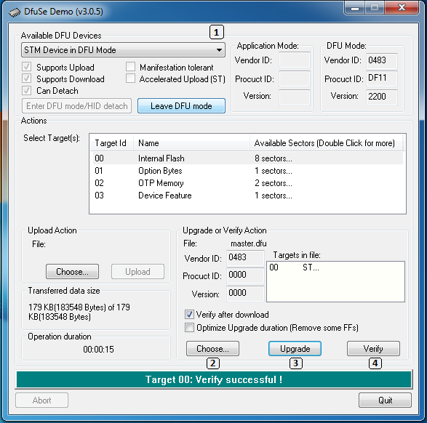
Snapshot of the DfuSe software

17. Appendices

17.1. Warranty information
Inceptor Technologies Pvt. Ltd's (Innovision’s) warranty obligations for the Braille Me are limited to the terms set forth below:
Inceptor Technologies Pvt. Ltd. is referred as INNOVISION henceforth.
INNOVISION warrants that the Braille Me will be free from defects in materials and workmanship for a period of one (1) year from the date of shipment. If the product proves defective during the warranty period, INNOVISION, at its option, will:
- repair the product by means of telephone support or depot service at no charge for parts or labor,
- replace the product with a comparable product which may be new or refurbished
INNOVISION recommends the Customer first utilize support materials shipped with the product, product diagnostics, information contained on the Web, and email support. If unsuccessful, to obtain service under this warranty the Customer must notify INNOVISION or its authorized service representative of the defect before the expiration of the warranty period. Customers will provide appropriate assistance to Telephone Support personnel to resolve issues. If telephone support is unsuccessful, INNOVISION or its authorized service representative will instruct the customer on how to receive warranty repair.
A description of the repair process may be obtained from the authorized INNOVISION reseller/distributor. Repair service is at INNOVISION or its authorized service representative’s sole discretion and is considered an option of last resort. If the Customer’s product contains features that enable INNOVISION or its authorized service representative to diagnose and repair problems with the product remotely, INNOVISION may request that the Customer allow such remote access to the product. In the maintenance of the product, INNOVISION may use new or equivalent to new parts, assemblies or products for equal or improved quality. All defective parts, assemblies, and products become the property of INNOVISION. INNOVISION may require the return of parts, assemblies and products to a designated INNOVISION representative from which the part, assembly, or product was originally purchased. Return and claims will be handled according to the current INNOVISION procedure. These warranties shall not apply to any defect, failure or damage caused by improper use or improper or inadequate maintenance and care. INNOVISION shall not be obligated under these warranties:
a) to repair damage resulting from attempts by personnel other than INNOVISION representatives/ authorized INNOVISION reseller/distributor to install, repair or service the product unless directed by a INNOVISION representative,
b) to repair damage, malfunction, or degradation of performance resulting from improper use or connection to incompatible equipment,
c) to repair damage, malfunction, or degradation of performance resulting from failure to properly prepare and transport the product
d) to provide software or firmware updates or upgrades.
Any service identified in the above list and provided by INNOVISION at the Customer’s request shall be invoiced to Customer at INNOVISION’s then current rates for parts, labor and travel. THE ABOVE WARRANTIES ARE GIVEN BY INNOVISION WITH RESPECT TO THIS PRODUCT AND ITS RELATED ITEMS IN LIEU OF ANY OTHER WARRANTIES, EXPRESS OR IMPLIED. INNOVISION AND ITS VENDORS DISCLAIM ANY IMPLIED WARRANTIES OF MERCHANTABILITY OR FITNESS FOR A PARTICULAR PURPOSE OR ANY SIMILAR STANDARD IMPOSED BY APPLICABLE LEGISLATION. INNOVISION'S RESPONSIBILITY TO REPAIR OR REPLACE FOR DEFECTIVE PRODUCTS AND RELATED ITEMS IS THE SOLE AND EXCLUSIVE REMEDY PROVIDED TO THE CUSTOMER FOR BREACH OF THESE WARRANTIES. Some states, provinces, and countries do not allow the exclusion or limitation of incidental or consequential damages or exclusions or limitations on the duration of implied warranties or conditions, so the above limitations or exclusions may not apply to you. This warranty gives you specific legal rights, and you may also have other rights that vary by state, province, or country. TO THE EXTENT ALLOWED BY LOCAL LAW, EXCEPT FOR THE OBLIGATIONS SPECIFICALLY SET FORTH IN THIS WARRANTY STATEMENT, IN NO EVENT SHALL INNOVISION AND ITS VENDORS BE LIABLE FOR ANY INDIRECT, SPECIAL, INCIDENTAL OR CONSEQUENTIAL DAMAGES (INCLUDING LOSS OF PROFITS) WHETHER BASED ON CONTRACT, TORT, OR ANY OTHER LEGAL THEORY AND IRRESPECTIVE OF WHETHER INNOVISION OR THE VENDOR HAS ADVANCE NOTICE OF THE POSSIBILITY OF SUCH DAMAGES.

18. Contact us
Inceptor Technologies Pvt. Ltd. (INNOVISION)
2nd floor Aai Building, besides Laxmi Vilas,
Near RBL bank, Gadkari Road,
Naupada, Thane, Maharashtra - 400602
Phone: +91-82-91-406811
E-mail: customercare@innovisiontech.co
Web: www.innovisiontech.co

