Breathe Payments
Troubleshooting Guide

Contents
1 Contents 1
2 Document Change History 2
3 Introduction 3
4 Online Manual link 3
5 MePOS 3
5.1 Diagnostic LEDs and Socket Layout 3
5.2 Tablet will not print or open the cash drawer when undocked from the MePOS 6
5.3 MePOS will not print when docked 6
5.4 Will not open cash drawer when docked 6
5.5 Tablet will not charge 6
6 POSzle 7
6.1 Diagnostic Status LEDs and Socket Layout 7
6.2 Will not open cash drawer 8
6.3 Will not print 8
6.4 Tablet will not charge 9
6.5 Re-Pairing the POSzle 9
7 Register Tablet Application (Tablet Cash Register) 10
7.1 Missing products on the Register 10
7.2 Issues finding products when scanning 10
7.3 Tablet is not opening in Register 10
8 Register Web Portal 11
8.1 Importing product issues 11
8.2 Report Issues 11
8.3 Receipt settings need changing 12
8.4 Customer has forgotten log on details for web portal 12
9 Payworks Portal 12
9.1 Transaction Status Messages 12
10 M010 13
10.1 Features and Button Layout 13
10.2 M010 Showing Tamper 14
10.3 Payment not being passed to M010 14
10.4 M010 shows payment failed 14
10.5 M010 not reading cards 14
10.6 M010 keypad not responding 14
10.7 M010 is stuck/frozen 14

Document Change History
Date | Version | Author | Comment
23/10/2018 | 0.1 | Phillip Baker | Initial Release
23/10/2018 | 0.2 | Phillip Baker | Add Section 8 and 9, moved some sub-sections into sections 9
23/10/2018 | 0.3 | Gary Fletcher | Change wording in Section 3 Introduction, Section 4.2 and add image of the underside of the MePOS.  Label the Images of the MePOS Image 1 and Image 2.
25/10/2018 | 0.4 | Phillip Baker | Moved the Socket diagrams into the sections with the diagnostics LEDs.  Added a socket diagram for the POSzle  Added a feature\button layout for the M010
30/10/2018 | 0.5 | Adam King | Added link to online manual

Introduction
This document details common issues and possible resolutions for hardware issues with the MePOS, POSzle and M010 Payment devices.
This document also includes common issues and possible resolutions for the Register application and web portal.

Online Manual link
https://www.manula.com/manuals/register-manual/register-manual?key=eybstPShxpqYOGAuCPIjOcQuV7oJEn0IMb27QKdeZu4D2tYt0x

POSzle

Diagnostic Status LEDs and Socket Layout
Interpretation of diagnostic LEDS is as follows. Yellow LEDs are numbered from the right:
LED | Colour | On | Off | Flashing
Power Indicator | White | Device on |  | Booting
Bluetooth indicator | Blue | Ready to connect |  | Ready to pair
1: Printer status | Yellow | Present | Not present
2: Scanner status | Yellow | Present | Not present | Scan in progress
3: Tablet comms | Yellow | Connected | Disconnected | Comms active
4: PED Status | Yellow | Connected | Disconnected | Comms active
5: Unused | Yellow
6: Tamper alert | Red |  |  | Tampered
7: Overall status | Green | OK |  | Tampered
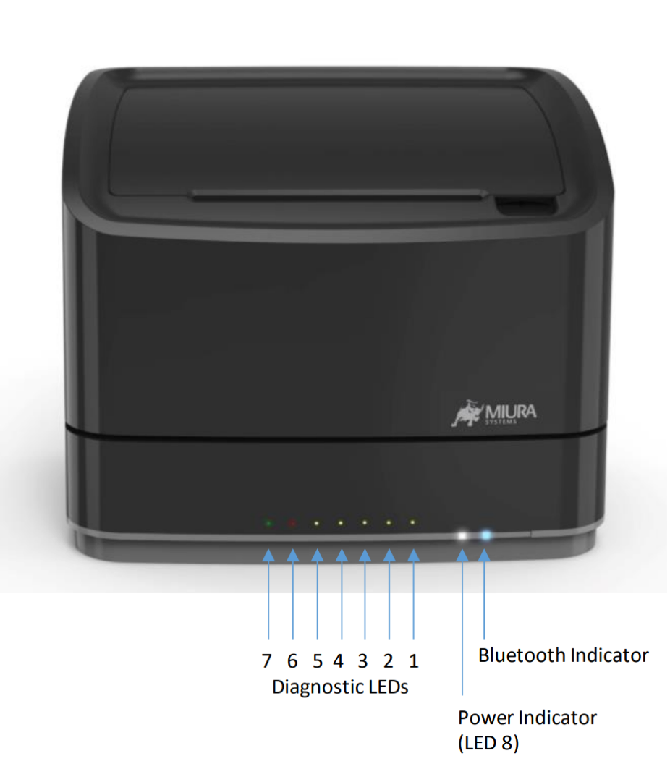

Number | Socket | Description
6 | Cash Drawer | 12V RJ11 socket provides power and comms to a cash drawer
7 | Ethernet | RJ45 socket for network connection
8 | Printer | 12V 6A power output to Miura printer
9 | Power Jack | 12V 10A power input
10 | USB Ports | standard 0.5A USB A sockets x4 for peripherals
11 | High Current USB Port | 2.1A USB A socket for high current peripherals (e.g. tablet)
12 | Revive Button | pin-hole reset button used to activate 'Revive' feature

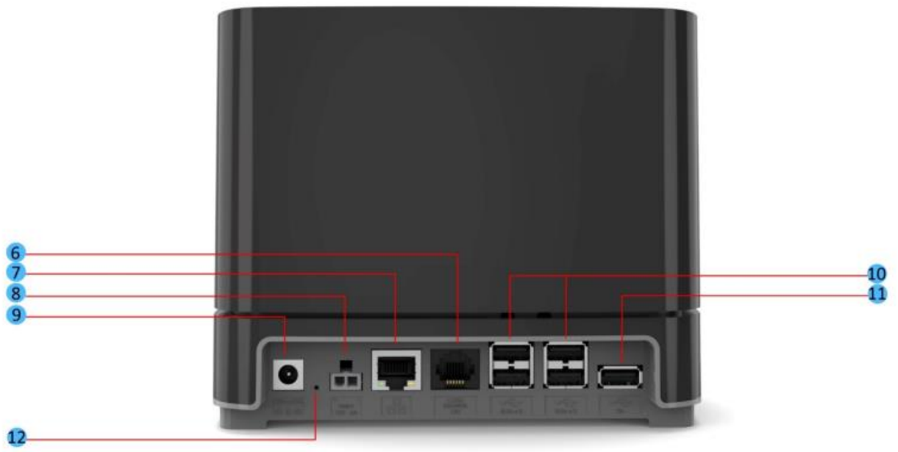

Will not open cash drawer
- Check that all of the cabling is secure
- Check that the tablet is pair to the POSzle
  - This can be done by the settings screen
  - The tablet show be pair with a device called Miura POSzle XXX
    - Where XXX is the last 3 digits of the serial number
- Ensure that the cash drawer cable is plugged into the cash drawer port
- Power off and on the tablet
- Reboot the POSzle turn it off and on at the wall power socket
- Ensure that the POS Software is setup correctly to use the cash drawer

Will not print
- Check that the till roll is in the correct way round
- Check that the tablet is paired to the POSzle
  - This can be done by the settings screen
  - The tablet should be paired with a device called Miura POSzle XXX
    - Where XXX is the last 3 digits of the serial number
- Power off and on the tablet
- Reboot the POSzle turn it off and on at the wall power socket
- Ensure that the POS Software is setup correctly to use the printer

Tablet will not charge
- Ensure that the cable is plugged into the tablet
- Ensure that the cabling is secured into the base

Re-Pairing the POSzle
- Remove the Bluetooth pair from the tablet
  - Enter the tablets settings menu by swiping down twice from the top of the tablet screen
  - Click the settings Cog Wheel Icon
  - Select the Bluetooth option.
  - Remove the pair named Miura POSzle XXX
    - Where XXX is the last 3 digits of the serial number
- Press and hold the pairing button for 5 seconds
- Once the button is release the Bluetooth light will begin flashing rapidly
- The device should show up in the Bluetooth screen
  - The device should show up as Miura POSzle XXX
    - Where XXX is the last 3 digits of the serial number
- Click the device
- Confirm any prompts to pair with the POSzle

Register Tablet Application (Tablet Cash Register)
(Check online manual for further details)

Missing products on the Register
- If the tablet is not showing all of the products that have been put into the web portal:
  - Ensure that the tablet has an internet connection:
    - Enter the tablets settings menu by swiping down twice from the top of the tablet
    - Click the settings Cog Wheel Icon
    - Select the WLAN/Wi-Fi option.
    - Ensure that there is a network that is showing the status as connected
  - Perform a sync using the ‘update data’ button on the staff sign in screen.
    - This can be found on upper right-side of the staff sign in screen
  - If this still isn’t working log into the web portal and check that the products have been loaded correctly in the customers ‘product’ area.
  - Go into settings menu within the application and do a ‘full sync’
    - The settings menu can be access from the staff sign in screen, by clicking the three vertical dots in the top right corner.

Issues finding products when scanning
- If the application is returning ‘product not found’ or similar when scanning an item
  - First go into the stock screen on the tablet, from there you can find the item and the associated details for that item on the right hand side. Check that the product has a barcode against it.
    - If there is no barcode against the product these will need to be added via the web portal; you can export the products, add the barcodes and then reimport the products to do this. Or you can add them in individually.
    - If there is a barcode against the product, first check that the barcode is correct. Sometimes these are imported incorrectly wrong for 2 common reasons.
      - Either the cell has changed formatting and is importing the barcode as a scientific cell (901E+12 for example)
      - The cells in excel have deleted the ‘0’ from the start of the barcode, this will also be due to formatting.
    - In both of these cases the barcodes will need adding via the web portal; again, you can export the products, add the barcodes and then reimport the products to do this. Or you can add them in individually.
  - If the customer cannot find the product through the stock screen then you can check these on the web portal instead.
  - If all the products seem to be loaded ok be sure to do a sync (‘update data’) on the tablet to pull the new information down from the portal.

Tablet is not opening in Register
- If the tablet for some reason is not in the Register application upon unlocking the tablet
  - First close any open applications on the tablet
  - Re-launch Register by using the home button on the tablet, choose the Register application and then choose the option ‘always’
  - Make sure this connects to the printer and cash drawer
  - Do a no sale and print feed on the till to check this

Register Web Portal
(Check online manual for further details)

The first thing to check when diagnosing Register Web Portal issues is to ensure that the customer is using GOOGLE CHROME as their browser. All testing is done on Google Chrome and this is the only browser that is supported.
There can also be issues when trying to change things via the portal on the tablet, we would always recommend using a PC/laptop when using the web portal to make changes.

Importing Product Issues

When the customer imports a CSV file with their products on, if there are any issues, the portal will show the customer exactly what the issue is and what field the issue is in. There are occasions though where the products get imported but there are errors on them, due to user error.
(Always ensure that the customer is saving the import file(s) as a CSV).

- The most common issue is that barcodes are imported as formulas (e.g. 901E+12) rather than numbers. To correct this:
  - Export all of the products using the export tool on the products screen.
  - Correct the barcodes that have the errors and make sure the formatting is correct when saving the spreadsheet as a CSV file.
    - Please note: When you save a CSV file, the formatting is kept, however if you re-open the CSV file before importing, the formatting will be removed meaning the barcodes may return to their formula state. Once the CSV is saved, do not re-open until imported.
  - Make sure the ‘Import Record’ column is set to YES otherwise some lines of products will be ignored.
  - Re-upload the products using the import tool.
  - Double check in some of the products that the barcode is now correct.
- There has also been issues where the customer has uploaded duplicate products due to using different SKU’s, to resolve this:
  - First export the products
  - You can then use data validation in excel to show the duplicate values (you can do this by barcode, product name etc.)
  - Next to the duplicate values, use the ‘delete’ column on the spreadsheet to remove the duplicate products from Register.
  - Save the file as a CSV and re-import using the import tool.

Report Issues

There are certain reports that need certain parameters set to be able to run them, if they aren’t set then there will be no data returned when the report is created. These are below:

- Stock Report – you need to select departments to run this.
- Department Report – you need to select departments to run this.
- Low Level Stock Report - you need to select departments to run this.
- Department Product Report - you need to select departments to run this.

Receipt settings need changing

If the receipt settings are set incorrectly it will not print properly and may be out of line, this can occur if a customer doesn’t follow the correct procedure when updating the receipt details.

- Log into the web portal and find the customer account (merchant) via the tenants tab.
  - E.g. Tenants > FIS Live Customers > Ben’s Garage
- You can then go into their profile and look at their current receipt settings.
  - Config > Profiles > ‘edit profile’ > Receipt tab
- Here you can edit the receipt footer and header, if you click the ‘i’ logo this will give you instructions on how to set the receipts.
  - You need to put ‘Cxx:’ before the text at the start of each line, this will then set that line to the centre of the receipt. ‘Lxx:’ will align left and ‘Rxx:’ will align right. The ‘xx’ value is the character width of the receipt printer.
    - POSzle Receipt Width: 40
    - MePOS Receipt Width: 44
  - Example:
    - C44:Secure Retail Ltd
    - C44:Walker Road
    - C44:Bardon Hill
    - C44:Coalville
    - C44:Leicestershire
    - C44:LE67 1TU
    - C44:Tel:+44 (0) 1530 511150

Customer has forgotten log on details for web portal

You can reset any customers’ passwords easily through a tenant login for the web portal.

- Log into the web portal and find the customer account (merchant) via the tenants tab.
  - E.g. Tenants > FI S Live Customers > Ben’s Garage
- You can then go into their portal users
  - Admin > Portal Users
- From here you can edit (pencil icon) the user that requires the password resetting and change their password from that screen. If you give them a generic one similar to ‘Reset123’, for example, they can then amend this when they log in.

M010

Features and Button Layout
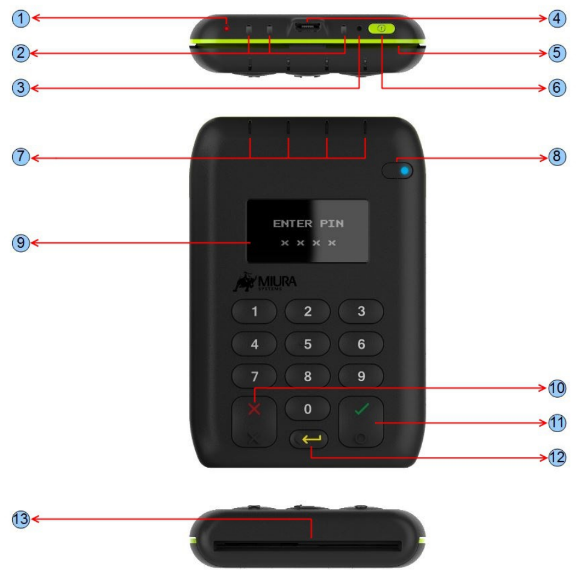
Number | Feature | Function
1 | Charging LED | Red LED indicates unit is charging
2 | Charging Cradle Contacts | Charging contacts for standard or fast charge cradles.
3 | Revive Button | Pin-hole reset button used to activate the Revive feature
4 | USB connector | USB Micro-B receptacle - used for charging / file transfer
5 | Swipe slot | Reads magnetic stripe cards (stripe downwards and facing away from user)
6 | Power button | Used to power the terminal on and off and enter sleep mode
7 | Contactless LEDs | Green LEDs indicate different stages of a contactless card transaction
8 | Bluetooth Key | Press and hold for a few seconds to put the device in pairing mode
9 | OLED display | Displays instructions for user
10 | Cancel Key | Cancels actions including PIN entry
11 | Enter Key | Confirms actions including PIN entry
12 | Clear Key | Deletes last PIN digit entered
13 | Smart Card Slot | Reads chip cards (insert card with chip facing upwards)

M010 Showing Tamper
- The device is not usable will need to be replaced with a new device

Payment not being passed to M010
- Ensure that the M010 is powered on
- Ensure that Bluetooth is enabled on the tablet
  - Enter the tablets settings menu by swiping down twice from the top of the tablet
  - Click the settings Cog Wheel Icon
  - Select the Bluetooth option.
  - Ensure Bluetooth is toggled to on
- Reboot the tablet
- Re-Pair the M010 to the tablet
  - Enter the tablets settings menu by swiping down twice from the top of the tablet
  - Click the settings Cog Wheel Icon
  - Select the Bluetooth option
  - Remove any existing pair for the M010 (This should show up as the serial number of the M010. For Example M010-852369)
  - Press and hold the Bluetooth button on the M010 until it starts to rapidly flash blue
  - Select the device on the tablet
  - Confirm the pairing on both the tablet (Select Ok) and the M010 (Press the green tick)

M010 shows payment failed
- Ensure that the tablet is connect to the Wi-Fi:
  - Enter the tablets settings menu by swiping down twice from the top of the tablet
  - Click the settings Cog Wheel Icon
  - Select the WLAN/Wi-Fi option.
  - Ensure that there is a network that is showing the status as connected

M010 not reading cards
- Does this issue appear with more than one card
- Clean the card slot with cleaning cards
- Replace with a new device

M010 keypad not responding
- Power off and on the device
- Replace with a new device

M010 is stuck/frozen
- Power off and on the device
- If this is not possible or fails, use a paper clip to press the revive button this will put the M010 in revive mode
  - The button is located at the top of the device next to the power button
  - The button is recessed into the case, to prevent accidental pressing
- Select the option 1) “Power up as Normal”

