

INSTRUCTION MANUAL

Table of Contents
1.0 IRBManager 4
1.1 What is IRBManager? 4
1.2 How Can I Obtain Access to IRBManager? 4
1.3 How do I Log-In? 4
2.0 Passwords 5
2.1 What Happens At Your First Log-In? 5
2.2 After Log-In... 6
3.0 Navigating the Home Page – DASHBOARD 7
3.1 Actions 7
3.2 Recent Items 8
3.4 My Documents and Forms 8
3.5 Studies 9
3.6 xForms 9
3.7 Events 10
3.8 Top Headings 11
3.8.1 Change Password 11
3.8.2 Change Your Profile 12
3.8.3 My Phone Numbers 12
3.8.4 My Address 13
3.9 My Studies 13
4. Navigating the Study Protocol Page 15
4.1 Study 15
4.2 Study-Site 15
4.3 Contacts 16
4.4 Events 16
5.0 Event Details 17
5.1 Study Site 18
5.2 Event 18
5.3 Notes 18
18
5.4 Steps 19
5.5 Actions in the Event Details 19
5.5.2 Attachments 20
5.5.3 Generated Docs 20
5.5.4 X-Forms 20
6. Submitting an X-Form 21
6.1 Submitting an X-Form for an Initial Study 21
6.2 Submitting an X-Form for an Existing Study that has Received Initial Approval 21
6.3 Completing an xForm 23
7.0 Using xForms 25
7.1 Attaching Documents 25
7.2 Attaching Documents 25
Frequently Asked Questions 26
I forgot my password. How do I obtain a new password? 26
How can I check on the status of my submission? 26

1.0 IRBManager

1.1 What is IRBManager?
IRBManager allows users to enter IRB Applications and protocol related information including: forms, attachments, documents and events which can be associated with the study.
Investigators have access to see the studies they're investigating as well as attachments, events and documents generated for their study but do not have the authority to edit them after they have been submitted and/or approved. Changes to studies must be submitted via a Revisions Form; available from Start Form option on a study. Progress on all submissions including new applications is viewable to all personnel involved with the study.
IRBManager is a fully web based system. As long as IRBManager and the remote user are on the same logical network (LAN, WAN, VPN, internet, etc), remote users can have access.

1.2 How Can I Obtain Access to IRBManager?

- A PI or Study Coordinator can request a user ID through IRBManager for anyone that needs access, such as an outside PI, but the PI or Study Coordinator must be able to log-in to IRBManager to request the ID.

1.3 How do I Log-In?
- Go to https://cchhs.my.irbmanager.com/Login.aspx
- Enter your username and password. Your username will always be an email address.
- Enter CCHHS as the Client (check box ‘Remember Client’ to set the client permanently for the computer you are working on.
- Click Login.

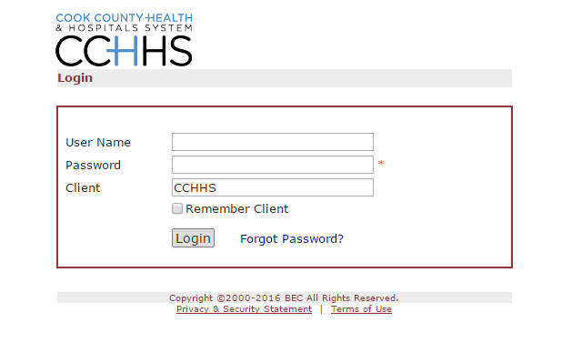

2.0 Passwords

2.1 What Happens At Your First Log-In?
On your first log-in, you will be prompted to change your password. Your password must meet the following requirements:
- A valid password must be at least 6 characters long and contain characters from at least 3 of these groups: uppercase letters, lowercase letters, numbers, special characters (!,@,#, etc.).
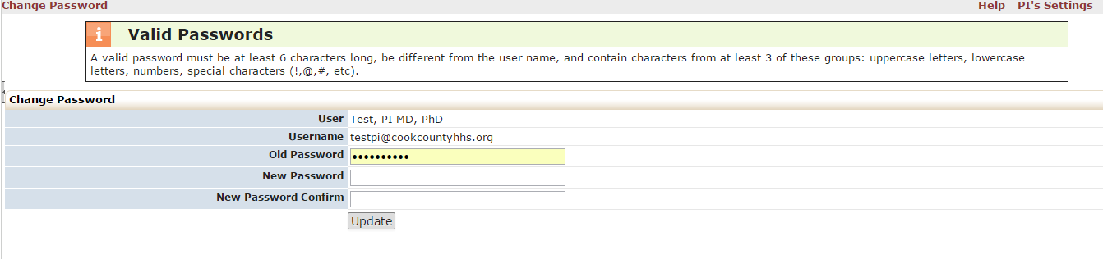
To change your password and proceed:
- Step 1: Enter old password.
- Step 2: Enter new password (see requirements above) and then enter new password again to confirm.
- Step 3: Click “update”.
When you log-in in the future, be sure you know your username and password. If you enter the wrong username/password three times, IRBManager locks your account as a security precaution. If that happens, you can click the Forgot Password link on the login page.

A password reset screen will ask for your email address and client. Your client is CCHHS. Please enter the email address you used to register your account and we will send a new password to that email account and also unlock your account.

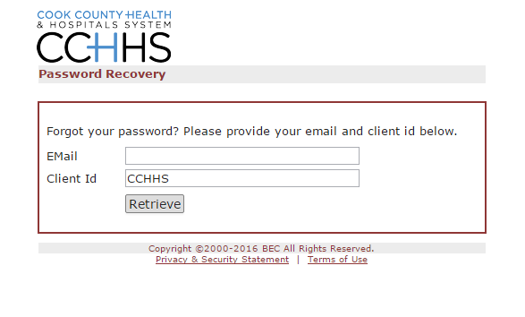

You will be asked to reset your password when you login using the temporary password.

2.2 After Log-In...

Once your password has been updated, you will be logged into the system. Your view will depend on your assigned role. If you are a researcher, your studies will appear on your home screen.

Later when asked to sign a document, you’ll be able to provide a required signature electronically simply by entering your password each time.

Navigating the Home Page – DASHBOARD

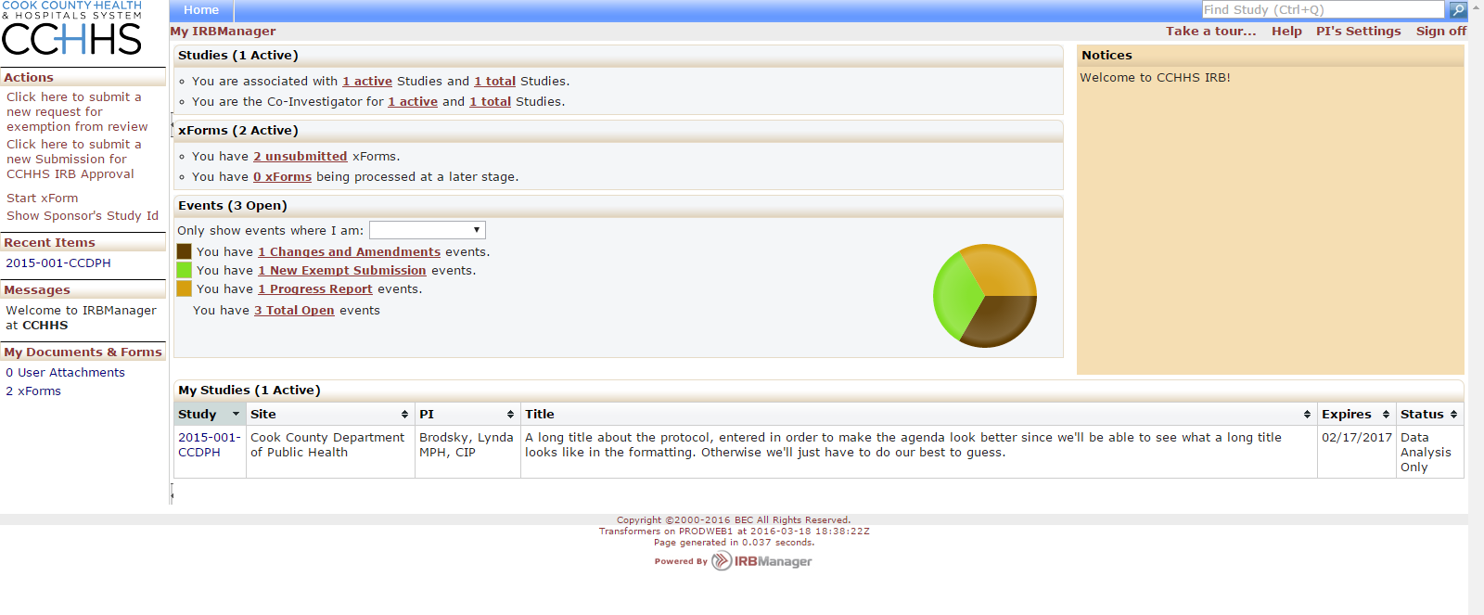

Actions
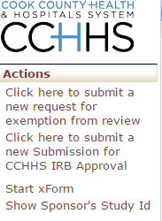
If you see “Show Local Study ID” in the actions on the left, please click the link to show the CCHHS IRB # for the study.

If you see “Show Sponsor’s Study ID” in the actions menu, please leave as is. You are seeing the CCHHS IRB # in the lists of studies and do not need to change.

The Sponsor Study IDs are to allow researchers to view their studies by the number assigned by the grant funder number / sponsor number instead of the IRB Number.

3.2 Recent Items

The hyperlinks under this heading will show the most recent items you have viewed in IRBManager. You can just click on any link under “recent items” to go directly to that item.

3.4 My Documents and Forms

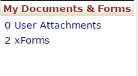

This heading shows how many attachments and xforms the user has associated to their account.

3.5 Studies
This shows the studies each user is associated with, shows what studies the user is the Principal Investigator for and what studies the user is “Associated with” which means you are either the PI, Co-Investigator, Attending Advisor, Coordinator, or a Research Assistant for the study.

Note: By clicking on the underlined link, you will go to the studies you are associated with.

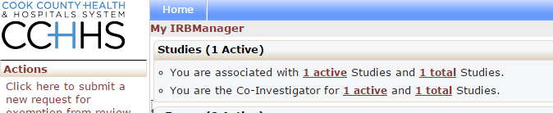

3.6 xForms
The xForms tab shows the forms or applications currently being processed at this time for the user. xForm is also referred to as a submission to the IRB.

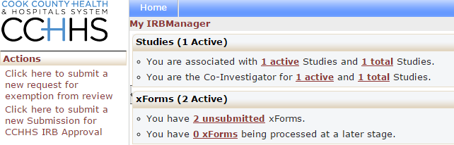

In this view of the DASHBOARD:
- You have 2 unsubmitted xForms.
This line denotes xForms (submissions) started but not yet submitted. Instead, the user clicked “Save for Later” and did not submit them to the IRB.

Note: By clicking the underlined link, “2 unsubmitted” the user can go straight to the unsubmitted xForms.

- You have 0 xForms being processed at a later stage.
This denotes xForms the user created and submitted. The form is still being processed at a later stage. This could include PI review or at a stage being reviewed by the IRB. By clicking on the link “0 xForms” the user could see what stage each submission has reached.

- If you see a sentence saying that there are “ xForms currently awaiting your attention” then there are forms where you either need to review and sign or the submission has a problem that needs to be addressed.(Possibly a clarification regarding an answer or a condition which needs to be resolved before approval can be granted.) You will always be notified via email that these submissions are awaiting your attention.
Note: By clicking the underlined link, “ xForms” the user can go straight to the Forms that need the user’s attention.

3.7 Events
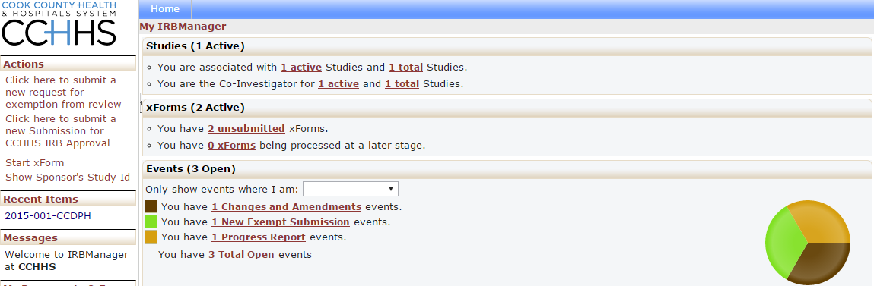

The events section of the DASHBOARD shows the submissions open by submission type.

This section shows all open events and the submission name, such as Renewal Request, New Submission, Closure and Revisions.

Note: An event stays open until the all actions which are part of the event have been completed. It’s possible for the xForm to be complete and approved, but the event is still open until a board meeting occurs where the board would be notified.

3.8 Top Headings

HELP – Institutional relevant help is being created. Over time this Help tab will provide additional information regarding the page you are on.

PI’s Settings – allows the user to edit their profile settings. “PI” will be replaced with your first name.

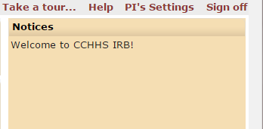
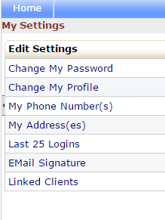

Under My Settings you can:
- Change your password
- Change your profile
- Change your phone number
- Change your address
- View last 25 logins
- Create an email signature

3.8.1 Change Password
- Step 1: Click on “change password” link.
You will then see this view:

- Enter old password.
- Enter new password that meets requirements and then enter new password again to confirm.

Your password must meet the following requirements:
- Be 6 or more characters
- Contain any 3 of the following: upper case letter(s), lower case letter(s), number(s), special characters (!,@,#, etc.)
- Click “update”.

3.8.2 Change Your Profile
- Click on “Change My Profile” link.
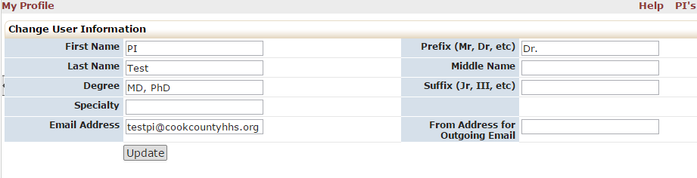
You will then see this view:

- Update your name or email address.
- Click “update.”

3.8.3 My Phone Numbers
- Click on “My Phone Number” link.
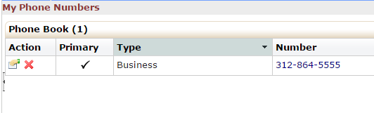
You will then see this view:

- Click the “hand holding a piece of paper”
You will then see this view:
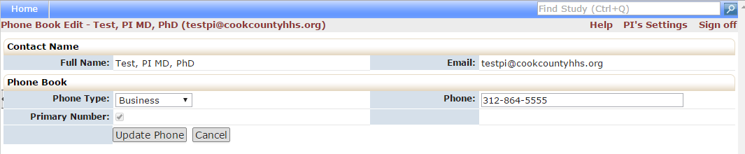

- Update your phone number.
- Click “Update Phone.”

3.8.4 My Address
- Click on “My Address(es)” link.
You will then see this view:
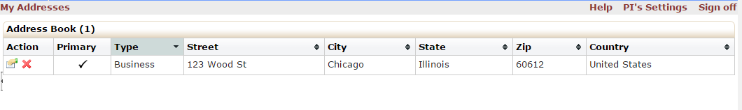

- Click the “hand holding a piece of paper”
You will then see this view:
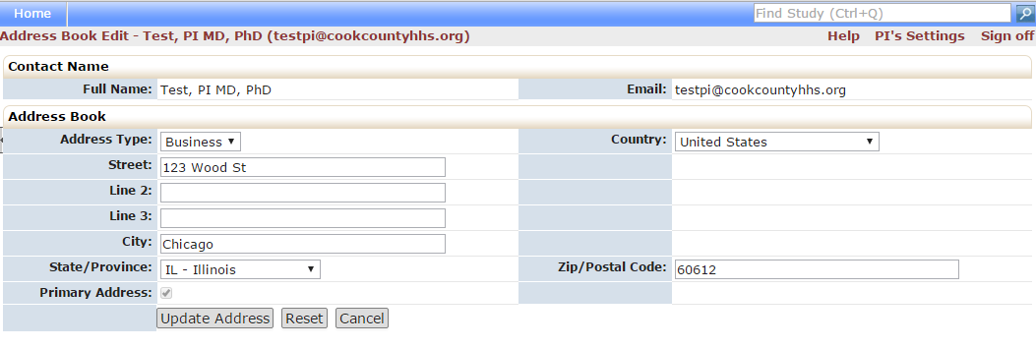

- Update your address information.
- Click “Update Address.”

3.9 My Studies
This is a list of all the active studies for the user logged in to the dashboard.
- The study number.
- The site the study is taking place.
- The PI name.
- The study title.
- Expiration date of the study.

Note: By clicking on the blue link under “Study” the user can go straight to the study.

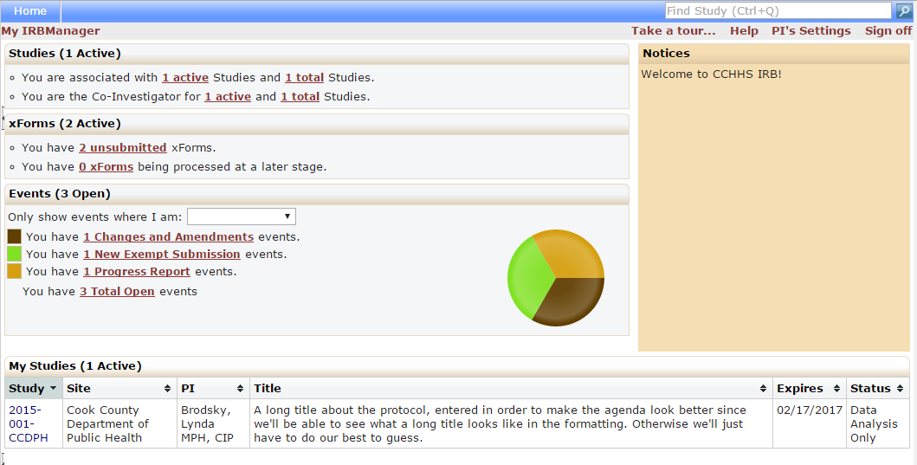

By clicking the arrow beside the column header for Study, Site, PI, Study Title, Expiration Date and Status you can sort the studies accordingly.

- Studies can be sorted by IRB Number
- Site can be sorted alphabetically
- PI is sorted alphabetically
- Study Title is sorted alphabetically
- Expiration dates are sorted by numerical date
- Status is grouped and sorted alphabetically

Navigating the Study Protocol Page

From the home page, you can access a protocol page for each of your studies. Click on the blue Study Code or IRB number link to access this page.

Study
This section notes basic information about the protocol, such as:
- IRB number
- Sponsor (Funding Organization, if any)
- Sponsor ID - (Funding Organization Acronym or ID, if any)
- Category of study (Will display the department of study)
- Agent Type (Interview, Online Survey, Physical Intervention, etc…)
- Study Title
- Year of initial submission
- Comments – Abstract or Purpose of the study

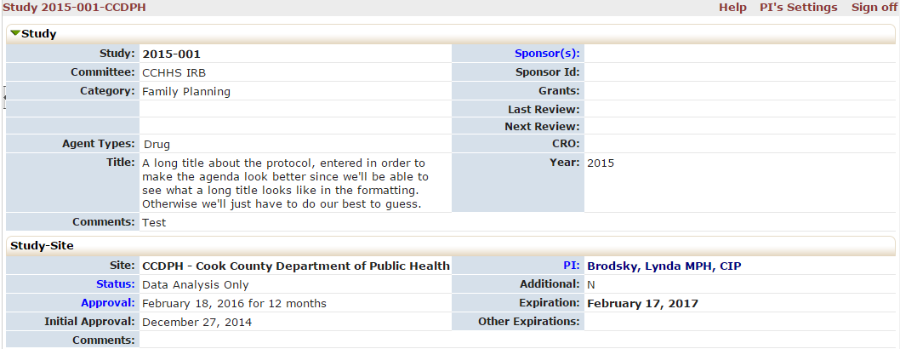
You can click on any blue link; in this section, to view more information on the linked item. Clicking on Sponsor(s) will provide detailed funder information.
.

Study-Site
This section notes information about the study and the study site, such as:
- Status (Active, Closed, New from PI, Withdrawn)
- Initial approval date
- PI name
- Expiration date for continuing review
- Comments
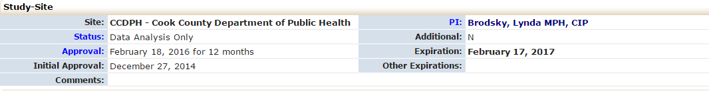

Contacts
This section list the contacts associated with the study.
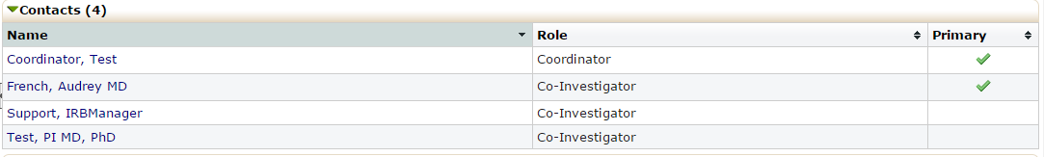
All contacts involved in the study must be listed in this section. Researchers will only be able to view the study in IRBManager if they are listed as a contact.

Events
This section lists all the IRB “events” or submissions that have been or are being conducted for this protocol. The event line contains the following sections:

- Type of Event (Adverse Event, Changes and Amendments, Initial Full Board or Expedited, New Central IRB Submissions, New Exempt Submission, Progress Report, etc….)
- Att – number of attachments associated with that event or review.
- Instance/UDF – the material being reviewed for the submission (Change in consent form, Addition of Co-Investigator, etc…).
- Start – the date the event was started or loaded into IRBManager
- Complete – the date the event was completed and reported to the board.
- Last Mtg – shows the last meeting this event or review was submitted to. Even if a submission is expedited, it shows up on a convened IRB meeting agenda.

You can click on any blue event; in this section to view information specific to the event. After clicking on the blue link, it will take you to event details (See Section 5.0)

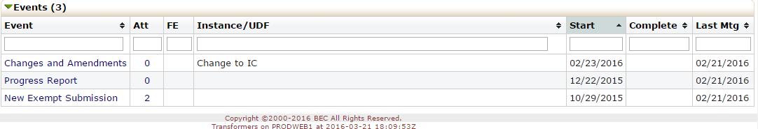

5.0 Event Details
Event Details are specific to the event or submission.
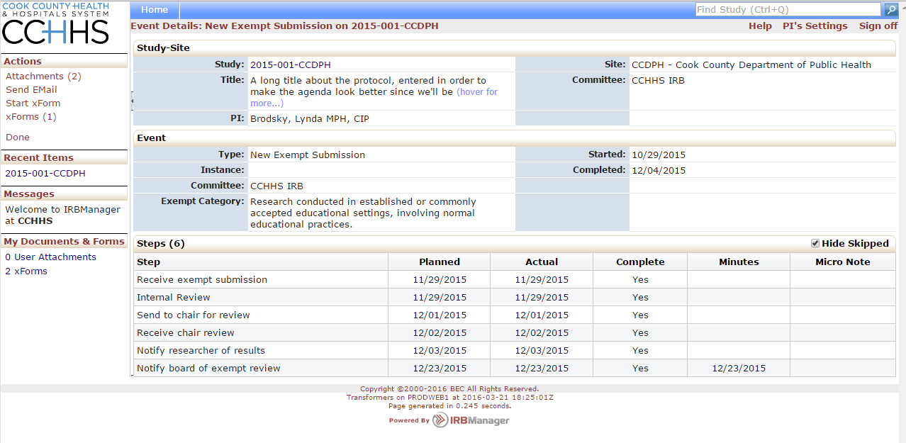

The event details contain the following:

5.1 Study Site
Study Site:
- IRB Number (Study Number)
- Site (Location)
- PI Name

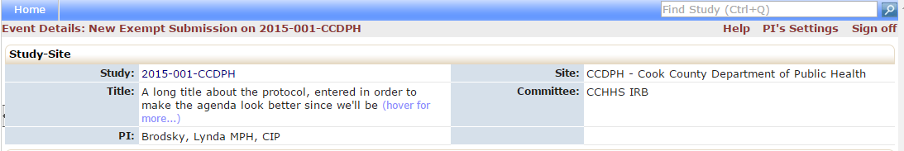

5.2 Event
The Event shows specific details about the submission you are viewing.

Event:
- Type (Adverse Event, Changes and Amendments, Initial Full Board or Expedited, New Central IRB Submissions, New Exempt Submission, Progress Report, etc….)
- Instance (documents or information related to the event)
- Defined (the date the event first started)
- Completed (the date the event was completed)

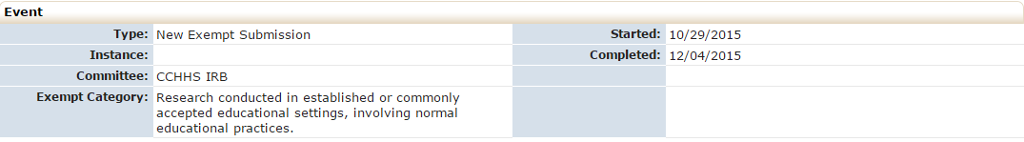

5.3 Notes
Lists the summary of the submission and the documents related to the event. For instance, this shows the modification summary and the documents being modified.

5.4 Steps
This shows the steps of the submission with the dates. Each event will have the steps listed with a planned date, actual date and when it will go to the full board for either review or notification.
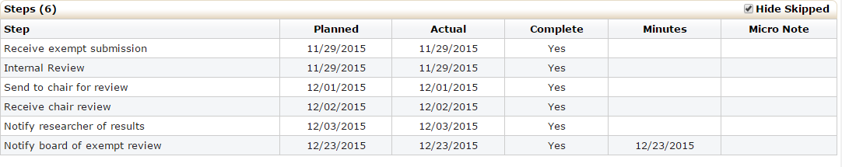

For example in this event the following has occurred:
- The IRB received the exempt submission on 11/29/15.
- The IRB staff completed an internal review for completion on 11/29/15.
- The IRB staff sent to chair for review 12/1/15.
- The IRB staff received chair review on 12/2/15.
- The PI was notified that their study was approved on 12/3/15.
- The IRB was notified on 12/23/15 that the approval had been granted during its regularly scheduled meeting.

5.5 Actions in the Event Details
Actions in the event details screen are as follows:
- Attachments – shows the attachments related to the event detail
  - Generated Docs – shows the approval documents associated with the study
- X-Forms – shows the form used to submit the event.

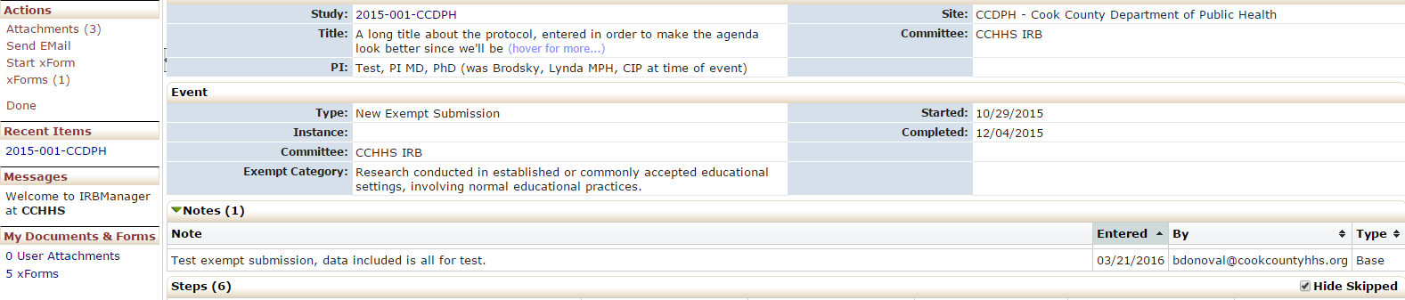

5.5.2 Attachments
The attachment list shows both items that are attached to the event and letters that were generated by the IRB Office regarding the submission.
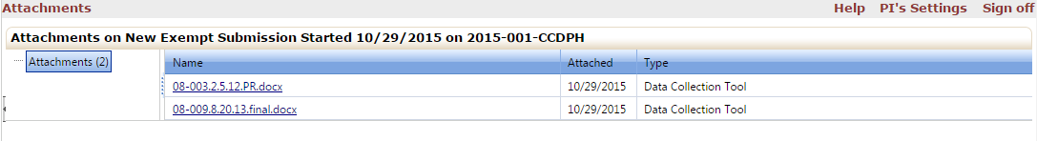
Shows the attachments related to the event detail. These are the attachments uploaded by the PI. This may also include approval letters from other institutions, consent forms, survey instruments and all other documents provided for this submission.

5.5.3 Generated Docs
Shows the approval documents associated with the study. The IRB staff generates the approvals after the Chair has approved the review.

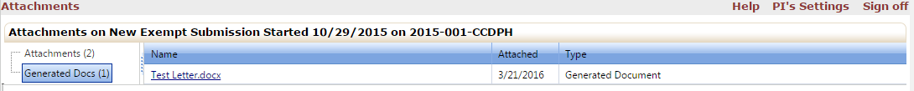

5.5.4 X-Forms
Shows the application associated with the event. This is the application completed by the researcher.

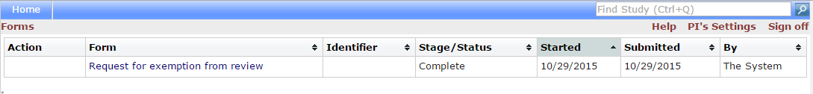

Submitting an X-Form

Submitting an X-Form for an Initial Study
- To begin an Initial Application, go to the Home page and look at the Actions on the left.
- Click on “Click here to submit a new Submission for CCHHS IRB Approval”.

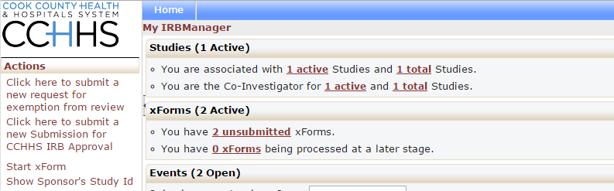

- This will bring you to the Initial Review Application.

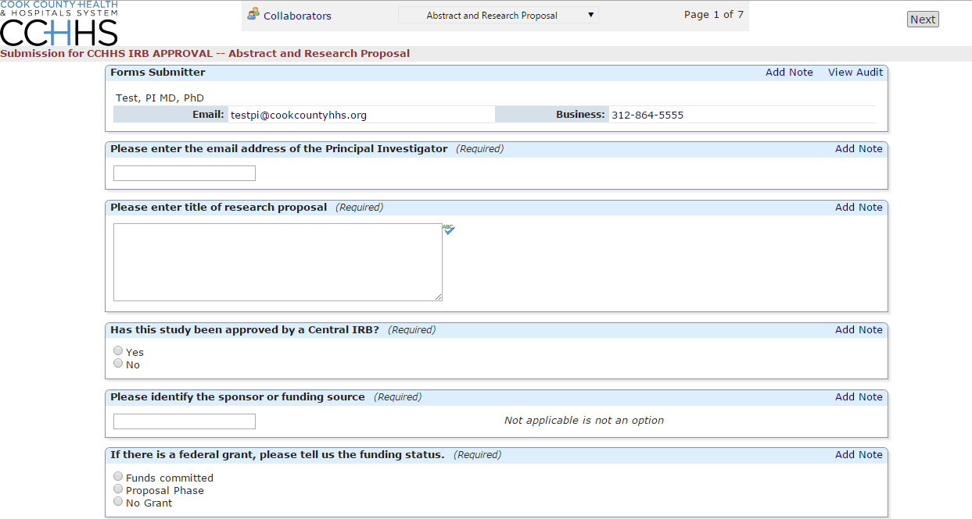

Note: Researchers (Co-I’s and other research personnel) will receive an email with a link explaining that they must fill out a Potential Conflict of Interest Form, and attach to the Initial Submission Application. They must also attach a copy of their CITI certification as part of the process before the IRB is ever notified.

Submitting an X-Form for an Existing Study that has Received Initial Approval
In order to complete an event (submission) on an active study, such as Renewal Request, Revision Request or Closure Report, you must first go to the study. There are three ways to go into the study.

- Go to the Home Screen
- Click on a study in the “My Studies” screen
OR
- Go into the active studies link and choose the study or go into the PI link and choose the study.

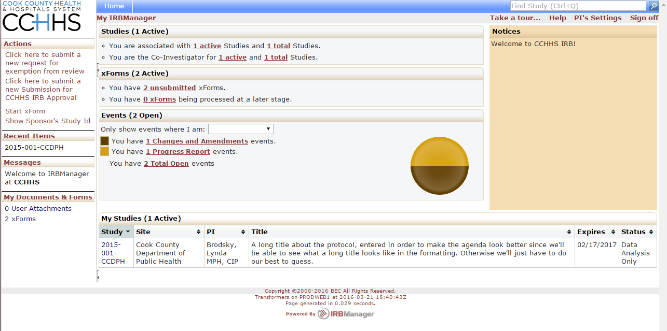

Once you are in the study, you click the Start xForm button.

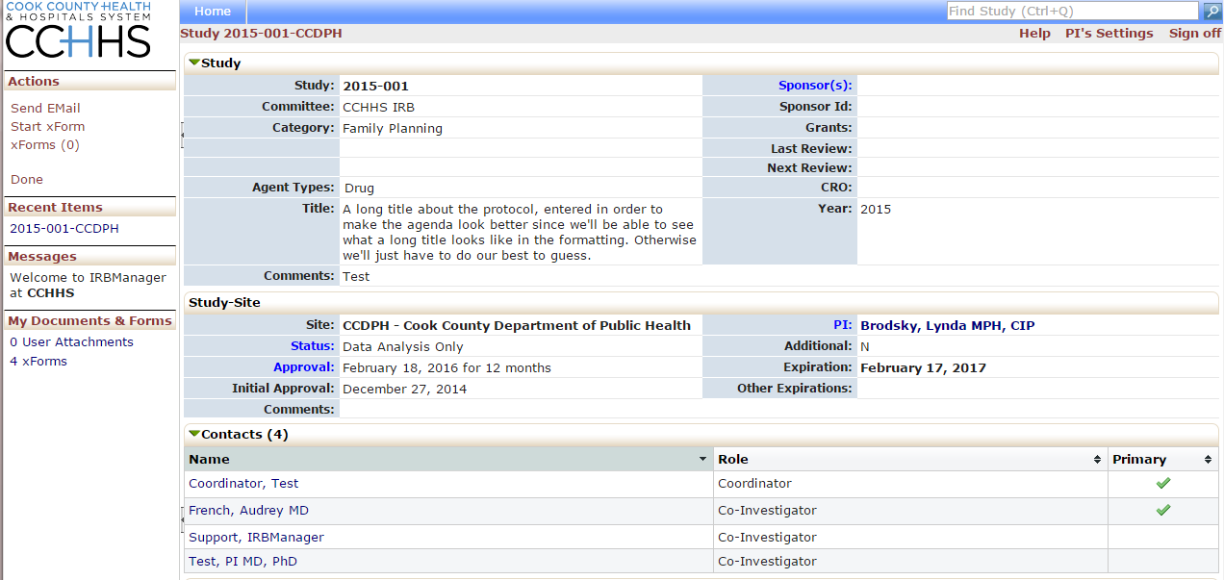

You will then choose the appropriate submission form (xForm).

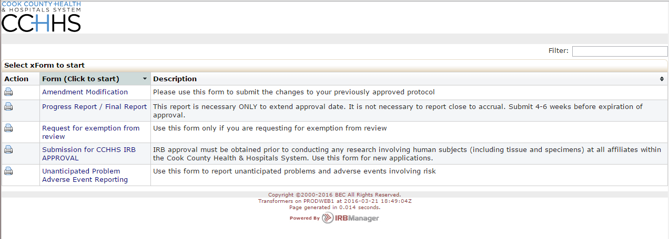

Completing an xForm
Answer the questions on the xForm (submission) and submit the application.

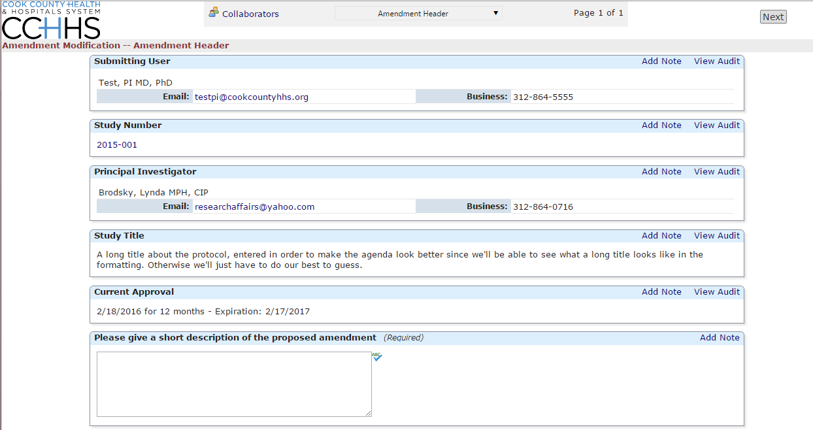

Notice that IRBManager automatically inputs the PI name, the IRB number, the title, and who is submitting the form.

The next questions in the xForms are directed by the answers that you give. For example, if you answer that you have funding for the study; subsequent questions will prompt you to describe the funding. If you indicate that you do not have funding related to the study, those subsequent funding questions will be hidden.

Click “next” to move on to the next page of the xForm. Click “save for later” to stop working on the form. The xForm can then be reopened by going to the xForm link under “Actions.”

- You may have to scroll down to view and answer all the questions.
- If a question is labeled (Required), an answer must be provided. If you fail to answer a required file, an error message will appear. The system will not allow you to continue until the field has been populated.
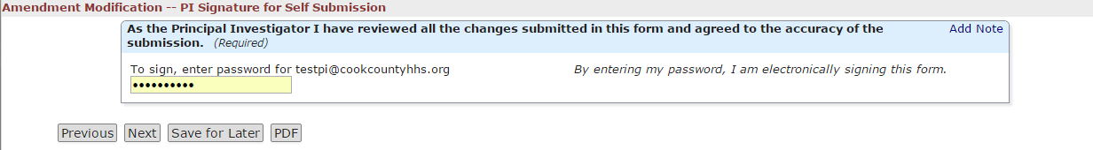

After completing the xForm (submission) you enter your password and hit the submit button.

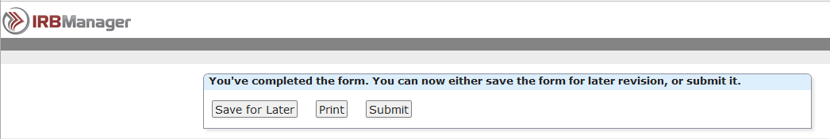

Other options than submitting: You can print the application or decide not to submit the form and wait until a later time to submit the form.

7.0 Using xForms

7.1 Attaching Documents
Protocols, informed consents, recruitment material, etc. can all be attached to your xForms.

To attach a document:

- Click “add attachment” on specified attachment questions.
- Enter name for your attachment. If you want to just use the name of the uploaded file, leave this field blank.
- Select the type of attachment if that option is available. On some questions, only a certain type of document is intended to be attached, and the type is pre-set.
- Click the “browse” button to locate the file on your computer.
- Click “attach” to finish the process.

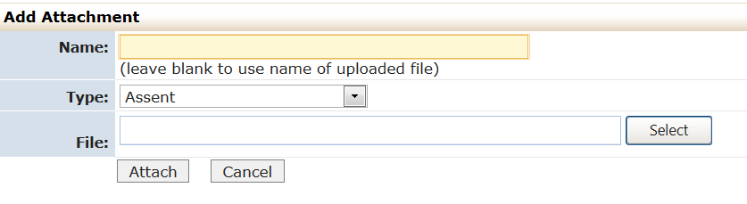
Note: The file name will be listed in the approval letter, so please make sure the file name can identify the document.

7.2 Attaching Documents
Be sure to review your form before submitting to the IRB. Once you submit a form to the IRB, it will be locked for IRB review.

If the form has not yet been submitted to the IRB, you can view the form from the protocol page (click xForms in the Action section to view forms attached to this protocol OR click xForms in the My Documents and Forms section to see forms).

Once the form has been completed and submitted to the IRB, IRBManager will automatically assign a study event on the protocol page. You can then click on the event name (blue link) to track the event progress (see earlier section, Tracking the Event).

Frequently Asked Questions

I forgot my password. How do I obtain a new password?
Use the forgot password feature at the log-on screen. You will be emailed a temporary password and allowed to reset the password.
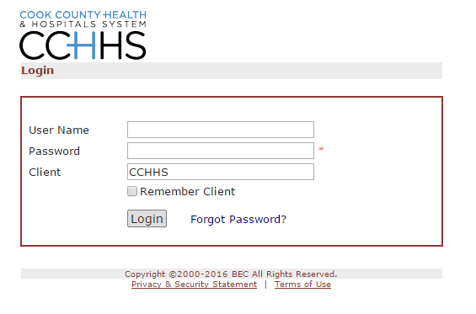

How can I check on the status of my submission?
Log into the system and click the blue protocol link for the appropriate study protocol page. Once on the study protocol page, click the blue event link for the event that you wish to check on. The event page will open up and within the Steps section, you can see which steps have been completed by the “yes” or “no” answers in the “completed” column.

