CLEARPIX Server Software
CPX Digital Recorders

User Manual

Clearpix Server Software
Operations Manual

Manual Edition 34860AB - MARCH 2016

©2016
All Rights Reserved

No part of this document may be reproduced by any means, electronic or mechanical, for any purpose, except as expressed in the Software License Agreement. We shall not be liable for technical or editorial errors or omissions contained herein. The information in this document is subject to change without notice.

The information in this publication is provided “as is” without warranty of any kind. The entire risk arising out of the use of this information remains with recipient. In no event shall we be liable for any direct, consequential, incidental, special, punitive, or other damages whatsoever (including without limitation, damages for loss of business profits, business interruption or loss of business information), even if we have been advised of the possibility of such damages or whether in an action, contract or tort, including negligence.

This software and documentation are copyrighted. All other rights, including ownership of the software, are reserved to ClearPix Server Software; Windows, and Windows Embedded are registered trademarks of Microsoft Corporation. All other brand and product names are trademarks or registered trademarks of the respective owners.

The following words and symbols mark special messages throughout this guide:


Note Text set off in this manner indicates information that is necessary for proper operation of the product.

IMPORTANT SAFEGUARDS
- Read Owner’s Manual – After unpacking this product, read the owner’s manual carefully, and follow all the operating and other instructions.
- Power Sources – This product should be operated only from the type of power source indicated on the label. If not sure of the type of power supply to your home or business, consult product dealer or local power company.
- Ventilation – Slots and openings in the cabinet are provided for ventilation and to ensure reliable operation of the product and to protect it from overheating, and these openings must not be blocked or covered. The product should not be placed in a built-in installation such as a bookcase or rack unless proper ventilation is provided or instructions have been adhered to.
- Heat – The product should be situated away from heat sources such as radiators, heat registers, stoves, or other products that produce heat.
- Water and Moisture – Do not use this product near water. Do not exceed the humidity specifications for the product as detailed in the Appendix section in this manual.
- Cleaning – Unplug this product from the wall outlet before cleaning. Do not use liquid cleaners or aerosol cleaners. Use a damp cloth for cleaning.
- Power Cord Protection – Power-supply cords should not be routed so that they are likely to be walked on or pinched by items placed against them, paying particular attention to cords at plugs, receptacles, and the point where they exit the product.
- Overloading – Do not overload wall outlets; extension cords, or integral convenience receptacles as this can result in a risk of fire or electrical shock.
- Object and Liquid Entry Points – Never insert foreign objects into the recorder, other than the media types approved, as they may touch dangerous voltage points or short-out parts that could result in a fire or electrical shock. Never spill liquid of any kind on the product.
- Accessories – Do not place this product on an unstable cart, stand, tripod, bracket, or table. The product may fall, causing serious personal injury and serious damage to the product.
- Disc Tray – Keep fingers well clear of the disc tray as it is closing. Neglecting to do so may cause serious personal injury.
- Burden – Do not place a heavy object on or step on the product. The object may fall, causing serious personal injury and serious damage to the product.
- Disc – Do not use a cracked, deformed, or repaired disc. These discs are easily broken and may cause serious personal injury and product malfunction.
- Replaceable Batteries – CAUTION: Risk of Explosion if Battery is replaced by an Incorrect Type. Dispose of Used Batteries According to the Instructions.
- Grounded Outlet – This equipment shall be connected to a properly grounded outlet.
- Outlet Location – This equipment must be installed within six feet of an easily accessible outlet.
- Damage Requiring Service – Unplug the unit from the outlet and refer servicing to qualified service personnel under the following conditions:
- When the power-supply cord or plug is damaged.
- If liquid has been spilled, or objects have fallen into the unit.
- If the unit has been exposed to rain or water.
- If the unit does not operate normally by following the operating instructions. Adjust only those controls that are covered by the operating instructions as an improper adjustment of other controls may result in damage and will often require extensive work by a qualified technician to restore the unit to its normal operation
- If the unit has been dropped or the enclosure has been damaged.
- When the unit exhibits a distinct change in performance - this indicates a need for service.
- Servicing – Do not attempt to service this product unless instructed to by an engineer. Opening or removing covers may expose the user to dangerous voltage or other hazards. Refer all servicing to qualified personnel.
- Replacement Parts – When replacement parts are required, be sure the service technician has used replacement parts or have the same characteristics as the original part. Unauthorized substitutions may result in fire, electric shock or other hazards.
- Safety Check – Upon completion of any service or repairs to this unit, ask the service technician to perform safety checks to determine that the unit is in proper operating condition.

NOTES ON HANDLING
Please retain the original shipping carton and/or packing materials supplied with this product. To ensure the integrity of this product when shipping or moving, repackage the unit as it was originally received.
Do not use volatile liquids, such as aerosol spray, near this product. Do not leave rubber or plastic objects in contact with this product for long periods of time. They will leave marks on the finish.
The top and rear panels of the unit may become warm after long periods of use. This is not a malfunction.

NOTES ON LOCATING
Place the unit on a level surface. Do not use it on a shaky or unstable surface such as a wobbling table or inclined stand.
If this unit is placed next to a TV, radio, or VCR, the playback picture may become poor and the sound may be distorted. If this happens, place the recorder away from the TV, radio, or VCR.

NOTES ON CLEANING
Use a soft dry cloth for cleaning.
For stubborn dirt, soak the cloth in a weak detergent solution, wring well and wipe. Use a dry cloth to wipe it dry. Do not use any type of solvent, such as thinner and benzene, as they may damage the surface of the recorder.
If using a chemical saturated cloth to clean the unit, follow that product’s instructions.

NOTES ON MAINTENANCE
This recorder is designed to last for long periods of time. To keep the recorder always operational we recommend regular inspection maintenance (cleaning parts or replacement). For details contact the nearest dealer.

NOTES ON MOISTURE CONDENSATION
Moisture condensation could damage the recorder. Read the following information carefully.
Moisture condensation might occur under the following circumstances:
- When this product is brought directly from a cool location to a warm location.
- When this product is moved to a hot and humid location from a cool location.
- When this product is moved to a cool and humid location from a warm location.
- When this product is used in a room where the temperature fluctuates.
- When this product is used near an air-conditioning unit vent.
- When this product is used in a humid place.

Do not use the recorder when moisture condensation may occur.
If the recorder is used in such a situation, it may damage discs and internal parts. Remove any CD discs, connect the power cord of the recorder to the wall outlet, turn on the recorder, and leave it for two to three hours. After two to three hours, the recorder will warm up and evaporate any moisture. Keep the recorder connected to the wall outlet and moisture will seldom occur.

WARNING
TO REDUCE THE RISK OF ELECTRICAL SHOCK, DO NOT EXPOSE THIS APPLIANCE TO RAIN OR MOISTURE.
DANGEROUS HIGH VOLTAGES ARE PRESENT INSIDE THE ENCLOSURE.
DO NOT OPEN THE CABINET.
REFER SERVICING TO QUALIFIED PERSONNEL ONLY.

EXPLANATION OF GRAPHICAL SYMBOLS
The lightning flash with arrowhead symbol, within an equilateral triangle, is intended to alert the user to the presence of un-insulated "dangerous voltage" within the product enclosure that may be of sufficient magnitude to constitute a risk of electric shock to persons.

FCC STATEMENT
This equipment has been tested and found to comply with the limits for a Class A digital device, pursuant to Part 15 of the FCC Rules. These limits are designed to provide reasonable protection against harmful interference when the equipment is operated in a commercial environment. This equipment generates, uses, and can radiate radio frequency energy and, if not installed and used in accordance with the instruction manual, may cause harmful interference to radio communications. Operation of this equipment in a residential area is likely to cause harmful interference in which case the user will be required to correct the interference at his own expense.

EN 55022 Class A Notice

WARNING
This is a class A product. In a domestic environment, this product may cause radio interference in which case the user may be required to take adequate measures.

Standard Warranty
All new products are warranted to be free from defects in workmanship and material under normal use for a period of three years after the date of purchase. Any defective product that falls under this warranty will, at discretion, be repaired or replaced at no additional charge. We may elect to replace defective products with new or factory reconditioned products of equal or greater value. Repairs made necessary by reason of misuse, alteration, normal wear, or accident are not covered under this warranty.
All products shall be covered by a one year advance replacement warranty*.
We will warrant all otherwise out of warranty replacement parts and repairs for 90 days from the date of our shipment.
The above warranty is the sole warranty and is in lieu of all other warranties express and implied, including without limitation the warranties of merchantability and fitness for a particular purpose. Under no circumstances will we be liable for any consequential, incidental, special, or exemplary damages arising out of or connected with the sale, delivery, use or performance of the product, even if we are apprised of the likelihood of such damages occurring. In no event, shall liability exceed the purchase price of the product.
This warranty gives you specific legal rights and you may also have other rights which vary from state to state or country to country.
*Requires corresponding security deposit. Advanced Replacement limited to components only outside of the USA and Canada.
28574AG

Table of Contents
Introduction 10
Product Description 10
Features 10
Thin Client System Requirements 11
Browser Live Grid View Support 11
Controls and Connections 12
CPX-AP / CPX-DT Front Panel 12
CPX-AP Rear Panel (8 / 16 Channel) 12
CPX-DT REAR 12
Getting Started 13
Box Contents 13
Keyboard Setup 14
Mouse Setup 14
Monitor Setup 15
Connecting a Camera Using a PoE Port (CPX-AP Only) 15
Setting Up the Recorder for the First Time 16
Turning On the Recorder 17
Turning Off the Recorder 17
Reimaging Your ClearPix Server Recorder 17
ClearPix Server Software 18
Installation and Setup 18
Default Administrator Username / Password 18
Setup WIZARD 18
Setup Menu 19
General Configuration 19
Camera Management 19
Advanced Camera Management 26
System Settings 27
General Settings 27
Storage 30
Licensing 31
Software Update 32
Network Configuration 33
Video Streaming 34
User Management 36
Remote Services 38
ClearPix Web Managed Services Account 38
ClearManage 38
Tools / Logs 39
Power On / Restart 39
Support Tools 39
Advanced Network Management 40
LAN Smart Forwarding 40
Direct Connection via Port Forwarding 41
Live Screen Viewing Pane 42
Navigation Bar 43
Right-Click Menu 43
How Do I Add / Remove Cameras from the Live Screen Display? 43
Add Camera 43
Remove Camera 43
How do I Adjust the Layout of Camera Tiles in the Viewing Pane? 44
How do I Adjust the Live Screen View? 44
How do I Adjust the Live Video Stream Quality? 44
How Do I Turn the OSD On / OFF? 45
Toggle OSD for All Viewing Panes 45
Toggle OSD Per-Camera 45
Digital Zoom 45
Performing a Search 46
How Do I Perform a Date / Time Search Via a Recorder (ClearPix Console)? 46
Date / Time Search Bar Playback Controls 46
Add Camera(s) to the Date / Time Search Viewing Pane 46
Perform a Date / Time Search 47
How do I Perform a Timeline Search (Thin Client Only) 48
Timeline Search Bar Playback Controls 49
Add Camera(s) to the Timeline Search Viewing Pane 50
Perform a Timeline Search 50
How do I Perform a Thumbnail Search (Thin Client Only) 51
Thumbnail Search Bar Playback Controls 51
Perform a Thumbnail Search 52
How Do I Export From Search? 52
Export Image Locally 52
Export Video Clip Locally 53
Export Video Clip to Cloud Video Archive 53
How Do I View Exported Video Clips in ClearPix Web Managed Services? 54
Recorder Specifications 55

Introduction

Product Description
The CPX-AP and CPX-04DT web managed network video recorders are designed to be a cornerstone of a surveillance system integrated into the ClearPix Web Management Services (CWMS) platform. CWMS offers centralized user management, single sign-on convenience, mobile apps and a Web client that allows for easy remote connection to your recorders. With CWMS, you have easy access to high definition video anytime, anywhere. Using technologies such as NAT Traversal and Web relay, CWMS makes it easier than ever to navigate complex networks and access recorders from your PC or mobile device.
To make setup and operation easier, CPX-AP and CPX-04DT web managed network video recorders eliminate the need for port forwarding by using CWMS. There is no need to write, remember, or type IP addresses and other network information for remote connections. Simply enable CWMS on your recorder, and then connect using the CWMS Web Client to manage recorder configurations and user access.
CPX-AP and CPX-04DT web managed network video recorders are the hardware cornerstone of an CWMS-enabled video surveillance system. Available in 4, 8, or 16 channel models, the CPX-AP and CPX-04DT recorders can connect with ONVIF cameras.
With ClearPix Web Management Services, video security management is simple and hassle free, the way it should be.

Features
The CPX-AP and CPX-04DT web managed network video recorders include the following features:
- Fully integrated with ClearPix Web Management Services (CWMS)
- Web Connect for no-hassle online access
- Plug and Play Operation via ONVIF on PoE models
- 8 and 16 channel on-board PoE (CPX-08 and CPX-16 models only)
- Configuration wizard for quick setup
- Single Sign-On
- Online User Management via CWMS
- Online Video Clip Sharing and Backup via CWMS
- Cloud based health monitoring
- Push software updates from the Cloud with no need to be on-site

Thin Client System Requirements
CWMS can be accessed locally via the CWMS Console or remotely via the CWMS Thin Client. The Thin Client runs in a Flash environment, making it compatible with a wide range of browsers and without additional software installation.

For an optimal Thin Client experience, ensure that you’re using the following:
Minimum Browser Requirements |  |  |  | Recommended Browser Requirements
Most current version of Adobe Flash |  |  |  | Most current version of Adobe Flash
Mircrosoft Windows® 7, 8.1, or 10 64-bit Operating System with dual core i3 processor |  |  |  | Mircrosoft Windows® 7, 8.1, or 10 64-bit Operating System with dual core i5 Quad Core processor
Microsoft Edge®, Microsoft Internet Explorer (11.0 +) / Chrome / Safari (Quicktime) web browser |  |  |  | Microsoft Edge®, Microsoft Internet Explorer (11.0 +) / Chrome / Safari (Quicktime) web browser
Broadband internet connection (25 Mb/s download, 5 Mb/s upload) |  |  |  | Broadband internet connection (25 Mb/s download, 5 Mb/s upload)

The Thin Client can be accessed from the local area network by typing in the recorder’s IP address, or over the internet via ClearPix Cloud Services.
For more information about configuring CCS, see the Web Services Account section of this manual.

Browser Live Grid View Support
Live View Support | 1 Channel | 4 Channel | 9 Channel | 16 Channel
Chrome | X | X | X | X
Edge | X | X | X | X
Internet Explorer 11 | X | X | - | -
Firefox | X | X | X | -
Safari (OSX only) | X | X | X | X

Controls and Connections

CPX-AP / CPX-DT Front Panel

USB 3.0

CPX-AP Rear Panel (8 / 16 Channel)

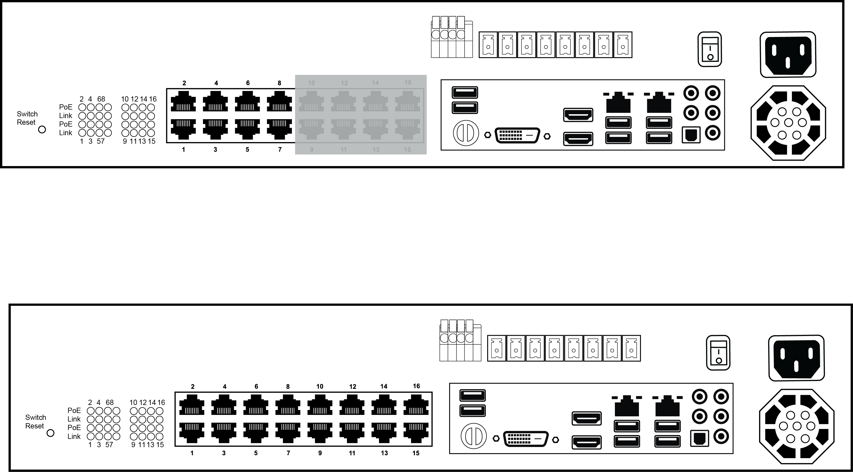
Relay
COM
PoE Switch
Reset
PoE Connectivity
Indicators
PoE IP Camera Ports
Alarm
I/O Block
Power
On/Off
Switch
Power Supply
Client NIC
CameraNIC
Keyboard and
Mouse USB
USB 3.0
HDMI
DVI-I
Audio In/Out

CPX-DT REAR
Relay
COM
Alarm
I/O Block
Client NIC
CameraNIC
USB 3.0
HDMI
DVI-I
Audio In/Out
Power Supply
Power
On/Off
Switch
Keyboard and
Mouse USB

Getting Started

Box Contents
CPX-AP and CPX-04DT web managed network video recorders come with a power cord, keyboard, mouse, and a recovery USB. A Quick Start guide and other necessary documentation are also included. Identify the following components to make sure everything has been properly included with your new recorder. If any of the following items are missing, contact the dealer to arrange a replacement.

 | 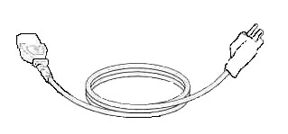
CPX-AP / CPX-DT Recorder | Power Cord
 | 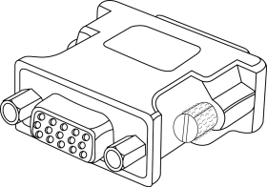
Keyboard and Mouse | DVI-I to VGA adapter
   | 
Recovery Instructions  and Recovery USB | Quick Start Guide

Keyboard Setup
To attach the keyboard, connect the keyboard to a USB port located on the back of the recorder.

Mouse Setup
To attach the mouse to your recorder, connect the mouse to a USB port located on the back of the machine.
In this manual:
Click means to position the mouse cursor over an item and to single click the left button.
Right click means to position the mouse cursor over an item and to single click the right button.
Double-click means to position the mouse cursor over an item and to click the left button twice.
Select means to position the mouse cursor over a radio button, checkbox, or list item and click on it.
The scroll wheel in between the two buttons is used for added navigation functionality. By moving the wheel with index finger (scrolling), quickly move through multiple pages, lines, or windows. The wheel may also function as a third button allowing the user to quickly click or double-click an icon or a selected item.
Right Button
Scroll Button / Third Button
Left Button

Monitor Setup
These connections are available to connect a monitor:

 | HDMI Output | To TV / Digital Display
 | VGA Output (via adapter) | To TV / Analog Monitor
 | DVI-I Output | To TV / Digital Display

Attach the monitor(s) to the rear of the recorder using the cable supplied by the monitor manufacturer. Refer to the monitor manual for detailed information on how to setup and use it.
Note The monitor must be capable of a minimum screen resolution of 1024x768 and support 32 bit color.

Connecting a Camera Using a PoE Port (CPX-AP Only)
The CPX-AP web managed network video recorder is equipped with an on-board Power over Ethernet (PoE) switch for use with PoE IP cameras. PoE cameras are connected to the recorder using the PoE switch and begin displaying video immediately with no manual configuration required.

Connect one end of the CAT 5 Ethernet cable to the RJ-45 connector of the camera and the other end of the cable to the network switch or recorder.
Note If you are connecting the camera directly to a recorder, a crossover cable is necessary for most configurations.
Check the status of the link indicator and activity indicator LEDs. If the LEDs are unlit, check the LAN connection.
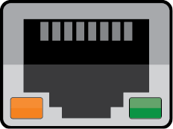
The Orange activity light flashes to indicate network activity.
The Green link light indicates a good network connection.

Setting Up the Recorder for the First Time
- Plug the supplied power cord into the recorder. Do NOT connect the power cord to a power source at this time.
- Connect the network cable intended for remote connection to the Client NIC.
Note The Camera NIC is intended for use with a dedicated camera network.
Note The CPX-04DT recorder does not have Power over Ethernet ports. For these models, use the Camera NIC to connect a camera network.
- Connect the supplied keyboard and mouse using the rear USB ports.
- Connect a monitor using the HDMI or DVI-I ports.
- Connect the cameras to PoE ports, if available.
- Connect the power cord to a power source, and then turn the recorder ON.
- Log in to the ClearPix Server Software recorder using the default credentials:
Username: admin
Password: 1234
- Follow the Setup Wizard to complete basic setup of your system.

Turning On the Recorder
- Turn on the monitor connected to your recorder.
- Use the power switch on the rear of the recorder to turn the recorder On.
- The recorder will run a series of self-tests. If asked to respond to any messages, follow the instructions carefully.

Startup is complete when the ClearPix Server Software is finished loading and displays the main login screen.

Turning Off the Recorder
- Click Setup, and then click Power Off / Restart.
- Click Power Off.

Reimaging Your ClearPix Server Recorder
- Insert the Recover Media USB drive into an available USB port, and then restart the recorder.
- Immediately press the F12 key on the keyboard until the Boot Device Menu appears on the screen.
- Select the UEFI: General UDisk 5.00 option, and then press Enter.
- When the System Recovery window appears, click Continue, and then click Ok.
- In most cases, choose the Conditional Reimage option. It is highly recommended to use the Export / Import tool to retain the system settings and licensing.
- Type the unit serial number found on the back or side of the unit.
- Accept the warning message, and then click Continue.
- Upon successful completion, click Finish, and then remove the USB drive.
Note The Conditional Reimage will erase the Operating System and all Settings on the ClearPix unit, but will retain video data on the drive. The Complete Reimage will completely erase the primary drive, including all settings and stored data.
Note Call Support at 866-932-6316 for more information regarding the re-imaging process.

ClearPix Server Software

Installation and Setup
Note ClearPix Server Software setup can be performed through the ClearPix recorder console or through the web browser Thin Client.

Default Administrator Username / Password
When ClearPix Server Software is launched, you will be prompted to login. The default Administrator username and password are as follows:

Username: admin
Password: 1234
Note Once registered to CWMS, your CWMS credentials can be used to log in, in addition to the default credentials listed above.

Setup WIZARD
The Setup Wizard can be accessed from both the thin client and the local console and will guide you through a basic setup of your ClearPix recorder. This includes establishing a new administrator password, configuring basic network settings, updating date and time settings, enabling ClearManage, and adding your device to ClearPix Web Managed Services.
If you wish to make system changes after the initial setup process using the Setup Wizard, continue further through this manual.

Setup Menu

General Configuration

Camera Management
Use Camera Management to perform basic and advanced camera functions.
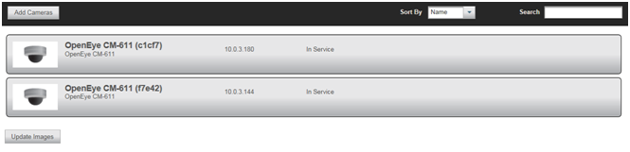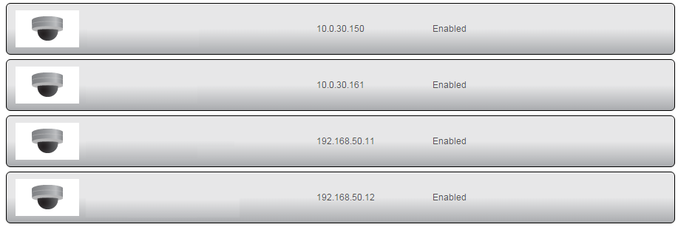
Camera List
Update Image
Add Cameras
CM-811
CM-816
CM-7012
CM-6412
Camera List – List of cameras currently connected to the selected recorder.
IP Address – The current IP address of the camera.
State – The current camera state.
- Enabled: The camera is enabled, active, and recording.
- Disabled: The camera is disabled, but previously recorded video is still available.
Add Camera – Add a camera(s) to the Camera List.
Update Image – Refresh the thumbnail preview image for cameras in the Camera List to reflect the current camera stream.
Sort By – Sort the cameras in the camera list by IP Address, Model, or State.
Search – Search for a camera in the Camera List.

Add Cameras Using Global Credentials
- Click Setup.
- Under the General Configuration tab, click Cameras.
- Click Add Cameras. The add camera menu will appear, and automatically discover ONVIF cameras available on the physically connected network.
- Check the appropriate boxes to select the camera(s) you wish to add.
- Enter the appropriate credentials (username and password) for the cameras you wish to add, and then click Add Selected Cameras.
Note If multiple cameras are selected, the system will attempt to use the same credentials to connect to all selected cameras.

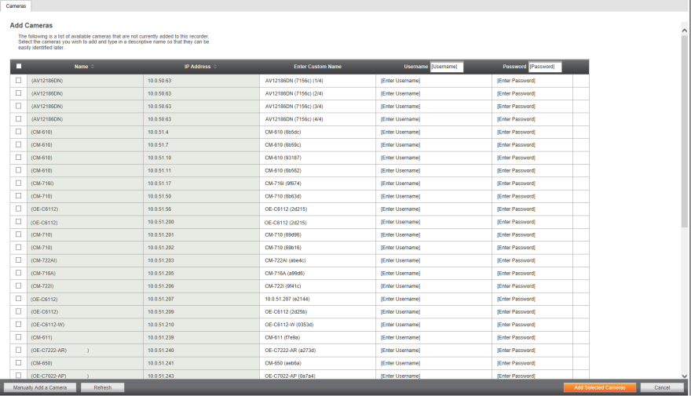
Manually Add a Camera – enter camera information manually to add it to the Camera List.
Refresh – refresh the camera list to reflect changes.
Add Selected Cameras – add the cameras selected from the Add Camera list to the Camera tab.
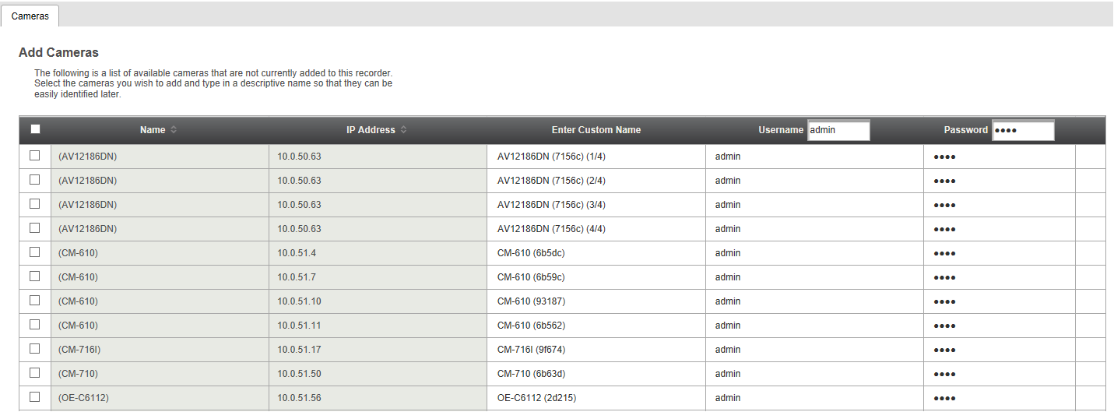
Camera Name – the make and model of the camera.
IP Address – the IP address of the camera.
Enter Custom Name – enter a custom name for the camera to make it more easily identifiable.
Username / Password – the necessary credentials to access the camera.

Camera Auto-Discovery
ClearPix Server Software recorders automatically configure cameras attached to the onboard PoE switch. Cameras not connected to the PoE switch will automatically be discovered, but need to be configured via the Add Camera menu.
Note Automatic configuration (PnP) of cameras attached to the PoE switch can be disabled.
CPX-DT recorders automatically discover cameras, but the cameras need to be configured via the Add Camera menu.
Note If a layer 3 switch isn’t available, the Camera NIC can be configured to be a DHCP server. Or, the IP address of the recorder and associated cameras should be set as static.

Add Cameras Manually
If you do not see the camera you wish to add in the Add Cameras list you may need to add it manually.

- Click Setup.
- Under the General Configuration tab, click Cameras.
- Click Manually Add Camera.
- Enter the appropriate connection information to add the camera.
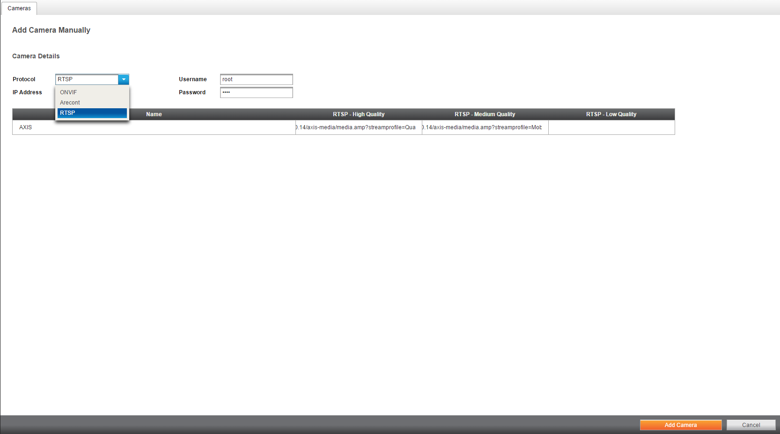

Note Cameras can be added using ONVIF, Arecont or RTSP. If RTSP is selected, the stream URLs need to be input manually. Consult your camera manufacturer’s documentation for URL stream information.
Note Multi-sensor support is available for cameras.
- Click Add Camera.
Note The camera image will not be immediately available. The image will be visible after clicking Apply and the connection to the camera is made.

Edit Cameras
To edit an existing camera in the Camera List:
- Click the desired camera in the Camera List.
- In the camera window, make the desired changes, and then click Update Image to update the camera image.
- Click Apply, and then click Save.
Note Clicking the IP address link in the Camera Information section from the ClearPix Server Software console will connect you directly to the camera firmware.
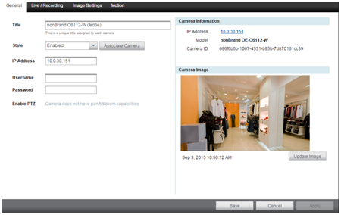

Title – Customizable camera name, seen on the Camera List and in the Live Screen.
Status – Set the camera to Enabled or Disabled.
Associate Camera – Select another camera to transfer camera information to in case of hardware failure or change in camera status. Previously recorded video and sensor events will remain intact.

IP Address – Camera IP address.
Username and Password – Credentials to access camera.
Enable PTZ – Enable PTZ capabilities on a PTZ camera.
Camera Model – Model number of the camera (transmitted from the camera itself).
Update Image – Update the thumbnail image for this camera to the current live view.

Live / Recording
The Live Recording tab displays Recording Options, which determines when and how the camera will record.
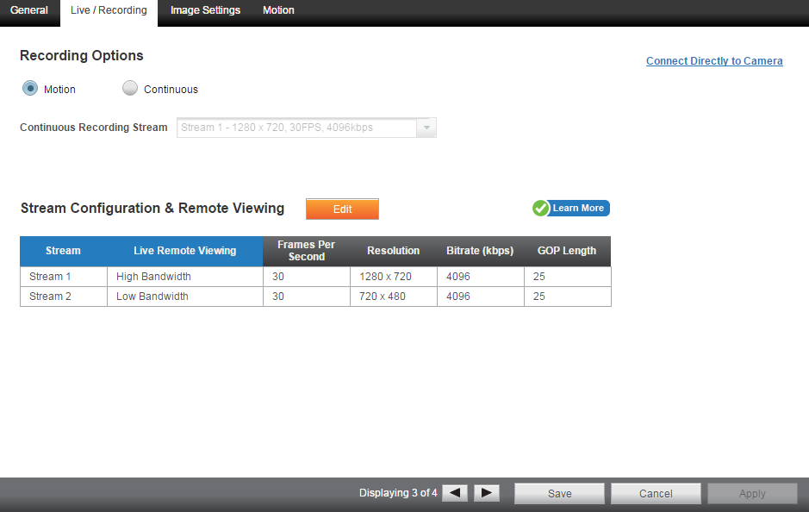
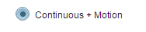

Motion – Record only motion detected by motion thresholds.
Continuous – Record motion continuously.
Continuous + Motion – Record one Continuous stream, and then records a Motion stream in addition when motion is detected. (Professional licenses only).
Motion Recording Stream – Higher resolution and/or frame rate camera video stream used when Continuous + Motion recording option is selected.
Enable Minimum Retention – This forces the recorder to save video for that camera stream for the number of days you specify. If you set it to 30 days and the recorder runs out of room, ClearPix Server Software will not delete data from that camera stream within the 30 day range, and instead delete more data from other streams. This range can be specified for each stream independently.
Stream Configuration & Remote Viewing – This is where you designate what high, medium, and low quality streams are. You can choose one of these as the recording stream, and the system automatically chooses the highest res stream under 720x576 (D1) to use for motion detection. These streams are also used as high, medium, and low quality streams in the live view.
Note If at least one resolution at 720x576 or below is not available, the following warning will appear.

Image Settings
The Image Settings tab displays Picture Adjustment Settings and Exposure Settings. These settings have a direct correlation to the camera performance and recorded video quality. The settings displayed here are options made available through the appropriate ONVIF drivers. Making changes to these settings will then push the changes to the camera.
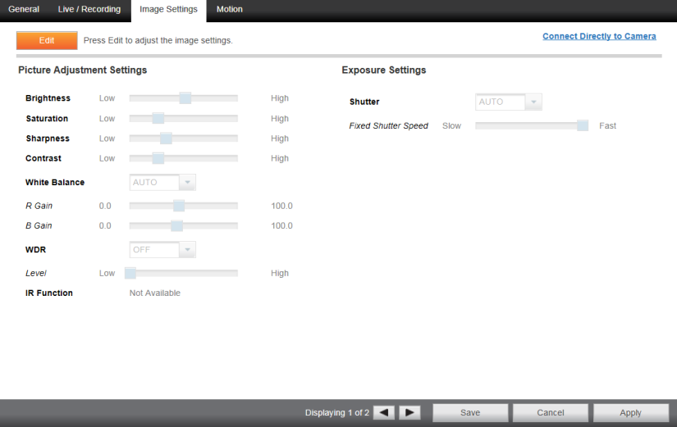

Brightness – depth of light and shadow in the image*
Saturation – depth of color in the image*
Sharpness – manage image texture, particularly visible in dark scenes*
Contrast – difference between bright and dark areas of the image*
White Balance – preset colors corresponding to natural or artificial lighting for the most accurate color representation
Wide Dynamic Range – enhances details both in the foreground and background**
IR Function – activate the camera IR (infrared) lights if available, for use with night-time recording
Shutter – designate shutter speed. Longer shutter speed will increase visibility at night, but also result in blurred movement in the frame**

* This option can drastically affect the quality of recorded video. The default value is recommended.
**Using this option results in improved video quality but increases recorded video file size.

Motion
To configure Motion:
- Click the desired camera in the Camera List.
- Click the Motion tab.
- Click Add Motion Area, and then click and drag the capture square to create the area.
Note By default, the entire camera will be configured as a motion area.
- Continue modifying Motion Areas as desired.
Note Motion Areas can be subtracted to disable motion detection for specific areas of the video stream.
- Click Save.
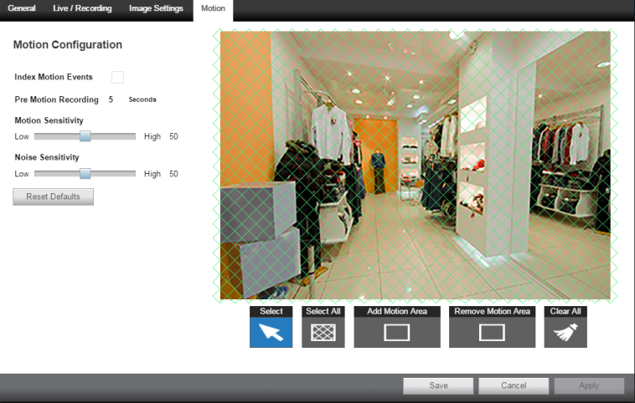

To delete a Motion Area:
- Click to select the desired Motion Area.
- Press the Delete key on the keyboard.

Advanced Camera Management
Cameras set to static IP addresses, third party cameras, and cameras not supported by ONVIF may not be detected automatically. To configure cameras not automatically detected by ClearPix Server Software, follow the steps below.

Configuring Cameras with a Static IP Address
- Click Setup, and then click Support Tools.
- Click Launch Support Tools.
- Click Network Camera Manager.
- Note the discovered IP address for the desired camera.
- Click Exit to return to ClearPix Server Software.
- Follow the steps in the Adding Cameras Manually section, typing the Static IP Address.

Configuring Cameras with DHCP
- Click Setup, and then click Support Tools.
- Click Launch Support Tools.
- Click Network Camera Manager.
- Select your desired cameras, and DHCP, and then click Apply.
- Click Exit to return to ClearPix Server software.
- Follow the steps in the Adding Auto-Detected Cameras section to add the camera.
Note Once your camera is set to DHCP, your ClearPix recorder will detect the camera within 60 seconds.

Adding Third Party Cameras
Third party cameras may require installing a manufacturer camera discovery tool on a separate PC. Once the camera discovery tool is installed, follow the steps for adding a camera with a static IP address or using DHCP as outlined above.

Adding Cameras Not Supported by ONVIF
Single and multi-sensor cameras that are not ONVIF compliant must be added using the RTSP stream(s) of the camera. Consult the camera manual for more detailed information regarding RTSP streams. When you know the URL for the RTSP stream(s) of your camera, follow the steps in the Adding Cameras Manually section, selecting RTSP protocol.

System Settings

General Settings

Time Settings
Use the Time Settings section to make changes to the time zone, NTP server, or the time on the recorder. A Time Zone is required whether or not an NTP server is selected.
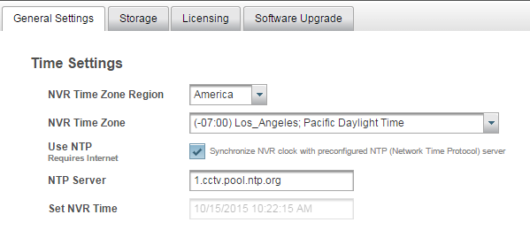

Network Time Protocol is a protocol used to synchorinize time across a range of computers or recorders to within miliseconds of each other. All recorders shoud poit to the same NTP server to achieve this synchonicity.

To enable use of a Network Time Protocol (NTP) Server:
- Click Setup, and then click the Global Configuration tab.
- Click System Settings.
- In the General Settings tab, check the Use NTP checkbox.
- Enter the URL of the NTP Server.
- Click Save.

Import/Export Configuration
This function exports most configuration options on the recorder to a file. This file can then be imported as needed to restore the configuration options to the saved state. The ClearPix Web Managed Services account information is not exported and will therefore need to be manually configured upon import.

To export recorder configuration settings:
- Click Setup, and then click the Global Configurations tab.
- Click System Settings, and then click Export.
- When prompted, Save the exported configuration file.
Note In the CWMS Web Client, the default location to save the .zip archive file is in the Downloads folder.
To import recorder configuration settings:
- Click Setup, and then click the System Settings tab.
- Click Import, and then click Select Import File.
- Navigate to the desired file.
- Click Import.
Note Imports / exports can be performed on both the local console and the Thin Client. Console exports will require an attached USB storage device.

Remote Assist Session
The Remote Assist Session enables a ClearPix Technical Support agent to remotely control your recorder, allowing them to assist you with troubleshooting your system.
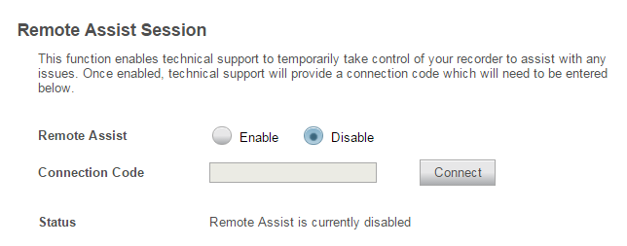

- Contact Technical Support by visiting 866-932-6316.
- Once you are connected with a Support agent, click Enable, and then enter the Connection Code give to you by the Support agent.
Note When a Remote Assist Session is enabled and the session code is entered, the Support agent will have full remote access to your recorder.
- Click Connect.

Export Signing Certificate
Videos and images exported from ClearPix Server Software have an embedded digital signature. This is used to validate that these items have not been tampered with.

To validate the files have not been tampered with, you will need the following:
- The image or video file you wish to validate
- The Digital Signature Verifier (DSV)
- The Certificate Thumbprint from the ClearPix recorder
Note The DSV is a small utility that allows you to validate that the file has not been tampered with. This utility can be downloaded from the ClearPix Web Managed Services site.
Note The thumbprint is a value derived from the certificate that uniquely identifies it; specifically it is a SHA-1 hash of the certificate
The DSV utility will attempt to verify the exported file, and then present one of two findings:
- Digital Signature Validated: the thumbnail for the ClearPix recorder will match the thumbnail displayed for the validated file.
- Digital Signature Invalid: this indicates that the file does not contain a valid certificate.

Storage
The Storage tab displays all partitions available for recording.
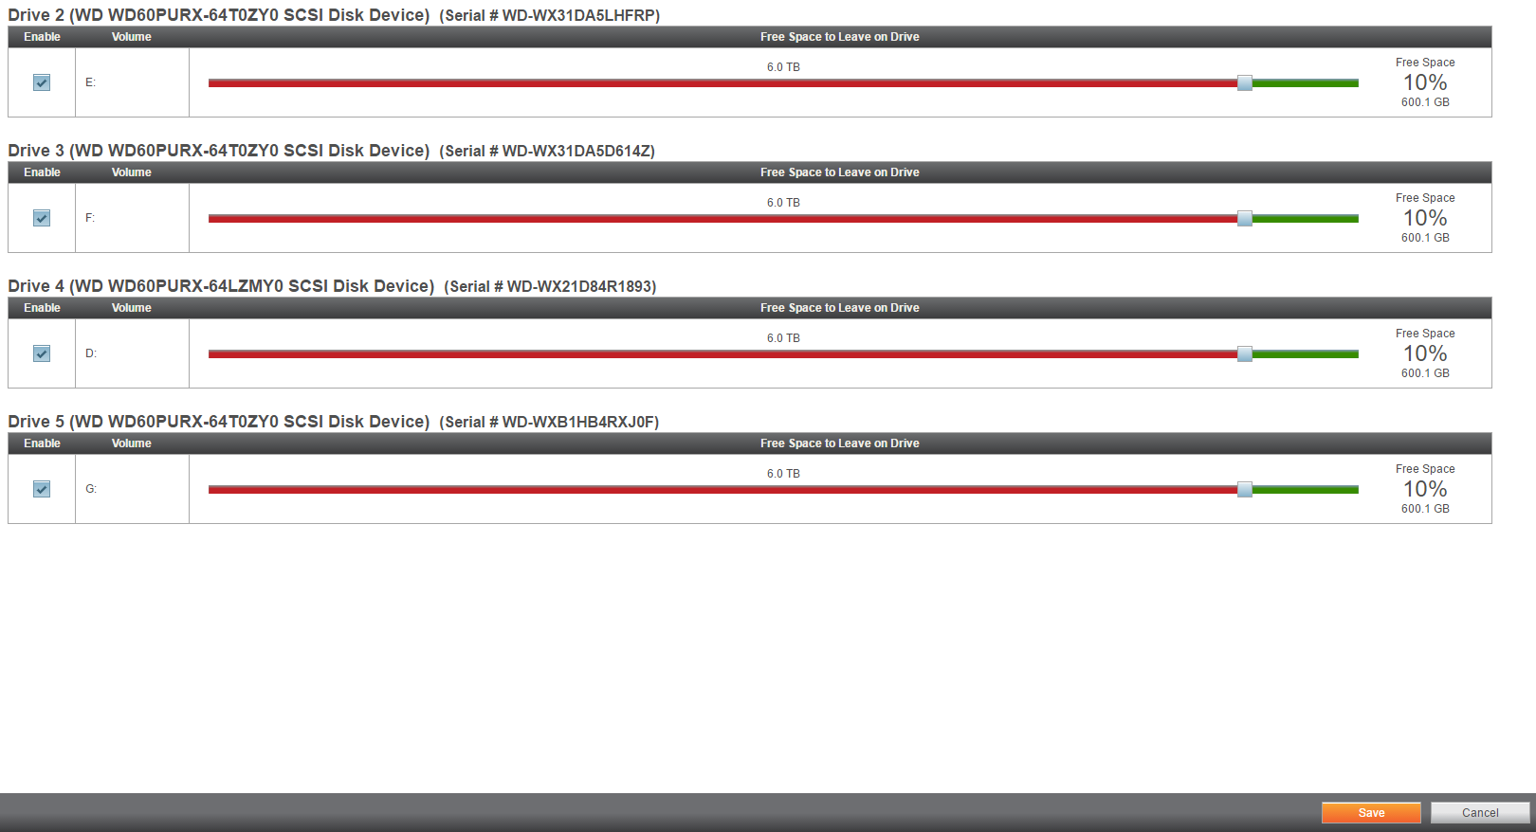

Adjusting Storage Space
- Click Setup, and then click the General Configuration tab.
- Click System Settings, and then click Storage.
- Use the Free Space to Leave on Drive slide-bar to adjust the amount of free space left on the Drive.
- Click Save.

Disable Recording
- Click Setup, and then click the General Configuration tab.
- Click System Settings, and then click Storage.
- Uncheck the Enable checkbox to disable the Drive.
- Click Save.

Licensing
Note Your ClearPix Server Software will be preregistered from the factory. The following instructions are needed if a new or upgraded license is necessary.
- Please contact ClearPix for the unlock code.
- Click Setup, and then click the General Configuration tab.
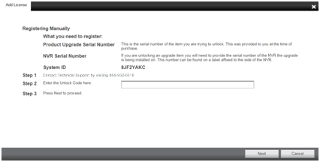
- Click System Settings, and then click Licensing.
- Enter the Unlock Code, and then click Next.

Software Update
By default, ClearPix Server Software will allow you to download and install updates direct from ClearPix Web Managed Services. Updates can also be performed manually via selected files or custom URLs.

Update via CWS
- Click Setup, and then click System Settings.
- Click Software Upgrade.
- Click Install.
Note This option is not available if there is no current software update.

Update via Manually Selected File (Linux only)
- Click Setup, and then click System Settings.
- Click Software Upgrade.
- Click Show More Options.
- Click Select File then navigate to the location of the .ssp upgrade file.
- Click Install.
Note Do not leave this page until the update is complete

Update via Custom URL
- Click Setup, and then click System Settings.
- Click Software Upgrade.
- Click Show More Options.
- Click Specify URL.
- Specify the URL where the upgrade file is located.
- Click Install.

Network Configuration

Adapters (Linux only)
This tab displays the Client NIC and Camera NIC available on CPX-AP and CPX-DT recorders.

To make changes to a NIC:
- Click Setup, and then click the General Configuration tab.
- Click Network Configuration, and then click the Adapters tab.
- Click the desired NIC and make any necessary changes.
Note The Client NIC must be set to static to manually choose an IP address.
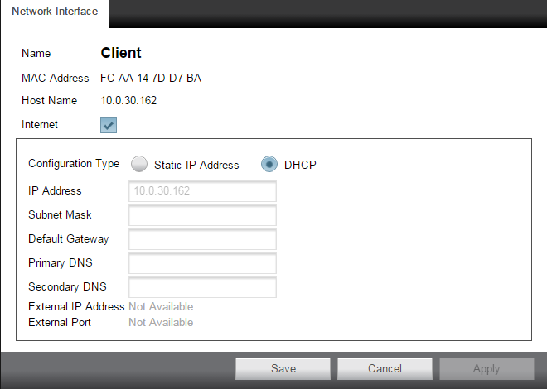

I SHIT ON EGGS

Settings
The Settings tab displays the status of network connections, allows for the manual ping of an IP address, and allows the camera NIC DHCP server to be enabled or disabled.

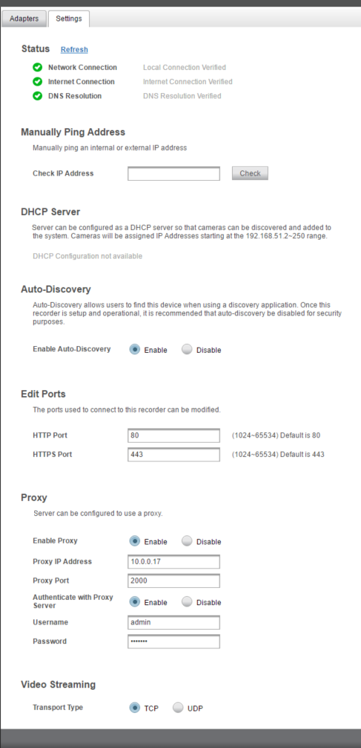
Edit Ports
The ports used to connect to the recorder can be modified.

Proxy
The proxy can be enabled or disabled.

To enable a proxy server:
- On the CWMS console or in the Thin Client, click Setup.
- For the CWMS Full Client, right-click the connected recorder and select Configure.
- Click Network Configuration in the menu, and then click the Settings tab.
- At the bottom of the page, click Enable in the Proxy section.
- Enter the Proxy Address and Port Number used by your network proxy server.
- Enable authentication and enter the Username and Password required to authenticate your network proxy server.

Video Streaming
Designate the video streaming transport type for global IP network traffic: TPC or UDP

Plug And Play
Plug And Play (PnP) allows you to disable automatic add and record for PoE cameras, as well as power cycle individual ports, which will reset the connected camera.
Note Plug And Play is only available on CPX-AP recorders.
To disable Plug and Play:
- Click Setup, and then click the General Configuration tab.
- Click Network Configuration, and then click the Plug And Play tab.
- Uncheck the Enable Plug and Play checkbox.
—OR—
Uncheck the Enable PnP checkbox for the desired camera.

To power cycle the PoE camera:
- Click the Power Cycle icon in the row for the desired PoE camera.

User Management
It is strongly recommended that you manage users through ClearPix Web Managed Services rather than on the local recorder. If the device is CWMS enabled, you will need to log in to CWMS User Management to manage users who have access to the recorder. Users added this way will have a ClearPix Web Managed Services account.
Note It is strongly recommended that you manage users through CWMS rather than on the local recorder.

User Roles
The default User Roles includes Administrator, Controller, Live, and Operator. Custom rolls can also be created.
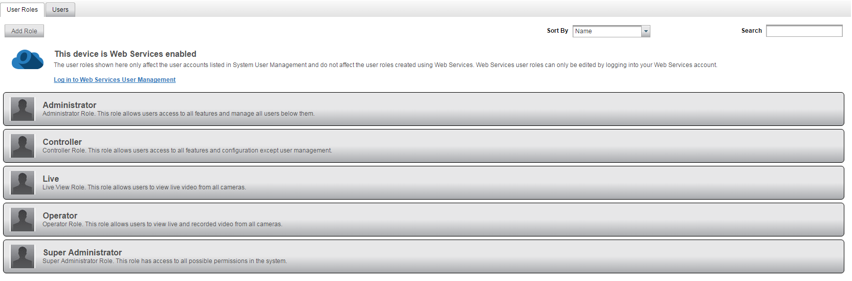

Add New Custom Role
Custom roles are user roles that have custom selected assigned permissions.
- Click Setup, and then click the General Configuration tab.
- Click User Role Management.
- Click Add Role.
- Type the role Name and Description, and then use the Assigned Permissions list to check the appropriate permission boxes.
- Click Save.

Edit Existing Role
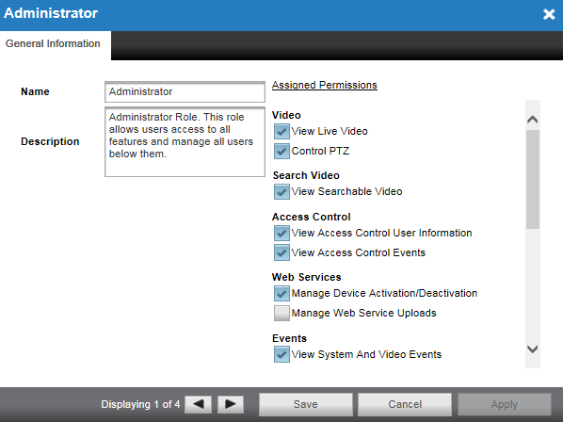
- Click Setup, and then click the General Configuration tab.
- Click User Role Management.
- Click on the existing role you wish to edit.
- Edit the Name, Description, and Assigned Permissions list as necessary.
- Click Apply, and then click Save.

Add System User
Note Adding a System User will create a user on the recorder. Users added this way will NOT have a ClearPix Web Managed Services account.
- Click Setup, and then click the General Configuration tab.
- Click User Management, and then click the Users tab.
- Click Add System User.
- Enter the appropriate user information, and then designate a Username and Password.
- Check the appropriate box to designate a user Role.
Note More than one user role can be selected.
- Click Save.

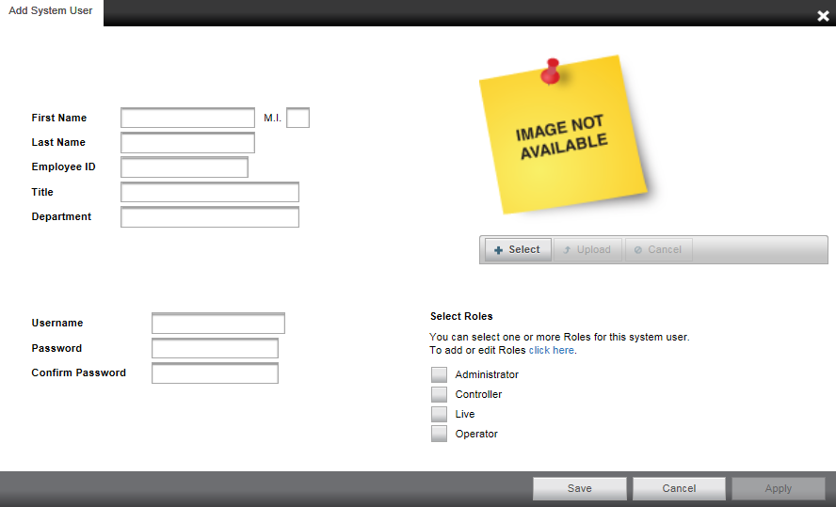

Adding User Image
- Click Select, chose a file, and then click Open.
- Once the file is listed under the user image, click Upload.
- Click Save to save your changes.

Remote Services

ClearPix Web Managed Services Account
ClearPix Web Managed Services is a cloud based service that enables you to turn your independent recorder and VMS installations into a cohesive platform, with online user and recorder management features.
To begin using CWMS, you will need to create an CWMS account, and add individual companies to associate with customers.
- Call ClearPix to request an account.
Note Account approval may take 1 to 2 business days.
- Once your account is approved, log in at https://clearpix.gp4f.com.
- Click Add Company.
- Type the Company Name for your customer, and then associate that customer with the appropriate Reseller account.
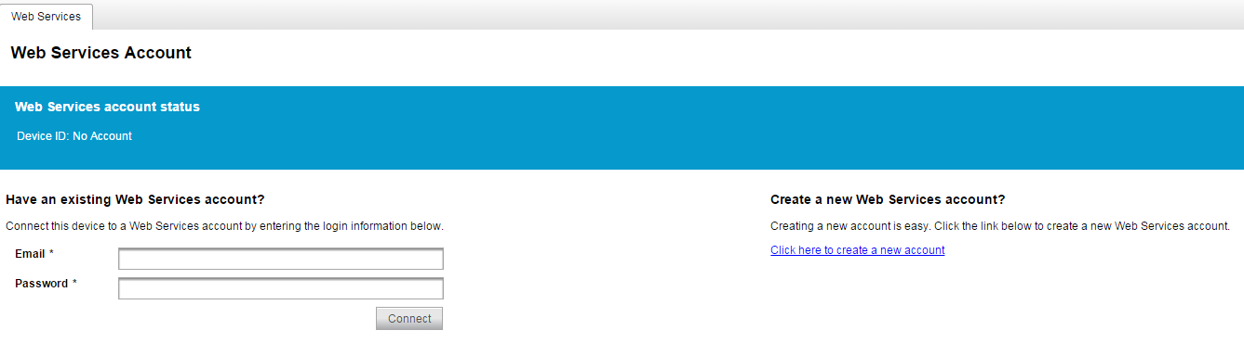

To enable ClearPix Web Managed Services on your recorder, follow the instructions below:
- Click Setup, and then click the Remote Services tab.
- Click ClearPix Web Managed Services.
- Enter your CWMS credentials, and then click Connect.

ClearManage
- Click Setup, and then click the Remote Services tab.
- Check the Use ClearManage checkbox.
- Designate the Send Report Time, Day Image Time, and Night Image Time.
- Click Save.

Tools / Logs

Power On / Restart
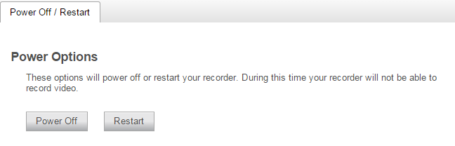

Note Recorders can be powered off from the local interface; however, the recorder can only be restarted from the thin client.

Support Tools
Support tools are a set of utilities that allows you to complete the following setup or diagnostic tasks:

Resource Monitor – Diagnoses system resources issues by monitoring memory and processor usage.
Network Diagnostics – Diagnoses connectivity and network issues by monitoring, recording, and analyzing network traffic.
Video Streaming – Manually connect to video streams to diagnose camera connectivity issues.
Web Browser– Connect to and configure camera firmware, routers, and switches.
Disk Management – Monitor hard drive partitions on the recorder.
Network Camera Manager – Configure network settings for cameras on the Local Area Network or attached to the recorder.

Advanced Network Management

LAN Smart Forwarding
To optimize local connections, CWMS utilizes a feature called LAN Smart Forward (LSF). This feature detects if the client machine is behind the same external IP address as the recorder, automatically switching from a cloud relay connection to a direct connection. This ensures that the fastest connection is being used, even if the recorder is initially accessed through the internet. The following conditions are required for LAN Smart Forwarding:
- Both client and recorder use the same external IP address, or IP addresses within an acceptable range.
- The Client NIC port must be used for the Internet connection.

To Enable LAN Smart Forwarding:
- Use a web browser to log in to your CWMS account, and then click on your desired Company Account.
- Click My Recorders, and then click Edit in the row of the desired recorder.
- Click the Remote Network Settings tab.
- Set LAN Smart Forwarding to On.
Note If your recorder and client machines have different external IP addresses, enter the IP range in which the client and recorder reside.

Direct Connection via Port Forwarding
With port forwarding, traffic bypasses the CWMS cloud relay services, allowing for optimal connection speeds. Additional setup is required, however, because the routers need to be configured to forward traffic to the correct recorder.
Note Visit https://portforward.com/router.htm for instructions on how to open ports on your particular router.
- Complete the CWMS cloud relay as instructed above in the Register ClearPix Server Software to Your ClearPix Web Managed Services Account.
- Access the router used for internet communication and forward TCP port 80 to the internal address of the ClearPix Server Software recorder.
- From CWMS, click My Recorders, and then click Edit in the row of the desired recorder.
- Click Remote Network Settings, and then enter the external IP or DNS entry for the router in the IP Address or Domain field, and 80 in the Port field.
Note Port 80 is the default port; if port 80 is blocked, use port 8888.
- Click Save.
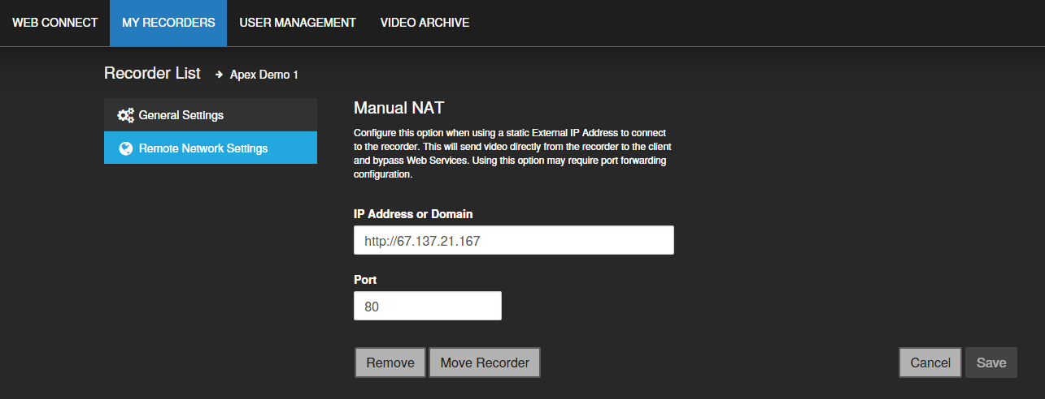

Live Screen Viewing Pane
The Live screen displays the camera list and live video. Customize the Live screen to view specific cameras in different layouts.
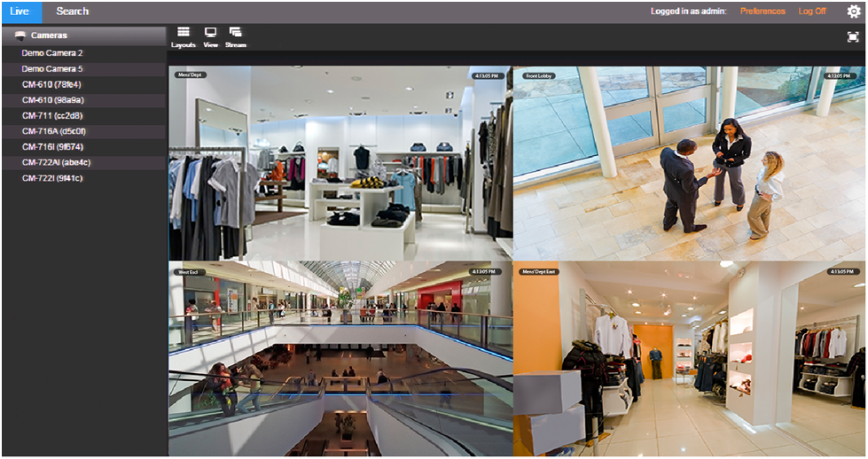
Viewing Pane
Navigation
Bar
Camera Tile
Full Screen
Grid
Stream
View
Camera
List
Search
Camera List – List of connected cameras, these cameras can be dragged into a camera tile to display live video.
Note The recorder console Live Screen does not display the Camera List.
On-Screen Display – Displays the resolution, video format, bit rate, and frame rate of the camera.
Camera Tile – Individual tile for viewing live video from one camera.
Viewing Pane – Comprised of camera tiles and makes up the viewing space in the Live Screen
Layout – Designate a screen division (1, 4, 9, or 16) to view live video from cameras in the viewing pane.
View – Drop down selection of Live video viewing options (4:3, 16:9, original (displays original aspect ratio of all cameras), and stretch (stretches camera images to fit Camera Tile).
Stream – Designate the stream quality for cameras in the Viewing Pane.
Full Screen – View live video in full screen mode.

Navigation Bar
Preferences
Settings
Log Off
Live Screen
Search Screen
Current User

Right-Click Menu
Right-clicking on a live camera tile while viewing live or recorded video will display the right-click options menu.

OSD – On-Screen Display (resolution, video format, bit rate, and frame rate).
Remove Camera – Remove the camera from the current Live Screen viewing pane.

How Do I Add / Remove Cameras from the Live Screen Display?

Add Camera
Click and drag a camera from the Camera List to the Viewing Pane to create a Camera Tile.
Note Change the Live screen layout if more camera channels are desired.
—OR—
Click the desired camera on the Camera List to automatically add it to the Viewing Pane in an available camera tile. Each subsequent camera clicked will be added to the next available camera tile.
—OR—
Drag one camera tile over in the Viewing Pane to swap their locations.

Remove Camera
Right-click in the desired camera tile to display the right-click menu, and then click Remove.
—OR—
Move the mouse to the top of the camera tile to display the tile toolbar, and then click the red ‘X.’

How do I Adjust the Layout of Camera Tiles in the Viewing Pane?
The Live screen display can be adjusted to show live video for 1, 4, 9, or 16 camera tiles.

- In the Live screen, click Layouts.
- Click on the desired screen layout. The layout will automatically apply.
- Adjust the camera tiles to display the desired cameras.

How do I Adjust the Live Screen View?
The Live screen view affects the camera tiles and the aspect ratio / format of the live video being displayed.

- In the Live screen, click View.
- Click the desired view. The Live Screen view will automatically apply.
Note Choose from aspect ratios of 4:3 or 16:9, and choose a format of Stretch or Original.

How do I Adjust the Live Video Stream Quality?
The Stream Quality option affects the resolution of live video as seen on the Live Screen. The stream resolution can be set to low, medium, high, or automatic.

- In the Live screen, click Stream.
- Click the desired streaming resolution (Low, Medium, or High). The Live Screen will automatically adjust.
Note The available streaming resolutions are dependent on camera setup.

How Do I Turn the OSD On / OFF?
The On-Screen Display (OSD) shows the video resolution, video format, bitrate, and frames per second on top of the live video feed. The OSD can be turned on / off per-camera or for all cameras.

Toggle OSD for All Viewing Panes
Right-click on any viewing pane to display the right-click menu, and then click OSD.

Toggle OSD Per-Camera
Move the mouse to the top of the desired viewing pane to display the pane toolbar, and then click OSD.

Digital Zoom
Digital zoom can be used in the Live screen or the Search screen.
Note Digital Zoom is currently only supported in the Apex Thin Client.
- Click to select the desired Camera Tile.
- Use the scroll wheel on your mouse to scroll up, zooming in.
- Scroll down to zoom back out, or use the Right-Click Menu to Reset Zoom per camera tile or Reset All Zoom.
Note Layouts will save Digital Zoom settings.

Performing a Search
Perform a Timeline Search or a Thumbnail Search to review recorded video, including playback and export of images and video clips.

Three different searches are available in ClearPix Server Software:
- Date/Time Search – standard search feature available only through the local recorder (ClearPix Console).
- Timeline Search and Thumbnail Search– advanced methods only available through the CWMS Web Client.

How Do I Perform a Date / Time Search Via a Recorder? (ClearPix Console)

Date / Time Search Bar Playback Controls
Skip Forward
Skip Backward
Pause / Stop
Play Forward
Play Backward
Playback Speed
Export
Date / Time Picker

Add Camera(s) to the Date / Time Search Viewing Pane
When the Search Screen is opened, the cameras that were in the Viewing Pane in the Live Screen will appear, however, cameras can be arranged separately in the Search Screen to facilitate the desired search.
To add cameras to the Search Screen:
In the Search Screen, click a camera in the Camera List.
—OR—
Click and drag a camera from the camera list to the Viewing Pane.

Customize the Camera Tile Layout
Changing the layout of the viewing pane allows for viewing multiple cameras. All cameras will begin playback of recorded video at the time designated on the horizontal Timeline Search Bar.

- Click the Layouts button.
- Click on the desired layout.
- Assign the available cameras to the desired camera tiles.

Perform a Date / Time Search
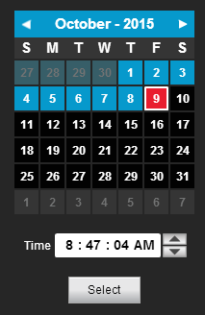
- Customize the camera tile layout in the Search Screen Viewing Pane if desired.
- In the Search Screen, click the Date / Time Picker.
- Select a date from the calendar, and then designate a time if desired.
- Click Select.

How do I Perform a Timeline Search? (Thin Client Only)
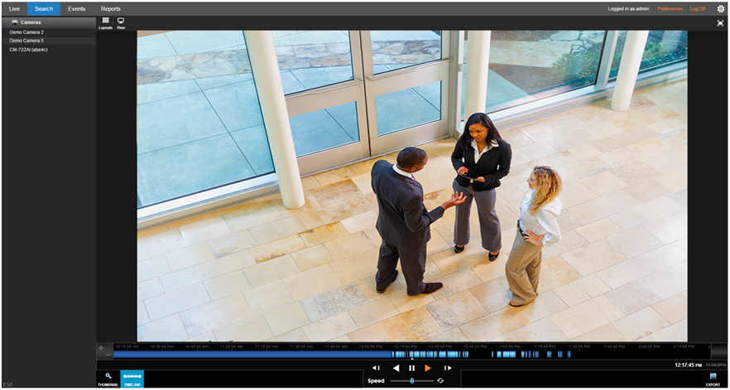
Grid
View
Full Screen
Timeline Search Bar
Thumbnail Search
Timeline Search
Camera
List

Timeline Search Bar Playback Controls
Timeline
Time Picker
Skip Forward
Time
Thumbnail
Search
Timeline
Search
Playback Speed
Date Picker
Skip Backward
Pause / Stop
Play Forward
Play Backward
Export
Note This Example Timeline Search bar shows recorded video that is based on Continuous + Motion recording, meaning video is recorded on a low-resolution stream continuously, and then recorded on a higher resolution stream when a motion event is triggered.
Timeline – Continuous recording is represented by dark blue coloration in the Timeline lines on the Timeline Search bar, with light blue lines on the Timeline Search bar representing Motion events.
Note Motion events trigger intensive recording; light blue lines on the Timeline Search bar also indicate intensive recording.
Skip Backward – Move to the previous frame of recorded video.
Play Backward – Play recorded video backward.
Pause / Stop – Pause / Stop video playback.
Play Forward – Play recorded video forward.
Skip Forward – Move to the next frame of recorded video.
Playback Speed – Control the speed of video playback.
Timeline Previewer – hovering over the timeline will show a preview of the recorded video.
Export – Export recorded video as seen in the current search playback.
Date and Time Picker – Use to designate a date and time to search recorded video.

Add Camera(s) to the Timeline Search Viewing Pane
When the Search Screen is opened, the cameras that were in the Viewing Pane in the Live Screen will appear, however, cameras can be arranged separately in the Search Screen to facilitate the desired search.
To add cameras to the Search Screen:
In the Search Screen, click a camera in the Camera List.
—OR—
Click and drag a camera from the camera list to the Viewing Pane.

Customize the Camera Tile Layout
Changing the layout of the viewing pane allows for viewing multiple cameras. All cameras will begin playback of recorded video at the time designated on the horizontal Timeline Search Bar.

- Click the Layouts button.
- Click on the desired layout.
- Assign the available cameras to the desired camera tiles.

Perform a Timeline Search
- Customize the camera tile layout in the Search Screen Viewing Pane if desired.
- Select a Date (and time) from the Timeline Search Date Picker.
- On the Thumbnail Search Bar, click the Timeline Search Date Picker.
- Select the desired Date (and specific time), and then the timeline will update automatically.
- Use the Play/Pause, Stop, Play Forward/Backward, and Skip Forward/Backward playback controls to control video playback during your search.

How do I Perform a Thumbnail Search (Thin Client Only)
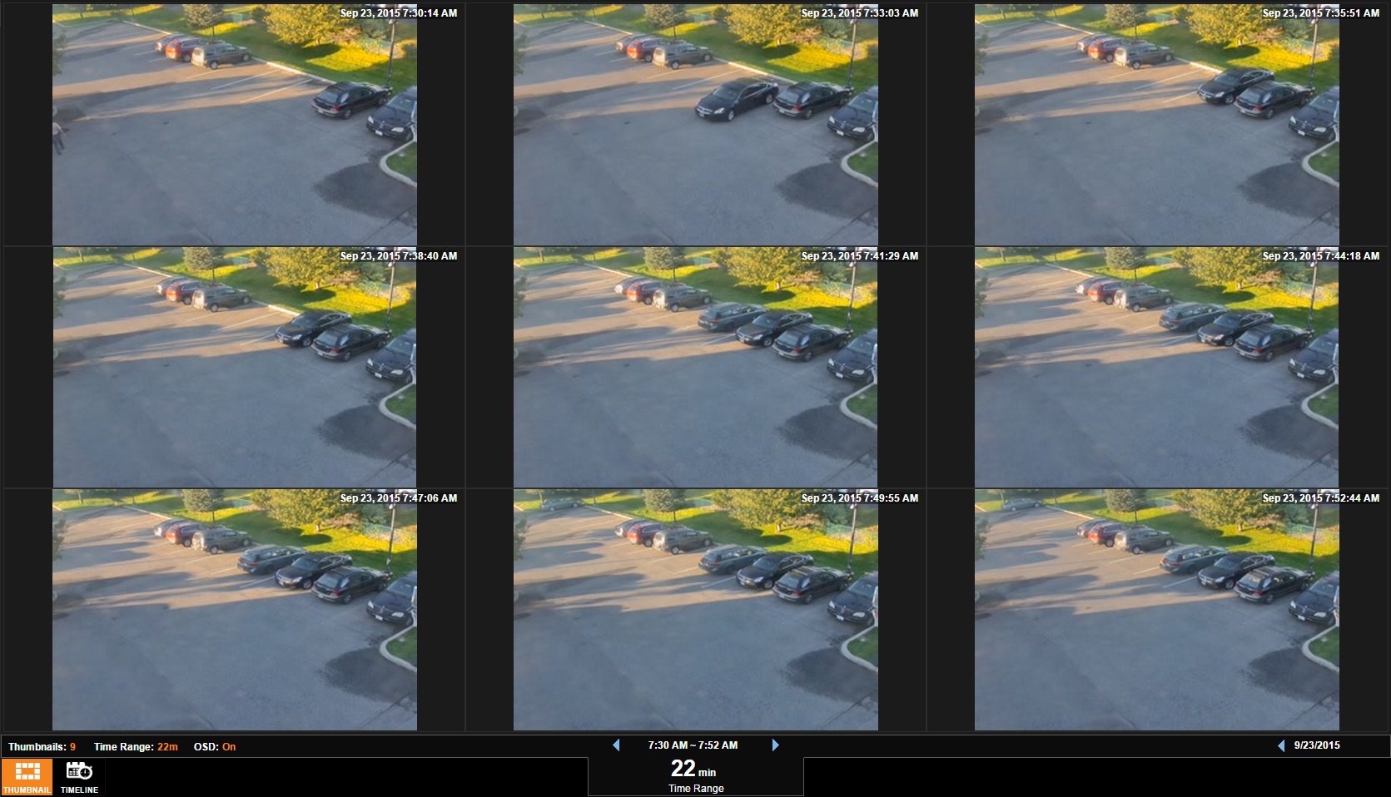
Timeline Search Bar
Thumbnail Search
Timeline Search

Thumbnail Search Bar Playback Controls
The Thumbnail Search bar displays the number of thumbnails displayed in the Viewing Pane, the Time Range interval between the first and last thumbnail, and the overall Video Interval.
Number of Thumbnails
On-Screen
Display Toggle
Time Range
Thumbnail Search Date Picker

Number of Thumbnails – Number of thumbnails distributed across the Time Range.
Time Range – Time interval between the first and last thumbnail.
Video Interval – Display of the exact start and end time for the designated interval.
On-Screen Display Toggle – Toggle the on-screen display on or off during search.
Thumbnail Search Date Picker – Calendar display tool for choosing Thumbnail Search Dates.

Perform a Thumbnail Search
- Select a camera from the Camera List.
Note Thumbnail searches allows for only one camera displayed at a time.
- Select a Date from the Thumbnail Search Date Picker.
- On the Thumbnail Search Bar, click the Thumbnail Search Date Picker.
- Select the desired Date, and then the thumbnails will update automatically.
- Select the Number of Thumbnails, the Time Range, and turn the OSD On / Off as desired.

Your combination of thumbnail quantity and time range will determine the time interval between each snapshot displayed. For example, 25 thumbnails in a 24 hour time range will result in 1 hour time intervals between displayed pictures.

- Left-click on the desired thumbnail to narrow the time interval, opening new thumbnails.
Note When the thumbnail is narrowed to the smallest time interval, left-clicking again will begin recorded video playback in the Timeline Search Screen.
- Right-click the desired thumbnail to expand the time interval, opening new thumbnails.

How Do I Export From Search?
Note Exports during Search are only available from the Timeline Search Screen. Thumbnail Searches must be narrowed to the Timeline Search Screen before an export is possible.
During a Timeline Search, you have the option to export an image or a video clip.
Resulting image files can be saved locally.
Resulting video files can be saved locally OR remotely to your ClearPix Web Managed Services account where they can be viewed and managed remotely.

Export Image Locally
- In the Search Screen, perform the desired Timeline Search.
- Click Export.
- In the Image tab, click Save Locally.
Note Locally exported images are saved in the Downloads folder as JPEG files.

Export Video Clip Locally
- In the Search Screen, perform the desired Timeline Search.
- Right-click and select Export.
- In the Video Clip tab, designate the Length of Clip and Video Quality.
Note Larger Length of Clip and higher Video Quality will result in larger video files.
- Click Save Locally.
Note Locally exported video clips are saved in the Downloads folder by default as AVI files.
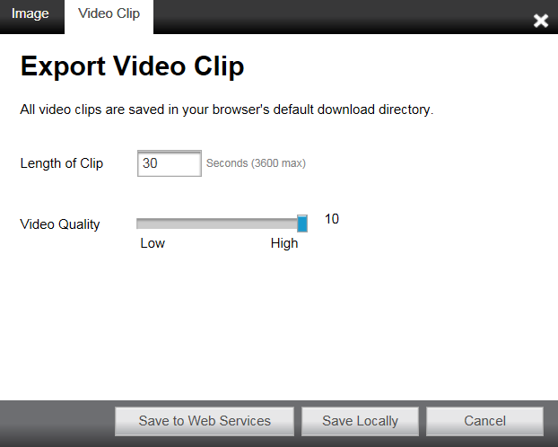

Export Video Clip to Cloud Video Archive
Exporting a video clip remotely saves the clip in your ClearPix Web Managed Services account. For more information regarding viewing exported video clips, see the Viewing Exported Video Clips in ClearPix Web Managed Services section.
- In the Search Screen, perform the desired Timeline Search.
- Right-click and select Export.
- In the Video Clip tab, designate the Length of Clip and Video Quality.

Note Larger Length of Clip and higher Video Quality will result in larger video files.
- Type the desired Clip Information.
- Click Export.
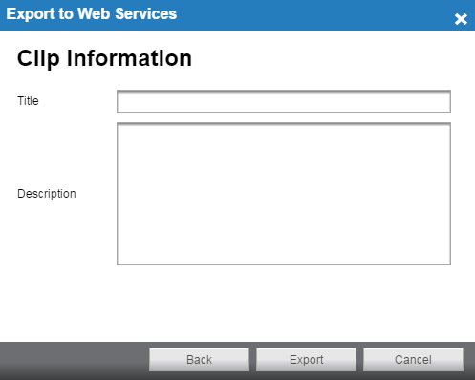

How Do I View Exported Video Clips in ClearPix Web Managed Services?
CWMS allows you to view video clips exported during a search. These clips are stored in the Video Archive and can be watched, shared, and downloaded.
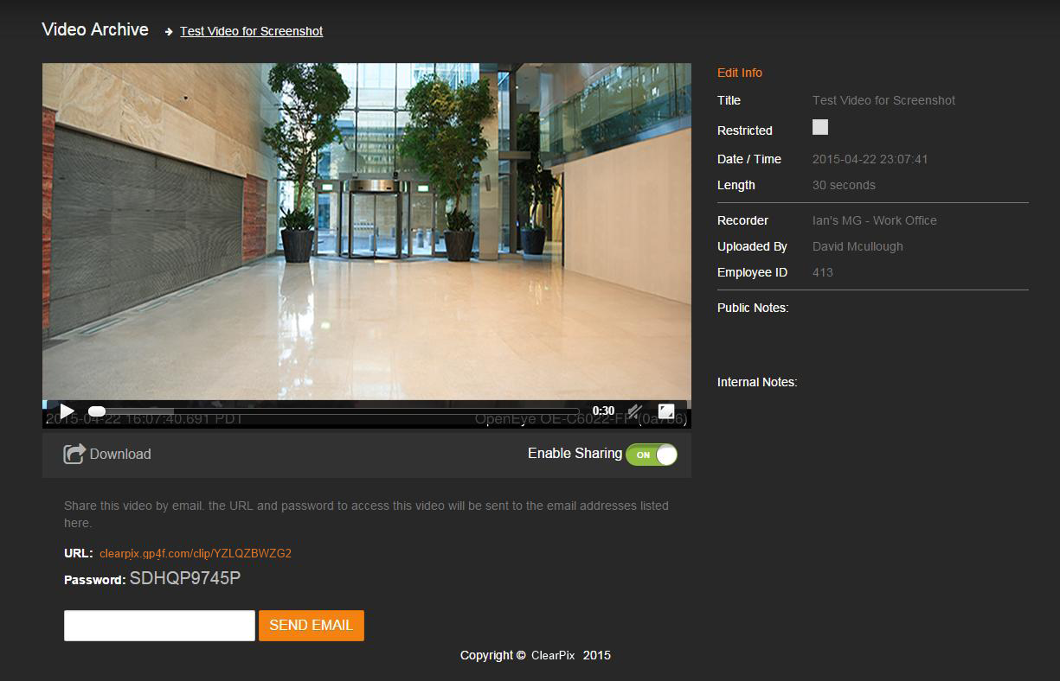

- Navigate to http://clearpix.gp4f.com and login.
- Click Video Archive.
- Select the desired video clip, and then click the Play icon.
Note If desired, Share the video clip. A URL will be provided with an access password which can then be distributed to others.
Note If desired, download the video clip to your default download location.

Recorder Specifications
Recorder Model | CPX-08AP |  | CPX-16AP | CPX-04DT
Camera Channels | 8 | 16 |  | 4/8/16/24
PoE Ports | 8 | 16 |  | Non-PoE*
Switch Load | 175W (Max 30W per port) |  |  | N/A
Max IPS per Channel | 30IPS (dependent on IP camera settings)
Recording Resolutions | Up to 10MP (dependent on IP camera settings)
Recording Rate | 200Mbps
Live Display Rate | Up to 16 channels real time (dependent on IP camera settings) |  |  |  | Up to 24 channels (dependent on IP camera settings)
Audio Channels | Up to 16; requires external device or network video device support*
Audio Outputs | Line Out
Video Outputs | 2 x HDMI / 1 x DVI-I, maximum one monitor support
Alarm Sensor Inputs | 4 x Form A contacts, support network relay contracts via ONVIF standard
Digital Relay Outputs | 4 x Form A contacts, support network relay contracts via ONVIF standard
NIC Ports | 2 x LAN connections (10/100/1000Mbit)
USB Ports | Front: 2 x USB 3.0 ports / Rear: 4 x USB 3.0 and 2 x USB 2. 0 ports
Video Signal Loss Detection | Yes
Motion Detection | Server side only (adjustable sensitivity, custom grid)
Remote Operation | Complete remote operation (Live view, Search, Setup, Updates)
Remote Software | Desktop VMS client) / Web Viewer / Mobile Apps
Recording Mode | Continuous / Motion / Continuous + Motion
Playback Search | Multi-channel playback (1, 4, 9, 16) / Calendar / Timeline / Thumbnail
Clip Backup | Cloud / USB / DVD±RW (option)
Digital Signature Support | Support for AVI and JPG
NAT Traversal | Yes
Operating System | Embedded Linux (standard) / Windows (optional)
Preloaded VMS Software | CWMS Economy Software
DVD Drive | Optional
Keyboard and Mouse | Included
Maximum Hard Drives | 2 |  |  |  | 3
Storage Configurations | 2TB, 4TB, 6TB, 8TB, 12TB |  |  |  | 2TB, 4TB, 6TB, 8TB, 12TB, 18TB
Dimensions
Warranty | 3 Years

ClearPix Technology
www.clearpix.com
144 Westwoods Dr. Liberty MO 64068
866.932.6317

© 2016 ClearPix Technology

All rights reserved. No part of this publication may be reproduced by any means without written permission. The information in this publication is believed to be accurate in all respects. However, we cannot assume responsibility for any consequences resulting from the use thereof. The information contained herein is subject to change without notice. Revisions or new editions to this publication may be issued to incorporate such changes.

