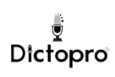

IC Recorder

User Manual
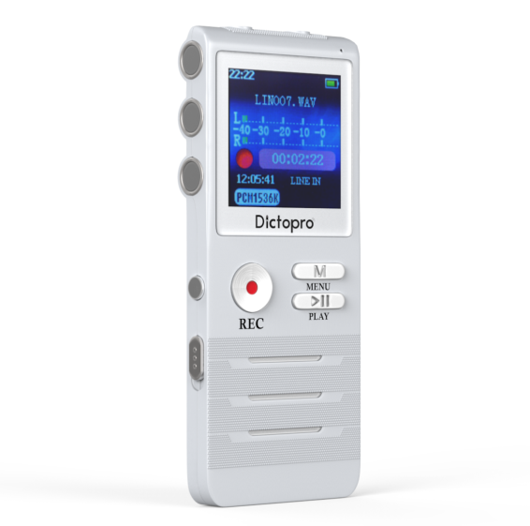
Contents

APPEARANCE 5
FEATURES 6
PARTS LIST 7
CHARGING 8
POWER ON OR OFF 9
RECORDING 10
Pausing 10
SAVING RECORDED FILES 11
RECORDING SETTINGS 12
Recording mode 13
Recording format 13
Recording quality (set bitrate) 13
Recording source 14
Recording from a phone 14
Recording monitoring 15
VOR/Line-in recording 15
MIC Sensitivity 16
Denoise level 16
Automatic Gain Control level 16
AUTO RECORDING 17
Setting the Start Time 17
Setting the End Time 18
Timed Recording 19
MUSIC PLAYING 20
Upload music 20
RECORDED FILE PLAYING 21
Volume Adjustment 22
Music Skip Forward, Fast Forward/ Backward 22
A-B Repeating Adjustment 22
FILE DELETION 23
Deleting Music 23
Deleting All Recorded Files 23
Deleting a Single File 24
SYSTEM SETTINGS 24
Play settings 24
Sound settings 25
Equalizer 25
Volume limit 25
Timed power-off 26
Display settings 26
Brightness 26
Backlight time 27
Date and time 26
Time setting 26
Date setting 26
Language 27
Information 27
Formatting setting 27
Backup/download your files 28
Factory settings 28
WARNINGS 29
WARRANTY/CONTACT US 29

APPEARANCE
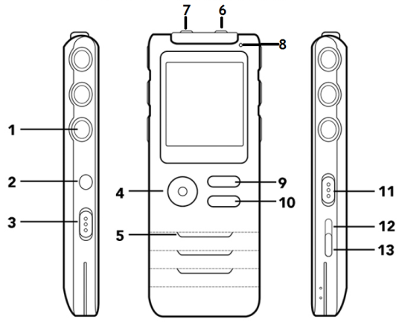
1 | Deco overlay
2 | VOL/volume button
3 | Power switch
4 | Recording button
5 | Speaker/Deco overlay
6 | Earphone jack (green)
7 | LINE-IN port (red)
8 | Recording indicator
9 | Menu button
10 | Play
11 | Lock
12 | Previous
13 | Next

FEATURES
- Zinc alloy die cast casing – for durability
- Recording time settings – for repeating events
- Recording indicator on/off - to indicate when the device is recording
- Recording low-voltage automatic saving – auto save when the battery is low
- Built-in high-sensitivity dual microphone – two onboard recording microphones for stereo recording
- Stereo recording – stereo quality recording
- A-B repeating – repeat or loop the audio recording from two different points
- Recording gain settings - adjust recording levels
- MP3 music playing – play music when not recording
- Dual-core stereo noise reduction recording – surround sound signal processing with echo cancellation
- LINE-IN recording – record telephone conversations

PARTS LIST
No | Item
1 | IC Recorder
1 | Telephone jack wire (1 foot/30 cm) | 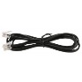
1 | 3.5mm audio line-in wire with 2 male ends (18 inches/45cm) | 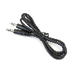
1 | Telephone adapter (2 telephone jacks and 3.5mm audio line jack) | 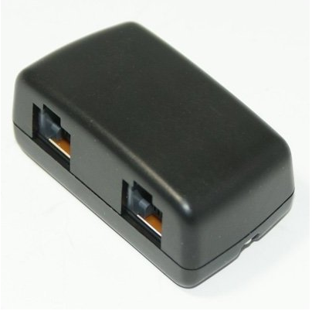
1 | USB 2.0 to mini USB cable (4.33 feet/1.3 meters) | 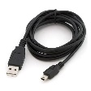
1 | Earphones | 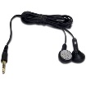

CHARGING
When you receive your device, you will need to charge it. This will take 3-4 hours
- Plug the USB end of your charging cord into a USB port.
- Plug the micro USB connector end into the base of the IC recorder.
A battery shaped picture will appear indicating its charging progress.

NOTE: Do not charge your device for longer than 3-4 hours at a time, because this can lead to a reduction in battery capacity.

POWER ON OR OFF
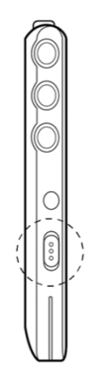 | Turn the Power switch to the On position and the device will turn on.  Press and hold ►❚❚ for soft power off.  In soft power-off status, press and hold  ►❚❚for soft power-on.  When this device will be not used for a long time, please:  1. Turn off this device in soft power-off. (Press and hold  ►❚❚ for soft power off.)  - Turn the ON/OFF power switch to the Off position.  CAUTION: To avoid file damage when recording or playing music, do not turn off the device using the ON/OFF switch.

RECORDING
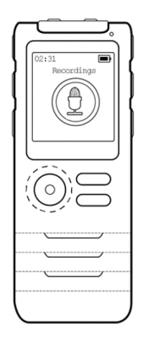 | In power-on status, press the Recording button and the device will start to record.  Pausing  While recording, press the Recording button to pause recording. The recording indicator will flash a red light.  Note: When the device is playing music or a recorded file, press Pause before starting to record.

SAVING RECORDED FILES
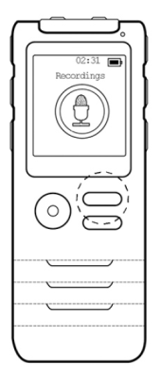 | While recording, press the M menu button to save the recorded file. The recorder will stop recording.  After saving the recorded file, you can play the current recording by pressing  ►❚❚.

RECORDING SETTINGS
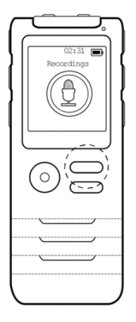 | To enter the recording interface,  - Press ►❚❚. Music, Recordings, Auto Record, or Set appears.  - Use the Up or Down to find Recordings.  - Press ►❚❚. Recording Library appears.  - Use the Down to select Recording settings.  - Press ►❚❚to select. These are the options:  - Recording mode  - Recording format  - Recording quality  - Recording source  - Recording monitoring  - VOR/Line-in recording  - MIC sensitivity  - Denoise level  - AGC level

Recording mode  Options: Normal recording or Dual-core denoise recording to reduce echo and provide surround sound.  - Press Up or Down to select the recording mode settings.  - Press ►❚❚ to enter.  - Press Up or Down to select Normal scene or Dual-core denoise recording.  - Press ►❚❚ for confirmation.  The normal recording files will be saved with the extension of REC and dual-core denoise recording files with RNC. | Recording format  To change the recording file format:  - Press Up or Down to select the recording format settings.  - Press ►❚❚ to enter.  - Press Up or Down to select WAV or MP3 format as desired.  - Press ►❚❚for confirmation.  Recording quality (set bitrate)  To change the recording quality:  - Press set rec bitrate to select the recording quality settings.  - Press ►❚❚ to enter.  - Press Up or Down to select the bit rate desired.  - Press ►❚❚for confirmation.

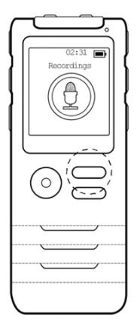 |  | Recording source  To change the recording source:  - Press Up or Down to select Recording source.  - Press ►❚❚ to enter.  - Press Up or Down to select Line-in or Microphone.  - Press ►❚❚for confirmation.  Line-in recording files save with the extension of LIN.  Recording from a phone  To record telephone calls:  - Unplug the telephone handset and plug it into the provided telephone adapter.  - Take the provided short telephone line, plug one end into the telephone adapter and the other end into the back of your phone.  - Plug the provided 3.5mm audio line into the telephone adapter and plug the other end into the Line-in on the Dictopro.  - Change the recording source to Line-in (see previous procedure).  - When you want to record a phone call, press Record.
 | Recording monitoring  To change the recording monitoring:  - Press Up or Down to select the recording monitoring settings.  - Press ►❚❚ to enter.  - Press Up or Down to select On or Off as needed.  - Press ►❚❚for confirmation. |  | VOR/Line-in recording  The VOR function, also called voice operated recording, saves memory. There are two options:  - Normal (records continuously)  - VOR mode (only records when noise is over 40 db).  When you choose VOR mode, the device will record automatically after your press Record.  - Press Up or Down to select VOR mode.  - Press ►❚❚ to enter.  - Press Up or Down to select Normal or VOR mode recording as needed.  - Press ►❚❚ for confirmation.  Note: When in VOR mode, the VOR voice control function is available for MIC recording and the automatic separation function is available for Line-in recording.
MIC Sensitivity  This means line-in sensitivity. Adjust the gain on the microphone to reduce distortion. To adjust the microphone sensitivity:  - Press Up or Down to select Input gain set.  - Press ►❚❚ to enter.  - Press Up or Down to select the setting needed (Class 1-Class 7).  - Press ►❚❚ for confirmation.  Denoise level  To remove excessive background noise, you can adjust the level:  - Press Up or Down to select Denoise level.  - Press ►❚❚ to enter.  - Press Up or Down to select the setting needed (1-6).  - Press ►❚❚ for confirmation. |  |  |  | Automatic Gain Control level  Automatic Gain Control amplifies or reduces the voice level for better voice quality. When the source of the noise is loud, AGC reduces the “volume”. When the source of the noise is faint, AGC increases the “volume”.  - Press Up or Down to select AGC level.  - Press ►❚❚ to enter.  - Press Up or Down to select the setting needed (0-16).  - Press ►❚❚ for confirmation.

AUTO RECORDING
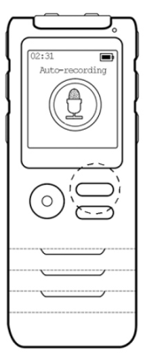 | To set a time to begin a recording:  - Press ►►❚. Music, Recordings, Auto Record, or Set appears.  - Use the Up or Down to find Auto record.  - Select Auto record and press ►❚❚ to enter.  - Use the Down to select Auto Record.  - Press ►❚❚ button to enter. Auto Record on/off appears.  - Press ►❚❚ button to enter.  - Press Up or Down to select On or Off.  - Press ►❚❚ button for confirmation.  Setting the Start Time  To set the start recording time:  - Select Start time.  - Press ►❚❚ to enter and press Up or Down to set the clock.  - Press M menu button and the minute icon will be highlighted.  - Press Up or Down to set the minutes.  - Press ►❚❚ for confirmation and return to the previous menu.

Setting the End Time
To set the end recording time:
- Select End time.
- Press ►❚❚ to enter and press Up or Down to set the clock.
- Press M menu button and the minute icon will be highlighted.
- Press Up or Down to set the minutes.
- Press ►❚❚ for confirmation and return to the previous menu.

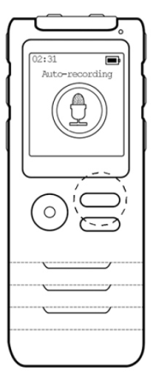 | Timed Recording  Options include: Once, Every day, Work days  Once setting:  - Select Once and press ►❚❚ to enter. At this time, the date shown on the top of the screen is red.  - Press Up or Down to select the date.  - Press M button. The month is shown in red.  - Press Up or Down again to set the month required.  - Press M button and the year is shown in red.  - Press Up or Down to select the year required.  - Press ►❚❚ for confirmation. The settings are completed.  Timed recording files will save with the extension of TMREC.  Note: After setting the timed recording or alarm, please turn off the device or return to the main interface. Otherwise the settings will not become effective.

MUSIC PLAYING
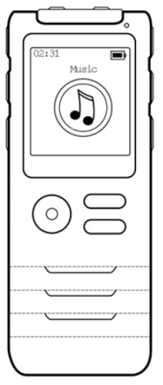 | To play music:  - Turn on the device.  - Press Up or Down to select Music.  - Press ►❚❚ for confirmation.  - After entering the menu, select All music files.  - Press ►❚❚ for confirmation.  - Press Up or Down to select the music files you want to play.  - Press ►❚❚ to play.  - To pause, press ►❚❚.  - Press ►❚❚ again to continue playing.  Upload music  To upload music to the Dictopro:  - Plug the USB/mini USB cable into your computer and the Dictopro. A window will appear on your computer with a Record folder.  - Copy any MP3s from your computer to the root of the Dictopro i.e. copy them beside the Record folder.

RECORDED FILE PLAYING
To play your recordings:
- Turn on the device.
- Press Up or Down to select Recording.
- Press ►❚❚ for confirmation.
- After entering the menu, select Recording library.
- Press ►❚❚ for confirmation.
- Press Up or Down to select the recorded files you want to play.
- Press ►❚❚ to play.
- To pause, press ►❚❚.
- Press ►❚❚ again to continue playing.

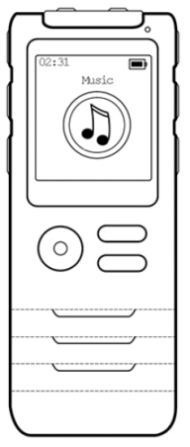 | Volume Adjustment  To decrease or increase the volume:  - Press VOL button.  - Press Up or Down to increase or decrease the volume.  Music Skip Forward, Fast Forward/ Backward  To fast forward or backwards:  - Press and hold Up or Down.  To skip forward or backwards:  - Press Up or Down.  A-B Repeating Adjustment  To replay a section of a file in a repeating loop:  - Press Recording button to select the starting point of AB repeating. At this time, A on the screen starts to flash.  - Press Recording button again to select the ending point of AB repeating. At this time, B on the screen starts to flash.  - Press Recording button again to start repeating the corresponding part of the file.  - While the recording is repeating, press Recording button to exit repeating mode.

FILE DELETION
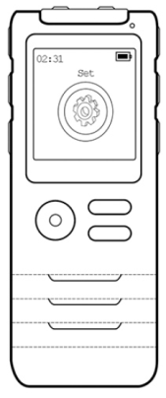 | Note: Please backup important files before deletion.  Deleting Music  To delete music files:  - Play the song.  - Press ►❚❚ to pause.  - Press and hold VOL button to enter the file options.  - Press Up or Down to select Delete.  - Press ►❚❚ button again for confirmation.  - After entering the menu, select YES/NO.  - Press ►❚❚ button again to confirm and delete the file.  Note: Only single music files can be deleted on this device.  Deleting All Recorded Files  To delete all recorded files:  - In Recording interface, press ►❚❚to enter.  - Press Up or Down to select the Recording library.  - Press ►❚❚ again to enter.  - Press Up or Down to select Delete all files.  - Press ►❚❚ to enter.  - Press Up or Down to select whether to delete.  - Press ►❚❚ for confirmation.

Deleting a Single File
To delete a single recorded file:
- Select the file you want to delete in the recording file library.
- Press and hold VOL button to enter the file list. Delete appears.
- Press ►❚❚ button again for confirmation.
- Press Up or Down button to select YES/NO.
- Press ►❚❚ button again to confirm and delete.
You can also delete the current file by pressing and holding VOL button in playing pause status.

SYSTEM SETTINGS
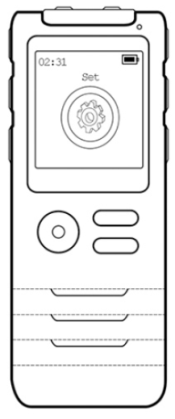 | Note: When performing any setting operation on this device, you can press the M menu button to return to the previous menu, or, press and hold the menu button to return to the main interface directly.  Play settings  - Enter Set menu.  - Press Up or Down to select Play mode.  - Press ►❚❚ to enter and set repeating mode and shuffle playing.
Sound settings  Equalizer  To adjust the sound equalizer for various kinds of music:  - Enter Set menu  - Press Up or Down to select Sound Settings.  - Press ►❚❚ to enter.  - Press ►❚❚ to select Equalizer.  - Press Up or Down to select equalizer type: (EQ options include Rock, Funk, Jazz, Classic...).  - Press ►❚❚ for confirmation. | Volume limit  To change the volume limits for a recording:  - In Sound settings, select Volume limit.  - Press ►❚❚ to enter for adjustment.  - Press Up or Down to select the maximum volume for recording/music output.  - After making the selection, press ►❚❚ for confirmation.

Timed power-off  - In Set menu, press Up or Down to select Sleep timer.  - Press ►❚❚ to enter.  - Press Up or Down to select the time required (the maximum value can be 99 minutes).  - After setting, press ►❚❚ for confirmation.  Display settings  - In Set menu, press Up or Down to select Display settings.  - Press ►❚❚ to enter.  Brightness  - Press Up or Down to select Brightness adjustment.  - Press ►❚❚ to enter.  - Press Up or Down to select the setting required.  - After setting, press ►❚❚ for confirmation.  Backlight time  - Press Up or Down to select Backlight time.  - Press ►❚❚ to enter.  - Press Up or Down to select the time setting required.  - After setting, press ►❚❚ for confirmation. | Date and time  - Press Up or Down to select Date and time.  - Press ►❚❚ button to enter.  Time setting  - Press Up or Down to select Time.  - Press Up or Down to select hours.  - Press M button to select minutes.  - Press Up or Down to select minutes.  - Press ►❚❚ button to enter.  Date setting  - Press Up or Down to select Date.  - Press Up or Down to select the date.  - Press M button to select Month.  - Press Up or Down to select the month.  - Press M button to select Year.  - Press Up or Down to select the year.  - Press ►❚❚ button to enter.  Language  - Press Up or Down to select Language.  - Press ►❚❚ to enter.  - Press Up or Down to select the language required.  - Press ►❚❚ for confirmation.
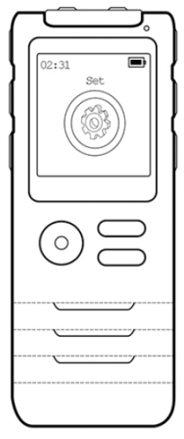 | Information  - Press Up or Down to select Information.  - Press ►❚❚ to enter.  You can check the player information, disc space and supported file types.  Formatting setting  - Press Up or Down to select Formatting setting to perform formatting operation on the device.  Note: Before formatting, please backup/download any important files, to avoid any loss.
Backup/download your files  To backup your files for safekeeping or prior to reformatting the Dictopro:  - Plug the USB/mini USB cable into your computer and the Dictopro. A window will appear on your computer with Record Folder.  - Copy the folder or select files to your computer.  - If desired, delete any unwanted files from the Dictopro using your computer. | Factory settings  Press Up or Down to select Factory settings to restore the device to the conditions when shipped from the factory.

WARNINGS
 | Never disassemble or modify your recorder for any reason. Doing so may cause the recorder to malfunction or catch fire. Damage to your device voids your manufacturer's warranty.
 | Do not allow your device to get wet; liquids can cause serious damage. Water damage to your device voids your manufacturer's warranty. Avoid exposing your device to very cold or very hot temperatures (below 37F or above 1 12F).
NOTE Do not use the device during a thunderstorm. Thunderstorms can cause the device to malfunction and increase the risk of electric shock.

WARRANTY/CONTACT US
We really appreciate you choosing DICTOPRO as your trusted brand of digital voice recorders and we sincerely hope you enjoy your purchase. We love making our customers happy by providing true value with our products.
If you have any questions or concerns, please let us know immediately. We will do everything to make sure you are happy.
support@dictopro.com or www.dictopro.com
Warranty
1 year parts and labor warranty. To register your warranty, please visit www.dictopro.com

