
Instruction Manual for Item: 902-600
QuikCrimp 12 Ton
Battery Operated Crimper

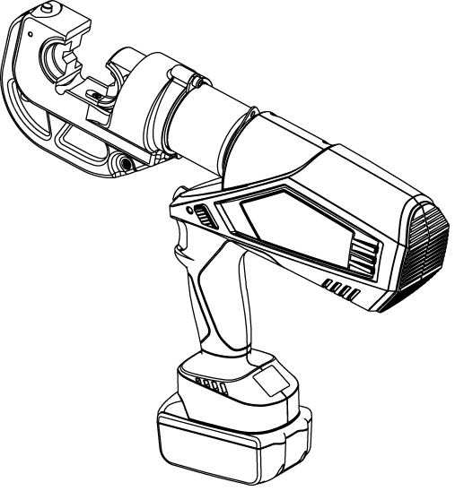

Due to continuing improvements, actual product may differ
slightly from the product described herein.

Read this material before using this product.
Failure to do so can result in serious injury.
SAVE THIS MANUAL

SAVE THIS MANUAL
Keep this manual for the safety warnings and precautions, assembly, operating,
inspection, maintenance and cleaning procedures. Write down the month and year of
purchase. Keep this manual and the receipt in a safe and dry place for
future reference.

IMPORTANT SAFETY INFORMATION
In this manual, on the labeling, and all other information
provided with this product:

This is the safety alert symbol. It is used to alert you to potential
personal injury hazards. Obey all safety messages that follow this
symbol to avoid possible injury or death.


DANGER indicates a hazardous situation which,
if not avoided, will result in death or serious injury.


WARNING indicates a hazardous situation which,
if not avoided, could result in death or serious injury.


CAUTION, used with the safety alert symbol,
indicates a hazardous situation which, if not avoided,
could result in minor or moderate injury.

GENERAL SAFETY RULES
TO WORK IN SAFE CONDITIONS WITH THIS TOOL, IT IS IMPERATIVE TO READ THE DIRECTIONS CAREFULLY AND TO FOLLOW THE INSTRUCTIONS. IF YOU DO NOT RESPECT THE INFORMATION WRITTEN IN THIS MANUAL THE WARRANTY MAY BE VOIDED.

1. Work area safety:
  - Keep work area clean and clear.
  - This tool is not insulated; do not use on live conductors.
  - Please do not use or store the tool under high temperatures, or around corrosive fluids. Pay attention to the sealing kits wearing down.
  - Keep children and bystanders away while operating the battery powered crimping tool. Distractions will cause you to lose control.

2. Electrical safety:
- Make sure the plug matches the outlet. Never try to change the plug.
- Do not put tool, battery or charger in a rainy or humid environment, it is easy to trigger an electrical shock if any water contacts the electrical system of the tool.
- Do not use electric wire to carry, pull, or draw out the plug and do not connect the “-”and “+”. The damaged or twined wire may cause an electrical shock.
- If the charger is crushed or dropped or if any other damages occur, please do not try to repair it by yourself. Instead, send it back to the authorized service center as soon as possible. The damaged charger may cause an electrical shock.
- The best temperature for charging is between 50°F-104°F. Make sure the air hole of the battery and charger are uncovered during charging.
- Please cut off the power to the charger each time to reduce the risk of injury to children or the those who are not experienced with the tool.
- Do not wait until the battery is completely depleted for recharging.
- Please keep the battery out of the tool to avoid power discharge.
- Please do not burn the battery or cause short-circuiting, this may cause an explosion.
- Do not use a inoperable battery otherwise it can cause an electrical shock.
- Do not disassemble the battery and charger yourself. If any problem occurs, please contact the manufacturer or agent.

3. Personal safety:
- Stay alert, watch what you are doing and use common sense when operating the tool. Do not use the tool when you are tired or under the influence of drugs, alcohol or medication. A moment of inattention may result in series personal injury.
- Use safety equipment. Always use safety equipment such as a mask, helmet, safety cap, insulating shoes, etc. to reduce the risk of personal injury.
- Dress properly. Do not wear loose clothing or jewelry. Keep your hair, clothing and gloves away from moving parts. Loose clothes jewelry or long hair can be caught in moving parts.
- Maintain your power tools. Check for misalignment or binding of moving parts, breakage of parts and any other condition that may affect the tool’s operation. If damaged, have the tool repaired before use. Many accidents are caused by poorly maintained power tools.
- Please use the tool properly, the tool with a correct power source will do the job better and safer at the rate for which it was designed.
- Do not put your fingers into the head of the tool during operation. Your fingers could be injured severely.

3. Service:
Make sure your Battery Crimping Tool is serviced by a qualified service technician using only identical replacement parts. This will ensure that the safety of the Battery Crimping Tool is maintained.

SPECIFIC SAFETY RULES
- Maintain all labels on the tool which carries important safety information. If unreadable or missing, contact the agent to replace.
- This product is not a toy, keep out of reach of children.
- Do not put your fingers into the head of the tool during operation. Your fingers could be injured severely.
- Make sure the head is locked firmly during operation.
- Do not use the tool without dies.
- Do not crimp on live cables or conductors.
- Do only crimp Cu copper or Al aluminum material.
- Do not remove limit screw in the head of the tool. This prevents the head from dropping or popping.
- Make sure the head is locked firmly during operation.
- This tool is not meant for continuous use. After 30 to 40 cycles, allow the tool to cool for 15 minutes.
- Do not secure this tool in a vise. This tool is designed for hand-held operation.
- The built-in safety valve goes through strict pressure tests before marketing; please do not adjust the pressure yourself. For any pressure related issues, please return the tool back to the service center. Continue use only after the tool is reissued by trained service technician.
- The warnings, precautions, and instructions discussed in this instruction manual cannot cover all possible conditions and situations that may occur. It must be understood by the operator that common sense and caution are factors which cannot be built into this product, but must be supplied by the operator.

UNDERSTAND YOUR TOOL
902-600 is a tool for crimping Cu/Al lugs with cable from 6 AWG- 750 MCM. It is powered by a Li-ion battery, actuated by motor and controlled by MCU, with OLED display and a high pressure hydraulic system, it is a perfect tool to be used in the electrical and construction industries.

1. Specifications:
Max. crimping force: | 12 Ton
Crimping range: | 750 MCM Cu and Al
Stroke: | 1.65 in
Hydraulic oil: | Shell Tellus T15# S2V HV15
Oil capacity: | 160ml
Ambient temperature | -14 to 104°F
Voltage/Capacity: | 18V/3.0Ah
Time/crimp: | 5-15s(Depend on the size of cable)
Time/charger: | Approx. 120 times (CU 300 MCM)
Charging time: | Approx.1hour
Size of tool: | 16x13x3in
Package: | Plastic box
Accessories: | None
Crimping dies: 6, 4, 2, 1/0 2/0, 3/0 4/0 AWG and 300, 350, 500, 600, 750 MCM
Battery: | 2 pcs
Charger: | 1 pcs
Sealing ring of cylinder | 1 set
Sealing ring of safety valve: | 1 set

2. Description of components:

Parts No. | Description | Function
1 | Pin | Locks/unlocks the upper die
2 | Die | Crimping, interchangeable crimping die
3 | Retaining clips | Locks /unlocks down dies
4 | Limited block | Prevents head from dropping or popping
5 | Label | Company logo
6 | Light(LED) | Lighting
7 | Start button | Starts operation
8 | Retract button | Manually retracts the piston in case of an incorrect operation
9 | LED indicator (red LED) | Indicates the operating condition and battery discharging situation
10 | OLED display | Shows crimping time, electrical error info
11 | Battery lock | Locks / unlocks the battery
12 | Battery | Supplies power, rechargeable Li-ion（18V）

3. Function description:
Microcomputer control system automatically detects pressure while crimping.


OLED display - Dot matrix OLED display, which shows crimp times, battery power, working pressure (if equipped with pressure sensor), maintenance reminders and fault code.


Supports Bluetooth wireless communication technology - Download and install software. Tool can establish wireless communication with mobile phones, tablets, etc., to read tool using times, usage status, maintenance reminders and other information. (if configured)


Pressure monitoring and control technology -The pressure of the tool system is monitored by a pressure sensor and the tool is pressure-controlled. (if configured)

Auto reset- Release the pressure automatically, retract the piston to the
starting position when max output is reached.


Manual reset —Can retract the piston to the starting position when incorrect operation has occurred.


The unit is equipped with a double piston pump which is characterized
by a rapid approach of the die towards the connector and a slow crimping motion.

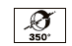
The head can be smoothly turned by 350° around the longitudinal axis
to gain better access to tight corners and other difficult working areas.


Audible and red flashing identifier occurs when pressure and battery level is low.


The whole tool is controlled by one trigger. This allows for easy handling and a better grip compared to a two-button operation.

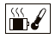
A temperature sensor causes the tool to stop working automatically when
a prolonged temperature reading of over 140°F is detected. If the fault signal sounds, this indicates the tool cannot continue operation until normal
temperature is reached.
Series No | Instruction | LED  (red) | LED  (white) |  | OLED screen | What it means
1 | Self-checking | ¤¤  （2Hz） |  |  |  | Self-checking to assure proper operation
2 | Light |  | Delay 20s off |  | 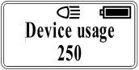 Timeout 5 minutes off | Enter the working state, the battery is full
3 | Charging signal | ¤¤¤  （2Hz ) |  |  | 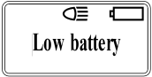 | Lacking power- tool needs charging
3 | Charging signal | ¤ （5ms) |  |  | 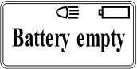 | Lacking power- tool needs charging
3 | Charging signal | ¤（100ms) |  |  |  | No power- charge immediately
4 | High temperature warning | ¤¤¤¤  （2Hz） |  | ◎◎◎◎  （2Hz） | 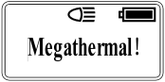 | Motor surface temperature is too high, waiting for tool to cool down before restarting
5 | Overload | ¤ (3s) |  |  | 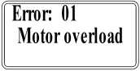 | Battery reloading, recovery work interface
6 | Crimp is not normal | ¤ (5s) |  | ◎  (5s) | 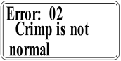 | Battery reloading, recovery work interface
7 | Maintenance reminder |  |  | ◎  (0.5s) | 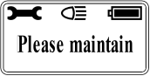  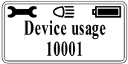 | Tool must be maintained

OPERATING INSTRUCTIONS
Read the entire SAFETY INFORMATION section at the beginning of this manual including all text under subheadings therein before using this product.

Use this tool for the manufacturer’s intended purpose only. Alternate use can result in injury or property damage.

Charging:
Push battery into charger and connect the plug with the plug seat. Make sure the room temperature is between 50°F-104°F. The charging time is around 1hour. Please see the illustrations below.
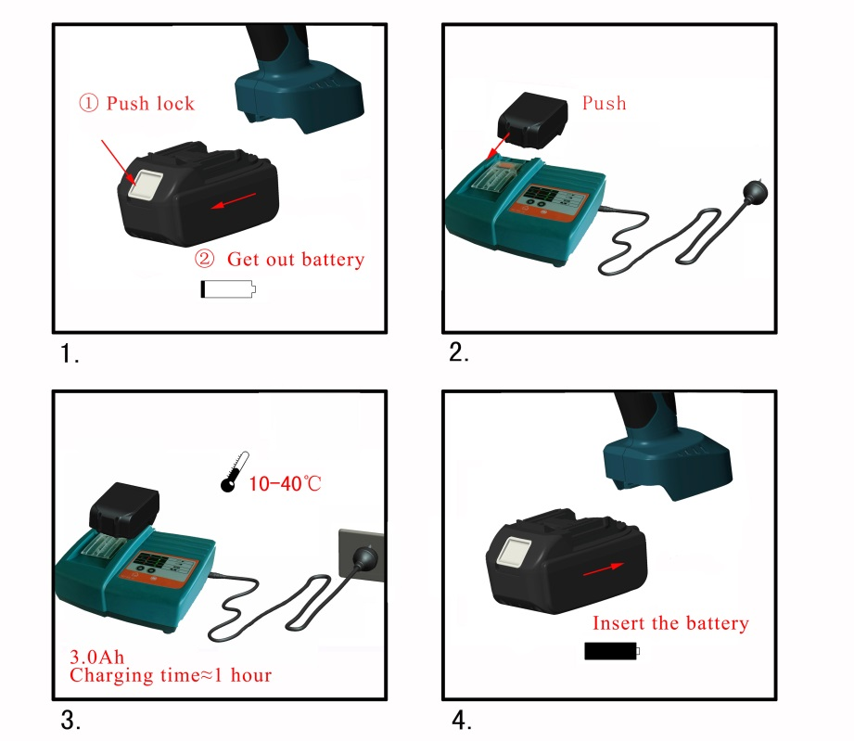


The battery can be used hundreds of times. When the lifespan is obviously reduced, change to a new battery.
Do not wait until battery is fully depleted to charge; this will ruin the battery. If the battery is inactive for a long period of time, it will discharge automatically. Charge battery at least once per/quarter.

Usage of the tool:
OLED display interface description:

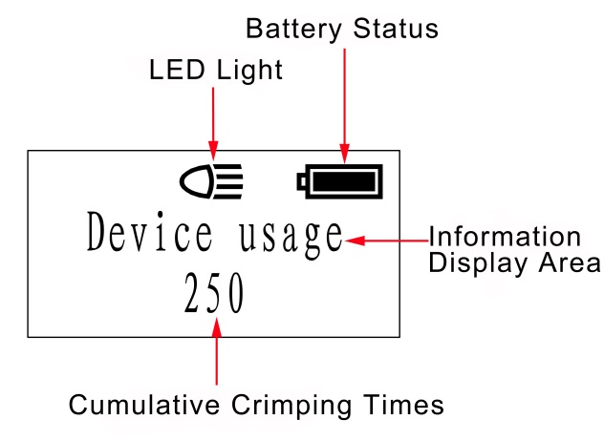

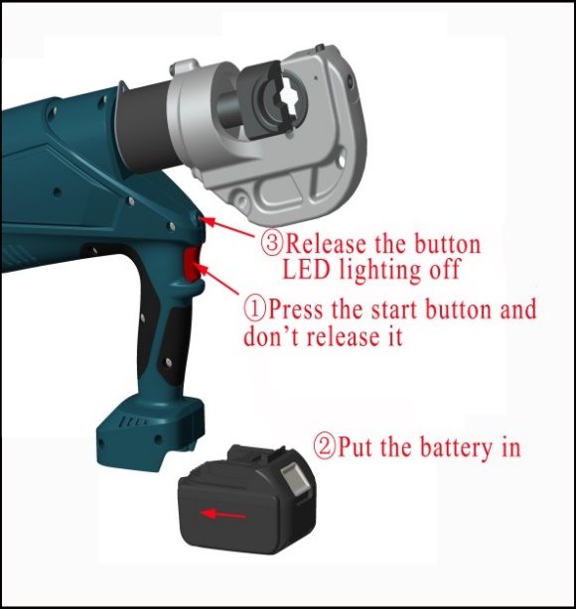
Tool LED illuminator: After pressing the start button, the LED illuminator light will turn on, After the tool is released, the button will automatically turn off after a delay of 20 seconds. Press the start button before installing the battery. When the battery is installed, release the start button and the LED light will turn off. If the light is still on, the battery must be reinstalled immediately as shown in the figure.

- Crimping operation:
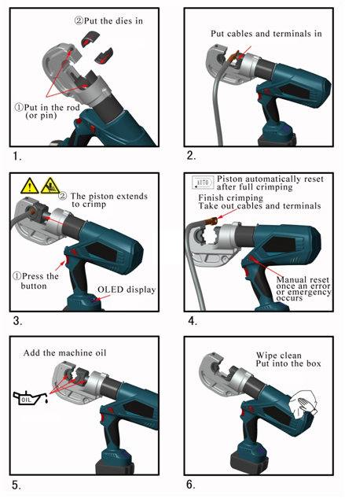

MAINTENANCE AND SERVICING


Damaged equipment may cause serious personal injury. Do not use damaged equipment. If abnormal noise or vibration occurs, have the problem corrected before further using.

- Before each use, inspect the general condition of the tool. Check for loose screws, misalignment or binding of moving parts, cracked or broken parts, or any other condition that may affect safe operation.

- After using, clean external surfaces of the tool with a clean, moist towel. Then coat any metal surface, including dies, with rust-preventing oil to avoid environmental damage. Store the tool in a dry environment.

- Service to the tool should only be done by a qualified Service Technician.

- To prolong the life of the tool, change the oil each year. Make sure the oil is filtered by a 120-mesh net or over a 30µm strainer. Keep dust away from the oil cup.

- If leaking occurs, please contact the manufacturer and/or the distributor to change the sealing kit.

6） If tool is inactive for a long period of time, please make sure the piston stays in the starting position. Be sure to clean the tool and apply rust-proof oil both to the tool and accessories. Take out the battery and put it away in a box and store the tool in a dry environment.

TROUBLESHOOTING

FAULT | ANALYSIS | SOLUTION
- Tool  is inoperative | - Dirt, contaminants, etc. in ram area of tool.  - The battery needs charging  - Tool components worn or damaged. | - Clean hydraulic system  - Charge the battery  - Return tool to manufacturer or distributor
- No power during operation or not up to the rated power | - No oil  - Dirt, contaminants inside of oil sac.  - Inner leakage | - Fill oil  - Return tool to manufacturer or distributor  - Return tool to manufacturer or distributor
- Crimp is not tight | - Not up to rated power  - Error select on the crimping die | - Return tool to manufacturer or distributor  - Return tool to manufacturer or distributor
- Create many scrap | - Error select on the crimping die | - Change crimping die
- Leakage on the crimping head o plunger | - Sealing kit worn down | - Return tool to manufacturer or distributor
- Motor running but no power output | - No oil in the oil sac  - Air present in the hydraulic system  - Cold oil | - Fill or change the oil  - Return tool to manufacturer or distributor  - Use the tool under 104°F

LIMITED 1 YEAR WARRANTY
We make every effort to assure our products meet high quality and durability standards and warrants to the original purchaser that this product is free from defects in materials and workmanship for the period of one year from the date of purchase (90 days if used as rental equipment). This warranty does not apply to damage due directly or indirectly, to misuse, abuse, negligence or accidents, repairs or alterations outside our facilities, normal wear and tear, or to lack of maintenance. We shall in no event be liable for death, injuries to persons or property, or for incidental, contingent, special or consequential damages arising from the use of our product. Some states do not allow the exclusion or limitation of incidental or consequential damages, so the above limitation of exclusion may not apply to you. THIS WARRANTY IS EXPRESSLY IN LIEU OF ALL OTHER WARRANTIES, EXPRESS OR IMPLIED, INCLUDING THE WARRANTIES OF MERCHANTABILITY AND FITNESS.

To take advantage of this warranty, the product or part must be returned to Eclipse with transportation charges prepaid. Proof of purchase date and an explanation of the complaint must accompany the merchandise. If our inspection verifies the defect, we will either repair or replace the product at our election or we may elect to refund the purchase price if we cannot readily and quickly provide you with a replacement. We will return repaired products at our expense, but if we determine there is no defect, or that the defect resulted from causes not within the scope of our warranty, then you must bear the cost of returning the product.

The warranty gives you specific legal rights and you may also have other rights which vary from place to place.

