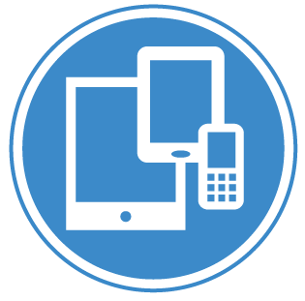
CSE 3203 Overview of Mobile Systems Study Guide
Module 2: Mobile Device Connections
Prepared by Jack G. Zheng, Fall 2018

Overview and learning outcomes
In this module, we will start some details of the ecosystem with connectivity first. This include carriers which provide connection services and connection types.
Learning outcomes:
- Explain mobile service carriers/operators including mobile virtual network operators.
- Describe major mobile service providers in the world and in the US.
- Compare types of connections used by mobile devices: cellular, WiFi, Bluetooth, NFC
- Describe generations of cellular technologies and the standards: 1G to 5G, GSM, CDMA, LTE.
This module is related to course learning outcome 3 and 4.

Task list
- Complete the required readings listed in learning materials. Use the questions in “Research and Discuss” section to guide your reading.
- Use the lecture notes as a reading and learning guide; follow the resources and links presented in the notes for further information and additional learning.
- Review and research (optional; please discuss them in the discussion board if you want to):
  - What are the major advantages and disadvantages when choosing a MVNO over MNO? Start from here https://www.slideshare.net/Dewet_Boshoff/amgoocom-mvno-in-usa-the-future-of-smart-phone-ownership
  - Can 4G network support enough needs for speed? Describe some common scenarios where 5G can really improve the use of mobile? https://www.pcmag.com/article/345387/what-is-5g
  - How does your mobile device connect to the Internet besides your mobile plans?
  - What is the major difference between Bluetooth and NFC? What are their major intended uses?

Learning Materials
- Core learning materials
  - How Mobile Networks Work (chapter 4 from the book “Wireless Networking”): http://www.informit.com/articles/printerfriendly/2021961 - the free sample chapter is provided in D2L.
  - Mobile carriers
    - http://www.investopedia.com/articles/markets/030216/worlds-top-10-telecommunications-companies.asp
    - https://en.wikipedia.org/wiki/Mobile_virtual_network_operator
  - Cellular technologies
    - https://www.qualcomm.com/wireless-simplified/technology-evolution especially https://www.qualcomm.com/videos/evolution-mobile-technologies-1g-2g-3g-4g-lte (slides provided in D2L)
    - https://www.tomsguide.com/us/5g-networking-faq,news-20629.html
  - Bluetooth: http://www.edgefxkits.com/blog/bluetooth-technology-and-its-working/
  - NFC: https://www.androidauthority.com/what-is-nfc-270730/
- Instructor’s lecture notes: connectivity.pdf
- More resources:
  - https://www.qualcomm.com/wireless-simplified/wireless-fundamentals
  - https://www.qualcomm.com/wireless-simplified
  - https://www.techrepublic.com/article/does-the-world-really-need-5g/
  - https://learn.sparkfun.com/tutorials/bluetooth-basics
  - http://pubs.sciepub.com/ajss/2/4/5/
  - FCC Mobile Wireless Competition Reports: https://www.fcc.gov/general/mobile-wireless-competition-reports
  - https://www.androidcentral.com/what-alternative-mobile-carrier
  - https://www.slideshare.net/noorec786/generations-of-network-1-g-2g-3g-4g-5g

