Energy Management (EM) Toolbox
User Manual (SWI)
DTE Energy Partnership & Services (EP&S)

Table of Contents

1. PRELIMINARY INFORMATION 2
2. Energy Management (EM) Toolbox 2
2.1 Toolbox Structure 2
2.2 Using the EM Toolbox 3
2.2.1 EM Toolbox Index Table 3
2.2.2 Building Operational & Maintenance Initiative (BOMI) Matrix 4
2.2.3 Energy Conservation Measure (ECM) Matrix 8
2.2.4 Roadmap Tables 8
2.2.5 Checklist Tables 16
2.2.6 Performance Dashboard 17
3. Other Procedures (SWIs) 20
4. Security 21
5. General Notes 21

PRELIMINARY INFORMATION
Description: This document describes the process for using the Energy Management (EM) Toolbox. The EM Toolbox provides your Energy Team a file system that allows them to benchmark the buildings’ energy conservation best practices from the operational, maintenance, and system upgrade perspectives. The file system also provides the means to track energy efficiency projects identified using benchmarking tools and energy performance metrics based on actual energy usage and building gross area.

Required Special Tools:

- Desktop or Portable Computer
- Microsoft Excel
- EM Toolbox

Prerequisites: Basic-Moderate Microsoft Excel experience

Definitions:

BOMI Matrix: Excel benchmarking table in the “EM Toolbox” used to identify best practice opportunities within the buildings’ operational and maintenance procedures (one table that covers all buildings in the file system).

ECM Matrix: Excel benchmarking table in the “EM Toolbox” used to identify best practice opportunities within the building’s systems and infrastructure (one table that covers all buildings in the file system).

Roadmap: A unique table used to track active and potential energy efficiency projects (one table per building in the file system).

Hyperlink: Hyperlinks are actionable heading/list items used to navigate among tables within the file system (BOMI Matrix, ECM Matrix, and Roadmaps).

Best Practice: Industry and/or expert recognized technologies and management practices used to prevent energy waste.

Best Practice Status: Status or percentage value that represents the extent to which the existing best practice is already being utilized.

Energy Management (EM) Toolbox

Toolbox Structure
The EM Toolbox is a file system comprised of one common Microsoft Excel file entitled “EM Toolbox.xlsx”. There are three (3) types of tables within this system. Two (2) benchmarking tables are used to identify best practice opportunities within the buildings’ operational and maintenance procedures and within the buildings’ systems and infrastructure. Roadmap tables are used to keep track energy use, cost, and active and potential energy efficiency projects. A toolbox index table is used to navigate through the different tables/tabs within the file system using hyperlinks. The hyperlinks will take the user to the corresponding Excel tab containing the tables in the “EM Toolbox” system (see list below).

- EM Toolbox Index Table
- Building Operation and Maintenance Incentives (BOMI) Matrix
  - BOMI Definition table
- Energy Conservation Measures (ECM) Matrix
  - ECM Definition Table
- Checklist Tables
  - BOMI & ECM Checklist
  - Roadmap Checklist
- Buildings’ Roadmap Tables (One table per building in the file system + One Template)
- Performance Dashboard

The index table, two (2) benchmarking tables, BOMI and ECM definition tables, Checklist tables, Roadmap tables and Performance Dashboard are found in the main toolbox file called “EM Toolbox.xlsx”. All the files are located in a central folder called “EM Toolbox Directory”. The system can be run locally from the hard drive of a PC computer or from a central network system with Excel capability.

Using the EM Toolbox

EM Toolbox Index Table

As mentioned previously in this SWI, the EM Toolbox index table allows the user to navigate through all the benchmarking, roadmap, checklist, and dashboard tables from a central location. The toolbox index table is found on the first tab of the main EM Toolbox file. The toolbox index table is an excel table that uses actionable hyperlinks that connect the index table with the BOMI Matrix, ECM Matrix, Checklists, roadmap tables, and Performance Dashboard. The screenshot below shows the EM Toolbox Index Table.

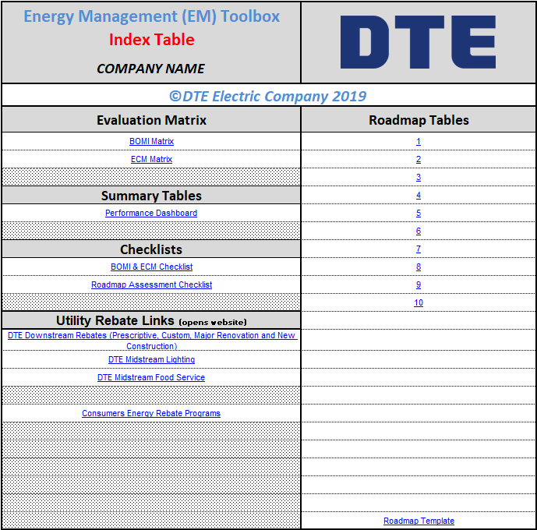
Hyperlink to Roadmap Template
Hyperlink to utility rebate programs
Hyperlink to checklists
Hyperlink to Performance Dashboard
Hyperlink to BOMI and ECM tables
Hyperlink to Roadmap Tables

Building Operational & Maintenance Initiative (BOMI) Matrix

The BOMI Matrix is an Excel table that allows the user to benchmark the buildings in the file system based on the actual implementation of operational and maintenance best practices. To access the BOMI Matrix, open the main EM Toolbox file and click on the “BOMI Matrix” hyperlink highlighted in yellow on the screenshot below.

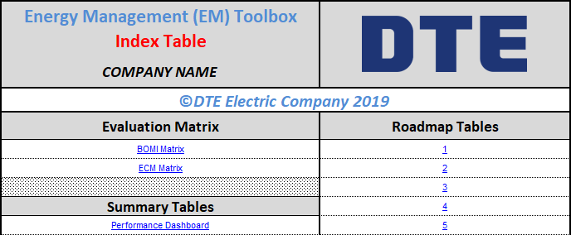

The records on the BOMI Matrix list the operational and maintenance best practices while the fields in the table list the buildings included in the system. Please, note that the building’s label/heading listed on the BOMI Matrix is also a hyperlink that can be used to access the roadmap tabs. As the screenshot below shows, the best practices are grouped by the building’s systems/technologies.

Lighting O&M Best Practices
Best Practice Status Cells/Records
Lighting Totalizer Record
Buildings listed on the BOMI Matrix and hyperlink to Roadmap tabs
BOMI Best Practice Reference Number
Hyperlinks to Index, ECM, and Dashboard tables

A BOMI reference number was added to the matrix to keep track of BOMI projects in the roadmap tables. The BOMI reference number is also a link that will take the user to the BOMI Definition table. The BOMI Definition table lists the scope or type of application in which the BOMI best practices could be used. See screenshot below.

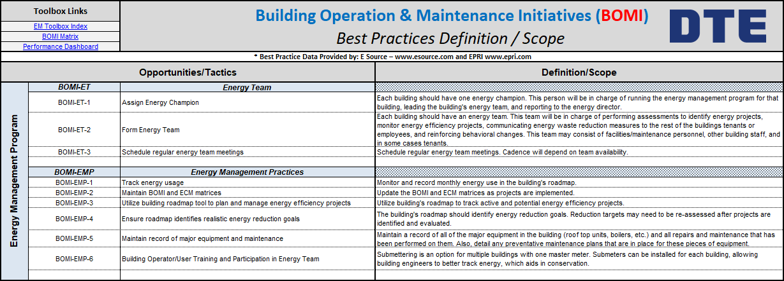
Best Practice Definition and/or Scope
Best Practice Name

In the BOMI Matrix, there are O&M best practice groups for the systems located in your facilities. Each group of best practices has a totalizer cell for each building. The totalizer cell automatically calculates a BOMI rating per system and building based on the implementation status of the BOMI best practices listed in the table. Therefore, the BOMI rating indicates which building and building system could be improved based on the buildings’ existing O&M procedures.

To calculate the BOMI rating, the totalizer cell uses the best practice status data entered by the energy team into the Best Practice status cells for each building and BOMI best practice listed on the BOMI Matrix (see partial screenshot below).

Lighting Totalizer Record
Best Practice Status Cells/Records

The user can select the following best practice implementation statuses from the best practice status cells: Under Consideration, Plan in Progress, 0%, 10%, 20%, 30%, 40%, 50%, 60%, 70%, 80%, 90%, 100%, and Not Applicable (see partial screenshot below)

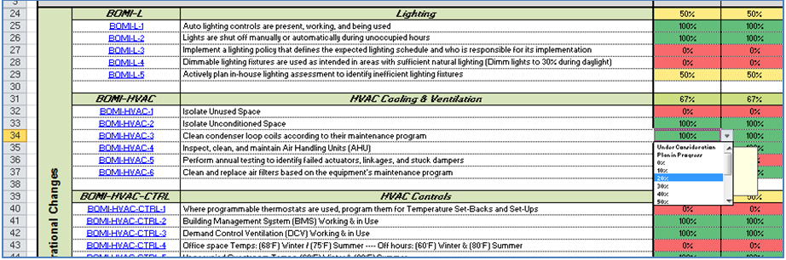
Dropdown list for Best Practice Status Cell

The best practice status cell is an indication of the extent to which the respective best practice is used or implemented in the building. Once the best practice status is selected, the color of the best practice cell will automatically change to some color within a Green-Yellow-Orange-Red color gradient (see screenshot below).

Please note that if Not Applicable is selected, the best practice status cell color will change to green, and that best practice will automatically be ignored by the calculation of the BOMI rating for that particular system and building. On the other hand, if “Under Consideration” and “Plan in Progress” is selected, the cell color will change to a shade of orange and yellow respectively to indicate some progress, but they will be included in the BOMI rating calculation as if they are not being implemented; that is 0% implementation status.

In addition, note that the system best practice totalizer cells are set to show “TBD” (to be determined) on red background when all the best practice status cells within the system are blank. When any one (1) best practice status cell is entered, the totalizer record will change to a percentage value based on the total number of best practices in the system group. Therefore, at this point, the user must enter the implementation status of all the best practices within the system group to get an accurate system’s BOMI rating.

The BOMI ratings per system and building are summarized on the bottom of the BOMI Matrix (see screenshot below).

Building BOMI Index

The BOMI rating summary also shows the total BOMI Index score per building. The total BOMI Index score is calculated based on the average BOMI ratings per building and it provides the user with insight into which building might have opportunities to improve its O&M practices/procedures using a 0% to 100% scale.

Once the BOMI matrix is filled out or updated, go back to the EM Toolbox Index table, and save the Excel file. To go back to the EM Toolbox Index table, click on the index table hyperlink found on the top-left corner of the BOMI Matrix (see screenshot below).

Hyperlinks to Index, ECM, and Roadmap summary tables

Note: The toolbox links section of the BOMI Matrix can also be used to navigate to the ECM Matrix and the Dashboard.

Energy Conservation Measure (ECM) Matrix

The ECM Matrix is an Excel table that allows the user to benchmark the buildings in the file system based on the actual implementation of building’s system upgrades; that is, based on infrastructure and building system changes that require capital investment. To access the ECM Matrix, open the main EM Toolbox file and click on the ECM hyperlink highlighted in yellow on the screenshot below.

The ECM Matrix and the BOMI Matrix are both benchmarking tables. They are very similar in format and functionality, so navigating and populating the ECM Matrix is just like navigating and populating the BOMI Matrix. Please, refer to 2.2.2 Building Operational & Maintenance Initiative (BOMI) Matrix in this manual to use the BOMI and ECM Matrix.

Roadmap Tables

The building roadmap table allows the energy team at each building to keep track of energy use, cost, and active and potential energy conservation projects that have been identified using the BOMI Matrix, the ECM Matrix, or any other energy management tool available to the company. As mentioned previously, each building in the file system has its own roadmap tab/table.

The roadmap tabs/tables can be accessed from the EM Toolbox Index table (see screenshot below).

Hyperlink to Roadmap Template
Hyperlinks to Roadmap tabs/tables

The roadmap tabs/tables can also be accessed from the BOMI Matrix, the ECM Matrix, and the Performance Dashboard table by selecting the hyperlinks listing the buildings’ name on the tables’ headings (see screenshots below).
Buildings listed on the BOMI & ECM Tables and hyperlinks to Roadmap tabs/tables
Buildings listed on the dashboard and hyperlinks to Roadmap tabs

As the following screenshot shows, the Roadmap table includes an energy performance summary of the building. White cells in the table are input cells. Any shaded cell contains titles or calculations. The top section of the Roadmap table is the energy performance summary. The summary shows the annual energy usage and cost baseline, the desired percentage of total usage and cost reduction target, and the energy performance metric in kBtu/ft^2. The energy performance summary also shows the total energy usage and cost savings realized from the active projects listed on the roadmap table. If your organization also tracks water, water consumption and cost baselines, the desired percentage of total usage and cost reduction target, and the water performance metric in Gal/ft^2 will also be displayed in this area. Lastly, water and cost savings realized from any active projects will also be displayed in the performance summary (see screenshot below)
Active and Potential projects
Energy Baseline and Goals

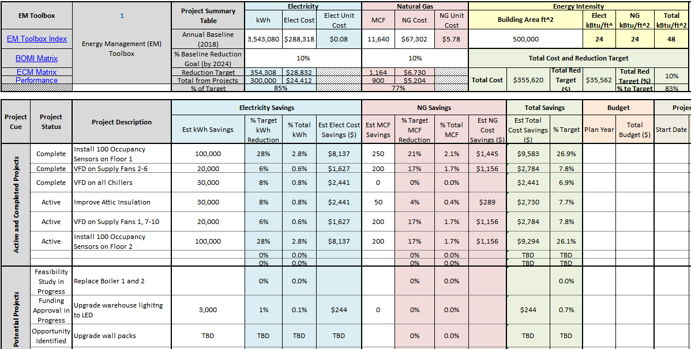

The project tracking portion of the roadmap table is divided into two (2) sections, the active project section, and the potential project section. The roadmap table allows the building energy team to have the option to track the following items for active and potential energy conservation projects:

Roadmap Input Fields:
Input Field | Description
Project Status | This is a selectable field. Potential project statuses include “Funding Approval in Progress”, “Feasibility Study in Progress”, and “Opportunity Identified”. Active and Complete statuses can be chosen for projects that have approved funding.
BOMI/ECM Best Practice | Best practice description listed on the BOMI and ECM tables.
Project Description | Detailed description of the project.
Est kWh Savings | Estimated annual kWh savings after project implementation is completed.
Est MCF Savings | Estimated annual MCF of natural gas (NG) savings after project implementation is completed.
Est Gal Savings | Estimated annual gallons of water savings after project implementation is completed.
Plan Year | Fiscal year when funds are allocated to the project and when the project implementation begins.
Total Budget | Total funds allocated to implement the project.
Start Date | Actual date when implementation begins.
Completion Date | Actual date when project is completed.
Utility Rebates | The dollar amount of utility rebates available for the project.

Roadmap Output Fields:
Output Fields | Description
% Target kWh Reduction | Percentage of estimated project annual savings in kWh based on total reduction target.
% Total kWh | Percentage of estimated project annual savings based on total kWh usage.
Est Elect Cost Savings | Estimated annual electricity cost savings based on estimated project annual savings and annual energy cost baseline in US dollars per kWh.
% Target MCF Reduction | Percentage of estimated project annual savings in MCF based on total reduction target.
% Total MCF | Percentage of estimated project annual savings based on total MCF of NG usage.
Est NG Cost Savings | Estimated NG cost savings based on estimated project savings and annual energy cost baseline in US dollars per MCF.
% Target Gal Reduction | Percentage of estimated project annual savings in gallons based on total reduction target.
% Total Gal | Percentage of estimated project annual savings based on total gallons of water used.
Est Water Cost Savings | Estimated water cost savings based on estimated project savings and annual energy cost baseline in US dollars per gallon.
Total Savings (Cost) | Total utility cost savings per project (electricity + natural gas + Water).
% Total Savings (Target) | Percentage of total utility cost reduction target per project.
Est Total Savings | Total utility cost savings based on estimated kWh, MCF, Gallons project savings and annual utility cost baseline in US dollars per kWh, MCF and gallon.
Est SPB (Years) | Estimated simple payback (SPB) based on estimated total utility cost savings and total project cost (total budget allocated to implement the project).

The roadmap table has 30 records available to keep track of active and potential projects. The first fifteen (15) records are available for active projects while the reminder 15 records are available for potential projects (see screenshot below).

Roadmap Potential Projects Section
Roadmap Active Projects Section

Projects listed in the potential project section of the roadmap can be moved to the active project section when the plan year is defined and funds are allocated to the project. Note that the active and potential project list should be updated at the beginning of the plan year to document the plan’s progress on an annual basis.

To add projects identified using the BOMI and ECM tables, select from the dropdown list on the BOMI/ECM Ref Number field the BOMI or ECM reference number associated with the best practice in question (see the screenshot below).

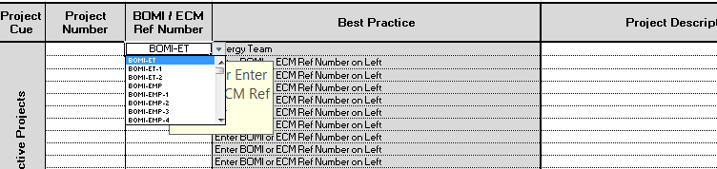
BOMI/ECM Ref Number Dropdown List

Once the BOMI or ECM reference number has been selected, the Best Practice field will be automatically populated with the corresponding best practice description (see the screenshot below).

The above screenshot also shows that the energy team can enter a more detail description of the project in the Project Description field.

Again, all shaded cells contain formulas or titles. Any white cells in the tables are data entry cells. The estimated energy usage saving fields are manually filled out by the building energy team while the percentage of target reduction, the percentage of total kWh and MCF, and the estimated energy cost saving fields are calculated automatically. Please note that to enter a project with kWh savings only, ensure that the MCF field is blank or 0 (and vice versa for entering MCF only, ensure kWh is blank or 0). Typing in characters, such as “none” or “NA”, will cause the Total Savings and Simple Payback calculations to default to “TBD” and “Estimate Elect and/or NG Savings” to display. You can use “TBD” as a signal that savings for that energy type still needs to be calculated. The plan year, total budget, and the project plan (actual start and completion dates) fields are manually entered by the building or central energy team, while the estimated total savings and simple payback (SBP) fields are calculated automatically (see screenshots below).
Others are automatic fields (Percentage and Cost Savings)
Automatic fields
Others are automatic fields (Percentage and Cost Savings)
Others are automatic fields (Percentage and Cost Savings)

Manual field
Manual field
Manual field

Manual fields
Manual fields
Automatic fields

The roadmap can also be used to track energy conservation projects that are identified using energy management tools outside of the BOMI/ECM Matrix. To add a project outside of the BOMI/ECM scope, follow the procedure described previously for adding projects to the roadmap with the exception of selecting ‘----‘as the BOMI/ECM reference number for the project (see screenshot below).

Each roadmap contains performance metric gauges to help the energy team visualize the gap between the actual/current energy cost savings and the building’s target (see screenshot below).

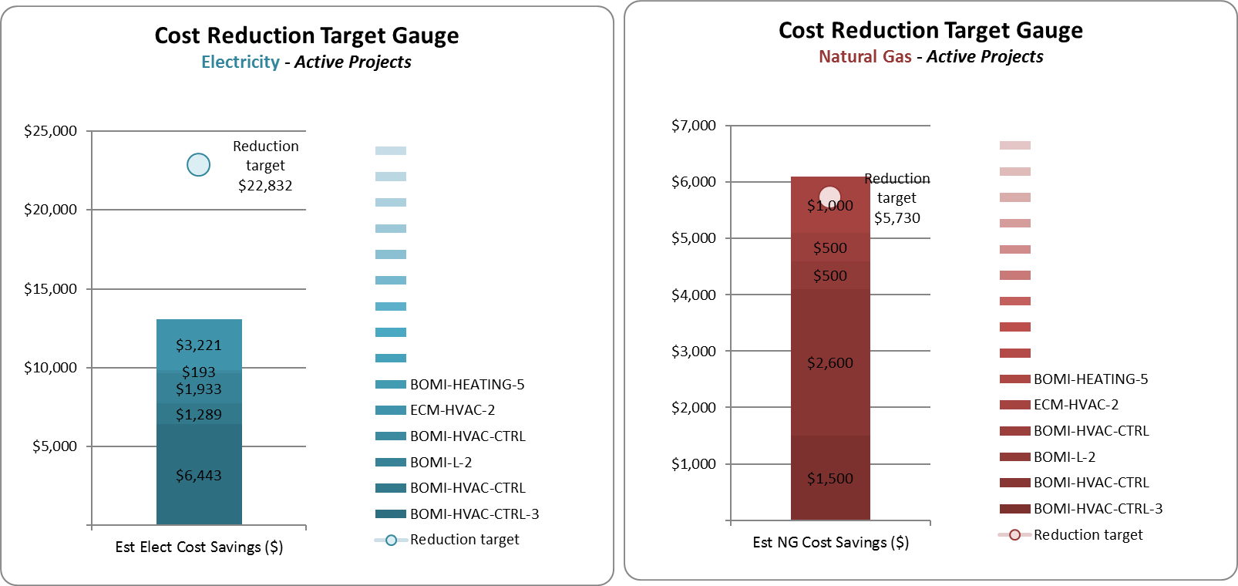
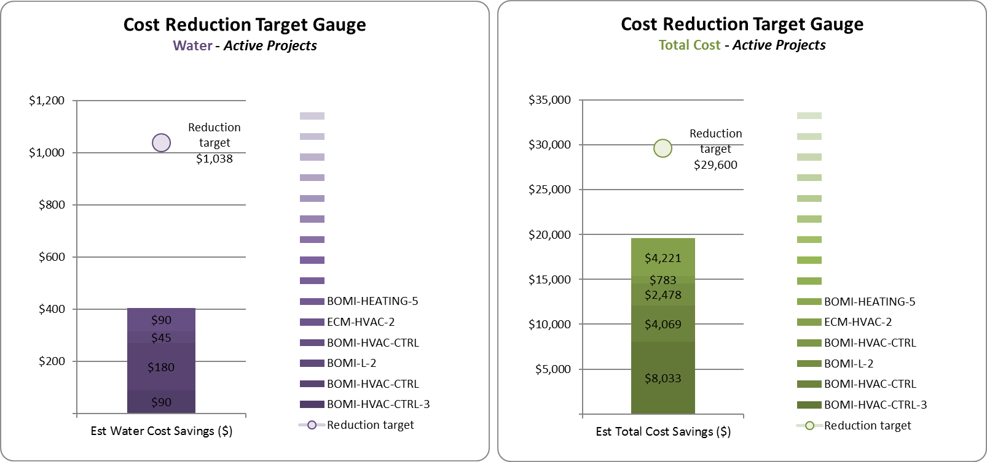

These gap charts display all projects, with their related electricity, natural gas, water, and total utility cost savings, in a stacked bar along with the associated reduction target. The gap charts are linked to the roadmap table, so they are automatically updated as the energy team updates the roadmap fields.

Additionally, an Energy and Cost tracking table, which includes monthly kWh, MCF, Gallon, Cost and Energy Intensity in kBtu/ft^2 is included in the roadmap tabs to help the energy team compare the energy performance metrics on an annual basis (see screenshot below). Note that EP&S builds EM Toolboxes that are unique for each customer. Therefore, your toolbox may contain additional years of historical data, weather and/or production metrics.
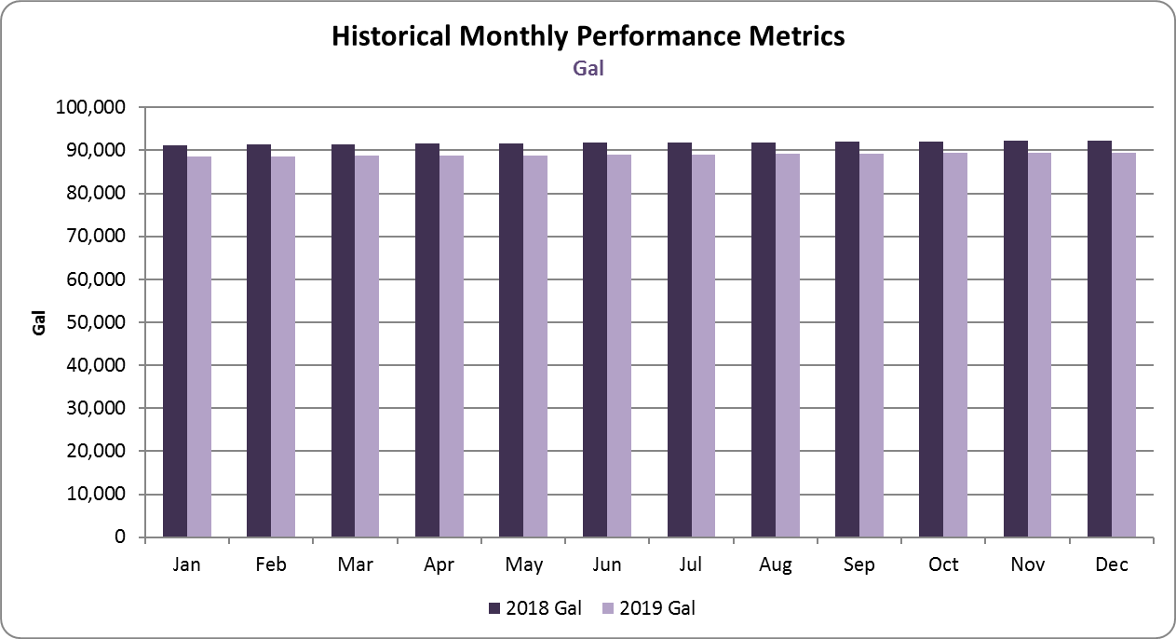
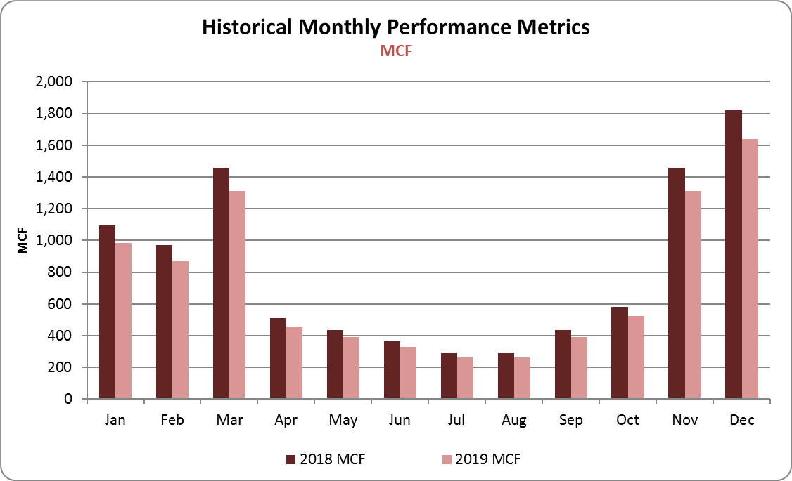
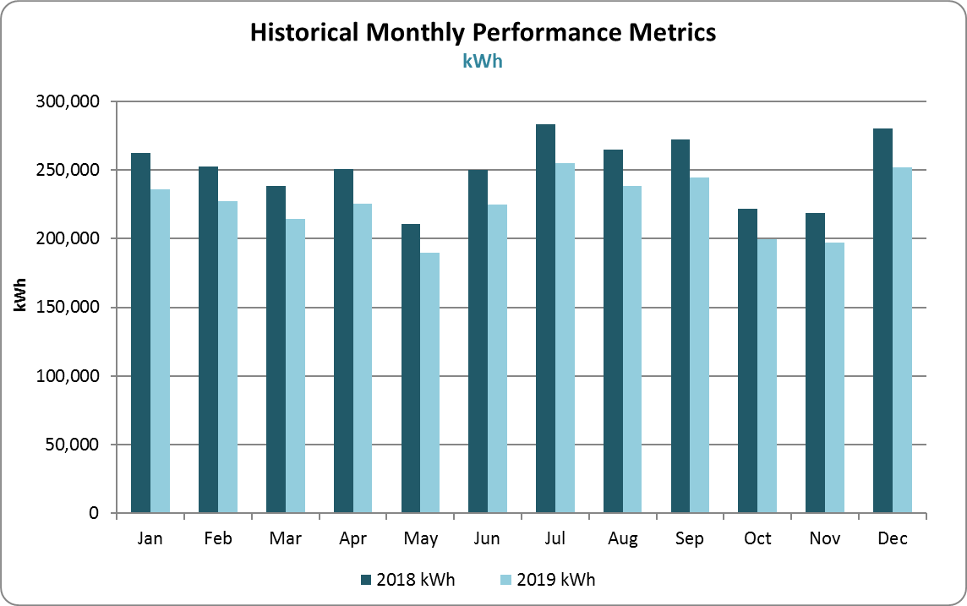
The kWh, MCF, Gallon, Cost and kBtu/ft^2 charts are linked to the Energy Tracking table, so the charts will be automatically updated as the energy team manually update the kWh and MCF data on the table. Note that the Energy Intensity fields in the table are automatically calculated.
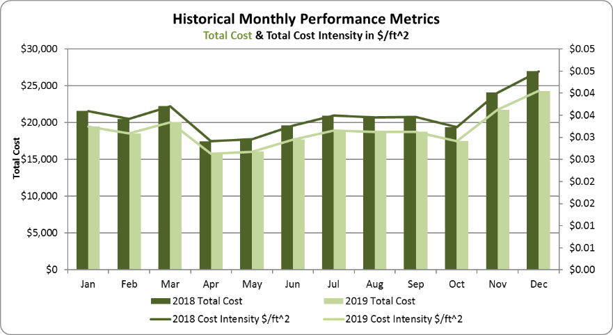
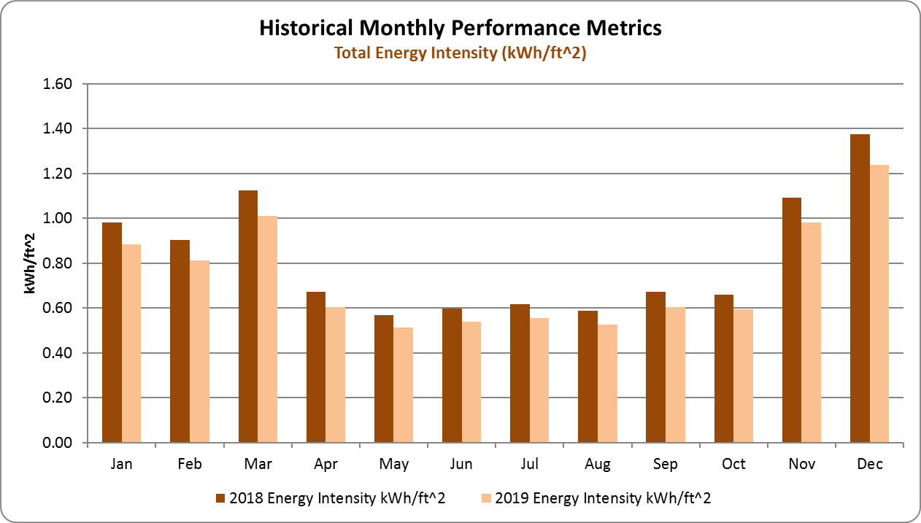

Checklist Tables

For your convenience two checklists are available to use when initially populating the BOMI matrix, ECM matrix, and Roadmap tables. To access the Checklists, open the main EM Toolbox file and click on the BOMI and ECM Checklist or Roadmap Assessment Checklist hyperlink highlighted in yellow on the screenshot below.

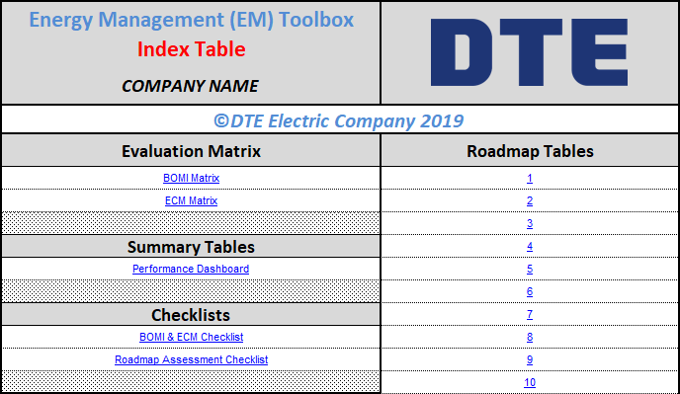

The checklists can be printed to assist in data gathering and building assessments. Partial Screen shots of the checklists are below.

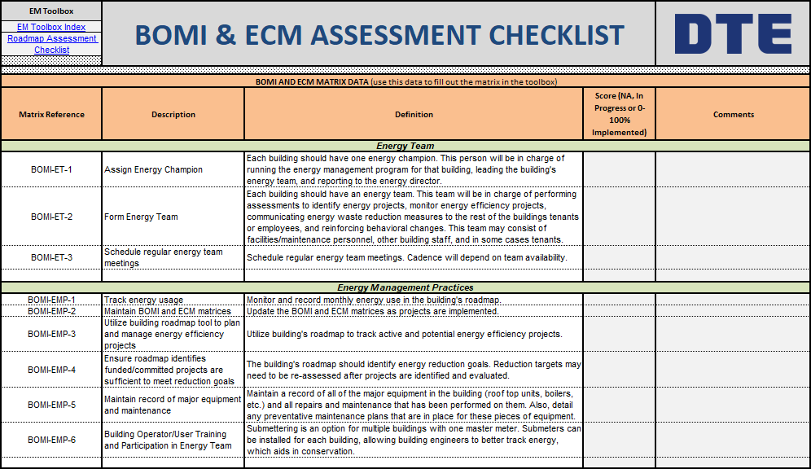
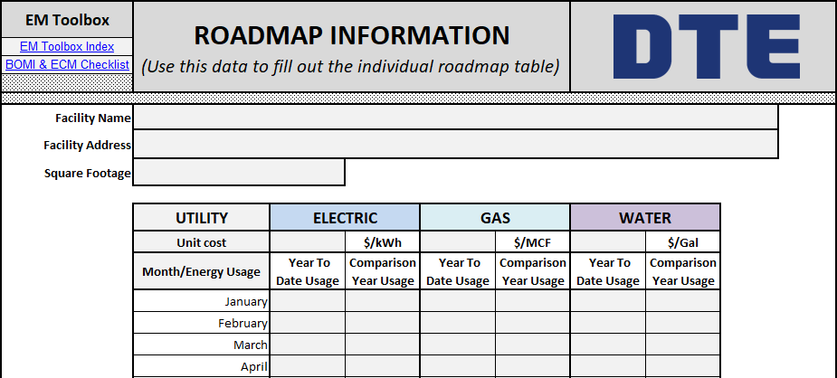

Performance Dashboard

To access the Performance Dashboard, open the EM Toolbox file and from the EM Toolbox Index table select the Performance Dashboard hyperlink (see screenshot below).

The Performance Dashboard can also be opened from the hyperlink section found in the top-left corner of the BOMI matrix, the ECM Matrix, and roadmap tables (See screenshot below).
Hyperlinks Section in BOMI Table
Hyperlinks Section in Roadmap table

The dashboard provides a summary of building energy performance for each of the facilities included in the Toolbox. On the left side of the dashboard, a BOMI and ECM Performance Index gauge illustrates the progress through implementation of best practices listed on the BOMI and ECM matrices. This is followed by scorecards that display the gap between estimated savings from active projects and the reduction targets identified for electricity, natural gas, and total energy savings. The dashboard also includes an energy and cost intensity scorecard that will help the energy team to identify buildings that fall further from the average energy intensity calculated for your portfolio of buildings. The metric is color coded based on a kBtu/ft^2 or $/ft^2 deviation greater than +/- 20% of the average. The scorecard data is complemented with the count of active and potential projects per building (see screenshot below).

BOMI and ECM Performance Index
Electricity, Natural Gas, and Total Reduction Scorecards
Energy and Cost Intensity Scorecard
Active and potential project counter

Next, the dashboard lists a summary of the annual energy usage and cost savings for electricity, natural gas, and total. In addition, the dashboard lists a summary of the annual energy usage baseline and energy intensity for each building (see the following screenshot).

Total projects summary (Elect)
Natural gas usage and cost savings summary
Electricity usage and cost savings summary
Annual natural gas usage and cost baseline
Annual electricity usage and cost baseline

If your organization is tracking water use, the dashboard will also display a similar set of metrics for your water utility data (see screenshot below).

Annual water usage and cost baseline
Water usage and cost savings summary
Water Reduction Scorecard
Water Intensity Scorecard

Below the main dashboard table, on the left side, you will find a BOMI and ECM Performance Index Scorecard that shows the overall (average of all facilities) progress through the implementation of BOMI and ECM best practices based on building systems (see screenshot below).

On the right side of the dashboard, below the main table, you will find a chart that illustrates the electricity, natural gas, and total energy intensity in kBtu/ft^2 for each facility included in the toolbox (see following chart).

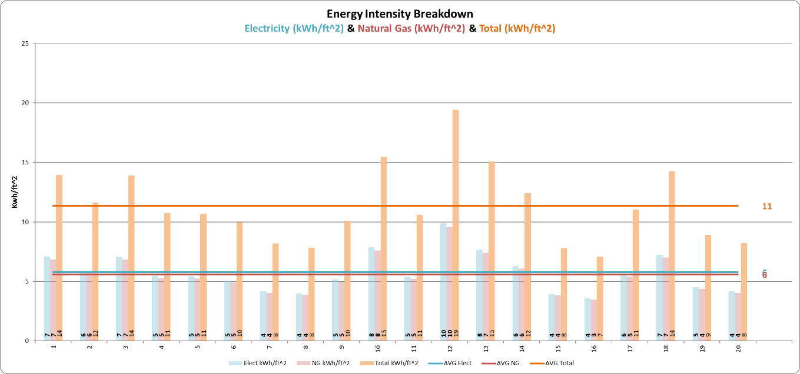

Below the Energy Intensity Breakdown chart, you will find a Cost Intensity Breakdown chart that illustrates the total cost of utilities in $/ft^2 for all facilities included in the toolbox (see following chart).

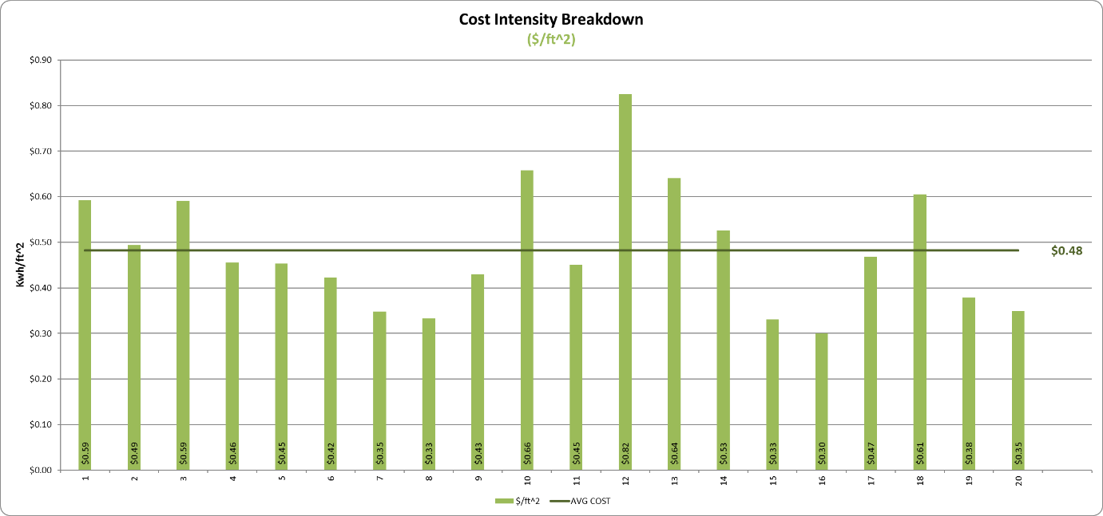

If your organization is tracking water, the performance dashboard will also display a Water Intensity Breakdown chart that illustrates water intensity in gallons/ft^2 for all facilities included in the toolbox (see following chart).

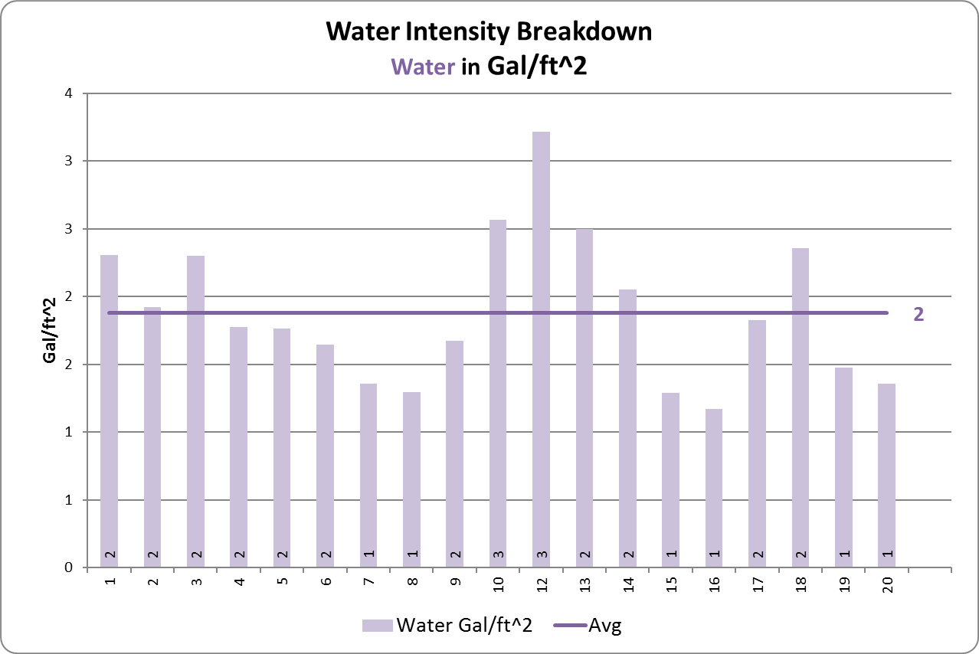

Additionally, an Energy and Cost tracking table, similar to the one provided in the roadmaps, is included in the performance dashboard. The main difference is that this table automatically sums all roadmap’s monthly kWh, MCF, Gallon, Cost, and Energy Intensity in BTU/ft^2, to help the energy team compare the energy performance metrics on an annual basis at the campus level. Again, kWh, MCF, Gallon, Cost and kBtu/ft^2 charts are linked to this Campus-Wide Energy Tracking table, so the charts will be automatically updated as the energy team manually update the kWh, MCF, and Cost data in the roadmaps.

Other Procedures (SWIs)
The present user manual is for training energy team personnel in the use of the EM Toolbox. A separate administrative manual is provided to train the energy team in file system maintenance, including changes to the Index, BOMI, ECM, Checklists, Roadmap, and Dashboard tables (see EM Toolbox Administrative Manual). The EM Toolbox Administrative Manual also describes the procedure for making changes such as adding/removing facilities or adding/removing best practices within the file system.

Security
The EM Toolbox tables and files are in protected format, allowing data to be entered in manual fields required to use the BOMI, ECM, and Roadmap tables only. To maintain the integrity of equations and hyperlinks, the auto fields containing equations and hyperlinks, and the tables’ field/record headings are in protected format, to guard against accidental deletion. For the same reasons, edits to the tables’ fields/records format are also protected.

General Notes
Note that all the tables/fields/charts listed in the Performance Dashboard are linked to the roadmap source tables, so they are all automatically updated when the EM Toolbox and roadmap tables are updated.

The facilities’ data used to create this manual does not represent the actual data of the facilities listed in your EM Toolbox.

