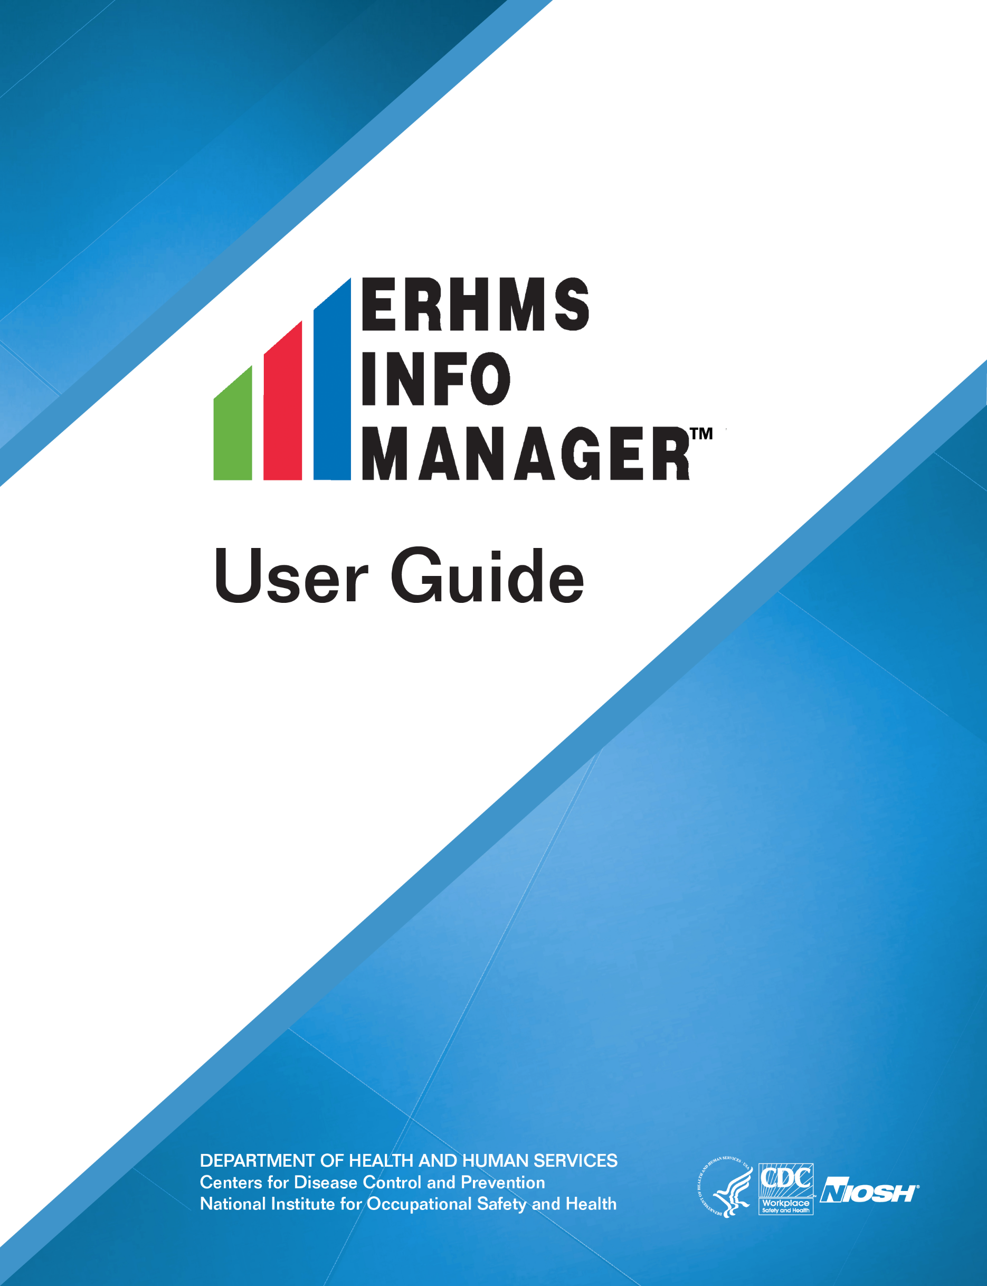
Version 1.0
This document is in the public domain and may be freely copied or reprinted.

Disclaimer
Mention of any company or product does not constitute endorsement by the National Institute for Occupational Safety and Health (NIOSH). In addition, citations to websites external to NIOSH do not constitute NIOSH endorsement of the sponsoring organizations or their programs or products. Furthermore, NIOSH is not responsible for the content of these websites. All web addresses referenced in this document were accessible as of the publication date.

Ordering Information
To receive documents or other information about occupational safety and health topics, contact NIOSH:
Telephone: 1–800–CDC–INFO (1–800–232–4636)
TTY: 1–888–232–6348
CDC INFO: https://wwwn.cdc.gov
or visit the NIOSH website at https://www.cdc.gov/niosh/.
For a monthly update on news at NIOSH, subscribe to NIOSH eNews by visiting www.cdc.gov/niosh/eNews.

Suggested Citation
NIOSH [2017]. ERMHS info manager user guide. By Shugart JM, McGarvey A, Williams S, Dowell CH. Cincinnati, OH: U.S. Department of Health and Human Services, Centers for Disease Control and Prevention, National Institute for Occupational Safety and Health, DHHS (NIOSH) Publication 2017–169.

DHHS (NIOSH) Publication No. 2017–169
July 2017

Table of Contents
Disclaimer i
Ordering Information i
Suggested Citation i
Background 1
ERHMS™ Framework 1
Setup 2
ERHMS Info Manager™ installation 2
Optional Components 3
Automatic Updates 3
First-Time Setup 3
User Interface Navigation 4
Settings 5
Email Settings 6
Mapping Settings 7
Web Survey Settings 7
Data Sources 8
Adding a New Data Source 8
Changing Data Sources 10
Responders 10
Creating a Responder Profile 10
Editing a Responder Profile 11
Incidents 12
Creating Incidents 13
Viewing and Adding Notes 15
Managing an Incident Roster 16
Locations 17
Forms 19
Creating a Form 20
Collecting Data 21
Publishing Forms to the Web 21
Templates 23
Creating a Form from a Template 24
Creating a Template from a Form 26
Data Import/ Export 27
Assignments 31
Distributing Surveys 31
Downloading FORMS from WEB Survey 32
Analysis 33
Help 35
ERHMS Info Manager™ Support 35
Logs 35
Viewing Logs 35
Deleting Logs 35
Packaging Logs 35
ERHMS Info Manager™ UnInstall 36
aBOUT 36
License Information 36
Appendix B: References 43

Background
The collapse of the World Trade Center and the subsequent persistent and complex health problems experienced by the emergency responders illustrated the need for improved health monitoring and surveillance of emergency responders. As a result, a multi-agency task force was created to address the problem. This task force worked with the U.S. National Response Team (NRT) to develop the Emergency Responder Health Monitoring and Surveillance™ (ERHMS™) Technical Assistance Document (TAD). The TAD details best practices and contains tools, examples, and forms that have been used by various agencies when responding to incidents. The TAD is available at https://www.cdc.gov/niosh/topics/erhms/.

ERHMS™ Framework
ERHMSTM is a framework designed to help protect emergency responders throughout the pre-deployment, deployment, and post-deployment phases of a response as depicted in this diagram.

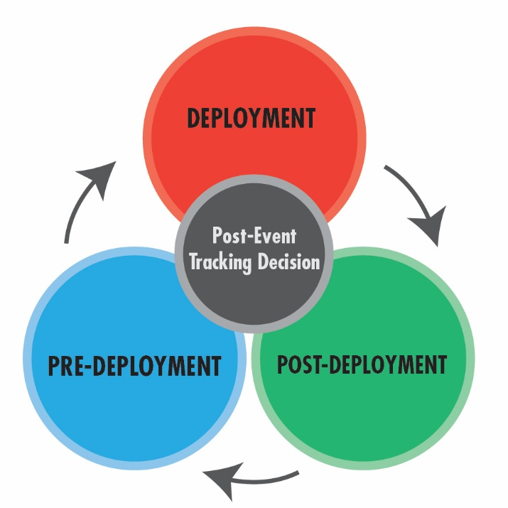

The intent of medical monitoring and surveillance of emergency response and recovery workers is to identify exposures and signs and symptoms early in the course of an emergency response to prevent or mitigate adverse physical and psychological outcomes and also to ensure workers maintain their ability to respond effectively and are not harmed in the course of their work. Monitoring and ongoing assessment can help determine whether protective measures are adequately being provided to the workforce and are sufficient to prevent or reduce harmful exposures to workers. Data collected during the pre-, during-, and post-deployment phases will also help to identify which responders would benefit from medical referral and possible enrollment in a long-term health surveillance program. Key concepts identified within the ERHMS framework include:

- Pre-deployment Phase: Rostering and credentialing of emergency response and recovery workers, health screening for emergency responders, health and safety training, data management, and information security

- Deployment Phase: On-site responder in-processing, health monitoring and surveillance during response operations, integration of exposure assessment, responder activity documentation and controls, communications of exposure and health monitoring, and surveillance data during an emergency response

- Post-Deployment Phase: Responders out-processing assessment, post-event tracking of emergency responder health and function, lessons-learned, and after-action assessments

This framework builds on systems and practices currently in use and can be used in both small and large scale incidents depending on the needs of the organization and event.

ERHMS Info Manager™ is a free software platform to track and monitor emergency response and recovery worker activities before, during, and after their deployment to an incident site. ERHMS Info ManagerTM enables organizations to implement the ERHMSTM framework. For more information on how to implement the ERHMSTM framework, install ERHMS Info ManagerTM, online training courses, and additional resources, visit the ERHMSTM website at https://www.cdc.gov/niosh/topics/erhms/.

Using ERHMS Info ManagerTM, you can:
- Create responder profiles
- Record response incidents and map incident locations
- Assign responders to an incident roster
- Design forms and surveys using custom and pre-built templates
- Request information from responders by using forms and surveys
- View and analyze forms and survey responses

ERHMS Info ManagerTM uses the free and publically-accessible software application, Epi Info™. ERHMS Info Manager TM uses Epi InfoTM for creating forms, capturing data, and analyzing data. Epi InfoTM is automatically installed with the installation of ERMHS Info ManagerTM. To efficiently utilize ERHMS Info ManagerTM, users should familiarize themselves with the functions and features of Epi InfoTM. The Epi InfoTM User Guide, User Community Q & A, FAQs, and Tutorials are excellent resources available on the Epi InfoTM website at https://www.cdc.gov/epiinfo/index.html.

Setup

ERHMS Info Manager™ installation
To install ERHMS Info ManagerTM, go to the installation link on the ERHMS Info ManagerTM web page at http://www.cdc.gov/niosh/erhms/software. Once you go to the link, the NIOSH ERHMS Info ManagerTM screen will appear. ERHMS Info ManagerTM installation has some prerequisites, namely, Windows® XP or higher and Microsoft® .NET Framework 4.
Once the prerequisites are installed, you can proceed with the installation of ERHMS Info ManagerTM, as shown in the image below.

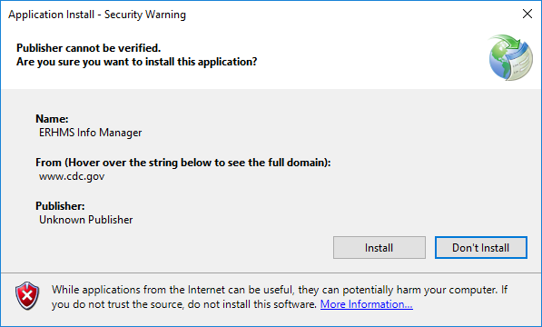

To uninstall ERHMS Info ManagerTM, go to the Uninstall section of this User Guide.

Optional Components
ERHMS Info Manager™ includes some advanced features which require interaction with other software components. Installing these components is only necessary if you would like to make use of these features. To see more information on Microsoft SQL Server®, visit the Adding a New Data Source section of this Manual.
- Microsoft SQL Server® may be used as the underlying database management system for ERHMS Info Manager™.
- Epi InfoTM Web Survey is a server-based software component that consists of a website and a database. It allows collection of information from responders through the internet by using a responsive web interface. Refer to the Epi InfoTM website at https://www.cdc.gov/epiinfo/cloud.html for more instructions on downloading, installing, and configuring Epi InfoTM Web Survey.

Automatic Updates
Each time you open ERHMS Info ManagerTM the software will check with the NIOSH server to see if there is an update. If an update is available, a prompt will ask if you would like to install the update or proceed without updating.

First-Time Setup
The software will be downloaded and installed under your user account. The first time the software is started, you will be prompted to select a location to store your application files. Browse your folders, select the location that you desire, and click OK. The software will create a folder named ERHMS Info Manager in that location to store your application files.

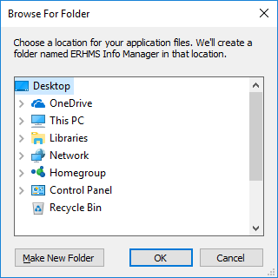

User Interface Navigation
ERHMS Info Manager TM includes a tabbed user interface that allows simultaneous access to multiple modules. As modules are opened, new tabs appear at the top of the window just below the ribbon. Each tab may contain subsections that are listed along the left-hand side of the window. See the screenshot below for an example.

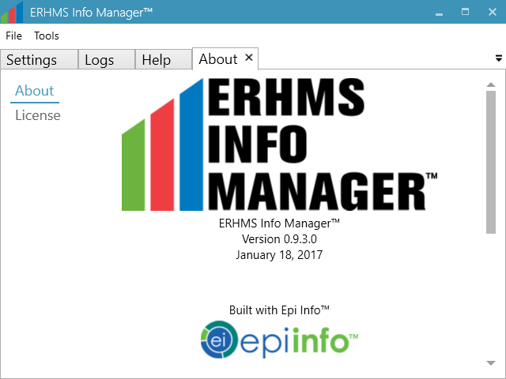
Tabs
Subsections

To navigate between modules or subsections using the mouse, simply select the desired heading. To navigate between modules using the keyboard, press and hold the Ctrl key, then press Tab. This brings up a dialog that lists the modules that are currently open (see below). While continuing to hold Ctrl, press Tab until the desired module is selected, then release Ctrl to display it.

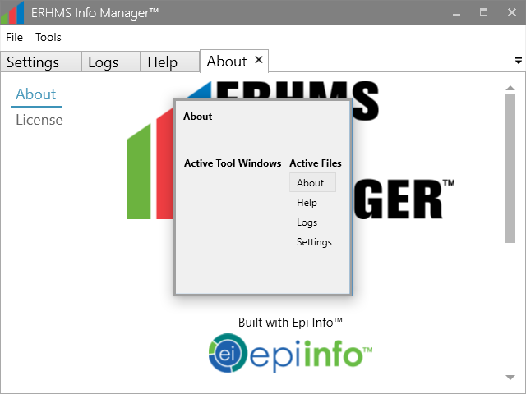

To navigate between subsections using the keyboard, press and hold the Ctrl key, then press Page Up or Page Down to cycle backward or forward through the available subsections.
To close a module using the mouse, select the close button on its corresponding tab, or select File – Close Tab from the ribbon. To close a module using the keyboard, press Ctrl+W.
ERHMS Info Manager TM also supports other standard mechanisms for keyboard navigation. For example, to cycle keyboard focus through the elements within a module, press Tab to move forward or Shift+Tab to move backward. Many elements are also directly accessible without having to cycle to them. Press and hold the Alt key to show any available shortcuts, which appear as underlined letters. While continuing to hold Alt, press the key corresponding to the underlined letter to activate the element.

Settings
The first time using ERHMS Info ManagerTM, configure its settings by selecting, Tools – Settings from the Ribbon. This tab will give you the ability to configure your Email Settings, Mapping Settings, and Web Survey Settings, each of which will be described further below. The General Settings (Logging Level and Root Directory) should not be changed during the routine operation of ERHMS Info ManagerTM.

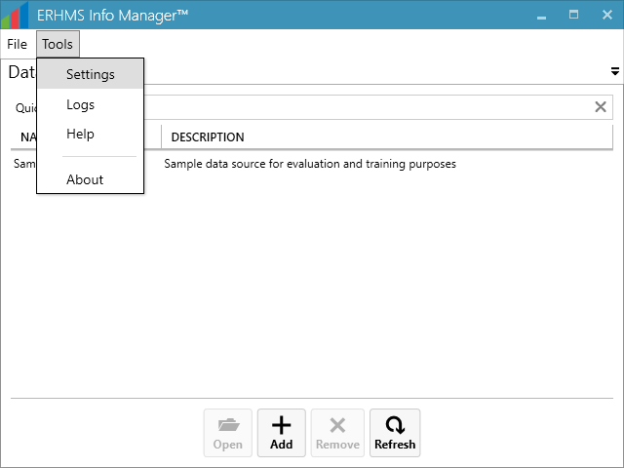

Email Settings
ERHMS Info ManagerTM allows users to distribute surveys to responders via email. To configure this feature, enter the following in the Email Settings section (your System Administrator can provide you with this information):

- SMTP Host
- SMTP Port
- Use SSL
- Sender Address: A valid email address that will be used for ERHMSTM administration
- Sender Password: The password used to log in to the mail server (leave blank to instead use the default credentials of the currently logged in user)

When you have finished entering the Settings information, select the Save button.

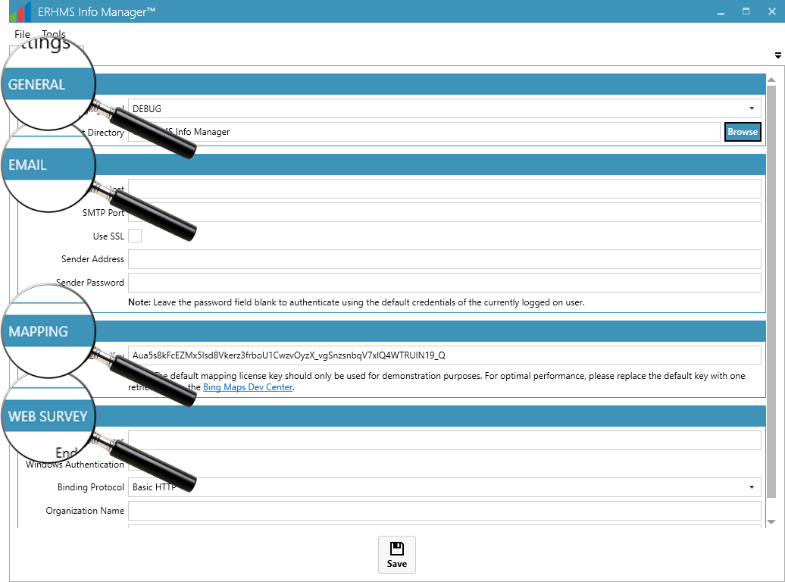
Web survey settings
Mapping settings
Email settings

Mapping Settings
ERHMS Info ManagerTM uses Bing Maps to plot incident locations. The default Map Service Key should only be used for demo purposes. For optimal performance with mapping and geocoding, replace the default key with one retrieved from Microsoft’s Bing service Bing Maps Portal at https://www.bingmapsportal.com/. To request a key, you will need to create a Microsoft or Azure account, or log in using an existing account. When you have finished entering the Settings information, select the Save button.

Web Survey Settings
Epi InfoTM Web Survey is a server-based software component (separate from ERHMS Info ManagerTM) that consists of a website and a database. If you are using Epi Info TM Web Survey, enter your connection information in the Web Survey settings section (sample values provided in the image below). Refer to the Epi InfoTM website at https://www.cdc.gov/epiinfo/index.html for more instructions on downloading, installing, and configuring Epi InfoTM Web Survey. For information on completing the Web Survey fields, visit the Web Survey Section of the Epi InfoTM’s User Guide at https://wwwn.cdc.gov/epiinfo/user-guide/survey/initial-setup.html. When you have finished entering the Settings information, select the Save button.
A description of each field that appears in the Web Survey section of the Settings screen, is provided below:
- Endpoint Address: The URL that ERHMS Info ManagerTM uses to connect to the Epi Info TM Web Survey server.
- Windows Authentication: Whether or not to pass your Windows credentials to the Epi InfoTM Web Survey server for authentication.
- Binding Protocol: The protocol used to communicate with the Epi InfoTM Web Survey server.
- Organization Name: The name of your organization in the Epi InfoTM Web Survey database.
- Organization Key: The password for your Epi InfoTM Web Survey.

Data Sources
A Data Source is a repository that stores the information that is entered through the ERHMS Info ManagerTM software. The first time you open Data Source, it prompts you to create a data source. When the software opens, it displays a list of the data sources available for use. Each data source represents a separate repository or workspace for ERHMSTM data, including responders, incidents, forms and surveys. A data source is typically maintained by a single emergency response organization. However, there are situations in which multiple Data Sources might be necessary. See the following list of options available on the Data Sources screen, which includes descriptions of when you might use each option:
- Add a new data source
Use this option if you would like to create a new, empty data source. This data source will initially contain no responders, incidents, or custom forms, so you will need to add these items once the data source is created. You would typically choose this option when first starting to use ERHMS Info ManagerTM in your organization.
- Open an existing data source from the list
Use this option if you would like to open a previously created data source that already appears in the list of data sources.
- Add an existing data source previously created in ERHMS Info ManagerTM
Use this option if you would like to open a previously created data source that does not appear in the list of data sources. You would typically choose this option when there are multiple users in your organization using ERHMS Info ManagerTM. In order to connect to a data source created by another user, first use this option to add the data source to your list. Then open the data source normally.
ERHMS Info ManagerTM includes a “sample” data source that you may use to familiarize yourself with the software. We recommend that you create a separate data source to store your organization’s data. A typical organization will use a single data source to store all their responders, incidents, forms, and surveys. However, you may choose to create additional data sources for a variety of reasons:
- You may create a “test” data source in order to test the features of ERHMS Info ManagerTM without modifying your organization’s actual data. You may also use the sample data source for this purpose.
- If you are managing data for multiple organizations, you may create a different data source for each organization.
- If you would like to keep data separate for organizational purposes, you could, for example, create a new data source every year, using it to store data related to the incidents that occur during that year. Note that the new data source would initially be empty, meaning that responders would need to be reentered. To avoid manual reentry, responders could be exported from the old data source and imported into the new data source. For more information on importing and exporting data, visit the Import/ Export section of this manual.

Adding a New Data Source
When ERHMS Info ManagerTM opens, the Data Sources screen will appear. This screen will display a sample data source that you can use to familiarize yourself with the software. Note the Quick Filter that appears at the top of this screen and many other screens in ERHMS Info ManagerTM. You may use the Quick Filter to search through a list for items matching a given string of text.

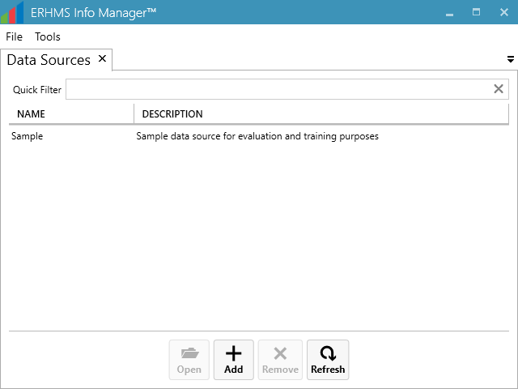

Add a new data source by selecting Add – New. In the pop-up window, enter the Name, Description, and Location of the new Data Source. Specify the Database Type from the dropdown list of options:
- Microsoft Access®—Select this option when a single user will be accessing the data source. ERHMS Info ManagerTM will create a new Access® database in the specified location. Note that the user does not need Microsoft Access® installed in order to use this option.
- Microsoft SQL Server®—Select this option when multiple users will be accessing the data source. Using a SQL Server® database requires server connection information from your database administrator. Each individual using a SQL Server® data source will need to install ERHMS Info ManagerTM on their computer, and all users will use the same server connection information.

If a user would like to use the Microsoft Access® option, select it and go to Create. For Microsoft SQL Server®, additional options (such as the server and database names) must be provided before selecting Create. When the data source creation is complete, the user will select the new data source from the Data Sources list and select Open. The next time ERHMS Info ManagerTM is opened, the new data source will be included in the list of previously opened data sources.

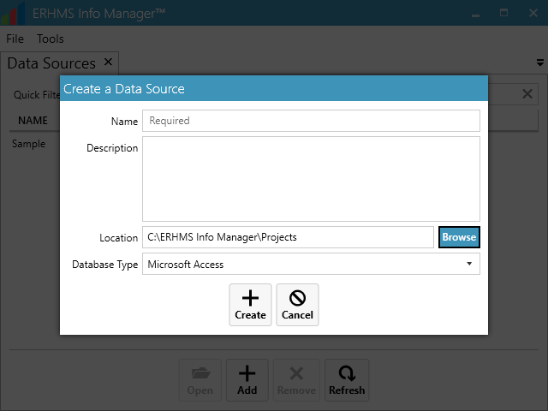

Changing Data Sources
You may switch to another data source at any time. Select File – Data Sources from the ribbon, select the data source from the list, and select Open. ERHMS Info ManagerTM will close the currently open data source before opening the selected one.

Responders

Creating a Responder Profile
To create a new responder profile, select Responders – Create New from the ribbon, which opens the responder detail screen. There are three sections of responder information to select from the subsection: 1) personal, 2) emergency contact, and 3) organization. The first name, last name, and email address fields are required. After entering the information, select Save. Note: The entire responder pool should be entered in order to track all responders who participated in an incident. This roster of responders can be used as a baseline contact mechanism to create a registry of affected workers if medical or legal follow-up is needed.

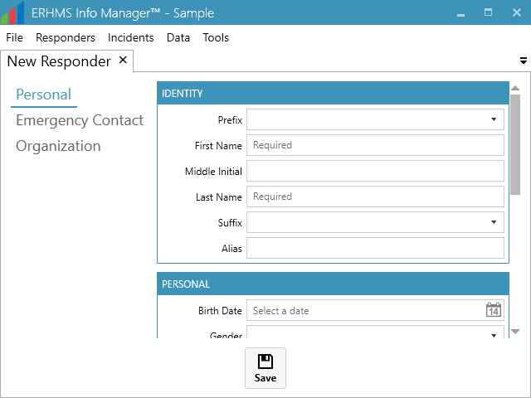

The responder data collected in ERHMS Info ManagerTM is stored in an underlying Epi InfoTM form. This means that you may use any of the form-related features provided by ERHMS Info Manager and Epi InfoTM to manage your responder data. You may access these features by selecting Data – Forms from the ribbon, selecting the Responders form, and choosing one of the available options.
A user can edit the form in order to add fields that are not provided by ERHMS Info ManagerTM, such as a responder’s mother’s maiden name or an organization-specific ID. These custom fields would not be displayed in the ERHMS Info ManagerTM responder detail screen, but they could be viewed and edited in the Epi InfoTM form designer, data entry screen, and analysis tools. See the Forms section of this document or the Forms Section of the Epi InfoTM User Guide at https://www.cdc.gov/epiinfo/pdfs/userguide/2_formdesigner.pdf for more information on working with forms.
Be careful not to delete the Responders form or any of the fields used by ERHMS Info ManagerTM, as this will cause system instability.

Editing a Responder Profile
Once a responder profile has been saved, their information will display in the list of responders, which can be accessed by selecting Responders – Show All from the ribbon. To edit a responder profile, select the profile from the list and go to Edit at the bottom of the screen. You may also use the Epi InfoTM data entry screen to edit responder data by selecting Data – Forms from the ribbon, selecting the Responders form, and selecting the Data – Edit button from the ribbon. This should only be necessary if you have added custom fields to the responder data as described above.

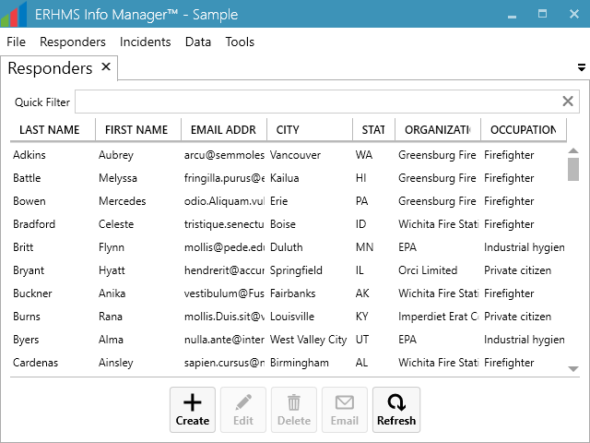

Incidents
An incident is an emergency event, such as a fire, oil spill, flood, tornado, or disease outbreak. To improve the effectiveness and management of responses to and recovery from incidents, use ERHMS Info ManagerTM to:
- Document the incident
- Define and map incident locations
- Add responders to an incident roster
- Manage and update responder information
- Request and collect information from responders
- Analyze collected information

Before an incident can be created, you must open a Data Source. Open ERHMS Info ManagerTM, select a data source, and select Open. Be sure to check that the correct Data Source is open before creating your Incident. Remember that the Data Sources screen can be accessed at any time by selecting File – Data Sources from the ribbon.

Creating Incidents
To create a new incident, select Incident – Create New from the ribbon.

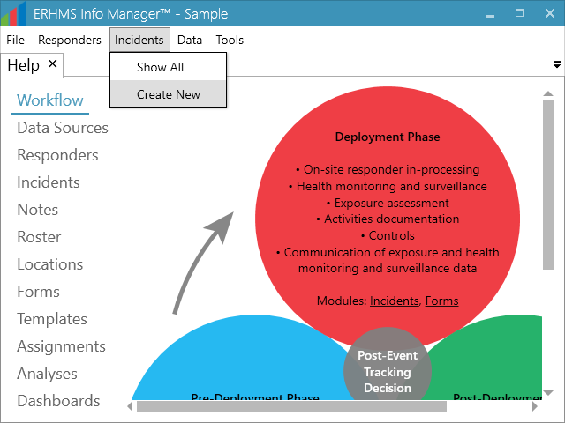

On the New Incident window, enter the following:
- Name
- Description
- Phase (Pre-Deployment, Deployment, Post-Deployment, or Closed)
- Start Date
- End Date (Estimated)
- End Date (Actual) – Leave blank until the incident is closed.

Select the Save button. If you would like to record additional information about the incident, you may do so by using the Notes functionality described below.

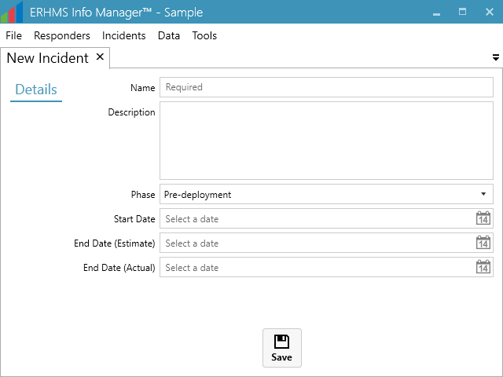

After clicking save, new incident options are displayed on the left sidebar, as shown in the figure below. The information provided by these options is incident-specific. For example, the Forms option displays only forms that have been assigned to the current incident. To view information that applies to any incident or that is non-incident-specific use the ribbon items (such as Data – Forms).
Note that forms, analyses, and dashboards that are created from the incident screen are automatically linked to that incident. Those that are created from screens opened via the Data ribbon item are not linked to any incident by default. To link a form, analysis, or dashboard to a different incident, first open the appropriate screen by selecting an option (Forms, Analyses, or Dashboards) under the Data ribbon item. Choose the desired item and select Incident. To associate the item with an incident, choose the desired incident and select Link, or select Unlink to remove an existing association with an incident.

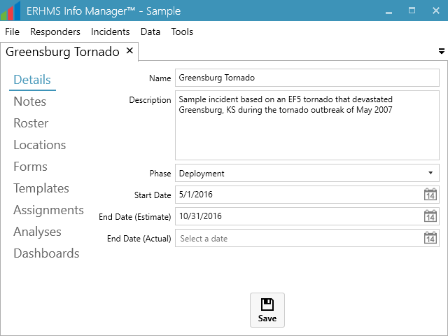

Viewing and Adding Notes
Go to the Notes option to enter incident information. Whenever new notes are added, a date and timestamp are also added to each record. To effectively document responses, enter as many notes as needed.

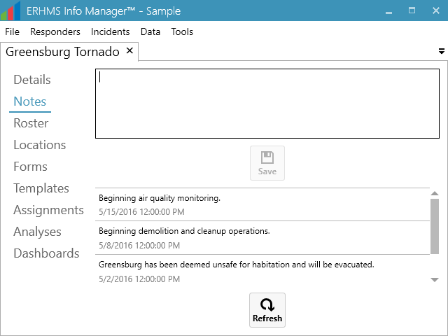

Managing an Incident Roster
From the list of Incident Options, select Roster to create a list of responders assigned to the incident. The list at the top of the screen includes the entire responder pool (all responders that you have added to ERHMS Info ManagerTM). Use the Quick Filter option at the top of the module screen to locate individuals by name, or to find all members of a specific organization, occupation, or city. Select multiple responders by holding down Ctrl or Shift, or by clicking and dragging. To add responders to the roster for your active incident, select the responder to be added to the roster and click Add.

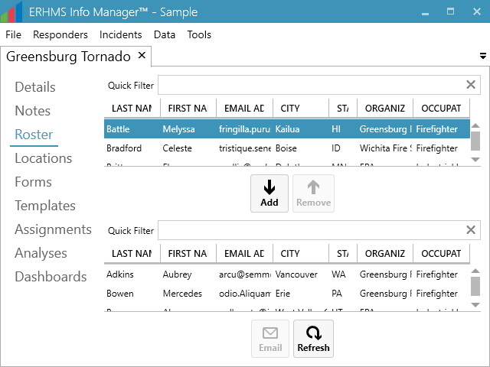

The individuals added to the incident roster disappears from the list of available responders and appears on the current roster list below. To remove a responder from the assignee list, select the responder from the list of assignees and select the Remove button. Note: In order to track all responders during an incident, no matter how long they have worked, it is strongly recommended to NOT remove a responder from the assignee list unless a mistake was made (e.g. an incorrect entry). Responders may be rostered to any number of incidents simultaneously.

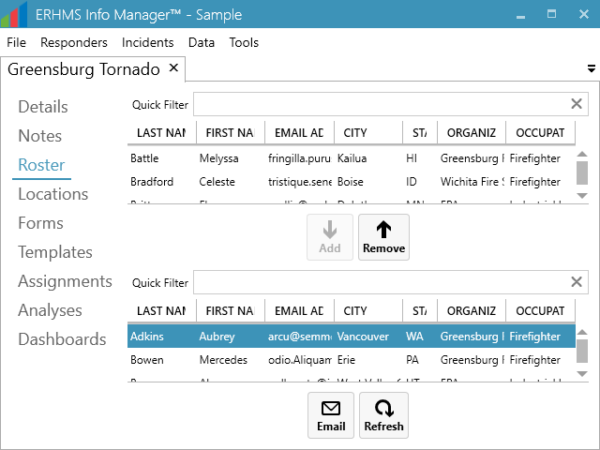

Locations
To add incident locations, select Locations from the Incident Options then click Create at the bottom of the page.

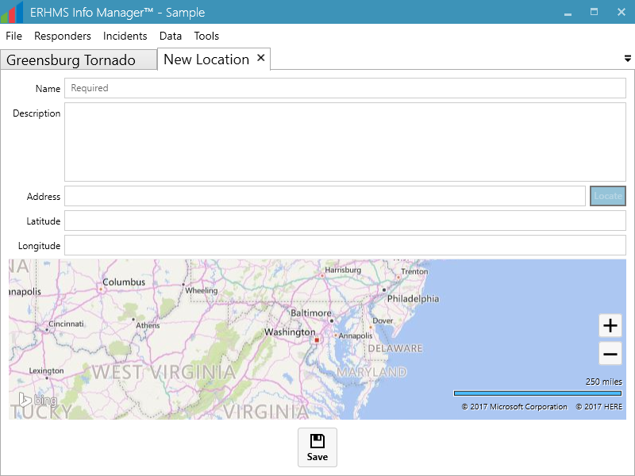

Enter the Name and Description of the location. If the location’s Address is known, enter the address and select Locate (to the right of the Address entry box), which automatically plots the latitude and longitude of the location. Select Save.

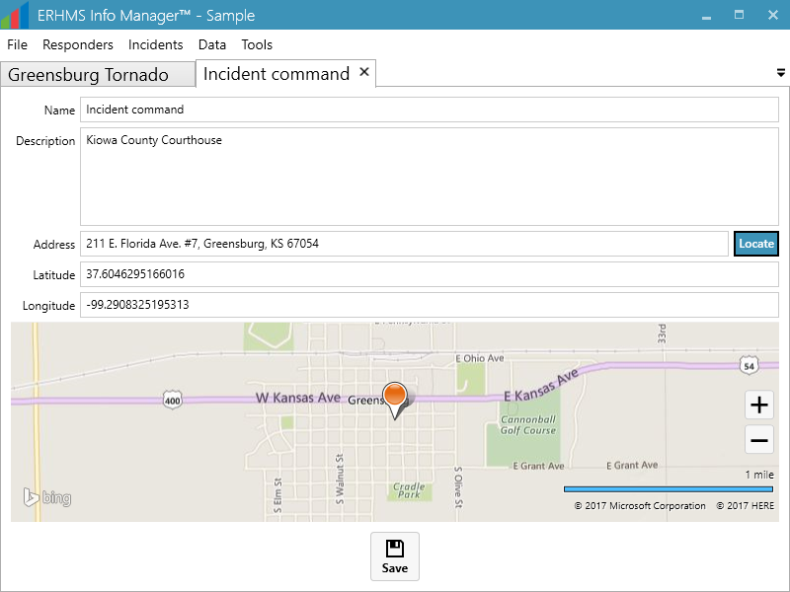

Use the Map feature when an address is unknown or unavailable. To get an approximate location of an unknown address, enter the nearest city or known address in the Address field and select the Locate button. Zoom by rolling the mouse wheel while hovering over the map or by selecting the plus and minus buttons. Double-click the spot corresponding to your location, which drops a pin on the spot and automatically plots the latitude and longitude. Select Save.

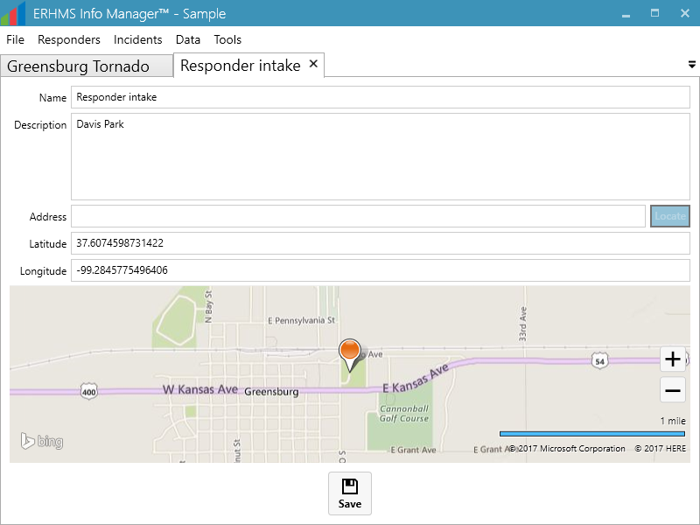

The locations option in the Incident tab will contain all locations associated with the incident. If a new location has been entered but is not displaying, select the Refresh button at the bottom of the screen.

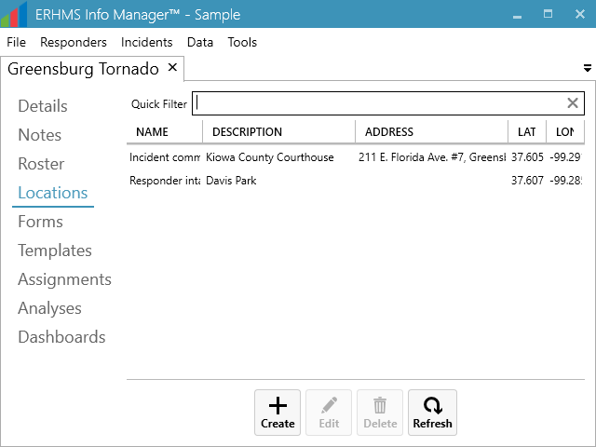

Forms
ERHMS Info ManagerTM uses Epi InfoTM for creating and editing forms, entering data into forms, viewing form responses, and analyzing the data. Visit the Form Designer Section of the Epi InfoTM User Guide for more information on Forms. Many forms have been included in ERHMS Info Manager™ as templates. To view these, select Data – Templates from the ribbon. You may also create forms from scratch if these templates do not meet your needs.

Many pre-deployment forms, such as those completed by potential responders during registration and credentialing, contain information that is not tied to a specific incident. It is strongly recommended that this information be updated at least annually, including in ERHMS Info ManagerTM.

Other forms are incident-specific and help us understand the impact of the incident on the responder. These can include check-in forms, exposure assessments, site specific training rosters, and sampling results.

Creating a Form
To manage incident-specific forms, select the Forms item from the incident subsections. To manage all forms, select Data – Forms from the ribbon. You may create a new form by selecting Create. In the Epi InfoTM Form Designer, give the form a Name, then select OK. It is suggested that the name for an incident-specific form be prefixed by the name of the incident, but this is not a requirement. If the form that has been created meets your needs, select yes on the prompt that comes up asking whether Epi InfoTM should be closed. If you intend to make changes, press no and proceed with making edits using the Epi InfoTM Form Designer.

By default, forms created in ERHMS Info ManagerTM contain a responder ID field. This field allows you to link form responses back to the responders who provided them. If you do not require this functionality, you may delete the responder ID field.

When you are done making changes to the form, close the Form Designer. Changes are saved automatically, and the new form will display in the Forms list.

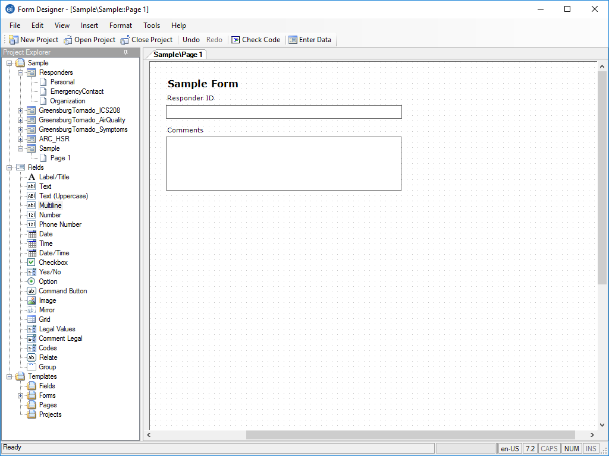
Populate Responder ID field in this box.

Collecting Data
To enter data into a form, select the form and go to Data - Enter at the bottom of the screen. If the form contains a responder ID field, you will be asked to select the responder to whom the entered data applies. Choose a responder from the list and select Continue. In the Epi InfoTM data entry window, enter data into the form fields. Select Save when you are done. Use the New Record or arrow buttons to navigate between records. Close the data entry window when you are done.

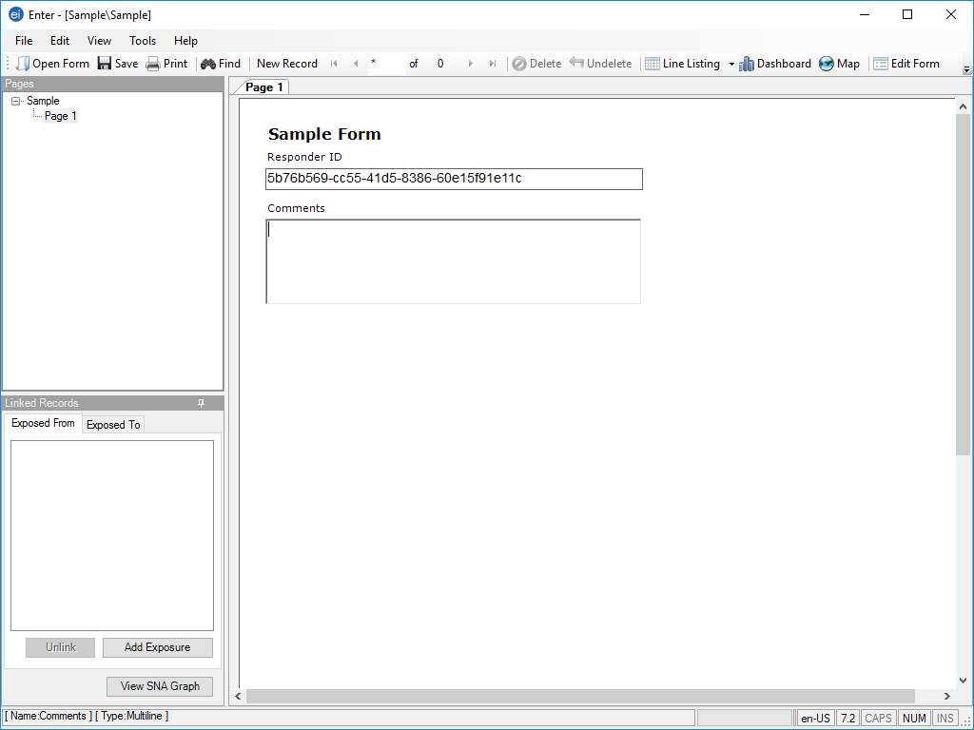
Select when you are done.

Publishing Forms to the Web
By using ERHMS Info ManagerTM, you can publish forms to the web that will serve as a questionnaire or signup/information gathering document that responders can complete online. With web publishing, you can:

- Create a web link for surveys
- Send the web link to multiple recipients by using email
- Allow users to complete the survey online by using responsive web pages
- Download the survey responses into ERHMS Info ManagerTM

Additionally, if your form contains a responder ID field, each web link sent via email will be unique to the recipient, allowing you to link form responses back to the responders who provided them. ERHMS Info Manager TM is integrated with the Epi InfoTM Web Survey system. To utilize the web publishing feature, install Epi InfoTM Web Survey, available at https://www.cdc.gov/epiinfo/pdfs/userguide/5_websurvey.pdf. To allow ERHMS Info ManagerTM to send web survey links to responders, provide a sender email address in the Email section under Settings. For further detail, please see the Email Settings section of this user guide.

To publish a survey to the web, first choose a form to publish. To locate forms, select Data – Forms from the ribbon. Forms related to individual incidents are also found by selecting Forms in the subsection of the incident screen. Select the form and go to Publish - To Web.

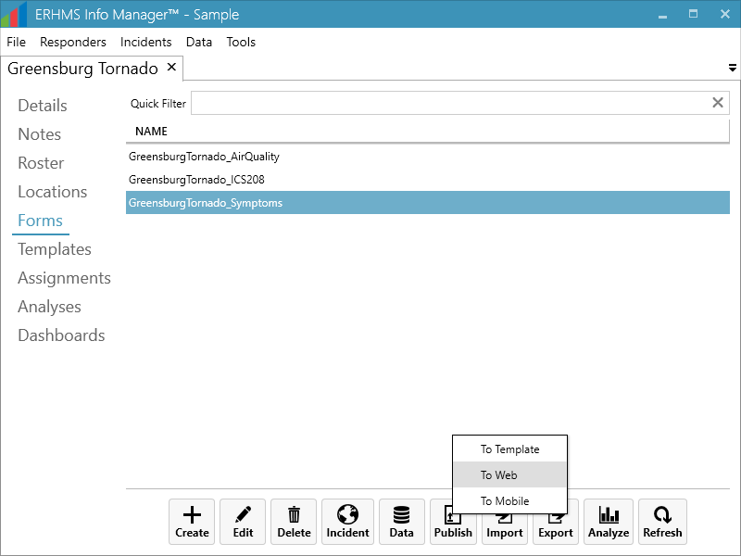

You can customize the survey publication options listed below. For more information on customizing these options, visit Epi InfoTM’s User Guide, Publish Form to the Web Section at https://wwwn.cdc.gov/epiinfo/user-guide/survey/publish-form-to-web.html.
- Title: The name of the survey that will be displayed to users.
- Start Date: The first date on which the survey is available to be filled out.
- End Date: The last date on which the survey is available to be filled out.
- Response Type: Whether multiple responses are accepted per person.
- Welcome Text: The text that is displayed when the user starts the survey.
- Completion Text: The text that is displayed when the user finishes the survey.
After entering the appropriate information in the Publish to Web window, select Publish.

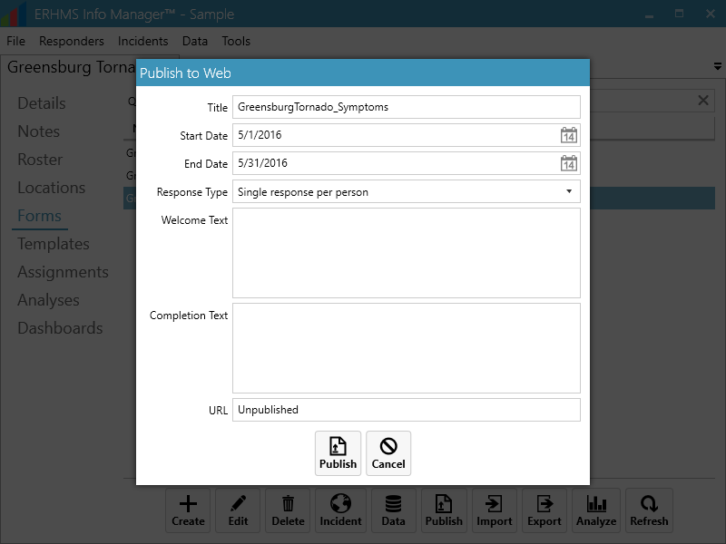

Templates
There are various standardized form templates in the ERHMS Info ManagerTM Templates tab, including forms from Federal Emergency Management Agency (FEMA), The American Red Cross, Occupational Safety and Health Administration (OSHA), and other organizations that frequently send emergency responders to incident sites. These are just a few examples of forms that are available. You can use these form templates unchanged, edit them for your purposes, or create an original form to meet the needs of your organization. Information that could be collected when responders report for duty at the incident, include: exposures, work activities, personal protective equipment (PPE) use, contact information, and other pertinent information from the incident. This information can allow for prompt recognition of risks, understanding the health effects of ongoing or new exposures, setting up medical surveillance, or performing follow-up related to work at an incident.

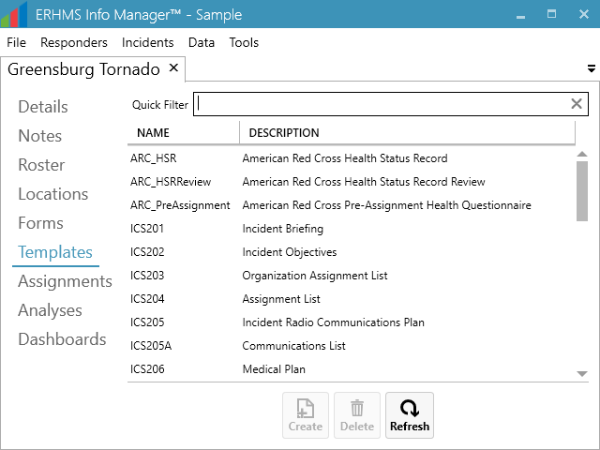

Creating a Form from a Template
A template can accelerate the creation of a form. To create a form that is not linked to a specific incident, begin by selecting Data - Templates from the ribbon. To create an incident-linked form, begin by opening the incident and navigate to the Templates subsection. Then choose the template that fits your needs and select Create.

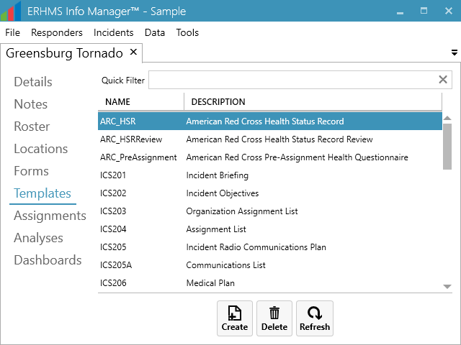

Once you press the Create button, the Epi InfoTM Form Designer window opens up. A pop-up prompts for the name of the template. After you enter a name and select OK, Epi InfoTM creates a form using the template selected. It may take a few moments for Epi InfoTM to add all the template fields to the new form.

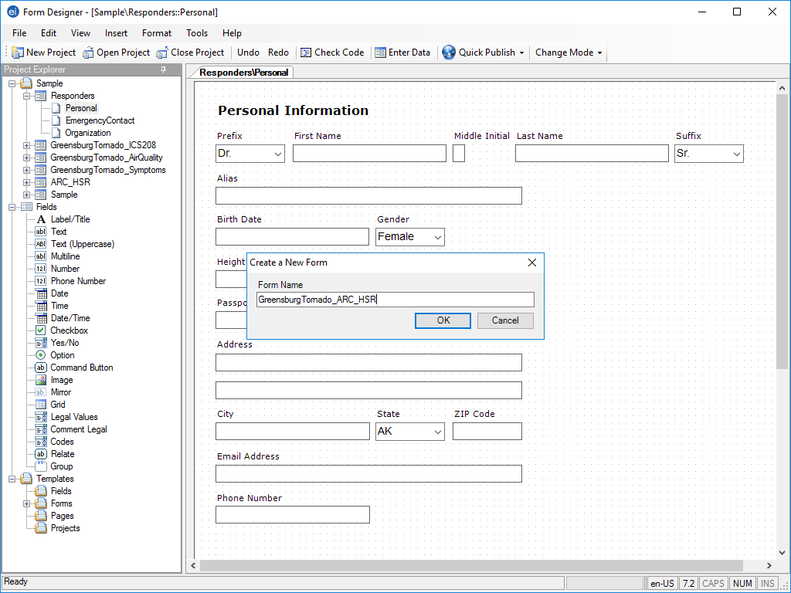

If the form that has been created meets your needs, select yes on the prompt that comes up asking whether Epi InfoTM should be closed.

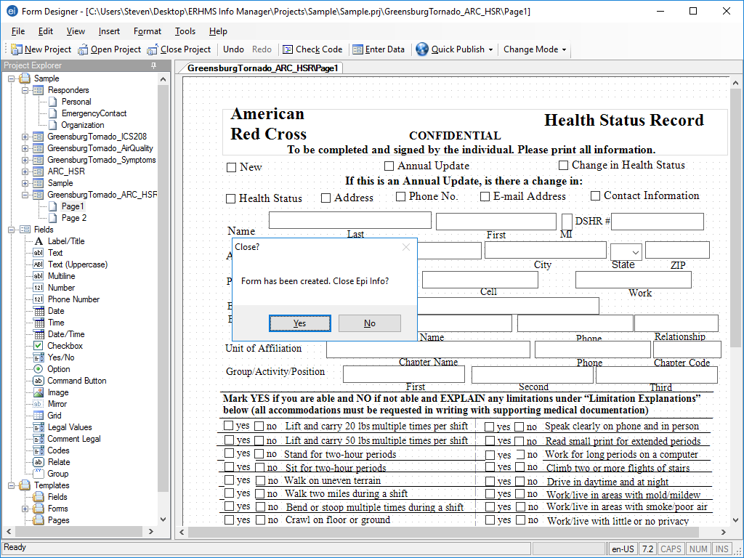

If you intend to make changes, press no and proceed with making edits by using the Epi InfoTM Form Designer. Once the changes are finalized, close the Epi InfoTM Form Designer window. Changes will be saved automatically.

Creating a Template from a Form
Existing forms may also be converted into templates. You would typically do this if you have an incident-specific form that you would like to reuse for future incidents. Start by selecting the desired Form. Press the Publish button and choose the To Template option.

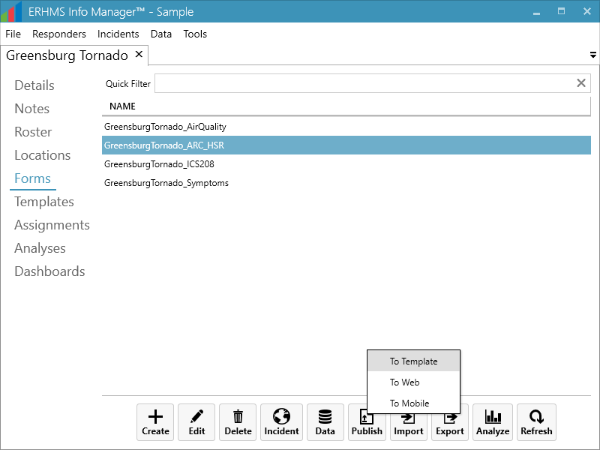

The Epi InfoTM Screen opens up the newly created template with the option to rename the template. Also, the user is able to provide a more detailed description within the template if necessary. Once the template has been created, select yes when prompted to close Epi InfoTM. Note that templates cannot be edited. In order to make changes to a template, you must create a form using the template, edit that form, and republish it to a new template.

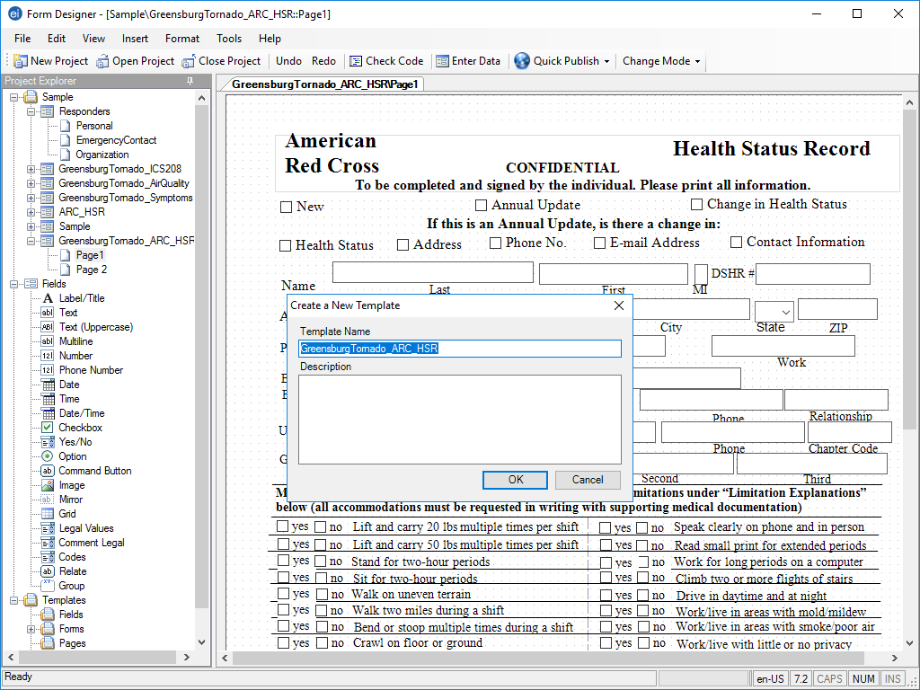

Data Import/ Export
If you would like to import data, go to Data – Forms and select the desired form. Press the Import button to see the multiple options available.

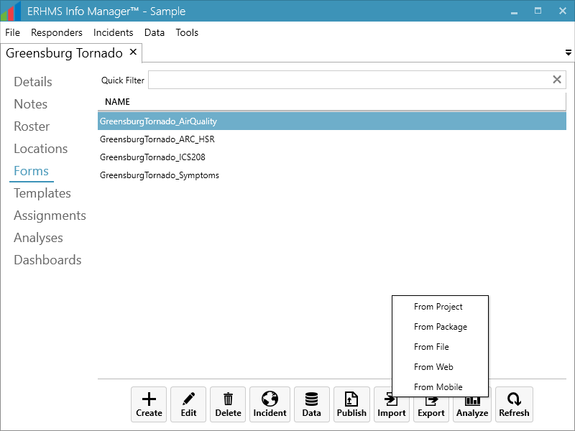

To import data from an Epi Info project, select From Project and take the following steps:
  - Note: this procedure requires an Epi Info™ project file (.prj) and a data file (.mdb – if data tables were created in Microsoft Access®).

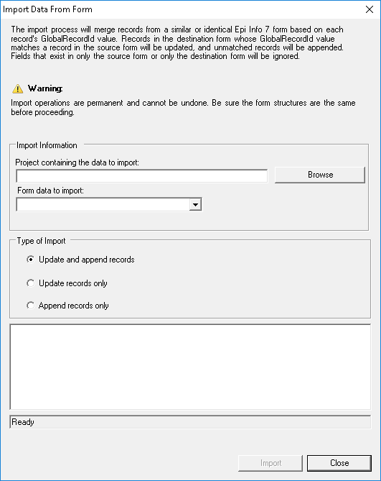

- Browse for the Epi InfoTM project file by clicking the Browse button next to the Project containing the data to import field. Select the .prj file
- Select the Form from the Form data to import drop-down list.
- Select the manner in which you would like the data imported from the Type of Import list.
- Update and append records – Records in the destination form containing the same GlobalRecordId values as the source form will be updated (overwritten) if there is new information. However, values in the destination table will never be overwritten with a null or missing value. All other records will be appended (added) to the end of the table.
- Update records only – Records in the destination form containing the same GlobalRecordId values as the source form will be updated (overwritten) if there is new information. However, values in the destination table will never be overwritten with a null or missing value. All other records will be ignored.
- Append records only – All records in the source form will be appended (added) to the end of the table. No records will be updated (overwritten).
- Click Import. Import Complete will appear at the bottom of the dialog box upon successful completion of the import.
- Click Close. The data is imported into the form.

To import data from an Epi Info data package, select From Package and reference the Data Packager section of the Epi Info User Guide at https://www.cdc.gov/epiinfo/pdfs/userguide/7_datapackager.pdf.

To import data from a file (such as a CSV file, Excel spreadsheet, or Access database), select From File. An Epi InfoTM Classic Analysis window will open. Step through the dialogs for selecting the file and mapping its variables to the fields of the selected form.

To import data from the web, select From Web and reference the Distributing Surveys Section of this User Guide. Note that this will only work for forms that have been previously published to the web.

To import data from a mobile device, select From Mobile and reference the Companion for Android section of the Epi Info User guide at https://www.cdc.gov/epiinfo/pdfs/userguide/6_android.pdf.
If you would like to export data, go to Data – Forms and select the desired form. Press the Export button to see the multiple options available.

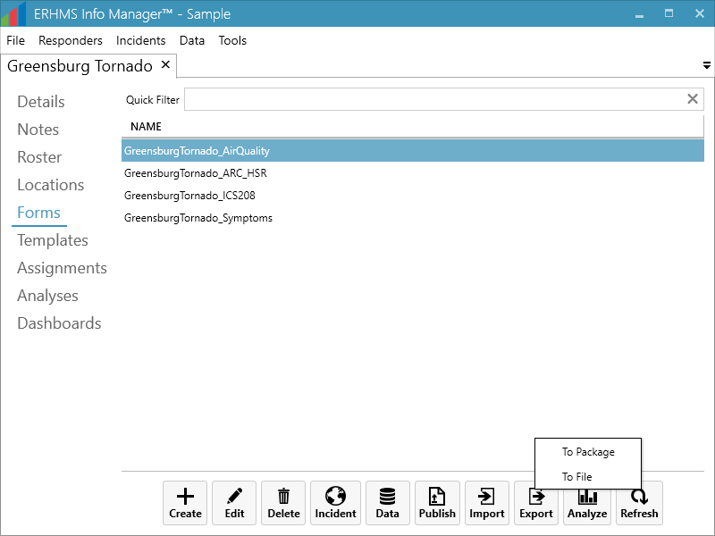

To export data, press the Export button to see the multiple options available.

To package and export data, select To Package and take the following steps:

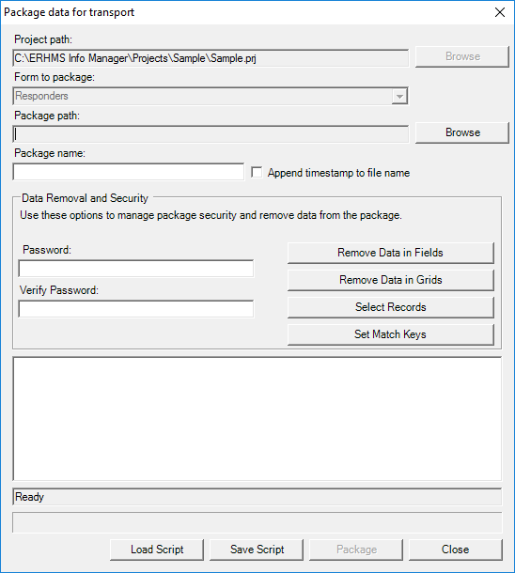

- The Project path and Form to package textboxes automatically populate with the project and form information. Click Browse and select a Package Path. The package path designates where the data package will be saved. Click OK.
- Enter a name for the data package in the Package Name field.
- Check the Append Timestamp to File Name checkbox if you wish to add a timestamp to the file name. The default setting is unselected.
- Enter Password if you wish to encrypt the data package. This increases the security of your data transmission. Save your password in a safe location as this password will be required to access the data package. If you do not wish to encrypt your data, leave the Password field blank and proceed to step eight.
- To Verify Password, re-enter the password from the step above.
- Click the Remove Data in Fields button to omit specific fields from the data package.
- Click the Remove Data in Grids button to remove data from columns in the selected grid.
- Click the Select Records button to select specific records to include in the data package.
- The Package data for Transport dialog box appears.
- Click the Package button. When complete, the Package Creation Complete verbiage will appear at the bottom of the dialog box
- Click Close to exit.
- The data package appears at the location (Package Path) specified in step three.

For more information on importing or exporting data, visit the Entering and Editing Data Section of the Epi InfoTM User Guide at https://www.cdc.gov/epiinfo/pdfs/userguide/4_enter.pdf.

Assignments

Distributing Surveys
If you have previously published a form as a web survey, you can distribute the survey to your responders by first assigning the survey to them, and then sending the assigned responders an email that contains a web link to the survey. To assign pre-deployment forms, select Data – Assignments in the ribbon. To assign deployment and post-deployment forms, select the Assignments in the Incident Options sidebar in the incident module. First, select a Form from the dropdown box at the top of the screen, then select the responders you wish to give the survey to. To select multiple responders, hold down the Ctrl or Shift key while clicking. To quickly select all responders, select any responder in the list then press Ctrl+A. Select Add to confirm the responders you wish to provide the survey to, who are then added to the list at the bottom of the screen. To notify responders of their pending surveys via email, select the desired surveys and go to Email.

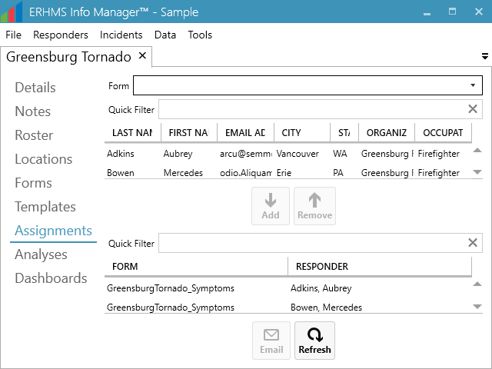

The email will display all of the selected recipients. To send a survey to individuals who are not in your list of responders, click the Add button in the Recipients section and enter each of their email addresses manually by choosing the Email address option in the Add a Recipient pop-up window. Note: You will not be able to link form responses back to a responder record for those responders with a manually added email address. This option is not recommended. It is best to add the individual to the list of responders and assign them to an incident first.

Enter the Subject and Body of your email. When sending an assignment email for a web survey, the box labeled Append web survey URL should be automatically checked, and the assigned form will already be selected. Only forms that have been published to the web will appear in this dropdown. If your form contains a responder ID field, you may wish to check the box labeled Prepopulate responder ID field. This will allow you to link your responders to their data later. Note: You will not be able to check this box if the form you have selected does not contain a responder ID field. You can also attach documents to the email if desired by using the Add button in the Attachments section. When you are finished, send the email by selecting Send.

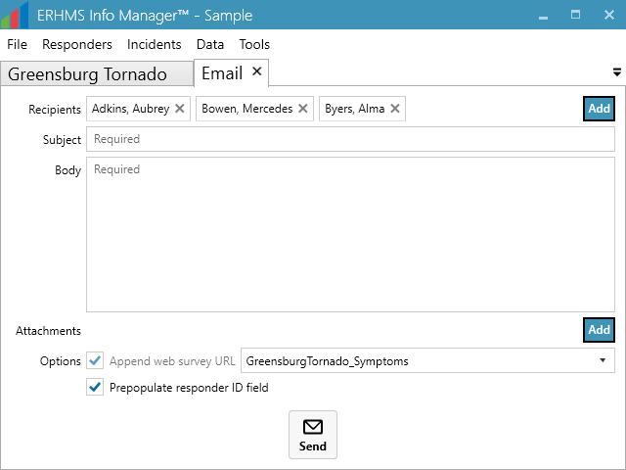

Downloading FORMS from WEB Survey
As recipients complete the form, Epi InfoTM Web Survey will automatically save responses to a separate database. To download Web Survey responses into the main ERHMS Info ManagerTM database for a given form, navigate to the Forms tab, select the form and select Import - From Web.

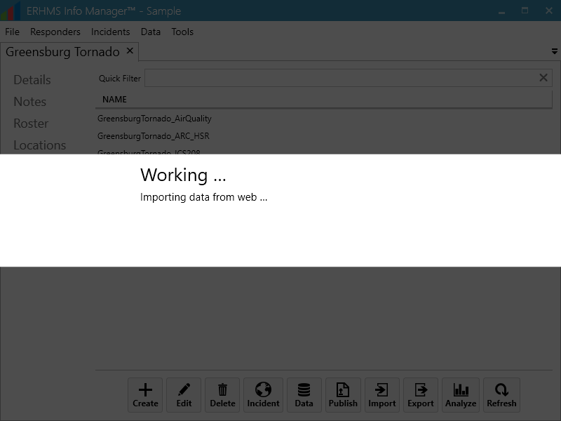

To display all imported survey responses (any data already in selected form prior to the import procedure), select the form again, and select Data – View.

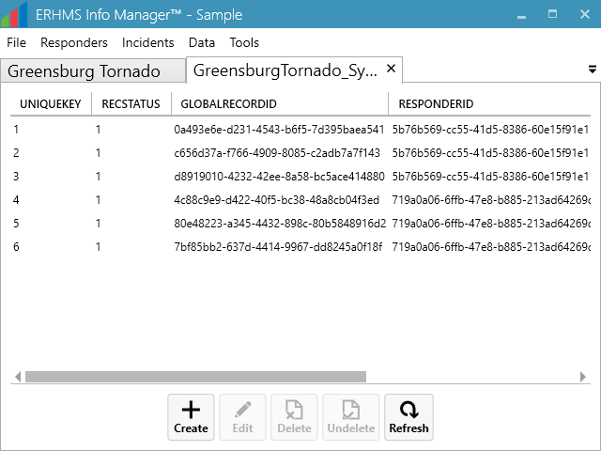

Analysis
Epi InfoTM’s Classic Analysis and Visual Dashboard modules may be used to analyze data collected through forms. Start by opening the list of forms either on the desired incident’s Forms subsection or by selecting Data – Forms from the ribbon. Select the form, then go to Analyze - Classic or Analyze - Visual. Provide a Name for the analysis or the dashboard in the resulting pop-up window and select Create.

In Classic Analysis:
- Add commands by selecting from the Command Explorer on the left-hand side of the window.
- When prompted, specify the desired options, which vary depending on the selected command.
- Save the analysis using the Save button in the Program Editor on the bottom of the window.

In Visual Dashboard:
- Add text and images by right-clicking on the dashboard background and selecting an option under Add Report gadget.
- Conduct analyses and add tables, charts, and graphs by right-clicking on the dashboard background and selecting an option under Add Analysis gadget.
- Move existing gadgets around the dashboard by dragging them with the mouse.
- Save the analysis by clicking the Save or Save as button represented by an image of a floppy disk(s) on the top left of the dashboard window, or by right-clicking on the dashboard background and selecting Save canvas.

For more information on data analysis in Epi InfoTM, visit the Classic Analysis and Visual Dashboard Sections of the Epi InfoTM’s User Guide available at https://www.cdc.gov/epiinfo/pdfs/userguide/9_classicanalysis.pdf and https://www.cdc.gov/epiinfo/pdfs/userguide/8_visualdashboard.pdf.

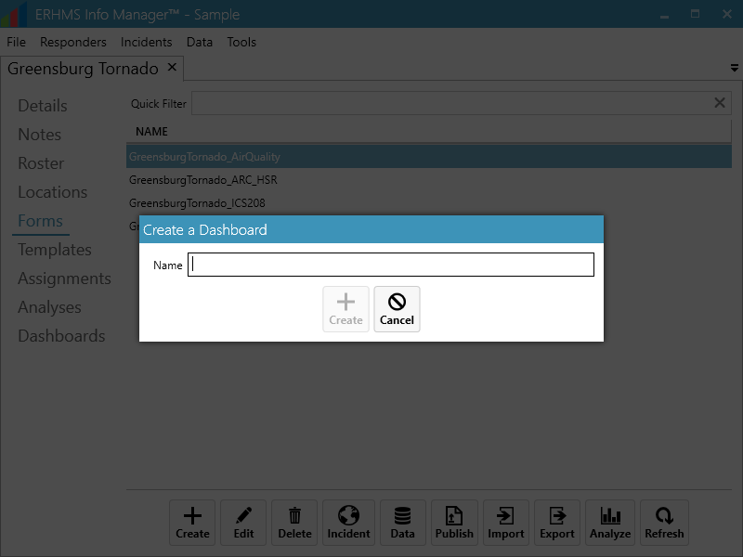

Help

ERHMS Info Manager™ Support
Submit all questions and comments about ERHMS Info ManagerTM to the Epi Info™ Help Desk at http://www.cdc.gov/epiinfo/support/helpdesk.htm. The Epi Info™ Help Desk is monitored from 8:00 a.m. until 5:00 p.m. ET. Monday through Friday and is not available on weekends or federal holidays. Users should expect to receive a response back to their inquiries within 48 hours.

Logs
During the course of normal operation, ERHMS Info ManagerTM creates log files that track user activity and record debugging information. To manage these files, select Tools – Logs from the modules ribbon.

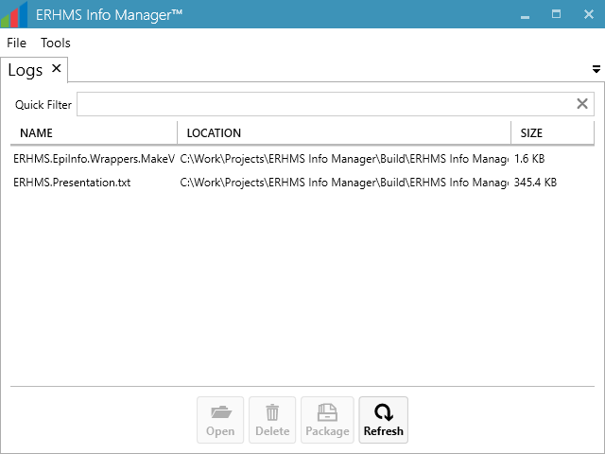

Viewing Logs
To view a log file, select it from the list of available files within the Logs module (Tools – Logs) in the Logs tab and go to Open. The file will open in your default text editor.

Deleting Logs
If you would like to reclaim the hard drive space used by a log file, you may delete it by selecting it from the list of available files and going to Delete. The file will be recreated the next time ERHMS Info ManagerTM attempts to write logging information.

Packaging Logs
Logging information may be easily shared with software support staff by packaging log files into a zip file. To package one or more log files, select them from the list of available files and go to Package. ERHMS Info Manager™ will create a zip file that contains all the selected log files. You may then save this file to its default location (usually the desktop) or another location of your choice.

ERHMS Info Manager™ UnInstall
To uninstall ERHMS Info ManagerTM, follow the steps below:
- Go to the Control Panel of your computer
- Open Programs and Features in the Control Panel
- Select ERHMS Info Manager from the list of installed software
- Select Uninstall/Change from the ribbon above the list of installed software
- In the popup that appears, select Remove the application from this computer.
- Select OK

aBOUT

License Information
ERHMS Info ManagerTM and Epi InfoTM tools are in the public domain and free to download and use. ERHMS Info MangerTM is licensed under the Apache License Version 2.0, January 2004 at http://www.apache.org/licenses/
TERMS AND CONDITIONS FOR USE, REPRODUCTION, AND DISTRIBUTION
1. Definitions.
"License" shall mean the terms and conditions for use, reproduction, and distribution as defined by Sections 1 through 9 of this document.
"Licensor" shall mean the copyright owner or entity authorized by the copyright owner that is granting the License.
"Legal Entity" shall mean the union of the acting entity and all other entities that control, are controlled by, or are under common control with that entity. For the purposes of this definition, "control" means (i) the power, direct or indirect, to cause the direction or management of such entity, whether by contract or otherwise, or (ii) ownership of fifty percent (50%) or more of the outstanding shares, or (iii) beneficial ownership of such entity.
"You" (or "Your") shall mean an individual or Legal Entity exercising permissions granted by this License.
"Source" form shall mean the preferred form for making modifications, including but not limited to software source code, documentation source, and configuration files.
"Object" form shall mean any form resulting from mechanical transformation or translation of a Source form, including but not limited to compiled object code, generated documentation, and conversions to other media types.
"Work" shall mean the work of authorship, whether in Source or Object form, made available under the License, as indicated by a copyright notice that is included in or attached to the work (an example is provided in the Appendix below).
"Derivative Works" shall mean any work, whether in Source or Object form, that is based on (or derived from) the Work and for which the editorial revisions, annotations, elaborations, or other modifications represent, as a whole, an original work of authorship. For the purposes of this License, Derivative Works shall not include works that remain separable from, or merely link (or bind by name) to the interfaces of, the Work and Derivative Works thereof.
"Contribution" shall mean any work of authorship, including the original version of the Work and any modifications or additions to that Work or Derivative Works thereof, that is intentionally submitted to Licensor for inclusion in the Work by the copyright owner or by an individual or Legal Entity authorized to submit on behalf of the copyright owner. For the purposes of this definition, "submitted" means any form of electronic, verbal, or written communication sent to the Licensor or its representatives, including but not limited to communication on electronic mailing lists, source code control systems, and issue tracking systems that are managed by, or on behalf of, the Licensor for the purpose of discussing and improving the Work, but excluding communication that is conspicuously marked or otherwise designated in writing by the copyright owner as "Not a Contribution."
"Contributor" shall mean Licensor and any individual or Legal Entity on behalf of whom a Contribution has been received by Licensor and subsequently incorporated within the Work.
2. Grant of Copyright License. Subject to the terms and conditions of this License, each Contributor hereby grants to You a perpetual, worldwide, non-exclusive, no-charge, royalty-free, irrevocable copyright license to reproduce, prepare Derivative Works of, publicly display, publicly perform, sublicense, and distribute the Work and such Derivative Works in Source or Object form.
3. Grant of Patent License. Subject to the terms and conditions of this License, each Contributor hereby grants to You a perpetual, worldwide, non-exclusive, no-charge, royalty-free, irrevocable (except as stated in this section) patent license to make, have made, use, offer to sell, sell, import, and otherwise transfer the Work, where such license applies only to those patent claims licensable by such Contributor that are necessarily infringed by their Contribution(s) alone or by combination of their Contribution(s) with the Work to which such Contribution(s) was submitted. If You institute patent litigation against any entity (including a cross-claim or counterclaim in a lawsuit) alleging that the Work or a Contribution incorporated within the Work constitutes direct or contributory patent infringement, then any patent licenses granted to You under this License for that Work shall terminate as of the date such litigation is filed.
4. Redistribution. You may reproduce and distribute copies of the Work or Derivative Works thereof in any medium, with or without modifications, and in Source or Object form, provided that You meet the following conditions:
- You must give any other recipients of the Work or Derivative Works a copy of this License; and
- You must cause any modified files to carry prominent notices stating that You changed the files; and
- You must retain, in the Source form of any Derivative Works that You distribute, all copyright, patent, trademark, and attribution notices from the Source form of the Work, excluding those notices that do not pertain to any part of the Derivative Works; and
- If the Work includes a "NOTICE" text file as part of its distribution, then any Derivative Works that You distribute must include a readable copy of the attribution notices contained within such NOTICE file, excluding those notices that do not pertain to any part of the Derivative Works, in at least one of the following places: within a NOTICE text file distributed as part of the Derivative Works; within the Source form or documentation, if provided along with the Derivative Works; or, within a display generated by the Derivative Works, if and wherever such third-party notices normally appear. The contents of the NOTICE file are for informational purposes only and do not modify the License. You may add Your own attribution notices within Derivative Works that You distribute, alongside or as an addendum to the NOTICE text from the Work, provided that such additional attribution notices cannot be construed as modifying the License.
You may add Your own copyright statement to Your modifications and may provide additional or different license terms and conditions for use, reproduction, or distribution of Your modifications, or for any such Derivative Works as a whole, provided Your use, reproduction, and distribution of the Work otherwise complies with the conditions stated in this License.
5. Submission of Contributions. Unless You explicitly state otherwise, any Contribution intentionally submitted for inclusion in the Work by You to the Licensor shall be under the terms and conditions of this License, without any additional terms or conditions. Notwithstanding the above, nothing herein shall supersede or modify the terms of any separate license agreement you may have executed with Licensor regarding such Contributions.
6. Trademarks. This License does not grant permission to use the trade names, trademarks, service marks, or product names of the Licensor, except as required for reasonable and customary use in describing the origin of the Work and reproducing the content of the NOTICE file.
7. Disclaimer of Warranty. Unless required by applicable law or agreed to in writing, Licensor provides the Work (and each Contributor provides its Contributions) on an "AS IS" BASIS, WITHOUT WARRANTIES OR CONDITIONS OF ANY KIND, either express or implied, including, without limitation, any warranties or conditions of TITLE, NON-INFRINGEMENT, MERCHANTABILITY, or FITNESS FOR A PARTICULAR PURPOSE. You are solely responsible for determining the appropriateness of using or redistributing the Work and assume any risks associated with Your exercise of permissions under this License.
8. Limitation of Liability. In no event and under no legal theory, whether in tort (including negligence), contract, or otherwise, unless required by applicable law (such as deliberate and grossly negligent acts) or agreed to in writing, shall any Contributor be liable to You for damages, including any direct, indirect, special, incidental, or consequential damages of any character arising as a result of this License or out of the use or inability to use the Work (including but not limited to damages for loss of goodwill, work stoppage, computer failure or malfunction, or any and all other commercial damages or losses), even if such Contributor has been advised of the possibility of such damages.
9. Accepting Warranty or Additional Liability. While redistributing the Work or Derivative Works thereof, You may choose to offer, and charge a fee for, acceptance of support, warranty, indemnity, or other liability obligations and/or rights consistent with this License. However, in accepting such obligations, You may act only on Your own behalf and on Your sole responsibility, not on behalf of any other Contributor, and only if You agree to indemnify, defend, and hold each Contributor harmless for any liability incurred by, or claims asserted against, such Contributor by reason of your accepting any such warranty or additional liability.
NOTICE
The end-user documentation included with the redistribution, if any, must include the following acknowledgment: "This derivative product includes ERHMS Info Manager™ and Epi Info™ software developed by NIOSH and CDC, which can be found at http://www.cdc.gov/niosh/topics/erhms/ and http://www.cdc.gov/epiinfo/index.html.”

Appendix A: Key Terms

Term | Definition
Epi Info™ | A software application created by CDC and available to the public via the internet. It is used by physicians, nurses, epidemiologists, and other public health workers who might lack a background in information technology who often have a need for simple tools that allow the rapid creation of data collection instruments and data analysis, visualization, and reporting using epidemiologic methods. Epi Info™, a suite of easy to use software tools, delivers epidemiologic functionality without the complexity or expense of large, enterprise applications.
Emergency Responder Health Monitoring and Surveillance™ (ERHMS™) | A framework of activities designed to allow for the monitoring and surveillance of emergency response and recovery safety and health during all phases of emergency response: pre-deployment, deployment, and post-deployment.
Incident Command System (ICS) | A standardized on-scene incident management construct specifically designed to provide an integrated organizational structure that reflects the complexity and demands of single or multiple incidents, without being hindered by jurisdictional boundaries. ICS is the combination of facilities, equipment, personnel, procurements, and communications operating within a common organizational structure and designed to aid in the management of resources during incidents. It is used for all kinds of emergencies and is applicable to small, as well as large and complex, incidents. ICS is used by various jurisdictions and functional agencies, both public and private, to organize field-level incident management operations. For more information visit  https://training.fema.gov/EMIWeb/IS/ICSResource/index.htm
Medical Monitoring | Ongoing clinical assessment of physical and behavioral health in an individual worker to detect emerging health and injury effects that may be work-related (e.g., physiological, psychological), and to inform needs for medical treatment or other services and/or worker exposure control(s). Once the baseline clinical status has been established, participants in the program are periodically assessed for changes in their clinical status.
Medical Screening | Medically assessing individual workers for the presence (or absence) of specific physical or mental health conditions at a specific time, with the express purpose of early diagnosis and, if appropriate, treatment. Medical screening focuses on assessment of fitness and ability to safely and effectively deploy on a response and may entail history taking, examination, and/or testing procedures.
Medical Surveillance | Systematic and ongoing collection and evaluation of population- level clinical data (e.g., physical and mental health, work histories, medical/psychiatric examination, laboratory and imaging studies or other clinical testing) that is used to identify hazards, to eliminate ongoing hazardous exposure, and to evaluate exposure–health outcome relationships.
Responders | Includes paid affiliated personnel, contractors, subcontractors, and volunteer workers involved in incident operations. Responders include police, fire, and emergency medical personnel, as well as other responder groups such as public health personnel, cleanup, and repair/restoration workers.
Response | Immediate actions to save lives, protect property and the environment, and meet basic human needs. Response also includes the execution of emergency plans and actions to support short-term recovery.
Roster | A roster is a list of response workers who have been or continue to be participating in any capacity during a response event, or who are available and ready to respond before an event. The purpose of maintaining such a roster is to provide a formal record of all those who have participated in response and cleanup activities. It functions as a mechanism to contact workers about possible work-related symptoms of illness or injury, as needed, and serves as the basis for determining which workers may require post-event tracking of their health.

Appendix B: References

NIOSH Emergency Responder Health Monitoring and Surveillance™ topic page:
https://www.cdc.gov/niosh/topics/erhms/

Emergency Responder Health Monitoring and Surveillance™ National Response Team Technical Assistance Document (TAD):
https://www.nrt.org/sites/2/files/ERHMS_Final_060512.pdf

Epi Info™
https://www.cdc.gov/epiinfo/index.html



Delivering on the Nation’s promise:
safety and health at work for all people
through research and prevention
To receive NIOSH documents or more
information about occupational safety and
health topics, contact NIOSH at
1-800-CDC-INFO (1-800-232-4636)
TTY: 1-888-232-6348
CDC INFO: www.cdc.gov/info
or visit the NIOSH website at www.cdc.gov/niosh.
For a monthly update on news at NIOSH, subscribe to
NIOSH eNews by visiting www.cdc.gov/niosh/eNews.
DHHS (NIOSH) Publication No. 2017-169

