INSTRUCTIONS FOR USE
ERNEST BLUETOOTH GATES
INSTALLATION OF THE DEVICE:
ERNEST devices are recommended to be installed by a certified electrician (preferably, by authorised partners of “Valet and Knave” SIA). Prior to installation of the device, ensure that the gate/barrier has been disconnected from the power! The device requires no fuse in the power circuit, as it is already integrated. The device has one relay, which is designed for current not exceeding 0.5 A. The relay circuit has no fuse. If a fuse is still required, it must be added separately. In the activated controller, the relay is permanently open (for complete installation instructions see ernestapp.com, in the respective product section).
REGISTRATION:
- New ERNEST users shall create an account at www.ernestapp.com. When registering, specify the user’s name and surname, e-mail address and phone number (and similar information).
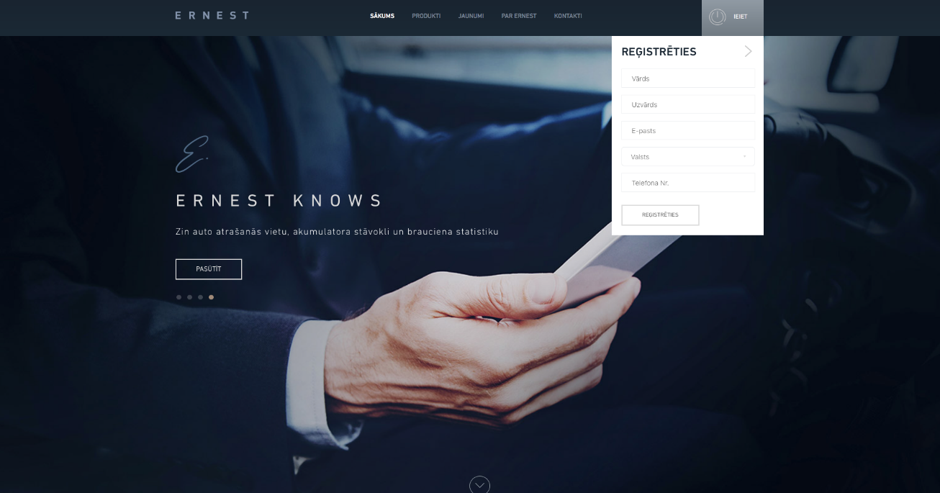

- To start using ERNEST AUTO & HOME free application, it shall be downloaded onto the user’s smart device. For smart devices using the Android™ operating system, the ERNEST AUTO & HOME application must be downloaded from Google Play Store™. For smart devices using the iOS™ operating system, the ERNEST AUTO & HOME application is available from iTunes® AppStore.

ACTIVATION (UPON INSTALLATION OF THE DEVICE)
- To add a new device, turn on mobile data and Bluetooth. In the application section DEVICES, select the type of device - GARAGES or GATES. After the type of device has been selected, press the button ADD GARAGE/ADD GATE.
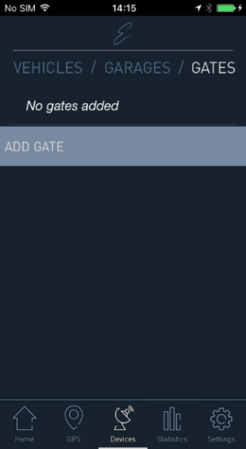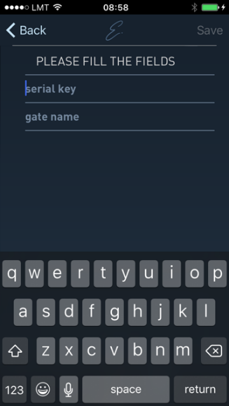
- In the ADD GARAGE/ADD GATE window, specify the following information :

  - Serial Key – 16 symbol combination, which may be found in the Ernest Bluetooth Gate product box.
  - Gate Name – in this field, set the name of the device.
  - After filling in the requested fields, save the settings by pressing the button SAVE.

- When the device data are successfully saved, the view with the available ERNEST devices will open. The user shall select the ERNEST Bluetooth name in the device information. To proceed with this, the smart device shall be within the area of the Bluetooth signal.
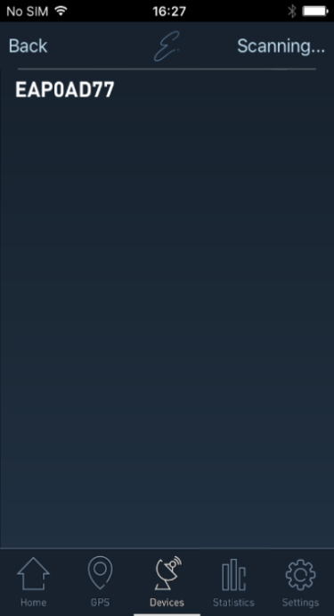
- The added device will appear in the application section DEVICES. The respective Garage or Gate button will be functional in HOME view.
ADDING NEW USERS TO THE DEVICE
- To add new users to the device, in the DEVICES menu, press the editing button (Ξ) for the respective device. Only the owner of the device may add new users.
- In editing view, choose the button USERS.
- In USERS view, you may review and edit existing users, as well as add new ones.
- To add a new user, select the button ADD USER, where you may invite additional users via their e-mails.
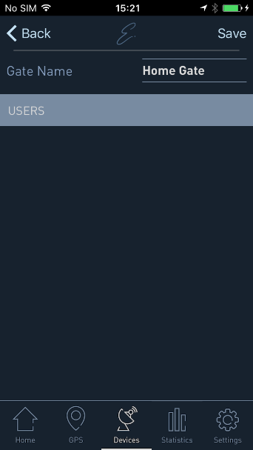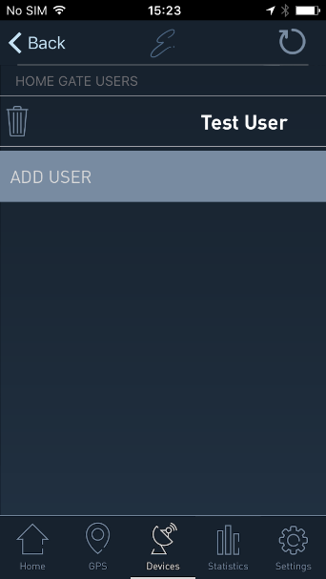

- The User must enter the e-mail address of the new user, confirming it with the button SAVE. Sending of an invitation to e-mail requires mobile data transfer.

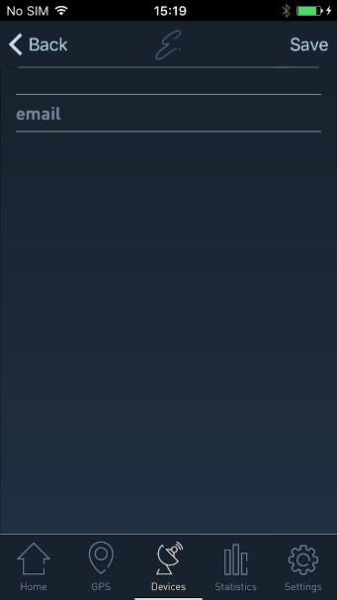
- Upon completion of the invitation procedure by e-mail, the new user must log-in to their existing account or create a new one, if no such account has been created before.

WARNING
If the house, gates or barrier have experienced any power supply interference or outage, the device may show Bluetooth connection issues.


CONTACT INFORMATION
SIA “VALET AND KNAVE”
Sergeja Eizensteina iela 29,
4th Floor, Riga, LV-1079
office@valetandknave.com
www.ernestapp.com

