ReadEasy Evolve

Feature Pack User Manual
Copyright (C) 2019, VisionAid International Ltd, all rights reserved.

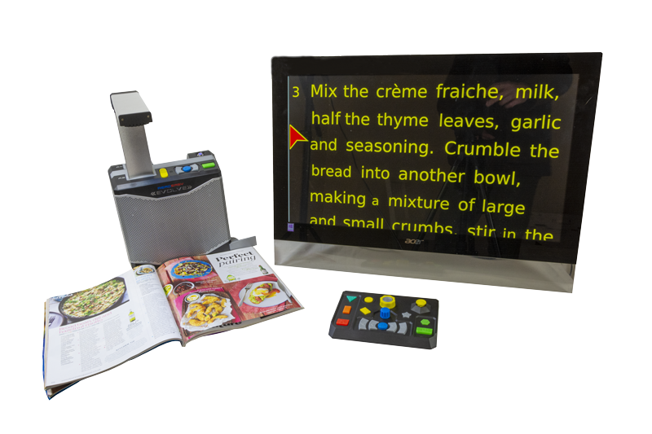

English, Version 1.2

Table of Contents
Introduction Page 4
Improvement program Page 4
Safety Page 5
Pacemaker safety guidelines Page 5
Feature Pack contents Page 5
Feature Pack connections Page 6
Wireless Control Pad Page 8
Key additional features for blind users Page 8
Key additional features for low vision users Page 9
Removing the Wireless Control Pad Page 10
Storing the Wireless Control Pad in the ReadEasy Evolve Page 10
Wireless Control Pad batteries Page 10
Wireless Control Pad connection Page 11
Simplifier Page 12
Controls for no vision and low vision users – Quick reference Page 13
Controls for no vision & low vision users Page 14
Help & Cancel Page 14
Capturing documents Page 15
Capture button Page 15
Append button Page 15
PowerRead feature Page 16
Navigating documents Page 17
Play / pause button Page 17
Word dial Page 17
Next & Previous sentence buttons Page 17
Next & Previous paragraph & page buttons Page 18
Main menu Page 19
Menu navigation Page 19
Main menu button Page 19
Document management Page 20
Pages management Page 22
Bookmarks Page 24
Recognition profiles Page 25
Display and pointer Page 25
Menu settings Page 27
Advanced settings Page 27
Additional controls for low vision users – Quick reference Page 29
Additional features for low vision users Page 30
Modes for Reading and Writing Page 30
Controls for Low Vision Features Page 31
View mode button Page 31
Zoom dial Page 31
Reading colours button Page 32
Joystick Page 32
Text views button Page 34
Text Views Page 35
Touch Screen Features Page 39
Caring for your touch screen Page 40

Introduction
This manual assumes you have followed, or are familiar with, the steps and information provided in the ReadEasy Evolve Standard User Manual.
This manual then goes on to detail the additional functions available for the optional Feature Pack.

Improvement program
Users are the best people to help us improve and develop our products so if you have any ideas or suggestions, no matter how small, please do contact us.

Email:
suggestions@visionaid.com

Post:
ReadEasy Evolve Suggestions
VisionAid International Limited
Bridge Lodge
Spalding
Lincolnshire
PE11 3AU
United Kingdom

Phone:
+44 (0) 1775 711 977
Thank you and enjoy your new ReadEasy Evolve reading machine!

Safety

Pacemaker safety guidelines
The ReadEasy Evolve contains magnets in multiple locations.
If you have a pacemaker fitted please consult the manufacturer’s guidelines for safe operating distances.
Do not use the ReadEasy Evolve near inadequately shielded medical devices.
There are magnets located in the main unit, the camera arm, the Wireless Control Pad and the Wireless Control Pad Simplifier. Do not put any of these items on or near your chest if you have a pacemaker fitted.

Feature Pack contents
- Wireless Control Pad
- Batteries for Wireless Control Pad (2 x AAA)
- Magnetic simplifier for Control Pad
- HDMI to HDMI cable
- Quick Reference Guide (Laminated)
- This User Manual

Feature Pack connections
All of the input and output connections are located on the rear of the ReadEasy Evolve, in a row running horizontally in-line with the power connection. The connections are directly above the camera storage section, 2.5 inches (6.5cm) up from the base.
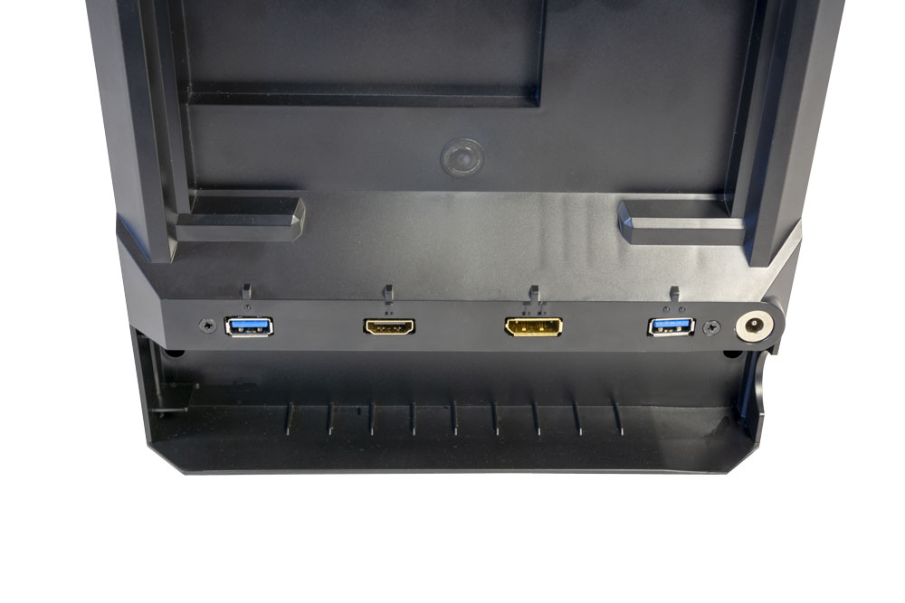
WARNING:
USB, HDMI and DisplayPort connectors only fit into their sockets one way. Only a small amount of force is required to plug in the connectors and too much may damage the connector and socket. Any damage to the connectors or sockets is not covered by warranty so please take care.

USB 3.0 port 1
HDMI port
USB 3.0 port 2
DisplayPort

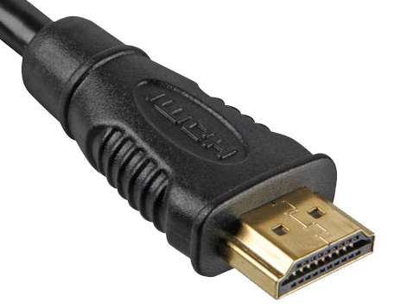
HDMI and DisplayPort for monitor or television connection
The HDMI and DisplayPort can be used to connect your ReadEasy Evolve to a monitor or television enabling you to also use it like a powerful desktop video magnifier to magnify and enhance the view of your documents.
An HDMI cable is included with your Feature Pack.
The HDMI port is located at the back of the ReadEasy Evolve. When the rear of the unit is facing you, it is the second port in from the left-hand side. It is 3.15 inches (8 cm) from the left-hand side and 2.5 inches (6.5cm) up from the base. The port has a Roman numeral ‘I’ directly above it.
TIP:
The HDMI video signal is the same as a DVI one. If your monitor only has a DVI connector, an HDMI to DVI cable or adaptor should enable it to work without the need to purchase a new monitor.

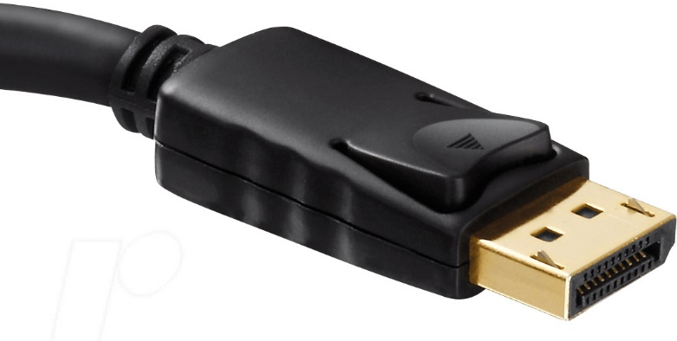
There is also a DisplayPort connector, labelled with the Roman numeral ‘II’. This is located 2 inches (5cm) to the right of the HDMI port.
A DisplayPort to DisplayPort cable or an Active DisplayPort to HDMI converter is required in order to use this and is sold separately.

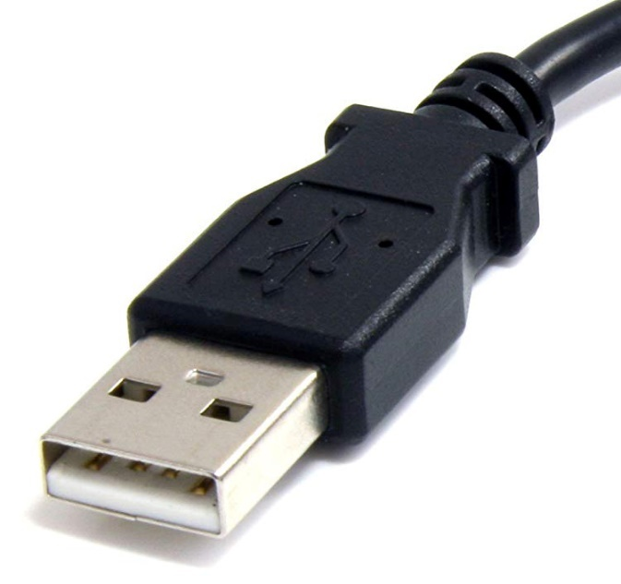
USB ports
The ReadEasy Evolve features two USB 3.0 ports to connect devices such as mice, trackballs, touch screens and memory sticks for document import / export and software updates.
USB port 1 is located 1.75 inches (4.5cm) from the left edge of the unit. It has a single raised dot directly above it.
USB port 2 is located 1.75 inches (4.5cm) from the right edge of the unit. It has two raised dots directly above it.

Wireless Control Pad
The ReadEasy Evolve Feature Pack includes a tactile, 16 button, Wireless Control Pad that enables many additional features.
The controls are all individually shaped (and coloured for low vision users) for easy navigation. The capture, play / pause and forwards / backwards controls are the same as the controls on the top of the ReadEasy Evolve itself.

Key additional features for blind users
- Capture multiple page documents quickly and easily so they can be read without interruption.
- Unique PowerRead function allows you to listen and navigate your currently captured pages whilst adding additional pages.
- Finer navigation control including a unique navigation dial to quickly skip word-by-word to rewind / fast-forward.
- Saving, loading, importing (PDF, image, text) and exporting of documents (PDF, Word, image, MP3).
- Bookmark your documents to quickly return to a particular section.
- Dedicated ‘Help’ button with intuitive audio instructions.
- Magnetic simplifier which reduces the available controls to 9.

Key additional features for low vision users
- Display your documents in large print on any screen.
- Adjust the size and enhance them as they are being read back to you.
- Integrated joystick allows your documents to be panned without having to physically move the page around under the camera.
- Smoothly scroll the text of your captured documents making reading using your eyes easier, faster and more comfortable.
- Screen-by-screen reading for users who prefer to read text when it is static.
- Multi-touch touch screen support is also available when your ReadEasy Evolve is connected to a compatible touch screen. This allows you to intuitively pan around your document, start and stop reading and zoom in and out, all with your finger touching the screen and words directly.
- Unique ReadHere feature allows you to be magnifying a document in Live view, then click or press on a word to start reading directly from that word. This eliminates the frustration of always having to start reading from the beginning of a document.

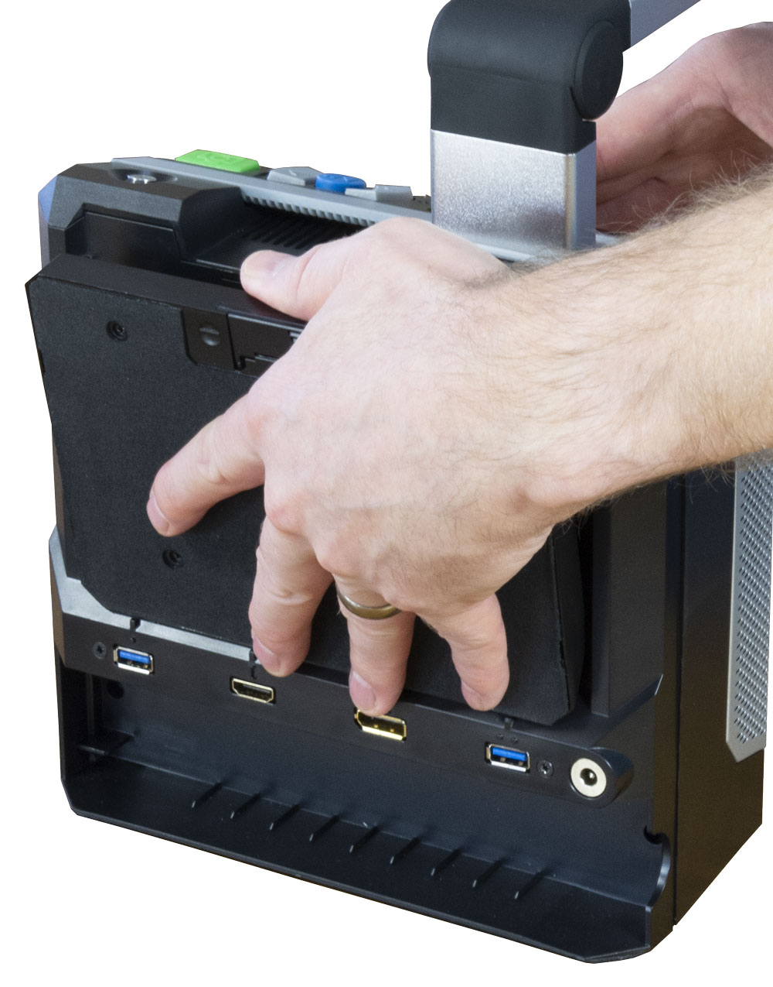
Removing the Wireless Control Pad
To make the ReadEasy Evolve easy to move from place-to-place, the Wireless Control Pad is stored in the back of the unit. It is magnetised into place and requires a small amount of force to pivot out from the back.
There is a dip on the top of the ReadEasy Evolve, in the middle just behind the handle. The Wireless Control Pad sticks out slightly above this dip.
Place your thumb in this gap with your fingers over the back (you’ll feel the soft padding of the Control Pad’s base). Then, whilst supporting the Control Pad from the back, push it backwards using your thumb and you will feel it pivot outwards away from the Evolve.

Storing the Wireless Control Pad in the ReadEasy Evolve
To put the Wireless Control Pad back into the ReadEasy Evolve’s case, please follow the instructions of removing the Wireless Control Pad but in reverse order.

Wireless Control Pad batteries
Two triple A (AAA) batteries to power the Wireless Control Pad are included with the ReadEasy Evolve Feature Pack.

Inserting or replacing the batteries
Your distributor may have already inserted the batteries into the Wireless Control Pad for you. If not, please follow the instructions below:
Carefully open the hinged battery compartment cover on the base of the Wireless Control Pad. To do so, turn it over so the soft foam base is facing upwards. There is a cut out at the top of the foam for the battery cover.
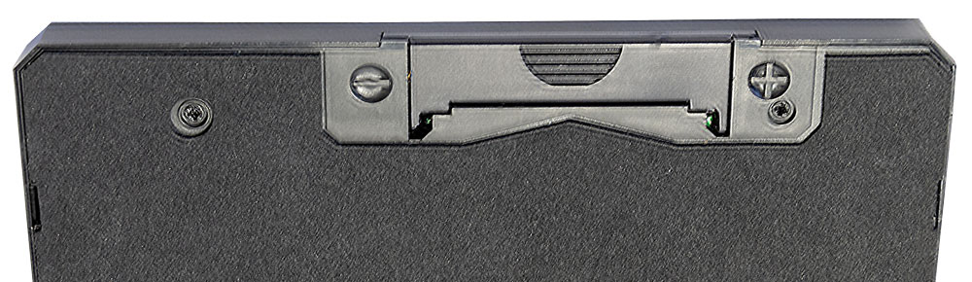
Locate the semi-circular grip in the centre of the cover. Using both thumbs, gently but firmly slide the cover away from you until it clicks.
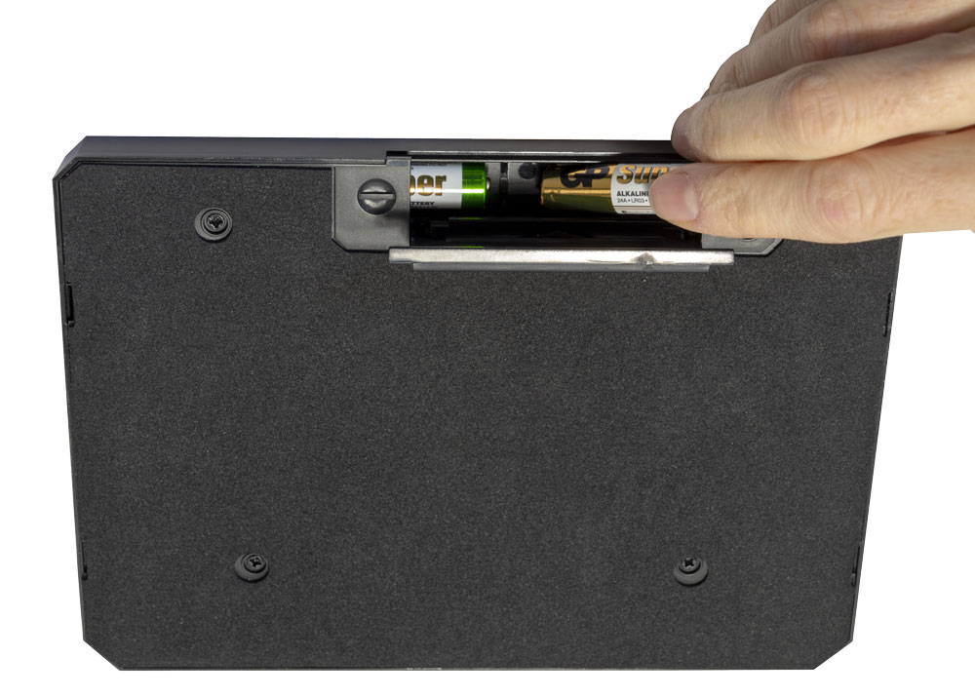
Once the cover is released, hinge it open (it doesn’t detach) by gently pulling it outwards & upwards to fully raise it to expose the battery compartment.
Then, carefully insert the two supplied AAA batteries.
The negative terminal is to the left and positive terminal is on the right as indicated by the minus and plus signs etched into the base, either side of the battery cover.
Please ensure the batteries are inserted the correct way around. Damage caused by incorrectly inserting the batteries is not covered by warranty.
Then close the battery cover.

Wireless Control Pad connection
When any of the Wireless Control Pad buttons are pressed, it will automatically connect to the ReadEasy Evolve (providing the ReadEasy Evolve is turned on). As it connects the Evolve will announce “Wireless Control Pad connected”. It can take up to 10 seconds for the Wireless Control Pad to connect after a button it pressed.
The Wireless Control Pad will power itself off automatically after the ReadEasy Evolve is turned off, it has no on / off switch of its own.

Simplifier
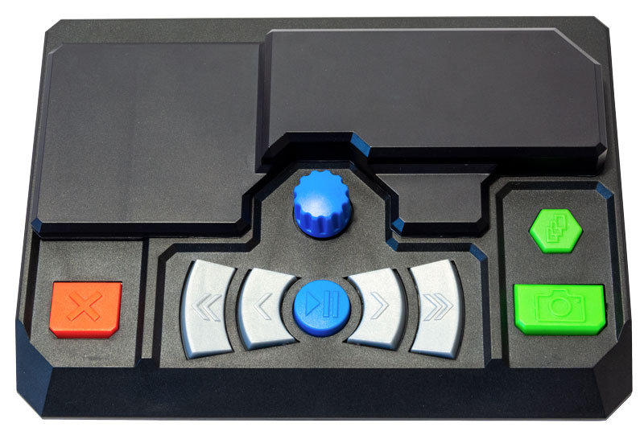
The Wireless Control Pad includes a simplifying overlay which hides the low vision controls, Main menu, Bookmarks and Help buttons, reducing the controls to 9.

With simplifier

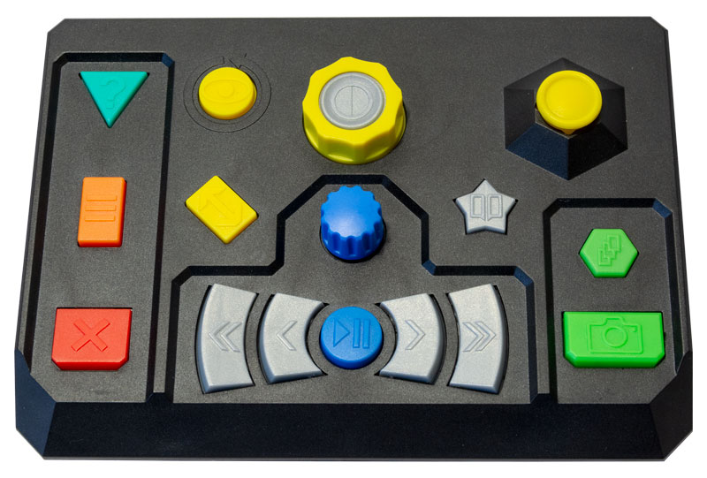
Without simplifier

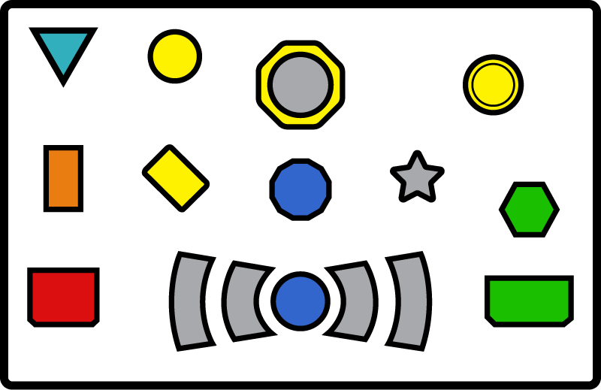
Play / Pause

Cancels capturing, question dialogs & exits Menu

Help
Quick press: Document management
Press & hold:
Main menu

Quick press: Capture & read
Press & hold:
Table mode
(for bank
statements etc.)

Quick press: Adds a page to your current document
Press & hold: Start multi-page capture

Quick press: Add bookmark
Press & hold: Bookmark menu

Next sentence
Quick press:
Previous paragraph
Press and hold:
Previous pages
Quick press:
Next paragraph
Press and hold:
Next pages
Previous sentence
Quick press: Spell word
Rotate:
Next / previous word

Controls for no vision and low vision users – Quick reference

Controls for no vision & low vision users

Help & Cancel


Help button
This is the turquoise triangular button located in the very top left of the Wireless Control Pad.

Normal operation help (Live or Document modes)
If you are wondering what a particular button does on the Wireless Control Pad, pressing the Help button, (when not in a menu or question dialogue) starts Help mode which is an intuitive control describer mode.
When in Help mode, the first press of any button on the Wireless Control Pad describes what that button does. If that’s the button you were looking for, then a second press automatically exits Help mode and performs that button’s function.
To exit Help mode directly, press the Help button again.

Menu or Question dialogue help
If you are in a menu or question dialogue, pressing the Help button will first repeat the menu or question dialogue and then provide you with context sensitive help, including controls.


Cancel button
This is the red horizontal rectangular button located in the very bottom left.
It has an “X” embossed on it.
Pressing the Cancel button stops capturing or exits a menu or question dialogue.

Capturing documents
There are two controls to capture documents, both are located in the bottom right corner of the keypad.
Please note, for information regarding how to position your document, please see “Positioning Documents for Capture” on page 13 of the ReadEasy Evolve Standard User Manual.


Capture button
This is the green horizontal rectangular button located in the very bottom right of the Wireless Control Pad.

Capture: Quick press
This captures a page to a new document and reads it aloud.
ReadEasy Evolve features an intelligent motion detection system that will not allow your document to be captured if it is moving (e.g. when positioning and holding a book open). Your document will be captured a short while after the last movement is detected. An audible “beep” will be emitted while movement is being detected.
To override this function and force ReadEasy Evolve to capture your document, press Capture again. Overriding the motion detection can be useful if there is something moving under the camera all the time, (e.g. a video or animation playing on an iPad next to the text you wish to read).

Capture as table: Press & hold
To capture a page that contains tables (e.g. bank statements) to a new document, press and hold the Capture button until, “Capturing as table,” is announced. This forces ReadEasy Evolve to read across the columns of information.


Append button
This is the green hexagonal button located 1 inch (2.5cm) above the Capture button.

Append: Quick press
Each quick press adds an additional page to your current document. This is ideal for capturing short multiple page documents (e.g. a 3 page letter).

Multi-page automatic capture: Press & hold
If you wish to capture multiple pages of a document automatically (e.g. a chapter of a book), after your first page has been captured, press and hold the Append button until, “Multi-page capture started” is heard.
Once active, ReadEasy Evolve will capture your first page as normal and will then ask you to, “Turn page”, ready to capture the next page automatically. This will continue until you stop capturing using the Cancel button. When this is pressed, “Multi-page capture complete” is announced and you are taken back to your document, to the same position before multi-page capture began.

PowerRead feature
PowerRead allows you to start reading and navigating longer documents immediately after capturing the first page while adding additional pages in the background.
To use PowerRead, capture a page and have it reading. Then append a page or start multi-page capture. Your document will continue being read to you while the additional pages are added. The normal notifications of page capturing are replaced by “bing” sounds. A single bing signifies a page turn has been detected. A double bing means a page has been captured.
While PowerReading, you can fully navigate your document with the exception of bookmarks.

Navigating documents
Captured documents can be navigated using the group of 6 navigation controls. They are coloured blue and silver.


Play / pause button
This is the blue circular button located in the centre of the bottom row of buttons. It has a triangle and two rectangles embossed on it.

Play / pause: Quick press
To start and stop the reading of your document, press the Play / pause button.


Word dial
This is a blue dial located directly above the Play / pause button in the centre of the Wireless Control Pad.
This is particularly useful if you miss a word when reading, or need to have one spelled out letter-by-letter.

Word-by-word: Rotate
Rotating the Word dial clockwise moves forwards 1 word with every click. Rotating it anti-clockwise moves backwards 1 word with every click.

Spell current word: Press
To spell the current word or number, press the Word dial.



Next & Previous sentence buttons
These are two grey crescent shaped buttons located either side of the Play / pause button. They have a single right and left arrow embossed on them.
To navigate forwards or backwards one sentence, press the right or left crescent buttons.



Next & Previous paragraph & page buttons
These are the two taller outermost grey crescent shaped buttons located either side of the Next and Previous sentence buttons. They have double right and left arrows embossed on them.

Next & Previous paragraph: Quick press
To navigate forwards and backward a paragraph, press the taller right or left crescent buttons.

Next & Previous page: Press and hold
To navigate forwards and backwards a page, press and hold the taller right or left crescent buttons. Pressing for longer navigates more quickly. Releasing navigates to that page. During page navigation, you can also release the button and quick press it to navigate a page with every press.

Main menu
ReadEasy Evolve has additional features and settings which are accessed through the Main menu. Some features have shortcuts for faster, direct access and are described in the relevant sections.

Menu navigation
You are presented with a vertical list of options and you always start at the top of the list.
In all of ReadEasy Evolve’s menus, to scroll down through the options, press the Slower button, move the joystick down or rotate the Word dial clockwise. To scroll up, use the Faster button, move the joystick up or rotate the Word dial anti-clockwise.
To choose the current option, press the Play / pause button or press the Word dial. To go back to the previous menu, press the Previous sentence button or move the joystick left.
To exit the Main menu directly, press the cancel button or quick press the Main menu button.
The Main menu comprises:
- Document management
- Pages management
- Bookmarks
- Recognition profiles
- Display and pointer
- Menu settings
- Advanced settings
- About


Main menu button
This is the orange vertical rectangular button located on the far left of the keypad in the middle. It has three horizontal lines embossed on it. It is above the Cancel button and below the Help button.

Open Main menu: Long press
To open the Main menu, long press the Main menu button.

Document management
This is the first item in the Main menu. It allows you to store, retrieve, import and export documents, both on ReadEasy Evolve’s built-in memory and on external USB memory sticks and MP3 players.
ReadEasy Evolve’s internal memory can store over 10,000 pages worth of documents.
Document management has the following options:
- Save document with voice tag
- Save document with automatic name
- Open a document
- Import a document
- Export a document
- Delete documents

Open Document management: Quick press Main menu button
To directly open Document management, quick press the Main menu button.

Save Document with Voice Tag
Saves a captured or imported document to ReadEasy Evolve’s internal memory with your own personalised voice tag.
You’ll be asked to start the recording using the Capture button and to press it again to stop. Recordings can be up to 10 seconds long.

Save document with automatic name
Saves a captured or imported document to ReadEasy Evolve’s internal memory with an automatic name. ReadEasy will attempt to identify a suitable title automatically from the first page of your document.

Open a document
Select from a list of your saved documents to open. ReadEasy Evolve remembers your last position and automatically opens your document at that point. Documents are ordered with the most recently saved one at the top of the list.
Please note, ReadEasy Evolve’s user manual will be stored on every ReadEasy Evolve after an upcoming software update.

Import a document
If you have a supported document type stored on an USB memory stick and the USB memory stick is inserted into one of ReadEasy Evolve’s spare USB ports, you can then import the document to be read by the ReadEasy Evolve.
You can choose to import the file at the end of your current document or to a new document.
Currently supported import formats include PDFs and images.
If you wish to import text or Microsoft Word documents, please print these to PDF files first.
More import formats will be natively support in an upcoming software update.

Export a document
If a USB memory stick is inserted into one of the ReadEasy Evolve’s spare USB ports, you can choose to export your current document to it.
Choose your desired document format, followed by the location you wish to export it to. When you are at the correct folder level, press the Capture button to begin exporting.

Delete documents
This allows you to remove documents from your ReadEasy Evolve’s internal memory.

Pages management
This is the second item in the Main menu and is not yet implemented.
This allows you to perform advanced functions on your currently open document.
Page management has the following options:
- Page information
- Document information
- Go to page
- Move pages
- Collate pages
- Delete pages
- Rotate pages
- Split book pages
- Recognise pages

Page information
This provides information on the currently selected page. This includes the original page orientation, heading, number of paragraphs, words and which settings were used when recognition was carried out on the particular page.

Document Information
This provides information on the current document. This includes file name, title, number of pages and words, when it was created, last modified and its size.

Go to page
This allows you to navigate directly to a particular page number.

Move pages
This allows you to re-order pages within your document. Select the pages you wish to re-order using play / pause, confirm the action using the capture button and then choose if you wish to move the pages up or down in the document.

Collate pages
This is extremely useful if capturing a large number of pages in a document where the left and right pages together are larger than A4 (or letter paper size) and you wish to capture at A4 camera height for maximum accuracy. You can capture all the pages on one side of your document, followed by all the pages on the other side, before using Collate pages to knit them back together in the correct order.
The purpose of this is to save time by not having to slide your document around underneath the camera to change it from the left to the right-hand page each time.

Delete pages
This allows you to remove pages from your document.

Rotate pages
For users with a screen connected, you can manually rotate your captured documents in 90-degree increments. This is useful if the document you wish to photograph has no text and therefore cannot be rotated automatically (photographs for example).

Split book pages
Attempts to split the pages you select into both a left and a right page. This helps to match page numbers of books and magazines to their originals. This option can also be set at capture time, in your chosen Recognition profile. To adjust Recognition profile settings, please “Recognition profiles” on page 25

Recognise pages
This allows the selected pages to be recognised. Recognising a page for a second time, (especially after rotation or split book pages has been applied) can yield different text results.

Bookmarks
This is the third option in the Main menu.
Bookmarks enable you to set markers in your document to quickly navigate between. This can be useful when there are places in your document that you’d like to refer back to at a later date, such as the beginning of chapters or particular points of interest.
For every document with more than one page, a first and last page bookmark is automatically created enabling you to instantly jump to the beginning and end of your document from the Bookmarks menu.


Bookmarks button
This is a grey star shaped button located directly to the right of the Word dial and directly above the Next paragraph button.
This allows direct access to the Bookmarks menu from your document as well as the ability to instantly add bookmarks.

Add bookmark: Quick press
To add a bookmark at the current position in your document, quick press the Bookmarks button.

Access Bookmarks menu: Long press
To access the Bookmarks menu, press and hold the Bookmarks button.

Bookmark menu
When in the Bookmarks menu:
To scroll down through your bookmarks, press the Slower button, move the joystick down or rotate the Word dial clockwise. To scroll up, use the Faster button, move the joystick up or rotate the Word dial anti-clockwise.
To navigate to your chosen bookmark, either quick press the Word dial or Play / pause button.
To delete a bookmark, first select it and then press and hold the Bookmarks button.
To exit the Bookmarks menu, press the Cancel button or quick press the Bookmarks button.

Recognition profiles
This is the fourth option in the Main menu and is an advanced setting.
Please refer to this section in the Standard User Manual for all but two additional options below:

Page straightening (enabled by default)
When enabled, automatically straightens and corrects for curvature and rotation of documents. For example, spines of books, cans of food etc. This should only be turned off if you know the document you are capturing contains no text.

Split book pages (disabled by default)
When enabled, if capturing the left and right hand pages of a book in one go, this will attempt to automatically split them in to two pages. This can be useful if capturing an entire book where preserving the pages numbers is important.

Display and pointer
This is the fifth option in the Main menu.
This section is only relevant to low vision users with a screen connected to the device. It allows you to customise the visual settings to your exact requirements, optimising how text and images are displayed for your eye condition.

Colour Combination
Allows you to choose from a list of predefined custom colour combinations as well as choose your own custom foreground (text) and background colours (120 combinations).

Highlight colour
Choose the colour of text highlighting.

Highlight type
Choose the way the currently selected word is highlighted. Options include: None, Rectangle, Inverse rectangle, Underline, Colour text.

Pointer Colour
Choose the colour of the pointer on screen (appears when the joystick or optional mouse is moved).

Pointer Style
Choose the appearance of the pointer. Options include: Solid and Transparent.

Pointer Size (default: 150)
Adjust the size of the pointer from 20 to 200.

Maximum pointer speed (default:150)
Adjust the maximum speed of the pointer.

Pointer acceleration (default: 1)
Adjust how quickly the pointer accelerates.

Maximum continuous scrolling speed (default: 150)
Adjust the maximum speed text can scroll at continuously.

Choose available Text views (default: all enabled)
Let’s you disable which Text views are available when cycled with the Text views button. These are described in detail in “Text Views” on page 35.

Line spacing (default 0)
Adjust the spacing between lines (for Column and Vertical views).

Word spacing (default 0)
Adjust the spacing between words (for Column, Horizontal and Vertical views).

Character spacing (default 0)
Adjust the spacing between characters (for Column, Horizontal, Vertical and Word views).

Center on word when reading (default: disabled)
By default, the ReadEasy Evolve tracks words on screen in a natural way, only moving the screen when required. Enabling this option keeps the word being read in the middle of the screen at all times.

Draw paragraph boundaries (default: enabled)
These are horizontal or vertical lines shown at the end of paragraphs in certain views. They give the user a visual indication that they have crossed a paragraph boundary.

Retain typefaces (font) (default: disabled)
This determines whether the typeface is preserved within your document (Serif, Sans-serif or Monospace). Disabling this setting means all of the text within your documents will be displayed in your chosen “Custom typeface” setting, described next.

Custom typeface if Retain typefaces (font) disabled (default: Sans-Serif)
Allows you to manually select the typeface of your displayed text from Serif, Sans-serif or Monospace typeface, providing the “Retain typefaces (font)” option is disabled.

Retain font styles (bold italic, underline etc) (default: enabled)
Allows the style of the font in your document to be retained.

Automatic screen size detection (default: enabled)
Attempts to detect the size of the connected screen automatically. If disabled, you are able to enter your own screen size.

Menu settings
This is the sixth option in the Main menu.
Please refer to this section in the Standard User Manual.

Advanced settings
This is the seventh option in the Main menu.
Please refer to this section in the Standard User Manual for all but the one option below.
When the Wireless Control Pad is connected, an additional option appears which is not documented in the Standard User Manual:

Calibrate Wireless Control Pad joystick
This enables you to re-calibrate the joystick on the Wireless Control Pad. You will be asked to rotate the joystick for 10 seconds. To ensure the most accurate calibration possible, make sure to move the joystick fully up, down, left and right and then rotate it in circles around the edge.

Additional controls for low vision users – Quick reference
Rotate:
Adjust magnification

Quick press:
Switch between Document mode & Live mode

Press & hold: Cycle between Live mode & Writing mode

In Live mode
Move:
Pan around document
Quick press:
Start reading from word nearest pointer

Move:
Continuous scrolling or read screen-by-screen
Quick press:
Stop continuous scrolling
In Live mode, Image & Overlay views
Reformatted views
Quick press:
Cycle between preferred reading colour, its inverse & full colour
Press & hold & rotate Magnification dial:
Set preferred reading colours

Quick press:
Cycle text views
Press & hold:
See original image (currently only in Overlay view)

Rotate image

In Live mode
In Document mode

Additional features for low vision users
ReadEasy Evolve has many additional features for low vision users. This section is only useful for users with some usable vision who also have their ReadEasy Evolve connected to computer monitor or television.
Documents can be magnified, highlighted, automatically scrolled, contrast and colour enhanced and more, to make reading far easier than with traditional video magnifiers or reading machines.

Modes for Reading and Writing
ReadEasy Evolve features 3 main modes for reading and writing:
- Live mode
- Writing mode
- Document mode

Live mode
Live mode is used for magnifying and colour enhancing documents to make them easier to read with your eyes (without speech). It is ideal for viewing small pieces of information such as phone numbers, addresses or medicine bottles.
You can then move around the document using the Joystick. This can be far easier and faster than sliding a document around under the camera as you would with a traditional video magnifier.

Writing mode
This is only accessible when in Live mode. It provides a much higher frame rate from the camera (at the expense of some image quality) and allows users to magnify as they write in real time. Please note, for best results, the camera must be positioned in the A4 location.

Document mode
Once a document has been captured and recognised, you can display your document in 6 enhanced modes as well automatically scroll it whilst having it read out loud.

Controls for Low Vision Features
The 5 main low vision controls are yellow (one has a grey centre) and are located at the top of the keypad in the centre and over to the right.


View mode button
This is the yellow rectangular button rotated 45 degrees. It is located to the right of the Main menu button and to the left of the Word dial.

Switch between Live & Document mode: Quick press
To switch between Live mode and Document mode, quick press the View mode button. In order to switch to Live mode, ReadEasy Evolve’s camera must be connected in either the A4 or A3 position. To switch to Document mode, a document must have been captured or opened.

Switch between Live & Writing mode: Long press when in Live mode
When in Live mode, to switch to Writing mode, long press the View mode button. To switch back, long press again.


Zoom dial
This is a yellow octagonal dial with a grey centre. It is located directly above the Word dial in the centre of the Wireless Control Pad, at the top.

Adjust magnification: Rotate
To increase the size of your document or text on screen, rotate the Zoom dial clockwise. To decrease the size of your document or text on screen, rotate the zoom dial anticlockwise. This also increases and decreases the size of text when you are in a menu.


Reading colours button
This is a grey round button located in the centre of the Zoom dial.

Cycle preferred reading colour, its inverse & full colour: Quick Press
To change between your preferred reading colour (text and background colour), its inverse and full colour, quick press the Reading colours button.

Select your preferred reading colours: Press & hold whilst rotating Zoom dial
To select your preferred reading colours from a list of 8 popular ones, together with 1 custom one, press and hold the Reading colours button whilst rotating the Zoom dial.
To set a custom preferred reading colour, please see “Colour Combination” on page 25.

Adjust contrast of image: Press & hold & move Joystick left or right when in reading colour mode in Live mode or Image view
To increase and decrease the contrast of the 2 colour image when in Live view with your reading colours or of a captured document when in Image View and in your reading colours, press and hold the Reading colours button while moving the Joystick right or left.


Joystick
This is a yellow round thumb stick located in the top right of the Wireless Control Pad.

Pan around your document: Move the Joystick in desired direction
To pan around your document in Live mode, Image view and Overlay view, move the Joystick in the direction you want to move your document. The further you move the Joystick, the faster you will pan.

Start reading from word closet to pointer & stop reading: Joystick press
To begin reading from the word closest to the pointer in Live mode (ReadHere feature) or Document mode, press the Joystick straight down until it clicks.
When reading in Image and Overlay views, press the Joystick straight down to stop.

ReadHere
This is a unique feature which allows you to start reading from the exact point on the document that you want to when in Live mode.
In Live mode, use the joystick to position the pointer over the word you want to read from. Then press the Joystick down and the document will be captured and read aloud, starting from the word you clicked on.
If you have a mouse connected, then you can do the same by left clicking on the word under the pointer.
If a touchscreen is connected, you can also do this by single tapping on the word.

Continuously scroll text: Move Joystick in direction of text scroll
In Column, Horizontal or Vertical views, move the Joystick in the direction you’d like the text to start scrolling. Keeping the Joystick held in the direction of scroll will increase the speed. To decrease the speed and eventually reverse the direction of scrolling, hold the Joystick in the opposite direction.

Stop continuous scrolling: Joystick press
To instantly stop continuously scrolling your document, press the Joystick straight down.

Navigate by a screen of text: Move Joystick in the opposite directions of continuous scrolling
Some users prefer to read text when it is static rather than scrolling continuously. ReadEasy Evolve features an intelligent screen-by-screen reading mode which allows you to instantly advance or go back one screen of text at a time. This can reduce eye strain and allow you to read faster and for longer periods.
When in Column, Horizontal or Vertical views, move the Joystick in the opposite directions used for continuous scrolling to move forwards and backwards one screen of text at a time.
For example, in Horizontal view, moving the Joystick right and left will continuously scroll the document left and right. To instantly move forwards and backwards one screen of text at a time, move the Joystick down and up.


Text views button
This is a yellow round button located to the left of the Zoom dial and to the right of the Help button.

Rotate Live or Handwriting mode 90 degrees: Quick press
When in Live or Handwriting mode, quick press the Text views button to rotate the view in 90 degree increments.
This is useful when positioning documents in landscape under the camera so the whole document fits within the camera’s viewing area but you want to see them the correct way around on screen.

Cycle Text views in Document mode: Quick press
When in Document mode, quick press the Text views button to cycle through the enabled Text views. By default, all 6 views are enabled. Please see “Text Views” on page 35 for full details of the view. To disable unwanted Text views please see “Choose available Text views (default: all enabled) on page 26.

Peek at Image view from Overlay view: Press and hold
When in Overlay view, press and hold the Text views button to peek at the original Image view. This can be extremely useful if ReadEasy Evolve hasn’t recognised a word correctly as it allows you to quickly see the original picture of the word so that it can be read.

Text Views
ReadEasy Evolve has 6 different text views which allow you to view your documents in a way which best suits your vision.
They are fully customisable as detailed in the “Display and pointer” section on page 25.
The 6 views can be split into two groups. The first group preserves the position of text and images as they were in the original document. These are called “Original text position views”.
The second group, reformats the text and layout of the page so are called “Reformatted views”.
Original text position views
- Image view
- Overlay view

Reformatted views
- Column view
- Horizontal view
- Vertical view
- Word view

Image view
This displays the unenhanced original image of your document. It is perfect for looking at handwritten documents or photographs.


Overlay view
This view preserves the formatting, layout and pictures of your document and replaces the words with crystal clear text in your chosen two-colour reading combination. This makes it ideal for looking at documents with pictures, tables and diagrams.


Column View
This view re-flows the text across your screen. No matter what size your document is magnified to, the text will automatically flow from one line to the next. Text can be continuously scrolled vertically and screen-by-screen.


Horizontal view
This view repositions all of the text in the document onto a single line. Text can be continuously scrolled horizontally and screen-by-screen.


Vertical view
Ideal for some users with Retinitis Pigmentosa, (tunnel vision), the vertical visualisation displays one word per line. Text can be continuously scrolled vertically and screen-by-screen.
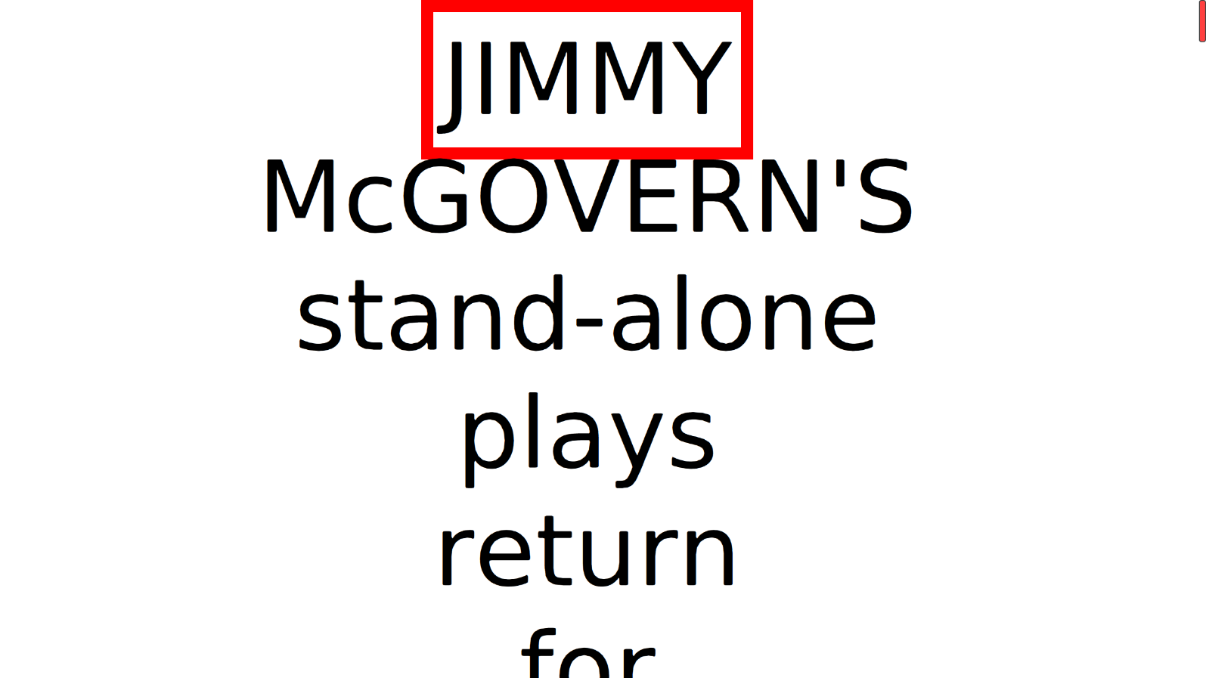

Word view
Displays one word on screen at a time. Text can be advanced screen-by-screen.


Touch Screen Features
If you have a compatible multi-touch monitor connected to your ReadEasy Evolve via HDMI or DVI and USB, there are several features that are only applicable to you.

Finger controls
Rather than tracking a cursor around the screen, you can use your fingers on the screen to directly manipulate documents. The specific touch screen controls are detailed below.

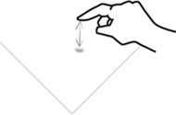
Start and stop reading / menu activation
Pressing on a word, will start your document reading from that word. Pressing anywhere on the screen will stop reading.

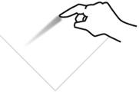
Navigate around your document
To move around your document, simply place one finger on the screen and maintain contact as you move your finger around.

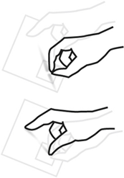
Zoom in / out
To decrease the magnification, use your index finger and thumb to make a pinching movement on the screen.
To increase the magnification, move your closed finger and thumb apart.

You can also do the pinching and stretching motion with two fingers on separate hands. Some people can find this easier.

Caring for your touch screen
Your touch screen will attract finger marks over time. Please follow your particular touch screen’s guidelines for cleaning.
Printed in the UK

