

Citus Migration Suite

User’s Manual

Table of content
Citus Migration Suite 1
User’s Manual 1
Table of content 2
1 Introduction 6
1.1 Purpose 6
1.2 Definitions, acronyms and abbreviations 6
2 Data migration process 7
3 Citus data migration suite usage 8
3.1 Citus Extractor (Tool#1) 8
3.1.1 Verify environment variable 8
3.1.2 Configure tool (Mandatory) 10
Screenshot of Citus Extractor tool 10
3.1.2.1. Connect to Notes database 11
3.1.2.2. Connect to SQL server 11
3.1.2.3. Export users and links 12
3.1.2.4. Setting log file path 12
3.1.2.5. Setting Temporary folder 13
3.1.2.6. Store attachments to a separate table 13
3.1.3 Configure Advance functions of tool (Optional) 14
3.1.3.1. Get Access Control List Permission of Notes Database 14
3.1.3.2. Filter data by date 14
3.1.3.3. Filter data by UNID 15
3.1.3.4. Extract only from designed fields 15
3.1.3.5. Extract from fields not in design fields 16
3.1.3.6. Extract computed fields 16
3.1.3.7. Only fill data to database 17
3.1.3.8. Store all fields type changed to table 17
3.1.3.9. Create database structure from excel file 17
3.1.3.10. Create table name using prefix 18
3.1.3.11. Only create database structure 19
3.1.3.12. Store path’s attachments 19
3.1.3.13. Select form to extract 20
3.1.3.14. Extract by select Fields 21
3.1.3.15. Extract with exclude selected fields 21
3.1.3.16. Setting files (Optional) 22
3.1.4 Save Configuration file 23
3.1.5 Extract execution 23
3.1.6 Migrate multiple Notes Database 23
3.1.7 Verify result 25
3.2 Pre-Processor tool (Tool#2) 26
3.2.1 Configure tool 27
3.2.1.1. Export users from text fields (Optional) 28
3.2.1.2. Update mapping file 29
3.2.1.3. Connect to SQL Server 31
3.2.1.4. Create Job 32
3.2.1.5. Create new SQL database 33
3.2.1.6. Transform Richtext 34
3.2.1.7. Mapping user 35
3.2.1.8. Create SQL script 37
3.2.1.9. Collect users which hadn’t used. 38
3.2.1.10. Provide template for processing tab characters 38
3.2.1.11. Display icons which are not available in Images Library of SharePoint 39
3.2.2 Execute Pre-process 40
3.2.3 Verify result 40
3.3 Transformer tool (Tool #3) 41
3.3.1 Configure tool 42
3.3.1.1. Connect to SQL Server 42
3.3.1.2. Connect to SharePoint Site 43
3.3.1.3. Common settings of Transformer tool 44
3.3.1.4. Create jobs and mapping fields 46
3.3.1.5. Migrate ACL Permission to SharePoint Site (Optional) 50
3.3.2 Execute transformation 51
3.3.2.1. Resume transforming data 51
3.3.2.2. Transform duplicate data 52
3.3.2.3. Transform Document List 52
3.3.3 Verify result 52
3.4 Post-processor tool (Tool #4) 53
3.4.1 Configure tool (Mandatory) 54
3.4.2.1 Connect to SharePoint site 54
3.4.2.2 Create jobs 56
3.4.2 Other Setting (Optional) 57
3.4.3 Setup environment to use Post-process service (Using for SharePoint 2007) 60
3.4.1.1. Setup Citus Post-Processor service 60
3.4.1.2. Setup Environment variables 63
3.4.4 Run Post-Process 65
3.4.5 Verify result 65
4 Appendix 67
4.1 Create SQL database 67
4.2 Verify the number of tables 67
4.3 Count the number of items in Notes view 69
4.4 Count the number of items in SQL data table 70
4.5 Count the number of items in SharePoint list 71
4.6 View data 71
5 Common Errors 72
5.1 Tool1: 73
5.1 73
5.1.1 Tool1 crashes when users double click on “CitusExtractor.exe” to start the tool 73
5.1.2 FILESTREAM feature is disabled 73
5.1.3 Error: Could not find a part of the path: “DiskName:\...\Report.xlsx”. 74
5.1.4 Error create table 75
5.2 Tool2: 75
5.2 75
5.2.1 Rich-text was not transformed to HTML format 75
5.2.2 T-SQL Job run successfully but data were not updated correctly 76
5.2.3 Missing tables in Destination Database created by tool2 when Source Database created by tool1 and Destination Database running in different SQL servers. 76
5.2.4 Error happens when opening mapping file in the job Mapping Users 76
5.3 Tool3: 77
5.3 77
5.3.1 Cannot migrate attachment files to SP 77
5.3.2 The tool cannot migrate data with error message: 78
5.3.3 Cannot display the list to be selected in the Destination Connection. 78
5.3.4 Cannot fill Replies (Response, Response to Response) into Discussion List. 78
5.3.5 Cannot migrate attachment file larger than 50 Mb 78
5.4 Tool4: 79
5.4 79
5.4.1 After running tool, attachment links, Document Link, View Link, DataBase Link are not correct. Inline images are not showed. 79
5.4.2 Tool cannot perform the post-process with the message: 79
5.4.3 Tool cannot perform post-process correctly on the users of System fields with the error message: 79
5.4.4 Tool did not perform the post process correctly on the date-time data of System fields. 80

Introduction

Purpose
Citus Migration Suite is a toolset, copyrighted by FPT Software, for migrating data from Lotus Notes databases to other platforms including SharePoint, Office365... This document is a step by step guide on how to use the tool to migrate data in various scenarios.
In this manual, it is assumed that Citus Migration Suite has been installed correctly; otherwise please follow “Citus Migration Suite Installation Guide” to get it installed.

Definitions, acronyms and abbreviations
Abbreviations/ Acronyms | Expansion | Description
Damai | Data Migration | The process to transfer data between platforms, in Citus Migration Suite usage context, the source platform is Lotus Notes database, target platform is often MS SharePoint site and sometimes MS SQL, Oracle RDBMS database or MS Word document.
Damai Script | Data Migration Script | Configuration for a pair of Lotus Notes database and corresponding SharePoint site, it includes field mappings and other rules for filter, split, merge fields, transform values
UAT | User Acceptance Test | The verification step, usually done by power user before moving SP site to Production environment
SP | SharePoint | Microsoft SharePoint web application platform for group collaboration
DB | Database
LN | Lotus Notes | IBM groupware application platform

Data migration process
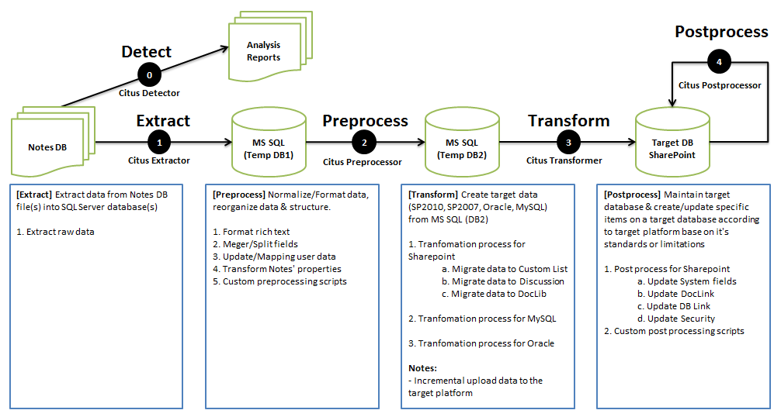
Consolidated from Lotus Notes migration projects over the years, our matured migration process offers both flexibility and solidness to resolve migration requirement in various situations.
The migration process is depicted in the diagram above, and following sections in this document will show how Citus Migration Suite aligns with the process.

Citus data migration suite usage

Citus Extractor (Tool#1)
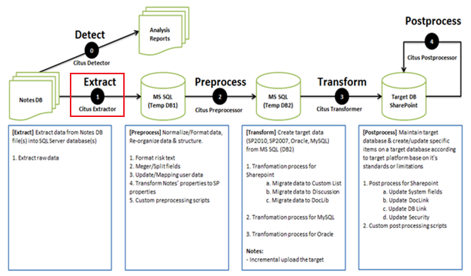
At this step, all data from Notes database will be extracted and inserted to an SQL database. SQL database is chosen to be intermediate storage because of its processing power.
Activities at this step are:
- Verify environment variable: to ensure the tool can invoke Notes API commands
- Configure tool: specify which LN DB to extract and which SQL server to store temporary data
- Extract execution
- Verify extraction result
- Data filtration
- Export user, database link, document link, view link

Verify environment variable
Extractor tool uses Notes API to open and read Notes databases, so Notes client version 6.5 or later must be installed, and path to Notes DLL files must be added to the Environment Variables “Path” for the tool to locate and invoke Notes API commands.
Follow the steps below:
- Step 1: Open System Properties, click on Environment Variables
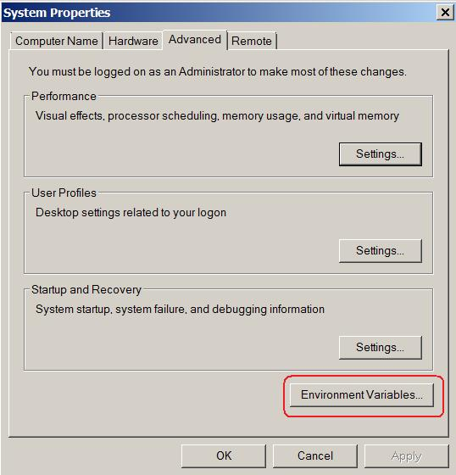
- Step 2: In System Variable, chose Path, then click on Edit button
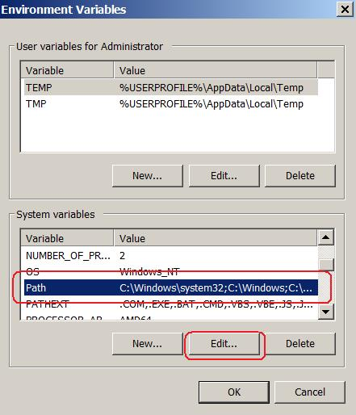
- Step 3: Add path of Notes folder into variable value
For example: add “;C:\Program Files (x86)\lotus\notes” for default path when install Lotus Notes version 6.5 on a Windows 7 machine.
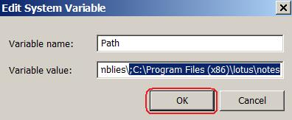

Configure tool (Mandatory)
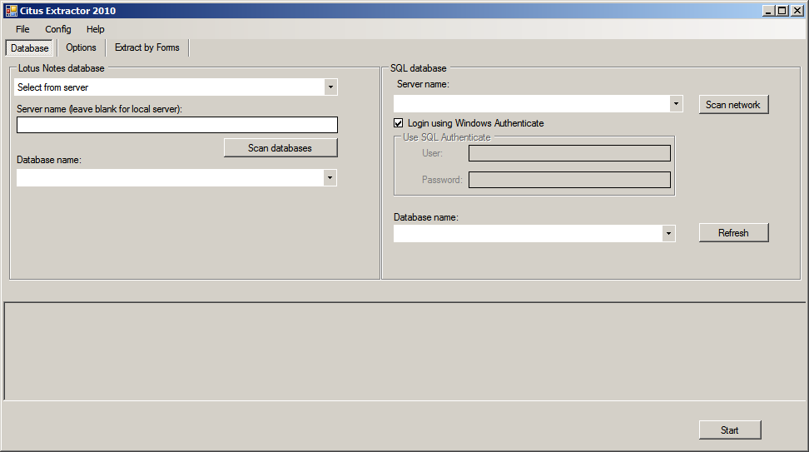

Screenshot of Citus Extractor tool
Before you run the tool, some configuration must be done: This section guides you on Do-s and Don’t-s within the configuration. They are:
Mandatory Setting
- Connect to Notes database
- Connect to SQL server
- Export users and links
- Setting log file path
- Setting Temporary folder
- Store attachments to a separate table
Optional Setting
- Get Access Control List Permission of Notes Database
- Filter data by date
- Filter data by UNID
- Extract only from designed fields
- Extract from fields not in design fields
- Extract computed fields
- Only fill data to database
- Store all fields type changed to table
- Create database structure from excel file
- Create table name using prefix
- Only created database structure
- Store path’s attachment
- Select form to extract
- Extract by select Fields
- Extract with excluded selected fields
- Setting files
Follow the below steps to configure the tool.

Connect to Notes database
This configuration defines the source of Lotus Notes database through the following steps:
- Step 1: Click on Database tab
- Step 2: Browse the database file. The file can be located on local folders or Domino server.
If the Notes database file is located on local folder, follow the steps below:
- Select Browse in the Dropdown list
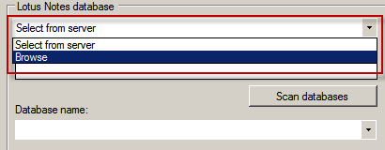
- Click on Browse button
- Browse to Notes database file
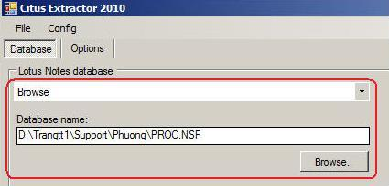
Otherwise, the Notes database file is located on Domino server, follow the steps below:
- Select Select from server in the dropdown list
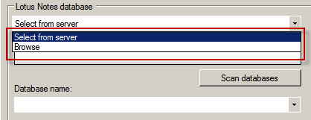
- Input server name into Server name box
- Click on Scan databases button
- Select a database in the generated database list

Connect to SQL server
The configuration defines to specify SQL Server and SQL database to store intermediate data through the following steps:
- Step 1: Click on Database tab
- Step 2: Input server name into Server name box
- Step 3: If using SQL Server Authentication, uncheck Use Windows Authenticate. In case using SQL Server Authentication, do as the follows:
- In the User box, type the User Name which is associated with the SQL server certificate
- In the Password box, type the password for the user name that is associated with the SQL server certificate
- Step 4: Click on Scan Button to scan all matching databases
- Step 5: Select database which will store data in Database list.
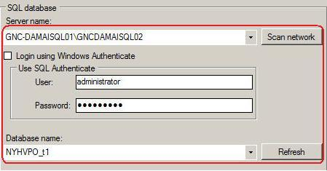
In most cases, two above factors must be configured. Besides, the tool also provides different options to deal with special scenarios.

Export users and links
When migrating from Lotus Notes to SharePoint, there are data conversions that must be done to map Notes entities with new entities in SharePoint. The Citus Extractor saves all information such as users, links… of Notes in excel files and you need to fill in the corresponding SharePoint information. Then the information will be corrected in a different process. Follow the steps below to configure output for this process:
- Click on Options\Output tab
- In the Export users and links to, ensure that the correct path to your excel file (called Mapping file) is specified
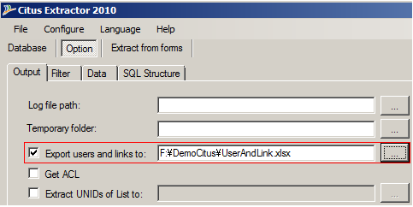

Setting log file path
This configuration is used to set up log file location. The steps are:
- Click on Options tab
- In the Log file path box, ensure that the correct path to your log file is specified
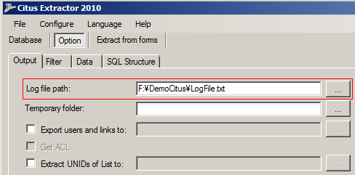

Setting Temporary folder

Textbox [Temporary Folder] allows users to set a folder path. This folder is used to save attachment files during the tool execution process.
- If this text box is empty: The tool saves automatically attachment files in the folder “Temp” of the package containing the tool. We have to ensure user can “write” into the folder “Temp” of the folder containing the tool.
- If this text box is set a folder path: The tool saves automatically attachment files in this folder, and so we have to ensure user can “write” into this folder.
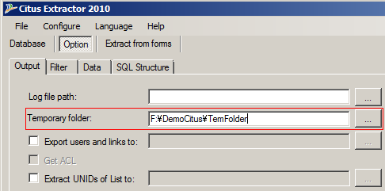

Store attachments to a separate table
To avoid some of the limitations of SQL Server during data conversion, you should separate the content and attachments into two tables. This function is used to create 2 tables for each Notes form: one contains the contents of fields and the other contains attachments named by form names and ““_Attachments” suffix.
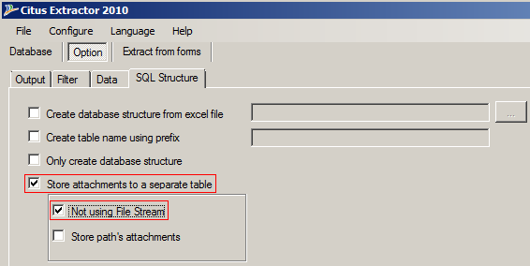

Normally User should select check box “Not using File Stream” in this function.

Configure Advance functions of tool (Optional)

Get Access Control List Permission of Notes Database
User using function này để export thông tin permission (ACL) của Notes Database ra excel file
- Click check box Export users and links to and input a excel file path into checkbox next by

- Click check box Get ACL to selected it
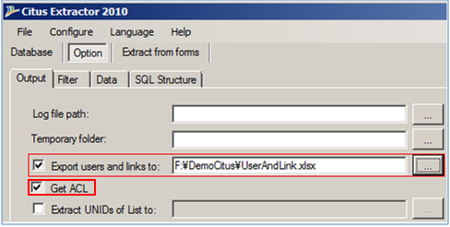

Filter data by date
This option is used in case you want to migrate only data of specific time period. Tick on this option, choose start date and end date, only data from start date to end date will be migrated into SharePoint. Follow the below steps:
- Click on Options\Filter tab
- Input date into Extract data from and to
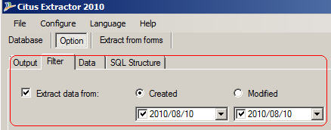

Filter data by UNID
This option allows to choose each document or list of documents by UNID to migrate to SharePoint by doing the below:
- Click on Options\Filter tab
- Input UNID into Extract only list of UNIDs
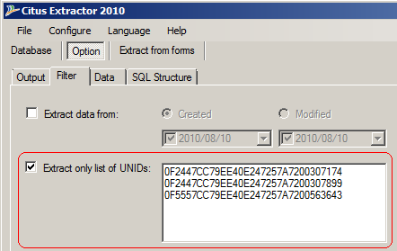

Extract only from designed fields
This option allows you to extract the fields in the current design only. See below example for more details:
Firstly, Notes Design form had three Notes Fields (NotesField1, NotesField2, and NotesField3) and you have been created some documents which are always three Notes Fields. Now, by changing requirements, you must delete NotesField3 from design form, and then you create some documents with new design forms. The Notes document now contains two fields: NotesField1 and NotesField2.
If you only want the tool to get two fields (NotesField1, NotesField2) without NoteField3, the tool will provide an option called “Extract for only Design fields”. This function will retrieve all documents, but keep the fields existing in Design Notes form and ignore other fields.
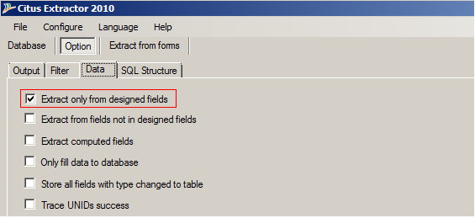

Extract from fields not in design fields
This function will get all data in fields which exist in Notes documents but it ignores all design’s fields.
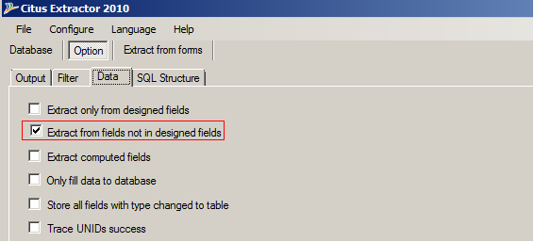

Extract computed fields
This function will provide you feature to extract value of “Computed for display” fields in Notes.
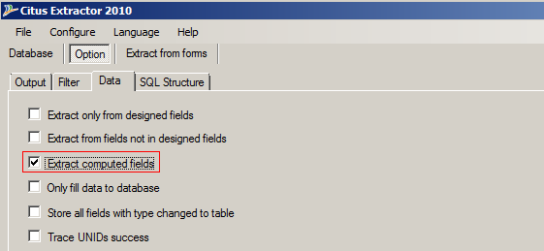

Only fill data to database
You can use this function when you want the tool to dump data from Notes database to an existing SQL database. This option is useful when you want to force SQL database structure.
This function will insert data into the existing tables in the SQL database; the database schema is not altered.
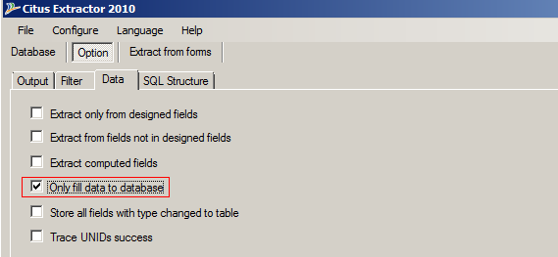

Store all fields type changed to table
As Extract for only Design fields option above, the Notes database design can be changed at any time during use. This function will create a SQL table which stores changed fields.
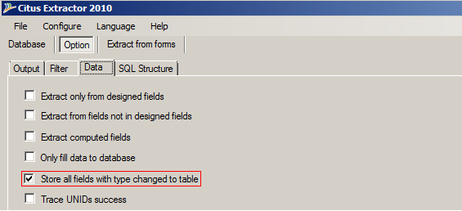

Create database structure from excel file
This option is usually used in combination with the Citus Detector tool when you want to enforce customization to the SQL database schema (e.g. data type casting). The steps are:
- Run Citus Detector tool to export Lotus Notes database field list in Excel format
- Modify the Excel file as required
- Run Citus Extractor with options “Do not scan Notes documents”
To specify the Excel file which stores database schema, click on Browse button then select Excel file
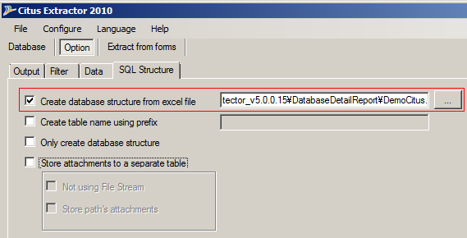
Following is the Notes database template:
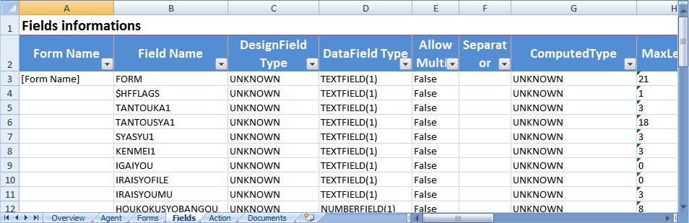

Create table name using prefix
This function allows users to set prefix for table name that the tool creates during the export data process. The prefix is entered into the textbox as the figure below. This function is used to migrate data into an available SQL database in order to avoid overwriting tables with the same name.

Note:
- If this text box is empty, the default value is Notes DB name. The tool name the table according to the following formula: NotesDBName_000_FormName
- If this text box is set, the tool name the table according to the following formula: PrefixName_NotesDBName_000_FormName
- If after using prefix, there exists still tables with the same name, then these tables are overwritten.
- For the old versions of the tool (from the version 20120919_Tool1_V5.0.0.43 to the previous versions), the table name is the name of the corresponding form in Notes DataBase.

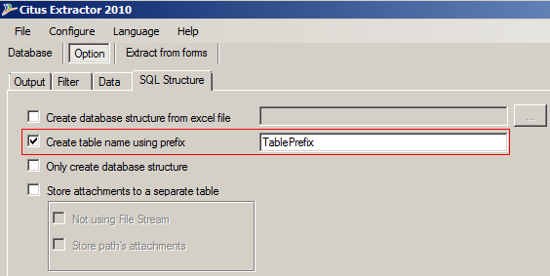

Only create database structure
In the case you just need to get the SQL database structure corresponding to the Notes database, check this option to save time that otherwise will be spent to extract all data.
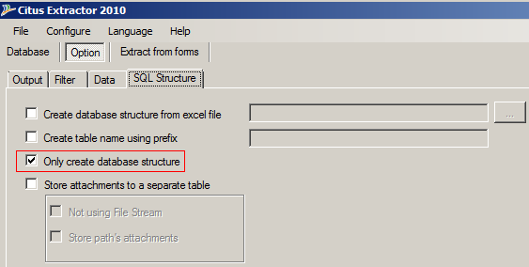
Notes: Please make sure the SQL database schema is compatible with the Notes data. The good practice should be:
- Run Citus Extractor with option “Only create database structure” which creates tables structure, modify the generated schema to fit your specific requirements (e.g. data type casting)
- Run Citus Extractor again with the option “Only fill data to database”.

Store path’s attachments
When working with a large Notes database, storing all data in SQL is restricted. Besides, it also affects the performance. So this function is used to allow saving attachments to files stored in a folder on the computer hard disk and the path to the file is store in SQL.
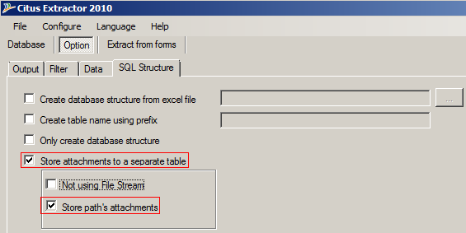

Select form to extract
In some cases, some forms in Notes are not migrated to SharePoint. This option will allow you to choose specific forms to extract. The steps are:
- Click on “Extract by form” tab
- Select check box “Extract by select form”
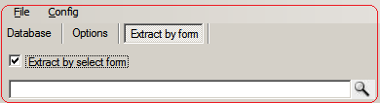
- Click button “Scan form” to load all forms in the current Notes database
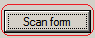
Then all the forms will be displayed as the following:
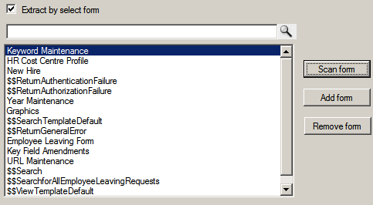
- Select forms to extract. You can type into the textbox to find the form.
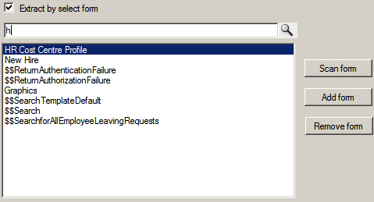
- Click Add form or Remove form to specify forms to extract:
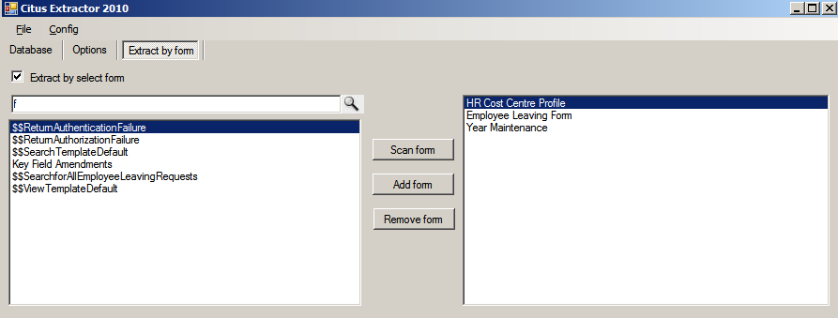

Extract by select Fields
This option must run with the option “Extract by forms” to specify fields to extract data. Use button “Add” to select fields to migrate.
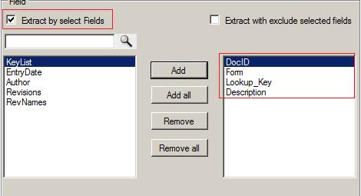

Extract with exclude selected fields
This option must run with the option “Extract by forms”. Use button “Add” to add fields from left list to the right list which contains all fields to be ignored when extracting.
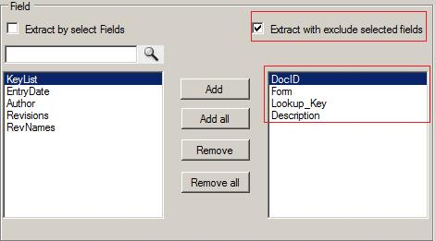

Setting files (Optional)
User can change the information in files “lncppapiext.ini” and “CitusExtractor.exe.config” based on specific requirement when migrating data. Both files are include in package of the tool.
- File lncppapiext.ini: This file is used to store information about OLEs so that the tool can identify to migrate.
On running, if an error like “Unknown OLE…” occurs, follow the steps below:
E.g.: If OLE is a Word 2010 file that was not addressed in lncppapiext.ini, when migrating the tool will throw the message “Unknown OLE Word.Document.12”.
To resolve the problem, user has to find the extension of this OLE (as in this example, it is “.docx”). After that, add the definition of OLE file to lncppapiext.ini following the structure: [Name of OLE]=[file extention].
E.g.:
With Microsoft Word 2010: Word.Document.12 = .docx
With Microsoft Word 2007: Word.Document.8 =.doc,1
Notes: The default file extension must consist of 4 characters, but for Word 2007 the file extension consists of 3 characters “doc”. Therefore, “,1” is added to the end.
- File CitusExtractor.exe.config: Change the value of key name depending on each specific situation below:
Key Name and Default Value | Meaning of key name
<add key="SeperatorPrefix" value="_000_" /> | Use this default value to be prefix for the SQL table name
<add key="AttachFileMax" value="200" /> | This is the max value of file size (Mb) that tool allows to extract.
<add key="FillReportError" value="false" /> | If set to “True”, the tool will save all error occurred in running process to excel file  (default folder is “Report” folder)
<add key="CollectChangeType" value="false" /> | If set to “True”, the tool will extract all fields that have change compared to design to excel file.  (default folder is “ChangedType” folder)
<add key="AllowTraceBugAPI" value="false" /> | If set to “True”, the tool will save all error of Notes API. This is convenient for development team in bug tracking.
<add key="MakeUrlsToHotspot" value="True" /> | Change all text that has format like hotspot to hotspot link
<add key="hostpot" value="http://#https://#ftp://#gopher://#mailto:#News:#notes://" /> | This is the prefix to check if the format of the text is the like a hotspot.
<add key="DefaultFormat" value="mm/dd/yyyy hh:mm:ss tt" /> | If Notes field has DateTiem datatype but the value does not follow the DateTime format, the tool will re-format this value.
<add key="SpecialCharacterSQL" value="65286,$"/> | This is the special character that the tool will replace by underscore character (“_”) when creating tables in SQL database. User can add more special character following the structure:  {ASCII code of the special character} + “,” + {special character}

Save Configuration file
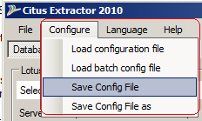
- Users click the “Configure\Save Config File” menu to save information into the configuration file
- Users click the “Configure\Save Config File as” menu to save information into a new configuration file

Extract execution
After all configurations are done, click Start button to extract data from Notes to SQL.
You can check the status and the error occurs during the running of the tool through the trace information screen.

Migrate multiple Notes Database
Users can use the “run Tool in Batch Mode” function to migrate multiple Notes Database at the same time.
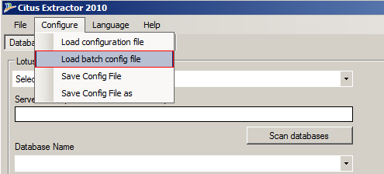
- Create the Configuration file as the steps given in 3.2.1 section
- From the main screen of Citus Extractor tool, select sub menu “Load batch config file” in menu “Configure”
- Select a Configuration File (.xml) to load Citus Extractor tool in Batch Mode
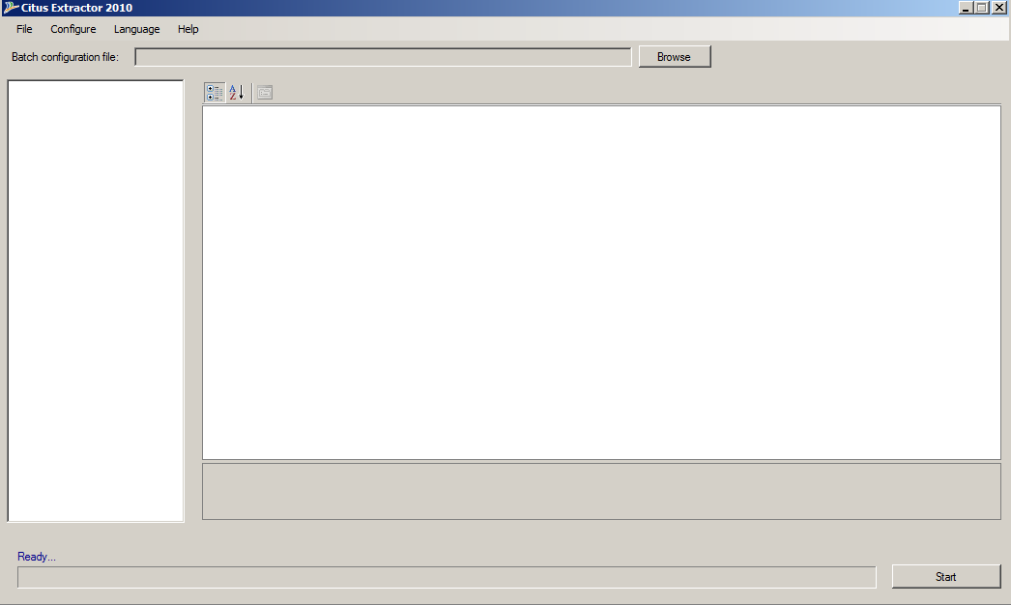

- Open Batch Configurations Template file, and input information as sample bellow:

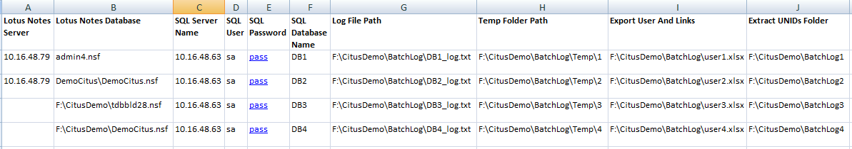
- Click buttion [Browse] to open the Batch Configurations file

- From the main screen of Citus Extractor tool, select sub menu “Load batch config file” in menu “Configure”
- Verify information of the configure tool displayed on the screen by clicking the name of the DataBases:
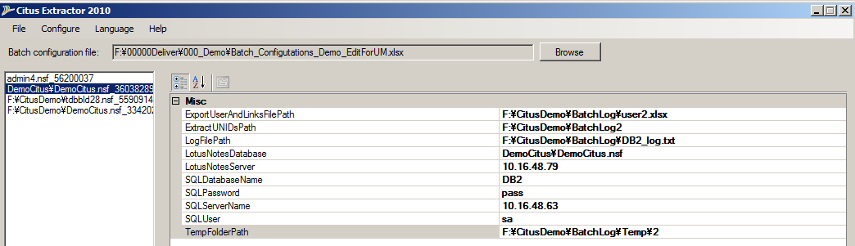
- Click [Start] button to run the tool

Verify result
When the tool has finished, go to SQL database to see results. Follow the below to compare the extracted data in Notes and in SQL.
- Verify number of forms: Verify the number of tables
- Verify number of items
- Count the number of items in Notes view
- Count the number of items in SQL data table
- Verify data: Verify that data extracted from Extractor tool is the same or corresponding with data in Notes (View data)

Pre-Processor tool (Tool#2)
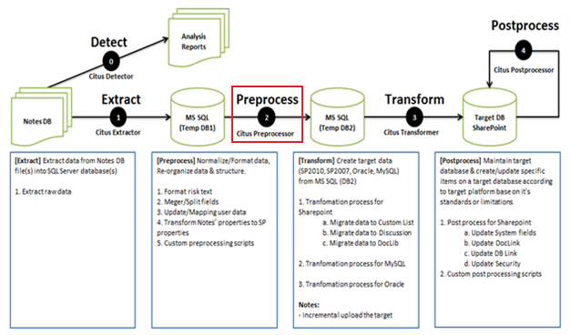
Citus Extractor extracts all raw data from Notes to SQL. It will be input for Pre-Processor tool to implement a number of steps for pre-processing the data, so the raw data can be appropriate with data used in SharePoint site.

Configure tool
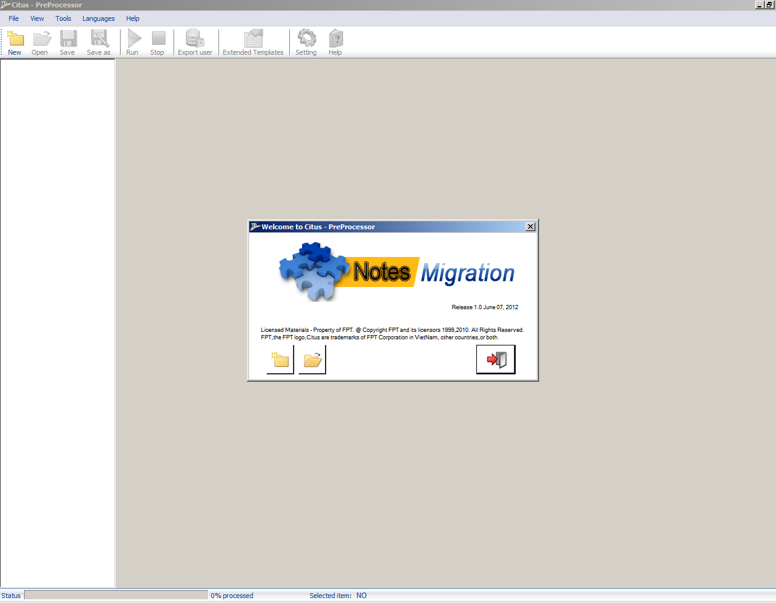
Pre-Processor tool: Screenshot

The tool provides functions to perform Notes data processing before dumping into SharePoint. Some tasks need to be done in this process, such as: backup SQL database in case the preprocessor error, transform Rich text fields to html format, transform users…
Before running the tool, you have to complete following steps:
- Export Users from Text Fields.
- Update Mapping File.
- Connect to SQL Server.
- Create Job.
- Create new SQL Database.
- Transform Richtext.
- Mapping user.
- Create SQL script.
- Collect users which hadn’t used.
- Provide template for processing tab characters.
Follow the below steps to configure the tool:

Export users from text fields (Optional)
This function allows you to export Users to an excel file. Follow the below steps:
- Open Citus Pre-processor tool
- Click on Export User button on the top navigator
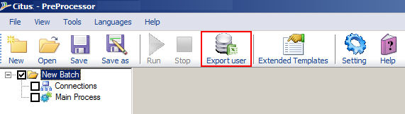
- Follow the steps below to export users

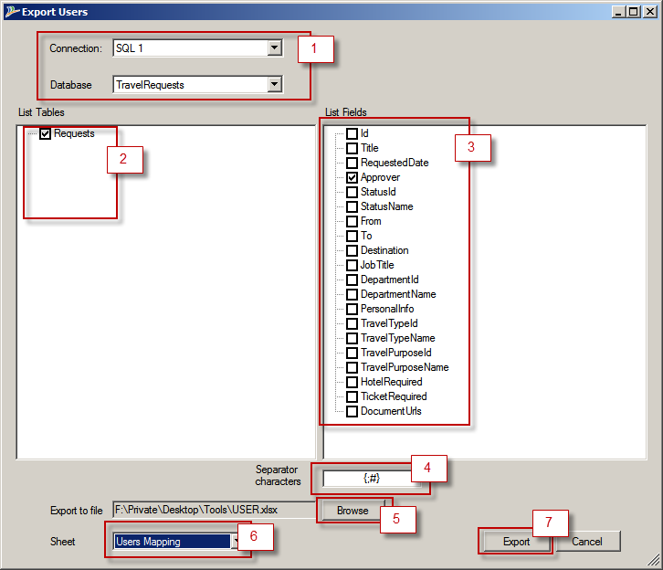

- Select connection in Connection list, then select database which will store data in Database list (1)
- Choose table names in Table list (2), and field names in Field list (3)
- Input separator characters for multi-user text fields (4)
- In the Export to File box, input the path of excel which will map with the user file (5)
- Select User mapping sheet in Sheet list (6)
- Click Export button (7)
3
2
1
5
4
- For each table in table list
  - Select a table on table list
  - For each field in field list
    - Select field
    - Input separator characters for multi-user and separator characters for each user
    - Click on Export button
- For example:
With string: “May 3, 2005 11:16:43 AM: Yulia Arteaga/NewYork/DBNA/DeuBa;#May 3, 2005 11:11:44 AM: Yulia Arteaga/NewYork/DBNA/DeuBa;#May 3,…”
    - Users are ‘Yulia Arteaga/NewYork/DBNA/DeuBa’ and ‘Yulia Arteaga/NewYork/DBNA/DeuBa’
    - Separator character for multiuser is ‘;#’
    - Separator character for each user is ‘: ‘

Update mapping file
The tool #1 will create an excel file including multiple sheet, each sheet contains information on Notes users, Database links, Document links and View links. This information is used to correct data migrated to SharePoint by the tools afterward. In order to fill suitable information into this excel file, users have to do the following:
Note: Users have to use Microsoft Excel 2007 or newer versions

Open Mapping file (see Export users and links part in 3.1.2.3)

- In Database links sheet:
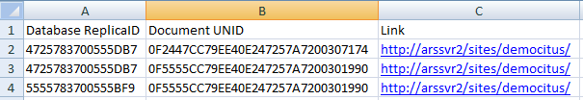
- Database ReplicaID: contains list of Notes Database IDs.
- Document UNID: contains list of Document UNIDs that have database links linking to corresponding Notes database.
- Link: Allow User input information of corresponding URL.

Note: Due to SharePoint do not have element suitable to Database Link on Notes, so normally User should put a site collection URL to [Link] column.

- In Document links sheet:
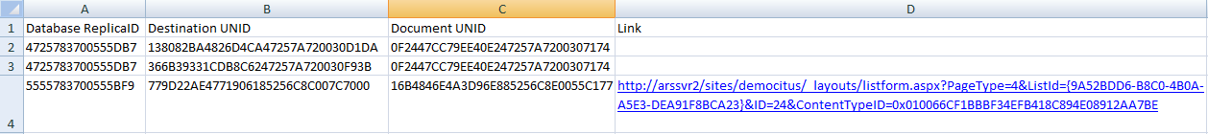

- Database ReplicaID: contains list of Notes Database IDs.
- Destination ID: contains list of Destination IDs that have UNID of destination document.
- Document UNID: contains list of Document UNIDs that have document links link to corresponding document.
- Link: Allow User input information of corresponding URL (User can put a URL link in this column or not):
  - Normally: User do not need to input in this column
  - To improve performance user can put a URL link to a specific list of SharePoint site. In this case Tool only searching document in this List)
  - Incase external Document link (Document link to Document in other Notes Database): User need input a absolute link to document item into this column (See line 5)

- In View links sheet

- View UNID: contains list of View UNIDs that have UNID of destination view.
- Database ReplicaID: contains list of Notes Database IDs.
- Document UNID: contains list of Document UNIDs that have document links link to corresponding view.
- Link: Allow User input information of corresponding URL to a specific View.

- In Users Mapping sheet: insert corresponding SharePoint users into SharePoint User column

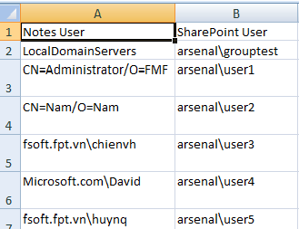
- Notes User: contains list of Notes Users.
- SharePoint User: User have to input corresponding SharePoint users into this column.

Connect to SQL Server
- In Connections, right mouse click and choice New Connection to create source connection and destination connection.
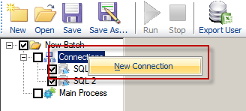
- Input Database information
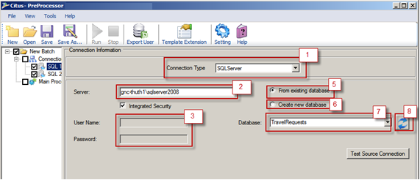
- Select SQLServer in Connection Type list (1)
- In the Server box, type the SQL server name (2)
- In case of not using SQL Server Authentication, uncheck Integrated Security (3) and
  - In User Name box, enter the User Name that is associated with the SQL server certificate.
  - In Password box, enter the Password for the user name that is associated with the SQL server certificate.
- Select From existing database option if it’s the source connection (5) then:
  - Click on Refresh button (8)
  - Select source database name in database list (7)
- Select Create new database option if it’s the destination connection, and then enter the new database name in the Database box.

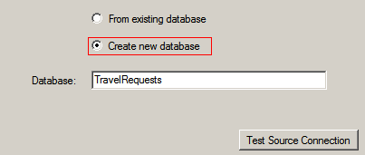

Create Job
This function allows you to create some processes to pre-process raw data extracted by Citus Extractor, such as: change format. This function can be done by right mouse clicking and choose New Job in Main Process.
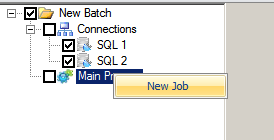
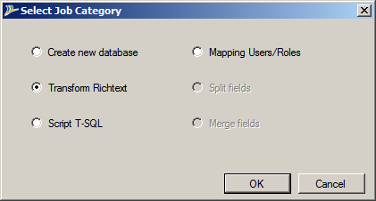
There are some options for specific purposes:
- Create new database function will create a new destination database and copy structure from source database.
- Transform Richtext function will transform Notes Richtext content to Html format.
- Script T-SQL function will execute the custom SQL script.
- Mapping Users/ Roles

Create new SQL database
To avoid losing data when errors occur, you should backup data by creating new SQL database and performing pre-process.
In Create new database option, follow the steps:
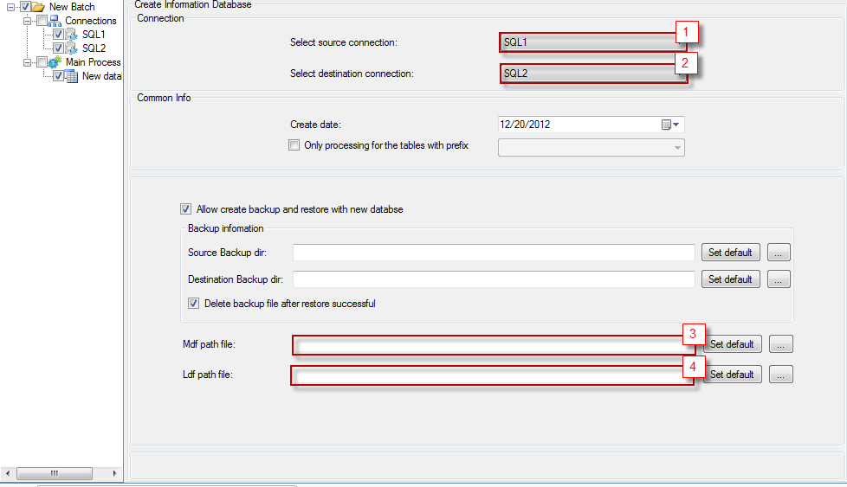
- Select source connection (1) which is the SQL database output after Citus Extractor tool is run.
- Select destination database (2).
- In Mdf File Path box, enter the path of new LDF File (3).
- In LDF File Name box, enter the path of new MDF File (4).
- Select Allow create backup and restore with new database option if you want backup and restore the database in copy database step.
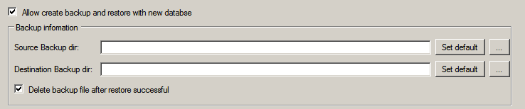
  - In Source Backup dir box, type the path of backup file.
  - In Destination Backup dir box, type the path of backup file.
- From the version 5.0.1.1, users can select tables according to a prefix entered when running the tool (3.1.3.10). If this function is selected, users cannot create database by option “Allow creating backup and restore with new database”.
In the case the database exists:
- If the corresponding table exists, then the tool will overwrite data of this table
- If the corresponding table does not exist, then the tool will create the table and insert data into this table.

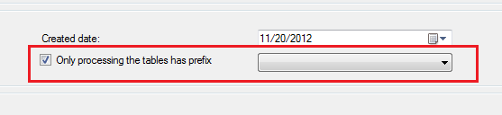
  - Select “Only processing the tables has prefix”
  - Select Prefix from the dropdown list above.

Transform Richtext
The data type Richtext is still in XML format after conversion. So to display the original content properly, you need convert into HTML format. This step also creates pattern links in Richtext which are useful for correcting data later. The steps are:
- In Main process, right mouse click and choose New Job.
- Select Transform Richtext option.
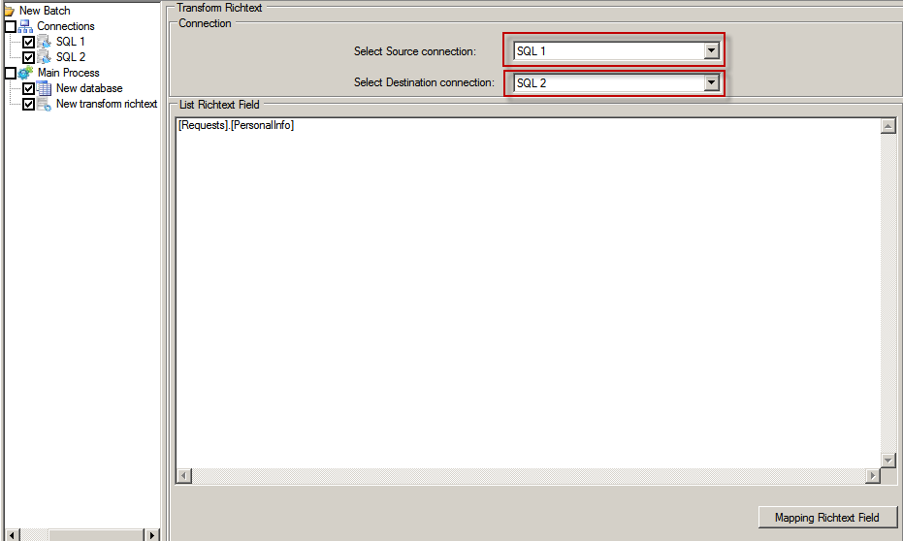
- Select Source connection and Destination connection.
- Click on Mapping Richtext Field button then select Richtext fields as the below:
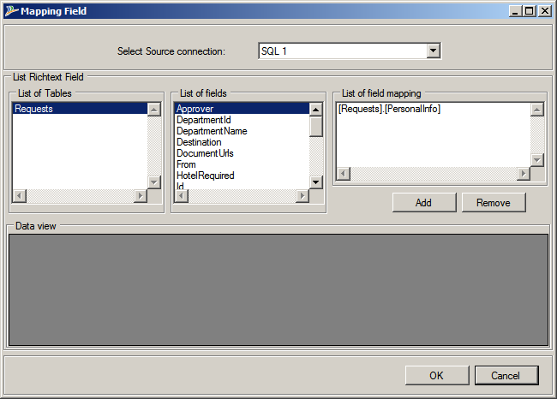
  - Select Table of List of Table which contains user fields.
  - Select user fields of List of fields and click Add button to add fields into List of field mapping. Click on Remove button to remove selected fields.
  - Click on Ok button to complete or click on Cancel button to cancel.

Mapping user
After detaching the data from Notes, Notes users will be stored in an excel file and you have to map with SharePoint users in the excel file. This step helps you map users from excel file to SQL data.
- In Main process, right mouse click and choose New Job.
- Select Mapping Users/Roles option
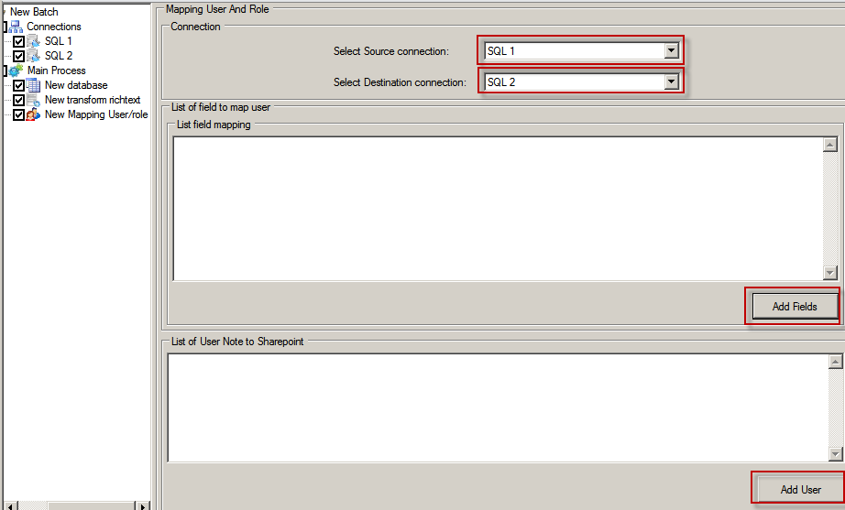
- Select Source connection and Destination connection
- In List field mapping, Click on Add Fields to select mapping fields
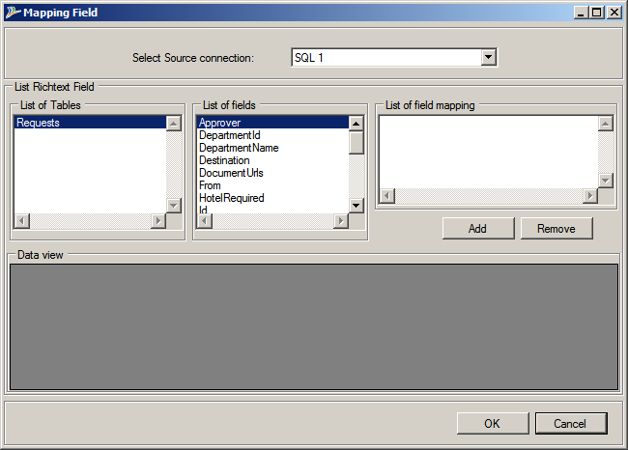
  - Select Table of List of Tables which contains Richtext fields
  - Select Richtext fields of List of fields and click Add button to add fields into List of field mapping. Click Remove button to remove selected fields
  - Click Ok button to complete or Click on Cancel button to cancel
- In List of Users note to SharePoint, click on Add user button, then Mapping User dialog will display as the below:
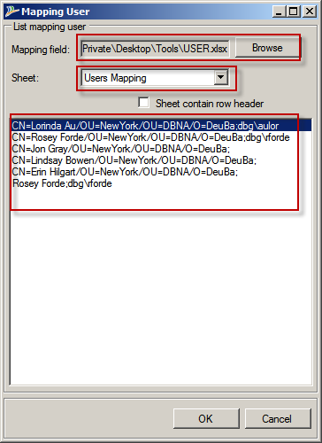

Follow the steps:
  - Browse to Mapping file (Generated from Citus Extractor and updated by Export User function of Citus Pre-Processor tool).
  - Select User mapping sheet in Sheet list.
  - Click on Ok button to complete or click on Cancel button to cancel.

Create SQL script
This function will help you perform some SQL data manipulation to match raw data from Notes to data format in SharePoint, such as: split a Notes form into 2 SharePoint list or merge 2 Notes forms into 1 SharePoint list…
- In Main process, right mouse click and choose New Job.
- Select Script T-SQL option
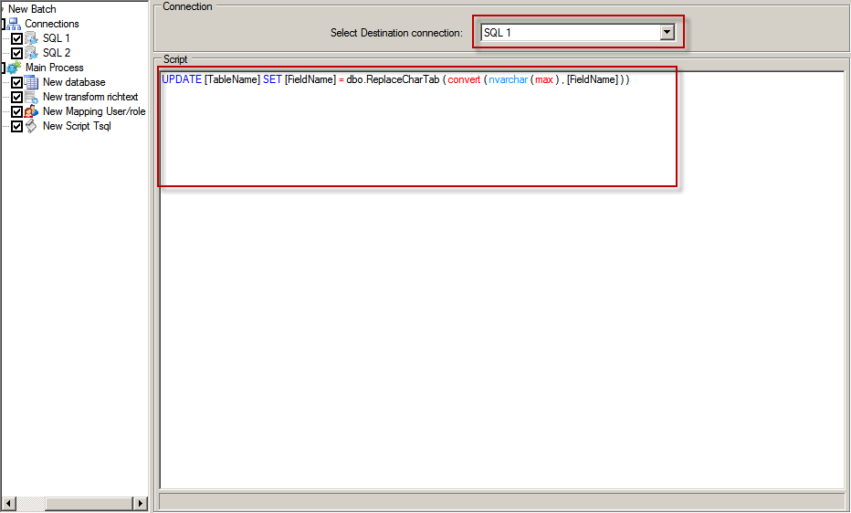
- In Connection, select Destination connection, which will execute a SQL-Script
- Input script into Script textbox

Collect users which hadn’t used.
This feature is used to collect user accounts that no longer exist. You must run Mapping user feature above before running this feature. The tool will create a column to store these users in the corresponding table.
Follow the steps below:
- Click on Setting on the tool screen
- Fill prefix for the name of a new column.
- Click on OK button.
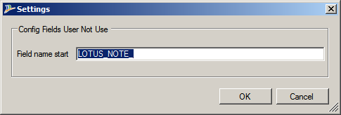

Provide template for processing tab characters
This feature is used to replace all tab characters in Richtext field by space character. The steps are:
- Click Template extension button on the top navigate and the following dialog will be displayed.
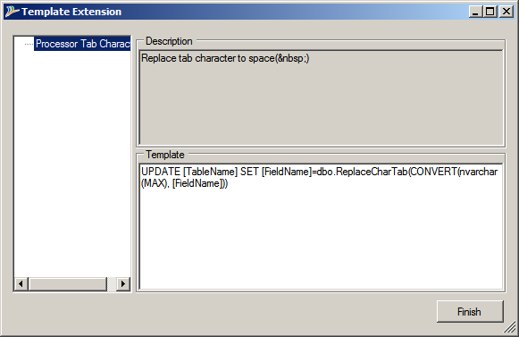
- Copy template and paste into script SQL
- Change corresponding table name and field name where you want to replace.

Display icons which are not available in Images Library of SharePoint
In the case icons are not available in Images Library of SharePoint, the tool will use the default icon. However, users can do the following to add these icons when migrating.

- Copy the .gif file that you want to use for the icon to the following folder on the server, as appropriate for your version of SharePoint:
SharePoint Server 2007- Drive:\Program Files\Common Files\Microsoft Shared\Web Server Extensions\12\Template\Image
SharePoint Server 2010 - Drive:\Program Files\Common Files\Microsoft Shared\Web server extensions\14\Template\Images

- Open file StyleSheet.xsl trong package of Tool2 by NotePad.
- Search tag <xsl:variable name="fileExcepsionTemp"> and input the following tags under tag <xsl:choose>:
<xsl:when test="$fileExtension='[FileExtension]'">
<xsl:value-of select="'[NameOfIcon]'"/>
</xsl:when>
See image:
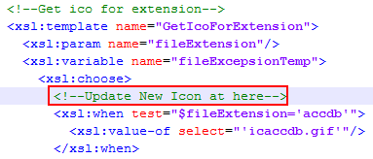
Example for icon PDF file:
<xsl:when test="$fileExtension='pdf'">
<xsl:value-of select="'icpdf.gif'"/>
</xsl:when>
- Save and Close file StyleSheet.xsl
- Navigate to C:/Program Files/Common Files/Microsoft Shared/Web Server Extensions/14/TEMPLATE/XML and open DOCICON.xml
- It is a good idea at this time to make a backup of the file by simply copying it to another location.
- Add the line <Mapping Key=”pdf” Value=”pdficon_small.gif”> where the other mapping key entries are and save back the file.
- Open a command prompt as administrator and type in IISRESET and press enter.
- Run tool

Execute Pre-process
After all configurations are finished, you can run the tool by clicking on Run button on the top navigator. You can check the status and error occurs during running the tool through the trace information screen.

Verify result
After the tool has finished, you can go to SQL database to see the results.
- Verify number of tables: Compare number of tables between SQL1 and SQL2
- Verify number of items: Compare number of items between SQL1 and SQL2
- Map users: Verify that users in fields has been mapped to users in SharePoint (View data)
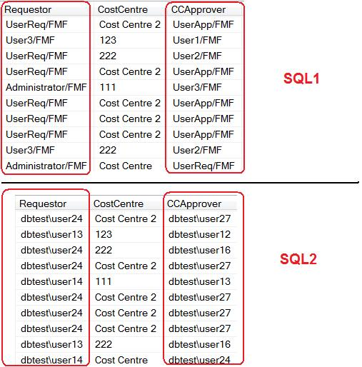
- Verify multi value fields: Verify that separate characters in the multi value fields have been processed (View data)
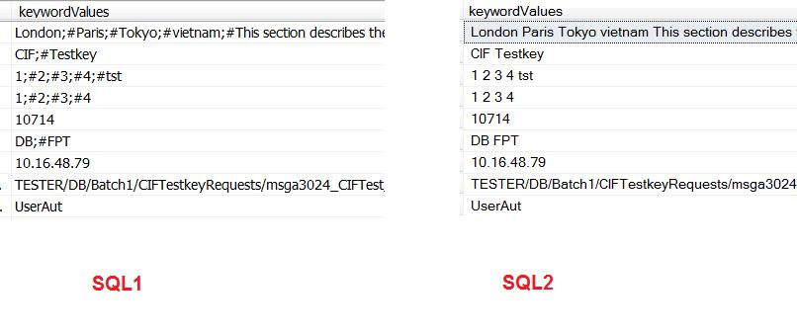

Transformer tool (Tool #3)
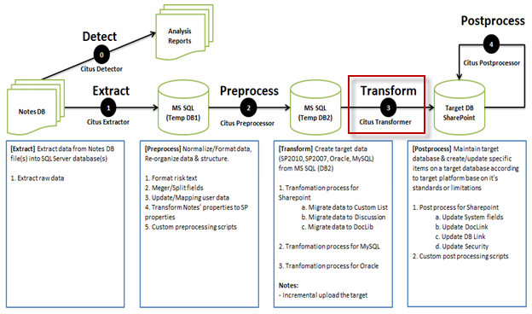
Transformer tool will read all data from output database of Pre-Processor tool (Tool#2) and correct it to avoid limitations on the target connection. Data will be transferred to the target databases based on the pre-settings.
See the screenshot below:
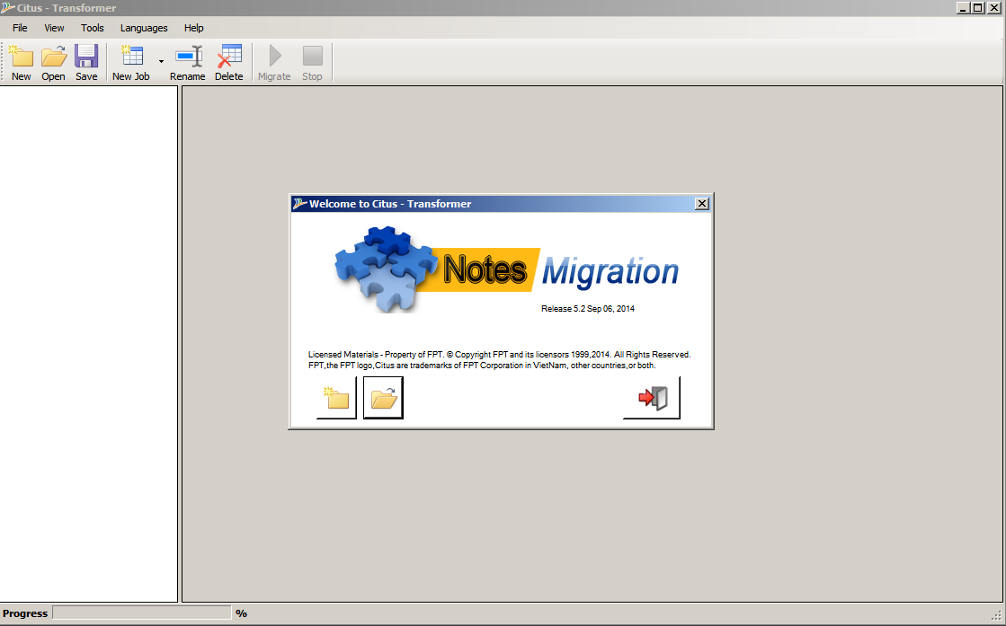

Configure tool
To run this tool, you must configure the tool by defining connections, defining jobs, and doing some settings. Before running the tool, you have to complete following steps:

Connect to SQL Server
You can create many connections to use, and select two of them in a job: one is the source connection and the other one is the destination connection. We have 2 kinds of connections: to SQL and to Share Point.
The tool provides two ways to create a new SQL connection:
- The first way: From left panel, select Connection (1), then click to New Connection (2) and select to New MSSQL Connection as the follows:
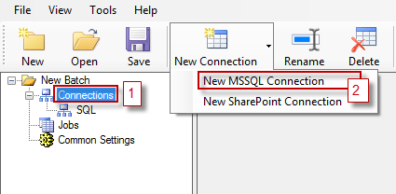

- The second way: From left panel, right-click to Connection (1) and select New MSSQL connection (2) as the follows:
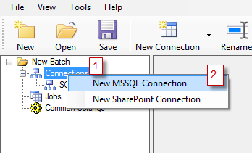

In MSSQL Connection window, input connection information and then click on Test button to ensure your connection is already in use. See the figure below:

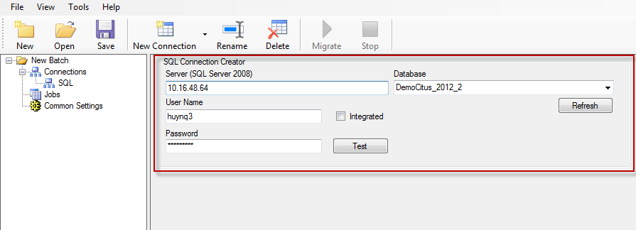

Connect to SharePoint Site
Like creating new SQL connection, Transformer tool also provides 2 ways to create a new SharePoint connection:
- The first way: From left panel, select Connection (1) and click to New Connection (2) and select to New SharePoint Connection as the following:

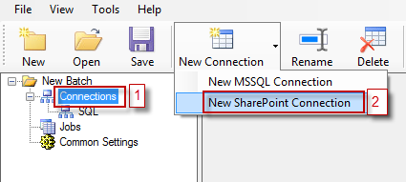

- The second way: From left panel, right-click to Connection (1) and select New SharePoint connection (2) as the follows:
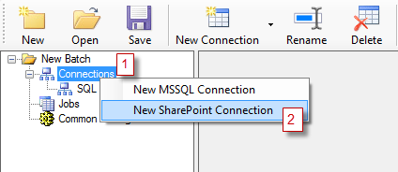
In SharePoint Connection window, input connection information, and then click on Test button to ensure your connection is already in use. See the figure below:

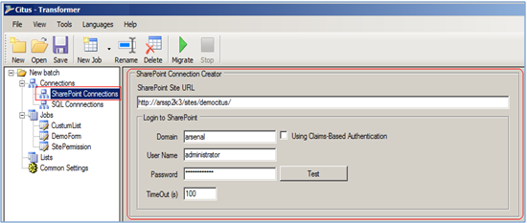
Note: In order to migrate to SharePoint Online site, at the beginning, users must catch login information to SharePoint site by Internet Explorer, then select checkbox “Using Claims-Based Authentiaction” on the screen.

Common settings of Transformer tool
The tool also provides some common settings for all jobs.
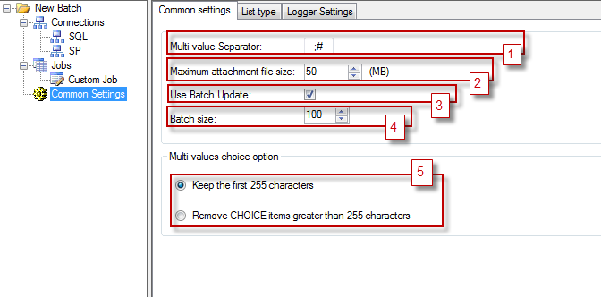
(1) Choose multi-value separator (by default: ‘;#’) to separate values in multi value fields.
(2) Set maximum attachment file size (by default: 50MB)
(3) Use/Unused batch updating functions
(4) Number of items when using batch update (option 3 is selected) to define the number of items will be uploaded to SharePoint site each time
(5) With choice field, select a processing mode when the number of characters of its value is greater than 255 characters, keep the first 255 characters or remove its value.
List Type
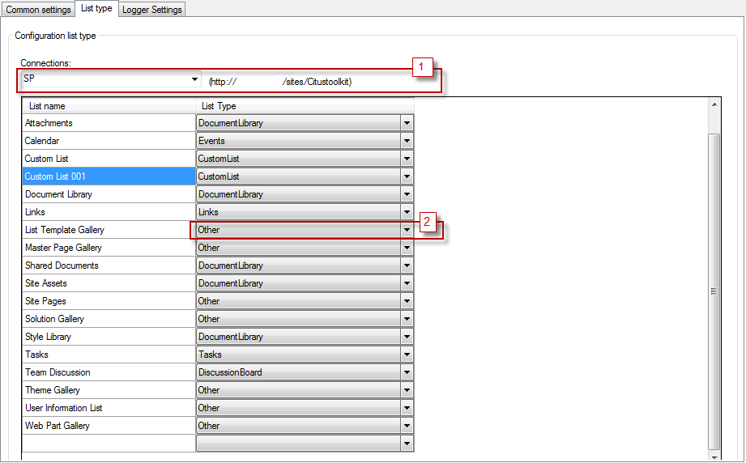
In case you have a list which cannot be mapped into any list type in SharePoint, you can convert it into a common type in SharePoint by the following steps:
(1) Select a site from connections created.
(2) Change type of the list.

Create jobs and mapping fields
Transformer tool provides 2 ways to create a new Job for specific purposes:
- The first way: Select Jobs from left panel, and then click to New Job button on tool bar (top panel). A list job types will appear and you can choose a job type you want to create.
- The second way: Right-click to Jobs from left panel, then a list job types will appear. Choose a job type you want to create.
See the figure below:
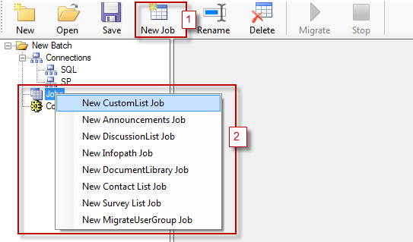
After you select a Job type, the job content will be loaded to the right panel containing 6 tab pages:
- Main job: Map fields from source fields in SQL with destination fields in SharePoint.
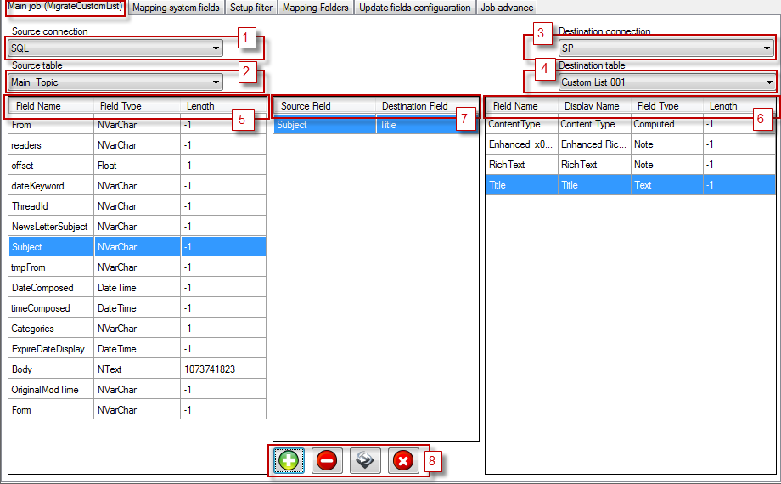
  - (1) Allow to select source connection.
  - (2) Allow to select a source table.
  - (3) Allow to select a destination connection.
  - (4) Allow to select a destination list.
  - (5) Display all source fields.
  - (6) Display all destination fields.
  - (7) Display mapping fields.
  - (8) Job control bar contains actions to manage mapping fields.
    - Button  (Add): Select one field from (5) and one field from (6) and click to add.
    - Button  (Remove): Choose a pair of fields from (7) and click to remove it
    - Button (Auto map): Automatically select fields from (5) and (6) to create mapping fields. The function is based on the consistence of source field names and destination field names.
    - Button  (Remove all): Remove all pairs from (7).
- Mapping system fields: Select a source field and a system field from the destination field to add in pair.

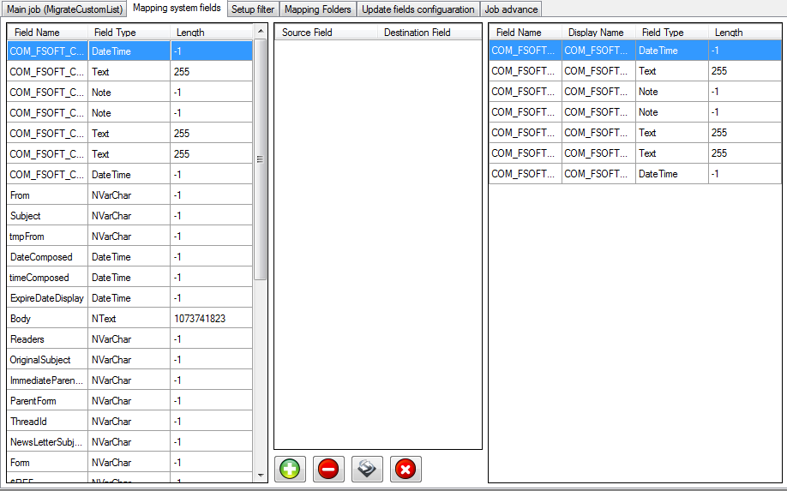

- Setup Filter: Make filter to execute some specific conditions.

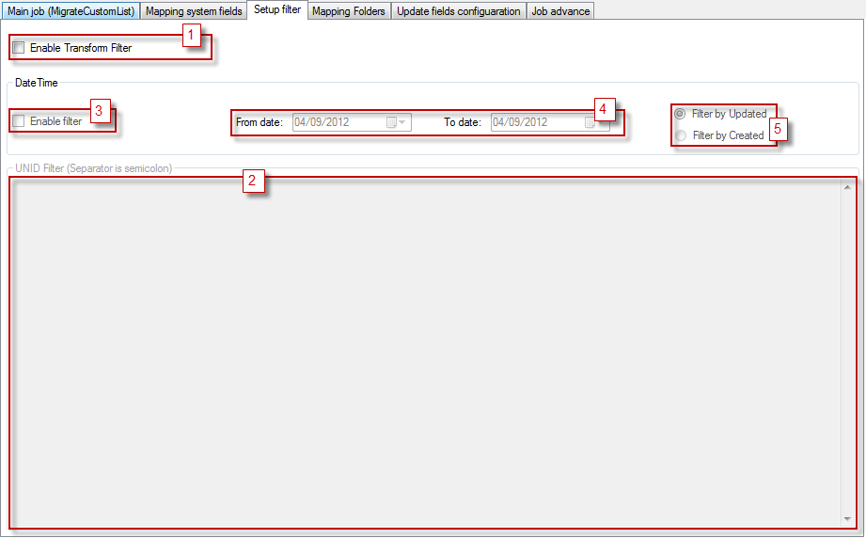
  - (1) Enable/Disable filter
  - (2) List of UNID will be process
  - (3) Enable/ Disable filter with date time
  - (4) Select date time
  - (5) Select field to filter

- Mapping Folder: A folder structure will be created to SharePoint list following the configuration from here.

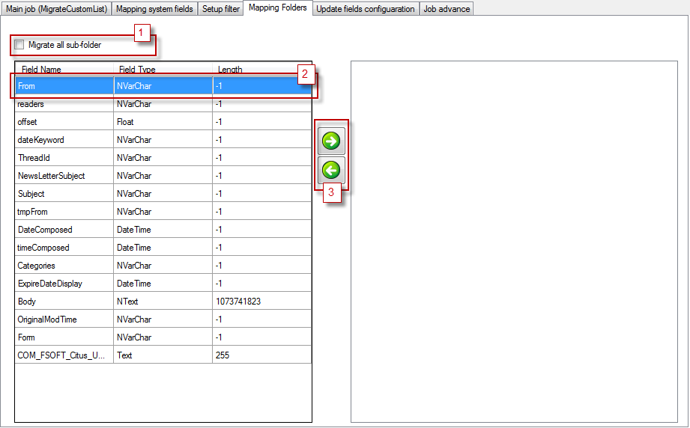
  - (1) Enable/ Disable create all child folders in parent folders
  - (2) Select a field
  - (3) Click to add

- Update fields configuration: Select fields to update when executing this job.

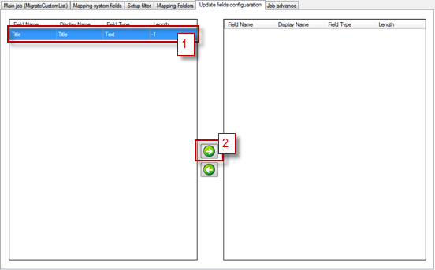

  - (1) Select field.
  - (2) Click to add.

- Job Advanced: Some advanced configuration for job. Exam: file attachments, key field …

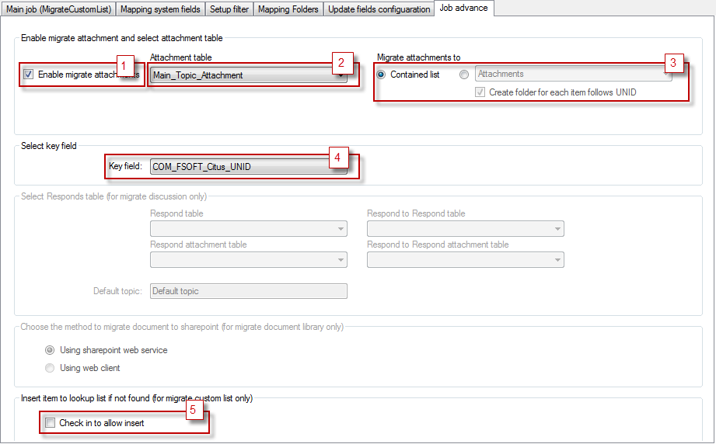

  - (1) Enable/Disable migrate attachments
  - (2) Select attachment’s table
  - (3) Migrate the attachment mode, migrate to the main list or to the other document library. And Enable/Disable creates a folder containing attachments in the document library.
  - (4) Select key field
  - (5) Enable/Disable inserts new items to the lookup list if it is does not exist.

Migrate ACL Permission to SharePoint Site (Optional)
- Update [ACL ] sheet for mapping Users/Groups Notes to SharePoint
  - Open User Mapping file and go to [ACL] sheet
  - Input Users/Group of SharePoint suitable to [Sharepoint User] Column
  - Input name of group in [Sharepoint Group] column to assign User to group
  - Input Standard Permission SharePoint into [SharePoint Permissions] column. If User let blank in this column, Tool will auto create Permission Level with name as in column [Notes Permission]

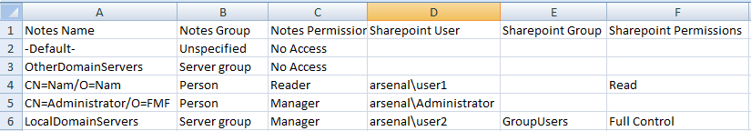

- Create a job connect to SharePoint site
- Create a job by right click [Job] category and select [New Migrate Site Permission Job] menu
- Browse to User Mapping file and select [ACL] sheet in section [Excel file]
- Save configuration file and Run tool
- Go to SharePoint site and verify result

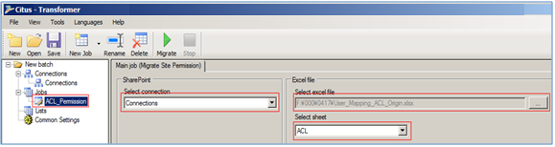

Execute transformation
Click on Run Job(s) button on top navigator after configuration jobs are done.

There are three options to control the ways to run each job: Resume, Overwrite and Duplicate. The following will explain each way in details.

Resume transforming data
- In RESUME mode, Transformer Tool only runs to transform items which have not been pushed into SharePoint yet. If Incremental option is selected, Transformer Tool cannot run Resume Mode.
- If RESUME option is not selected, Transformer Tool will push all items in SQL to SharePoint, even some items which have been transformed before.
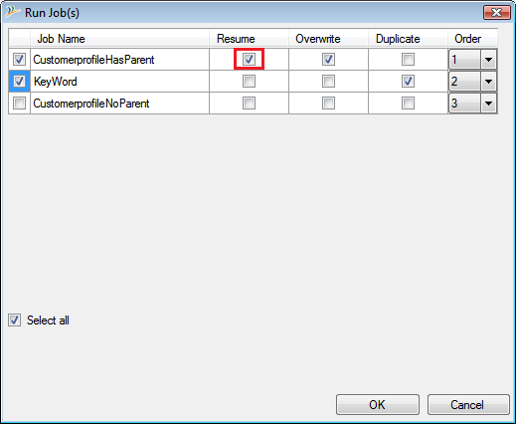

Transform duplicate data
- In Duplicate mode, Transformer Tool will push all items that have same UNID into SharePoint. Items’ UNID in the list is unique.
- If Duplicate option is not selected, Transformer Tool only push the first item on list of items have same UNID into SharePoint and warning about others.
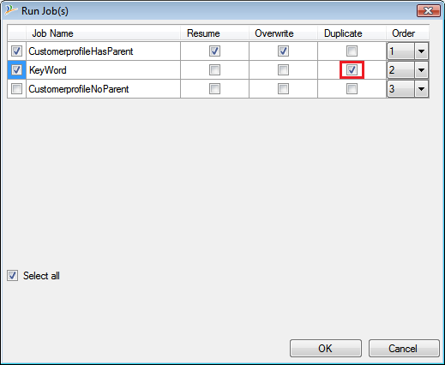
Note: only select Override or Duplicate for a job.

Transform Document List
From version 4.1.1.10, Tool#3 will support transforming Document List. All steps of processing and configuring are as same as transforming Custom List.

Verify result
- Verify number of items:
- Verify number of items in SQL
- Verify number of items in SharePoint
- Verify rich text fields: Verify that the format of rich texts in SharePoint is the same as that in Notes (View data)
- Verify calculated fields: Verify that the value of calculated fields is correct (View data)
- Verify multi value fields: Verify that the format of multi value field in SharePoint is the same as that in Notes (View data)
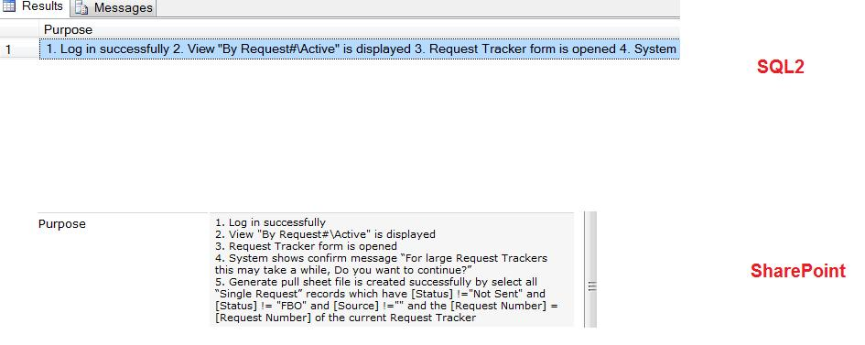

Post-processor tool (Tool #4)
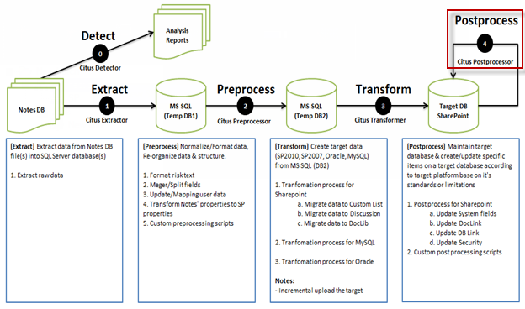
Post-Process tool will maintain target database and create or update specific items on target data according to the target platform based on standards or limitation.
After completing the transformation process by running Transformer tool, the data is added to target database, but all system fields, links, permission levels for lists, for items… are not consistent with the source data because it retrieves information from destination environment of target connection (exam: Created by, Last updated by which contains information of target connection, Created, Last modified containing the time of executing tool. To correct such data, you must execute this tool to update them.
You can run Post-Processor Tool via two ways as the following:
- Using Client object model: In this version, Client Object Model is used to access the target SharePoint site, Lists and Items in the site. The advantage of this way is very easy to use, you do not need to prepare the environment, but it will be probably slower.
- Using Server object model: With a service installed from the farm server, in this version the SharePoint Object Model is used through a service (How to install this service?). If you want to use this version, you must install a service and configure something else. This method will help you save time.
See the screenshot of this tool in the following figure:
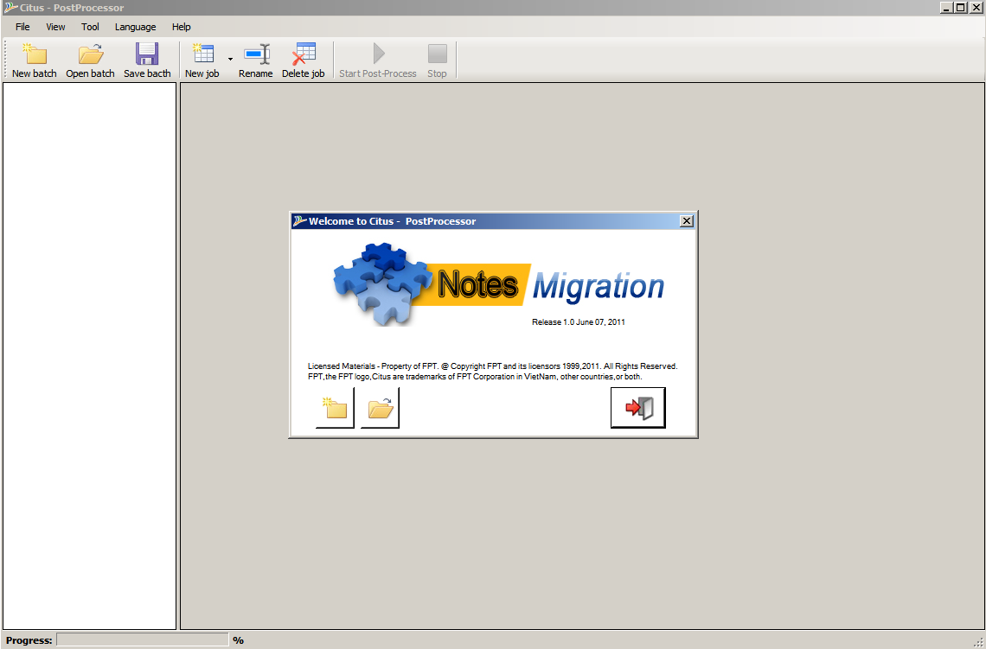
To use this tool, user must define some task following Connections, jobs and configure environment variables.

Configure tool (Mandatory)
Before you run the tool, you need to complete two steps: Connect to SharePoint site and Create Jobs.

Connect to SharePoint site
Post-Processor tool provides two ways to create New SharePoint connection:
- The first way: From the left panel, select Connection (1) and click to New Connection (2) and select to New SharePoint Connection as the follows:

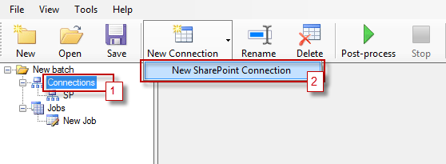
- The second way: From the left panel, right-click to Connection (1) and select New SharePoint connection (2) as the follows:
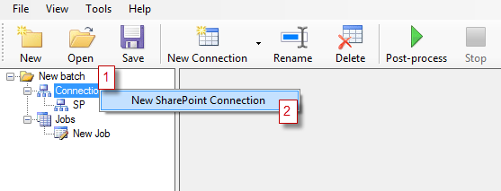
In MSSQL Connection window, input connection information and then click on Test button to ensure your connection is already in use. See the figure below:
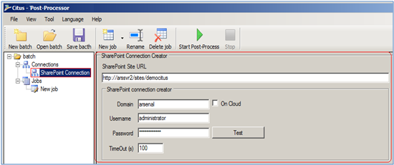

Note: In order to migrate to SharePoint Online site, at the beginning, users must catch login information to SharePoint site by Internet Explorer, then select checkbox “On Cloud” on the screen.

Create jobs
Post-Processor tool provides 2 ways to create a new Job for specific purposes:
- The first way: Select Jobs from the left panel, and then click to New Job button on the tool bar (top panel), a list job types will appear, and then choose a job type you want to create.
- The first way: Right-click to Jobs from the left panel, a list job types will appear, and then choose a job type you want to create.
The tool provides some kinds of jobs: Post-Process Job and Post-Process Permission Folder.
Post-Process Job
If you want to configure Post-Process job, follow the steps:
- Main Job
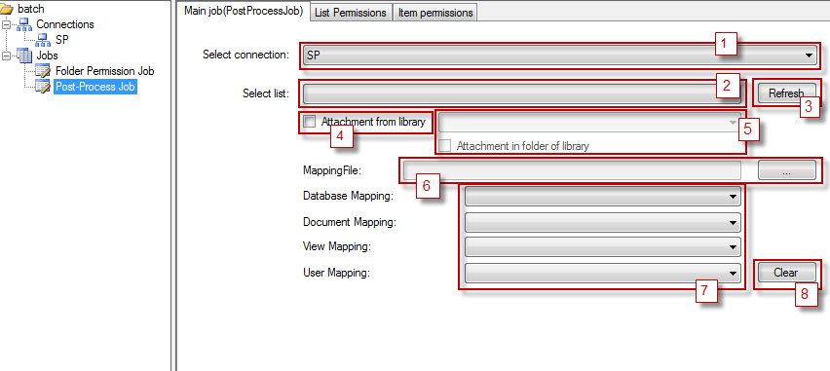
(1) Select a connection
(2) Select a List
(3) Click to refresh connection
(4) Select if attachments belong to other library: Normally, the attachments of a list item will be included in the list, but if the attachments are stored in a different document library, you must check in this option.
(5) Select document library if (4) is selected. Tick on “Attachment in folder of library” option if attachments are included in a folder. (Normally ignore do not select the option)
(6) Choose Mapping file from local hard disk
(7) Select mapping sheet consistent
(8) Clear information with mapping file

Select a process mode for this job
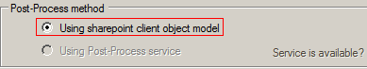
Note: Option “Using Post-Process service” will enable when User using Citus Tool version for migrate Lotus Notes to SharePoint 2007

Other Setting (Optional)

- Break list permission: When you want to do settings of some specific permissions of the list, select List Permission tab and configure from here.
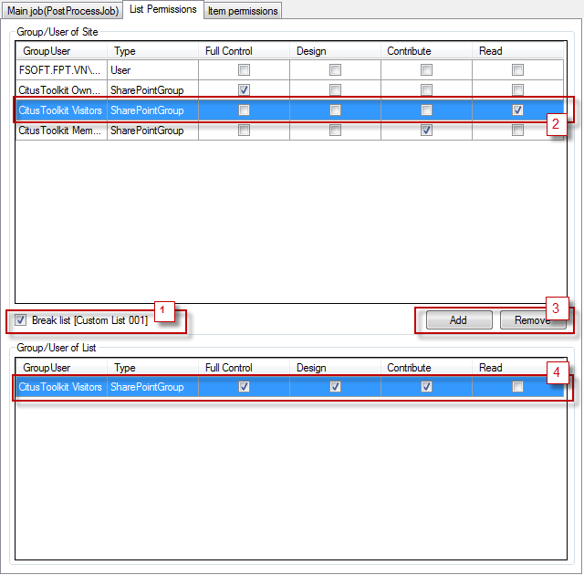
(1) Check into start configuring this list
(2) Select a user name/group name to add
(3) Add/Remove the item selected
(4) Check in the permission levels which you want to add to the item or uncheck to remove the permission level(s) from this user or group
- Items permission: When you want to setup some specific permissions of items of a list, select Item Permission tab and configure. In this case, the item will be processed following the rules defined here.
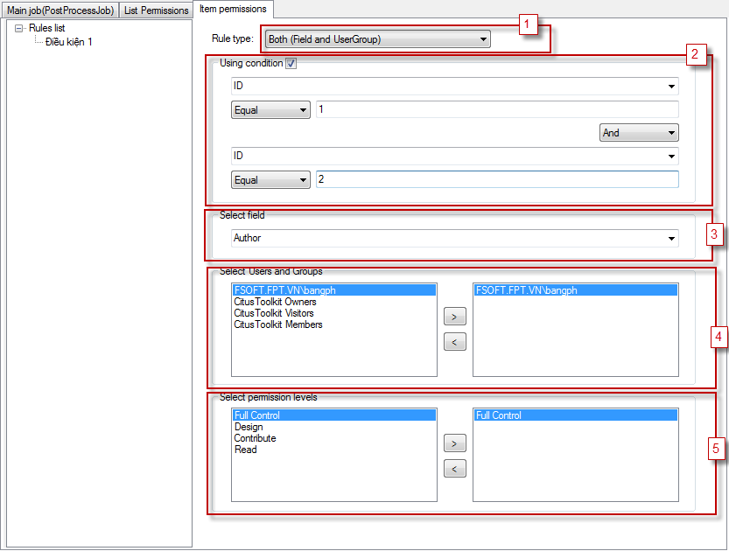
(1) Select Rule type
(2) Use/Not use condition
(3) Select a user field
(4) Select a user and/or a group that you want to process
(5) Set permission for the user/group from (4) and the user/group in the field content (3)
To remove a Rule, select Rule from Rules list right-click and click Delete
To edit a Rule, select Rule from Rules list right-click and click Edit
To rename a Rule, select a Rule from Rules list right-click and click Rename
Post-Process Permission Folder
This is an extent job for process permission of a folder of a document library. Permission will be copied from items consistence.
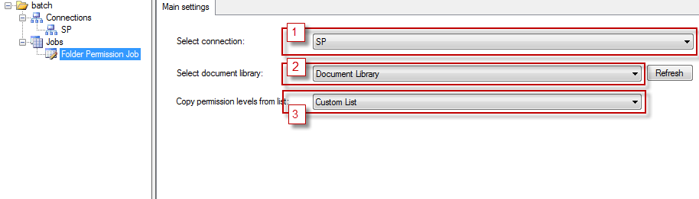
(1) Select a connection
(2) Select a document library to process
(3) Select a List to copy permission

- Reduce or increase the time for date time system fields
This option enables to increase or decrease the time of the fields “Created” and “Modified” after performing Post Process.
- Default value in the text box is: 0
- After the post process, if the time of the fields “Created” and “Modified” is not correct, users need to change the value in the textbox “Reduce or increase the time for dateTime system fields”.

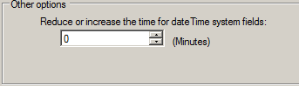

Setup environment to use Post-process service (Using for SharePoint 2007)
(NOTE: User only using Post-Processor service for Post Process data on Share Point Server 2007. For Share Point version later please ignore this step and go to step 3.4.2)

The configuration is only used if you use Post-processor by using server object model (Check again). You need to setup Citus Post-Processor service and Environment variables.

Setup Citus Post-Processor service
Post-Processor has a service which will be installed to farm server to process data. Setup this service to ready use by steps:
- Installation: The following is Service setup package. If older version is already installed, remove it, then click setup.exe file.
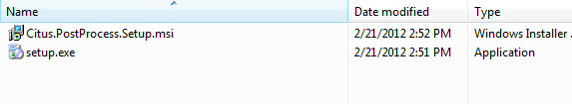
Click next until the installation is complete.

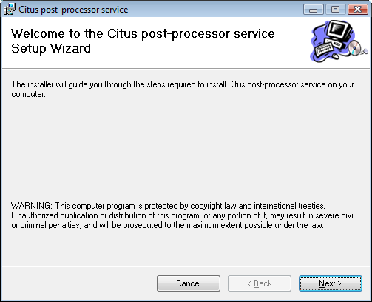

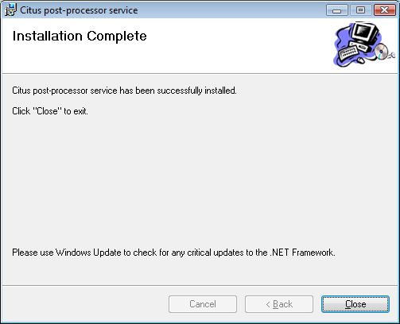

- Configuration:
  - After completing installation, open services manager.
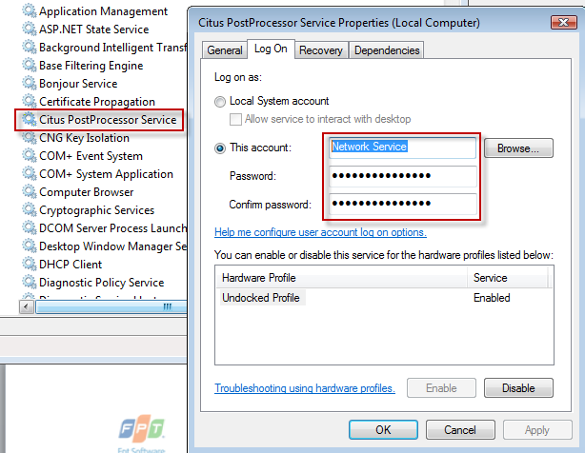

  - Right-click and select Properties, input account, password and confirm password.
  - Close properties and start service.
Note: Account is used to run service and to run Application Pool must be the same. It must be granted permission to use SharePoint Server Object Model.

Setup Environment variables
Beside setting up Citus Post-Processor service, some environment variables need to be configured. Follow the steps below:
- Checking CitusMappingFilesPath variable which has been installed.
- Checking CitusProjectFilesPath variable which has been installed by:
  - Open system properties
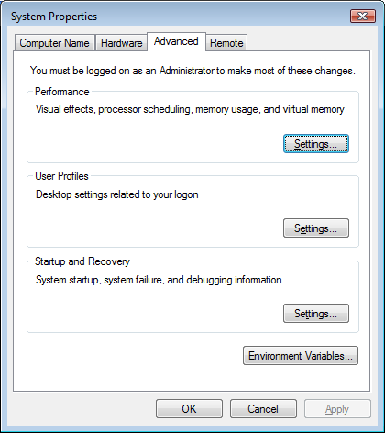

  - Select Advanced tab
  - Click to Environment Variables
  - Add CitusMappingFilesPath and type value is path of Mapping files
  - Add CitusProjectFilesPath and type value is path of Configuration files

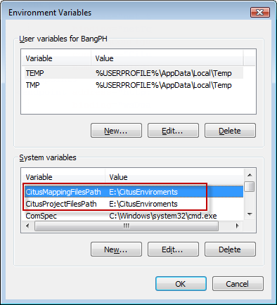

  - Connect from client by:
- Open Citus.PostProcessClient.exe.config find the tag <client>

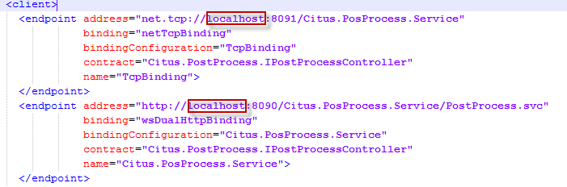

- Change the local host to IP or server name of server containing post-process service.

Run Post-Process
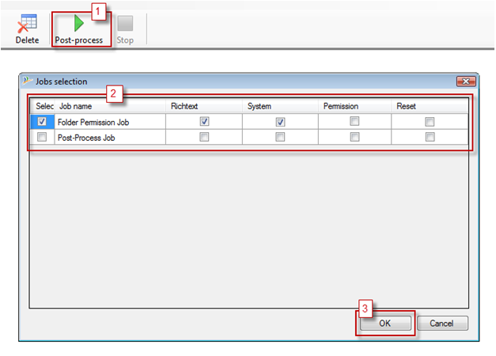
Follow the steps to run the tool:
- Click Post-Process button (1) from the tool bar, then the Jobs selection dialog will appear.
- Select Post Processor Jobs (2)
  - Select Rich Text option to Post Process Rich Text fields
  - Select System Fields to Post Process System fields
  - Select Permission check box if Users configuration Permission for List or Items (Normally do not select the checkbox)
  - Select Reset Post Process if you want to Re-Post Process all data. If Reset Post Process option is not selected, Post Processor Tool will Post Process items which are not Post-Processed before only.
- Click OK button to run post-process (3)
If Reset Post-Process was chosen, Tool will work under two steps:
- Reset Post-Processed status of all Items in list with Job(s).
- Process Post-Process for all Items in list with Job(s).

Verify result
- System fields: Verify that the value of system fields is correct (View data)
- Verify rich text fields: Verify that attachment files, document links, inline images, view links are correct (View data)
- Verify calculated fields: Verify that the value of calculated fields is correct (View data)
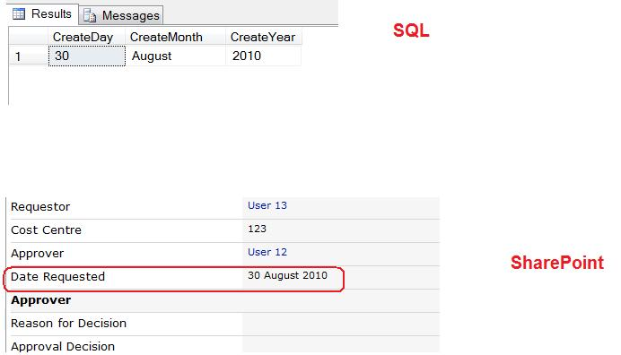
- Using Filter Post Process: After Post Process, you can check PostProcessCompleted, RichTextFieldsUpdated, SystemFieldsUpdated fields to filter which items are Post Processed, the contained value of 3 fields will be “Yes” if Post-Process for corresponding selected type is success, Or “No” if error(s) occurs.
- Set properties of People and Group field: Before running Tool#4, you have to set up People and Group field as account type (not Display name) as the follows:
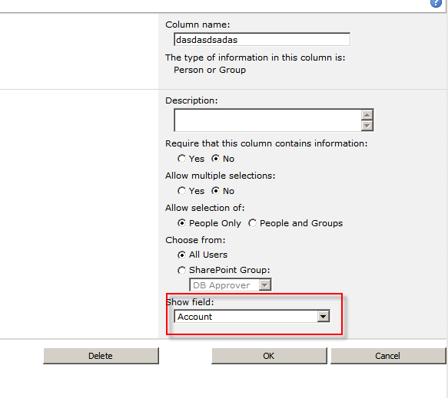

Appendix

Create SQL database
This section will be provided you how to create a new database in SQL by going to SQL Server and follow the steps:
- Right click on Database in your SQL server
- Choose a New Database
- Enter name of the database in Database Name text box
- Click on OK to create new database
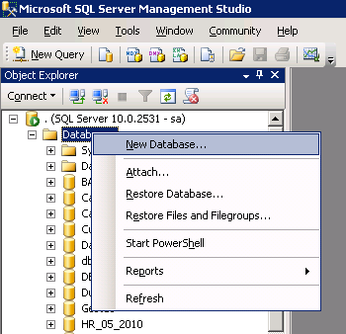
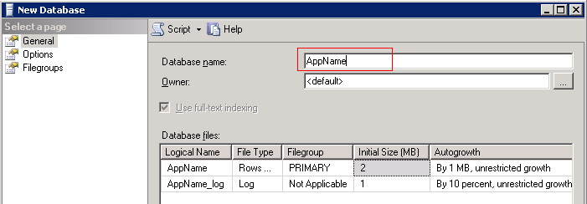

Verify the number of tables
- In Notes:
  - Open Notes Designer
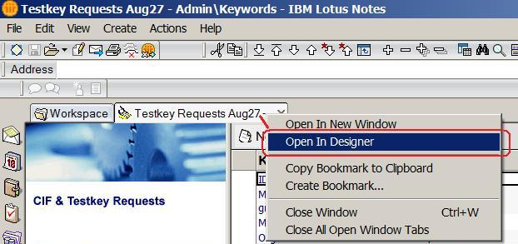
  - Click on Form then count the number of Forms in Notes
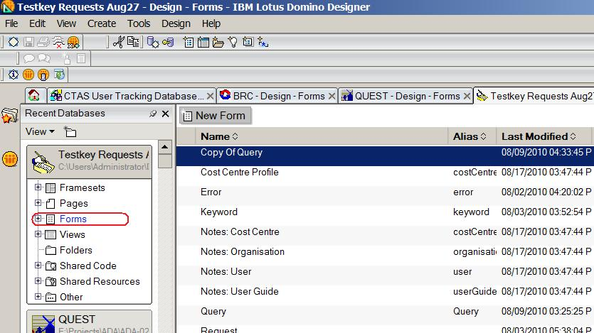

- In SQL: open the following screen and count the number of tables.
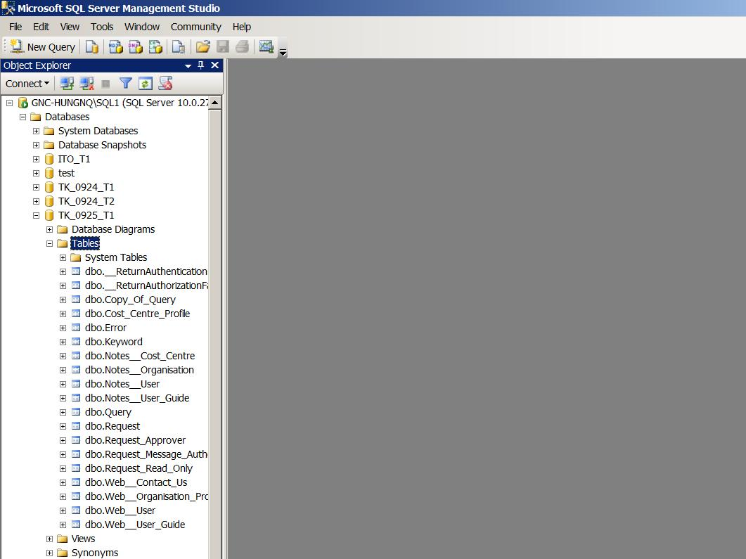
- Verify that the number of Forms in Notes equal to the number of table in SQL.
However, there is a special case for discussion form. In Notes, the tool will create 6 SQL tables, and other Notes forms, the tool will create 2 SQL tables per one. So, the number of SQL tables will follow the equation:
Total number of SQL Tables = (Count of Discussion Notes form * 6) + (Count of other Notes form * 2)

Count the number of items in Notes view
- Open Notes Designer
- Open a view, insert new columns as the below:
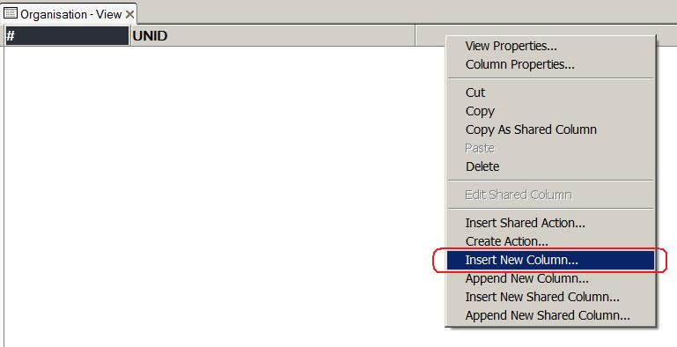

- In Column Properties, select Sorting tab then select Total in Totals list
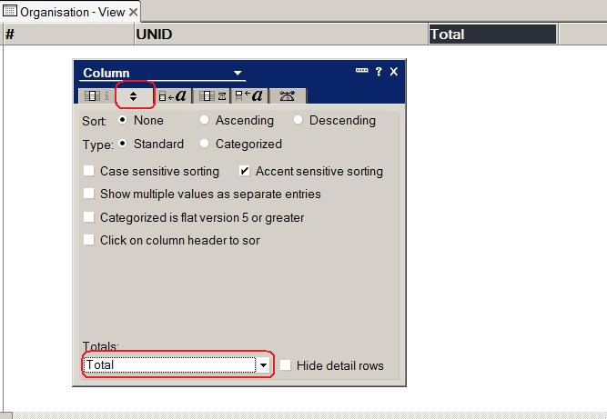
- Input “1” into formula and click Accept button
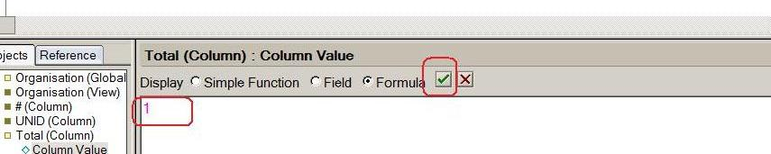

- Click Refresh button and number of items in view will be displayed as the following:
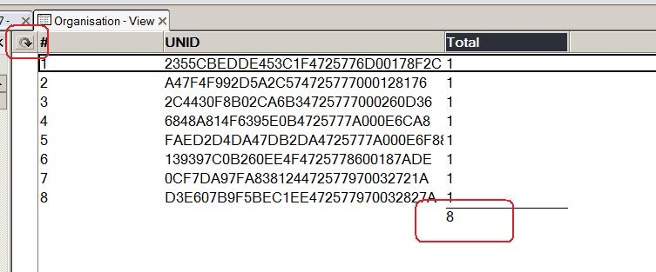

Count the number of items in SQL data table
- Open SQL Server Management Studio and log in
- Select database and table
- Open Table Properties
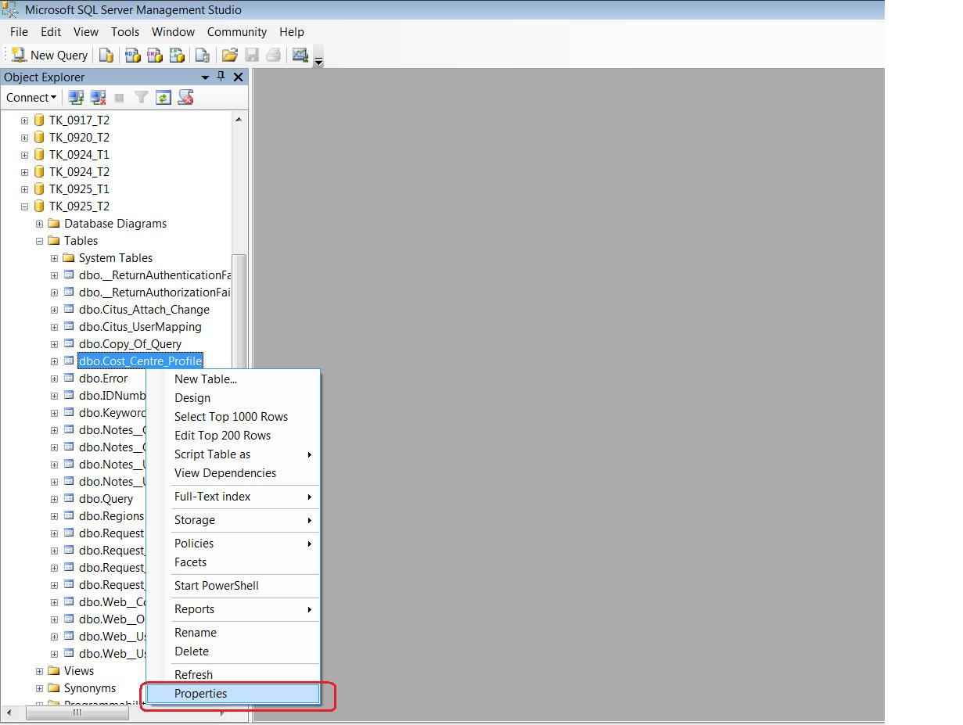
- Select Storage and view Row count and find out the number of items in SQL as the follows:
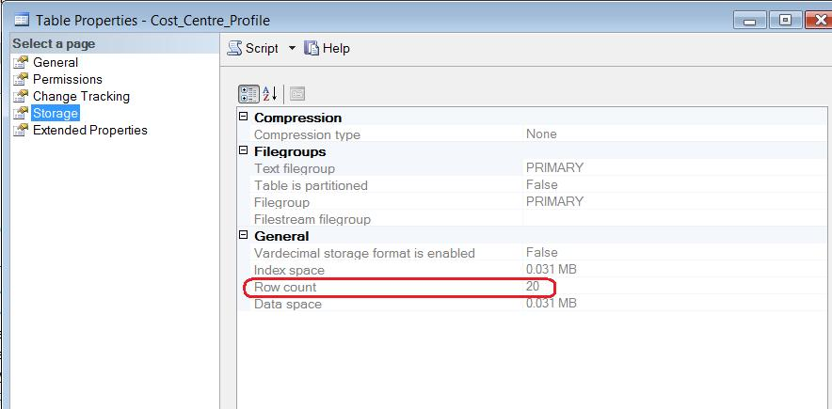

Count the number of items in SharePoint list
- Open SharePoint Home Site
- Click on All Site Content
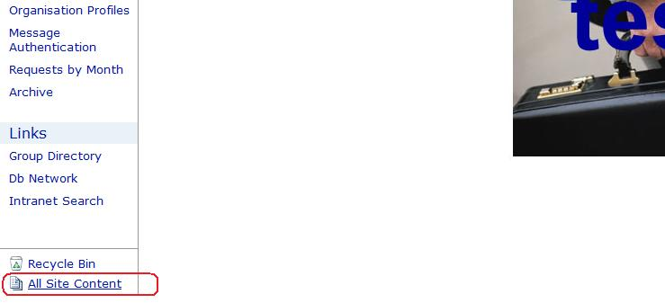
- Check the number of items in List

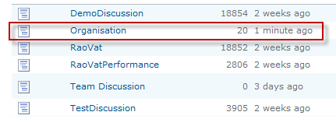

View data
- In Notes:
  - Open Notes Designer
  - Open a View and click on Notes Preview button
  - Double click on an item
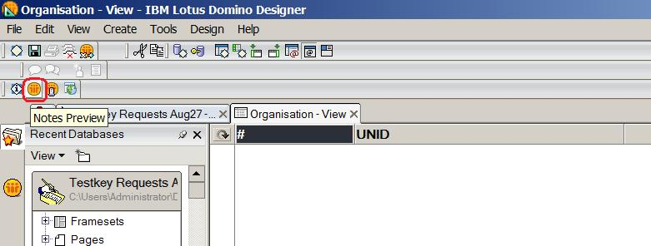
- In SQL:
  - Right click on table and select “Select Top 1000 Rows”
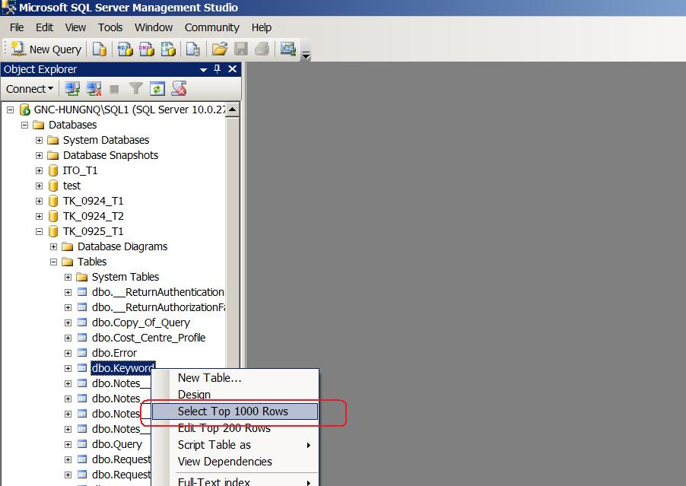

- In SharePoint:
  - Click on a view
  - Select an item and click on View Item button
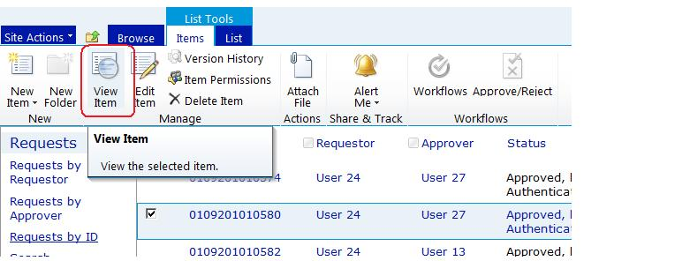

Common Errors

Tool1:

Tool1 crashes when users double click on “CitusExtractor.exe” to start the tool

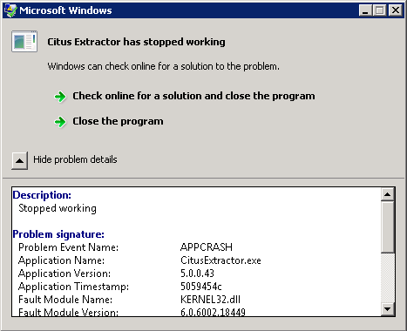

Cause: The environment to start the tool is not set up correctly.
Solution:
- Check to make sure .NET Framework 3.5 was already installed.
- Check to make sure Note client (version 6.5 or higher) was already installed.
- Check to make sure environment variable was set up correctly (see section 3.1.1)

Note: For Windows already integrating .NET FrameWork 3.5 or higher, it is necessary to check if this .NET Framework was already active in “Server Manager\Features”.

FILESTREAM feature is disabled

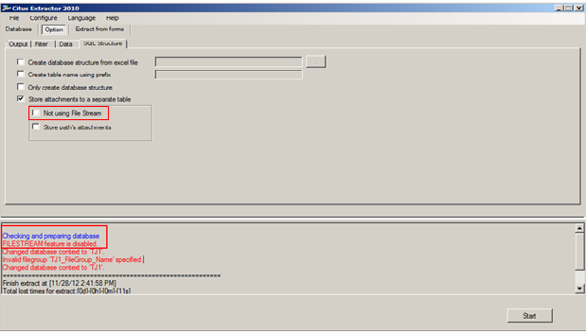

Cause: This error happens when the SQL server has not yet enabled File Stream.
Solution:
- Checked the option “Don’t use SQL File Stream” to use the tool without SQL File Stream.
- To use the tool with SQL File Stream, go to SQL Server Configuration Manager to start SQL FileStream (See more at http://msdn.microsoft.com/en-us/library/cc645923.aspx).

Error: Could not find a part of the path: “DiskName:\...\Report.xlsx”.
Cause: The tool was not run correctly in the required OS
Solution:
- Re-run the tool in OS as required in section “2.0 Pre-requisites” in document named “Data_Migration_Suite_Deployment_Guide_vx.x.docx”
- Users can work around by coping file “Report.xlsx” in the tool package to the path showed in the error message.

Error create table
Cannot create table [返答(_R)]
A column named 'COM_FSOFT_Citus_UNID' already belongs to this DataTable.
Cause: This happens because tables with the same name already exist in Notes DataBase
Solution:
- Open Note Design and rename the tables’ name to remove duplication and re-run the tool.

Tool2:

Rich-text was not transformed to HTML format
After running Tool 2, rich-text fields were not transformed to HTML format.
This screen shows the transforming job did not run correctly:
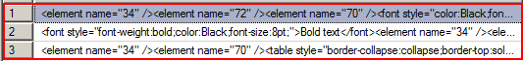
This is the screen shows the job run correctly:

Cause: This error happens when rich-text fields didn’t appear in the script used to run the tool or users didn’t map those fields correctly.
The other exceptional cause might be when users run the tool many times with the same database (this doesn’t always happen).
Solution:
- Check if users already select the right rich-text fields to be transformed.
- If there are fields wrongly selected, correct mapping for those fields.
- If all fields are correctly selected, remove all of those fields and reselect fields.

T-SQL Job run successfully but data were not updated correctly
Cause:
The T-SQL Job was timeout and some records were not processed.
Solution:
Copy SQL script to SQL editor and run

Missing tables in Destination Database created by tool2 when Source Database created by tool1 and Destination Database running in different SQL servers.
Cause:
Error occurs when copying tables.
Solution:
- Use the function “Allow create backup and restore with new database”
- Move Source Database and Destination Database to one SQL server.

Error happens when opening mapping file in the job Mapping Users

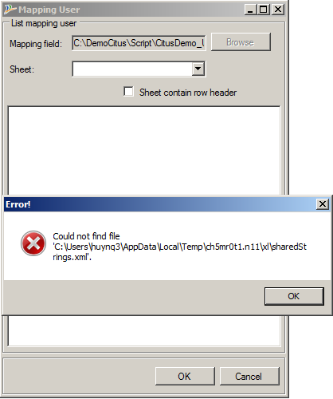

Solution:
Open Mapping file in MS Excel and just save it. Reopen the file with the tool.

Tool3:

Cannot migrate attachment files to SP
Cause:
- User didn’t check checkbox “Enable migrate attachment and select attachment table”

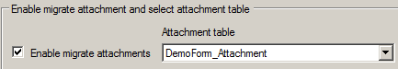
- Users didn’t select the right table containing the main table’s attachments that need to be migrated to SP. (table with _Attachment suffix)
- User didn’t select option “Store attachment to separate table” in tool1.
Solution:
Correct all of the above steps.

The tool cannot migrate data with error message:
“Please choose key field, key field cannot be null”
Cause: User haven’t selected the key field in Job Advange
Solution: Select key field in form “Section select key field” of Job Advange

Cannot display the list to be selected in the Destination Connection.

Cause:
- List type of the job was not chosen correctly.
- Some list codes don’t match SharePoint’s standard.
Solution:
- Recreate the job with SharePoint list type.
- If the above step still doesn’t solve the problem, reselect List Type to the right type to be migrated in tab “Common setting-> List Type”.

Cannot fill Replies (Response, Response to Response) into Discussion List.
Cause: Some fields that need to be migrated only exist in table Main Topic but don’t exist in table Response and table Response to Response.
Solution:
- Remove mapping fields that only exist in table Main Topic but don’t exist in table Response and table Response to Response from “Main mapping” tab
- Or, add these mapping fields to both table Response and table Response to Response and redo the migration.

Cannot migrate attachment file larger than 50 Mb
Cause:
- Default SharePoint site set limit file size less than or equal to 50Mb.
- Timeout happens when uploading the file to SharePoint site.
Solution:
- Set the limit file size in SharePoint central admin to larger than 50Mb.
- Set limit timeout in both ISS and web.config to a larger amount of time.
(See more in: http://blogs.technet.com/b/sharepointcomic/archive/2010/02/14/sharepoint-large-file-upload-configuration.aspx)

Tool4:

After running tool, attachment links, Document Link, View Link, DataBase Link are not correct. Inline images are not showed.
Cause:
- Users didn’t check the checkbox “Richtext” when running the job
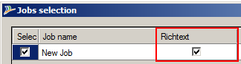

- RichText fields were not transformed correctly in tool2. (See more in 5.2.1)
Solution:
- Rerun the tool and select both “Richtext” and “Reset” options.

Tool cannot perform the post-process with the message:
“Access denied. You do not have permission to perform this action or access this resource.”
Cause: Users don’t have the permissions on SharePoint site
Solution:
Users need to be added to the group “Site collection Administrators” or “Full Control” in the site supposed to run the post process.

Tool cannot perform post-process correctly on the users of System fields with the error message:
“Cannot found user [xxxx] on SharePoint site”
Cause: The user was not added to SharePoint site before performing the post process.
Solution:
Users need to be added to the SharePoint site.

Tool did not perform the post process correctly on the date-time data of System fields.
Cause:
- The user-created application using Event Receiver will perform the post-back with the wrong date-time values of system fields after the tool already updated correctly (At this time the value of COM_FSOFT_Citus_P_System field was set to “Yes”).
- The computer running Tool3, the one running SQL server and the one running SharePoint server were in different time zone settings (At this point, the tool already perform the post process successfully but all the date-time values were different from the correct date-time values.
Solution:
- Disable all the Event Receivers on the related lists and rerun the tool with “Reset” option selected. (Data from tool3 might need to be reloaded)
- Change the time zone settings on the three computers running Tool3, SQL server and SharePoint server correspondingly to a same time zone setting.

