Air Heater

Installation Instructions and Manuals

D3/D5 diesel oil 12V Technical specifications and installation
D3/D5 diesel oil 24V Operation and security maintenance instructions

Contents

I. Introduction 01
1. Application fields and purpose of heater 01
2. Installation and operation safety instructions 01
II. Product information 02
1. Complete sets of equipment and installation components of heater 02
2. Technical parameters 03
3. Product dimension 03
III. Installation 04
1. Installation position 04
2. Installation angle and fastening 05
3. Installation of combustion air duct and exhausting device 06
4. Installation notes for heating air duct 07
5. Fuel supply 08
IV. Operation and Control Mode 10
1. Fuel filling 10
2. Control mode 10
V. Circuit 11
1. Wiring of heater 11
2. Circuit diagram 11
- Fault, maintenance and service 12

I. Introduction

Application fields of heater  The air heater will not be affected by the engine and will be installed in the following vehicles on the premise of following the heating power.  • Various natures of automobile and trailer  • Construction machinery  • Agricultural machinery  • Ships and boats  • Limousine  Purpose of heater  • Preheating and defrosting the glass  • Heating and insulating the following areas  - Driving cab, working cabin, ship cabin  - Cargo warehouse  - Within the personnel or team carrier  - Limousine  The heater cannot the applied in the following occasions regarding the regulations for functions:  • Long-time and continuous heating:  - Living room, garage  - Home ship, etc.  • Heating or drying:  - Life (people or animals), 1V direct heating mode will be used.  - Item  - Blow hot air to the container  Installation and operation safety instructions  • Setting of heater  Prevent the heater from high temperature or damages.  • exhaust gas system  When the discharge outlet of exhaust gas is placed, it should prevent the waste gas entering the automobile through the ventilation device, inlet of hot air or window.  • Air inlet of combustion air  Do not breathe the combustion air used in heater combustion from the passenger compartment.  When installing the air inlet, note that it should not be blocked by other materials.  • Inlet of heating air  The heating air which is supplied should be composed by the fresh air or cycled air and be drawn from a clean area.  The inlet pipeline should be protected with safety fence or other proper tools. | • Outlet of heating air  When the hot air pipeline is placed in the automobile, it should ensure that it is difficult to be contacted and prevent the personnel or materials from damages.  • Exhaust system  When placing the exhaust pipe, we should note that the outlet of exhaust pipe should avoid the combustibles and prevent heating or burning the ground combustibles or loading cargos.  Safety instructions for installation and operation  The following measures should not be taken.  - Change key parts on heater  - Use the parts of other manufacturers without the company's permission  - Go against the specifications specified in the instructions during the installation or operation.  • It is only allowed to use the original accessories and fittings during the installation or maintenance.  • It is not allowed to use heaters in the place where the Flammable vapor or dust may produce.  - Fuel depot  -Carbon storage warehouse  - Water material warehouse  - granary and similar points  • The heater should be closed when fueling.  • If the fuels flow (disclose) out of the fuel system of the heating equipment, it should be immediately returned to the service provider for maintenance.  • In the working process off heater, it is not allowed to stop heater by powering off.

II. Product information

Complete sets of equipment and installation components of heater

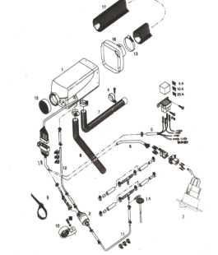

1. Heater; 2. Metering oil pump; 3. Control switch; 4. Fixed clamp of exhaust pipe; 5. Output line, positive/negative; 6. Control element transmission line; 7. Exhaust pipe: 8. Combustion air duct; 9. Belting; 10. Dose pump bracket; 11-12 Deoiling pipe; 13. Air outlet hose clamp; 14. Deoiler; 15. Air intake grille; 16. Outlet housing; 17. Air duct; 18. Heater harness
III. Product information

Technical parameters
Heater Model | XL-AIRD5 |  |  |  |  |  | XL-AIRD3
Heating media | Air |  |  |  |  |  | Air
Heat rating | Level |  |  |  |  |  | Rating
Heat rating | Super | High-level | Middle-level |  | Low-level | Close | Super | High-level | Middle-level |  | Low-level | Close
Calorific value (w) | 5000 | 3500 | 2000 |  | 900 | - | 3000 | 2200 | 1600 |  | 900
Dielectric flux (kg / h) | 185 | 150 | 110 |  | 60 | 24 | 150 | 120 | 90 |  | 60 | 24
Fuel consumption (L / h) | 0.64 | 0.40 | 0.28 |  | 0.11 | - | 0.35 | 0.25 | 0.18 |  | 0.10
Electric power consumption (W) | 40 | 24 | 13 |  | 7 | - | 24 | 16 | 10 |  | 7 | -
When starting:
Rated voltage | 12V or 24V |  |  |  |  |  | 12V or 24V
Lower limit of under-voltage protection | 10.5V or 21V |  |  |  |  |  | 10.5V or 21V
Lower limit of overvoltage protection | 16V or 32V |  |  |  |  |  | 16V or 32V
Environmental temperature, heater, dosage oil pump | When operating |  |  | Non operating |  |  | When operating |  |  | Non operating
Environmental temperature, heater, dosage oil pump | -40℃ to +40℃ |  |  | -40℃ to +85℃ |  |  | -40°CM+40°C |  |  | -40℃ to +85℃
Environmental temperature, heater, dosage oil pump | -40℃ to +50℃ |  |  | -40℃ to +125℃ |  |  | -40℃ to +50℃ |  |  | -40℃ to +125℃
Inlet temperature of hot air | +40℃( highest) |  |  |  |  |  | +40℃ (highest)
Weight | About 4.5kg |  |  |  |  |  | About 3kg
Product dimension
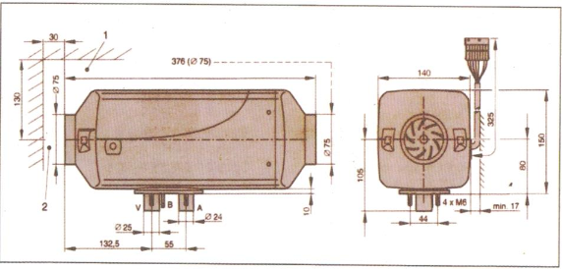
1. It is used in minimum installation space to open cover, dismantle ignition plug and controller. | A=Waste gas
2. It is used in the minimum installation distance to draw the heating air. | B=Fuel
* The above figure shows the product dimensions of XL-AIRD5. The overall length of XL-AIRD3 is 326mm. Other dimensions are the same with the overall dimensions of XL-AIRD5. | V=Combustion air
III. Installation

Installation position  Fasten the heater on the bottom of vehicle or the vehicle wall with four screws on the stand bar of heater.  When installing the heater, enough operation space should be reserved in the air inlet and the place to dismantle ignition plug and controller. (The suggested installation position and methods are shown as follows).  Installation position within truck  Within the truck, the heater will be installed in the driving cab.  If it is impossible to install in the driving cab, the heater may be installed in the toolbox or container.  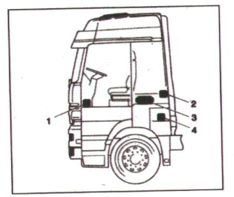  1. The heater is located at the foot of co-pilot.  2. The heater is located at the back wall of driving cab.  3. The heater is located at the back of driver's seat.  4. The heater is located in the toolkit.  Installation position in car/large car  In car/large car, the heater mainly is installed in the vehicle's passenger room or luggage.  If unable, the heater may be fastened under the vehicle, but we should note the water spraying.  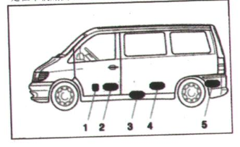 | - The heater is located in the front of co-pilot  - The heater is located between driver's seat and co-pilot seat.  - The heater is located under the undersurface.  - The heater is located under the back seat.  - The heater is located in the luggage.  Installation position within limousine  Within the limousine, the heater is mainly installed in the room or luggage. The heater may also be fastened on the vehicle bottom, but it should prevent the water spraying.  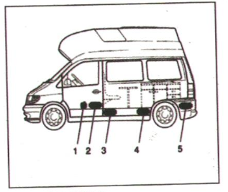  1. The heater is located in the front of co-pilot  2. The heater is located between driver's seat and co-pilot seat.  3. The heater is located in the bottom  4. The heater is located under the counter  5. The heater is located in the luggage.  Installation position in the driving cab of excavator  1. The heater is located in the box at the driver's seat  2. The heater is located at the back wall of driving cab.  3. The heater is located in the protection case  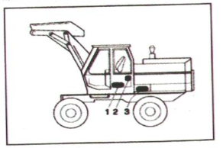
III. Installation

Installation angle and fastening
Allowable installation angle
As shown in the figure, the normal angle should be used to install the heater. According to different installation conditions, the heater may incline 30°(the flowing direction is downward) at most or rotate 90 around the long axis. (Exhaust pipe position, the ignition plug is upward).
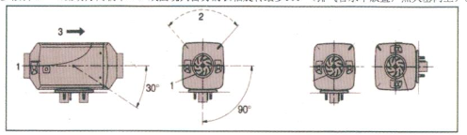
1. Inlet of heating air; 2. Position of ignition plug; 3. Flow directions.
Assembly and fastening
The holes used to process waste gas, combustion air and fuel pipe.
The mounting face of heater legs should be flat.
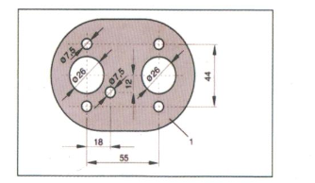
Fasten the heater on the vehicle bottom.
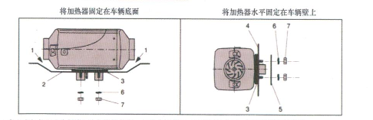
Horizontally fasten the heater on vehicle wall.
1. Be sure to reserve a space between heater and vehicle bottom. In addition, check whether the ventilation wheels operate freely: 2. The assembly surface should be flat: 3. The sealing gasket should be assembled; 4. The vehicle wall should be flat; 5. Reinforcement plate (used when necessary); 6. Spring sheet 7. M6 hexagon nut
III. Installation

Installation of combustion air duct and exhausting device  Guiding device of combustion air  The installation components contain a Flexible combustion air hose and the inner diameter is 25mm.  According to the installation conditions, the length of combustion air duct may be shortened to 30cm or prolonged to 1m at most.  Fasten the combustion air duct on heater with hose clamp. Another end is fastened with ribbon to prevent shaking and falling. | Safety instructions for guiding device of combustion air  • The orifice of combustion air duct should keep unblocked.  • When installing the suction inlet of combustion air, note that the waste gas should not be taken as the combustion air.  • The suction inlet of combustion air should not align at the driving direction.
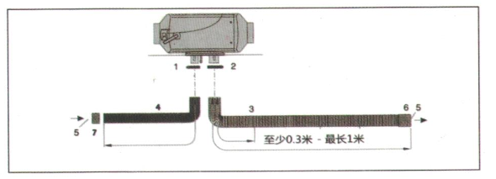

0.3m-1m

Exhausting device  The installation components should contain one exhaust pipe that the inner diamter is 24mm.  According to the installation conditions, the length of exhaust pipe may be shortened to 30cm or prolonged to 1m at most.  Fasten one end of exhaust pipe to heater with hose clamp and fasten another end on the vehicle with support.  Safety instructions for exhausting device  In the whole operation process from the heating operation, all parts of waste gas exhaust device will be burnt.  Therefore, be sure to install the exhausting device according to the installation instructions.  • The outlet of exhaust air should be placed outside the vehicle.  • The waste pipe should not go beyond the boundary on the vehicle side.  • The exhaust pipe should be placed downward to facilitate the discharge of condensate water.  • It should not affect the functions of parts which are important for the vehicle operation (note to keep enough spacing).  • When installing, note to keep enough spacing between the exhaust pipe and heat sensitive components. We should pay particular attention to the fuel pipe, wire and brake hose.  • To prevent the exhaust pipe from vibration and damages, it should be fastened stably (the recommended reference spacing is 50cm).  • When paving exhaust pipe, note that the waste gas which is discharged should not be used as the combustion air. | 1and 2. Hose clamp: 3.Exhaust pipe:  4. Combustion air pipe: 5. Inlet and outlet; 6. Sleeve of waste gas pipe 7. Clip of inlet pipe  • The opening of exhaust pipe should not be blocked by the dirt and snow.  • The opening of exhaust pipe should not direct to the driving direction.  Protection instructions  It will produce heat and toxic gas in burning time. Please install the exhausting device according to the installation instructions.  • In the heating period, it should not operate in the area where the exhaust guiding device locates in.  • When operating on the waste gas discharge device, firstly close the heater until all parts are cooled. Wear the protective gloves when necessary.  • Do not take the waste gas.
III. Installation

Installation notes for heating air duct  Heating air duct  • The installation components contain one flexible pipe that the diameter is φ75mm.  Safety instructions  • When paving and fastening the heating air guide tube or hot air outlet, we should not touch it directly due to high thermal radiation or directly blow the humans, animals or thermal sensitive materials with hot air, or it will cause unnecessary damages and injuries.  • In the whole operation process starting from heating, the thermal air conduit will be in high temperature. Therefore, the operation in the thermal air conduit should be avoided in the whole heating process. If the operation in the area is required, firstly close the heater. When all parts are completely cooled, wear the protective gloves when necessary. | Notes  • When placing the suction inlet of heating air, note that the waste gas from vehicle engine and heater should not be taken and the heating air should not permeate the dust and salt fog under the normal operation conditions.  • When heating with circulating air and placing the suction inlet of circulating air, note that the heating air cannot be directly taken in.  • In case of fault caused by heating, the local thermal air temperature may reach 15℃ and the surface temperature may reach 90℃ before shutdown. Therefore, it is allowed to guide the heat air with the high temperature air hose in the company's installation components.  • When checking the functions, after operating about 10 minutes, the average temperature of discharged heat air which is measured at about 30cm from the outlet should not exceed 110℃(the air suction temperature is about 20℃).  • The heater and air conduit and other components should not be trampled, covered and pressed, Or it will injure the personnel, burn the inflammables or damage the heater.
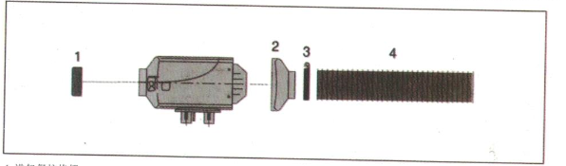
1. Intake grille protection 2. Outlet housing
3. Hose clamp 4. Soft air duct

III. Installation

Fuel supply  Installation angle of dose oil  When installing dose oil, note that the nozzle should be upward. The installation angle should be larger than - 15°. The installation angle between 15° and 35° should be given priority. As shown in the figure below:  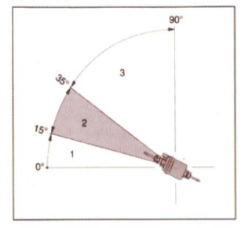  1. It is not allowed to select the installation angle between 0°-15°.  2. Give priority to the installation angle between 15°-35°.  3. It is allowed to select the installation angle between 35°-90°. | Connection of oil pipe  When connecting the oil pipe, after inserting heater oil nozzle, pump oil nozzle, oil taker and T-shaped TEE oil nozzle into the rubber house, it should be connected to the oil pipe in next end to prevent bubbles in the oil channel, or it will produce noise and influence the combustion effect.  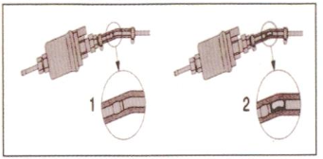  1. Correct connection; 2. Wrong connection - forming bubbles  Installation angle of T-shaped TEE parts  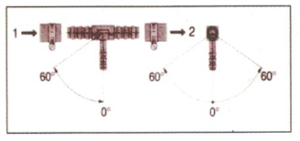  From oil tank; 2. Lead to auto engine
Take oil from oil tank near to the oil channel of auto engine with T-shaped TEE parts
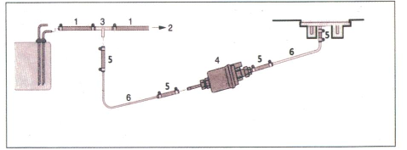
1. Deoiling pipe 3. T-shaped TEE parts 5. Connecting hose
2. Lead to auto engine oil pump 4. Dose oil pump 6. Oil pipe
III. Product information

Deoiling Installation Diagram of Deoiler
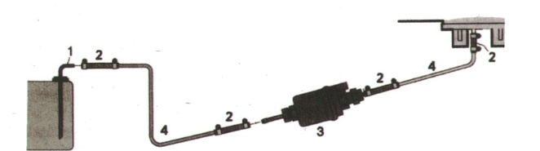
1. Deoiler  3. Dosage oil pump | 2. Connecting hoses  4. Deoiling pipe
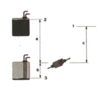 | 1. Joint on the heater  2. Maximum oil pressure height  3. Minimum fuel contents  Notes：  a. The vertical height a when the oil pump is installed below the oil tank shall be 3m maximally.  b . The vertical height b when the oil pump is installed above the oil tank shall be 1m or 0.5m at the most in case of diesel oil or gasoline.  c. The vertical height c from the oil pump to the heater (the oil pump shall be installed below the heater) shall be 2m maximally.
Safety Instructions of Deoiling Pipe Laying  - In order to avoid the oil pipe destroy or give rise to noise due to the vibration, the oil pipe shall be fixed firmly.  - During the laying, please avoid the oil pipe stretching, friction or vibration caused by the vehicle reversing or engine movement.  - The oil circuit shall keep away from the heat source, instead of being laid under the high-temperature environment. Please don't lay the exhaust pipe or fix the oil pipe along with the heater or vehicle engine at close range. When it is necessary to cross over these pipelines, please keep the enough heat insulation distance and put the protective hose when necessary.  - Please install all oil supply equipment, then, check the adapting pieces and the oil leakage phenomenon after heater has been started and operated for a certain period of time.  - The oil pump which is installed on the vehicle will be prohibited to provide oil for the heater. | Operating Requirements of T-shaped Triple Valve Body:  In order to avoid the fuel oil injection in the heater and the huge risks under the high pressure of vehicle oil pump, the triple valve body shall be installed between the vehicle oil pump and oil tank, instead of between the vehicle oil pump and engine. The vehicles of which the vehicle oil pump is installed in the oil tank shall apply the deoiler, instead of T-shaped triple valve body, to extract the oil.  Oil Circuit Maintenance and Overhaul Precautions  - Please check whether the adapting pieces of oil circuits have become flexible before using the heater in winter. Check whether the connecting hose and oil pipe have become aging. Check whether the connection between the oil circuits have suffered from electric leakage when the heater has been operated for a certain period of time. Any problems found should be solved promptly.  - When the heater is used for the first time, the heater is likely to be unable to be started during the early several launching due to the long-term unused behaviors. This is the normal phenomenon, at this moment, please start it for several times until the oil pump can suck up the fuel oil.

IV. Operation and Control Mode

Fuel filling
- You shall infill the oil circuit via the fuel oil infilling function when you have installed heater host, oil circuit and electric circuit, otherwise, the heater is likely to fail to be started due to the fuel oil absence in the oil circuit.
The fuel oil shall be refueled in the following way: Press the rocker switch for 8 times continuously at the following frequency after connecting the power line correctly, namely, open it for 1 second and close it for 1 second. At this moment, the heater will start the fuel oil heating procedures to continuously send out the drive pulse of fuel metering pump and keep it for 5 minutes. During that period, the indicator on the rocker switch will flicker at the one-second on and one-second out frequency, moreover, the buzzer will make beep. You shall pay continuous attention to the fuel oil's position in the oil circuit during the refueling period of fuel oil. When the fuel oil has approached the heater oil inlet for 10cm, please turn off the rocker switch to stop the refueling process.

V. Circuit

Wiring of heater  Safety instructions  It is requested to realize the electrical connection of heater according to the electromagnetic compatibility principle.  - Considering that the electromagnetic compatibility will be affected by the misoperation, please abide by the following requirements:  - Please make efforts to avoid destroying the insulation of power line and prevent abrasion, breakage, clamping or thermal influence.  - As for the waterproof plug, please make use of blind plug to block the unoccupied plug cavity and prevent the dirt and water.  - Please realize the electric connection and grounding firmly without corrosion. | Notes  Please pay attention to the following affairs when the electric wiring and element operation are conducted for the heater:  - Please keep away from the overheating parts to avoid the heating & humidity and affected function when the electric line, switch and controller are installed in the automobile.  - Please don't fix the hardness on the moving or vibrating components to avoid the tensile failure or joint falling when the hardness is fixed.  - The positive and negative electrode of the hardness shall not be lengthened without permission.
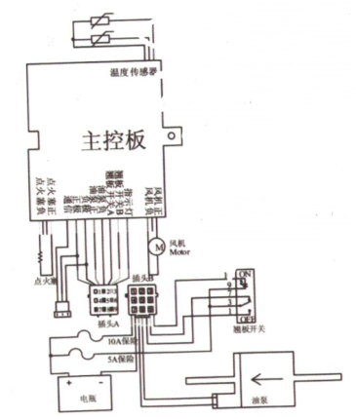 | Red (1.5mm) = positive electrode of storage battery (main control board)  Black (1.5mm) = negative electrode of storage battery (main control board)  Black (0.5mm) = negative electrode of oil pump (main control board)  orange (0.5mm) = positive electrode of oil pump (main control board)  purple (0.5mm) = communication (main control board)  Red (1.5mm) = positive electrode of storage battery  Black (1.5mm) = negative electrode of storage battery  Orange (0.5mm) = negative electrode of oil pump  Orange (0.5mm) = positive electrode of oil pump  White (0.5mm) = rocker switch No  Blue (1.5mm) = rocker switch OFF  Red (1.5mm) = negative electrode of indicator  Green (1.5mm) = positive electrode of indicator
 | Temperature sensor
 | Main control board
 | Positive electrode of draught fan
 | Negative electrode of draught fan
 | Indicator
 | Rocker switch B
 | Rocker switch B
 | Positive electrode of oil pump
 | Negative electrode of oil pump
 | negative electrode
 | Positive electrode
 | Communication
 | Positive electrode of ignition plug
 | Negative electrode of ignition plug
 | Wind turbine
 | Ignition plug
 | Plug B
 | Plug A
 | Safe electric current: 10A
 | Safe electric current: 5A
 | Storage battery
 | Rocker switch
 | Oil pump

VI. Fault, maintenance and service

Fault and handling  - The heater cannot start upon startup:  -Shutdown, Restart after shutdown.  - The heater still does not start, the following should be checked:  - Whether there is fuel in the oil tank and oil pipe?  - Whether the fuse is normal?  - Whether the circuits, the connection and the connectors are in good condition? | - The heater is likely to be out of order when the heater is used abnormally. The general using conditions, faults and disposing methods will be listed below.
  Item | Unit | Minimum value | Normal value | Maximum value
  Rated voltage | V | 21 | 27 | 32
  Rated voltage current | A | 0. 06 | 2 | 10
  Movement Noise | dB | 35 | 55 | 65
  Fuel oil consumption | Li tre/hr | 0. 138 | -- | 0.472
  Recirculating wind flow | cfm | 30 | -- | 85

．Please contact with the sales persons or manufacturers when the heater still fails to be normally started or steadily operated on the premise that the foregoing contents are normal.
Please pay attention to the followings:
Supposing that the heater is changed by others or due to the unknown installed components, or the heater is destroyed without normal operation due to the artificial factors, the customers will lose the power to ask the manufacturers to make repairing.
VI. Fault, maintenance and service

Maintenance instructions  - The heater shall be started for 10 minutes in summer and other months when the heater is not used.  - Please make the pilot run for the heater before the using period.  - Please close the heater as long as there is dense smoke for long term, or abnormal combustion noise or fuel smell or overheating electrical/electronic component.  - Take out fuse. Seek an advice from the installation company for inspection.  - Please check the oil circuit carefully before the using period of the heater, and check whether the connection has become flexible and whether the oil pipe has become aging. Please check whether there is oil leakage on the connection when the heater has made pilot run for a certain period of time.  - Please check the opening of heating air duct, combustion air duct and exhaust pipe after long-term unused behaviors. When necessary, please wash them. | Service  When you have any technical problem or your heating equipment is out of order, please contact with the sales installers in time.
After-sales Warranty
Dealer: | MM/DD/YY

User's name: |  | Contact No.:
Heater Model: |  | Installation position:
Type of license plate: |  | Installation time:
Vehicle type: |  | Installer:
Maintenance time |  | Maintenance items

Rotary Knob Panel Instructions
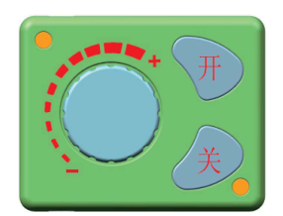  Off  On | Introduction of keys:  ON->startup  OFF-> shutdown  Rotary knob->temperature adjustment and wind speed control  Lighting instructions:  Considering that there is lighting below the ON/OFF key, the operators will find out the rotary knob easily under the dark environment. The lighting on the outside of rotary knob will show the temperature value and failure state.
Key function introduction
ON->Please press the ON key gently when the working voltage has satisfied the related conditions.
OFF-> Please press the OFF key gently when the machine is under the working state.
Rotary knob->the temperature will rise when the rotary knob is rotated clockwise, at this moment, the red indicators will be increased on the outside of the rotary knob.
The temperature will down when the rotary knob is rotated anti-clockwise, at this moment, the red indicators will be reduced on the outside of the rotary knob.
Fuel filling by hands
Please rotate the rotary knob clockwise under the OFF state until the red indicators are on, then, please press the OFF button for more than 3 seconds, at this moment, the manual oil pumping will be started. Please press the OFF key gently to stop the oil pumping when the air has been removed from the oil circuit.
Fault state description
Machine fault | State display | Treatment method
Under-voltage of power supply | 1 indicator flickers. | Boost the voltage of power supply.
Overvoltage of power supply | 2 indicators flicker. | Reduce the voltage of power supply
The ignition plug is out of order. | 3 indicators flicker. | Check whether the ignition plug has suffered from open circuit or short circuit.
Oil pump fault | 4 indicators flicker. | Check whether the oil pump has suffered from broken line or short circuit.
The machine is overheating. | 5 indicators flicker. | Check the temperature sensor on the shell or whether the fan has the abnormal rotation speed.
Motor fault | 6 indicators flicker. | Check the magnet polarity, the Hall sensor location or the looseness conditions of wiring terminal.
Break line fault | 7 indicators flicker. | Check the connecting plug of panel, and whether the blue harness connection has become flexible or disconnected.
The flame is extinguished. | 8 indicators flicker. | Check whether the oil circuit has air or blockage, check whether the temperature sensor on the shell is out of order or whether the connector terminal has become flexible.

Fault Code Description
Machine fault | Status display | Solution
Undervoltage power source | Panel display E-01 | Raise the power supply voltage
Overvoltage power source | Panel display E-02 | Reduce the power supply voltage
Ignition plug fault | Panel display E-03 | Check whether the ignition plug is open-circuit or short-circuit
Oil pump fault | Panel display E-04 | Check whether the oil pump is disconnected or short-circuit
Machine overheat | Panel display E-05 | Check the temperature sensor on the shell, or check whether the fan revolution speed is abnormal
Motor fault | Panel display E-06 | Check the polarity of the magnet and the position of the Hall sensor.
Disconnection fault | Panel display E-07 | Check the connecting plug to the panel, and verify whether the connection of the blue communication line is abnormal
Flame extinguishment | Panel display E-08 | Check whether the oil line has any air or whether it is obstructed. Check whether the shell temperature sensor is malfunctioning, or whether the contact of the socket terminal is abnormal.

The contents in the table are subject to the digital panel. Faults of the panel with remote control function are identical with the description in the above table. Faults of the panel with knob control are identical with the description in the above table, but the display mode of fault is indicated by the times of blinking of an indicators

12V-24V Common Digital Panel Operation Instruction
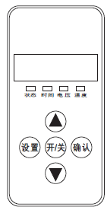  状态  Status  电压  Voltage  时间  Time  确认  OK  开/关  On/off  设置  Set  温度  Temperature | 1. Indicators  Status->Permanently on upon startup, blinking upon the initialization of shutdown, off upon the completion of shutdown  Time->Permanently on when displaying the time or setting the timed startup or shutdown, and off under other statuses.  Voltage->Permanently on when displaying voltage or setting the parameters in relation to voltage, and off under other statuses  Temperature->Permanently on when displaying the ambient temperature or setting the operating temperature, and off under other statuses.  2. Key Function  ▲->Under the setting status, press it to raise the parameter to be set; under the non-setting status, press it to raise the operating temperature to be set  Set->Enter the setting status to adjust parameters and change the machine’s operating status  On/off ->Promptly press it to start up the machine, and the status indicator becomes permanently on; press and hold the key for 2 sec to shut down the machine, and the status indicator becomes blinking  OK->Under the setting status, press it to confirm the current setting value and proceed to the next parameter to be set; under the non-setting status, press it to view the machine’s status  ▼->Under the setting status, press it to reduce the parameter to be set; under the non-setting status, press it to reduce the operating temperature to be set
Description of Setting Parameters (Press the Set Key to Enter)
1. Time setting |  | Use the up/down keys to adjust the parameter |  | Press the OK key, and consecutively set the Hour (24-hour system) and the Minute, and press the OK key to proceed to the next parameter
2. Timed startup and shutdown setting |  | It is off by default, displaying 1-OF; press the up arrow key to activate it, displaying 1-on |  |  |  | Press the OK key to consecutively set the first group of startup/shutdown time values and the second group of startup/shutdown time values, and then press the OK key again to proceed to the next parameter
Admin password input |  | Press the up/down arrow keys, and when the correct value appears, press the OK key to proceed to the next digit. After all four digits are input correctly, press the OK key again to proceed to the next parameter
3. Pump oil volume setting |  | Press the up/down keys to modify the minimum pump volume, and press the OK key when the required value is set |  |  |  | For the maximum pump oil volume setting, use the up/down arrow keys to modify it as required, and then press the OK key to proceed to the next parameter
4. Fan revolution speed setting |  | Press the up/down arrow keys to modify the minimum fan revolution speed, and press the OK key when the required value is set |  |  |  | For the maximum fan revolution speed setting, use the up/down arrow keys to modify it as required, and then press the OK key to proceed to the next parameter
5. Operating voltage setting |  | The main board’s operating voltage can only be adjusted under the shutdown status. Press the up/down arrow keys to switch the operating voltage to the 12V system (displaying U-12) or to the 24V system (displaying U-24). (Before startup, please check whether the oil pump, the motor and the ignition plug are suitable to each other, to avoid damage)
6. Revolution speed signal selection |  | Press the up/down arrow keys to set the revolution speed signal. Select 1 if the vane wheel has two magnets with the opposite polarity or has only one magnet. Please select 2 if the vane wheel has two magnets with the same polarity. If the parameter is incorrect, 1-fold speed error will occur.
7. Admin password modification |  | By default, the OFF status is displayed. Press the OK key if no modification is needed, to skip the password modification and automatically quit after saving the parameters. Press the up arrow key, and when the ON status is displayed, press the OK key to enter the modification status, and input a 4-digit new password, and press the OK key again to save the new password and the adjusted parameters for automatic quit.
Note: after all parameters are set, you must press the OK key to quit and save the set parameters. If you quit by pressing the Set key, the parameters will not be saved. Please carefully check each digit of the new password, and keep it in mind so that you can use it to change parameters next time.
4. Description of Machine Status Query
Time display |  |  | Ambient temperature display |  |  |  | Set temperature display (automatic temperature control)/set pump oil volume display (manual temperature control) | 
Under the non-setting status, press the OK key to view cyclically |  |  | Historical fault code display |  |  |  | Power supply voltage display
5. Manual Fuel Filling Description
Under the non-setting status, first press and hold the down arrow key, and then press the OK key simultaneously to enter the manual oil pumping interface. When H-OF is displayed, first release the OK key, and then release the down arrow key. Press the up arrow key to activate manual oil pumping, H-ON will be displayed and you will hear the oil pumping noise. Simply press the down arrow key or the Set key to deactivate it and quit the manual oil pumping.
6. Timed Startup/Shutdown Description
After setting the run time, press the OK key to enter the timed startup/shutdown setting function. By default, OF indicates the off status, and please press the up arrow key to activate the ON status, then you can press the OK key the set the first group of values, with the hour and minute values for the startup to be set first, and secondly enter and set the hour and minute values for the shutdown if the values for the startup are set. Then, press the OK key to enter the second group of values, with similar setting measures as those of the first group. You may specify an interval between the two groups of values. The timing function can only be performed once upon each setting, i.e. if the set timing values are performed, they will be invalid, and you need to reactivate the timing function and set new values for the timing.

7. Temperature Control Mode Switchover Description
Under the non-setting status, first press and hold the up arrow key, and then press the Set key simultaneously, if the panel displays P-xx (xx indicates pump oil volume), it indicates that you have entered the manual temperature control mode and the pump oil volume for operation is restrained within a range between the current pump oil volume and the initial pump oil volume. When you press the above mentioned keys simultaneously and the panel displays xx °C (xx indicates temperature value), it indicates that you have entered the automatic temperature control mode and the pump oil volume for operation is restrained within a range between the maximum pump oil volume and the initial pump oil volume. Under the two modes, the automatic changes of pump oil volume both depend on the variation of the temperature, but the difference between the two modes is that, under the automatic mode, the pump oil volume can reach the maximum value set for the parameter, which leads to higher temperature of the machine; under the manual mode, the pump oil volume is limited to the current setting value and can not reach the maximum value set for the parameter, thus the equipment’s temperature is limited to the selected range, which is more adaptable to certain old-fashioned drivers.
8.The instructions on the LCD panel
In the condition of not setting, press raised first, press the confirmation key at the same time, to keep more than 3 seconds. Remote control to the code into the interface, display HFA -, press on the remote control to open fire away
Control code, the code after the exit of code interface, the machine into the boot state, if the code does not enter the boot failure state. Timeout is wrong code automatically withdraw from code.
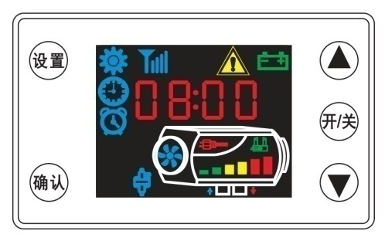LCD panel using the above method
Strive for the Perfect Vehicle Life
will serve you wholeheartedly.
  Warnings | 1. The fixed backboard shall be sealed and separated from the vehicle sheet metal during installation to avoid the physical injury to the driver when the combustion gas flows in the driving cab from the gap.  2. The exhaust pipe length shall be 30cm at least.  3. The exhaust gas outlet shall be firmly placed in the empty space.  4. The exhaust pipe outlet shall not look at the driving direction.
Recommendations: It is suggested to apply the sealant to block off the installation gap when the heater has been fixed.

