Warranty Information: Frequently Asked Questions

Q1. What is the warranty on HP laptops sold on Amazon.in?
HP consumer laptops sold by sellers on Amazon.in carry a one-year onsite manufacturer warranty from date of purchase. For more details refer: http://www.hp.com/go/hpsc.

Q2. Where can I check the warranty validity of my product?
You can check your warranty by entering your serial number also contact the manufacturer directly at the toll-free numbers given below.
Manufacturer | Check your warranty online | Toll free number (Laptops)
HP | http://h20566.www2.hp.com/hpsc/wc/public/find | #1800112267(MTNL & BSNL), # 30306363(Private)

Q3. What if I get a product with expired warranty OR my warranty starts before the actual date of purchase?
In the rare case that your laptop’s warranty is expired or your warranty starts before the actual date of purchase, please use the following links to verify and register your warranty.
- For registering your HP notebook and modifying warranty start date: https://register.hp.com/apac/flowPage/registration/index.do?execution=e1s1&cc=IN&lang=en
- For checking warranty status: http://h20566.www2.hp.com/hpsc/wc/public/find Detailed steps are at the end of this document
In case your issue is still unresolved, please contact Amazon Customer Service at https://www.amazon.in/gp/help/customer/contact-us through chat, email or phone and we will assist you in resolving this.

Q4. What if I get a damaged/defective product?
Please refer to the Amazon return policy at About Returns Policies . In case of a technical problem with your item, we may ask you to contact the manufacturer directly for better resolution of your problem.

HP Short Warranty updation steps

1. Go to https://support.hp.com/us-en
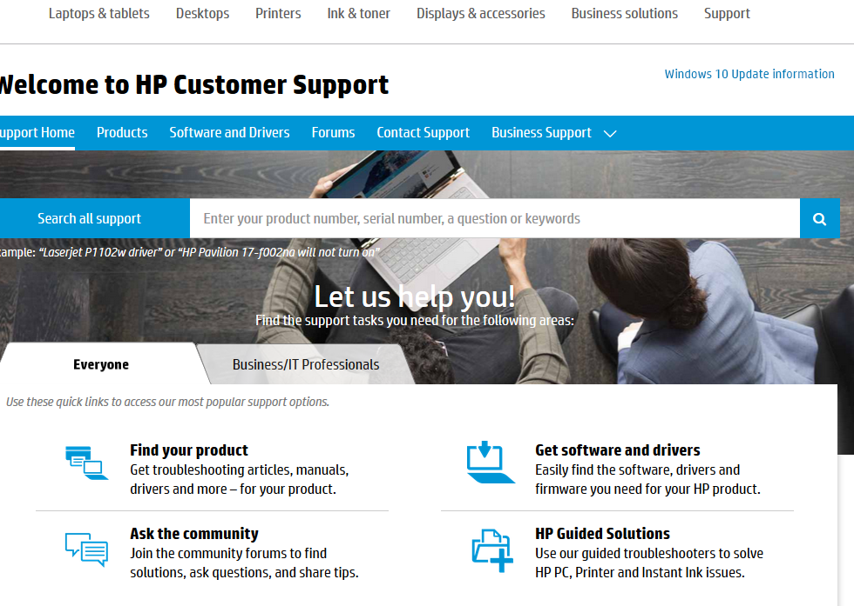
2. Enter the product serial number (and part number if required) This will you to a page which looks like this:

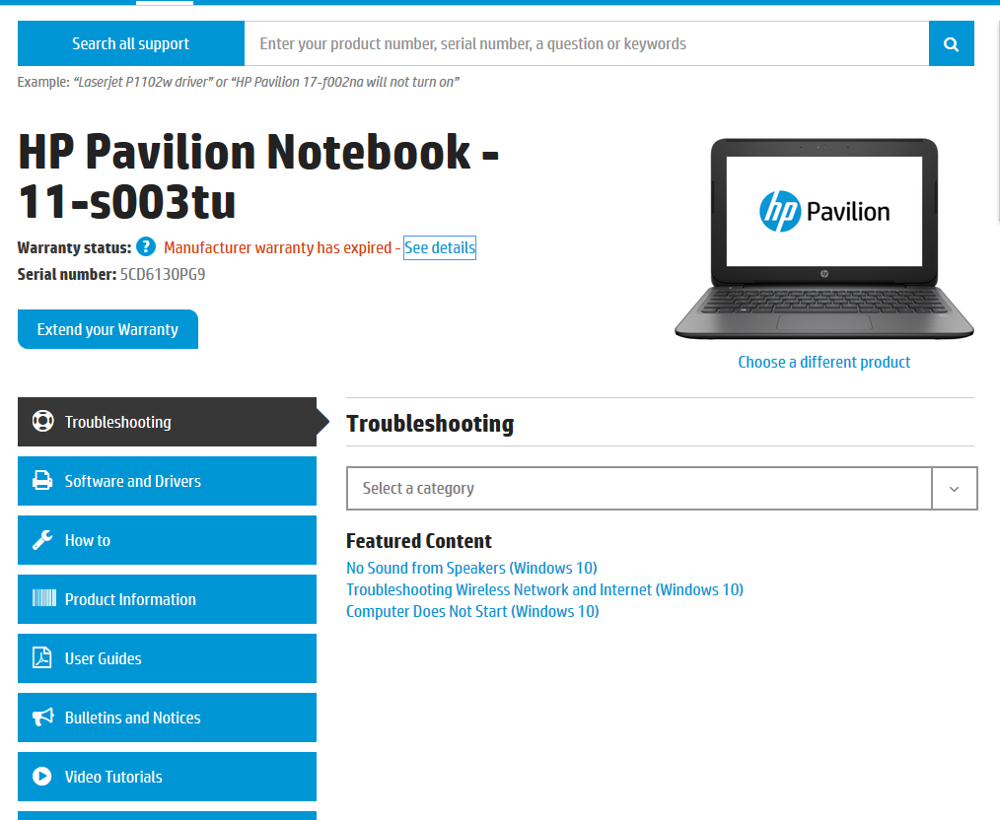
3. Click "See Details"
4. This will take you to a warranty details page which looks like the below:
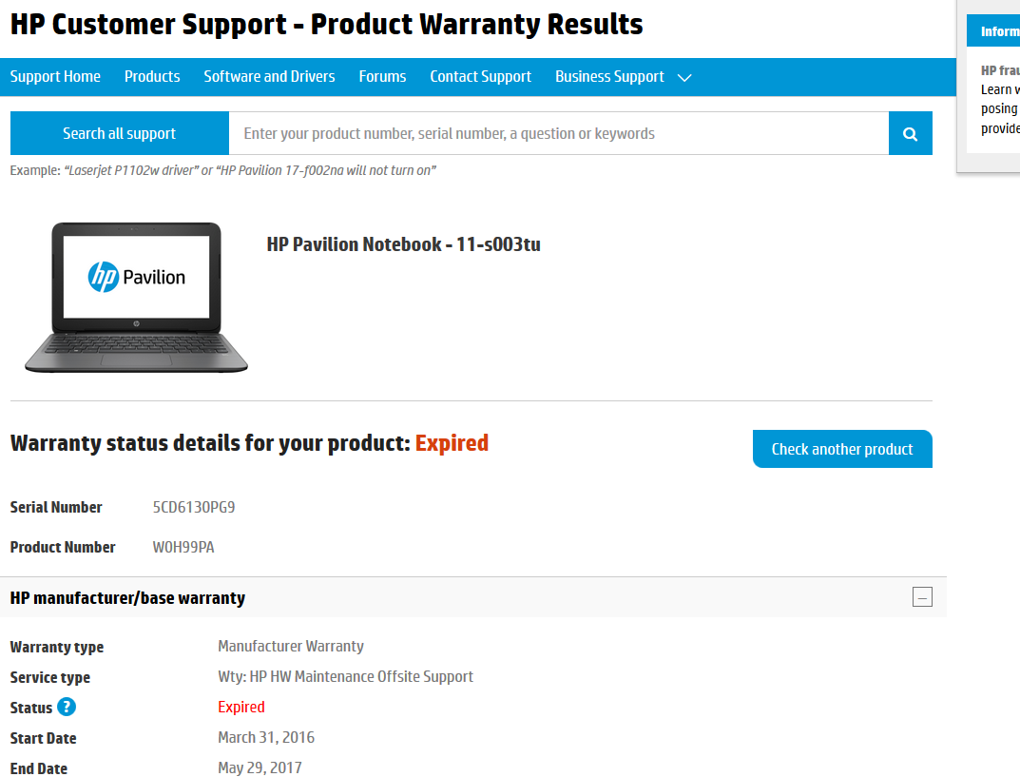
5. Scroll down to find the link “Dispute this” and click on the link
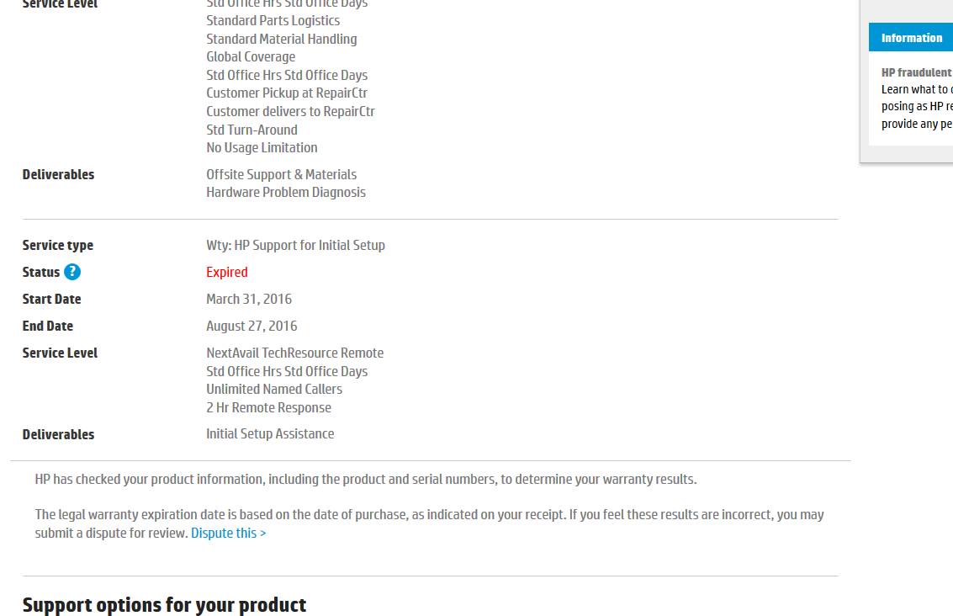
6. Click “Dispute this” which takes you to a page where you have to fill in all details and attach the invoice. The dispute reason should be selected appropriately.

