Tarah ENGLISH

USER GUIDE
WELCOME
In The Box 2
Charging / Battery Status 3
Pairing 5
Finding Your Perfect Fit 7
Eargel Size 7
Speed Cinch & Shirt Clip 8
DETAILED INSTRUCTIONS
Button Functionality 9
The Jaybird App 12
Multipoint - Connection to multiple devices 13
Smartwatches 14
Troubleshooting 15
Specifications 16
Warranty, Warnings & Safety 17

WELCOME
JAYBIRD TARAH
ESSENTIAL PERFORMANCE RUN WIRELESS
For detailed video instructions please visit jaybirdsport.com/support/
6 HOURS PLAYTIMESPEED CINCH
SWEAT & WATERPROOF (IPX7)PREMIUM SOUND WITH CUSTOM EQ
SPORT FIT - SECURE & COMFORTABLEMUSIC & CALLS
10 MIN = 1 HR OF PLAYTIME
Please refer to the safety warnings for important product safety information prior to installation or use of the product.

IN THE BOX
Shirt Clip
Speed Cinch
Wireless Headphones
Microphone
LED
Volume
+
Volume
–
Middle Button
R
R
R
L
L
L
Integrated USB Silicone Eargels (Size 1 / 2 / 3)
Charging Cable

CHARGING/BATTERY STATUS
Take the included USB
charging cradle and plug it
into a USB power source.
The white LED will start pulsing
when charging, and will turn
solid white when fully charged.
2
hours
charging gives
6
hours
of playtime.
10
mins
charging gives
1
hour
playtime.
A
B
We recommend you charge your earbuds using any 5V 500mA USB power source. Wall/car adapters/chargers that supply more than 5.5 V may damage your Jaybird earbuds and should not be used.

CHARGING/BATTERY STATUS
R
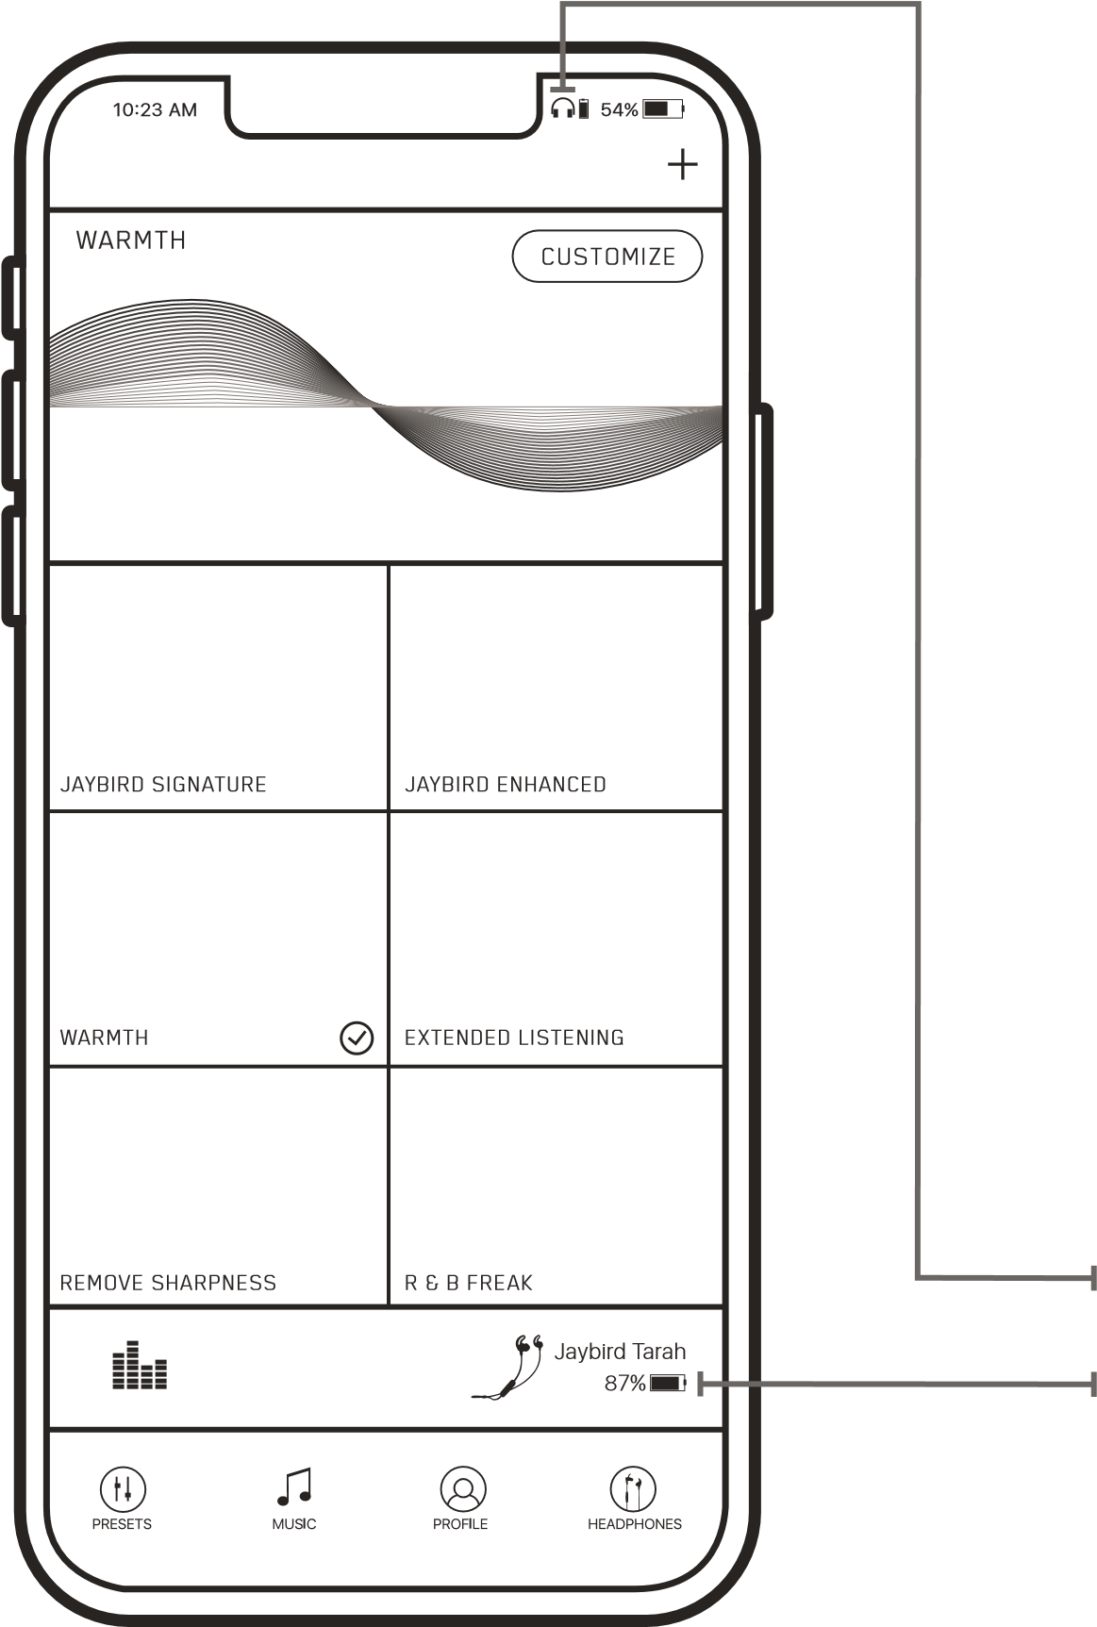
  When you turn on your earbuds, you will hear a battery level announcement. The battery level announcement is rounded to the nearest 20%.
  Your phone and the Jaybird app will also indicate the battery level. The Jaybird app will indicate the battery level to within 1%.
On your audio device, turn
Bluetooth
®
on and ensure it is
actively searching for Bluetooth
devices.
A
With your Tarah earbuds turned
off, press and hold the Middle
Button until you see the LED
blinking white. You will hear the
“
READY TO PAIR. DOWNLOAD
THE JAYBIRD APP FOR AN
ASSISTED SETUP
” voice
prompt.
Searching...
PAIRING
B
R
C
D
PAIRING
Select “
Jaybird Tarah
” in the
list of discovered devices.
Once your Tarah earbuds
have connected to your audio
device you will hear the
“
Connected
” voice prompt.
You are now ready to listen to
your music.
If the pairing is not successful
, switch off your earbuds by pressing the
Middle Button until the red LED illuminates and you hear a descending
“Power off” tone. Once your earbuds have powered off repeat steps A-D.
NOTE
:
When you turn your Tarah earbuds on for the first time or after a
reset, they will be in pairing mode.
Jaybird Tarah
R

FINDING YOUR PERFECT FIT

1. FINDING THE CORRECT EARGEL SIZE
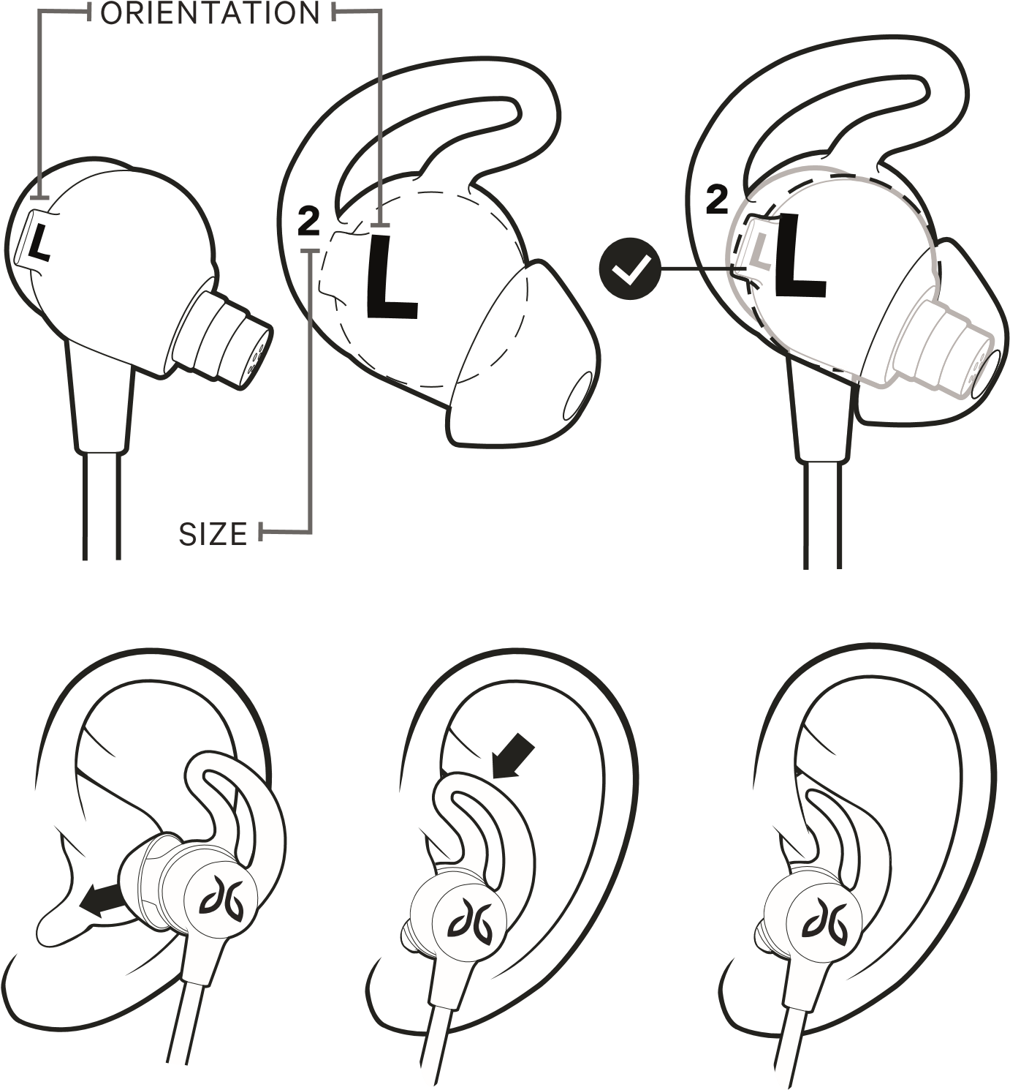
For an assisted fit set up, please download the Jaybird App or visit www.jaybirdsport.com/support/tarah
C
Once you are happy with the fit, you are good to go.
- Try with pre-installed size 2 eargels. Place these firmly within your ears as shown in the illustration.
- If your earbuds are not comfortable, or feel loose, or too tight, try alternative sized eargels (size 1 or size 3).
Be patient, it may take some time to get the perfect fit.
Note: It is quite common to use different sized eargels in each ear.

FINDING YOUR PERFECT FIT

2. SPEED CINCH & SHIRT CLIP
A
B
The
speed cinch
helps to keep the cord off your neck and
shoulders, which is ideal for sports use.
Place your Tarah earbuds in
your ears.
Grab the cord beneath the
cinch with one hand. With
your other hand adjust the
cinch up or down until you
find the right cord length
allowing a snug fit with
no excess slack.
Use the included
shirt clip
to secure your Tarah earbuds
to the back of your shirt.
A
B
Prior to using the shirt clip remove, the cinch.
Attach the shirt clip to your shirt as it shown in the
illustration below.

Turn your earbuds OFF: press and hold the
Middle Button until you hear a descending “Power off” tone and the LED illuminates red before turning off.

BUTTON FUNCTIONALITY
LONG PRESS
R
Turn your earbuds ON: press and hold the
Middle Button until you hear an ascending “Power on” tone and the LED turns solid white.
ON/OFF
PRESS LONG PRESS DOUBLE PRESS

PLAYING MUSIC
Play or pause, a song or video with a single press and release of the Middle Button.
To skip a song, long press the Vol. + Button.
To go backwards, long press the Vol. – Button.
To change the volume + or –, press the Vol. + or Vol. – Button.
To activate voice assistant, (Siri or Google Now), double press the Middle Button.
VOLUME UP SKIP FORWARD
PLAY / PAUSE VOICE ASSISTANT
CUSTOM CONTROL CUSTOM CONTROL VOLUME DOWN SKIP BACKWARD PRESS DOUBLE PRESS

PHONE CALLS
Accept/End a phone call, press the Middle Button.
To decline a phone call, double press the Middle Button.
To change the volume + or –, single press the Vol. + or Vol. – Button.
VOLUME +
ACCEPT / END A CALL DECLINE A CALL
VOLUME –

THE JAYBIRD APP
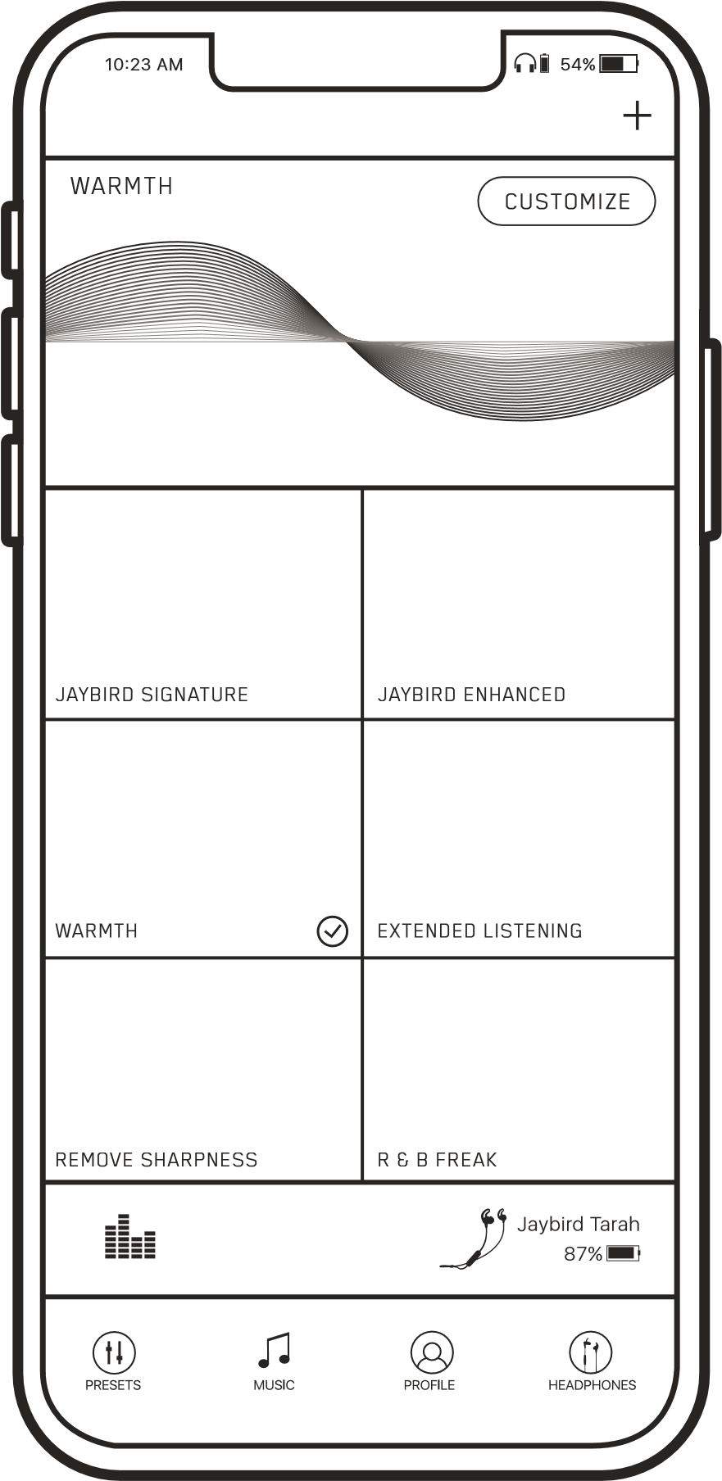
The Jaybird App lets you customize the sound profile of your Tarah earbuds. You can also enable Find My Buds to track your earbuds if lost. Connect your earbuds to the Jaybird App to see if a firmware update is available.
Your new sound settings are saved on your earbuds, so you can take your custom sound with you no matter where you go with any device you use.

DETAILED INSTRUCTIONS

MULTIPOINT - CONNECTION TO MULTIPLE DEVICES
Multipoint allows you to be connected to two devices simultaneously. You can for instance be connected to your laptop and your mobile phone. While listening to music on your laptop you will be able to accept an incoming call on your phone.
1
2
3
Ensure your earbuds are up to date. Connect to the
Jaybird app to see if a firmware update is available.
Ensure your Tarah earbuds are paired and connected to
both devices. Follow pairing instructions on page 5-6.
Make sure that only the two devices you want to
connect to are turned on and in proximity
Your Tarah can remember up to eight paired Bluetooth®
devices and can be actively connected two devices at a time.
R

DETAILED INSTRUCTIONS

SMARTWATCHES
With the right smartwatch you can leave your phone at home. Just sync music to your smartwatch and pair Tarah to your smartwatch. Use your smartwatch user manual for instructions on how to pair a Bluetooth device.
Apple WatchOS Samsung Android Wear Garmin

TROUBLESHOOTING
Soft reset: If your earbuds are not responding, put your Tarah in the charger cradle and connect the USB charging cradle to a power source. This will turn your earbuds off and perform a soft reset.
Factory reset: If this does not resolve your problem we recommend resetting your earbuds to their original factory settings. Before starting this process please “FORGET” or “REMOVE” your Tarah device in your Bluetooth list of discovered devices in your audio device.
1
2
3
Put your earbuds
in to pairing mode.
Press and hold the
Middle Button
until
the earbuds turn off.
Then press and hold
the Middle Button
for 5 seconds until
the
white LED
starts
blinking.
While the white LED
is blinking press the
Middle Button
twice.
The
red LED

illuminates briefly, and
then the
white LED

starts blinking again.
Now your earbuds are
reset and ready to pair.
Go to your audio device’s
Bluetooth menu and select
Tarah to re-pair.

SPECIFICATIONS
Bluetooth Version | 5.0, Multipoint
Codec | SBC
Profile | Handsfree, Headset, A2DP, AVCRP, SPP
Effective Range | 10 meters (30 feet)
Play Time | 6 Hrs*
Power Bluetooth headset: 5.0V , 1A
Charging Time | 2 Hrs
Quick Charge | 10 Min = 1 Hr play time
Dimensions | 13.25 x 23.6 mm earbud size, 490 mm cord length
Weight | Approx 13.85 g (without eargels)
* Play time and standby time may vary due to usage conditions. Adding additional bass to your sound profile through the Jaybird app will reduce play time.

WARRANTY, WARNINGS & SAFETY
Full warranty, care & maintenance details at: jaybirdsport.com/warranty +1.866.244.3399
WARNING: Due to the isolating characteristics of these headphones do not use while driving, riding a bike or where vehicular traffic is present, or in any other activity where failure to hear surrounding sounds could be dangerous. Use of these headphones at excessive volumes may cause permanent hearing damage. Always turn the volume down before use. Take caution in regards to inserting objects into ear canal, use at own risk. Do not wear the device while it is connected to a power source driven from main 110V or 220V lines.
Copyright 2018 Logitech. Logitech, Jaybird and the Jaybird logo are trademarks or registered trademarks of Logitech Europe S.A. and/or its affiliates in the US and other countries. The Bluetooth® word mark and logos are registered trademarks owned by Bluetooth sig, inc. Google Play and the Google Play logo are trademarks of Google LLC. Apple, the Apple logo, iPhone, and iPad are trademarks of Apple, Inc. Other trademarks are the property of their respective owners. Any use of such marks by Logitech is under license or with permission.
WATERPROOF
Your Jaybird Tarah earbuds feature an IPX7 waterproof rating. Tarah earbuds are designed to handle rain, mud and outdoor adventures.
Jaybird headphones are not designed for swimming, showering or exposure to pool or ocean water. In case of exposure to salted or chlorinated water, rinse the headphones gently with fresh water and air dry before use. The charging cradle is not water resistant, so please ensure your headphones are completely dry before charging.
EARGEL CLEANING
Keeping your Jaybird earbuds eargels clean is essential for safe, hygienic use.
IMPORTANT: DO NOT attempt to clean the eartips without first removing them from the headphones.
- Firmly grip the eargel with one hand and the earbud with the other. Carefully remove the eargel from the earbud.
- Use warm water and mild soap on a damp cloth to remove dirt and earwax from the eargel. Do NOT use harsh cleaning agents.
- Rinse and completely dry your eargel before placing them back on your earbuds.
- Carefully push the eargel back onto the earbuds.

LISTEN RESPONSIBLY
Avoid excessive volume levels and prolonged periods of listening. Prolonged listening at excessive volume levels may cause permanent hearing disability.
Do not use around road traffic.
Video instructions at
jaybirdsport.com

CARE AND MAINTENANCE
Clean eargels regularly of dirt and wax buildup. To clean, remove eargels from earbuds, then gently wipe away dust and oil with a dry cloth, and/or use warm water and mild soap to remove buildup. Rinse and completely dry before reattaching.
Before charging, ensure earbuds are completely dry of sweat and water.

