

2018

JCAL User Manual: Faculty/Staff
TAMUK Event Scheduler



Table of Contents
1. Introduction to JCAL 3
2. Logging In 3
3. ​​​​​​​​​How to Book Events 3
3.1. Creating Quick Events 3
3.2. Scheduling Event Request Forms 8
3.2.1. List of Request Forms 9
4. Calendars 12
4.1. Filtering Calendars 12
4.2. List of Calendars 14
5. Using the Scheduling Grids 15
5.1. List of Scheduling Grids 15
6. Setting up Notifications within Astra 18

Introduction to JCAL
JCAL is a system used to view and create special events, meetings and class schedules. It is a centralized system for scheduling and viewing room usage and displays on shared calendars everything happening on campus.
Depending on your role you will see events and/or classes pertinent to your role as Student, Faculty/Staff, or Approver.

Logging In

- Ad Astra link: https://jcal.tamuk.edu
- Log in using your TAMUK credentials (the username and password to login to your computer)

​​​​​​​​​How to Book Events
There are multiple ways to enter events into Astra. The fastest and simplest way is described below. Please keep in mind this is best for small meetings or events that don't need details. If you are booking places like Jones, MSUB or things that will require catering or technical resources see Scheduling Event Request Forms (pg 9).

Creating Quick Events
​​Step 1:
Go to the 'Calendars' tab at the top of the page.
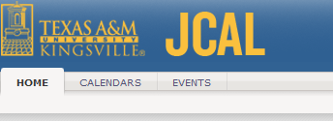
Step 2:
Choose 'Scheduling Grids'.
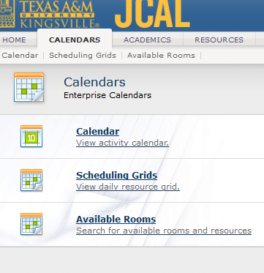
Step 3:
Astra will have a default calendar, specified by your work requirements. This example will show how to schedule a conference room, but the same things can be done for freely schedulable rooms in your calendars. Go to 'Choose Calendar' and pick the appropriate one. The All Activities Grid gives you the option to narrow things down into conference and training rooms. Similarly, the sports calendar will filter into specifics like tennis, etc.
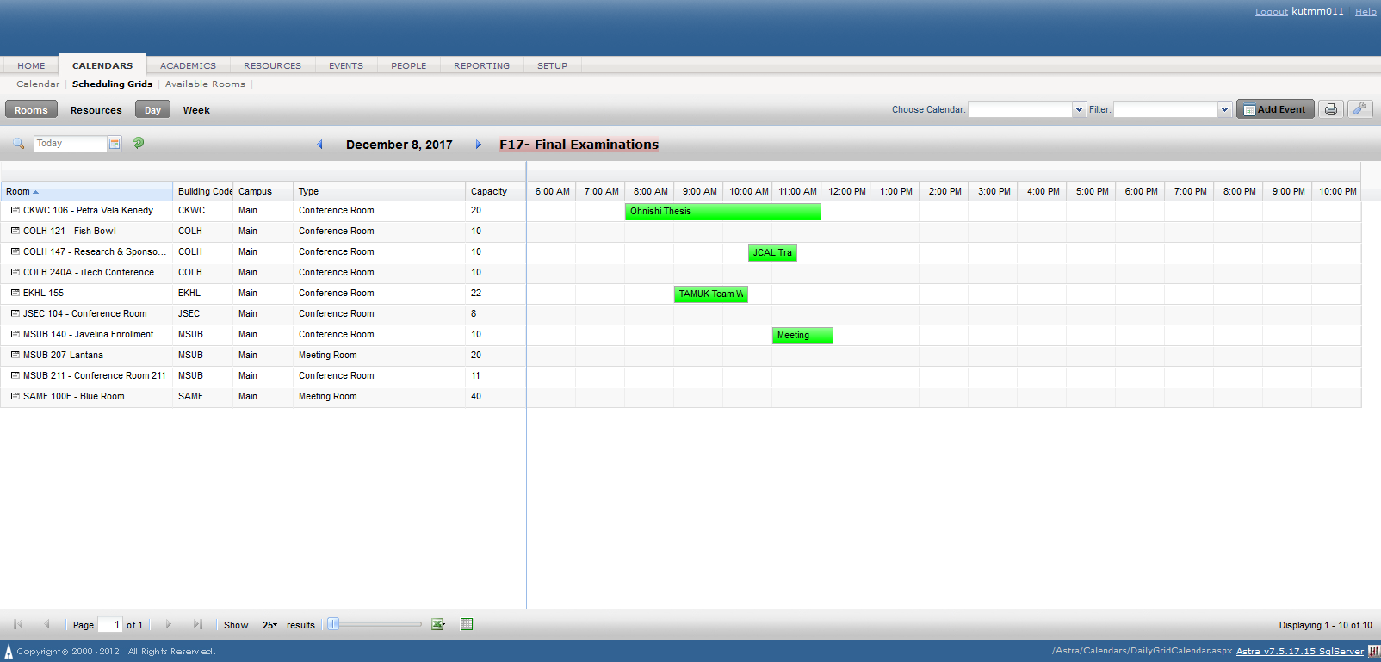

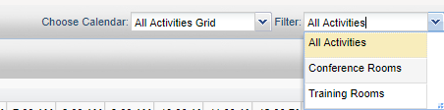
​​
Step 4:
Simply click and drag the appropriate room and times that you want. If you schedule at the wrong time or in the wrong room, the meeting can be picked up and moved appropriately. Green means that the event has been scheduled, while red means it is pending approval.
Green- Scheduled
Red-Needs Approval
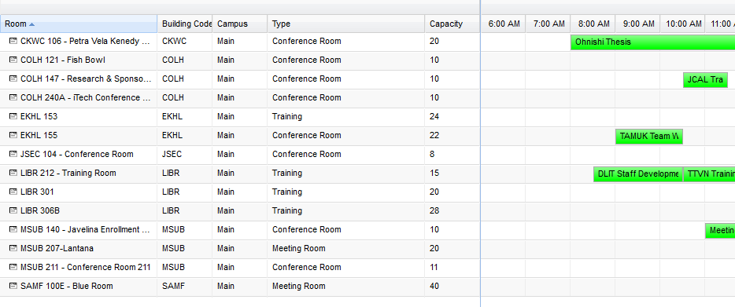
​​Step 5:
A pop-up will appear asking for a few more details before the event can be completed.
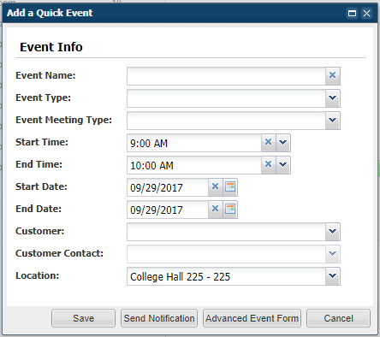
Step 6: ​
Fill out the form appropriately.
You can send notifications from Astra, or put more detailed event information if the event requires it. Once you are done completing the form, it should look something like the image below. Make sure to press Save when you are done.

Event Name | Something descriptive and specific to your Event
Event Type | Athletic - Feeds to Athletic Calendars  External - These are groups not directly part of the University  Faculty/Staff - Events that are intended for Faculty and Staff to attend  Student - Events that students can attend, feeds to the student activities calendars
Event Meeting Type | These are used to filter the different Event Types to specific calendars or reports.  Academic - Any Academic Event  Athletic - Athletic Events including Rec Sports  Events* - These are used by Event Planning to filter their Event Meetings  Exhibit - Used for Museum Calendars  Meeting - Used for Faculty and Staff for Internal Meeting Calendars  Orientation - Used for Orientation Events  Performance - Filters to Theater and Arts events calendars  Thesis/Dissertation - Used to Report on Thesis/Dissertation presentations.  Training - Used to report on Training events and to display training Calendars
Customer | Customer is the department, group, or company that is hosting the event.
Customer Contact | Drop-down list of people associated with the department (Customer). This is the main contact who will be e-mailed with confirmations about the event.

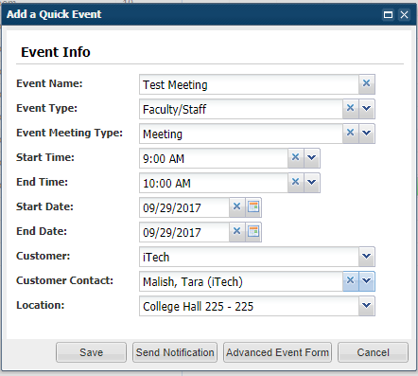​​​​​​
You can send notifications from Astra, or put more detailed event information if the event requires it.

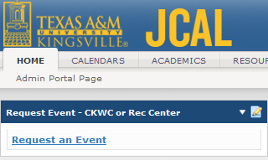
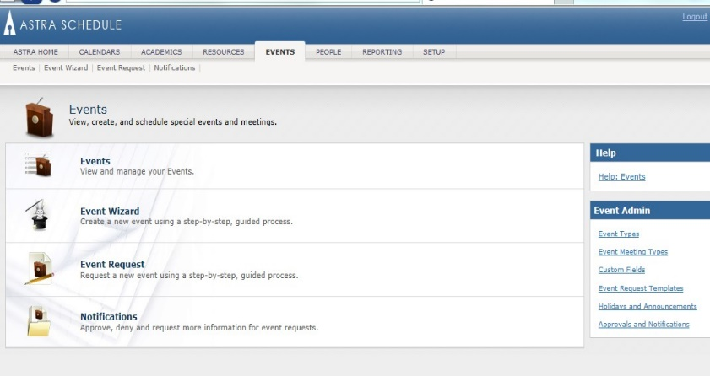
Scheduling Event Request Forms

Some rooms may require an approval process to be booked. These rooms have a form that can be filled out, explained in the following.
To access the event request forms, simply go to the Astra home page. There is a link labeled ‘Request an Event’. You can also access request forms under the events tab, seen in the images above.
Choose an appropriate form to the space you need to request.

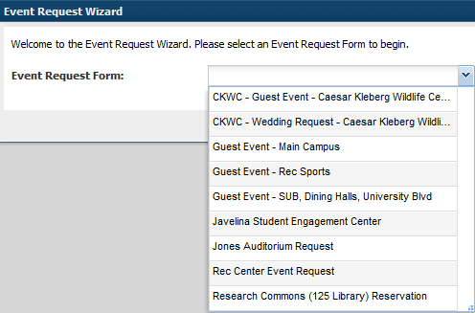
List of Request Forms

CKWC – Guest Event – CKWC – for non-wedding events in the Wildlife Center
CKWC – Wedding Request – CKWC – for weddings in the Wildlife Center
Conner Museum – External – Used for school tour requests or similar.
Guest event – Main campus – This is for an event that can be held anywhere available on campus, or for any that aren’t specifically listed in the other forms.
Guest Event- Rec Sports – Request an event with recreational sports or using the RECC fields, buildings, or courts. Used for guests or private events.
Great event – Sub, dining halls, university Blvd. – For events held in the Memorial Student Union Building, Javelina Dining Halls, or along University Boulevard.
Javelina student engagement center – Reservation for the JSEC Social Hall.
Jones auditorium request – Theater or Auditorium request for events.
Rec center event request – Recreational center requests.
Research commons (125 library) reservation – request the research commons room in the library.

- Fill out the event information on the form
NOTE: Fields with an (*) require information. If left blank, the system will not allow the request to be submitted.
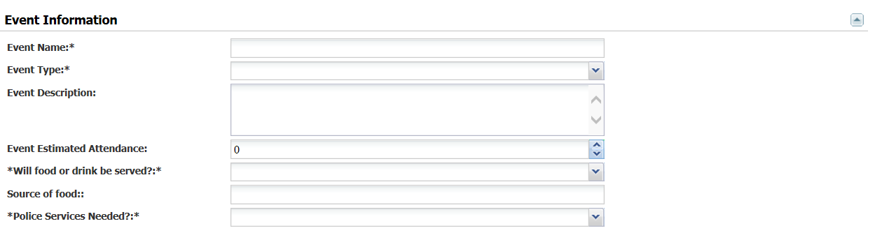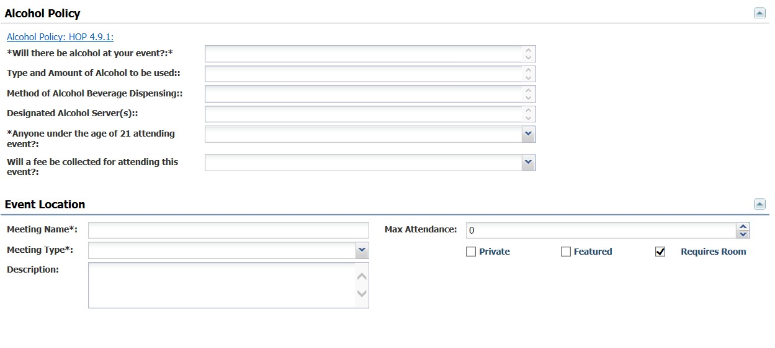
Please be aware of the difference between Event Type (located under the category Event Information) and Meeting Type (located under Event Location)
  - Event Type – General categorization for the type of event you are having. There are four event types:
    - Athletic – Anything pertaining to students/faculty in an educational setting
    - External – Anything pertaining to faculty/staff in a business setting
    - Faculty/Staff – Events that are open to the public and that will be displayed on the Campus Calendar
    - Student – Any events on campus that are open to students
  - Meeting Type – More specific categorization for the type of meeting you are having. There are many different kinds that should cover all types of events.
- You may create a Single Meeting for a one-time event or Recurring for an event that will be held more than once. *Please do not use the Spanning tab.
- Select the Start Time and End Time of the event.
- Select the date(s) the event will occur.
- Click on the CREATE button.

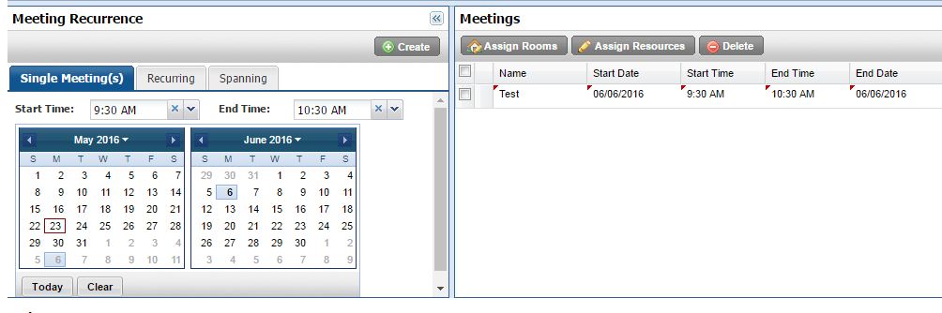
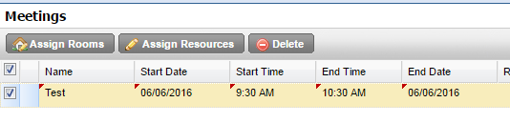
- Check off the box next to the event name.
- Click on the Assign Rooms button to get a list of available rooms
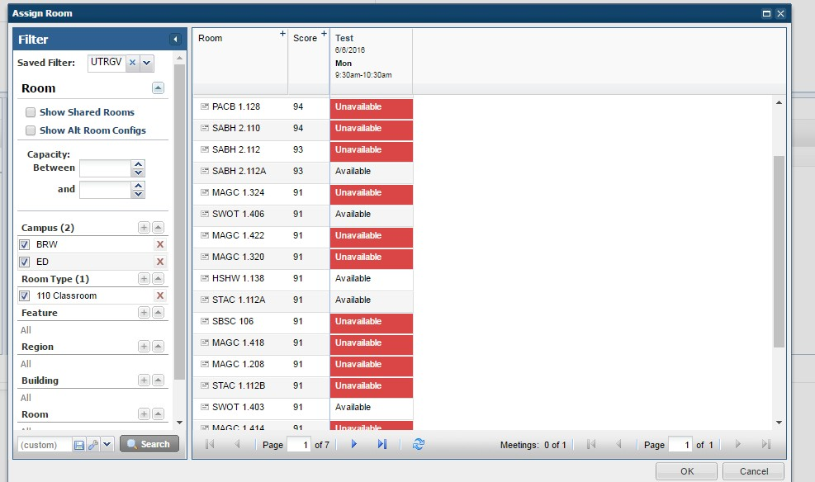
- You may narrow down the search by filtering out a specific classroom, room type, building, or room. Click on Search and the list of rooms will appear on the right. Select an available room and click Ok at the bottom of the screen.
- Click Submit at the top left of the screen to submit your request.

Things to remember:
***If you are requesting weekend dates, you must make a note of that in the event so UPD can prepare accordingly.

**Please allow 3-5 business days for your request to be processed. Please be aware that this is not a confirmation of a scheduled event, just a confirmation that your request has been received. A confirmation email will be sent once your event has been scheduled**

Once the event has been approved or denied, a notification will be sent with the status.

Calendars

Filtering Calendars
- Go to the Calendars Tab
  - On the top bar, you can choose different calendars that have different focuses. For example, the Athletic activity calendar only shows athletic events.

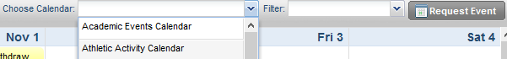
- After choosing an appropriate calendar, some may be further filtered based on preferences or need. Under the university calendar, there is an option to see only conference rooms for easier one-glance scheduling.
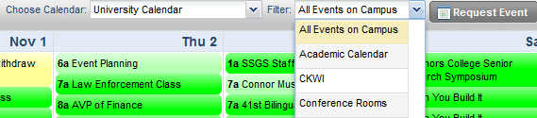
- Most calendars are set to view by the month, but there is also the option of viewing weekly, daily, or by list of events.
  - To open the ‘Filter’ sidebar, you will need to click the magnifying glass in the top left corner. This will let you see details of the filter. Not all calendars will have this option, but if you need to look for something specific in a month view, this is the way to do it.
  - Usually, when searching for something new, you will want to clear all of the filters that may be there. They may prevent you from seeing what you need if there are any left. To add to the filter, simply press the plus sign and choose the buildings, rooms, or even departments that you need to narrow down. Some things may be familiar to you, like building, but others may not. Customers are the departments, while regions are collections of rooms that may be in more than one building.
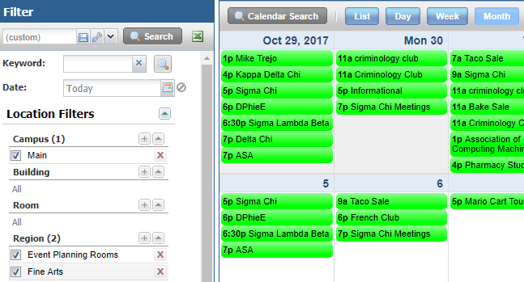
c
a
b
Familiarizing yourself with the Astra system is the best way to learn.

List of Calendars

Each Calendar has different key at-a-glance looks at sets of events. Some users will have calendars specific to their role, so this list is not comprehensive.
Academic Events Calendar – Classroom events.
Athletic Activity Calendar – Athletic Events. There are filters for different sports.
CKWC General Public – Public view of events at the CKWC.
Conner Museum -
Events Around Campus – Various events held around the campus. Includes sports and activities held around campus
Rec Sports Calendar – Recreational Sports.
Student Events and activities – Events held by students or for students.
University Calendar – General calendar. This calendar filters down into Conference and Training rooms in the Scheduling Grid.

Using the Scheduling Grids

List of Scheduling Grids
Many groups have personalized scheduling grids for faster scheduling, but there are some that are used by all. Scheduling grids are different from calendars in their view (a day-to-day look at events rather than a monthly summary) and are easier to schedule directly onto.
All Activities Grid – General grid. Contains filters for classes, training rooms, and conference rooms.

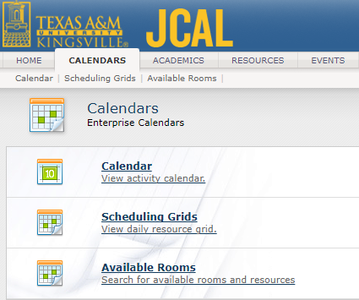
- After entering Astra, go into the Calendars tab. There you will find the scheduling grids; go there.
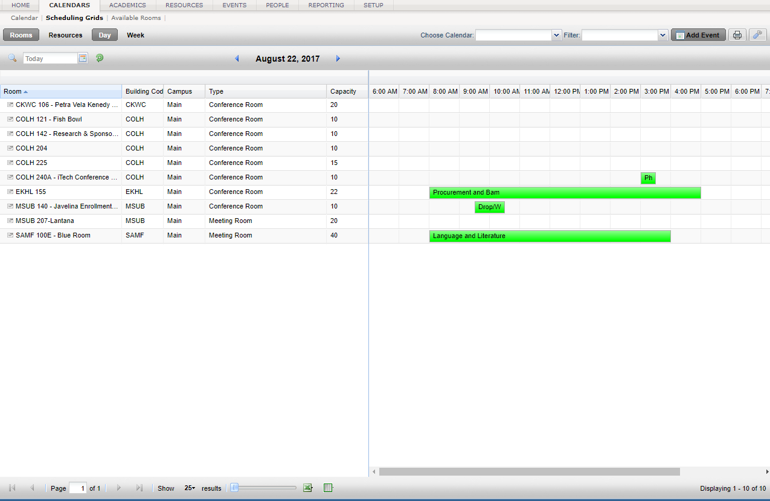
- It will go to your default view. Shown here are the Conference Rooms. You can change the grid at the top right, by ‘Choose Calendar’ and ‘Filter’.
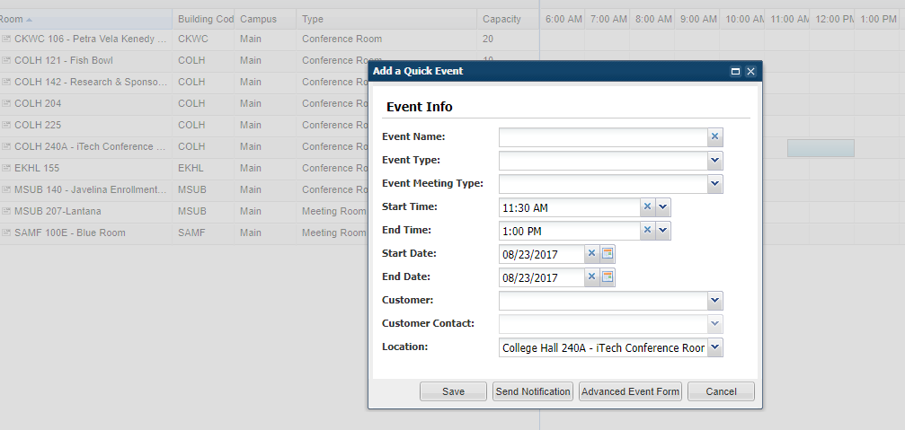
- To quickly schedule an event, simply click and drag the appropriate time and location. If you filled in the time in the wrong location, you can hold the mouse button and drag the time to the correct room.
- Make sure to fill in the appropriate information. The Customer could be the department, office, organization, etc holding the event. Make sure to select the correct customer contact, although it will default to one. Click save to save the event.
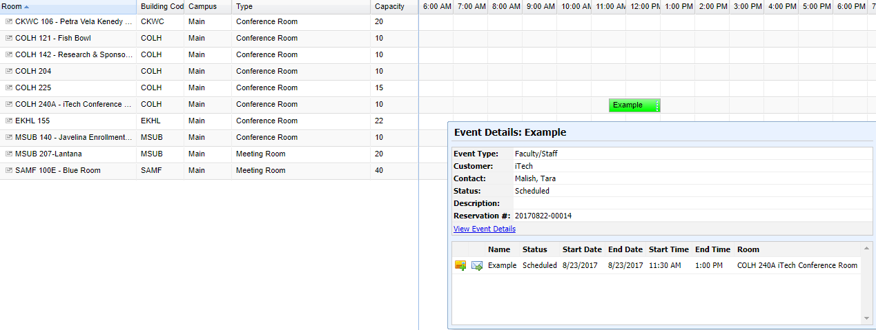
- You can check on the event you just scheduled by hovering over the event.

Setting up Notifications within Astra

- Within Astra, go to the resources tab. Then choose Notifications.
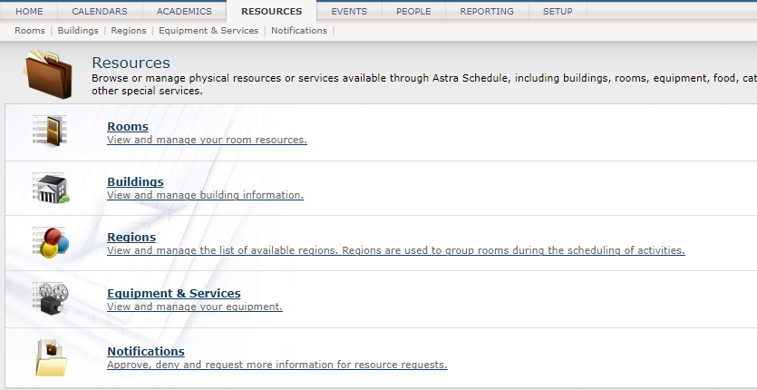
- To check your notifications, you will need to select: ‘Is Notification’ No; ‘Is Active’ Yes
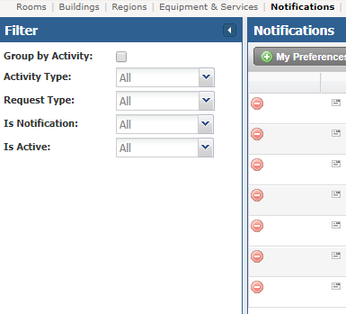
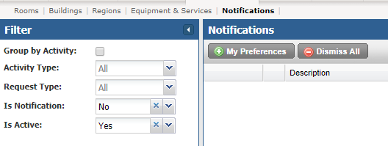
- Although you do not receive an email when you get a notification in Astra, you can set up an email reminder.
- To do this, go into ‘My Preferences’.
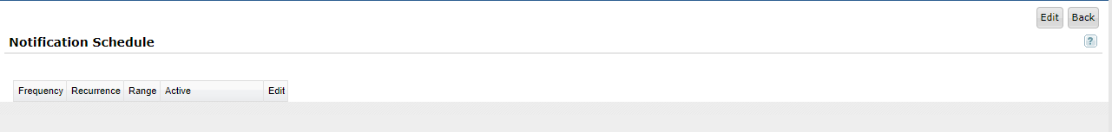
- It will take you to the Notification Schedule screen. You can see your current schedule here, if you have any. To set one, go to ‘Edit’ on the right side of the screen.
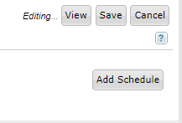
- Add Schedule to set one up.
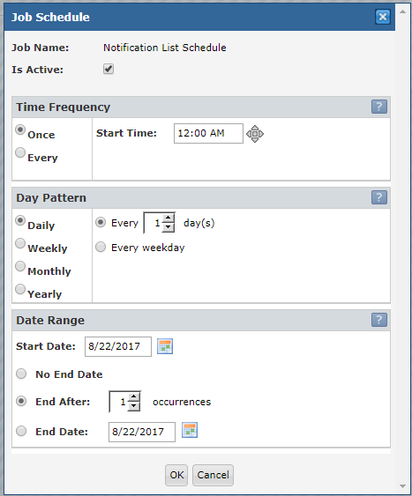
- You can set the frequency of the emails. For example, if you would like one every day at 9 AM:
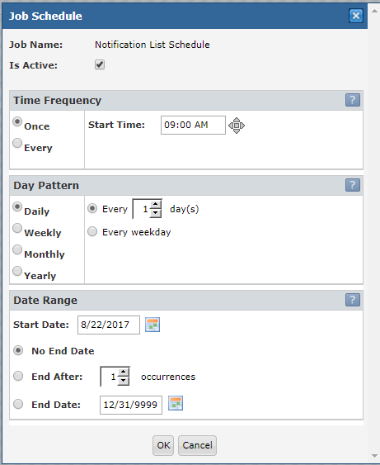
- Set it to the correct start time. Under Day Pattern, you can set it daily, weekly, etc. The Date Range can be set for No End Date, or if you only need to check for two weeks, you can end it appropriately.
- When you are done, click ‘OK’. Go back to the right side of the screen and make sure to click save so that it saves your schedule(s).

