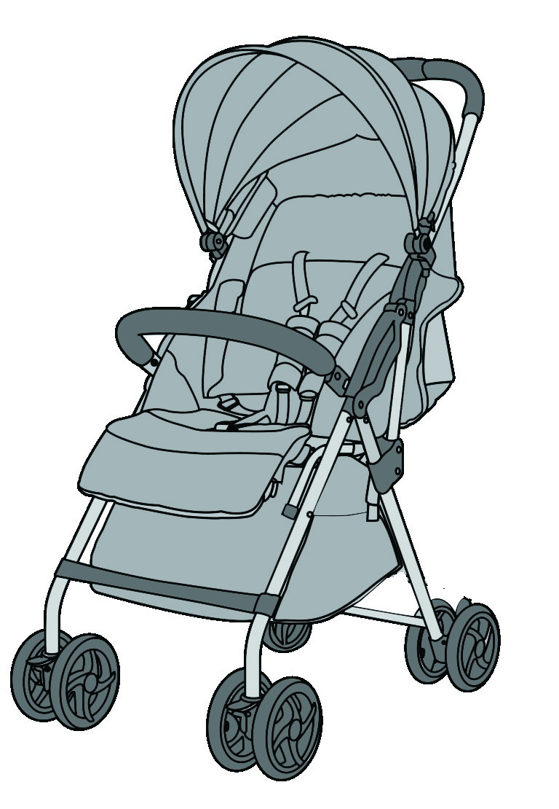
KidsEmbrace
Deluxe Light
Weight Compact
Stroller
Owner’s Manual
Read all instructions before using the
KidsEmbrace Deluxe Light Weight Compact Stroller.
WARNING!
Recommended for children
Weight:
- 50 lbs.
5
Max Height:
in.
43
R

Table of Contents Welcome
Table of Contents ................................................................................ 1 Welcome to the KidsEmbrace family and thank you for purchasing
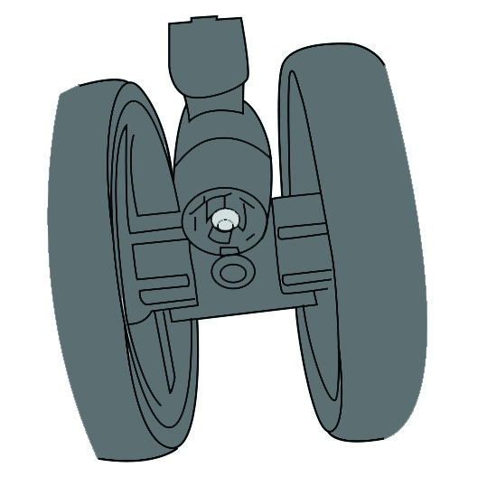
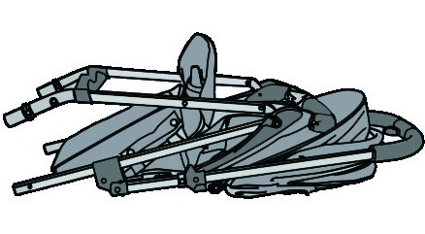
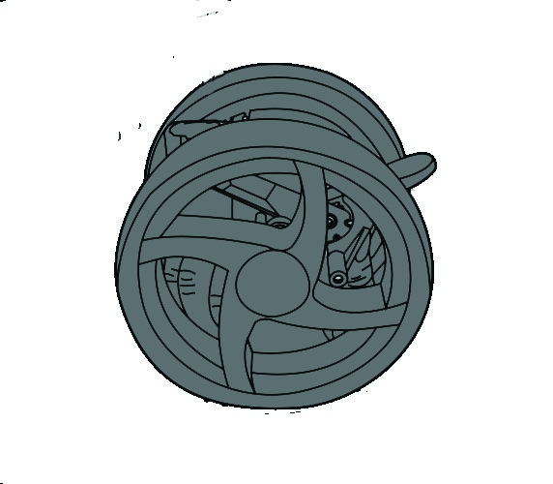
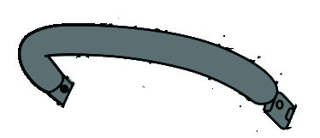
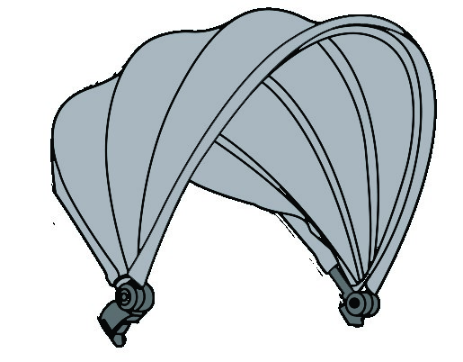
Welcome ................................................................................................ 2 your new KidsEmbrace deluxe stroller. Please make sure to carefully Parts List ................................................................................................. 2 read through all the information in this instruction manual to properly use your new stroller.
Warnings ................................................................................................ 3-4
Stroller Features .................................................................................. 5-6 KidsEmbrace takes safety seriously and is our #1 priority. Each
Assembly product starts with a strict internal design evaluation to assure it is a
Open the Stroller ........................................................................... 7 premium product. Next we begin the extensive government
Install Front Wheels ...................................................................... 7 compliance testing program to assure it meets/exceeds all
Install Back Wheels ........................................................................ 8 regulatory and internal standards. Only after the completion of this lengthy process we are proud to put the KidsEmbrace brand on the
Assemble Canopy .......................................................................... 8 product along with the global brands of our key partners.
Assemble Bumper Bar ................................................................. 8
Using Your Stroller Thank you again for choosing KidsEmbrace and enjoy your new
Set the Rear Brakes ............................................................... 9 stroller. If you have any questions or need assistance please contact Lock the Front Wheels (Swivel & Fixed) ........................... 9 us at 1-866-947-3287.
Install the Harness ......................................................................... 10 Item Name Quantity Picture
Adjust the Waist Strap .................................................................. 10
Adjust the Canopy ........................................................................ 11 A Stroller 1 pc
Fold the Stroller ....................................................................... 11
Adjust the Backrest ....................................................................... 12
Adjust the Footrest ....................................................................... 12 B Front Wheels 2 pcs Other
Maintenance ................................................................................... 13 C (Left and RightRear Wheels ) 1 pc each side
Cleaning ........................................................................................... 13
Warranty ........................................................................................... 13
Registration ..................................................................................... 13 D Canopy 1 pc
Notes ....................................................................................................... 14
E Bumper Bar 1 pc
1 2

Warnings Warnings

WARNING!
Failure to follow all warnings and instructions may result in serious injury or death.
Your child’s safety is important to us, so please follow the owner’s manual and labels when using this product.
Important - Please keep the owner’s manual for future use.
- Always ensure that all components are correctly fitted and adjusted before use. To avoid the danger of suffocation, remove all plastic covers before using the stroller. Immediately destroy the plastic cover to keep it away from babies and children.
- NEVER leave child unattended. Always keep child in view while in stroller
- Prevent serious injury or death from falls or sliding out. ALWAYS secure child in the restraint with the harness.
- When making adjustments to the stroller, ALWAYS ensure that all parts of the child’s body are clear of any moving parts of the stroller.
- To prevent injury keep children at a safe distance away from the stroller during the opening and folding. Care should be taken to prevent finger injury.
- DO NOT leave child in stroller near walls, curtains, or windows, where the child can become tangled, or where a child may be able to use its feet to push against the stroller.
- DO NOT use the storage basket to transport child.
- DO NOT overload the storage basket, Maximum weight should not exceed 6 lbs.
- It is recommened to use the most reclined backrest postion for children up to 6 months and with footrest in the up position.
- ALWAYS engage the parking brakes when placing and removing child from the stroller
WARNING!
- DO NOT place any heavy bags, packages, or other items on the stroller handle, canopy, sides, backrest, or bumper bar of stroller as they can tip the stroller over and injure child.
- DO NOT use the stroller if any part is broken, torn, or missing.
- DO NOT use this stoller for more than one child at a time and
- DO NOT leave other children playing unattend near the stroller.
- DO NOT use stroller with child in it on stairs and escalators
- DO NOT allow child to climb on or stand on stroller
- To avoid the risk of fire, never leave the stoller near sources of strong heat such as open fires, electric heaters, and gas stoves,
- If the stroller is exposed to direct sunlight, wait for it to cool down before placing your child in it.
This stroller is recommend for children up to 36 months old, or for children who weight less than 50 pounds and height of 43”.
- DO NOT use accessories, spare parts, and components other than those supplied by KidsEmbrace.
- Ensure the person using the stroller is responisble and knows how to use it safely.
- Always apply the brakes when the stroller is stationary.
- NEVER leave the stroller on a sloped surface with a child on board, even with the brakes engaged.
- DO NOT use the stroller on a beach as the sand and salt could damage the stroller.
- DO NOT use any infant car seat with this product. Serious injury could occur.
- This is not an excercise stroller. DO NOT run, jog, or in-inline skae or participate in other athletic activity.

3 4
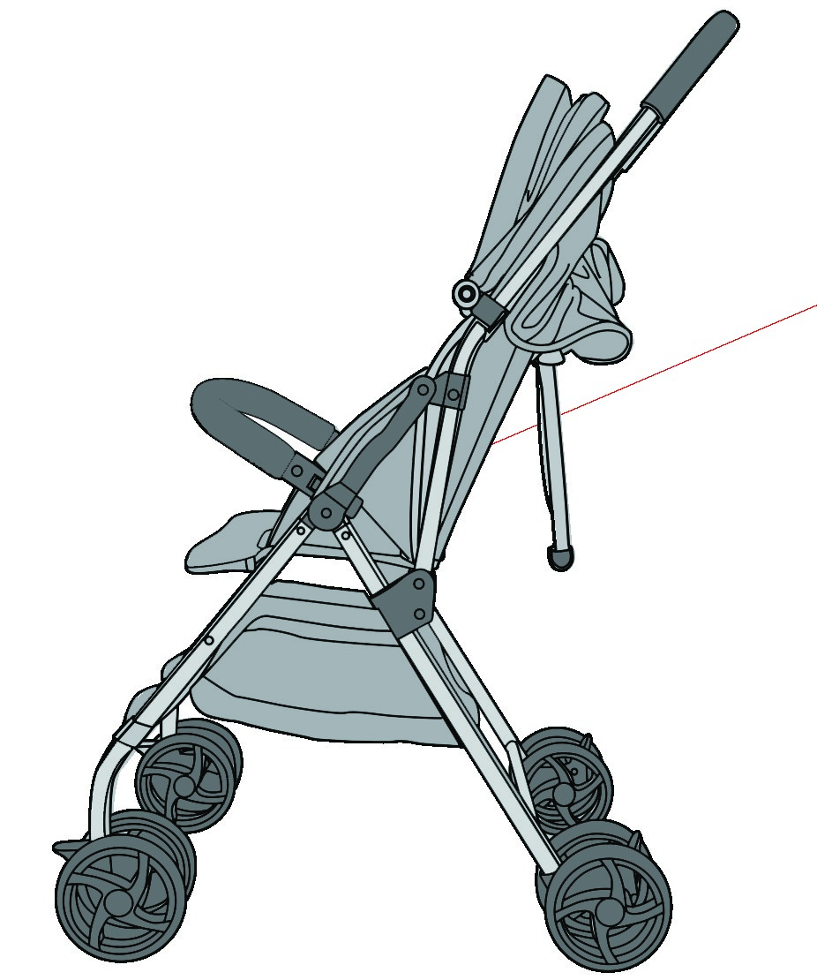
N
K
O
Deluxe trim cover
Legrest
Large storage basket
Backrest adjustment
Rear brakes (2)
Back wheels
K.
L.
M.
N.
O.
P.
L
M
P
Canopy
Harness system (3) height adjustments
Bumper bar
Footrest
Front wheel swivel lock
Front wheels
2
buttons to fold stroller (slide and squeeze button
)
Padded stroller handle
Comfort harness pads
Safety harness buckle
A.
B.
C.
D.
E.
F.
G.
H.
I.
J.
C
A
G
H
I
J
F
E
B
D
5
6
Stroller Features
Stroller Features

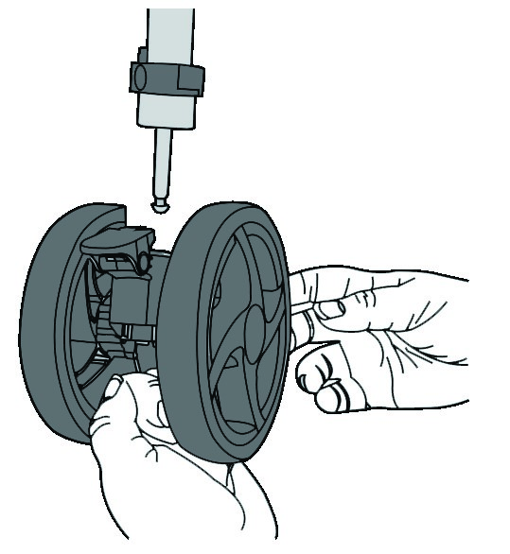
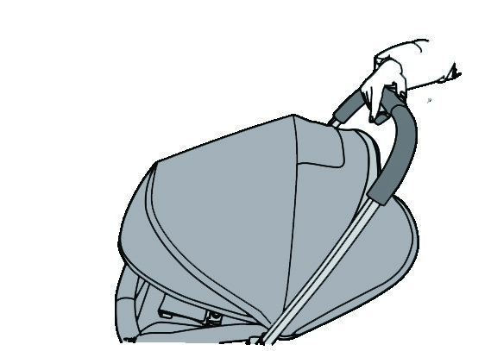
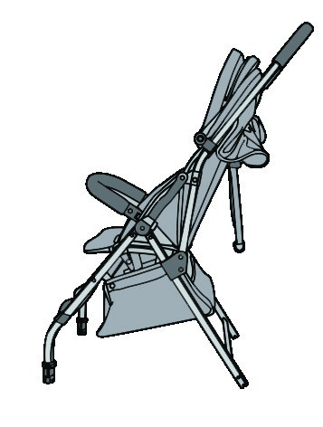
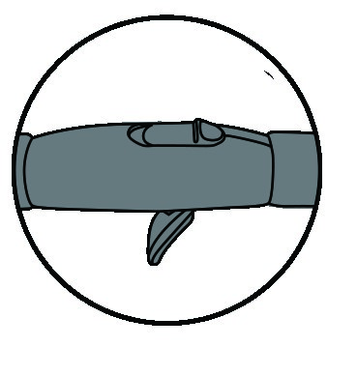
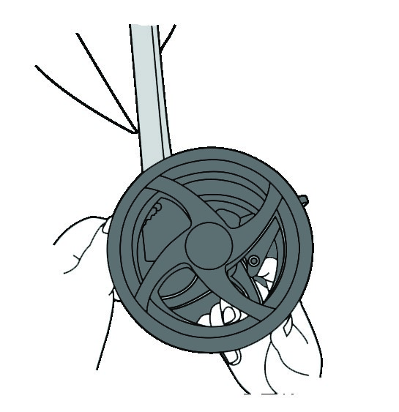
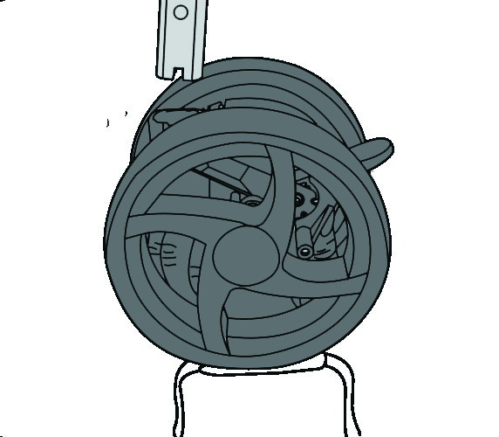
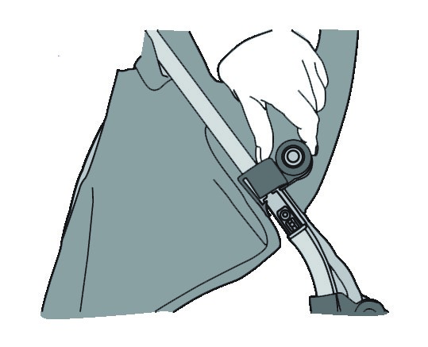
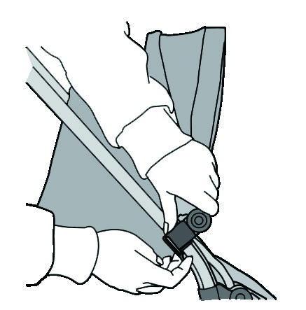
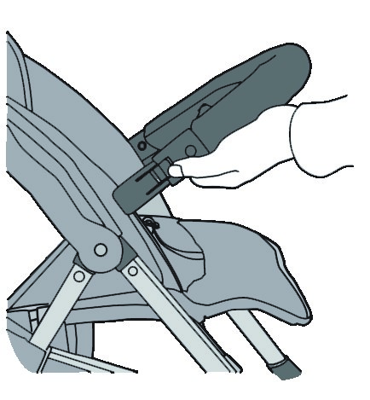
7
8
Assembly
Assembly
Unpack all contents and please check that all parts are present before
starting assembly. Please see
PARTS LIST
on page 2. After checking all
parts are present discard the packaging materials.
WARNING:
Please make sure children are at a safe distance while you are
opening the stroller.
Open the stroller
First protect the floor with cardboard, blanket, or small rug until wheels
have been installed. Next, locate the two buttons on the handle sliding
button across with your thumb and then squeeze button with your
fingers simultaneously to unlock the stroller. Pick up on the handle to open
then release both buttons and continue until you hear a “click” and the
stroller is in the fully open position shown in Figure 1.
Assemble front wheels
The front wheels are interchangable and can be installed on either side of
the front of the stroller. Insert the front wheel set peg into the plastic
base until you hear a “click” shown in Figure 2.
Figure 2
1
.
2
.
3
.
Figure 1
2
2
1
3
3
Assemble rear wheels
The back wheels are NOT interchangable and can only be installed on
the correct side. Put both wheels on floor with the break towards back.
Locate the button locks in the cog hole and position to the outside. AFter
locating the left and right wheels, align the cog hole with the rear leg
tube, push into until you hear a “click” shown in Figure 3. If you did not
hear a click, and you can pull the wheel downard it is on the wrong side.
Assemble canopy
Align the canopy plastic peg with the slot then press tightly to insert the
peg into the slot shown in Figure 4. To disassemble, press both tabs on
the back side and pull the peg from each slot.
Assemble bumper bar
Align the bumper bar pegs with the holes in the front of the seat and
insert into until you hear a “click” shown in Figure 5. To disassemble, press
down on the button of the bumper bar and pull out one side.
.
1
2
.
3.
Figure 3
4
Figure 4
3
4
Figure 5
1
3
5

5
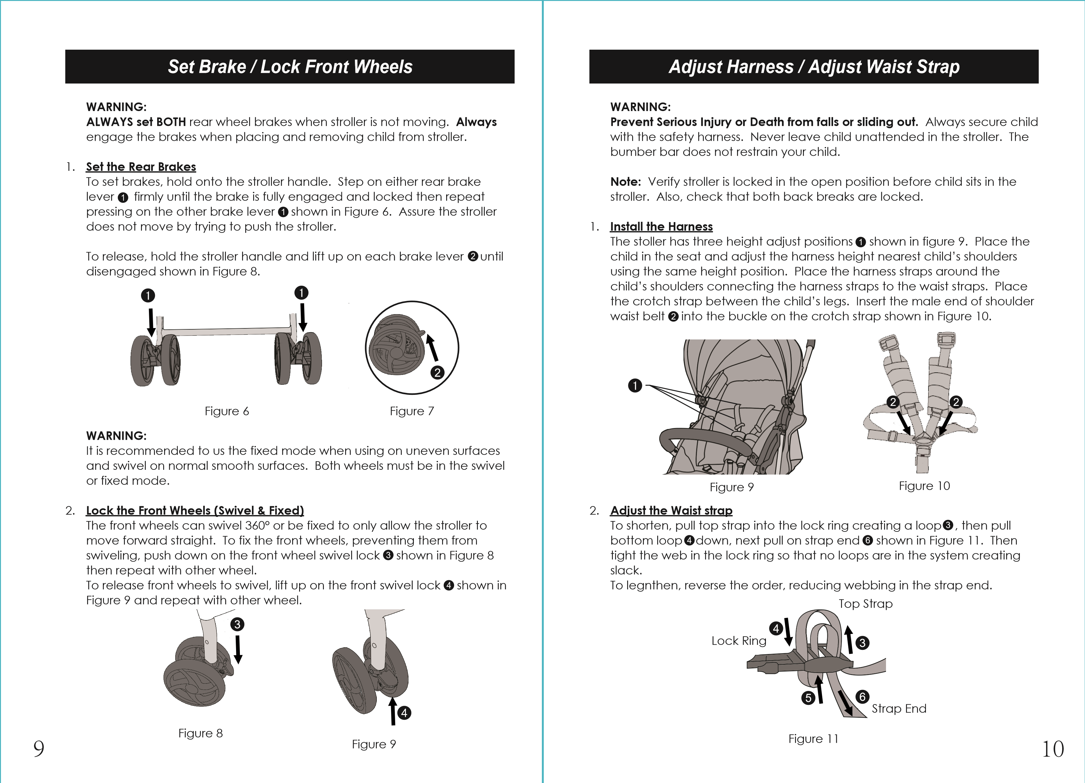
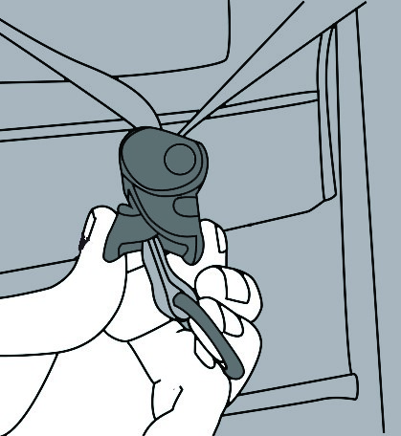
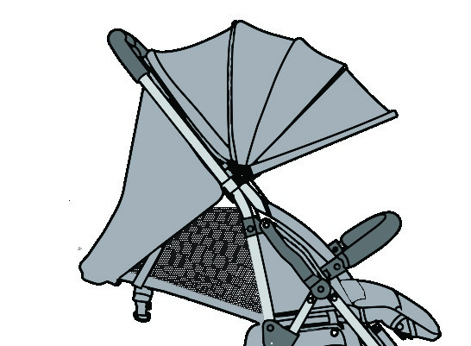
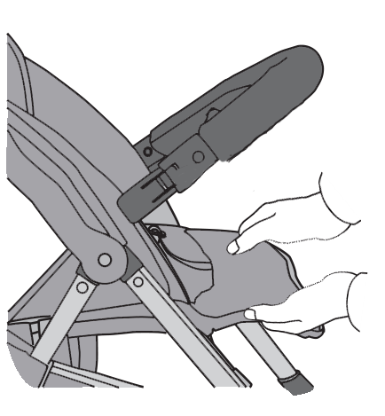
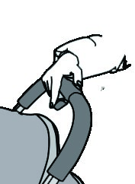
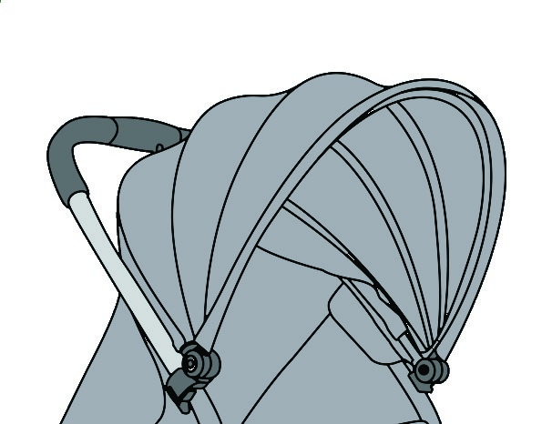
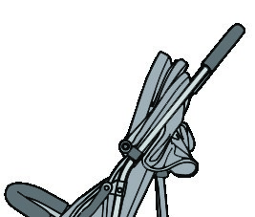
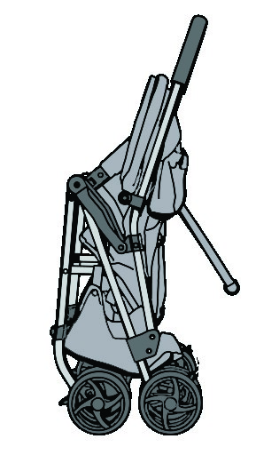
11
12
Adjust Backrest
Adjust Canopy / Fold Stroller
WARNING:
To avoid serious injury,
DO NOT
raise or recline the backrest with child in
stroller
Adjust Backrest
Grasp the adjuster on the back and squeeze both sides then pull down
on the strap to recline the backrest shown in Figure 15. To raise the seat,
hold the d-ring at the end of the strap and slide the adjuster up.
Adjust Legrest
The legrest has two adjustment positions for the child. To adjust, squeeze
both buttons on the sides of the leg rest and rotate up or down into
position as shown in Figure 16.
1
2
1
.
2.
1
1
2

Figure 15
Figure 16
3
3
Adjust the Canopy
To extend canopy, hold on front of canopy and push towards front of
stroller shown in Figure 12.
To retract canopy, hold on front of canopy and pull to the back of the
stroller towards the stroller handle shown in Figure 13.
WARNING:
Please make sure children are at a safe distance while you are
opening the stroller.
Fold the Stroller
First, fold the canopy then locate the two buttons on the handle sliding
button across with your thumb and then squeeze button with your
fingers simultaneously to unlock the stroller. Release the two buttons once
the lock is released and push the handle foward until the stroller is closed
and locked. The stroller is self standing on the wheels shown in Figure 14.
.
1
2.
Figure 14
2
1
2
Figure 12
Figure 13
3
4
3
4
3

.
1
2
.
3.
5.
6.
Maintenance
Before using always check for worn parts, torn fabric, or stitching. Replace
or repair the parts as needed. Use only KidsEmbrace replacement parts.
Cleaning
Use only household soap and warm water to clean the stroller inlcuding
trim cover. Always dry plastic and metal parts.
DO NOT
use bleach or detergent.
DO NOT
iron.
DO NOT
tumble dry.
DO
NOT
dry clean.
Limited One-Year Warranty
This product is warranted against defective materials or workmanship for
one year from the date of original purchase. Proof of purchase is
required. The exclusive remedy for this warranty is that KidsEmbrace will at
its option, provide repair or replacement components for this product or
refund the original purchase price of the product. KidsEmbrace reserves
the right to discontinue or change fabrices, parts, or products, or to make
substitutions. To make a claim under this warranty, contact KidsEmbrace
consumer services at 1-866-947-3287.
Warranty Limitations
This warranty does not include damages which arise from negligence,
misuse or use not in accordance with the product instructions. The use of
non-KidsEmbrace covers, inserts, toys, accessories, or tightening devises is
not approved by KidsEmbrace. Their use could take this stroller out of
compliance with the safety standard or negatively affect the perfor-
mance. Their use automatically voids the KidsEmbrace warranty.
Register
To register your KidsEmbrace product visit us online at
www.kidsembrace.com/product-registration or return the registration card
provided with your stroller. We do not accept product registrations from
those living outside the United States of America.
13
14
Notes
Other

13618.1
Keep this instruction manual for future use.
R
KidsEmbrace, LLC
6711
Odessa Ave
Van Nuys, CA 91406
www.KidsEmbrace.com
Questions or comments?
Email: info@kidsembrace.com
Call: 1-866-947-3287

