
User Manual Freshdesk – Five9 app

Table of Contents
2 Preface 2
2.1 Change log 2
3 Introduction 3
3.1 Goal 3
3.2 Scope 3
3.3 Delineation 3
4 General description 4
4.1 Location of the app 4
4.2 Supported Actions 4
4.3 Ticket creation flow 5
4.3.1 Notes 5
5 User guide 6
5.1 Important notes 6
5.1.1 Requirements for using the app 6
5.1.2 Use only the app for call handling 6
5.2 App settings 6
5.3 Login procedure 7
5.4 Checking and changing your agent settings 7
5.5 Using the phonebook 8
5.6 Answering a call 8
5.7 Customer search results 9
5.8 Recent tickets 10
5.9 Ending a call 11
5.9.1 Choosing a register option 11
5.10 Choosing a wrap-up code 14
5.11 Putting a call on-hold or taking it back 15
5.12 Transferring a call 15
5.12.1 Initiate transfer mode 15
5.12.2 Cold transfer 16
5.12.3 Warm transfer 17
5.13 Call manually 18
5.14 Choosing an outbound number (CLID) 18
5.15 Changing the agent’s work status 18

Preface

Change log
Version | Date | Description | Author
1.0 | 09-10-2019 | Initial version | J. Couwenberg, Loyally

Introduction

Goal
The purpose of this document is to describe the Five9 app and explain the ways it can and should be used by the call center agents.

Scope
The actions and examples described within this document are limited to the interaction of the Five9 app and Freshdesk.

Delineation
System organization, configuration, installation, consultancy, and training for Freshdesk or the Five9 platform are not within the scope of this document.

General description
The app is available in Freshdesk Mint. The app communicates with Freshdesk as well as with the Five9 platform and as such enables the user full control of the telephony from within the Freshdesk Mint user interface.
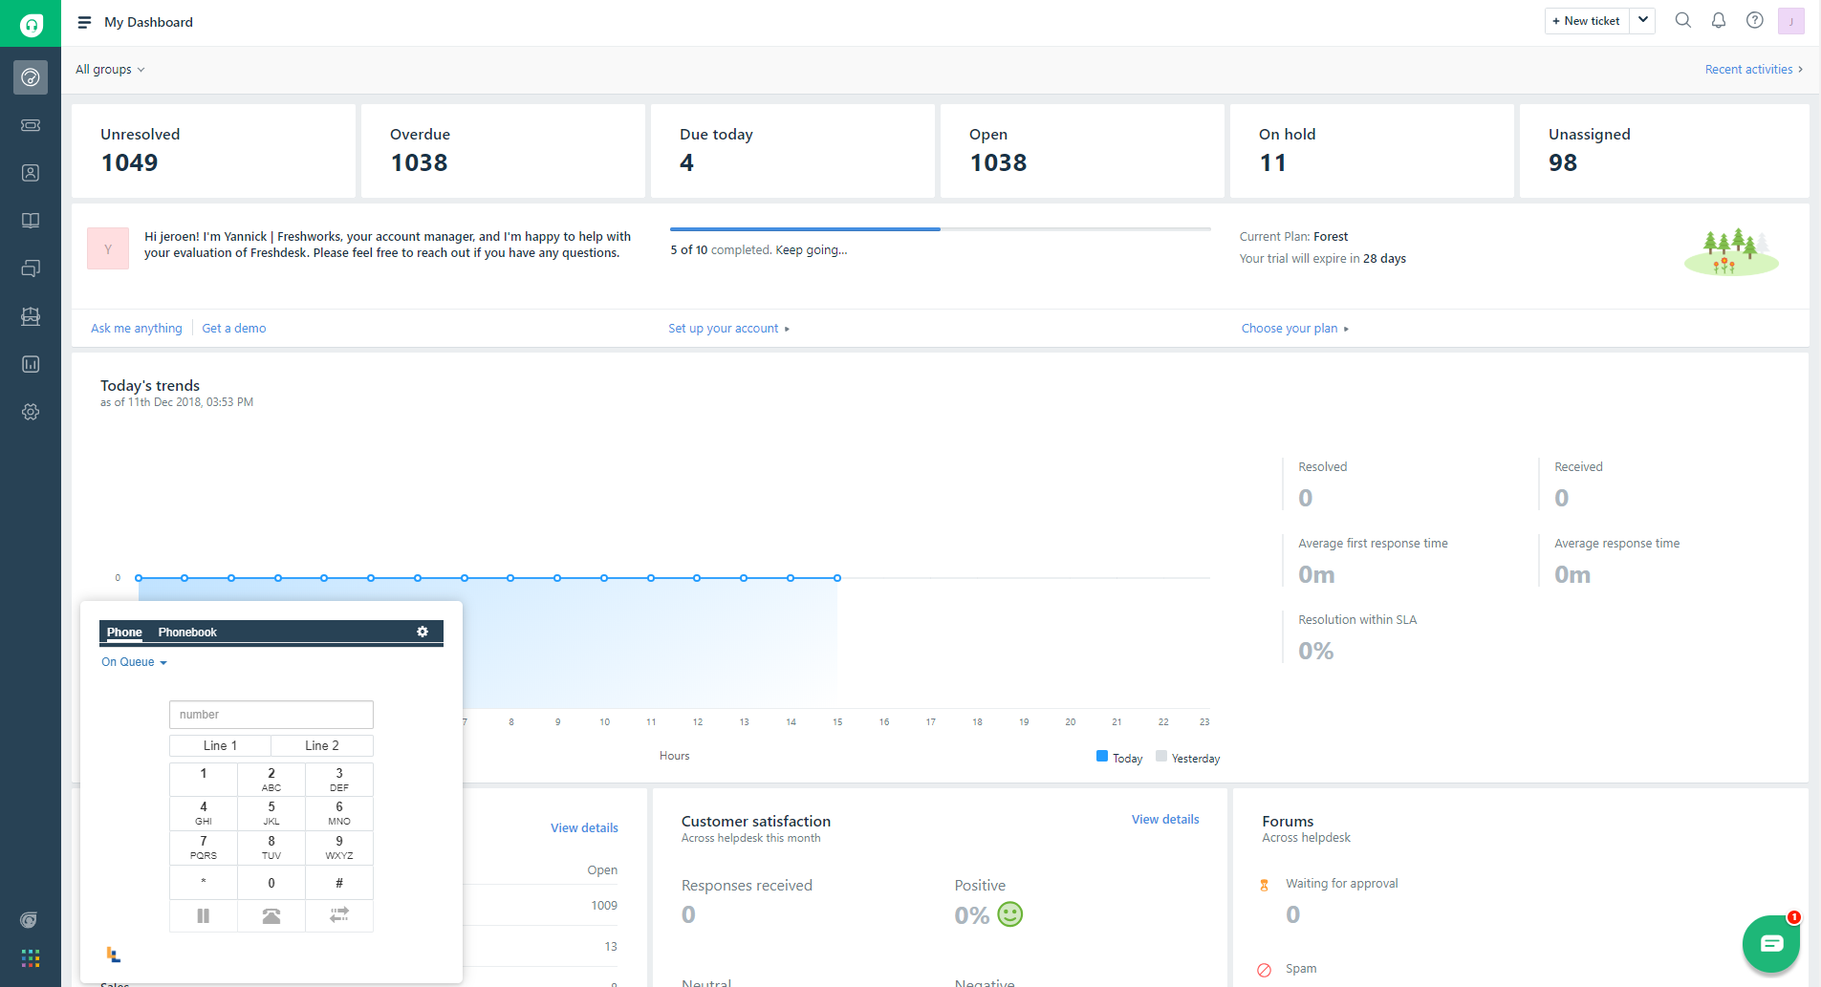

Location of the app
The call control app is available in Freshdesk from the app window. As shown in the screenshot above this will be at the bottom left corner of Freshdesk.

Supported Actions
The following actions are supported by the app. Please take note that some functionalities are dependent on the configuration of the Five9 configuration.
- Change your Five9 presence to “available”, “not available” etc.
- Answering a call
- Ending a call
- Rejecting a call
- Putting a call on hold
- Transferring a call directly
- Transferring a call after consulting
- Call outbound
- Choosing an outbound number (also known as CLID)
- Searching an agent’s number in the telephone book and calling them
- Display contact search results from Freshdesk based on the caller’s number inside the app
- Display the contact in the Freshdesk page to view all details
- Create a new contact if there are no search results
- Display all recent tickets for the selected Freshdesk contact inside the app
- Display the ticket in the Freshdesk page to view all details
- Create a new ticket or append text to an existing ticket
- After ending a conversation, you can select a wrap-up code
- Update your settings

Ticket creation flow
There are two ticket creation flows that can be enabled:
- The agent is allowed to create a ticket or append to a ticket during the call.
- The agent has to create a ticket or append to a ticket after the call is ended.
Which flow is active depends on the Freshdesk app setting called “Only allow ticket create/append after call is dispersed”. Contact a Freshdesk administrator if this needs to be changed.
Regardless of the selected flow, the agent is only allowed to create 1 ticket per call by using the app.

Notes
During the call you can type your notes in the Notes tab of the app. You can later convert these notes to a new or existing ticket.

User guide
This chapter explains how to perform the actions in the Five9 app. These descriptions will be clarified with the support of illustrations.
Except for chapter: ’6.2 Checking and changing your agent settings’, all descriptions will be based on the assumption that the user is already logged into Freshdesk and Five9.

Important notes

Requirements for using the app
When you use the Five9 application as voice device you must have an active Five9 session running in your browser. The reason for this is that the app is not a voice device. Therefor the Five9 application will need to be active in order to play audio for incoming calls and to handle the audio for the voice channel.

Use only the app for call handling
When using the app, it is very important that from here on out the agent never answers the call with either the connected physical phone device or Five9 application. Although it is probable this will work the app has been developed and tested to be used as a primary call control application. All phone related actions must be handled from within the app. Not doing this might result in missing data and errors on both the Freshdesk and Five9 side of the integration.
If this is done accidentally make sure to refresh your browser using ‘ctrl + f5’ after the call is finished. This must be done to make sure that starting from the next call the app will work correctly again.

App settings
After installing the app you can go to the apps page and click on the “settings” button (cogwheel) to fill out your app info.
The following settings are available:
Setting | Description
Freshdesk Domain | Your full Freshdesk domain.
API Key | This is your Freshdesk API key. You can find this on your Freshdesk “Profile settings” page,
Call ID Field | The app can save the Five9 Call ID to a custom ticket field when a ticket has been created. You can specify the ticket field here.

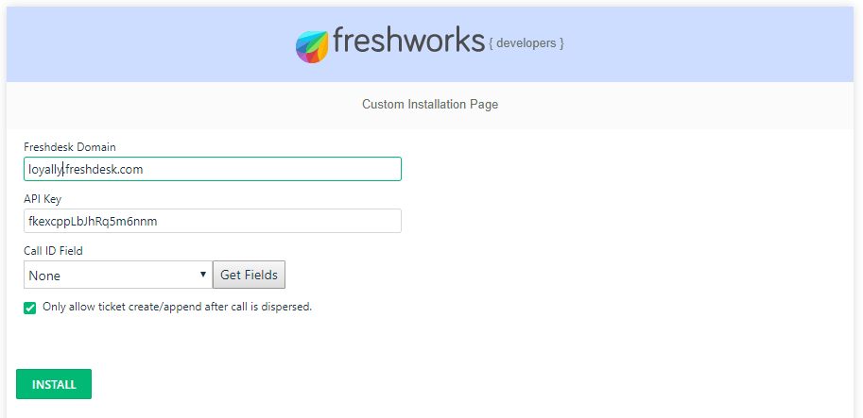

Login procedure
After you have logged into Freshdesk you should already see the app icon on the bottom left. It looks like this:

Make sure you are logged into the Five9 Agent Desktop Plus before making use of the app. If this is not the case please login to Five9 and then reload the Freshdesk page. The app should detect that you are now logged into Five9 in another browser tab and it makes us of that session.

Checking and changing your agent settings
To get to the settings panel open the app in Freshdesk and click on the cog-wheel icon in the top right of the call control.
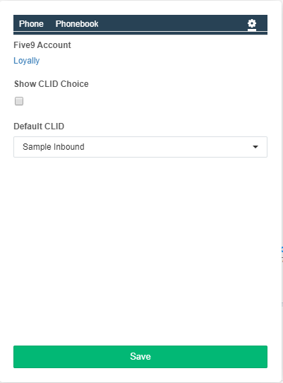
Figure B.1
The following settings are available:
Setting | Description
Show CLID choice | When enabled the app will present a list of possible CLID’s values when you place an outbound call. The CLID list contains values that correspond to the queues that are set up in Five9.
Default CLID | If you do not want to manually select a CLID each time you place an outbound call you can specify a default CLID.

Using the phonebook
The Phonebook tab enables you to search Five9 agents and groups by name or email. A red or green horn indicates the hook status of the result. Selecting a result will automatically paste the phone number into the number input.

Answering a call
As soon as a call is offered to an agent, the app will maximize and the so-called "queue" of the call will be shown. In this case "Sales queue". If configured in Five9 you will also see the IVR language selection.
At that moment the call can be answered by clicking on the green phone icon. Figure C.1.
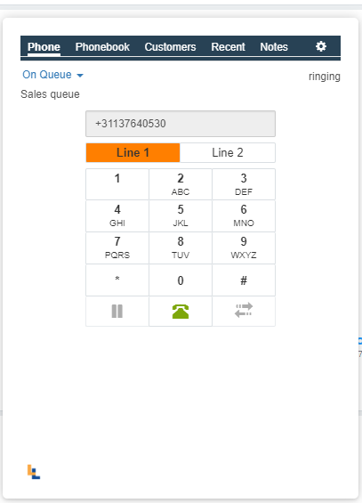
Figure C.1
After answering a call, the application will look like Figure C.2.
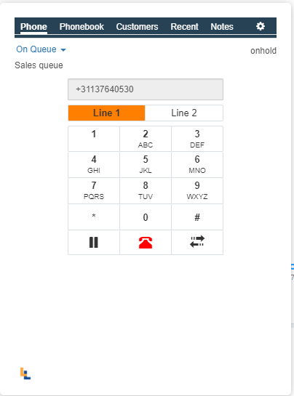
Figure C.2

Customer search results
When an inbound or outbound call takes place the app automatically looks up the Freshdesk contact by using the phone number.
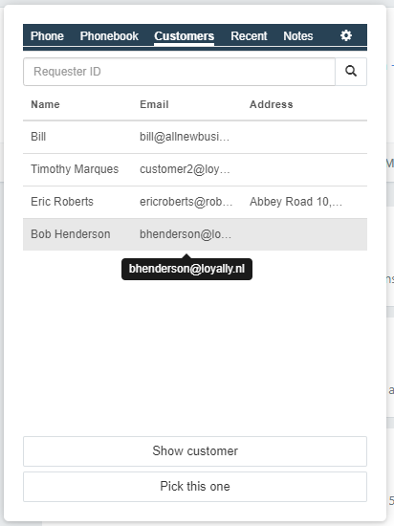
Figure C.3
The lookup has to matched 100% with the “phone” or “mobile” field of the Freshdesk contact. Search results are visible on the Customers tab of the app. See figure C.3.
You can click on one of the results which will highlight it and enable the “Show customer” and “Pick this one” buttons. Clicking the “Show customer” button will display the contact in a new browser tab or window. Clicking the “Pick this one” button will do several things:
- Display a checkmark icon next to the item
- Remember that when creating a new ticket via the app it should be related to this contact.
- Load the Recent tab with all of the contacts tickets.
Beside the automatic lookup you can also search for a contact by entering the requester ID and clicking on the button with the looking glass.
If there are no search results you can create a new Freshdesk contact by clicking on the “New contact” button. This will present a form that you can use to quickly create a new Freshdesk contact.
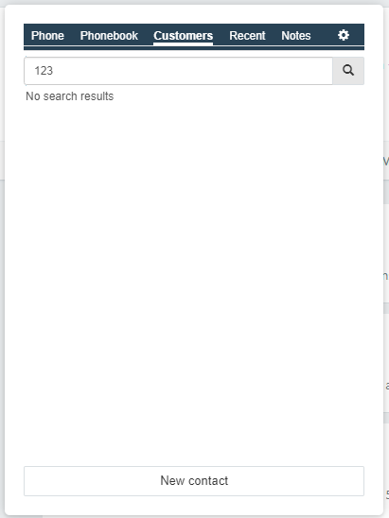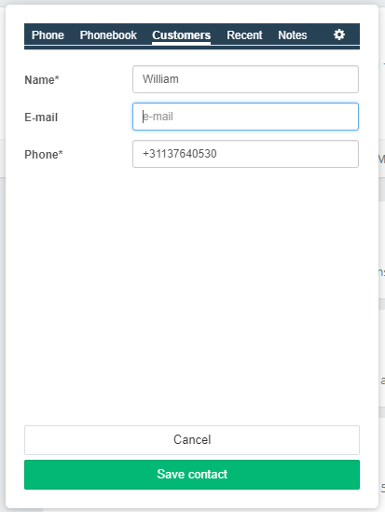
Figure C.4

Recent tickets
After clicking on a Customer search result and selecting the “Pick this one” button in the Customer tab, the Recent tab will load all of the tickets that are related to that Freshdesk contact.
You can click one a ticket which will open a new browser tab or window displaying the ticket in Freshdesk. You can also manually search for tickets by providing a ticket ID or the e-mail address of a known Freshdesk contact and clicking on the button with the looking glass icon.
Figure C.5 displays an example of the Recent tab containing several tickets.
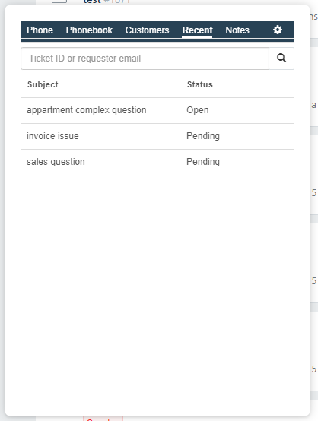
Figure C.5

Ending a call
After a call has been accepted, it is possible to end the call at any time by clicking on the red phone icon. See Figure C.2
Once the call has ended you have to select one of the Register options: create ticket / append to existing ticket / do not convert to ticket.
After doing so the application will display a screen where a wrap-up code can be chosen.

Choosing a register option
After the call is ended you will automatically see the Register tab. In this tab you can type your notes (during the call). When you are done with the notes you can click on the arrow on the right side of the green button in order to select one of the register options. See figure C.6.
We will discuss each option in this paragraph.

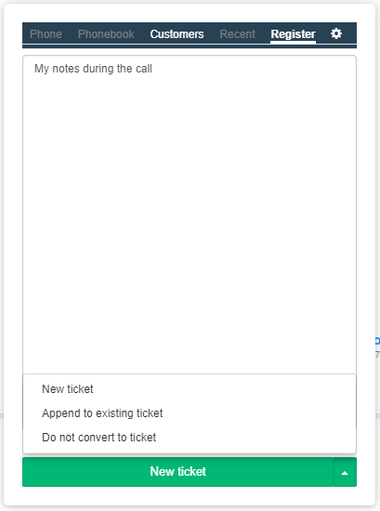
Figure C.6

New ticket
The new ticket option presents you with a ticket form. All fields marked with an “*” are mandatory.
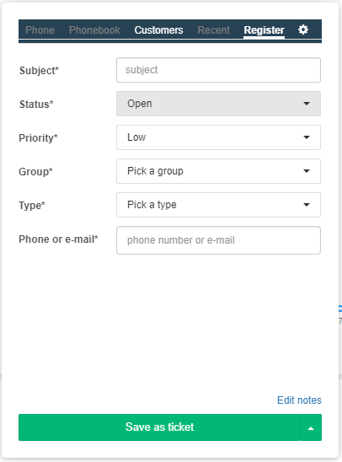
Figure C.7
If the “Phone or email” field is marked as mandatory this means you did not use the “Pick this one” button in de Customers tab. You can still do this in the Register phase.
You can click on the “Edit notes” link to switch back to your notes if you need to make any changes. You can then click on the “Ticket form” link if you want to switch back to the ticket form.
To save the ticket you need to click on the “Save as ticket” button. You will receive a notification including the created ticket ID. You can now proceed with choosing a wrap-up code.

Append to existing ticket
Choose this option if you want to append your notes to an already existing ticket. This could be the case if a customer calls about a ticket that already exists.

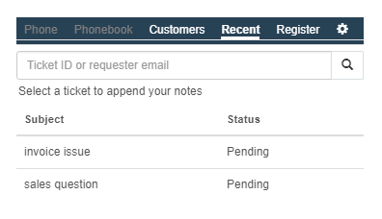
Figure C.8

After you have selected the “Append to existing ticket option” from the green dropdown button the Recent tab will be displayed. See figure C.8.
You have to select an existing ticket to indicate to which ticket the notes need to be appended. The Recent tab will only contain tickets if you selected a customer on the Customer tab by clicking on the “Pick this one” button or if you manually searched on a ticket ID or requester e-mail in the Recent tab.
After clicking on a ticket, the Register tab will be shown again. You can finish up you notes and save them by clicking on the green “Append to existing ticket” button, See figure C.9.
You can now proceed with choosing a wrap-up code.
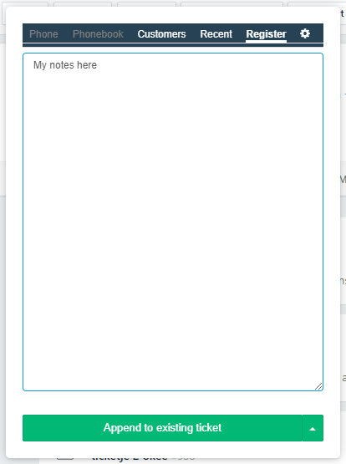
Figure C.9

Do not convert to ticket
Choose this option if you do not want to register your notes. You can now proceed with choosing a wrap-up code.

Choosing a wrap-up code
Active after the call has been dispersed and the Register flow is completed. You have to select a wrap-up code so that the Five9 platform can store this for reporting and analyses purposes. Depending on the current queue different wrap-up codes may be presented to you.
Wrap-up codes are only relevant when the previous call was with a customer. Calls from agent to agent do not need a wrap-up codes selection and thus will not be shown to you in the app.
After the wrap-up code is selected followed by clicking on the “Finish wrap-up” button the flow has ended. The app will now be minimized again.
See figure C.10 to view the wrap-up view in the Register tab.
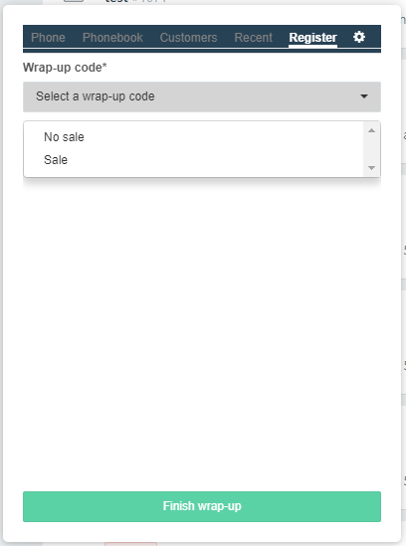
Figure C.10

Putting a call on-hold or taking it back
As soon as a call has been answered, you can put the caller on and off hold. You do this by using the pause button. The pause button changes color (white or gray) to indicate that someone is / is not on hold.

Transferring a call
You can transfer an already accepted call to another agent. This can be done in two ways:
- Cold transfer: You immediately transfer the caller without first consulting the other agent.
- Conference: You consult the other agent first and then you connect the caller.

Initiate transfer mode
To the customer directly you must first put the customer on hold so that you can look up and select the number of the agent or queue yourself.
Once the customer is on hold, click on the transfer button (icon with two arrows) after which you will see the Transfer options menu (figure C.11)
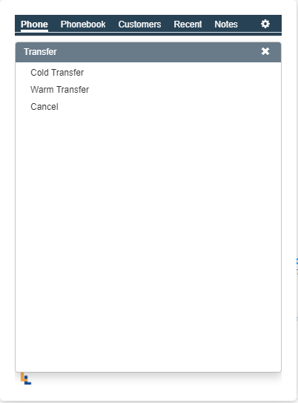
Figure C.11

Cold transfer
Once you are in the initial Transfer menu (figure C.11) you can click on “Cold transfer”.
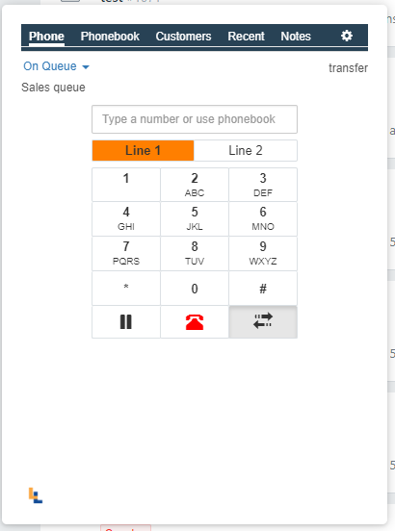
Figure C.12
Now you see the Phone tab indicating you can either type a number or lookup a number that you want to transfer to (Figure C.12). After a number has been entered or selected by using the phonebook you can click on the green phone button to transfer the caller. The app will return to its initial state after the call is transferred.

Warm transfer
Once you are in the initial Transfer menu (figure C.11) you can click on “Warm transfer”.
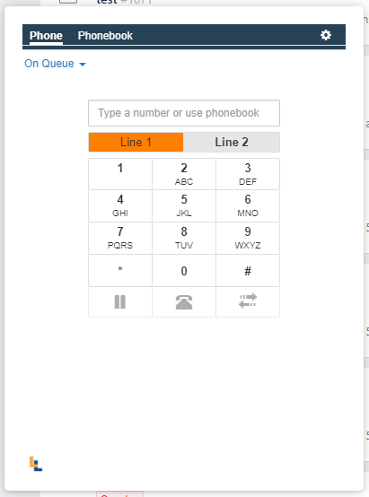
Figure C.10
Figure C.13 indicates that you want to dial someone on Line 2 by making the “Line 2” button bold and by showing the text “Type a number or use phonebook” in the number input field.
To call the number that was entered, click on the green phone icon. Once you are connected you can speak with the person you want to transfer to before actually doing so.
Once you are ready to transfer the caller to Line 2 you can click on Line 1 and click on the transfer button. The transfer menu will appear and you will have the option to “Patch through” the call to Line 2 or to Cancel the transfer. See figure C.11
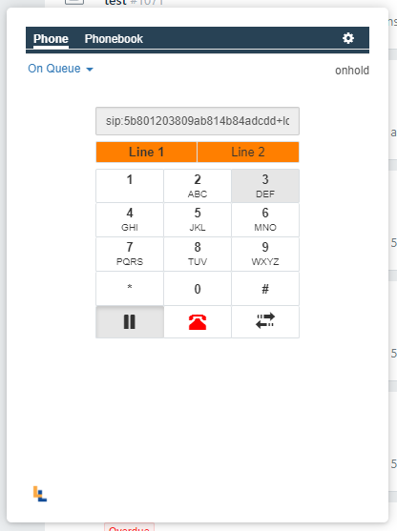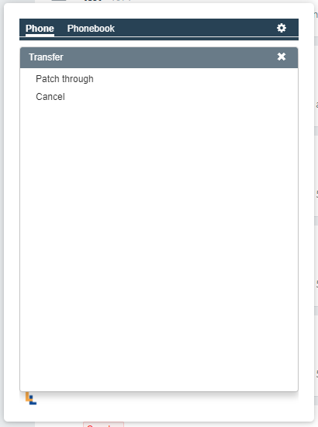
Figure C.11

Call manually
If you want to start a call to a manually dialed telephone number, you can do this by using the numerical keys on your keyboard or by using the phonebook if you need to call a fellow agent. You can input the number and click on the green phone button to start calling.

Choosing an outbound number (CLID)
Before you start an outbound call, you can choose an outbound number if the setting is enabled. For more information on this setting see paragraph “Checking and changing you agent settings”.
If you have inputted a phone number and click on the green phone button a CLID menu will appear to enable you to call with a specific Calling line identification. A dropdown list will be shown containing the available items.

Changing the agent’s work status
From the app it is possible to change you agent presence. Changing you agent presence will have impact on whether or not you will receive certain calls. For instance, calls that are routed to a queue will only be offered to you if you have set your presence to “On queue”. You can change your agent presence by clicking on the presence text in the upper left corner of the app and selecting an item from the list.
If you change your presence in the Five9 application it will be reflected on the app and vice versa.

