BARTLETT CELLO MIC
QUICKSTART GUIDE
Mounting

1. Squeeze the foam block between two strings under the bridge. The mic should “float” between the strings and cello body. Experiment with mic placement to vary the tone.
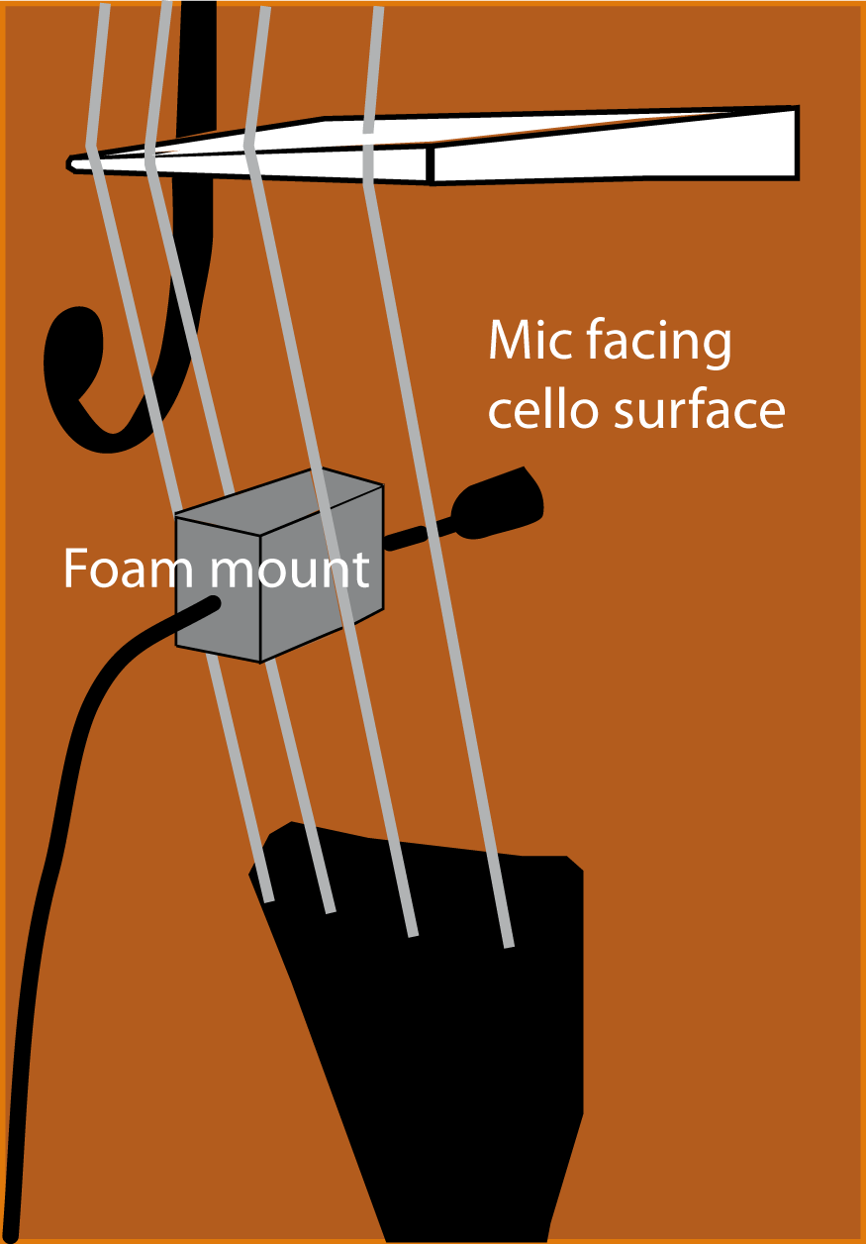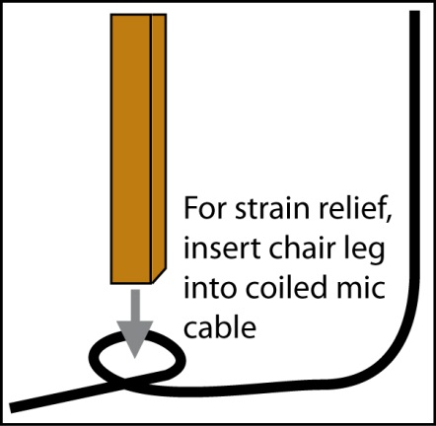

Operation
1. If your mixer or instrument amp has phantom power, plug the mic connector into a mic cable that is connected to a mixer mic input or amp mic input.

2. If your mixer or instrument amp does not have phantom power, plug the mic connector into a phantom power supply. Then connect the phantom supply output to a mixer mic input or instrument amp mic input.

3. If you are using an instrument amp, place it several feet behind you and slightly to the side to block feedback into the mic. Also, aim your cello slightly away from any floor monitor speaker.

4. After plugging in the mic, turn on phantom power.
5. The microphone is very sensitive or “hot”. Be sure to turn down the input gain trim on your mixer as needed to prevent mixer distortion and feedback. If you hear distortion when using an amp, insert a mic attenuator between the mic's XLR connector and the amp input. Example: Pearstone IMA-1030.

Complete specifications are at www.bartlettaudio.com. For free tech support, email info@bartlettaudio.com.

