

INSTRUCTION MANUAL
FOR
DISPLAY COOLER

Model No.: C-02RM

Please read this manual carefully, and make sure to keep this manual in the place accessible by the user at any time

MADE IN CHINA

Warning
- This appliance can be used by children aged from 8 years and above and persons with reduced physical, sensory or mental capabilities or lack of experience and knowledge if they have been given supervision or instruction concerning use of the appliance in a safe way and understand the hazards involved
- Children shall not play with the appliance
- Cleaning and user maintenance shall not be made by children without supervision
- -The instructions concerning persons (including children) with reduced physical, sensory or mental capabilities, or lack of experience and knowledge and children playing with the appliance are not required.
- - Do not store explosive substances such as aerosol cans with a flammable propellant in this appliance.
- -- Keep ventilation openings, in the appliance enclosure or in the built-in structure, clear of obstruction.
- -- If the supply cord is damaged, it must be replaced by the manufacturer, its service agent or similarly qualified persons in order to avoid a hazard.

1.Structural diagram
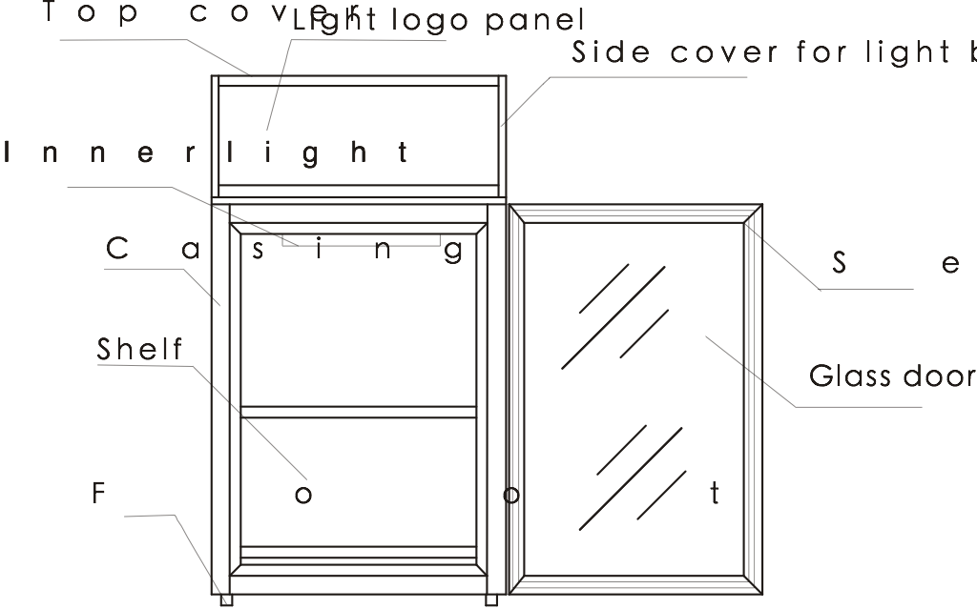
The above picture only for reference, refer to the real product.
2.Specifications
Model name | C-02RM
Climatic Class | N
Anti-shock protection Class | I
Storage Temperature (℃) | 0~10
Capacity (L) | 58
Rated Voltage | AC110-120V/60Hz
Input power | 82W
Refrigerant | R600a
Vesicant | C5H10

The above specifications are subject to improvements.

3. Safety Cautions
1.This unit uses AC220V-240V/50Hz or AC110V-120V/60Hz, there should be a 500va stabilizer if the voltage fluctuation exceed 198V-264V/50Hz or 98V-127V/60Hz respectively.
2.The user should hold the plug when the power is on/ off, dragging or pulling the power cord is prohibited.
3.Do not remove the power cord or plug.
4. Must use dependent socket and reliable ground wire. Ground wire must not connect with the null line of the gas pipe, warm gas pipe, water pipe and must be single power.
5.Never splash water on the unit directly.
6.Keep away from explosive, hazardous goods such as ether, gas, alcohol, bonding agents, gunpowder etc.
7.Keep away from spray of inflammables such as paints, coating materials etc.
8.After the unit is switched off, it should not be restarted within 5 minutes.
9.Do not leave the power cord under any heavy objects including the unit itself.
10.Do not drill holes or install other objects on the casing.
11.This cooler is not suitable for storage pharmaceutical products.
4. Portage and storage
1.Keep the unit vertical when carrying the unit, the angle to the horizontal line should not be over 50 °，otherwise it will damage the compressor and affect normal operation of the unit.
2.The unit should be place on a solid and firm ground, take away the bottom pack to lower the shock and noise.
3.Leave at least 20 cm of distance between the back of the unit and the wall for ventilation and leave a space with an open angle of 160 ° for the door.
4.Keep the unit away from heat sources and avoiding direct sunlight.
5.Never place the unit on a location where water can reach or with high moisture. Splashed water and dirt should be wiped off in time by using a soft cloth.
6.Do not place the unit in the environment cold enough to be iced.
7.Adjust the height with all the four feet adjusted.
5. Preparation
1.Remove the carton and packing foam (including the bottom foam) before using.
2.Clean the unit before using.
3.Adjust the foot to make the unit steady according to the ground condition to lower the noise.
4. After moving the unit, place the unit for 30 minutes before switching it on.
5. Running: close the door and connect the power, turn on the light switch on the casing back. The temperature should be suitable for normal use after half hour.
6.After connecting the power, the unit should be kept empty for one hour.
6. Setting and adjustment of temperature
1.Adjust the storage temperature through the temperature controller which is located on the back of the case (see the picture), adjust the temperature according to the ambient temperature and the foodstuff.
2.See the following picture about the knob scale. The temperature adjustable capacity is from “1”-“5”, adjust the storage temperature by turning the temperature controller clockwise. The “5” shows the lower of the storage temperature. The knob can turn freely but can’t turn clockwise from “5” to“1”. Factory setting position is on “3” position.

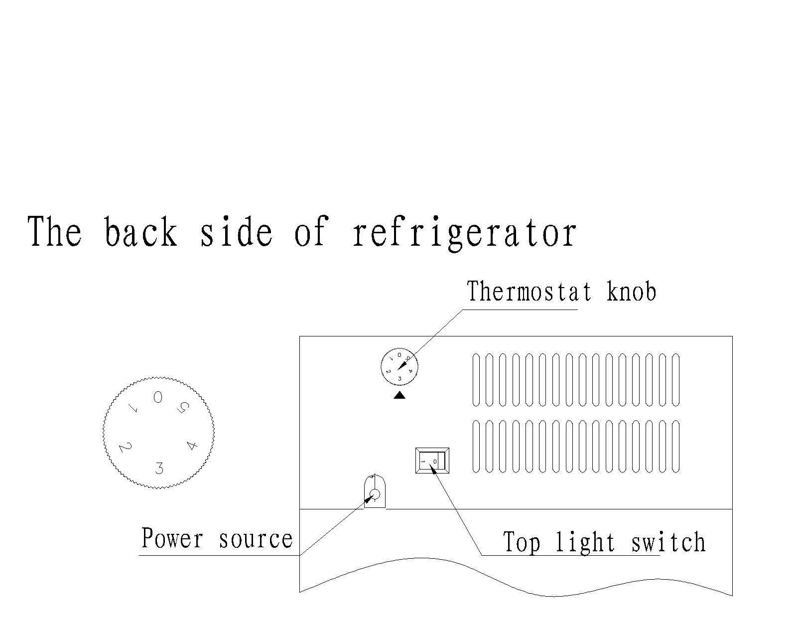
3.Check if the knob is on an appropriate position before using, frequent adjustment is not appropriate when using. Normally in summer, the ambient temperature is high, anti clockwise turn the knob to “5”, while in winter, the ambient temperature is low, clockwise turn the knob to “1”.
4. Position “0” means stop running.
7. Storage of articles
1.Do not put large amount of articles into the unit at one time, you should leave some space around the foodstuff to let cold air inside the cabinet counter to flow. Keep bottled articles away from the walls of interior cabinet so as not to freeze it until broken.
2.Shelves can be adjusted according to different applications
3.Do not put warm food into the unit directly until they are cooled under normal temperature, it will facilitate to lower its energy consumption and prolong service life of the compressor.
8. Maintenance
Disconnect the power supply before maintenance for the machine!
1.Keep the door gasket clean, remove it from the door and wash it. Dry and seal it as before. Putting some talcum powder on the magnetic surface would prolong its service life.

2.Light replacement:remove the top cover, take out the light, replace with a new light, then mount it again.. The power of light is 6W,the Voltage is AC220V/50Hz or AC110V/60Hz, Model : T4
3.If there is heavy frost on the evaporator after long usage, take out the stuff inside the case, disconnect the power, the frost will melt automatically, clean up the water and connect the power again.
4.Use a soft cloth and dip some water or soap (Non-caustic, neutral detergent is also available) to clean the unit. Dry the unit after cleaning to avoid rust.
5.Do not use organic liquid, boiled water, washing powder or acid stuff to clean the unit. Rinsing the case by water is not allowed ; don’t use hard brush, steel brush to clean the case.
6.If the unit will not be used for a long time, disconnect the power, clean it by following the above steps, wipe off the water inside the case with a soft cloth.
9.Caution
1.The unit is not suitable for storage of blood, pharmaceutical products and biological products.
2.Do not place heavy articles on the top of the unit.
3.In case of trouble, please ask professional person for service, do not dismantle the unit without prior authority to avoid hazard.
10.Normal Phenomena
1. Sometime hear light sound of water flowing in the unit, this is the sound of refrigerant flowing inside the pipe.
2. Compressor, condenser and the part of the unit near door is warm or too hot.
3. In a humidity place, there is dew on the casing or the door, it can dry by dry cloth.

11.Troubleshooting guide
problems | Possible cause | Ways to solve problems
The units does not work | Bad connection of plug | Unplug the plug and re-connect the plug to power supply .
Abnormal operation of the compressor or has buzz sound | The power voltage is out of the rated range. | Disconnect the power supply immediately and reconnect with it after normal voltage. It is necessary to have a voltage stabilizer in case of poor power supply.
Compressor operates too long time and no frost on the surface of the evaporator | Refrigeration system is at fault (leakage or blocked) | Send the unit to service department for repair
There is frost or ice on the walls of the inner cabinet and too low internal temperature, the compressor operates never stop. | Thermostat does not work | Ask service department for repair
The internal  temperature is too high and the  compressor operates  never stop | Bad heat dissipation and ventilation of casing, the ambient temperature is too high | Improve ventilation and lower the ambient temperature.
 | Too much warm food was put in at one time | Take out some food
 | Door open frequently and long time door opening | Decrease number and time of door opening.
Too high noise | The unit is not level | Adjust the adjustable feet
 | The fastener of the unit is loose | Fasten the loose  fastener
 | Pipes are touching the compressor | Careful separate the touched pipes
Light is not on | The light is burned out | Replace the light

Warning: Keep ventilation openings, in the appliance enclosure or in the built-in structure, clear of obstruction.
Warning: Do not use mechanical devices, or other means to accelerate the defrosting process.
Warning: Do not use electrical appliances inside the food storage compartments of the appliance.
Caution: Dismantling the unit by non-professional
staff is prohibited, it will cause hazard.

Please keep the products away from the fire or similar glowing substance before you dispose the refrigerator.

REQUESTING ASSISTANCE OR SERVICE
If the problem is not due to one of the items listed in Troubleshooting, Contact the dealer or authorized Service Company.
Correct Disposal of this product：
This marking indicates that this product should not be disposed with other household wastes throughout the EU. To prevent possible harm to the environment or human health from uncontrolled waste disposal, recycle it responsibly to promote the sustainable reuse of material resources. To return your used device, please use the return and collection systems or contact the retailer where the product was purchased. They can take this product for environmental safe recycling.

