NTID Alert System Phase II
User Manual
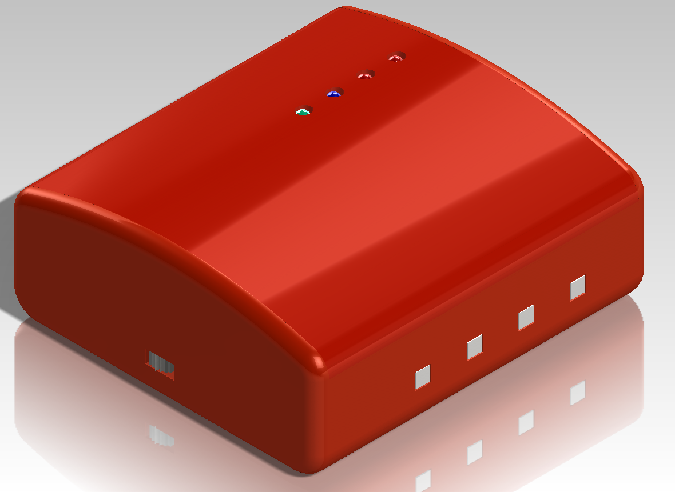

Contents:
- Features
- Setting an Alarm
- Choosing Wake-up Options
- Snooze Settings and Turning Alarm Off
- Indicator Lights/Switches/Jacks
- Battery Backup/Charging

Features:
  - Wake to any combination of light/ shaking options each with their own patterns and intensities to wake even the deepest of sleepers.
  - Easy-to-see high intensity LED alarm lights that reach every corner of your room.
  - Programmable alarm times can all be done through a Bluetooth connection.
  - Easy to understand indicators: Power On, Charging, Bluetooth Connected, and Alarm Set.
  - Travel ready, compact, robust design that can handle everyday use.
  - Long lasting rechargeable battery.
  - Tilt to activate the snooze function.

Setting the Alarm:
- First open the provided ‘Alarm Clock’ software and install it by following the on-screen guidelines.
  - Make sure that your computers clock is the correct time because during the installation process the program synchronizes with the computers clock
- Notice the Current Time in the upper right hand corner is configured to the current time and then directly below it is the Alarm Time box
  - Click on the Alarm Time box and type in the time you’d like your alarm to go off (Notice the AM/PM settings).
- Then to make the final connection hit the ‘Set Alarm’ button and watch for the Bluetooth Connected light and then the Alarm set light should stay lit.

Choosing Wake-Up options:
- Alert Lights only
  - Lights only enabled in software in the ‘Alarm Clock’ software labeled as ‘Alert Lights’.
  - Choose a Low, Medium, or High flashing frequency.
  - Next choose your preferred pattern by altering the ‘Patterns’ section (directly below) to be either pulse, burst pattern or off.
- Bed Shaker
  - Shaker only enabled in software in the ‘Alarm Clock’ software labeled as ‘Shaker’.
  - Check to see if signal box is connected to the main board as well as the 12V AC/DC converter is connected to an outlet.
  - Then choose your preferred pattern by altering the ‘Patterns’ section (bottom) to be either pulse, burst pattern or off.
- Both Alert Lights and Bed Shaker
  - Select ‘Both’ in the ‘Alarm Clock’ software.
  - Ensure shaker is connected as defined above.
  - Then choose your preferred pattern by altering the ‘Patterns’ section (bottom) to be either pulse, burst pattern or off as mentioned above.
Snoozing and Turning Off Alarm:
- Snooze grace period can be changed through the ‘Alarm Clock’ software in the bottom right hand corner.
  - Click on the ‘Snooze Wait Timer’ and change it to your desired snooze time
  - Note: To enable snooze upon alarm activation you need to either:
    - Shake a good couple of times OR
    - Tilt about 45 degrees in the lengthwise direction.
  - Disabling alarm can be simply done by switching the power switch off OR using the ‘Power Off Time’ in the software
    - This is a timer that can be set to turn off the alarm after it has been active for too long.
Indicator Lights/Switches/Jacks:
- Power: Red LED that indicates when the alarm clock is powered
- Charging: Red LED that indicates when the alarm clock is charging from an external device and turns off when the battery is fully charged
- Bluetooth Connected: Blue LED that is active only when the Bluetooth is linked to another device
- Alarm set: Green LED that shows when an alarm has been set and is active
- On/Off switch: Enables and Disables power to the entire alarm clock
- Micro-USB port: Charging port that requires a USB to micro-USB cable where the USB connects to a computer or wall converter
- Shaker Signal Jack: Signal connection to ‘Shaker junction box” for the bed shaker
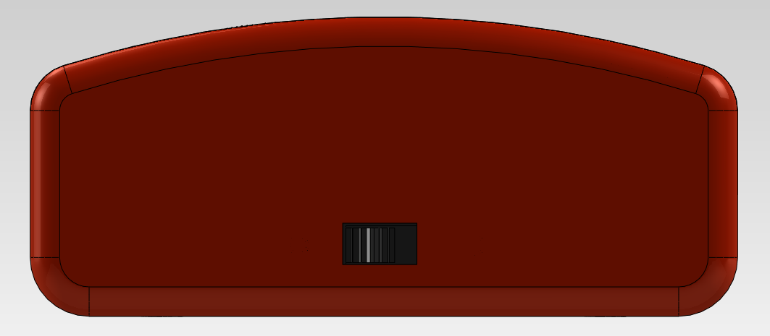

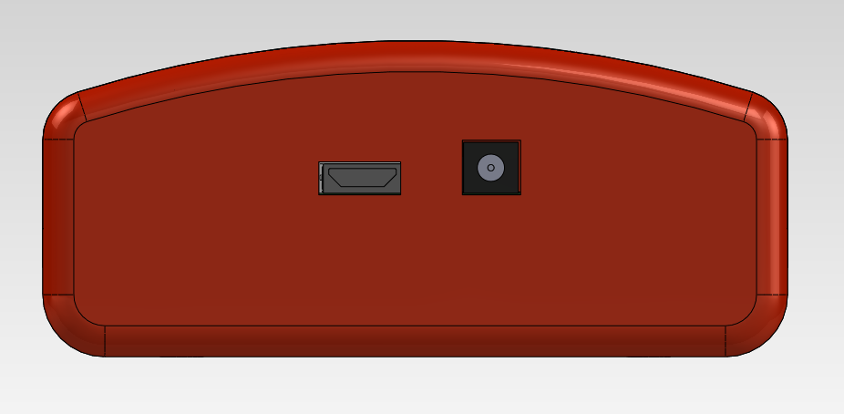
On/Off Switch
Micro-USB port
Shaker Signal Jack

Bluetooth Connected
Power
Alarm set
Charging
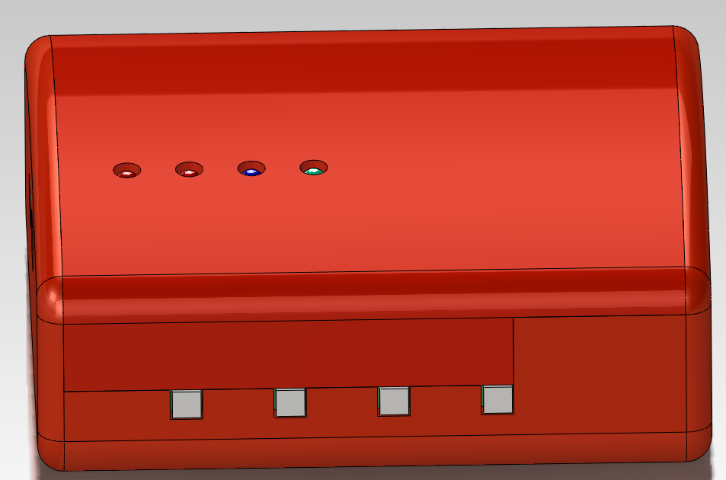
Alert LEDs

Battery Backup/Charging:
- If the power light does not turn on when the On/Off switch is in the On position then the alarm clock needs to be charged
- To charge the alarm clock a Micro-USB to USB adapter is needed to plug the alarm clock into a computer or USB wall adapter
  - Charging indicator light turns on while charging and will go of when battery is done charging

