

TTA360

User Guide for Requesters
October 2020

Table of Contents
1. Introduction 3
1.1 About This Guide 3
1.2 About TTA360 3
2. Getting Started 4
2.1 Create an Account 4
2.2 Log In and Log Out of TTA360 (Existing Users) 8
2.3 Reset Forgotten Password 10
3. Account Management 12
3.1 Update Your TTA360 User Account Profile 12
4. Working With TTA Requests in TTA360 13
4.1 Submit a TTA Request 13
4.2 View and Edit Existing TTA Requests 15
4.2.1 View a TTA Request 15
4.2.2 Edit an Existing TTA Request 16
4.2.3 TTA Request Status Types 18
5. Next Steps 19

List of Tables
Table 1 – Create an Account 4
Table 2 - Log In and Log Out of TTA360 8
Table 3 - Reset Forgotten Password 10
Table 4 - Update Your TTA360 User Account Profile 12
Table 5 - Submit a TTA Request 13
Table 6 - View a TTA Request 15
Table 7 - Edit an Existing TTA Request 16
Table 8 - TTA Request Status Types 18

Introduction

About This Guide
The purpose of this guide is to provide step-by-step instructions for how to use the Training and Technical Assistance System (“TTA360”) to request training and technical assistance (TTA). Individuals, who wish to submit requests for services and need instructions for navigating TTA360 to initiate requests and monitor the progress of submitted requests, should refer to this guide.

About TTA360
TTA360 is a centralized system used to track, monitor, manage, and report on TTA requests and services. All of the Office of Juvenile Justice and Delinquency Prevention (OJJDP) TTA providers use TTA360, which provides a single point of entry for requesters to access the full range of OJJDP’s TTA services.

Getting Started
First-time users must create an account in order to access the system.

Note: As you use TTA360, please keep in mind that your session will timeout anytime there is no activity for 15 consecutive minutes. No activity means that you have not clicked on any action buttons or hyperlinks, navigated to different pages within the application, nor refreshed the page within the last 15 minutes.

Create an Account
Follow the steps below to create a new user account in the TTA360 system.

Table 1 – Create an Account
Step | Action
1 | Go to https://tta360.ojjdp.ojp.gov.  The main TTA360 page appears.  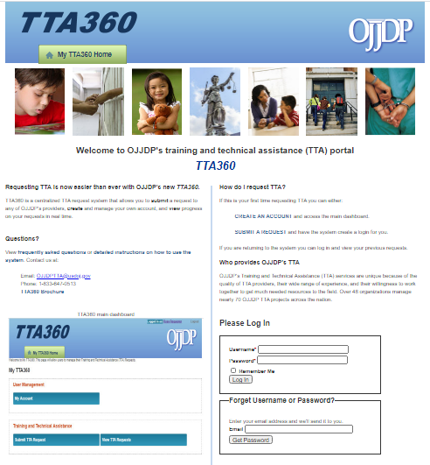
2 | Click CREATE AN ACCOUNT.  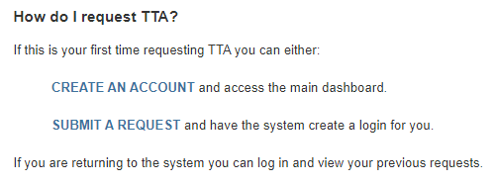  The User Registration page appears.  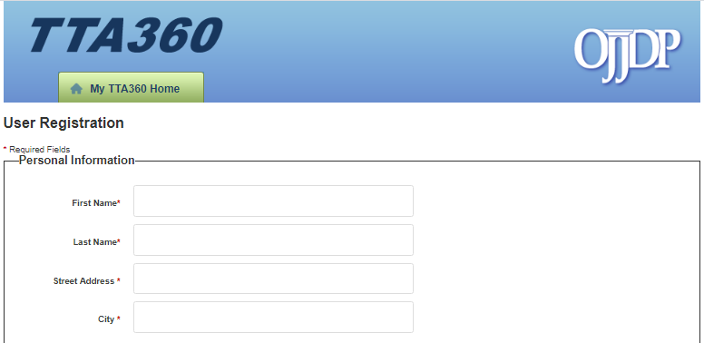
3 | Complete the following sections in the User Registration page:  - Personal Information  - First Name  - Last Name  - Street address  - City  - State  - Zip Code  - County (optional)  - Country  - Tribe (optional)  - Phone  - Email address  - Login Information  - Username. Once selected, you may not change your username. Note that your username is not necessarily your email address.  - Password. Your TTA360 password must contain at least 12 characters consisting of at last one upper case letter, at least one lower case letter, at least one number and, at least one special character.  - Organization Information  - Organization name  - Organization type  - Your title  - Your OJJDP contact (if known)
4 | Where prompted to identify your role in the context of TTA360, select Requester.  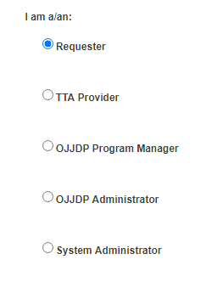
5 | Review your information for correctness and then click Register, at the bottom of the page.    Note: The system sends confirmation of your registration to the email address you entered in Step 3.

Log In and Log Out of TTA360 (Existing Users)
After you have created your TTA360 user account, you may log in again at any time using the username and password you created. Follow the steps below to log in to TTA360.

Table 2 - Log In and Log Out of TTA360
Step | Action
1 | Go to https://tta360.ojjdp.ojp.gov.  The main TTA360 page appears.
2 | At the Please Log In prompt, type your username and password into the fields, and click Log In.  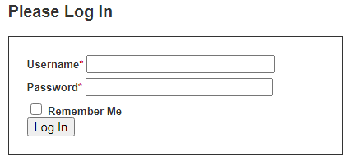  Note: If you have not logged in to your TTA360 account in over 90 days, your account will be set to an inactive state. In that event, contact the service desk at ojjdptta@usdoj.gov for log in assistance.
3 | When you have completed your work in TTA360, be sure to click Log Out.  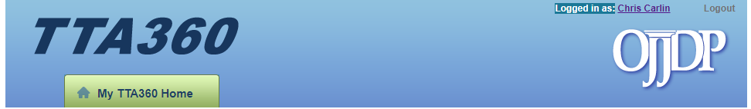

Reset Forgotten Password
If you have forgotten your password, you may request that the system send you a new, temporary password. Follow the steps below.
Note: if you know your current password and want to change it yourself, please refer to Account Management, Update Your TTA360 User Account Profile section of this user guide for instructions.

Table 3 - Reset Forgotten Password
Step | Action
1 | Go to https://tta360.ojjdp.ojp.gov.  The main TTA360 page appears.
2 | Under Forget Username or Password?, type the email address associated with your TTA360 account and click Get Password.  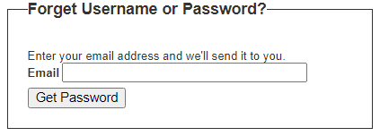
3 | You will receive an email with your TTA360 username and a temporary password, which you may then use to log in. Then you will be required to reset your password to a new one.  Note: Using this option will always force reset your password. If you only want to know your username and not have your password reset, please send an email to ojjdptta@usdoj.gov.

Account Management
The Account Management section of the dashboard is where you can update the details of your account profile.

Update Your TTA360 User Account Profile
Follow the steps below if you want to update any of your TTA360 user account profile information, including changing your password.

Table 4 - Update Your TTA360 User Account Profile
Step | Action
1 | From the My TTA360 home page, click on My Account to see your account information.  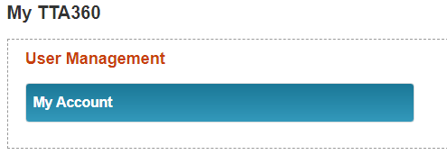
2 | Review the information and make changes, if needed. Click Update, located at the very bottom of the page.  Note: The system will apply your updates immediately after you click Update.

Working With TTA Requests in TTA360
This section describes how to submit new TTA requests, and how to track the status of existing TTA requests, using the TTA360 system.

Submit a TTA Request
The steps below describe how to submit a new TTA request.

Table 5 - Submit a TTA Request
Step | Action
1 | On the My TTA360 Home page, under Training and Technical Assistance, click Submit TTA Request.  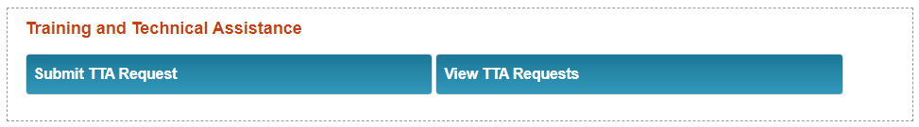
2 | A section entitled Requester Information appears. Select Yes or No for the question, “Current OJJDP Grantee?”  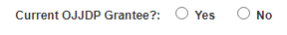  Note: You may not edit any of the other details in the Requester Information section. If you wish to update these details, return to the My Account area of TTA360.
3 | Enter the details of your request. Required fields are labeled with an asterisk (*), and sub-categories must be selected for every category chosen (sub-categories must be selected for Type of TTA and Request Topics).  Note: If attaching a file, complete Steps 4 and 5. If not attached a file, skip to Step 6.
4 | To attach a file, click Attach File, located at the bottom of the page.  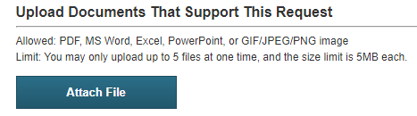
5 | Click Choose File and select the file you wish to attach.  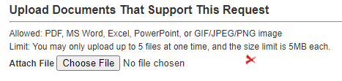  Note: File size may not exceed 5MB.
6 | Click Save As Draft if you wish to submit your request later. Otherwise, click Submit to send your request immediately.    Note: The system will not allow you to Save As Draft until you have at least entered a value for each required field. Required fields are marked with an asterisk (*).

View and Edit Existing TTA Requests
Once you have submitted a TTA request in TTA360, you may view it again. If needed, you may also edit any request up until the point that it has been assigned to a provider.

View a TTA Request
To review a previously created TTA request, follow the steps below.

Table 6 - View a TTA Request
Step | Action
1 | On the home page, under Training and Technical Assistance, click on View TTA Requests.
2 | Depending on the status of the request you would like to view, click on the Drafts or Submitted Requests tab.  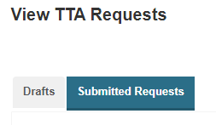
3 | Use the search filters, if needed, to narrow search results. Once you have selected the desired filters, click Find.  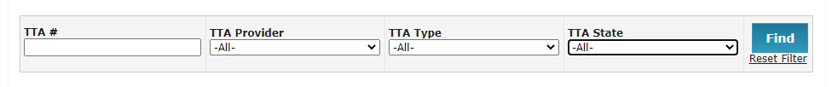
4 | Locate the Request record you want to review and click View.  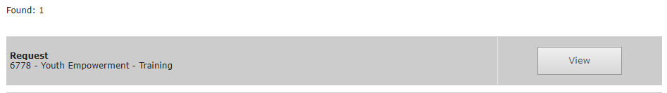

Edit an Existing TTA Request
You may make edits to Requests that have not yet been assigned to a Provider. The table below outlines the steps of this process.

Table 7 - Edit an Existing TTA Request
Step | Action
1 | On the home page, under Training and Technical Assistance, click on View TTA Requests.
2 | Depending on the status of the Request you would like to edit, click either on the Drafts or Submitted Requests tab.
3 | Use the search filters, if needed, to narrow your search results. Then click Find.
4 | Locate the Request record you want to review and click View.
5 | Click the Edit TTA Request Information button displayed next to the record you want to edit. Make changes to the record.  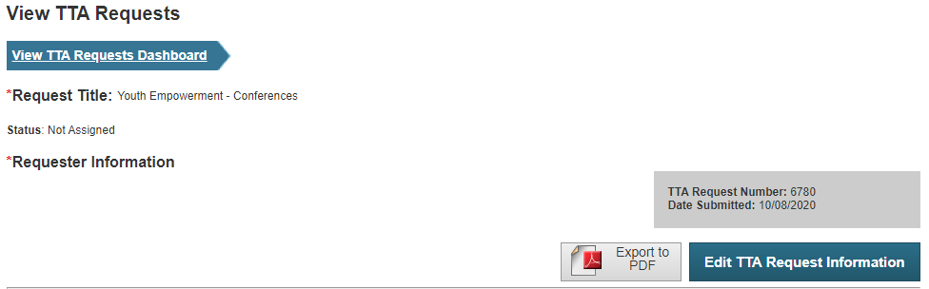
6 | If the Request you have updated is a Draft, you may choose to Save As Draft or Submit.  If the Request you have updated was Submitted previously, you may choose to Save your updates.  

TTA Request Status Types
At any point in time, a TTA request record will be in one of six (6) possible statuses. The table below provides a description of each status.

Table 8 - TTA Request Status Types
Status | Description
Draft | The requester has initiated, but not submitted, the request.
Assigned – Not Accepted | OJJDP has assigned a provider to fulfill the request, but the provider has not yet accepted the request.
In Progress | A provider has accepted the request and fulfillment is in progress.
Closed – Satisfied | The training or technical assistance has been successfully delivered.
Closed – Other | The request was not successfully fulfilled. View the request record in TTA360 for details.
On Hold | The request has been put on hold.

Next Steps
Once you have submitted your request, you will receive a confirmation email from ojjdptta@usdoj.gov. If you have not received the confirmation notice within five (5) business days, please send an email to ojjdptta@usdoj.gov.

Still have questions about using TTA360? Contact the OJJDP TTA360 Help Desk at ojjdptta@usdoj.gov.

