
PNI Escort HP 8000L
CB radio / Statie radio CB / CB Rádió-adó-vevő / Radio CB / Radio CB
User manual / Ръководство за употреба / Benutzerhandbuch / Manual de usuario / Manuel utilisateur
Használati utasítás / Manuale d’uso / Instrukcja obsługi / Manual de utilizare
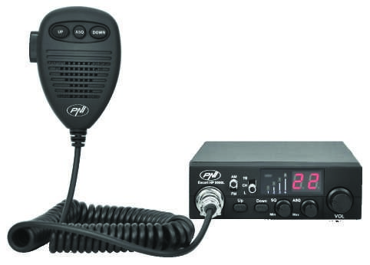
EN
BG
DE
ES FR
HU
IT
PL
RO
User manual ............................................. 2
Ръководство за употреба ......................, 8
Benutzerhandbuch ................................... 14
Manual de usuario .................................... 20
Manuel utilisateur ..................................... 25
Használati utasítás ................................... 31 Manuale utente ........................................ 37
Instrukcja obsługi ..................................... 43
Manual de utilizare ................................... 49
EN
WARNINGS
Please read the following precautions to prevent fire, personal injury or the radio destruction.
Do not attempt to adjust the radio while driving; is dangerous.
This radio is designed for power supply at 13.8V DC. Do not use a 24V battery to power the radio.
Do not place the station on an excessively dusty, damp or unstable surface.
Do not connect the antenna during transmission, risk of burning or electric shock.
Please keep distance from devices that cause interference (such as TV, generator, etc.)
People who use pacemakers are advised to keep distance from the antenna during transmission and especially not to touch it.
Do not connect metal objects to the internal electrical side; danger of electric shock.
Avoid exposing the radio to temperatures below -30°C and above + 60°C, the temperature on a vehicle may sometimes exceed 80°C, which can cause irreparable damage to electric devices. Do not expose the radio to sunlight.
Do not place anything on the radio, it will prevent it from cooling down.
Check to see if you have enough charged battery to avoid rapid discharge.
It is important to stop the radio before starting the engine, to avoid damage caused by high starting voltage.
You must use a 2A 250V fuse type F. Under no circumstances use a higher value.
If an abnormal odor or smoke is detected as coming from the radio, switch off the appliance immediately.
Do not transmit for a long time, the radio may warm up.
Keep the station away from children.
OTHER WARNING:
Before connecting or using this product, please read these operating instructions carefully. Keep this manual for future reference.
Before using the radio, please connect the antenna, then check the SWR before transmitting. A too high SWR can cause demage to the CB final output transistors, which is not covered by the warranty.
The radio does not includes components that can be repaired by the user. Please contact an authorized service center.
To prevent the risk of fire, use only a suitable power supply.
EN
MAIN CARACTERISTICS:
- 40 FM/AM channels
- FM / AM mode selection switch (AM only works by changing the norm)
- Emergency channel selection switch 9/19
- Key lock switch
- Channel selection UP / DOWN buttons
- Signal level LED
- 2-digit channel number indicator
- Volume and radio start / stop potentiometer
- LED indicators for RX / TX / ASQ
- Microphone with channel selection buttons (up / down) and ASQ activation
- 6-pin microphone jack on the front panel
- External speaker jack
- Manual squelch and adjustable ASQ
TECHNICAL SPECIFICATIONS:
 | Channels 40 |  | 40 AM/FM
 | Frequency band |  | 26.965 – 27.405 MHz
 | Frequency control |  | P.L.L.
 | Operating temperature |  | -26° - +60°C
 | Power supply |  | 13.8Vdc ±15%
 | Dimensions / weight |  | 115 x 36 x 152 mm / 0.8 kg
 | Receiver
 | Intermediate frequency |  | 1° 10.7 MHz / 2° 450 KHz
 | Sensitivity |  | -120dBm / 12dB SINAD (FM)
 |  |  | -107dBm / 12dB SINAD (AM)
 | Audio output |  | @10% THD 2.5W la 8 ohm
 | Audio distortion |  | <8% at 1 KHz
 | Image rejection |  | 65 dB
 | Canal adjacent |  | 85 dB
 | Current consumption |  | 200 mA in stand-by
 | Transmitter
 | Maximum RF power |  | 4W FM at 13.8Vdc
 | Modulation |  | 85% ~ 90% (AM)
 |  |  | 3KHz ±0.2 KHz (FM)
 | Antenna Impedance |  | 50 Ohm
 | Current consumption |  | 2 A
EN
FRONT PANEL DESCRIPTION:
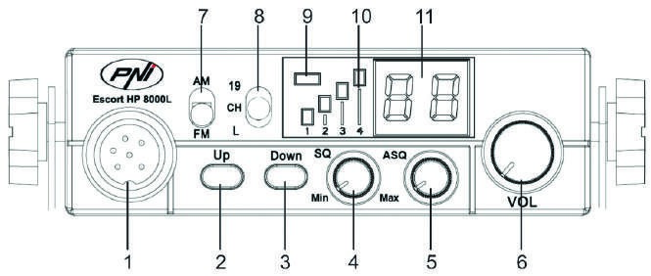
- 6-pin microphone connector
- Increase channel number
- Decrease channel number
- Potentiometer for squelch adjustment – the squelch makes your radio quieter by removing the background noise. Rotate the potentiometer clockwise to reduce the noise or counterclockwise if you want to hear even the weakest signals.
- ASQ Potentiometer – to increase the ASQ level rotate the potentiometer clockwise, in this case it reduces the background noise but also the signal level received.
Tip: turn on the station with ASQ turned left.
- Potentiometer for turing on / off teh radio and for volume adjustment – Turn clockwise to start station and increase volume. If no signal is received, we suggest you to adjust the squelch (by rotating the SQ potentiometer counterclockwise) and then the volume to a comfortable level. When switched on from the volume potentiometer, the radio will store the last channel used.
- AM / FM mode select button
Note: The radio works in AM mode only by changing the standard (details on page 6)
- Multifunctional switch:
- “19“: emergency channel selection
- “CH“: se pot selecta canalele 1~40 (according to the selected standard)
- “L“: key lock
- TX / ASQ LED indicator - During the transmission the LED will be red, and when the ASQ function is activated, the LED will be green.
- Signal level indicator – 4-bar indicator to monitor the power of the received / emitted signals
- LED display – displays the channel number
REAR PANEL DESCRIPTION:
- Antenna jack
ANT
EXT
13.8
VDC
1
2
3
- 13.8VDC power cable
- External speaker jack
EN
MICROPHONE DESCRIPTION:
  - PTT button – Push to Talk
ASQ
DOWN
UP
1
2
3
4
  - Increase channel number
  - Enable / disable ASQ function
  - Decrease channel number
INSTALLATION INSTRUCTIONS:
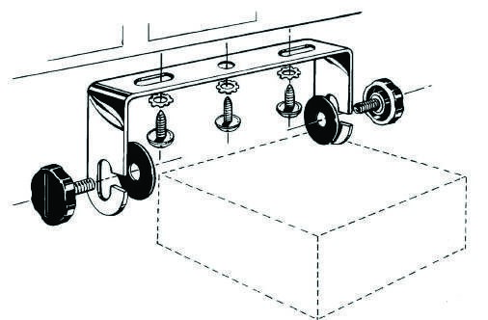
Before installing the radio in your vehicle, choose the most suitable location so you can use it without being disturbed while driving.
To install the radio, use the mounting bracket and accessories in the package. The screws must be securely clamped to avoid vibration of the station while driving. The mounting bracket can be positioned above or below the device and can be tilted depending on the installation mode (under the dashboard or under the truck cabin ceiling).
WARNING: Ensure that the voltage at which the station is powered is the voltage indicated by the manufacturer.
Installation of the central unit:
Before powering the radio, make sure that the power button is fully turned to the left.
The power cord of the station includes a protective fuse on the red wire. Connect the radio's power cable to the car's electrical system paying attention to the polarity (even if the radio has protection against polarity reversal).
Connect the red wire to the positive terminal (+) and the black wire at the negative terminal (-) of the vehicle's electrical system.Check the connections made correctly to prevent them from being disconnected or possibly short-circuiting.
WARNING: Do not replace the fuse with a higher value. The fone from the actory has 2A.
Antenna installation:
To use this radio, you need an antenna that operates at 27.225MHz.
To install the antenna, call a specialist.
Before connecting the antenna to the radio, it is necessary to check it with a specialized device to prevent the transmission circuit failure.

EN
Typically, the antenna should be positioned on the highest side of the vehicle without being obstructed by obstacles and as far from any electrical source or electromagnetic noise. The coaxial cable of the antenna should not be interrupted or pressed. Connect the plug at the end of the coaxial antenna cable to the antenna jack on the rear panel of the radio.
Check the radio:
Once installed and powered from the vehicle's electrical system, do the following to verify its operation:
- Check that the radio is powered correctly
- Check the antenna connection to the radio
- Connect the microphone to the jack on the front panel of the radio
- Turn on the radio by rotating the volume knob clockwise and adjust the volume to the desired level
- Select the desired channel with the UP / DOWN keys on the front panel or on the microphone.
- Press the SQ button in the limit area where the background noise disappears.
Note: If the ASQ mode is enabled (by pressing the ASQ on the microphone) the SQ button can not be activated
- Press the PTT button on the microphone to emit, and release it to receive
- Check the signal level received via the signal bars on the front panel
- Turn the ASQ function on the microphone and adjust its level from the ASQ button on the front panel of the station
USEFUL TIPS:
Do not reverse the polarity when powering the radio.
Do not replace the fuse with a higher value. The fone from the factory has 2A.
Do not emit without an antenna or a broken or not tuned antenna to avoid burning the CB final output transistors. Adjust the SQ and ASQ until the background noise disappears. By turning the SQ knob clockwise too much, you will receive only the strong signals (those emitted nearby).
CHANGING THE STANDARD:
To change the standard in which you are using the CB radio, do the following:
- While holding down the Down and PTT buttons on the microphone, turn on the station
- Use the up and down keys on the station to select the desired setting
- Turn off and then restart the station
To check the current norm do the same procedure.
Available standards:
 | CE | Romania |  |  | 26.9650-27.405 |  | FM 40 CH
 | 9 | Germany |  |  | 26.9650-26.955 |  | AM 40CH / FM 80CH
 | U | UK |  |  | 27.60125-27.99125 |  | FM 40CH
 | A | Russia |  |  | 25.6150-26.055 |  | AM / FM 40CH
 | b | Russia |  |  | 26.0650-26.505 |  | AM / FM 40CH
 | C | Russia |  |  | 26.5150-26.955 |  | AM / FM 40CH
 | d | Italy) |  |  | 26.9650-27.405 |  | AM / FM 40CH
 | E | Spain |  |  | 27.4150-27.855 |  | AM / FM 40CH
 | F | France |  |  | 27.8650-28.305 |  | AM / FM 40CH
 | P | Poland |  |  | 26.9600-27.400 |  | AM / FM 40CH
 | n | Netherlands |  |  | 26.3300-26.770 |  | AM / FM 40CH
 |  |  |  |  |  |  |  |  |  | EN
FREQUENCIES AND LEGAL POWERS IN EUROPE:
 | Band |  | Country | Channels number |  | AM or FM |  | Output power
 | CE (CEPT) |  | Europe | 40 |  | FM |  | 4 Watts (used all over Europe)
 | EU |  | Europe | 40 |  | AM and FM |  | 4 Watts FM, 4 Watt AM
 | UK |  | UK | 40 |  | FM |  | 4 Watts
 | SP |  | Spain | 40 |  | AM and FM |  | 4 Watts
 | I0 |  | Italy | 40 |  | AM and FM |  | 4 Watts
 | I2 |  | Italy | 36 |  | AM and FM |  | 4 Watts
 | FR |  | France | 40 |  | AM and FM |  | 4 Watts FM, 1 Watt AM
 | D2 |  | Germany | 40 FM, 12 AM |  | AM and FM |  | 4 Watts FM, 1 Watt AM
 | DE |  | Germany | 80 FM, 12 AM |  | AM and FM |  | 4 Watts FM, 1 Watt AM
 | PL |  | Poland | 40 |  | AM and FM |  | 4 Watts
 | RU |  | Russia | 400 |  | AM and FM |  | 4 Watts (not allowed in Europe)
 | PO |  | Russia | 400 |  | AM and FM |  | 4 Watts (not allowed in Europe)
CHANNEL SELECTION UK / CE (U-STANDARD)
If "U" has been selected, all 80 channels available for UK can be accessed using the AM / FM switch (EU / UK). In the AM (EU) position, the radio will operate in the FM band 40 FM channels. On the FM (UK) position, the radio will operate in the UK band 40 FM channels.
Note: To access the AM channels in the CE band, choose the CE standard and then switch to the AM using the AM / FM switch.

BG:

Опростена декларация за съответствие на ЕС
SC ONLINESHOP SRL декларира, че CB радио PNI Escort HP 8000L ASQ е в съответствие с Директивата EMC 2014/30 / EU и RED 2014/53 / UE. Пълният текст на ЕС декларацията за съответствие е достъпен на следния интернет адрес: https://www.mypni.eu/products/4390/download/certifications

DE: EU – vereinfachte Konformitätserklärung
SC ONLINESHOP SRL erklärt, dass das CB-Funk PNI Escort HP 8000L ASQ der Richtlinie EMC 2014/30/EU und RED 2014/53/UE entspricht. Sie finden den ganzen Text der EU Konformitätserklärung auf der folgenden Internetadresse: https://www.mypni.eu/products/4390/download/certifications
EN:

EU Simplified Declaration of Conformity
SC ONLINESHOP SRL declares that CB radio PNI Escort HP 8000L ASQ is in compliance with the Directive EMC 2014/30/EU and RED 2014/53/UE. The full text of the EU declaration of conformity is available at the following Internet address: https://www.mypni.eu/products/4390/download/certifications
ES:

Declaración UE de conformidad simplificada
SC ONLINESHOP SRL declara que el CB radio PNI Escort HP 8000L ASQ cumple con la Directiva EMC 2014/30/ EU e RED 2014/53/EU. El texto completo de la declaración de conformidad de la UE está disponible en la siguiente dirección de Internet: https://www.mypni.eu/products/4390/download/certifications
FR:

Déclaration de conformité simplifiée de l'UE
SC ONLINESHOP SRL déclare que la Radio CB PNI Escort HP 8000L ASQ est conforme à la directive EMC 2014/30/EU et RED 2014/53 / UE. Le texte complet de la déclaration de conformité UE est disponible à l'adresse Internet suivante: https://www.mypni.eu/products/4390/download/certifications
HU:

EU közlemény egyszerűsített megfelelés
SC ONLINESHOP SRL kijelenti, hogy a CB rádió PNI Escort HP 8000L ASQ megfelel az EMC 2014/30/EU és RED 2014/53/UE irányelvnek. Az EU-megfelelőségi nyilatkozat teljes szövege a következő internetes címen érhető el: https://www.mypni.eu/products/4390/download/certifications
IT:

Dichiarazione UE di conformità semplificata
SC ONLINESHOP SRL dichiara che il Radio CB PNI Escort HP 8000L ASQ è conforme alla direttiva EMC 2014/30/ UE e alla direttiva RED 2014/53/UE. Il testo completo della dichiarazione di conformità europea è disponibile al seguente indirizzo Internet: https://www.mypni.eu/products/4390/download/certifications
PL:

Uproszczona deklaracja zgodności UE
SC ONLINESHOP SRL oświadcza, że CB radio PNI Escort HP 8000L ASQ jest zgodny z dyrektywą EMC 2014/30/ EU, RED 2014/53/UE. Pełny tekst deklaracji zgodności UE dostępny jest pod następującym adresem internetowym: https://www.mypni.eu/products/4390/download/certifications
RO:

Declaratie UE de conformitate simplificata
SC ONLINESHOP SRL declara ca Statie radio CB PNI Escort HP 8000L ASQ este in conformitate cu Directiva RED 2014/53/UE. Textul integral al declarației UE de conformitate este disponibil la urmatoarea adresa de internet:
https://www.mypni.eu/products/4390/download/certifications

