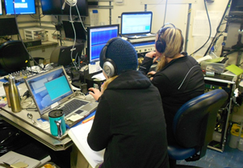
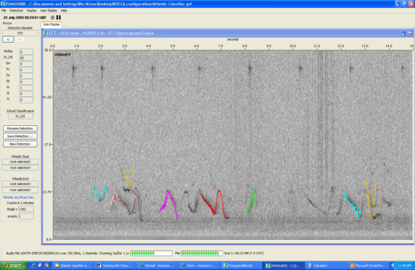
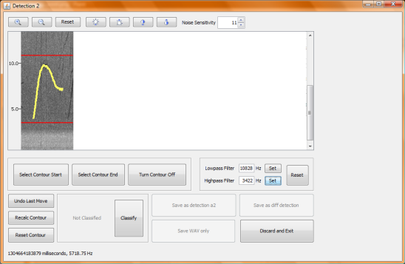
ROCCA (Real-time Odontocete Call Classification Algorithm) User’s Manual
Submitted to:
Naval Facilities Engineering Command Atlantic under
HDR Environmental, Operations and Construction, Inc. Contract No. N62470-10-D-3011, Task Order 03


Prepared By:

J.N. Oswald and M. Oswald
Bio-Waves, Inc.
364 2nd Street, Ste. #3
Encinitas, CA 92024
julie.oswald@bio-waves.net
Phone: (760) 452-2575
Fax: (760) 652-4878

30 September 2013

Suggested Citation:
Oswald, J.N., and M. Oswald. 2013. ROCCA (Real-time Odontocete Call Classification Algorithm) User’s Manual. Submitted to HDR Environmental, Operations and Construction, Inc. Norfolk, Virginia under Contract No. CON005-4394-009, Subproject 164744, Task Order 03, Agreement # 105067. Prepared by Bio-Waves, Inc., Encinitas, California.

J.N. Oswald and M. Oswald
Bio-Waves, Inc.
364 2nd Street, Ste. #3
Encinitas, CA 92024
julie.oswald@bio-waves.net
Phone: (760) 452-2575
Fax: (760) 652-4878

September 30, 2013

Table of Contents
Acronyms and Abbreviations iii
1. OVERVIEW 1
1.1 General Principle of Operation - ROCCA (Semi-Automated Contour Detection and Extraction) 1
1.2 General Principle of Operation WMD & ROCCA (Fully Automated Contour Detection and Extraction) 2
1.3 Systems overview diagram – Setting Up and Configuring ROCCA 4
1.4 Systems overview diagram – Capturing a Whistle 5
1.5 Systems overview diagram – Contour Extraction and Classification 6
2. LOADING SUPPORTING PAMGUARD MODULES 8
3. LOADING AND CONFIGURING ROCCA 10
3.1 Loading ROCCA 10
3.2 Configuring ROCCA 10
3.2.1 Source Data Tab 11
3.2.2 Contour/Classifier Tab 12
3.2.3 Output Tab 13
3.2.4 Filename Template Tab 14
3.2.5 ROCCA Mark Observers 15
4. SENDING DATA TO ROCCA – SELECTING A WHISTLE 16
5. CONTOUR MANIPULATION / EXTRACTION 18
5.1 ROCCA’S Interactive Contour Extraction GUI 18
5.2 Contour Extraction / Manipulation 20
5.2.1 Adjusting the Noise Sensitivity 20
5.2.2 Adjusting the High Pass/Low-Pass Filters 21
5.2.3 Adjusting the contour points manually 21
6. WHISTLE AND SCHOOL CLASSIFICATION 23
6.1 Whistle Classification 23
6.2 School Classification 23
7. DISPLAYING THE RESULTS – THE ROCCA SIDEBAR 25
8. OUTPUT 27
8.1 Whistle Clip 27
8.2 Contour Points 27
8.3 Contour Features 27
8.4 School Stats 28
9. literature cited 30

FIGURES
Figure 1. Overview of the main steps in the detection, contour extraction and classification of whistles using ROCCA. 3
Figure 2. Systems overview diagram for the set up and configuration of ROCCA in PAMGuard. 4
Figure 3. Systems overview diagram for capturing a whistle from PAMGuards scrolling spectrogram. 5
Figure 4. Systems overview diagram for extracting a whistle contour, extracting features from the contour and classifying the contour in ROCCA. 6
Figure 5. Source data tab in the ROCCA parameters dialog box. 11
Figure 6. Contours/classifier tab in the ROCCA parameters dialogue box. 12
Figure 7. Output tab in the ROCCA parameters dialogue box. 13
Figure 8. Filename template tab in the ROCCA parameters dialogue box. 14
Figure 9. PAMGuards scrolling spectrographic display with the ROCCA side bar. The whistle to be classified is contained in the red box. 16
Figure 10. ROCCA’s interactive contour extraction GUI. 18
Figure 11. An extracted whistle contour with contour points shown as green dots. 22
Figure 12. An extracted whistle contour with contour points shown as green dots and the selected contour point circled in red. 22
Figure 13. The ROCCA sidebar. 25

appendices
Appendix A:
Variables Measured by ROCCA 31
Genus Species Codes for the Tropical Pacific and Atlantic Classifiers 35
Description of CSV File Columns 39

Acronyms and Abbreviations
.csv Comma Separated Values text file extension
.wav Windows Waves audio file extension
FFT Fast Fourier Transformation
GUI Graphical user interface
ROCCA Real-time Odontocete Call Classification Algorithm
WMD Whistle and Moan Detector
This page intentionally left blank.

OVERVIEW
ROCCA (Real-time Odontocete Call Classification Algorithm) is a delphinid whistle classification algorithm that is available as a module in PAMGuard. PAMGuard is an open-source, freely available, suite of passive-acoustic monitoring software applications for marine mammals that was developed and is maintained by Dr. Doug Gillespie at the University of St. Andrews, Scotland (Gillespie et al 2008). PAMGuard is available for download at www.pamguard.org. ROCCA classifies delphinid whistles based on spectrographic measurements taken from extracted whistle contours. ROCCA can be used to extract whistle contours from spectrograms using either a semi-automated method (via the ROCCA interactive contour-extraction graphical user interface [GUI]), or a fully automated method (via the Whistle and Moan Detector [WMD] module in PAMGuard). ROCCA measures 50 different features from the extracted whistle contour, including duration, frequencies, slopes and variables describing the shape of the whistle. The measured features are then used as inputs for a random forest based classifier that is used to classify each whistle to species.
ROCCA groups individual whistle classifications based on user-defined encounters. An encounter is defined as a collection of whistles that are assumed to have been produced by a discrete school of dolphins. ROCCA classifies the encounter to one of several species based on results of the random forest analysis summed over all of the whistles in that encounter.
ROCCA output files include a clip of the whistle being classified (Windows Wave [.wav] file), a list of extracted time-frequency pairs for the whistle contour (Comma Separated Values [.csv] format), the measured features and classification results for each individual whistle (.csv format), and overall results for each encounter (.csv format).

General Principle of Operation - ROCCA (Semi-Automated Contour Detection and Extraction)
There are six main steps to the detection and classification of a whistle using ROCCA (Figure 1). ROCCA’s interactive contour-extraction GUI provides a simple way for a user to complete these steps (see Section 5.1 for details):
- The user selects a whistle from the spectrogram display (Section 4).
- ROCCA captures the whistle and displays it in a new spectrogram window (Section 5).
- ROCCA extracts the whistle contour and the user is allowed to manipulate it, if desired (Section 5).
- ROCCA measures the contour features (Section 6).
- ROCCA classifies the contour using the currently loaded classifier model (Section 6).
- ROCCA adds classification results the specified encounter (Section 7).

General Principle of Operation WMD & ROCCA (Fully Automated Contour Detection and Extraction)
There are four main steps to the detection and classification of a whistle using the WMD module (see Figure 1 and Section 3.2.1 for details):
- The WMD automatically detects and extracts whistle contours and sends the information to ROCCA.
- ROCCA measures the contour features (Section 6).
- ROCCA classifies the contour using the currently loaded classifier model (Section 6).
- ROCCA adds classification results to the specified encounter (Section 7).
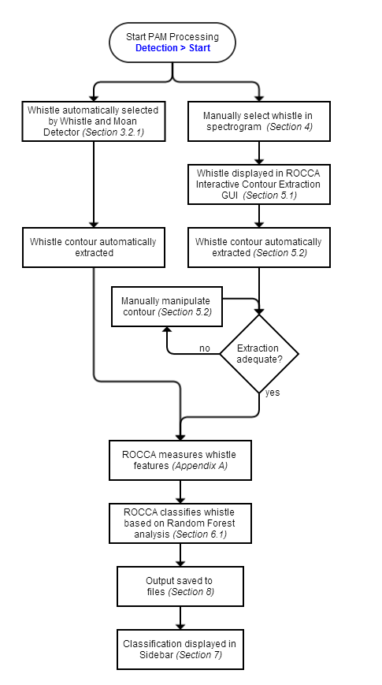
Figure 1. Overview of the main steps in the detection, contour extraction and classification of whistles using ROCCA.

Systems overview diagram – Setting Up and Configuring ROCCA
The following diagram gives an overview of the steps that you will need to set up and configure ROCCA. Each bubble or box contains a reference to the appropriate section of this user’s manual. You will find detailed instructions in these sections.
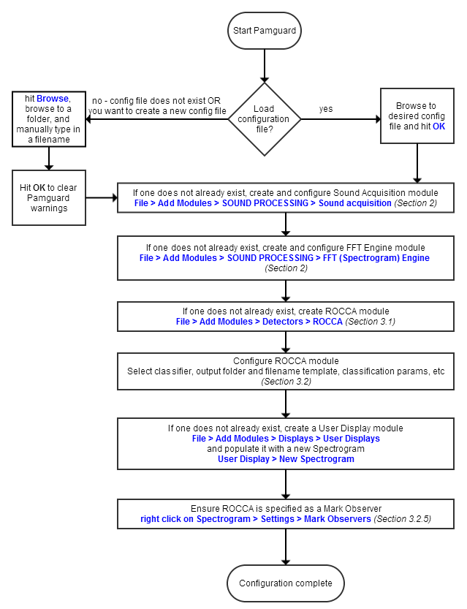
Figure 2. Systems overview diagram for the set up and configuration of ROCCA in PAMGuard.

Systems overview diagram – Capturing a Whistle
The following diagram gives an overview of the steps that you will need to capture a whistle from PAMGuards scrolling spectrogram. Each bubble or box contains a reference to the appropriate section of this user’s manual. You will find detailed instructions in these sections.
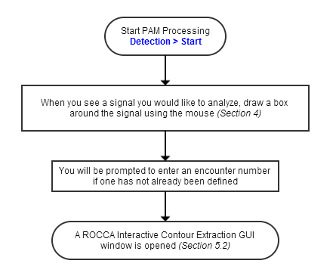
Figure 3. Systems overview diagram for capturing a whistle from PAMGuards scrolling spectrogram.

Systems overview diagram – Contour Extraction and Classification
The following diagram gives an overview of the steps that you will need to extract a whistle contour, measure features from the contour and classify the whistle to species. Each bubble or box contains a reference to the appropriate section of this user’s manual. You will find detailed instructions in these sections.
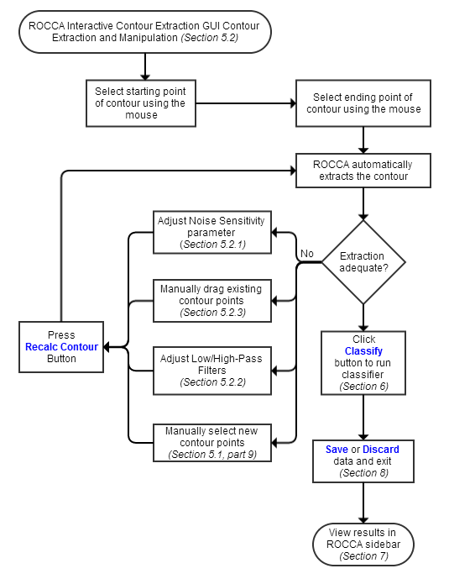
Figure 4. Systems overview diagram for extracting a whistle contour, extracting features from the contour and classifying the contour in ROCCA.
This page intentionally left blank.

LOADING SUPPORTING PAMGUARD MODULES
ROCCA requires an ‘FFT (Fast Fourier Transform) Engine module’ in PAMGuard to convert incoming audio data (either from a sound card or a .wav file) into a spectrogram. The FFT Engine in turn requires a Sound Acquisition module. The Sound Acquisition module tells the FFT where to look for audio data. To load the FFT Engine module, select
File > Add Modules > SOUND PROCESSING > FFT (SPECTROGRAM) ENGINE
from the toolbar. To load the Sound Acquisition module, select
File > Add Modules > SOUND PROCESSING > Sound acquisition
from the toolbar.
To display a spectrogram on the screen, select
File > Add Modules > DISPLAYS > USER DISPLAY
from the toolbar. Give the display an appropriate name when prompted. Then select
DISPLAY > USER DISPLAY > NEW SPECTROGRAM
from the toolbar and hit OK once the desired spectrogram parameters have been specified.
The DETECTION menu in the toolbar allows you to access configuration parameters for all modules. See the PAMGuard program help files for complete details on configuring the FFT Engine, Sound Acquisition, and User Display modules.
This page intentionally left blank.

LOADING AND CONFIGURING ROCCA
The following subsections give you detailed instructions on how to load and configure the ROCCA module in PAMGuard. Guidance is provided on selecting source data, classifiers, setting parameters for contour extraction and choosing output directories.

Loading ROCCA
From the toolbar, select
File > Add Modules > Detectors > ROCCA.
Enter a descriptive name for the module and select ‘OK’. If you have not already loaded an FFT engine module, you will be prompted to load one. The FFT engine module requires a Sound Acquisition module from which to receive data. If you have not loaded a Sound Acquisition module, you will be prompted to load one. You can access configuration parameters for all modules from the DETECTION menu in the toolbar. See the PAMGuard program help files for complete details on configuring the FFT Engine and Sound Acquisition modules.
When ROCCA is loaded, it will automatically try to load the classifier model. ROCCA will also check to see if a ‘School Stats’ file already exists. If it does, you will be given the option to load the contents of the file into memory.
Note! The School Stats file is continually overwritten while ROCCA is running. If you do not load the data into memory upon startup, the information in the file will be lost. Thus, if you do not wish to load the data, but still desire to keep it, you should rename the file before continuing with PAMGuard.

Configuring ROCCA
Note! It is recommended that you configure the Sound Acquisition and FFT Engine modules prior to configuring ROCCA. Configuration parameters can be found under DETECTION in the toolbar. See the PAMGuard program Help files for complete details on configuring the FFT Engine and Sound Acquisition modules.
Under DETECTION, select ROCCA Parameters. A new dialog should appear containing four tabs: Source Data, Contours/Classifier, Output, and Filename Template.

Source Data Tab
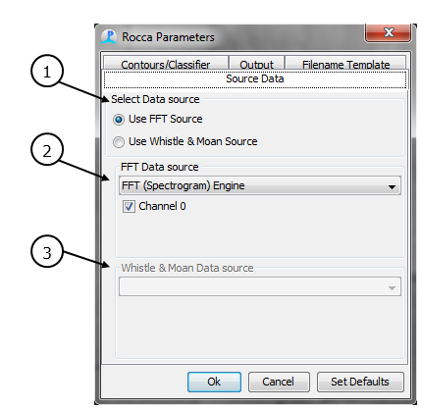
Figure 5. Source data tab in the ROCCA parameters dialog box.
- Select Data Source: ROCCA can process data from either the FFT module or the WMD module. In order to enable the WMD option, a WMD module must already be loaded. See the PAMGuard program help files for details on loading and configuring the WMD.
- FFT Data source: this specifies the FFT data source to be used. The channels listed are those currently selected in the FFT Parameters dialog. When a whistle has been classified, ROCCA will save a .wav file clip (i.e., clip file) of the whistle. Check the channel boxes corresponding to the channels you wish to save to this clip file.
Note! The channels selected at this step are different than the channels displayed in the spectrogram window, which are set in the display options dialog (right-click on the spectrogram and select SETTINGS). Whistles can be selected and contours can be extracted from any channel that is displayed, but the saved whistle clip files will only contain data from the channels selected in the FFT Data Source dialog. It is possible (although not recommended), to extract and classify a whistle from Channel 0, but only save the data from Channels 1 and 2.
- Whistle and Moan source: this specifies the WMD to be used. This drop-down box will list all currently configured WMD modules. In addition to its normal output, the WMD will send all detected whistle contours to ROCCA. ROCCA will then measure and classify the contours, add the classification results to ROCCA's sidebar and save the output. No pop-up spectrogram window will appear.

Contour/Classifier Tab
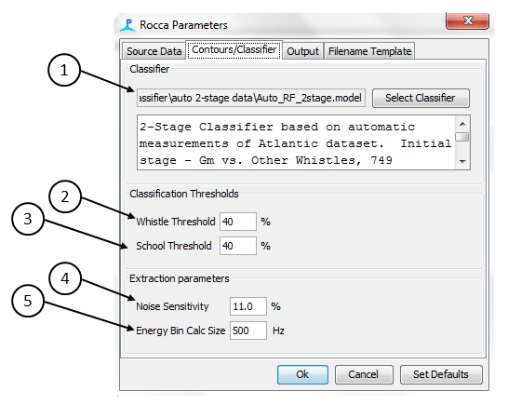
Figure 6. Contours/classifier tab in the ROCCA parameters dialogue box.
- Classifier: select the classifier to be used. Classifier models are created based on the Weka Random Forest model (http://www.cs.waikato.ac.nz/ml/weka/index.html). A classifier model always uses the file extension “.model.” If available, a description of the selected classifier is shown in the text box. At the moment, it is not possible to create new ROCCA classifiers within PAMGuard.
- Whistle Threshold: the strong whistle threshold to use when classifying individual whistles (Section 6.1).
- School Threshold: the strong whistle threshold to use when classifying encounters (Section 6.2).
- Noise Sensitivity: the ‘global noise sensitivity parameter’ value to use when extracting a contour (Section 5.1).
- Energy Bin Calc Size: the size of the frequency bin used to calculate the energy around each peak frequency.

Output Tab
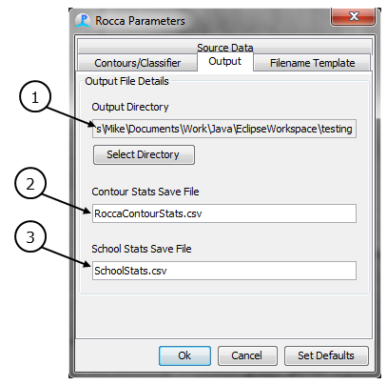
Figure 7. Output tab in the ROCCA parameters dialogue box.
- Output Directory: specify the directory in which to save clip files, extracted whistle contours, and whistle contour features.
Note! If using a Microsoft Windows© operating system, it is recommended to select a directory that does not require administrator privileges.
- Contour Stats Save File: specify the name of the output file for whistle contour features. This file contains measured features and classification results for each whistle. The file will be saved to the output directory specified above. Each classified whistle is appended to the end of the file when one of the Save buttons in the spectrogram popup window is clicked.
- School Stats Save File: specify the name of the school classifications output file. This file contains summarized classification results for each encounter. The file will be saved to the output directory specified above.
Note! In order to use the latest encounter numbers, this file is overwritten during each save. As long as PAMGuard continuously runs, this is not a problem; however, if this file exists when PAMGuard is first started, the contents of the file will be lost unless the file is loaded. If the file exists during startup, you will be warned and given a chance to load (and thus append to), rename, or back up the existing file.

Filename Template Tab
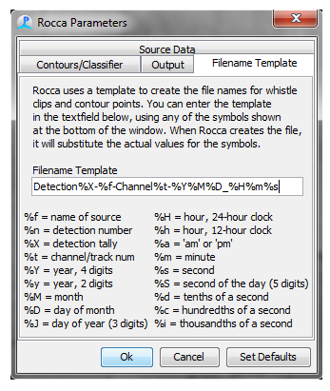
Figure 8. Filename template tab in the ROCCA parameters dialogue box.
In addition to the Contour Stats and School Stats files, ROCCA also saves a whistle clip (.wav file format) and a list of the time-frequency contour points (time and frequency, .csv format). ROCCA will name these files according to the template given in the text box on this tab. As part of the name, you are able to use any of the following symbols. When the files are saved, ROCCA will substitute the actual values for the symbol names.
Symbol | Meaning | Symbol | Meaning
%f | name of source | %H | hour, 24-hour clock
%n | encounter number | %h | hour, 12-hour clock
%X | encounter tally/count | %a | am or pm
%t | channel/track number | %m | minute
%Y | year, four digits | %s | second
%y | year, two digits | %S | second of the day, five digits
%M | month | %d | tenths of a second
%D | day of the month | %c | hundredths of a second
%J | day of the year, three digits | %i | thousandths of a second
Note! All date/time values are Greenwich Mean Time (GMT).

ROCCA Mark Observers
You must add ROCCA to the Mark Observers list in the PAMGuard spectrogram window in order for ROCCA to work. Modules that are on the Mark Observer list are the only modules that can receive data from the PAMGuard spectrogram module. If ROCCA is not on the mark observer list, ROCCA will not work. To add ROCCA to the Mark Observers list, right click on the spectrogram and select SETTINGS. Select the Mark Observers tab and check the box beside ROCCA.
Note! If ROCCA is not listed as a possible mark observer, it has not been added as a module.

SENDING DATA TO ROCCA – SELECTING A WHISTLE
Once the ROCCA module and all supporting modules have been loaded, you are ready to display audio data on the spectrogram. To do so, press the button labeled with a stop-sign icon located just under the toolbar.
To classify a whistle using ROCCA, select the whistle from the scrolling spectrogram display by drawing a box around it. To do this, move the cursor to one corner of the whistle, press and hold the mouse button while dragging the cursor to the opposite corner, and release the button. A red box will be drawn around the selection, and the time and frequency of the starting point (lower left corner) and ending point (upper right corner) are displayed in the ROCCA sidebar for reference. When you box the first whistle in an encounter, you will be prompted for an encounter number.
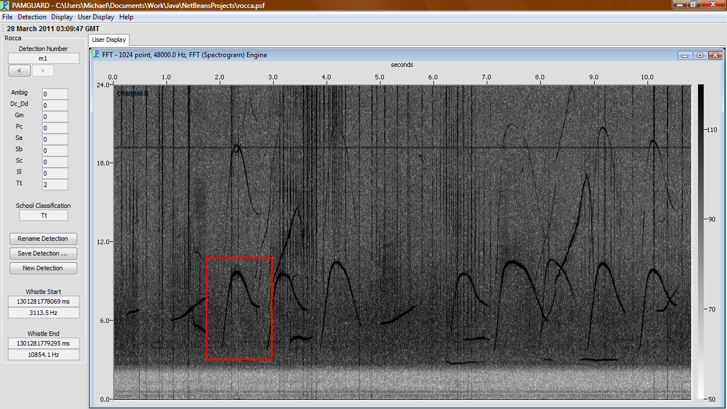
Figure 9. PAMGuards scrolling spectrographic display with the ROCCA side bar. The whistle to be classified is contained in the red box.
When the mouse button is released, a new window will open. This new window contains the portion of the spectrogram you selected. PAMGuard minimizes the new window automatically so that you can continue to monitor the scrolling spectrogram and select more whistles. This is important because PAMGuard’s spectrogram engine does not have ‘pause’ capabilities. When you are examining a .wav file and select STOP, PAMGuard will go back to the beginning of the .wav file when you select PLAY again. When you are monitoring real-time data, any data that comes in while the spectrogram is stopped will be lost.
At this stage, you have captured the whistle of interest and can continue monitoring the scrolling spectrogram for additional acoustic events. You do NOT need to classify the whistle immediately. The number of whistles captured is only limited by the amount of memory available on the computer.
This page intentionally left blank.

CONTOUR MANIPULATION / EXTRACTION

ROCCA’S Interactive Contour Extraction GUI
Once you have selected a whistle in the main spectrogram window, a new window opens. This new window contains the selected portion of the spectrogram. To extract the whistle contour, click on the starting point of the whistle, and then the ending point (note that these can be reselected later). Once the starting and ending points have been defined, ROCCA will automatically extract and display the whistle contour (shown below in yellow).
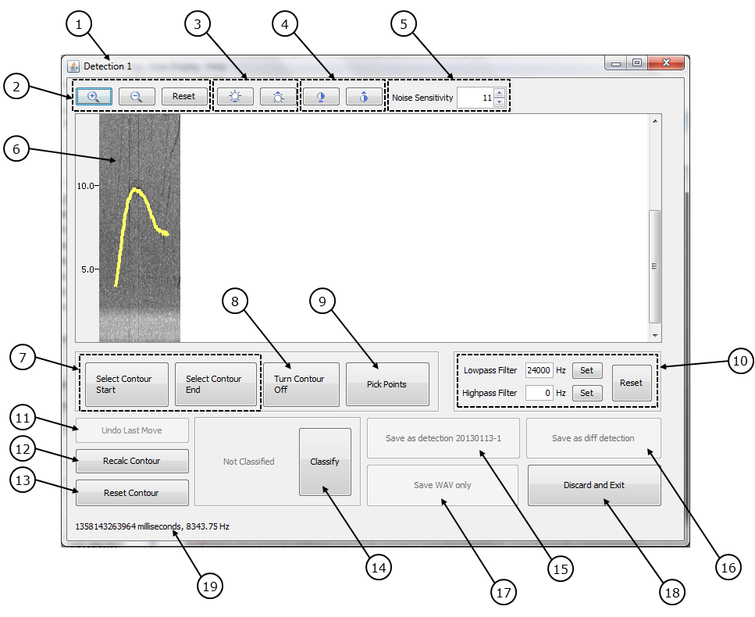
Figure 10. ROCCA’s interactive contour extraction GUI.
- Window Title: displays the current detection tally. ROCCA keeps track of the number of detected whistles since the start of the PAMGuard session and displays the information in the window title to make it easier to keep track of the order in which whistles were selected during an encounter.
- Zoom In/Out/Reset: changes the zoom level of the spectrogram.
- Increase/Decrease Brightness: modifies the brightness of the spectrogram.
Note! Modifying brightness only changes the spectrogram display; the underlying contour extraction algorithm is not affected.
- Increase/Decrease Contrast: modifies the contrast of the spectrogram.
Note! Changing contrast only modifies the spectrogram display; the underlying contour extraction algorithm is not affected.
- Noise Sensitivity Spinner: modifies the noise sensitivity parameter (Section 5.2.1) used for contour extraction. ROCCA automatically recalculates the contour when this value is changed, and the spectrogram display is updated.
Note! Any contour points that have been manually moved will not be changed. Note also that modifying the noise sensitivity using the noise sensitivity spinner does not change the global noise sensitivity parameter as specified in the ROCCA Parameters window. It only changes the noise sensitivity used in this spectrogram popup window.
- Spectrogram window: displays the current spectrogram.
- Select Contour Start/Contour End: allows you to reselect the starting or ending point of the whistle. Upon selection, ROCCA will automatically recalculate the contour.
- Turn Contour Off: toggles the contour display on and off.
- Pick Points: when clicked, the existing contour is erased and you enter 'Selection' Mode. Using Pick Points, you can manually select points along the contour by clicking on the spectrogram. You can select any number of points, but only one frequency per time bin is allowed. If multiple frequencies are selected in one time bin, only the first is kept and the rest are ignored. You can also hold the mouse button down and drag the mouse along the contour to quickly select multiple points. When the Pick Points button is pressed a second time, 'Selection' Mode ends. ROCCA will fill in any missing time bins by linear interpolation between selected points.
- Highpass/Lowpass/Reset Filters: limits the contour extraction algorithm so that it only examines a specific frequency band (Section 5.2.2). You can set a filter by either typing the desired frequency and hitting ENTER, or hitting the SET button and clicking on the desired frequency in the spectrogram. The filter is drawn as a horizontal red line on the spectrogram. ROCCA automatically recalculates the whistle contour when filters are set or modified. To reset filters, click the RESET FILTERS button.
Note! Any contour points that have been manually moved will not be changed when filters are set. Note also that the spectrogram display is not affected by the filters, only the contour extraction.
- Undo Last Move: returns the last contour point that was moved manually to its previous location.
- Recalc Contour: recalculates the contour after you have manually moved one or more contour points to new positions.
- Reset Contour: unlocks all manually moved contour points.
- Classify/Reclassify: classifies the currently extracted contour. The classification result is displayed to the left of the button.
- Save as encounter enc#: saves the whistle clip, contour points, and contour features to the directory specified in the ROCCA Parameters window using enc# as the encounter number. Clicking this button closes the spectrogram popup window and returns you to the main PAMGuard display. Classification results are added to the ROCCA Sidebar.
- Save as diff encounter: saves the whistle clip, contour points, and contour parameters to the directory specified in the ROCCA Parameters window, but first prompts you to input a new encounter number. Once the encounter number has been specified, the spectrogram popup window is closed and you are returned to the main PAMGuard display. Classification results are added to the ROCCA Sidebar.
- Save WAV only: saves the whistle .wav file clip to the directory specified in the ROCCA Parameters window using the current encounter number (shown in the window title bar). This option is useful when you do not want to classify the whistle immediately.
- Discard and Exit: discards the current whistle, closes the spectrogram popup window and returns you to the main PAMGuard display.
- Displays the current time and frequency location of the cursor.

Contour Extraction / Manipulation
Once you have clicked on the start and end point of the whistle, ROCCA automatically extracts the whistle contour by stepping through the spectrogram one time slice at a time and calculating the peak frequency within a specific frequency band for each time slice. The upper and lower limits of the frequency band are defined by the peak frequency of the previous time slice +/- the noise sensitivity (as defined in the ROCCA Parameters window). The frequency band of the first time slice is determined by the user-selected start frequency +/- the noise sensitivity.

Adjusting the Noise Sensitivity
If the extracted contour does not match the underlying whistle, the first step should be to adjust the noise sensitivity:
- Decreasing the noise sensitivity narrows the frequency band used when searching for the peak frequency in the next time slice. A narrower frequency search band means the extraction algorithm is less likely to jump from the whistle contour to a nearby noisy peak. However, a narrower frequency search band also means that if the algorithm does jump to a nearby noisy peak, there is less chance it will be able to jump back to the whistle contour.
- Increasing the sensitivity widens the frequency band used when searching for the peak frequency in the next time slice. A wider frequency search band increases the chances that an extraction that has gone off-track and is following noise will be able to jump back to the whistle contour. However, a wider frequency search band also increases the chances that the extraction will go off-track in the first place.
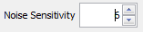 | A button is provided in the top toolbar to quickly adjust noise sensitivity. ROCCA will automatically update the spectrogram with the recalculated contour each time the sensitivity is changed. Change the value one step at a time to find the contour that most closely matches the underlying whistle.

Adjusting the High Pass/Low-Pass Filters
The high-pass and low-pass filters limit the contour extraction algorithm so that it will only function within a specific frequency band. The high-pass filter defines the lowest frequency that can be extracted, and the low-pass filter defines the highest frequency that can be extracted. Specify a filter by typing in the desired frequency and hitting ENTER, or hitting the SET button and clicking on the desired frequency in the spectrogram. The filter is displayed on the spectrogram as a red horizontal line. If the extraction algorithm finds a peak frequency that is lower than the specified high-pass filter, the peak frequency will be set as the value of the high-pass filter. Similarly, if the extraction algorithm finds a peak frequency that is higher than the specified low-pass filter, the peak frequency will be set as the value of the low-pass filter. The filters can be reset by clicking the Reset Filters button.

Adjusting the contour points manually
Individual contour points can be dragged manually to new positions. In order to view the points, move the mouse over the spectrogram and press the mouse button. Try to position the mouse so that it is away from the whistle contour to avoid accidentally dragging a contour point. Contour points are displayed as light green dots (Figure 11).
Contour points can only be dragged vertically. That is, the frequency can be changed but not the time slice. Once the inaccurate contour point is identified, position the mouse over the point and press and hold the left mouse button. The contour points will again be displayed as light green dots, but the point closest to the cursor will be circled in red (Figure 12). Move the mouse to the desired frequency and release the mouse button to move the contour point.
Once you have moved a contour point, it will be locked in the new position. It will remain in this position even if the contour is recalculated by adjusting the noise sensitivity, modifying filters or clicking the Recalc Contour button. In this way, if the contour extraction algorithm has followed noise instead of the desired whistle, you can move a point to the correct position and get the extraction back on track. The contour point can still be moved manually, and clicking the Reset Contour button will unlock all locked points.
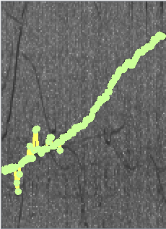
Figure 11. An extracted whistle contour with contour points shown as green dots.
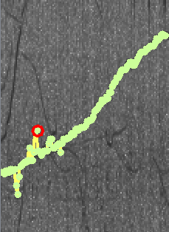
Figure 12. An extracted whistle contour with contour points shown as green dots and the selected contour point circled in red.

WHISTLE AND SCHOOL CLASSIFICATION
ROCCA uses a random forest classifier model based on the open-source statistical software package WEKA (http://www.cs.waikato.ac.nz/ml/weka/index.html). For more information on random forests and the WEKA package, please refer to Witten et al. (2011).

Whistle Classification
ROCCA measures the 50 features from each whistle contour. See Appendix A for a description of each of these variables.
ROCCA’s Random Forest classifier was trained using 50 variables measured from single-species schools of dolphins that had visual confirmation of species identity (see Oswald et al. 2007 and Oswald 2013 for details on the training datasets). During whistle classification, features measured from a whistle contour are run through the Random Forest model and each tree in the forest produces a species classification. Each tree can be considered 1 ‘vote’ for a given species classification. Votes are tallied over all trees and the whistle is classified as the species with the most ‘votes’. In addition to classifying individual whistles, encounters are classified based on the number of tree classifications for each species, summed over all of the whistles that were analyzed for that encounter.
The number of tree classifications for the predicted species is also used as a measure of the certainty of the classification. If a greater percentage of trees classifies the whistle as a particular species, then the classification is considered to have a higher degree of certainty. The ‘strong whistle threshold’ (specified in the ROCCA parameters window) is the percentage of trees that must classify the whistle as a given species in order for that classification to be considered reliable. If the percentage of trees classifying the whistle as a particular species falls below the strong whistle threshold, the whistle is classified as ambiguous. Similarly, encounters are classified as ambiguous unless the percentage of tree votes (summed over all of the whistles in the encounter) for the predicted species exceeds the ‘strong school threshold’ (see Section 3.2.2 for details on how to set the strong whistle and strong school thresholds). ‘

School Classification
The School Stats output file contains a list of possible species based on the classifier model used. There are two values stored for each species: the number of times a whistle has been classified to that species (also displayed on the ROCCA sidebar) and a cumulative total of the percentage of tree votes for the species (not displayed on the ROCCA sidebar). When a new whistle classification is saved to a School Stats file, the number of whistles classified as that species is increased by one and the percentage of tree votes for each species are added to the corresponding cumulative totals. ROCCA classifies an encounter as the species with the highest cumulative percentage of tree votes. If the highest cumulative percentage of tree votes falls below the school threshold (as specified in the ROCCA Parameters window, Section 3.2.2), the encounter is classified as Ambiguous.
Note! The species with the highest cumulative percentage of tree votes may be different than the species with the greatest number of whistle classifications (the value shown in the sidebar species list).
This page intentionally left blank.

DISPLAYING THE RESULTS – THE ROCCA SIDEBAR
The results of individual whistle classifications are grouped into encounters as defined by the user. Each group must be given a name, the encounter number. In addition to classifying individual whistles, ROCCA also classifies the overall encounter. The encounter classification is determined by summing the percentage of trees voting for each species over all of the whistles classified in that encounter. The species with the highest cumulative percentage of tree votes is the species classification for that encounter.
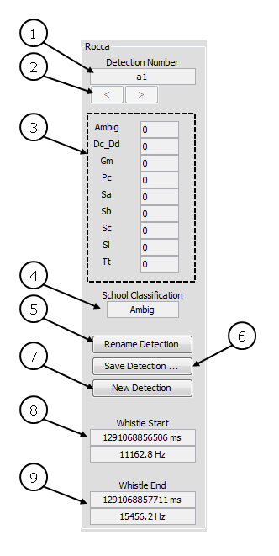
Figure 13. The ROCCA sidebar.
- Encounter number: the current encounter number. This is the encounter number used when a new whistle is selected from the spectrogram display. Any combination of numbers and letters can be used to specify the encounter number.
- Scroll buttons: allow you to scroll through the list of encounter numbers.
- Classification results: displays a tally of the number of whistles classified as each species for the current encounter number. The list of possible species is based on the currently loaded classifier model. Species are denoted by the first letter of the genus and species (ex. Gm = Globicephala macrorhynchus). The number beside the species name indicates the number of whistles classified to that species. See Appendix B for a list of species included in the tropical Pacific and Atlantic classifiers, along with their genus-species codes.
- School classification: displays the species classification for the current encounter.
- Rename Encounter: renames the current encounter. Any previously saved output files that use the old encounter number in the filename will be renamed using the new encounter number.
Note! The information contained within the whistle Contour Stats file is NOT updated—you must modify any references to the old encounter number manually. Also note that you are not allowed to duplicate encounter numbers.
- Save Encounter: overwrites the current School Stats file (as defined in the ROCCA Parameters window) with the current list of encounters and classification results. School classification results are also saved automatically every five minutes.
- New Encounter: creates a new encounter.
- Whistle Start: lists the time and frequency of the first user-selected point on the spectrogram.
- Whistle End: lists the time and frequency of the second user-selected point on the spectrogram.
Note! Once you select the second point, the portion of the spectrogram in between the first and second points is captured in a new popup window.

OUTPUT
ROCCA saves three different files during whistle classification: whistle clip, contour points, and contour parameters. ROCCA will also save detection stats automatically every five minutes, as well as when the Save Detection button is clicked in the ROCCA sidebar (Section 7).
If a database module is being used, ROCCA will also save the data in two tables: Rocca_Whistle_Stats and Rocca_Detection_Stats.

Whistle Clip
ROCCA saves the whistle clip in a .wav file format to the output directory. The start and end points of the clip are defined by the start and end points that you originally selected in the spectrogram popup window. The channels saved to the clip file are specified in the ROCCA Parameters window (Section 3.2.1). ROCCA saves the file according to the filename defined in the ROCCA Parameters window (Section 3.2.4)

Contour Points
ROCCA saves the time/frequency pair for each extracted contour point in a .csv file in the output directory. The duty cycle, the energy in a frequency band around the peak frequency (as defined in the ROCCA Parameters window), and the RMS value of the amplitude are also saved. ROCCA saves the file according to the filename defined in the ROCCA Parameters window (Section 3.2.4).

Contour Features
ROCCA saves the features measured from the current contour, as well as the classification results (the percentage of trees voting for each species), in a .csv format Contour Stats file in the output directory. The information from each classified whistle is appended to the end of the file, and the file is never overwritten. Thus, this file will continue to collect classification information every time ROCCA is run.
Other information that is saved for each whistle includes the sound source, date and time, and encounter number. The end of each row in the Contour Stats file lists the name of the random forest model, the percentage of trees voting for each species, and a corresponding list of the species names. The species names are added to each row instead of to the header line because the header is created based on information from the first whistle contour analyzed. If you use a different classification model for the analysis of subsequent whistles, the species list may be different and may no longer match the header. By including the species list in the row, you are always able to verify which species were included in the classification algorithm for a particular whistle contour.
ROCCA saves the file according to the filename specified in the ROCCA Parameters window (Section 3.2.3). If a database module is being used, the data will also be saved to the Rocca_Whistle_Stats table.

School Stats
ROCCA saves classification results for all encounters in a .csv format School Stats file in the output directory. For each encounter, ROCCA includes the cumulative random forest tree vote totals for each species, a list of species in the classifier, and the overall school classification (based on the species with the highest cumulative tree vote total).
Each time the School Stats file is saved, either through the auto-save function or by pressing the Save Detection button, ROCCA overwrites the file in order to update any renamed encounters numbers. Since an encounter number can be renamed but never deleted, no information will be lost when overwriting an old file during a single PAMGuard session. HOWEVER, if PAMGuard is closed and restarted, the file will be overwritten with blank data and all prior information will be lost. ROCCA searches for the file at startup. If the file exists, you are given the opportunity to rename it before it is lost, and/or load the existing data back into the system.
Note! When examining the classification results for a particular encounter number, you should refer to the species list at the end of the row instead of the species listed in the header. The header information is taken from the first encounter number listed. If subsequent encounter numbers use different classification models, the included species may change and this change is not reflected in the header.
ROCCA saves the School Stats file according to the filename specified in the ROCCA Parameters window (Section 3.2.3). If a database module is being used, the data will also be saved to the Rocca_Detection_Stats table.

This page intentionally left blank

literature cited
Gillespie, D., J. Gordon, R. McHugh, D. McLaren, D.K. Mellinger, P. Redmond, A. Thode, P. Trinder, and D. Xiao. (2008). PAMGUARD: Semiautomated, open-source software for real-time acoustic detection and localization of cetaceans. Proceed. Instit. Acoust. 30, Part 5. 9 pp.
Oswald, J.N. (2013). Development of a Classifier for the Acoustic Identification of Delphinid Species in the Northwest Atlantic Ocean. Final Report. Submitted to HDR Environmental, Operations and Construction, Inc. Norfolk, Virginia under Contract No. CON005-4394-009, Subproject 164744, Task Order 003, Agreement # 105067. Prepared by Bio-Waves, Inc., Encinitas, California.
Oswald, J.N., S. Rankin, J. Barlow, and M.O. Lammers. (2007). A tool for real-time acoustic species identification of delphinid whistles. J. Acoust. Soc. Am. 122, 587-595.
Witten, I.H., E. Frank and M.A. Hall. (2011). Data Mining: Practical Machine Learning Tools and Techniques. Morgan Kaufman Publishers, ISBN: 978-0-12-374856-0.

Appendix A:
Variables Measured by ROCCA
This page intentionally left blank.
Appendix A:
Variables Measured by ROCCA
Variable | Explanation
Begsweep | slope of the beginning sweep (1 = positive, -1 = negative, 0 = zero)
Begup | binary variable: 1=beginning slope is positive, 0=beginning slope is negative
Begdwn | binary variable: 1=beginning slope is negative, 0=beginning slope is positive
Endsweep | slope of the end sweep (1 = positive, -1 = negative, = 0 zero)
Endup | binary variable: 1=ending slope is positive, 0=ending slope is negative
Enddwn | binary variable: 1=ending slope is negative, 0=ending slope is positive
Beg | beginning frequency (Hz)
End | ending frequency (Hz)
Min | minimum frequency (Hz)
Dur | duration (sec)
Range | maximum frequency–minimum frequency (Hz)
Max | maximum frequency (Hz)
mean freq | mean frequency (Hz)
median freq | median frequency (Hz)
std freq | standard deviation of the frequency (Hz)
Spread | difference between the 75th and the 25th percentiles of the frequency
quart freq | frequency at one quarter of the duration (Hz)
half freq | frequency at one half of the duration (Hz)
Threequart | frequency at three quarters of the duration (Hz)
Centerfreq | (minimum frequency + (maximum frequency-minimum frequency))/2
rel bw | relative bandwidth: (max freq - min freq)/center freq
Maxmin | max freq/min freq
Begend | beg freq/end freq
Cofm | coefficient of frequency modulation: take 20 frequency measurements equally spaced in time, then subtract each frequency value from the one before it. COFM is the sum of the absolute values of these differences, all divided by 10,000
tot step | number of steps (10 percent or greater increase or decrease in frequency over two contour points)
tot inflect | number of inflection points (changes from positive to negative or negative to positive slope)
max delta | maximum time between inflection points
min delta | minimum time between inflection points
maxmin delta | max delta/min delta
mean delta | mean time between inflection points
std delta | standard deviation of the time between inflection points
median delta | median of the time between inflection points
mean slope | overall mean slope
mean pos slope | mean positive slope
mean neg slope | mean negative slope
mean absslope | mean absolute value of the slope
Posneg | mean positive slope/mean negative slope
perc up | percent of the whistle that has a positive slope
perc dwn | percent of the whistle that has a negative slope
perc flt | percent of the whistle that has zero slope
up dwn | number of inflection points that go from positive slope to negative slope
dwn up | number of inflection points that go from negative slope to positive slope
up flt | number of times the slope changes from positive to zero
dwn flt | number of times the slope changes from negative to zero
flt dwn | number of times the slope changes from zero to negative
flt up | number of times the slope changes from zero to positive
step up | number of steps that have increasing frequency
step dwn | number of steps that have decreasing frequency
step.dur | number of steps/duration
inflect.dur | number of inflection points/duration

Appendix B:
Genus Species Codes for the Tropical Pacific and Atlantic Classifiers
This page intentionally left blank.
Appendix B:
Genus Species Codes for the Tropical Pacific and Atlantic Classifiers
Tropical Pacific Classifier
Code | Scientific Name | Common name
Ambig | n/a | Ambiguous
Dc_Dd | Delphinus capensis and D. delphis | Long- and short-beaked common dolphin
Gm | Globicephala macrorhynchus | Short-finned pilot whale
Pc | Pseudorca crassidens | False killer whale
Sa | Stenella attenuata | Pantropical spotted dolphin
Sb | Steno bredanensis | Rough-toothed dolphin
Sc | Stenella coeruleoalba | Striped dolphin
Sl | Stenella longirostris | Spinner dolphin
Tt | Tursiops truncatus | Bottlenose dolphin

Atlantic Classifier
Code | Scientific Name | Common name
Ambig | n/a | Ambiguous
Dd | Delphinus delphis | Short-beaked common dolphin
Sc | Stenella coeruleoalba | Striped dolphin
Tt | Tursiops truncatus | Bottlenose dolphin
Sf | Stenella frontalis | Atlantic spotted dolphin
Gm | Globicephala macrorhynchus | Short-finned pilot whale

This page intentionally left blank.

Appendix C:
Description of CSV File Columns
This page intentionally left blank.
Appendix C:
Description of CSV File Columns
Contour Points File
Header | Description
Time [ms] | Time elapsed (since PAMGuard started)
Peak Frequency [Hz] | Frequency with the highest amplitude in the time slice
Duty Cycle, Energy, WindowRMS | Variables used internally by ROCCA

Contour Features File
Header | Description
Source | Source of acoustic data (sound card, filename, etc.)
Date-Time | Local (computer) date and time when the whistle was captured
Detection Count | Running tally of whistles captured since ROCCA was started. Number is incremented each time a whistle is sent to ROCCA
Encounter Number | Encounter number as specified by the user
Classified Species | Species classification of whistle
FREQMAX … STEPDUR | Features measured by ROCCA and used as input to the random forest classifier
Classifier | Name of classifier used
{no header} | The remaining columns contain the percentage of trees voting for each species. The final column contains the order of the species shown in the voting columns. For example, if the final column contains Gm-Dd-Sc-Sf-Tt, it indicates the first voting column contains the percentage of trees voting for Gm, the second voting column contains the percentage of trees voting for Dd, etc.

School Stats File
Header | Description
Encounter Number | Encounter number as specified by the user
{list of species, starting with Ambig} | The number of whistles classified as each species in the current encounter number
{list of species votes, starting with Ambig} | Percentage of trees voting for each species, summed over all whistles in the current encounter number. The species with the highest total percentage of votes is the overall encounter classification
Encounter Classification | Overall species classification for the current encounter
This page intentionally left blank.

References to sections within this user’s manual have been hyperlinked.
For questions and requests related to a new classifier based on custom data, please contact Dr. Julie Oswald at Bio-Waves, Inc. at: julie.oswald@bio-waves.net.

