Benchtop Rotifer System (30L)
Parts List:

1x Pump
1x Pump hose
1x Pump hose connector
2x Pump hose clips

1x Light housing fixture
2x Lights
2x Light housing leg bases

1x Benchtop rotifer system body
1x Benchtop rotifer air manifold
2x Benchtop rotifer supports
2x Wire snap pins

6x 5 liter plastic bags
6x flexible tubing lengths
6x rigid tubing lengths
6x red caps
6x rubber bands

Assembly Instructions:

- Lay out components before you and compare them to the parts list. Ensure that everything is present and accounted for.
- Take the pump and push the black pump hose connector onto the protruding port.
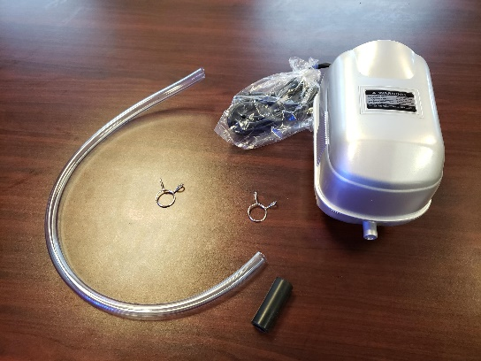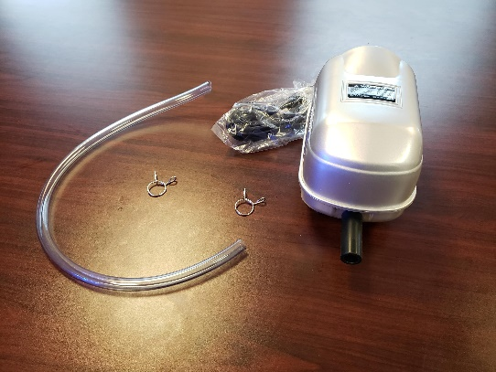

- Slide one of the pump hose clips onto the pump hose connector and push it to the back, up against the pump.
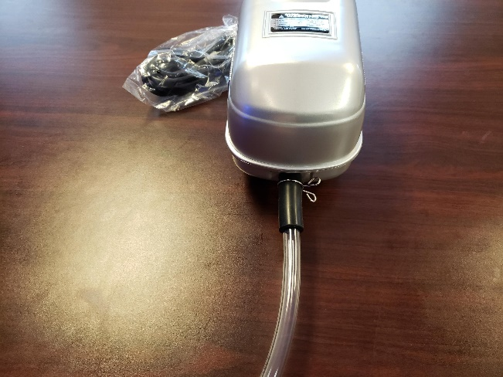

- Push pump hose into pump hose connector as far as it will go and secure it with the remaining clip. The hose should be tightly attached. Move the assembled pump to the side.
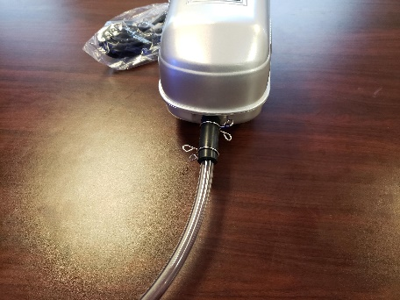
- The light housing fixture will have 2 lights already installed. Attach the light housing leg bases. Once done, move the entire fixture to the side.
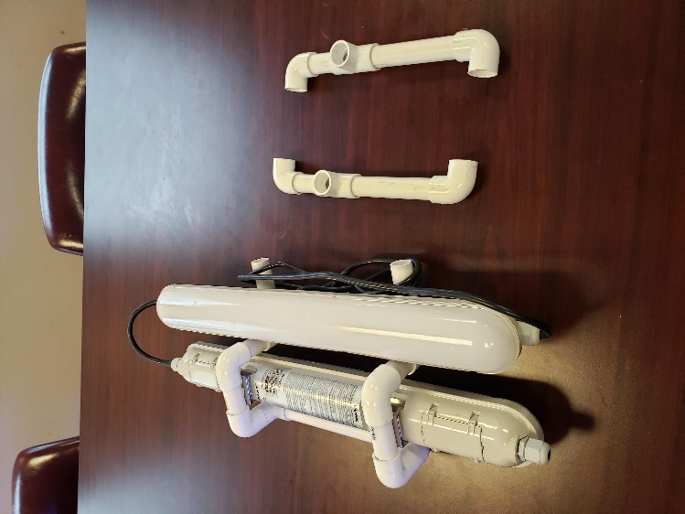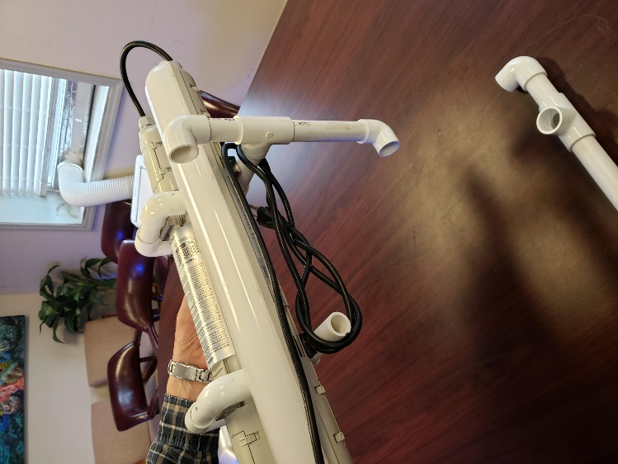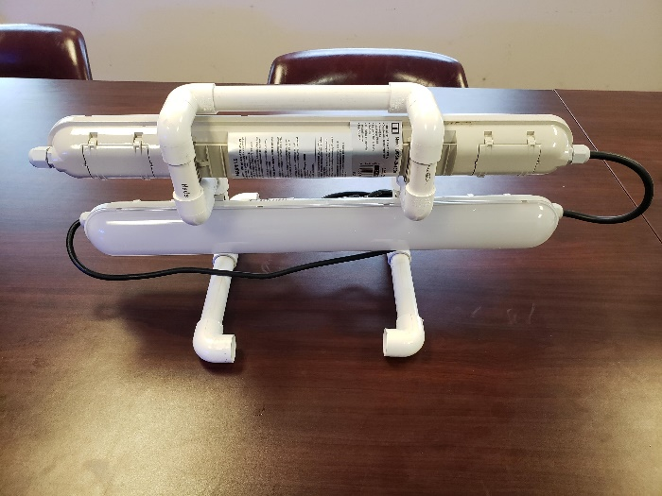

- The benchtop rotifer system body has 2 supports that connect to it and hold it up. Attach these to the sides of the body using the silver wire snap pins.
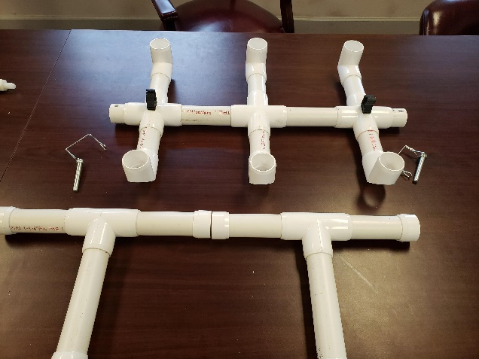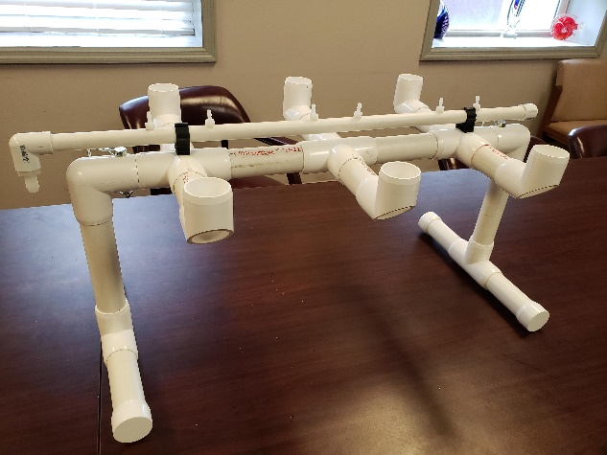

- Connect the air manifold to the top of the body using the two black clips that are attached to the body and snap closed.
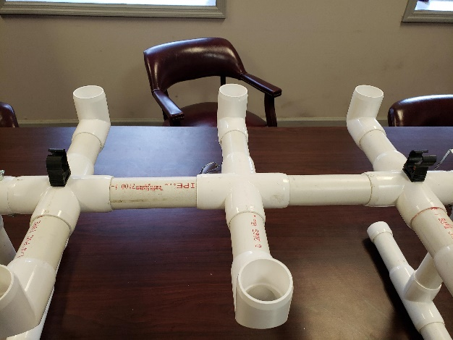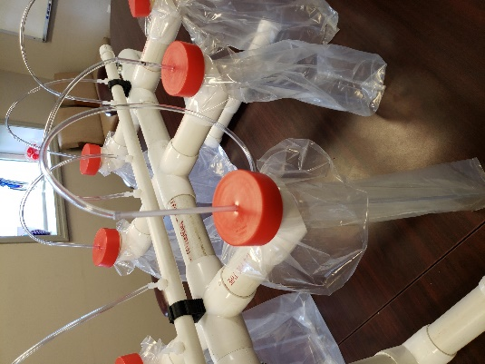
- Take one of the (5) liter bags and pull it through one of the openings with the opening of the bag pointing upwards. Fold the edges of the bag over and secure it with a rubber band.
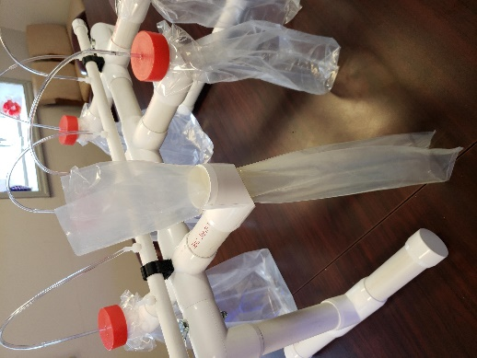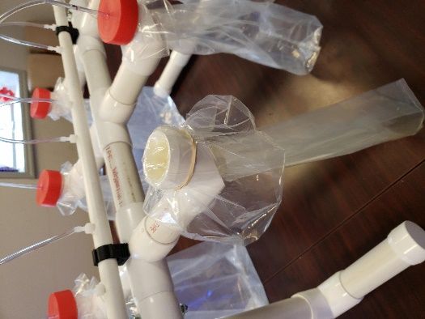
- Place one of the rigid tubes into the bag and place a red top over it with the tube going through the hole in the top.
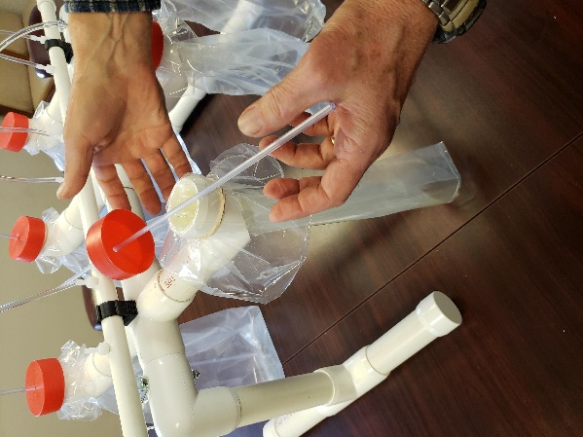
- Connect a length of flexible tubing to the end of the rigid tubing that is outside of the bag. Connect the other end of the flexible tubing to one of the ports on the air manifold.
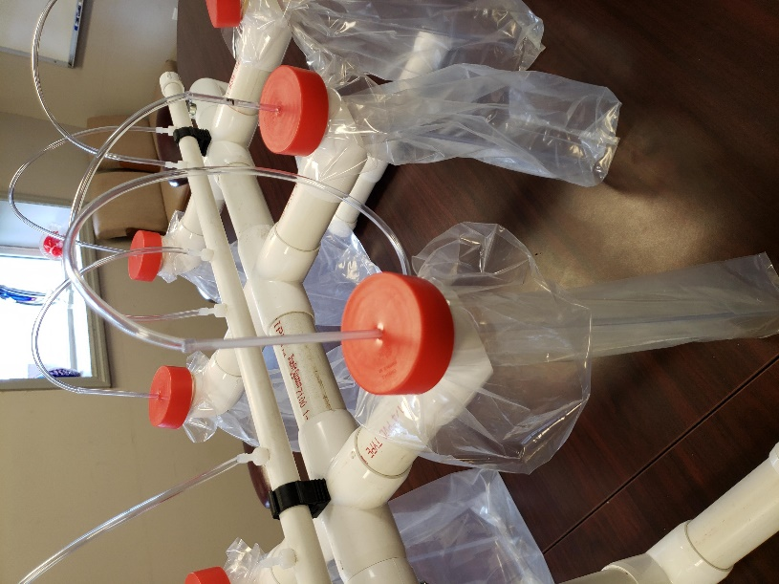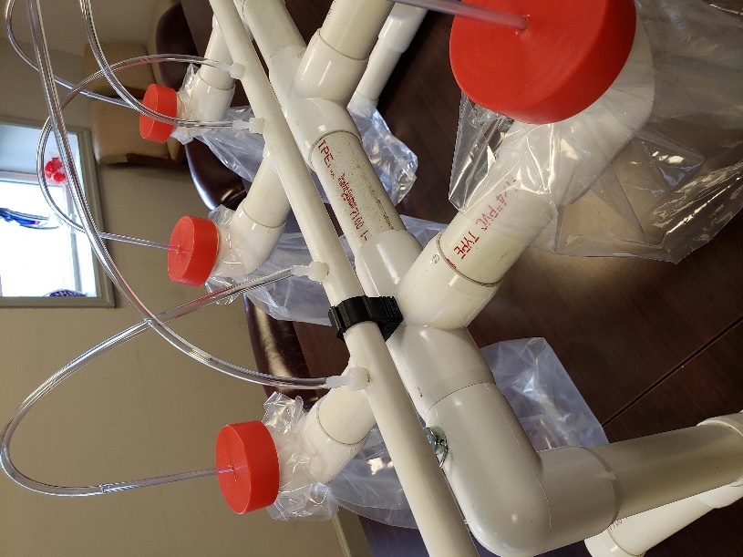

- Repeat this process 5 more times for each of the other bags.
- Place the lighting fixture beneath the completed body.
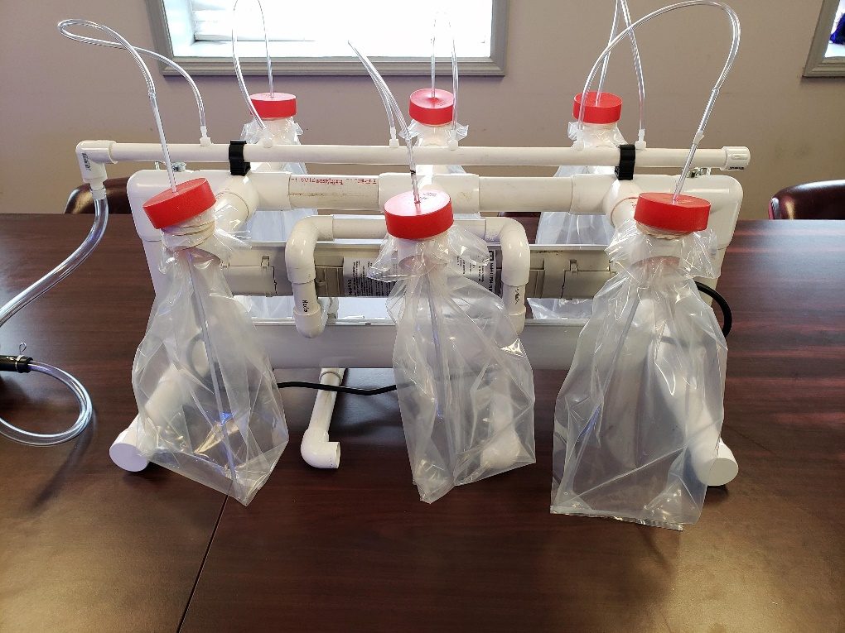
- Connect the hose from the pump to the air manifold.
- Plug in the lights and the pump to an outlet and ensure they are operational.

