
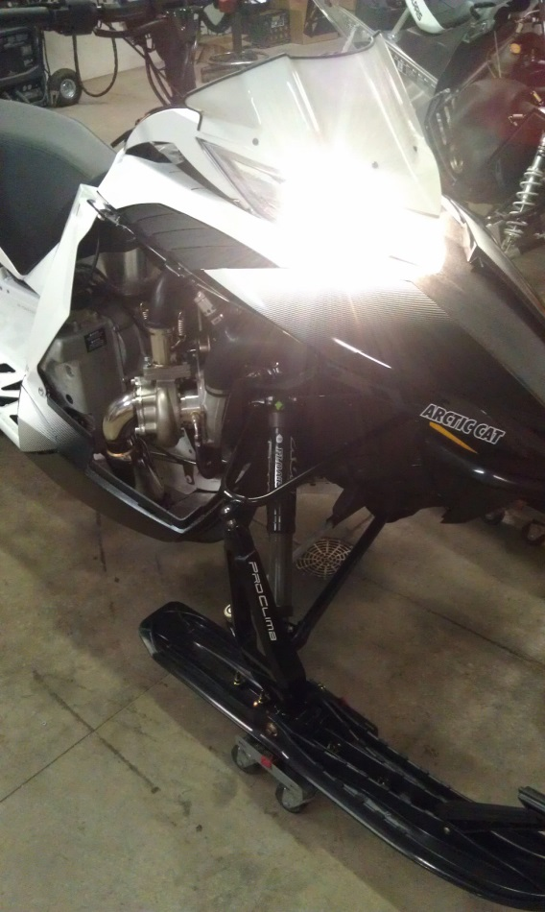

Thank you for purchasing your Silber Turbo kit. This product was designed to give you endless amounts of power and satisfaction. During the installation feel free to call us with any question or concerns you may have.
This product was designed for off road racing use only. This product requires professional installation. The product was designed to dramatically increase the performance of your vehicle, and you should operation your vehicle at your own risk and comfort level.

- Disassembly

- Remove your side panels, hood, muffler, exhaust pipe, air box.
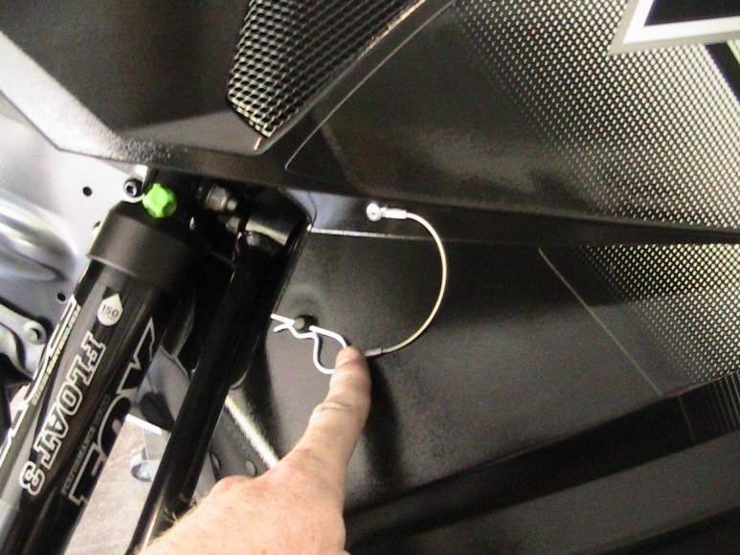
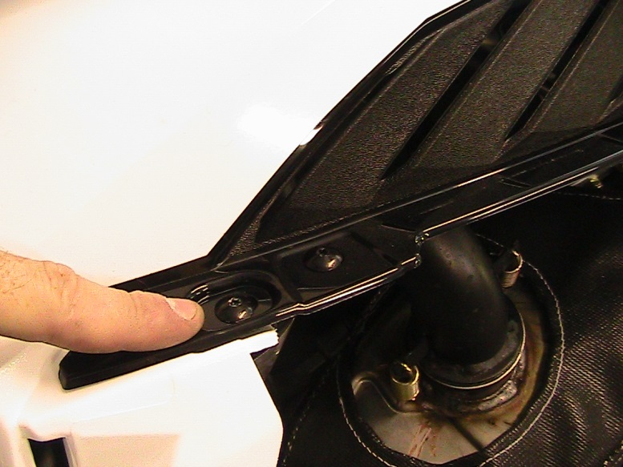
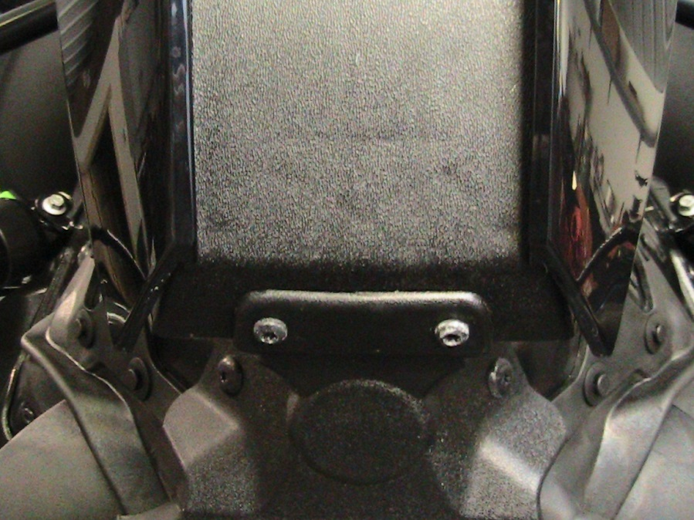
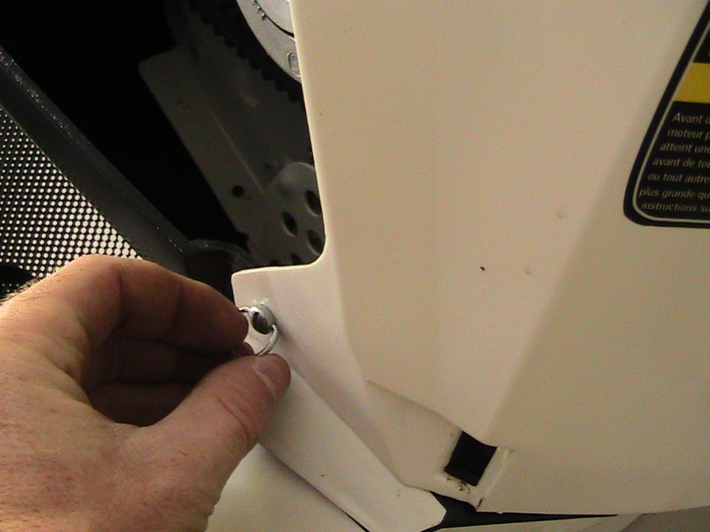
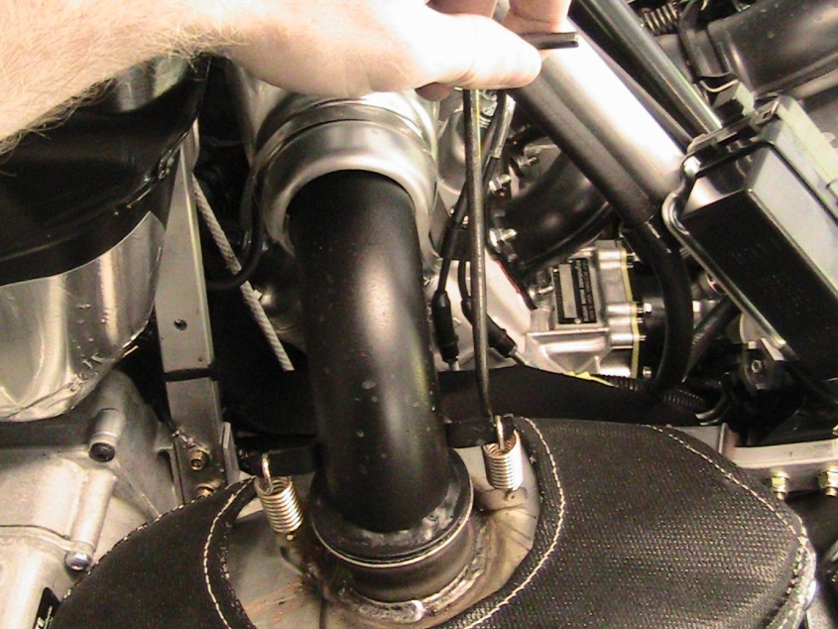
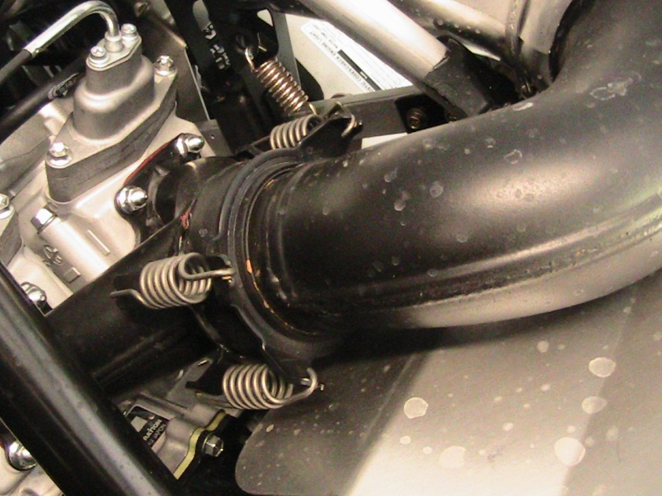
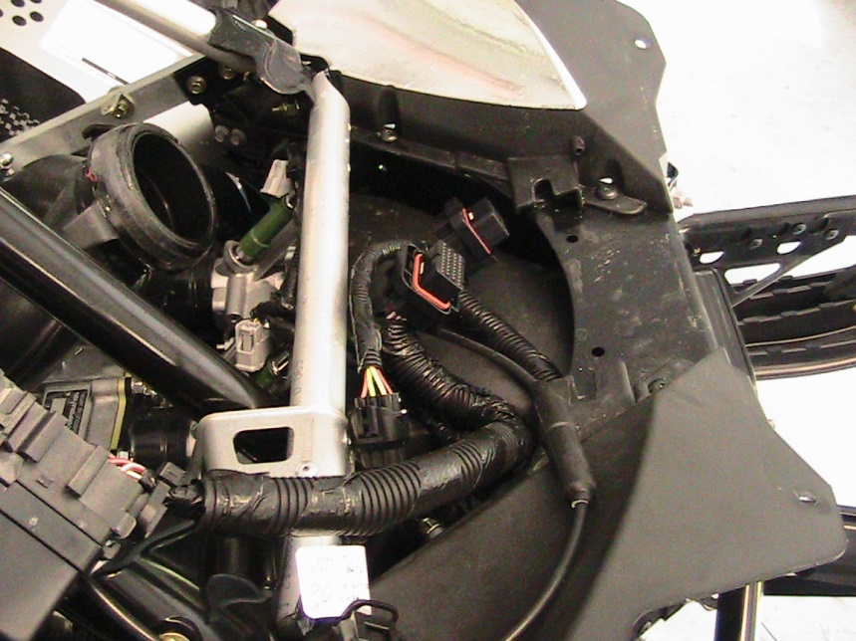
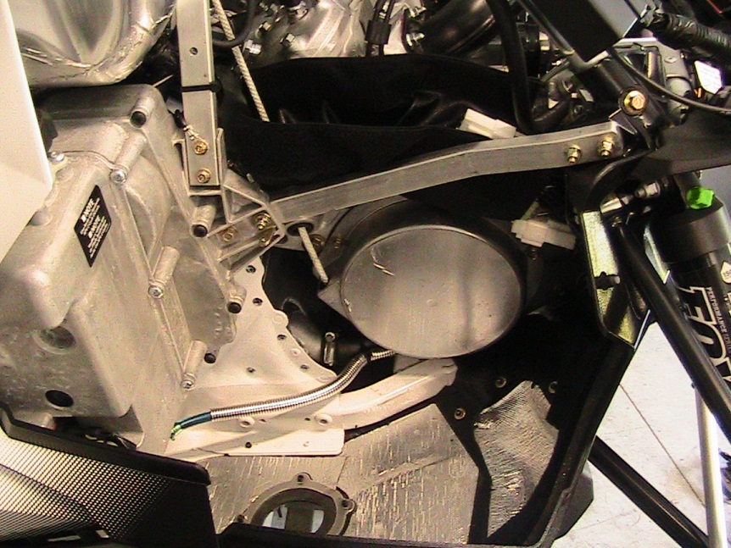
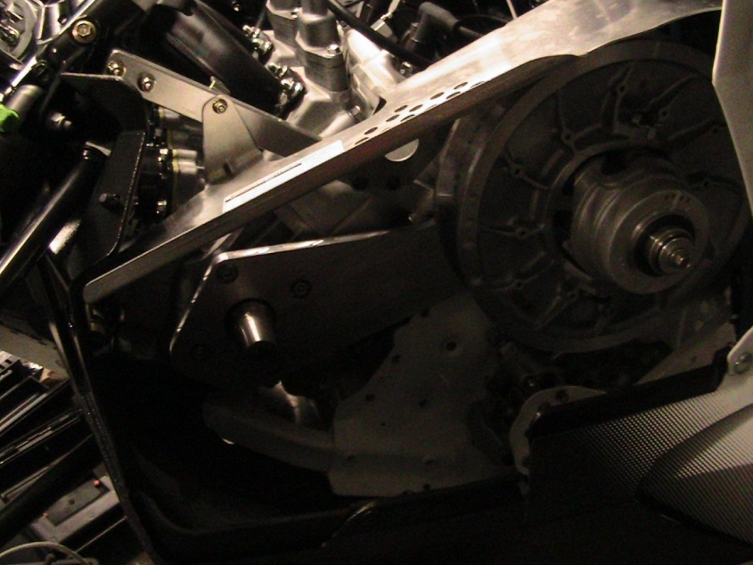
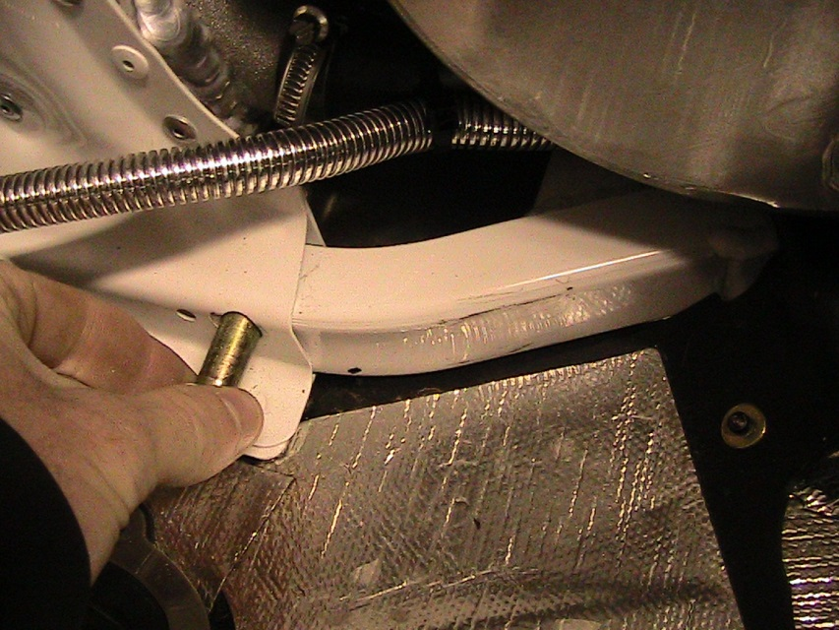

- Installation

- Mount the Factory ECU on the ECU bracket.
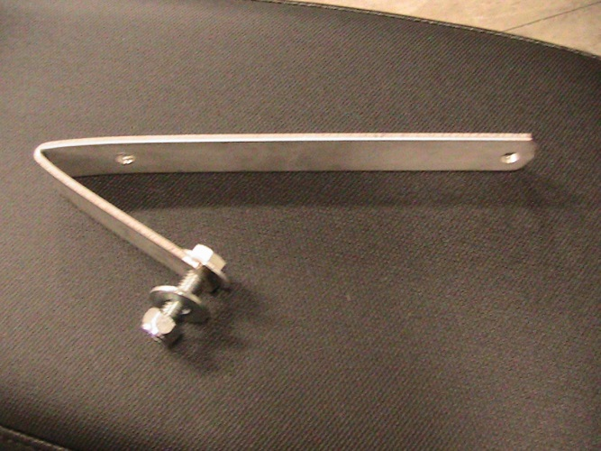
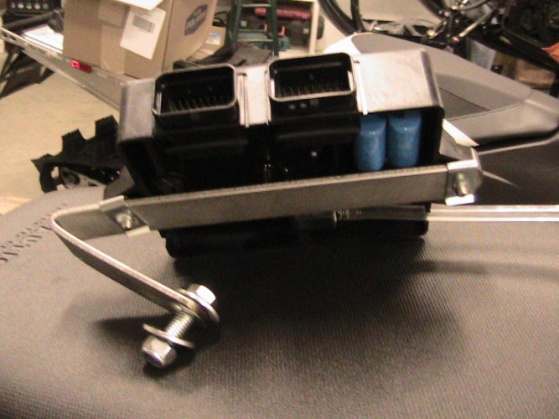

- Mount the ECU bracket to the bulk head under the throttle bodies. There is an existing hole already in the bottom of the bulk head.

- Air Box Installation

- Reinstall the throttle bodies ( make sure to hook up the oil linkage.)
- Install the aluminum turbo air box onto the throttle bodies. Mark on the throttle bodies to drill a ¼ hole for fastening the air box.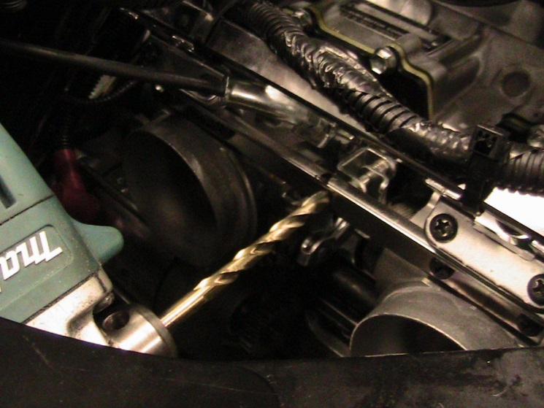
- Install the aluminum air box, fasten the air box with the supplied ¼ bolt and nut.

- Vacuum Line

- Drill a 3/16 hole into the rubber throttle body boot as soon. You will install the aluminum fitting into this hole. The hoses connected to the fitting will be used to connect to the ECU, BOV and Boost Gauge.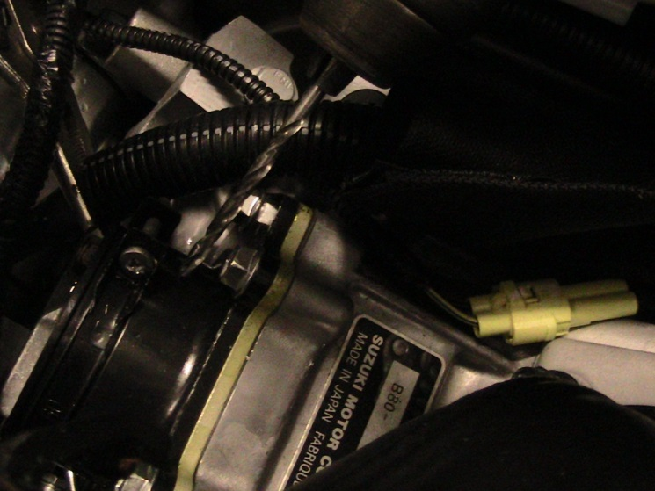

- Exhaust Valve Servo Relocation
- Remove the exhaust valve servo motor from the chassis support bar. Drill out the 3/16 rivets.
- 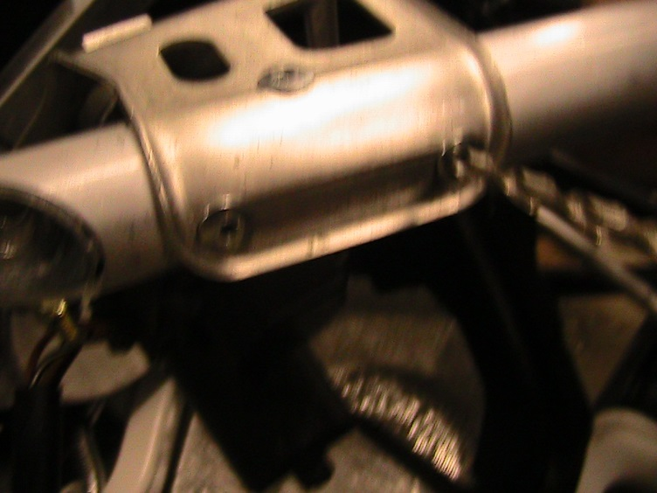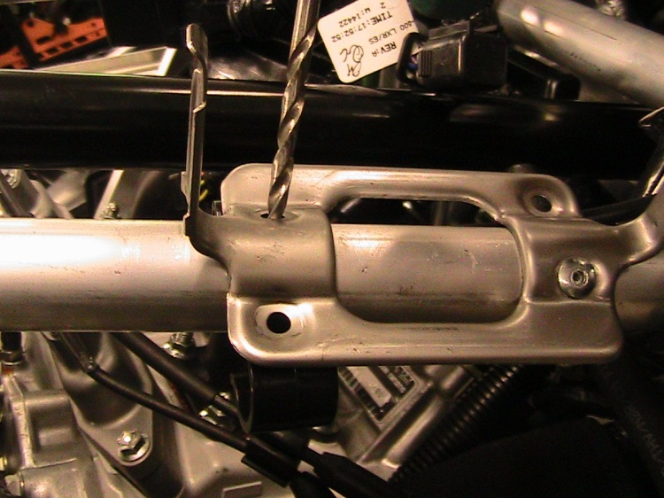

- Install the exhaust valve servo motor onto the tri spar frame bar. It can rivet to the existing holes in the bar. Fasten with a 3/16th rivet.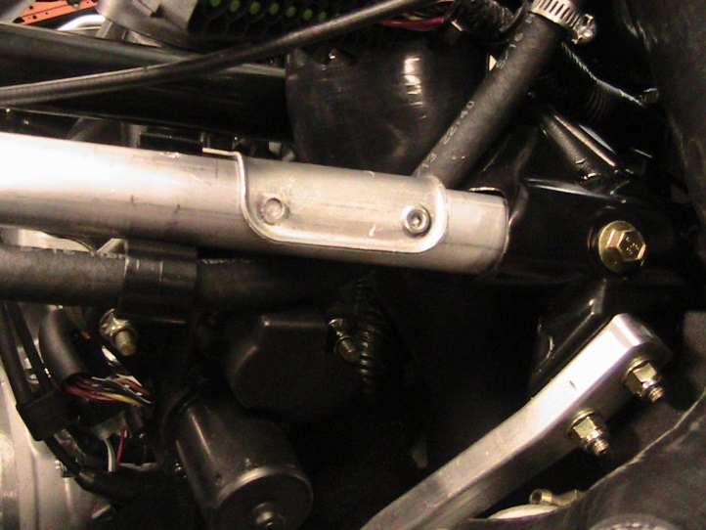

- Control Box Wiring Connections

- Connect The Control box wiring connection in line with the Mag. Fuel Injection plug.
- You will connect the TPS plug in line with the TPS Connector.
- Connect the Black ground wire to a good chassis ground.
- The last two plugs will connect to the 3 Bar borsch map sensor and fuel injector located in the charge tube.

- Turbocharger Assembly

- Install the Turbocharger and oil tank assembly. Fasten the Muffler to the chassis using the OEM bolt in the bulkhead. Reference the picture for mounting locating.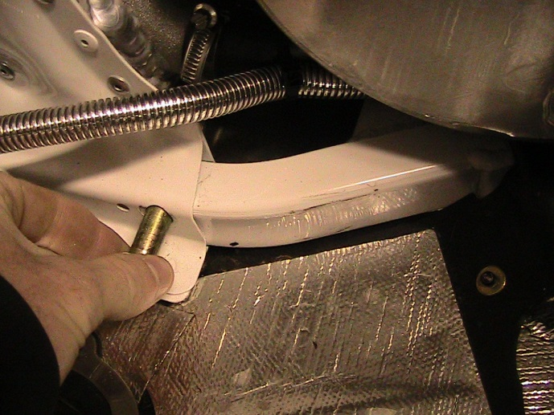
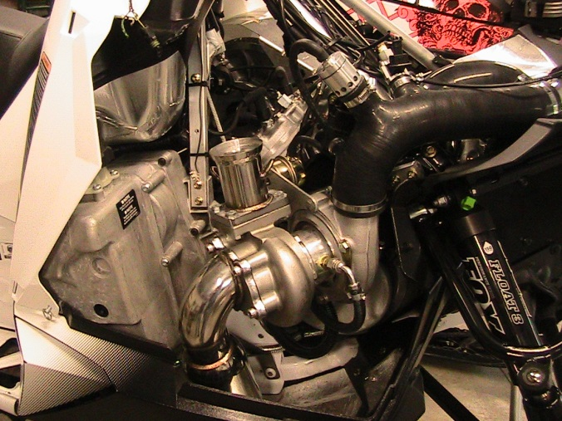

- Connect the Cold Air Intake Silicone Tube onto the Turbocharger. The larger 3” end will connect to the turbocharger.
- Connect the 2.5” end to the plastic air intake adapter. Fasten with the supplied hose clamps.
- Hook up the Coolant lines on the turbocharger. Remove the Mag side coolant line from the OEM throttle bodies. Connect the longer line from the turbocharger to the throttle bodies. Connect the OEM line to the other side of the turbocharger using the installed push lock fitting.
- 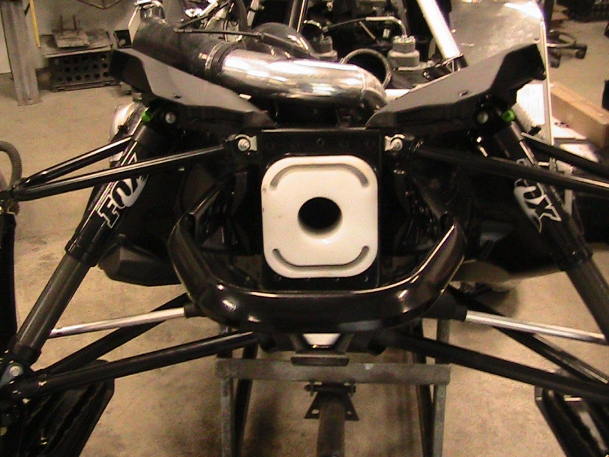

- Vacuum Line Hook Up

- Connect the preinstalled vacuum lines. The end with the check valve installed connects to the ECU hose. (Clear hose connected to the ECU).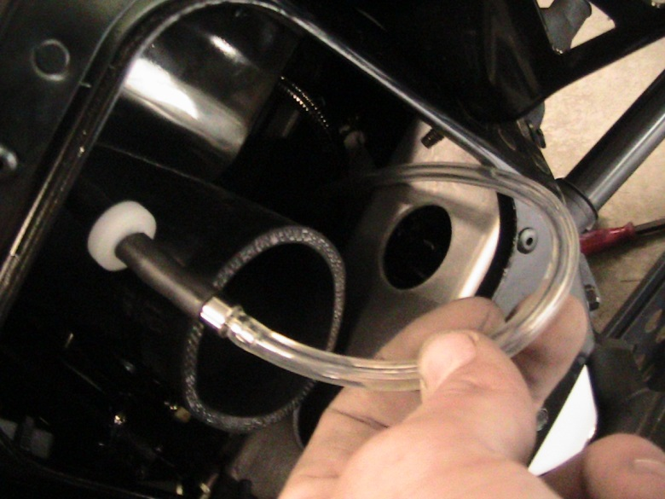
- Connect the 3/16 hose to Blow off valve located on the Charge Tube.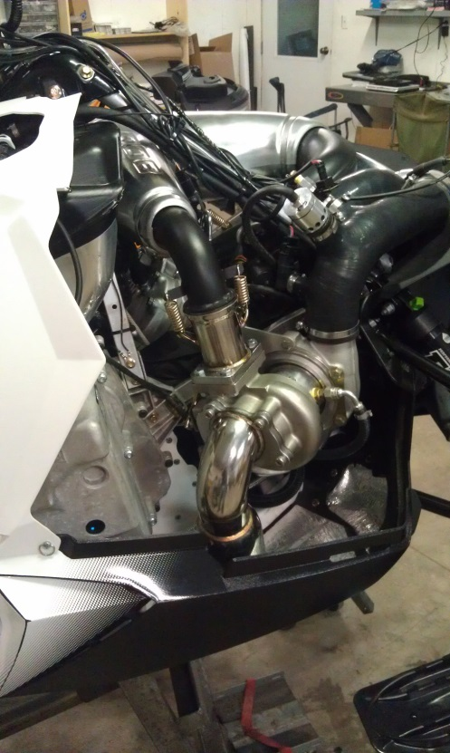
- The blank end will be used to connect the hose from your boost gauge.

- Charge Tube Installation

- Install the Charge tube onto the turbocharger. Fasten with the supplied hose clamps.
- Install the other end onto the air box. Fasten with the supplied hose clamp.
- Connect the Secondary injector fuel line, In line with the OEM fuel line that connects to the throttle bodies.
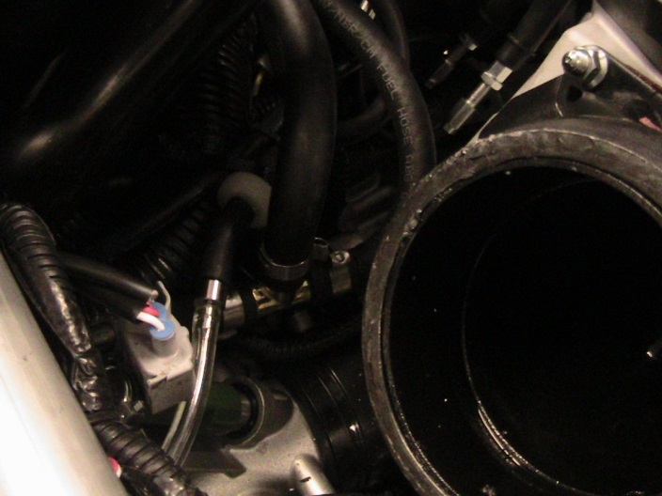

- Factory Pipe

- Install the factory pipe back onto the engine, and fasten it to the Y pipe and Turbocharger Assembly.
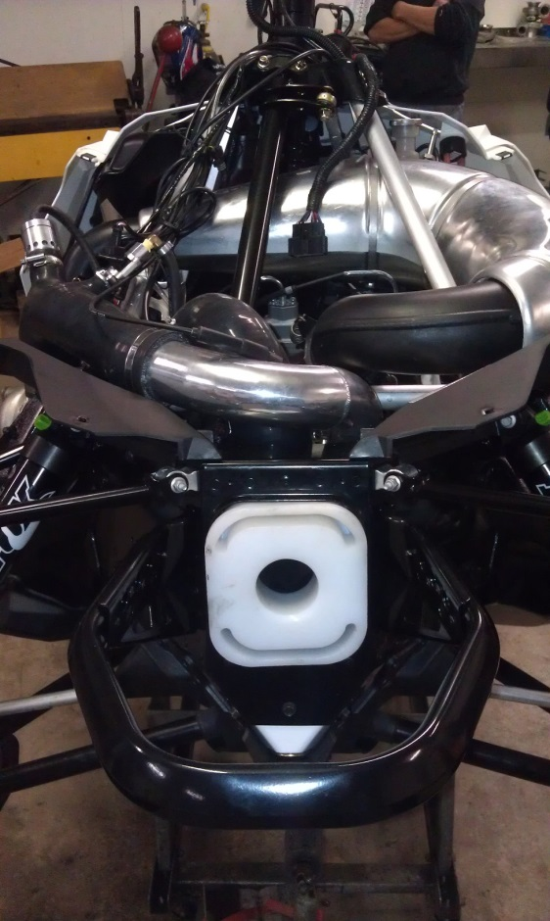

- Accessory Wiring Plug

- Locate the accessory wiring plug pigtail. This plug will install in line with the voltage regulator. The Connection is located in the black fabric pouch located above the recoil.
- Connect the pigtail inline.
- 1 end of the connector will be used to power your Wideband Air fuel ratio Gauge.
- The other end will be used to power the oil pump on the turbocharger assembly.

- Clutching

- Install the Clutch kit.
- Install the adjustable turbo weights and new primary spring. A good starting point is 6-8 grams heavier than your factory weights.
- Install the helix and secondary spring.
- Install the clutches back onto the snowmobile, be sure to torque your Primary Clutch back onto the engine.

- Gauges

- Install the Boost gauge and bracket onto the handle bars.
- Also install the Wideband air fuel ratio gauge onto the bracket.
- The boost gauge line will connect to the already installed vacuum lines you connected earlier.
- The Wideband will get power from the Accessory pigtail you previously installed.
- Install the o2 sensor into the muffler on the turbocharger assembly.

- Before you start.

- Make sure you calibrated your Wideband gauge and sensor, otherwise it will through and error code.
- Make sure all lines and hoses are properly installed and not rubbing on any sharp objects.
- Make sure the Fuel control box is properly connected and all connections are fully seated.
- Prime the oil Pump. Connect 12 volts to the oil pump and let it run for a few minutes. Do not hook the pump up backwards while priming. Also remove the oil feed line from the top of the turbocharger assembly to assure the oil is pumping.
- Top off all fluids, including the turbocharger oil tank, Should be half way into the sight glass. Also check coolant level.

- First start up inspection

- Instantly check that the turbo oil pump is pump oil under the sleds power. If it is not pumping recheck all your connections.
- Verify the control box powers up and functions through all the modes.
- Verify the Wideband Gauge powers up and reads correct AFR. If it reads 22.4 or 7 it’s not calibrated.

- Recommend Fluids

- Turbocharger Oil. Mobil One 5w30 or equivalent. Make sure to check your oil every ride. And during the first couple rides multiple times.

Follow the chart for recommended fuel and boost ratios.

Boost Fuel Chart
These Fuel mixtures should be used as a guideline to your turbo snowmobile settings.
3-5 PSI 5-7 PSI 7-10 PSI 10-13 PSI
0-3000 30% Race Gas 50% Race Gas 70% Race Gas 100% Race Gas
3-6000 20% Race Gas 30% Race Gas 50% Race Gas 70% Race Gas
6-9000 10% Race Gas 20% Race Gas 30% Race Gas 50% Race Gas
9-10000 0% Race Gas 10% Race Gas 20% Race Gas 40% Race Gas

