Fairmont II
Smart Watch + Cell Phone
User Manual
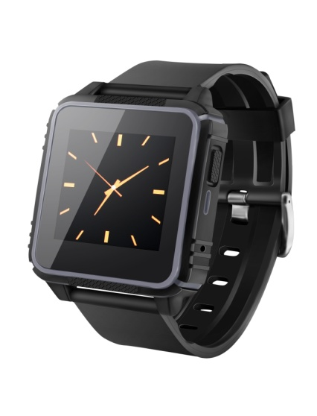

Please read the manual carefully before use

Many thanks for your purchase of our Fairmont II Surf Smart Watch + Cell Phone! , it is water-proof 3M, shock-proof, dust-proof and snow-proof sports smart watch, monitor your heart rate in real time, track steps walked , the distance taken and calories burned while you surf, swim, or workout.
Without the SIM card inserted，it is used as smart-phone mate which connects with phone via Bluetooth to your cell phone. With SIM card inserted, it is used as an independent smart watch cell phone. It is the best equipment for Surfing, Boating, Swimming, Water Safety outdoor sports enthusiasts, fitness, adventurers, etc.

Specification:
LCD Screen：1.54“
SIM Card：Nano Card
Battery Capacity：300mAh
GSM Frequency：850MHZ/900MHZ/1800MHZ/1900MHZ
Bluetooth ：BT V3.0 & V4.0
Waterproof Rating: IP68, submersible in 3M. No deep diving.
1

Touch Operation Guide：Swipe right to enter function option, select your wanted menu by scrolling up and down, and click to operate. Slide right to return to last page. Long-press clock interface accesses to the clock menu, there are three clock styles for option.

Key Function on Watch：Power on/off key and return key

SIM Card Inserting（NANO SIM card）
First use one finger to open SIM card cover as shown below, insert SIM card into slot as direction marked on the cover, fasten the slot cover, press and make sure all in position tightly.（detailed attention will be illustrated later）。 If you are not familiar with SIM Card Installation please see your preferred cell phone service provider and have one professionally installed for you.

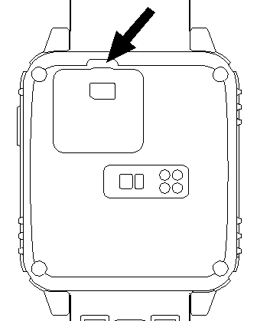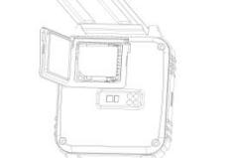

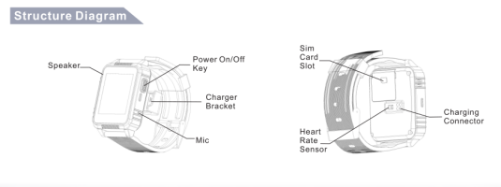

Battery Charging
The notch of the charging dock is locked towards right button of watch, put charging dock into the slots of watchbase and hear a “Ka” sound come out, then plug Mini USB of charging cable into charging dock and another USB plug into slot of computer or mobile adaptor. Within 2 hours, battery can be fully charged.
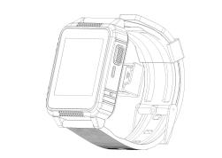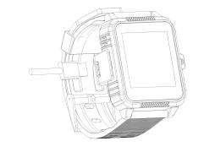

APK Download and Installation
PC terminal APK download:
For PC terminal download, pls access to https://play.google.com/
store/apps/details?id=com.kct.fundowear.btnotification to
download Fundo Wear  ,english and chinese version for option.

Android User:
Support Android 4.4 and above, lower version supports partial functions.
1: QR Code---Scan QR code on smart watch , download Fundo Wear 4
APK and click the English version to install after successful installation,
Fundo Wear will be shown in your mobile.
2. Connect Bluetooth V 3.0 firstly--- Switch on bluetooth on phone and smart watch to search each other, after successful finding and pairing with matching code, the blue bluetooth icon will be shown on the top left corner of menu and Bluetooth 3.0 is done.
3. Connect Bluetooth V 4.0--- Run Fundo Wear on phone into main interface 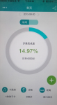, and click three points icon on the top left corner to log in， via email ID, wechat or, QQ to log in, after done, go back main menu and you will find a green round icon “+”， clicking green“+” show red bluetooth icon and click again to
search matchable smart watch, after pairing successful, Green bluetooth icon will be shown on the top left corner of menu, blue and green bluetooth icon is shown on menu at the same time, smart watch is ready now.
If just connect with Green BT V4.0 and you dont register and just log in, sport and healthy data cannot synchronize to phone.

IOS User
Support IOS7.0 and above.
1. Accessing to AppStore to download “Fundo wear”，after successful installation, Fundo Wear will be shown in your mobile.
2. Connect Bluetooth V 3.0 firstly--- Switch on bluetooth on phone and smart watch to search each other, after successful finding and pairing with matching code, the blue bluetooth icon will be shown on the top left corner of menu and Bluetooth 3.0 is done.

3. Connect Bluetooth 4.0--- Run Fundo Wear on phone into main interface , and click three points icon on the top left corner to log in， via email ID, wechat or QQ, to log in. After done,
go back main menu and you will find a green round icon “+”， clicking green“+” show red bluetooth icon and click again to search workable smart watch, after pairing successful, Green bluetooth icon will be shown on the top left corner of menu, blue and green bluetooth is shown on menu at the same time, smart watch is ready now. If just connect with Green BT V4.0, don’t register and log in, sport and healthy data could not synchronize to phone.

Functions for IOS and Android System After Connection：
1. Select your wanted language after first- time starting smart watch;
2. Sync current time and date with phone ;
3. Anti-Lost: start the button of finding device on smart watch, phone will alert and vibrate ,after smart watch is far away around 10 meters, smart watch will alert and vibrate too; the smart watch and phone can be found each other；
4. Sync all on-time message to phone (such as SMS, Wechat, QQ message, Email, Sina Weibo, News,& WhatsApp etc)
5. Dialing out and answering phone call on watch；
6. Sync music player on mobile phone 
7. Sync phone book and call log；
8. Sync to check and read real-time message on WhatsApp, Viber, Facebook,Twitter, Wechat, QQ etc, sync instant voice talk, sync voice message and picture notification with phone
9.1 Remote Camera for Android User: Click “remote camera”on watch to take pictures as selfie sticker ;
89.2. Remote Camera for IOS User: Run video or photo on iphone, and click “remote camera”on watch to take pictures or video as selfie sticker ;
10.1 DuVoice to make a voice call for Android User: firstly need to download Baidu VOICE APP to smart phone, press to voice call out;
10.2 Siri to make a voice call for IOS User: 11. All SMS are pushed from phone to smart watch which can be editted ,texted and sent back;
12. Change bluetooth name (only for Android phone)
13. Download the Yahoo Weather from phone application to watch and install to check global instant weather condition(Android User)
14. Sync all data of statical heart rate, steps walked, sleep quality to the Cloud to save lifetime.
15: Automatically answer the phone call after three-time ring and vibration, touch the Close while phone call coming to cancel the function. Adjust volume by scrolling up and scrolling down.

Other Functions
- Heart Rate Monitoring: “Once” and “Repeat ”mode for option;
- Pedometer: Record steps taken, distance traveled and calorie burned. target steps and weight can be preset on menu and always save the latest 10-time update;
- Sedentary Reminder：11-time period of reminding for option;
- Sleep Monitoring: Monitor and adjust the quality of sleep;
- Menu Style：White and orange theme for option;
- Power Saving : Normal and power saving mode;

- Alarm：Customized five kinds of alarms are provided;
- Stopwatch: Save the latest 20-time update record;
- Motion Sensor: Adjustable 5- motion sensor mode：flip to mute incoming call; flip to mute alarm; wake-up gesture; shaking switch main menu; shake to answer the call;
- Others: Calculator, Calender.

Heart Rate Monitoring Method and Notes
The Fairmont II is taking use of the advanced photoelectric sensor, high precision full-seal waterproof structure design and high-precise algorithm, is a light-weight and useful outdoor sports smart watch to provide real time heart rate monitoring anytime and anywhere.
To ensure of accuracy of heart rate monitoring, it is a must for user to fasten watch to your wrist tightly before test, green light is not
allowed to expose outside. start the button of heart rate monitoring, please don’t move and stay for around 10 seconds till heart rate reading. There is a different reading if wearing it on different skin color.
In lower battery indication, heart rate accuracy will be affected and not so accurate, which requests you to recharge till full.
Warning: The watch is not medical device, it is a recreational product, all the data on watch are just for reference and could not regard as a standard for clinic monitoring!

Waterproof Test and Installation Notes
Before shipment every Smartwatch is completely tested by high-precision waterproof test equipment to make sure of worry-free service. Before use it, please install and waterproof test as following procedures:

Step 1： Using a finger to pull SIM Card cover out, while pulling up, if longer fingernail, please control your used strength to avoid hurting
cover and digging out a tent. Any wispy hair or tent on cover will affect the performance of the waterproof feauture .
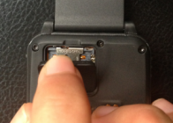
Step 2：Install the SIM card cover as the left arrow direction of below figure，back cover is completely coupled with the watch, press tightly to seal well. and then put watch into water to test for several minutes.
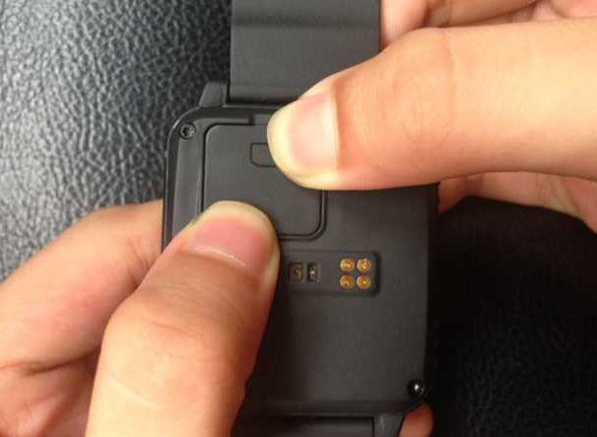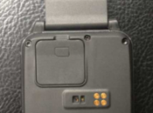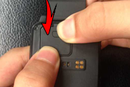
Step 3：Take watch out from water and wipe-off, open the SIM card cover slowly, if any small waterdrop on sides of cover dry these carefully. And check to make sure there is no water inside or on the Sim Card Cradle, and that there are no obstructions, hairs etc,, that could make the waterproof seal not work correctly.

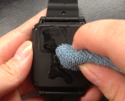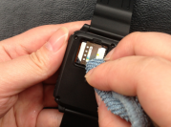
Step 4： Open SIM card slot ,put SIM card inside and cover it tightly, the watch is ready now
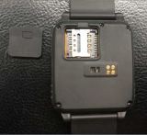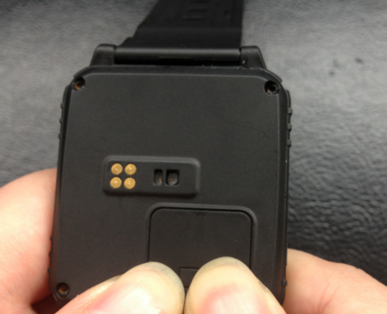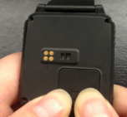
While swimming in water, before picking up phone call, it is best to pour out the extra water of speaker slot, water will stay inside of slots and affect the sound quality if don’t pour out or blow it out. After the waterproof adhesive lamination is completely dry, the sound volume will recover normally.

Notice: The manufacturer however reserves the right to amend the specifications according to market demand without notice.
Company Information and Support:
Website : https://www.detonate.co
FB: https://facebook.com/detonate.co
IG: https://instagram.com/detonate_surf_co
Webshop: www.shop.detonate.co
Customer Service Email Support: Smartwatch@detonate.co

Warranty Card
Item No
Buyer
Telephone
Purchase Date
SKU#
Address
Distributor |  | Signature & Stamp
Distributor Telephone |  | Signature & Stamp
Address
Repair Record

