Sportneer Folding Chair
User Manual
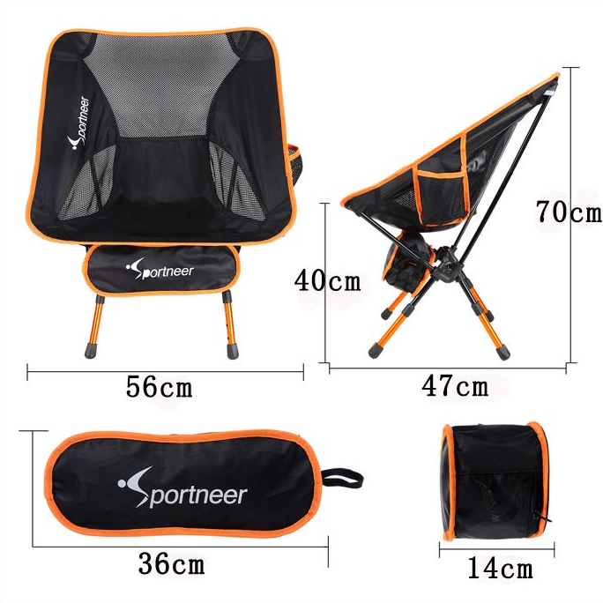
Description
Sportneer Portable Aluminum Alloy Folding Chair is the support you need from a convenient on-the-go chair. It is built to handle up to 350 lb in weight. The chair is simple to unpack and set up, and the material conforms to the shape of your body to enhance comfort. It is perfect for home and outdoor application like camping, hiking, picnicking, fishing, concerts, stadiums, parts, seashores and more!
Specifications
- Material: 7075 aluminum alloy + 600D denim fabric
- Bear Load: 350lb
- Product Weight: 2lb
- Unfolding Size: 56 x 47 x 70 cm
- Packing Size: 36 x 14 cm
Package Contents
1 x Aluminum Alloy Frame
1 x Chair Fabric
1 x Zipper Bag
Assemble the Folding Chair
Open the zipper bag, and take the metal frame and chair fabric out from the bag.
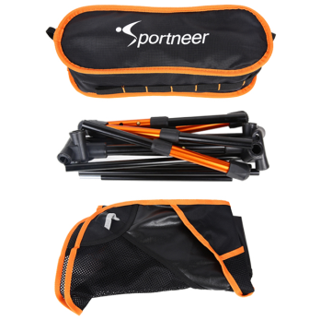
First assemble the 4 bottom legs (the orange bars). Insert these orange bars into the 3-way elbow fittings.
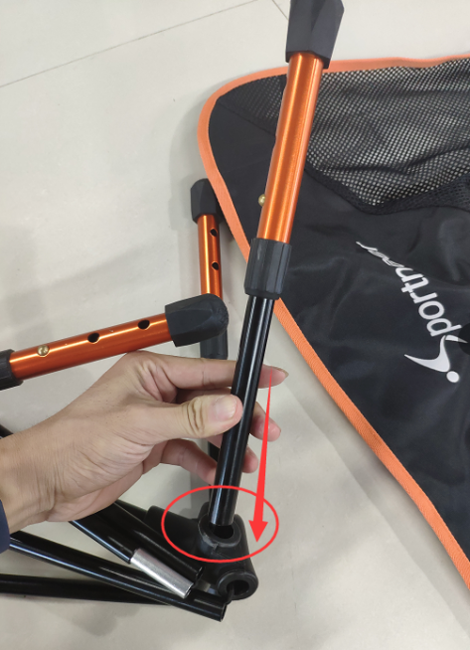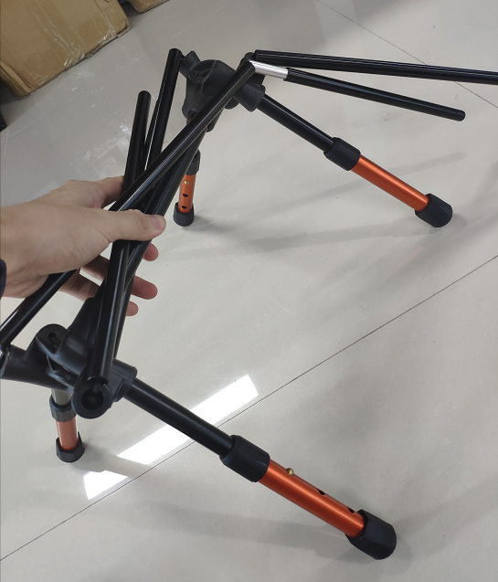
Assemble the upper frame by inserting the black bars into the elbow fittings.
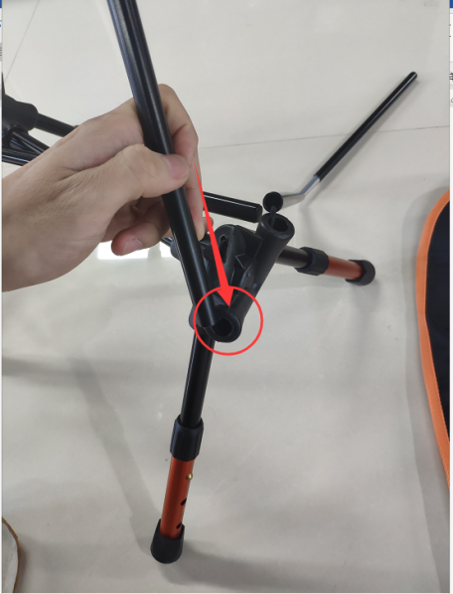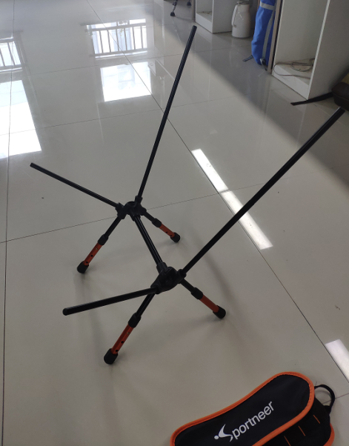
Mount the zipper bag on the upper frame (shown as picture).
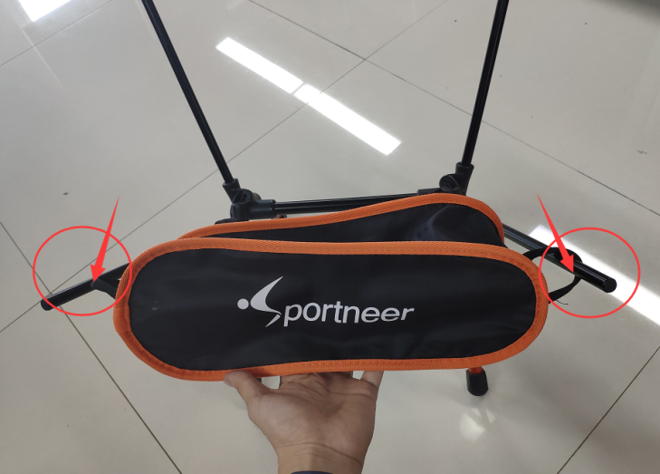
Mount the chair fabric and pay attention to face the side with Sportneer outward.
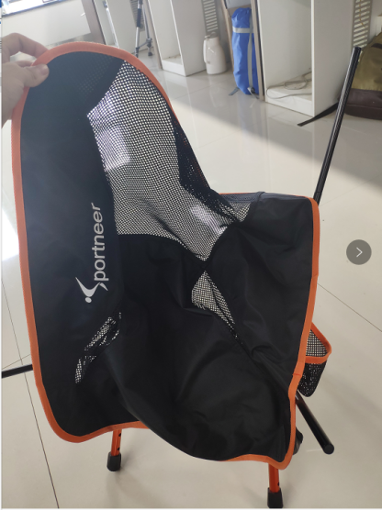
Fasten the 4 corners of fabric on the end of upper frame. It’s done!
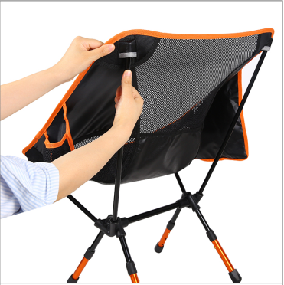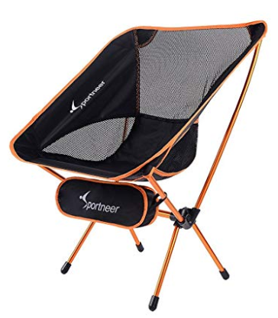
Disassemble the Folding Chair
Dismount the fabric from upper frame and pull out the black bars.
Pull out the orange legs and fold them down (leave the axis bar unplugged).
Axis bar
Store the aluminum bars and chair fabric in the zipper bag.
Tips: You can also take a reference of the website ：https://www.amazon.co.uk/dp/B07CJ9CS65
Cautions
Do not put forcible effort in assembly and disassembly to cause irreversible damage.
Place the folding chair on a sturdy, flat ground to avoid tumbling.
Be careful of the elastic rope inside the bar to prevent personal injuries.
Do not exceed the bear load.
Please contact the Sportneer customer service team for help if anything occurs or you are doubting in the assembly.

