


CSAB USER’S MANUAL
Key functions of the Communications service authorization and billing (CSAB) Portal

Last Updated: November 5, 2019

Table of Contents
Contents
1. Introduction 3
1.1. What is CSAB? 3
1.2. Key Functionality 3
2. Creating an account/logging in 4
2.1. Welcome Screen 4
2.2. Creating an Account 5
2.2.1. Replacing or Updating an Administrator 6
2.3. SUNCOM Network Services Agreement (SNSA) 6
2.4. Logging In 7
3. The Dashboard 8
4. Managing My Account 10
4.1. Creating/Editing Users 10
4.1.1. How to Create a User 10
4.1.2. How to Edit a User 10
4.2. Setting Permissions 12
4.3. Changing Your Password 13
5. Applications 13
5.1. Invoicing 13
5.1.1. Invoice Explorer 13
5.1.2. Reports 15
5.1.3. Invoice Search 15
5.2. Communications 16
5.2.1. SIMS 16
5.3. Ordering 18
5.3.1. How to Order a Service 18
5.3.2. Quote Builder 23
5.4. E-Rate 25
5.4.1. What is E-rate? 25
5.4.2. New E-rate Applicants 25
5.4.3. E-rate Guide 25
5.5. Inventory 25
5.5.1. Getting Started 26
5.5.2. Filters 26
5.5.3. Views 28
5.5.4. Actions 28
5.5.5. Reports 31
6. Organizations and Accounts 31
7. Help and Support 33
7.1. Help documents 33
7.2. SIMS 33
7.3. SUNCOM Helpdesk 33

Introduction

1.1. What is CSAB?
The Communications Service Authorization and Billing (CSAB) portal, also known as the SUNCOM portal or CSAB portal, is software that allows SUNCOM customers to manage their telecommunications accounts, inventory, ordering, as well as view their charges. CSAB uses an innovative combination of technologies to empower SUNCOM customers to track and minimize their charges.

1.2. Key Functionality
Technology used by CSAB includes:
- Metadata tags that allow customers to label charges, accounts, locations and more, so that tracking, reporting and auditing charges is easier and more complete.
- A Framework of Application Program Interfaces (APIs) that will allow customers and vendors to use CSAB software functions in their custom applications.
- An Open and Shared Library where customers can store custom applications and use applications written by other customers.
- Database restructuring that will give customers more flexibility and information and significantly enhance customer management and reporting of telecommunication charges.
- Messaging tools that will allow CSAB to exchange data in near real time with vendors and customers.

2. Creating an account/logging in

2.1. Welcome Screen
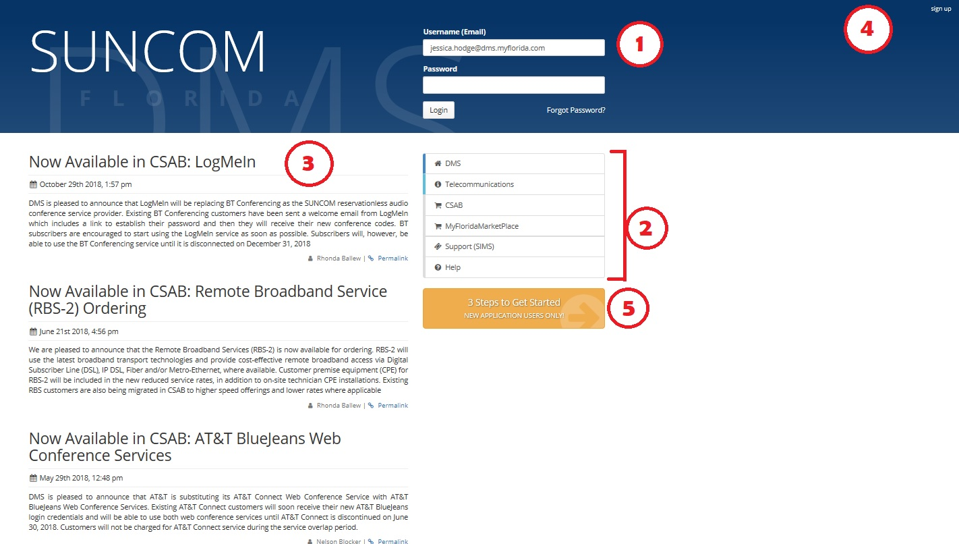
When you first open the CSAB site, you will be greeted by the following welcome screen:

Figure 1 -- CSAB Welcome Screen

Figure 2 -- CSAB Welcome Screen

- Login – Enter your username and password here to login.
- Quick Links – This connection contains quick links that allow you to view the Florida Department of Management Services (DMS) Website; the telecommunications section of the Division of State Technology website; MyFloridaMarketPlace, the state’s purchasing portal; the SIMS page; and the help page.
- News Feed – See news and updates related to the CSAB portal and SUNCOM services.
- Sign Up Link – Directs you to the Three Steps to Get Started, which is outlined in Section 2.2. Click here if you do not have an account or login.
- Three Steps to Get Started Link – Directs you to the Three Steps to Get Started which is outlined in Section 2.2. Click here if you do not have an account or login.

2.2. Creating an Account
If you do not have CSAB login credentials, click in areas 4 or 5 of the welcome screen (see Figure 1 -- -- CSAB Welcome Screen). You will be directed to the Three Steps to Get Started.
- The first step in the module is Find and Highlight your Organization. Search for your organization by typing in the search bar, then click its name in the resulting menu.

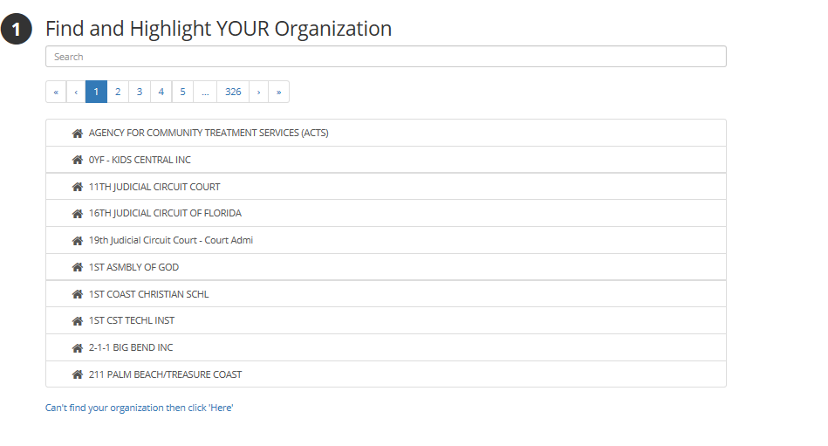
If you do not see your organization listed, click on can’t find your organization then click ‘Here’. For more information about this document, see Section 2.3.
Figure 2- Find Your Organization

Figure 3- Find Your Organization

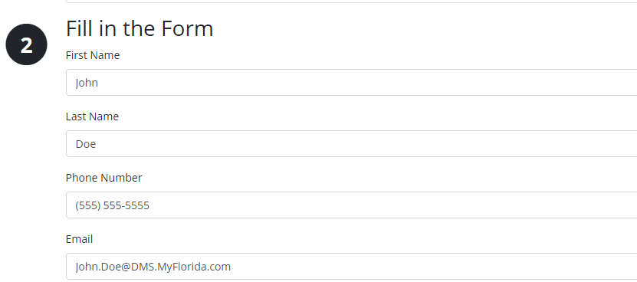
- Fill in the Form – Input your contact information. When the fields are completed correctly, they will highlight green.
Figure 3 - Fill in the Form

Figure 3 - Fill in the Form

- Fill out the human response test and submit the form to your administrator. If there is not an administrator on file, the request will be sent to SUNCOM to establish an administrator. If the form was submitted correctly, you should receive the following screen:

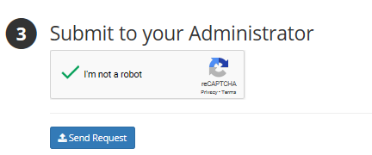
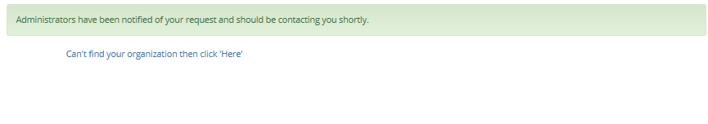
2.2.1. Replacing or Updating an Administrator
Figure 4 - Submit to your administrator

Figure 4 - Submit to your administrator
Figure 5 -- Submission Screen

Figure 5 -- Submission Screen
If an administrator account has been set up, but the email is no longer valid and/or the employee has left the organization, open a SIMS ticket (instructions in section 5.2.1.), making sure that New CSAB Administrator is the subject line. You will receive a response with further instructions.
If you require a new administrator, you will be asked to fax or email a letter from your CIO with the new administrator’s name, as well as the name of the former administrator. This letter must be written on the official letterhead of your agency or organization.
In both correspondence methods, please make sure that you include the Agency ID as well as the correct spelling of the new or replacement administrator’s name, their phone number, and email address.

2.3. SUNCOM Network Services Agreement (SNSA)
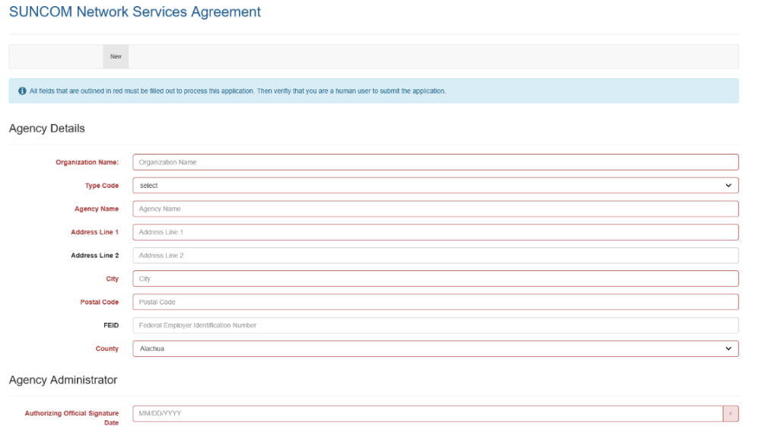
If your organization is not a SUNCOM network customer, or if no one in your organization has ever created a CSAB account, you must fill out the SUNCOM Network Services Agreement. Before you fill it out, select an organization administrator/contact and gather his or her contact information.
Figure 6 – SUNCOM SNSA

Figure 6 – SUNCOM SNS

2.4. Logging In
Once you have received your login credentials, you can access your approved applications within CSAB by logging in. However, there is a wide variety of information available without logging in. Click the Help link on the welcome page (see Figure 1 -- CSAB Welcome Screen).
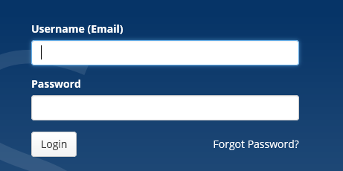
Instructions
- Enter your email address in the Username (Email) field.
- Enter your password in the Password field.
- Click the Login button.
Forgot Password?
If you forget your password, click the Forgot Password link and follow the on-screen instructions.

The Dashboard
When you log in to CSAB for the first time, the page that you immediately encounter is called the Dashboard. From this page, you can access CSAB applications and widgets. Please note that the dashboard may look different based on your permissions. Here are a few of the applications you might see on the left side of your screen:
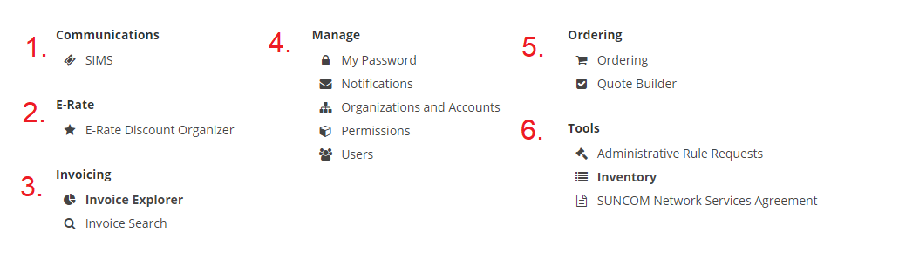
Figure 7 -- Dashboard, left side of page

Figure 7 -- Dashboard, left side of page
Below is a brief synopsis of applications that you may find on your dashboard. For a more in-depth explanation, or for more apps that may appear on the dashboard, please see Section 5.
- Communications applications
  - SIMS: This is the SUNCOM Incident Management System. Use this application to report an issue with a SUNCOM service.
- E-Rate (for verified users only)
  - E-Rate Discount Organizer: View and organize your e-rate discounts.
- Invoicing applications
  - Invoice Explorer: View, save and/or print your invoices
  - Invoice Search: Use this tool to find an invoice.
- Manage your account (for more information about managing your account, see Section 4)
  - My Password: Change your password.
  - Notifications: Manage and set the notifications you receive from the CSAB portal.
  - Permissions: Set permissions for users in your account (Administrators only).
  - Users: View existing users and add additional users (Administrators only).
- Ordering
  - Ordering: Order SUNCOM services/equipment, Request for quote.
  - Quote Builder: The application within which infrastructure requests are managed.
- Tools
  - Administrative Rule Requests
  - Inventory: This is a tool to view SUNCOM services inventory (to make changes to an inventory item, go to Actions). You can also search by inventory number in the Super Search (top right corner), selecting inventory, then scrolling down to Actions. You can make a change in this location as well.
  - SUNCOM Network Services Agreement.

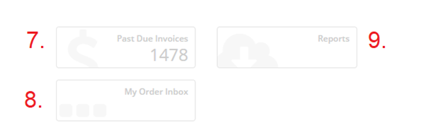
Figure 8 – Dashboard, right side of the page
Here are a few of the widgets you might see on the left or right of your screen, depending on how many appear based on your permissions.
Widgets
- Past Due Invoices: View past-due invoices.
- My Order Inbox: View your orders.
- Reports: View reports you’ve run in the past; these reports are stored for two weeks.

Managing My Account

Creating/Editing Users
Depending on your permissions, you may have the ability to create and edit new CSAB users.

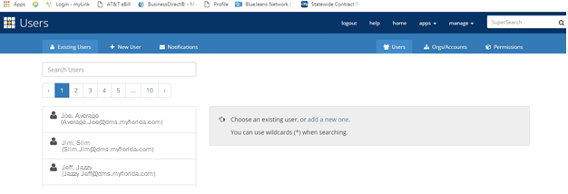
Figure 9 -- Users Page

4.1.1. How to Create a User
From the Dashboard (which is always available once logged in by clicking the Home link at the top of the page) click the Users link on the Manage menu. Once on the Users page, click the New User tab in the upper left portion of the screen.

Complete the New User form by filling in a valid Email Address, First Name and Last Name, and Contact Phone Number, then click save. Once saved, click Reset Password and the system will send the user a randomly generated password, which they can change upon signing in.

Currently, you must inform the new user about his or her account information. In the future, this may be automated via email.

4.1.1.1. Troubleshooting
What if I receive an error telling me the user already exists?

If the user already exists, then you may locate the existing user in the system by using the Users pane of the organizer. Once you’ve clicked on a user, additional actions should appear (the actual actions available to you will depend on your permission levels) in the Actions pane. From there you can edit the user’s name, email, address and phone number by clicking Edit Profile and reset the user’s password by clicking Reset Password.

4.1.2. How to Edit a User
If a user has outdated contact information that you would like to edit, use the following steps: from the Dashboard, click the Users link on the Manage menu. Once on the Users page, search for the user you wish to update. Once the name appears, click it, then click on Edit Profile. You will be able to update the user’s name and contact information. Once complete, click Save.

Setting Permissions
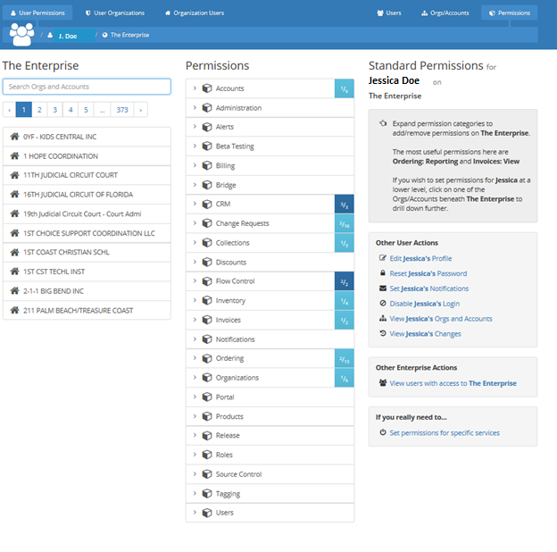
Depending on your permissions, you may have the ability to set permissions for users.
Figure 10 - The Permissions Page
Instructions
- Once the Permissions page loads, find the user you wish to set permissions for using the search user function in the Users pane of the organizer. Highlight the selected user.
- Choose the Organization Level at which you wish to grant the user permissions by using the Organization Explorer in the Organizations pane of the organizer. Highlight the selected organization.
- Choose the permissions to set by checking/unchecking the individual permissions in the Permissions pane of the organizer.
- Click Save to save the permissions for that user at that organization level.
You may notice that additional permissions (permissions you did not explicitly set) are now checked; these are implied permissions, or permissions that are inherent in the permissions you checked.

Changing Your Password
After logging into the CSAB Portal for the first time, you should immediately change your password.
Instructions
From the Dashboard page (always available once logged in by clicking the Home link at the top of the page), click the My Password link under the Manage option (either in the Dashboard menu or in the Drop-down menu). Enter your current password in the Old Password field, enter your desired password in the New Password field, then enter your desired password once again in the Confirm New Password field.
Requirements for Password:
- Minimum number of characters: 8
- Minimum number of numeric characters: 1
- Minimum number of special characters: 1
- Minimum number of uppercase characters: 2
- Click change to save the new password.
From now on you will log in with the new password.

Applications

5.1. Invoicing

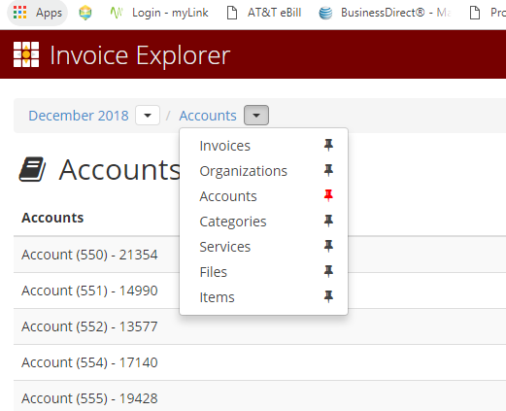
Invoice Explorer
Figure 11 – Filters in upper left corner of Invoice Explorer

Figure 11 – Filters in upper left corner of Invoice Explorer
The Invoice Explorer application allows you to view and manage your invoices.
Once you open the application, you will notice that you can tailor your view by selecting from the dropdown menu in the top left corner. You can view by date by selecting the appropriate month/year from the dropdown, and you can also choose whether to view by invoices, organizations, accounts, categories, services, files, and items.

If you choose to view by invoice, you can click on each one to view an itemized list of items charged. You will be able to see the item (phone number), the service, the vendor, tags (you can add/modify tags in inventory view), and the total amount charged. Click on each item to drill down to view a list of services charged per phone number, or the detail available for each service.
Please note that charges in parentheses are credits to your account.
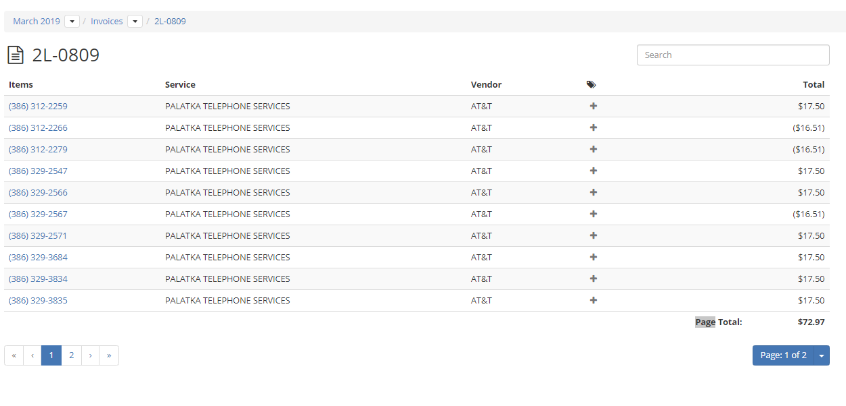
Figure 12 -- List of phone numbers/charges related to an invoice
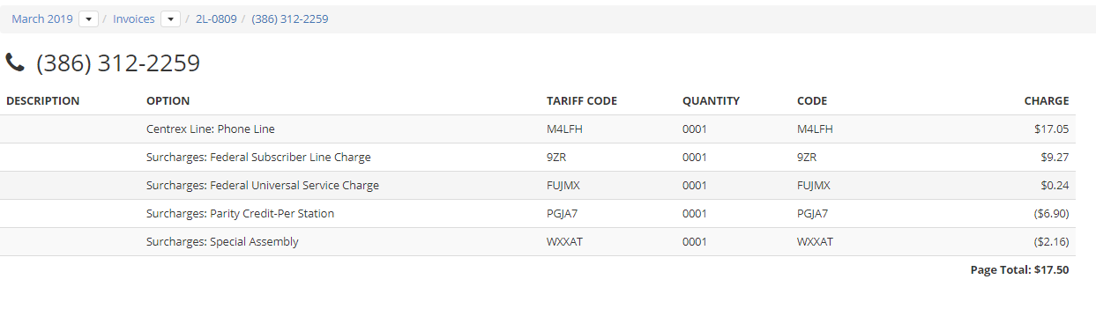
Figure 13 -- List of services/surcharges associated with a phone number.
As you drill-down to see detail, use the breadcrumbs at the top of the screen to go back to the previous levels/pages.
Figure 14 –Invoice Explorer breadcrumbs -- you would click the invoice # or phone # to go back to previous steps.

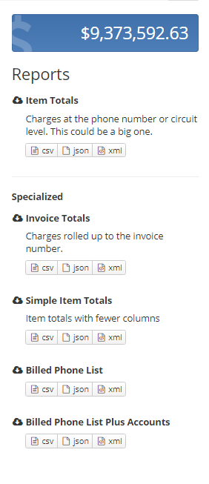
Reports
On the right side of the screen, you will see several reports you can run from your invoices. The reports offered can change based on the view you select and your permissions, but here are a few reports you can run in Invoice Explorer:
- Sub-Account Totals: Charges rolled up to the Service Category level. Categories include Data, Voice, Conferencing, Wireless, etc.
- Service Totals: Charges rolled up to the Service level.
- Sub-Service Totals: Charges rolled up to the Sub-Service level. Sub-Services are currently used to delineate Phone Systems within land-line telephone services.
- Invoice: Printer-friendly summary of charges for an account with payment information.
- Item Totals: Charges at the phone number or circuit level. This could be a big file.
- Item Detail: Individual charges including tariff charges, per-call utilization, and adjustments.
- Item Detail with Tags: Individual charges including tariff charges, per-call utilization, and adjustments. This report Includes tags.
Figure 15 -- Reports, right side of the Invoice Explorer screen
- Item Detail: This report shows all adjustments and reasons for adjustments as well as different lines/phone numbers.

5.1.3. Invoice Search
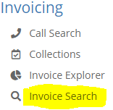
Use the Invoice Search application to search for an invoice. Enter the invoice number (do not include the dash), and the tool will return all related invoice(s). Do not hit enter after you have filled in in the full invoice number; otherwise, nothing will be displayed. Once the invoice appears, you may click on the invoice number and see all charges. You then can choose an item and view information regarding that specific item.

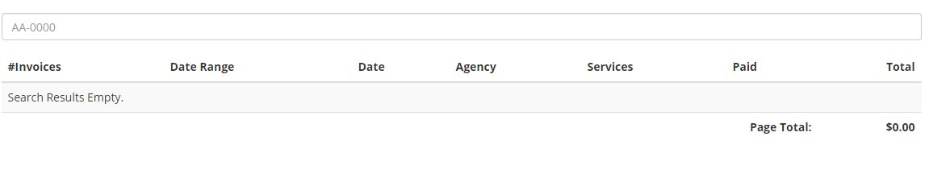 Figure 16 A&B - Invoice Search

Communications

SIMS
The SUNCOM Incident Management System (SIMS) is a ticketing system used to report issues surrounding a SUNCOM service.
Access the SIMS homepage through the CSAB homepage or the dashboard. Select whether you are a reporting a service provider incident escalation, a billing dispute/issue, a request for CSAB ordering help, a DNS Change Request, an eCMR, or a Change Management Request. Please note that you will have to login to CSAB to submit a DNS request, and the option to do so will only appear after successfully logging in.
If you would like to view contact information for various service providers, click the link in the upper right portion of the screen, labeled Support Contacts.
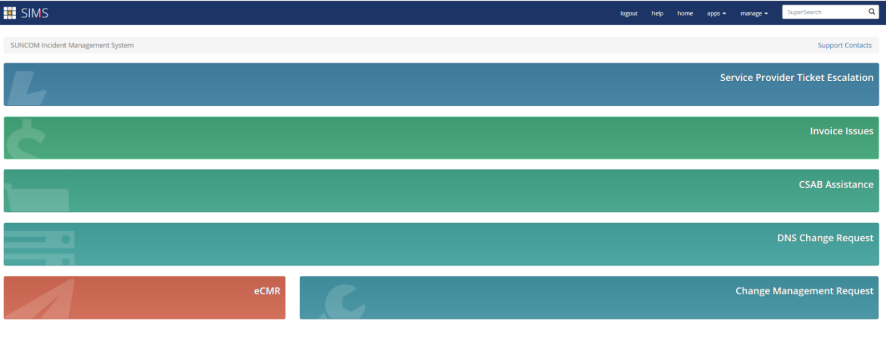
Figure 17 - SIMS Homepage
If you are reporting a Change Management Request, please view the tutorial available here: https://portal.suncom.myflorida.com/downloads/CSAB_SIMS_Tutorials_-_26SEP2018.pdf.
If you are reporting a service provider incident escalation, follow the following steps. Completing this ticket is very similar to submitting the other types of tickets.

- Select Service Provider Incident Escalation from the homepage.
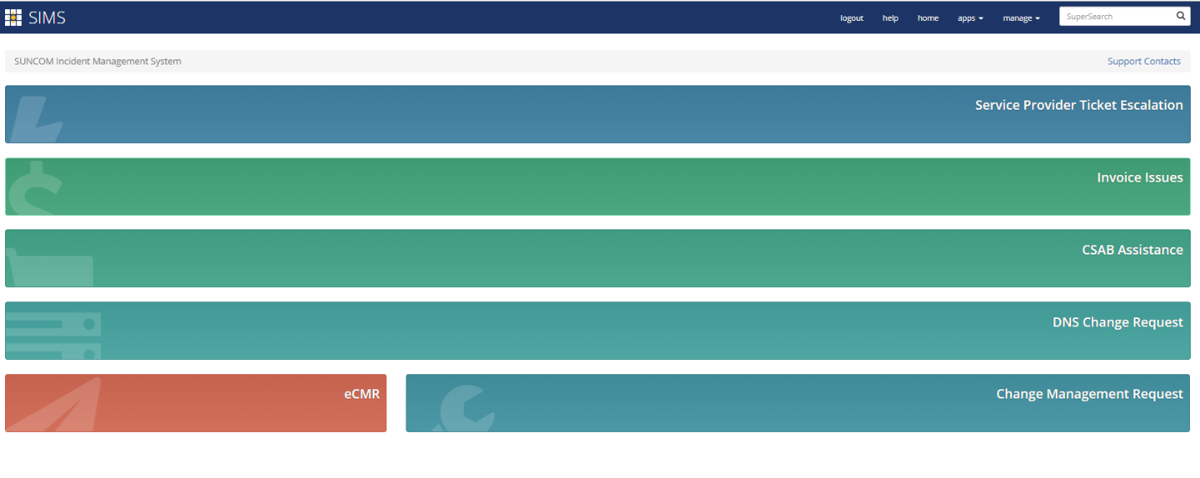
Figure 18 -- Select Service Provider Ticket Escalation
- Select a service.
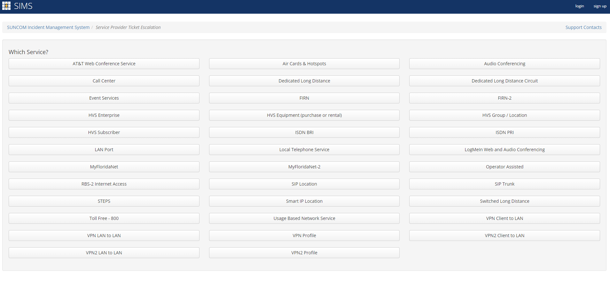
Figure 19 -- Select a service

- Select a vendor.
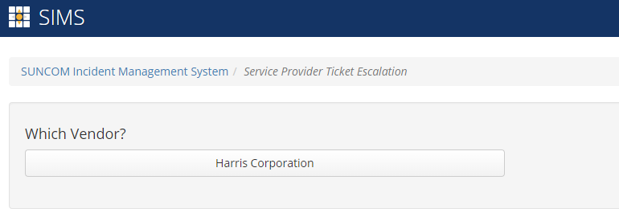
Figure 20 -- Select a vendor
- Enter the Vendor Incident Number. This is a REQUIRED field.
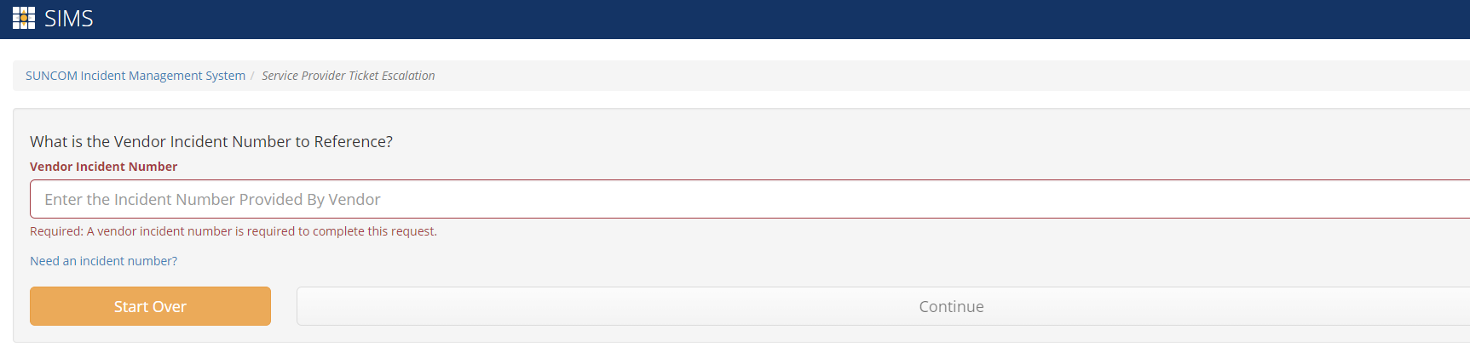
Figure 21 -- Enter the Vendor Incident Number
- Enter the details of your request.
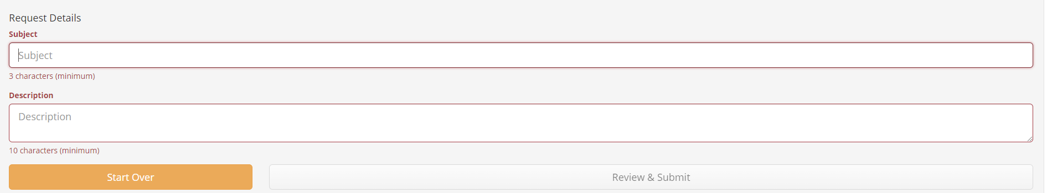
Figure 22 -- Enter request details

- Review and submit your request.

Ordering
The ordering application is where you would place an order for a new SUNCOM service. While you can use the interface to order a wide variety of services, please call Service Delivery (1-888-4-SUNCOM, and follow the menu instructions) for assistance with VPN2 and MFN2 requests.

How to Order a Service
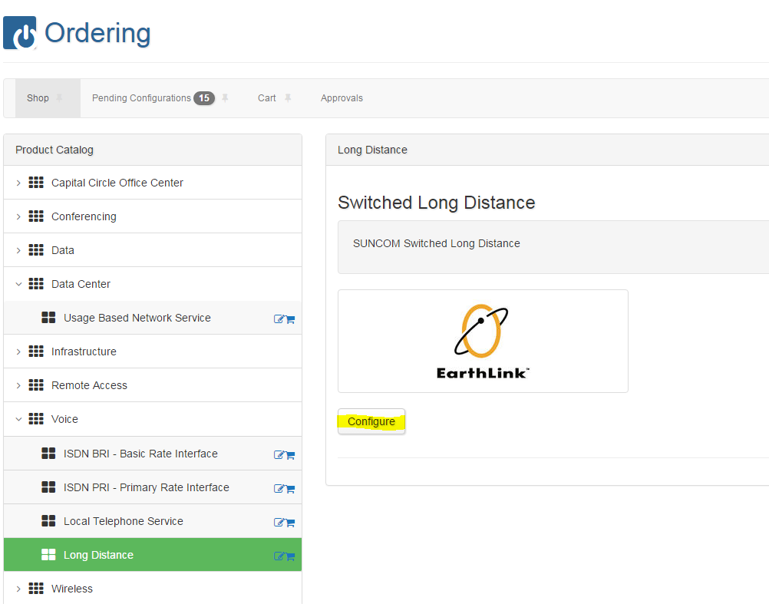
Use the following steps to order a new service. Let’s use ordering switched long distance as an example.
Figure 23 -- An example of the ordering home screen

- Click on Shop and then click on the product catalog service of your choice, then the data and click configure. If ordering switched long distance, select voice from the product catalog, then select long distance and click configure.
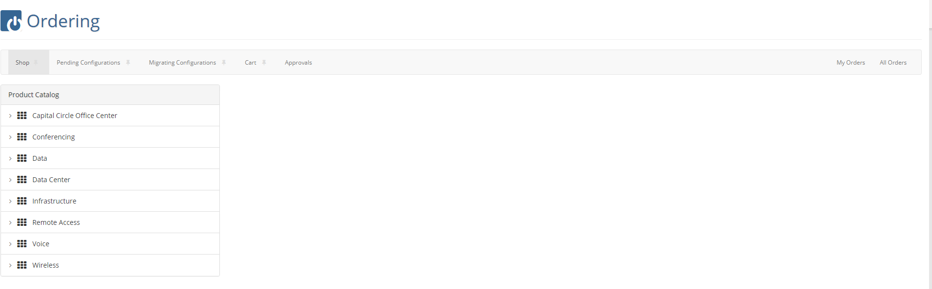
Figure 24 -- Ordering: Selecting a service and data
- Select the appropriate billing account and, if applicable, a sub-account. To add a sub-account, please see the Organization and Accounts section. 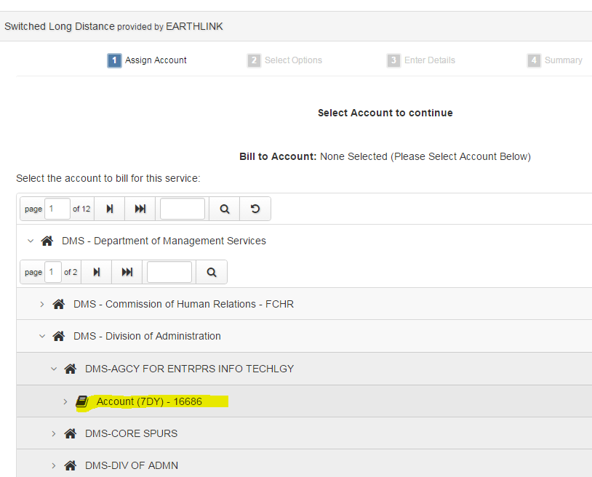
Figure 25 -- Ordering: Selecting an account
- Select your options. Services will vary, so make sure none of the drop-down areas are red. You must make a selection in those areas in order to proceed. If ordering switched long distance, expand the local service under Basic Features. Choose Business Line, Business BRI, or Business PRI. You will select Business Line in this case. If you want international calling, please select that option. If you want to be able to call all countries, then select all three options under international calling.
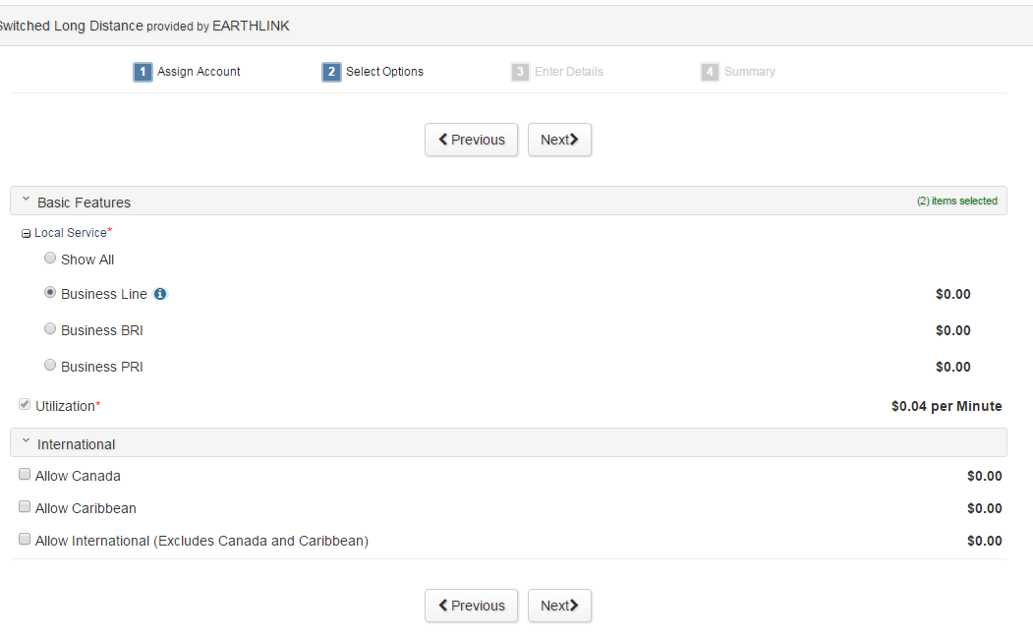
Figure 26 -- Ordering: Selecting Options for your service
- Supply customer information.
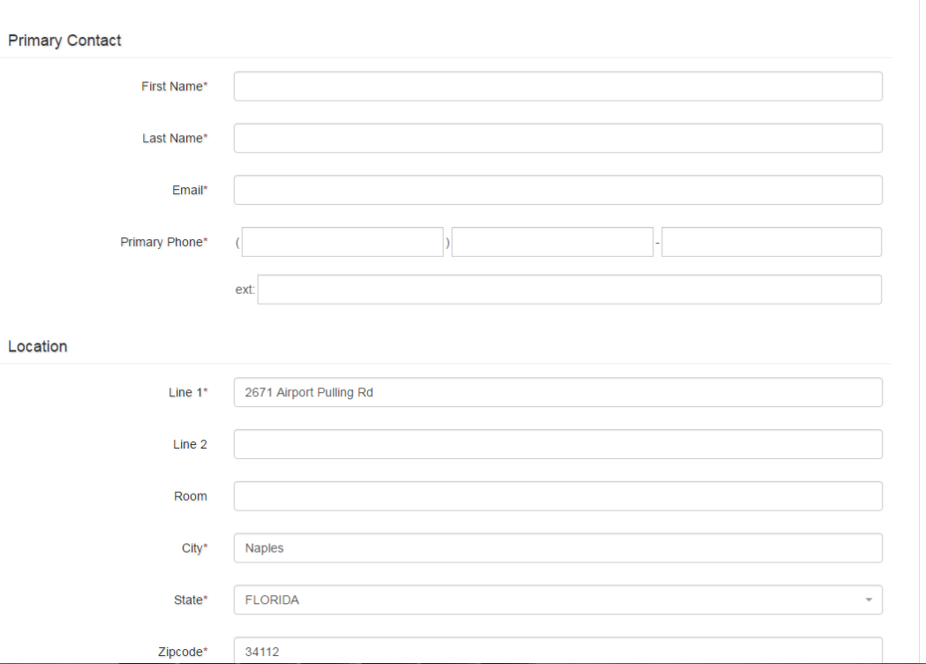
  - Some fields may be prepopulated, so check for accuracy. In addition, make sure all mandatory fields are filled out.
Figure 27 -- Ordering: Supplying customer info

- For switched long distance, enter in the requested telephone number needing long-distance access. Please note you do have to submit an order for each business line.
Figure 28 -- Ordering: Entering requested #
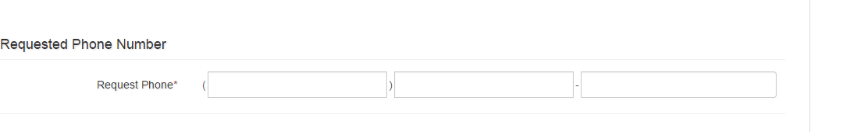
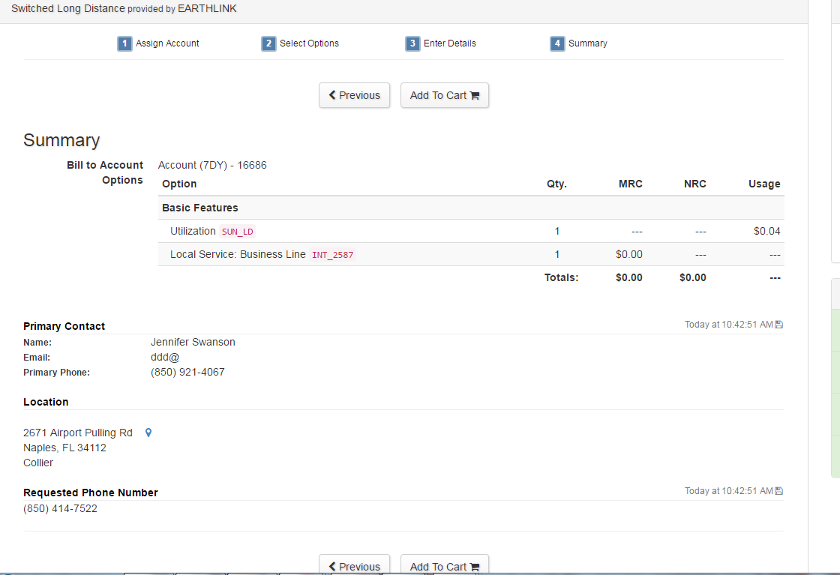
- On the summary page, click Add to Card and check out. Please enter in a preferred delivery date (a minimum of five business days). Then click Submit Order.

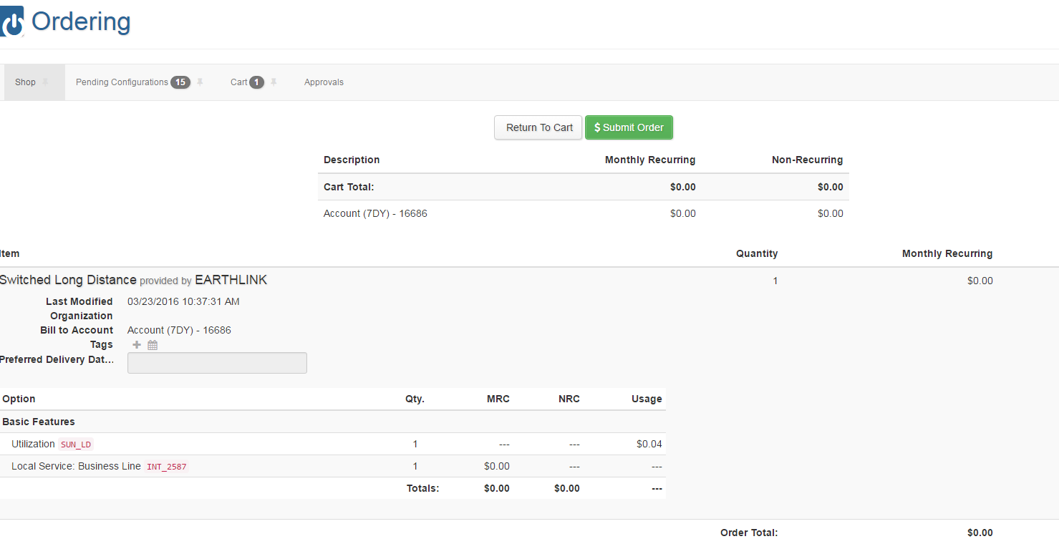
Figure 29 -- Ordering: Checking Out and Submitting Order

- To make changes to an order, go to the Inventory app.

5.3.2. Quote Builder
All requests for quote must be made in the Ordering application.
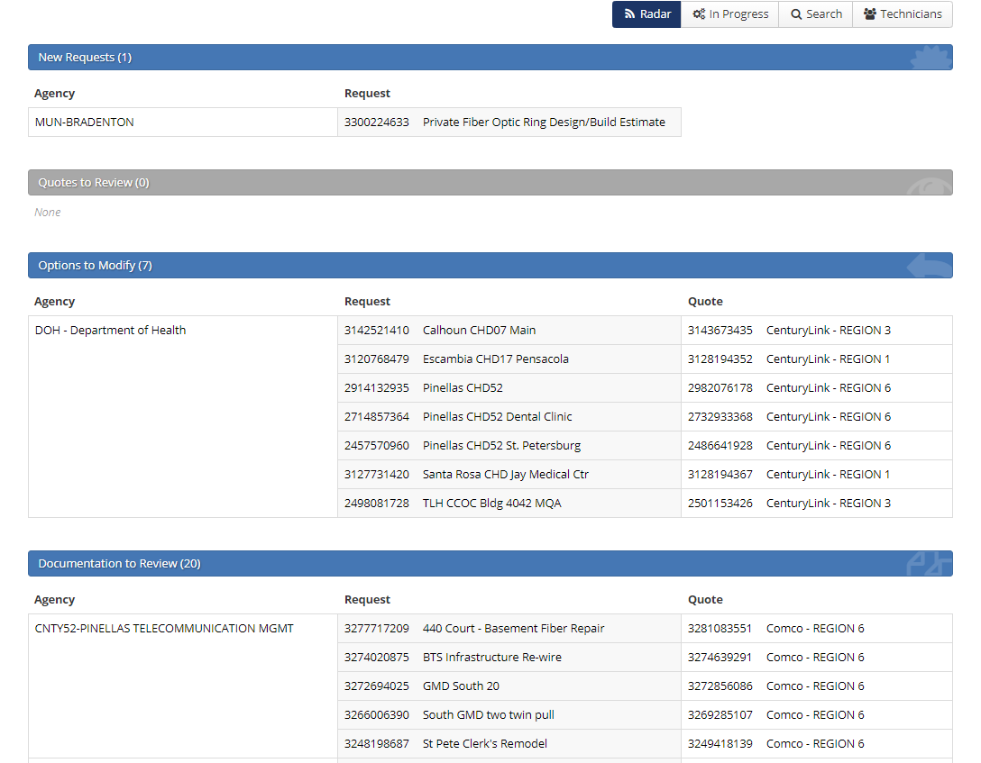
Figure 30 -- Quote Builder Screenshot
Quote Builder is the application within which infrastructure requests are managed.
Here, SUNCOM Engineers will:
- QA customer requests,
- QA vendor quotes,
- Enforce documentation requirements,
- Approve payment.
Here, Vendors will:
- Create quotes in response to customer requests,
- Opt-out of participating in certain requests,
- Manage documentation requirements,
- Submit documentation for payment.

E-Rate

What is E-rate?
As a result of the Telecommunications Act of 1996, the Federal Communications Commission (FCC) created the Schools and Libraries (E-rate) Program to ensure that schools and libraries have affordable access to advanced telecommunications services. Under the program, discounts ranging from 20% to 90% on Internet Access and 20%-85% on Internal Connections are provided to eligible schools and libraries, subject to an annual cap.
In order to receive discounts on eligible E-rate services, applicants must post an FCC Form 470 (Description of Services Requested and Certification Form) to request bids from eligible E-rate vendors. ”This process requires a minimum wait period of 28 days before the applicant can select the most cost-effective proposal. E-rate discounts are then requested by applying to the SLD. If discounts are approved, they are provided to schools and libraries via directly discounted bills, or a reimbursement process after services have been provided and paid in full. The E-rate funding year spans July 1 through the following June 30. (e.g. July 1, 2018 - June 30, 2019)
For official E-rate guidance, visit the SLD's website at www.sl.universalservice.org. For Florida-specific information visit the helpful links on the Florida Department of Management Services website.

New E-rate Applicants
For assistance, applicants should send inquiries to: erateassist@dms.myflorida.com
Applicants that are interested in seeking E-rate funding for internet access services provided through the State Master Contract will need to provide information necessary for the DMS E-rate team to process your application. Please be prepared to provide the following:
- Contact List: Name, Phone number, and E-mail for an authorizing official and an e-rate contact. One person can be the contact for both roles.
- Recipients of Service list: a list of all entities in your organization with BEN identifiers if applicable.
- Letter of Agency: Document required for DMS to submit applications on behalf of your organization.
- FCC Form 479: Document showing CIPA compliance. Required for internet access applications.
- Remittance Address: Primary address used by DMS to send checks when necessary.

E-rate Guide
An E-rate guide is available in the Help docs library. Access it here: https://portal.suncom.myflorida.com/docs/#/applications/discounts/guide?.

Inventory
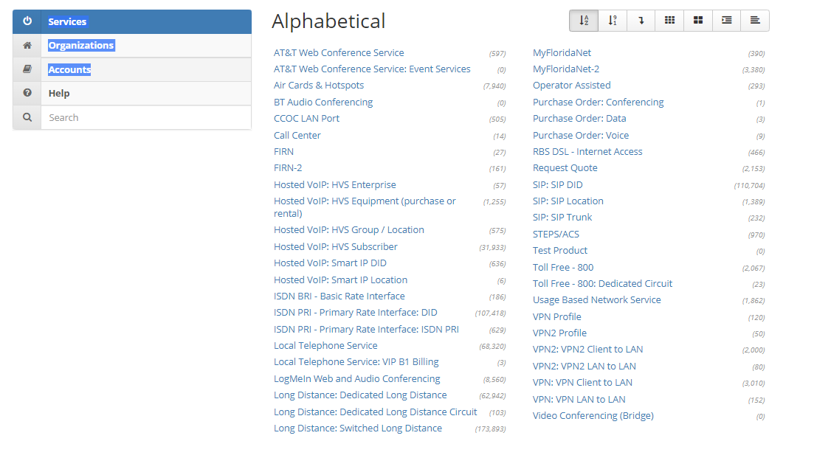
Figure 31 – Inventory homepage
Inventory provides a tool to view current options, details, and invoicing history for SUNCOM services. This is where to make option changes for any item. This includes adds, moves, configuration changes, and disconnects. There are various filters available to help navigate the inventory by Service, Organizations, or Accounts. This tool enables the user to customize views and filter on various sets of data. The reports area has a basic report, customized reports and other reports that have been used in the past.

Getting Started
Pick the view in which you would like inventory to be displayed. Click on Accounts, Organizations, or Services. You may also use the search field to Super Search for the item you seek. When you make your choice the first time in, you will see all associated inventory. The number in parentheses indicates the number of items. From here you can choose various filters to drill down further.

Filters
Once you have chosen the view of inventory you prefer by choosing the criteria on the left side of the page, you can filter down you what you are looking for specifically. Filters range from Organizations, Accounts, Item Status, Zip codes, IP Address, and a feature by service.
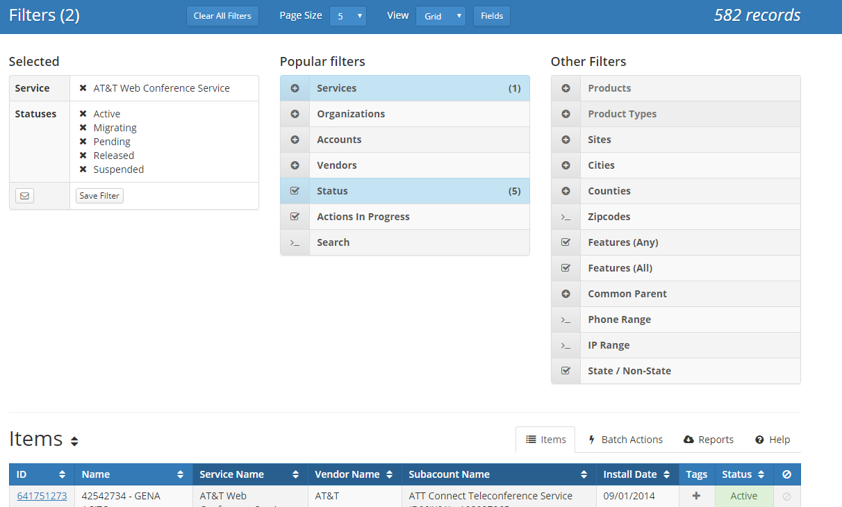
Figure 32 – Filters, notice that in this view two are selected, services and status.

Selected Filters
This shows what options you currently have selected such as Organization, Accounts, and Status. It will remember what you have selected for the next time you enter the inventory filter.

Popular Filters
The gray number in parentheses on the right of the filter results indicates the number of items matching the filter criteria. As the criteria changes so will that number.

Services
The service filter allows you to view SUNCOM services by Products, Product Type, Quantity, Alphabetically, etc.

Organizations
The organization filter shows inventory associated to an organization, such as Department of Transportation or Department of Health.

Accounts
The Accounts filter lists inventory by top level accounts - shows both Finance and Accounting and CSAB account numbers.

Status
You can filter on a certain status such as active, disconnected, pending migration, pending install, etc. This inventory status may change depending on the service.

Actions In Progress
This includes items that have a pending action such as pending migration, Release Freeze, Move, and Disconnect.

Search
The search function works like the overall system search but is limited to inventory. Type in the criteria you are looking for, the data set returned can then be filtered using various options.

Other Filters
There are other filters available such as providers, products, features, phone and/or IP range, cities, and many more to help you narrow down what you are looking for.

Views
This inventory tool allows the customer to view inventory by choosing a card view or a grid view.

Card View
While in the item tab the card view shows information such as inventory ID, service, vendor, address, and status. From the card you can select to see more info such as the item details, installed options, invoicing history, and what actions are available to take on the selected item. (Actions will depend of what CSAB permissions are assigned.) You can also make changes to all cards in the filter by hitting the action tab on the top right of the results page.

Grid View
The grid view only contains columns that are common in all services. For example, inventory ID, name, service, vendor and item status. From the grid you can select to see more info such as the item details, installed options, invoicing history and what actions are available to take on the selected item. (Actions will depend of what CSAB permissions are assigned.) You can also make changes to all items in the grid by hitting the action tab on the top right of the results page.

Page Size
This is found at the top of page while the item tab is selected. It allows the user to select the number of cards or grid items to be displayed per page. The option ranges from 3 to 50 per page.

Actions
The Action Tab contains the list of actions that are available for the filtered data you have chosen. On the right side of the data it will tell you how many items are available for the action you have chosen. If you only want to perform an action on one item, then you would select the individual item from the grid or card.

Limited Actions
There is a possibility that not all records in your filter are currently available for these actions that are listed. This may be due to differences in item status, actions in progress, or your ordering permissions. Choosing an action from this list will add that action to your filters. This will allow you to examine the limited list of items before triggering the action for all of them.

How to perform a batch action
- Click on New Inventory.
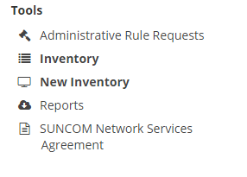
Figure 33 -- Performing a batch action, step 1
- Select Service.
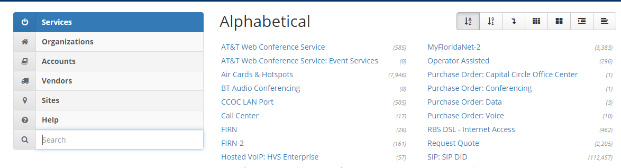
Figure 34 -- Performing a batch action, step 2
- Pick one (1) service you want to change.
Figure 35 -- Performing a batch action, step 3
- If you have another service, you can select it by clicking Services again, or you can select and add an account by clicking Accounts. A window will pop up with a list of services or accounts. You can have multiple selections, but you must select one at a time.
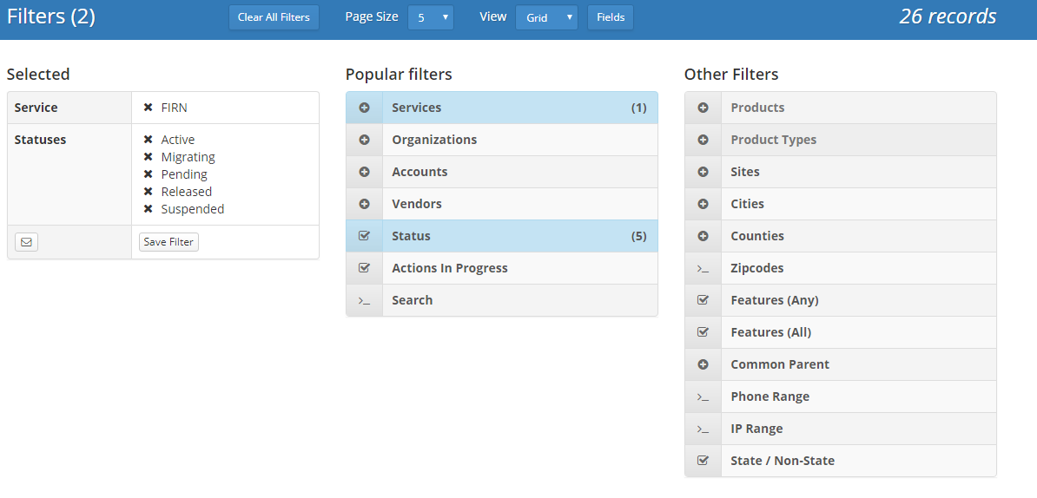
OR
Figure 36 -- Performing a batch action, step 4
- Click on Batch Actions.
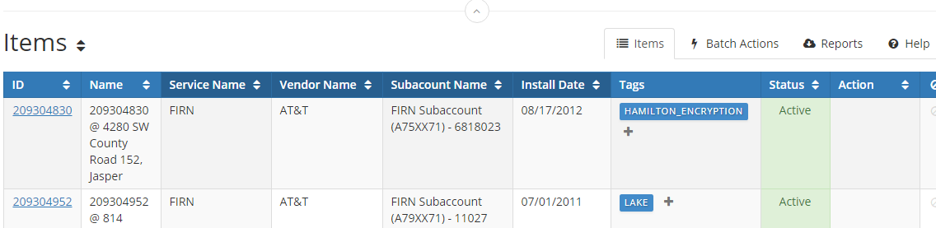
Figure 37 -- Performing a batch action, step 5
- Select Change Account.
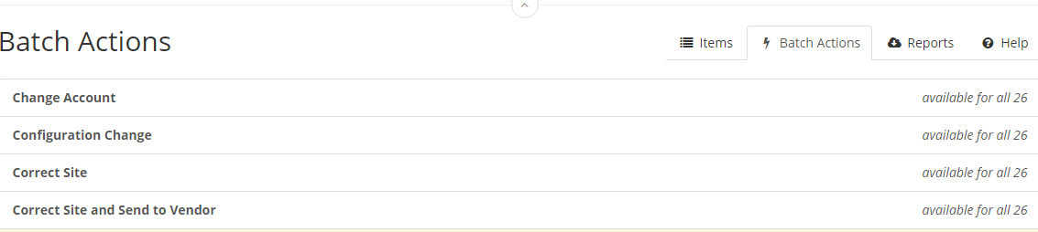
Figure 38 -- Performing a batch action, step 6

- Put in the new account and click Execute.
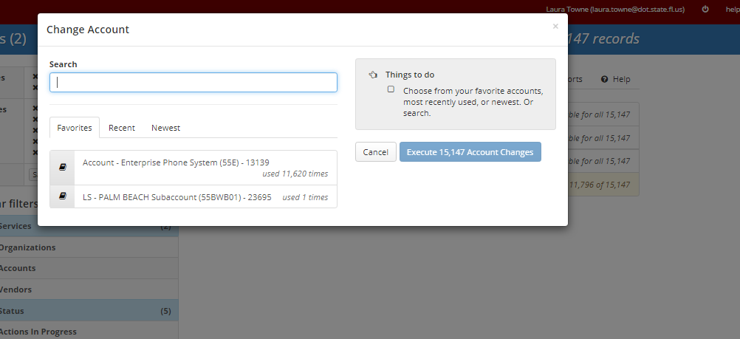
Figure 39 -- Performing a batch action, step 7

Reports

The Basic Report
The Basic Report contains the data that is visible in the grid view of your filtered data.

Filtered Reports
You can create customized reports using various filters such as basic info, service info, accounting, site info, contact info, invoicing, and options. The report can be saved to run again or to be modified with other criteria. When choosing filters, the green, yellow and red colors of the section area indicates the time it may take to run the report. Red being the longest.

Other Reports
There are other reports that have been used/requested in the past that are listed on the reports page. The reports listed depend on what permissions you have.

Organizations and Accounts
In the Organizations and Accounts application, you can view your organization(s) and/or add new ones. These accounts are visible in other applications, such as Ordering.
Once in the application, you can click + New Org at the top right of the screen to add a new organization, or you can click add a new one to add another application. To add a sub-account, select the organization you would like to be the parent organization in the left panel (in the screenshot below, you can see that The Enterprise is selected as the parent organization. You can also search for an organization by using the search bar.
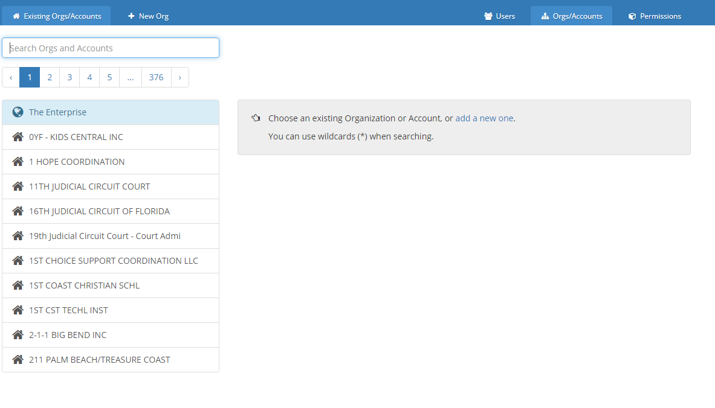
Figure 40 -- Organizations and Accounts Homepage

Help and Support

7.1. Help documents
Here are two ways to view help documents:
Before logging in: click Help from the home screen.
After logging in: click Help from the top navigation bar on any page.
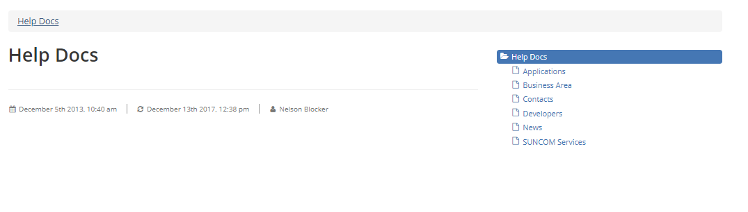
Figure 41 -- Help Docs

SIMS
Please see Section 5.3 for more information on the SIMS ticketing system.

SUNCOM Helpdesk
Call 888-4-SUNCOM, or 888-478-6266.

