

RECUMBENT BIKE WITH ARM EXERCISER
SF-RB4631
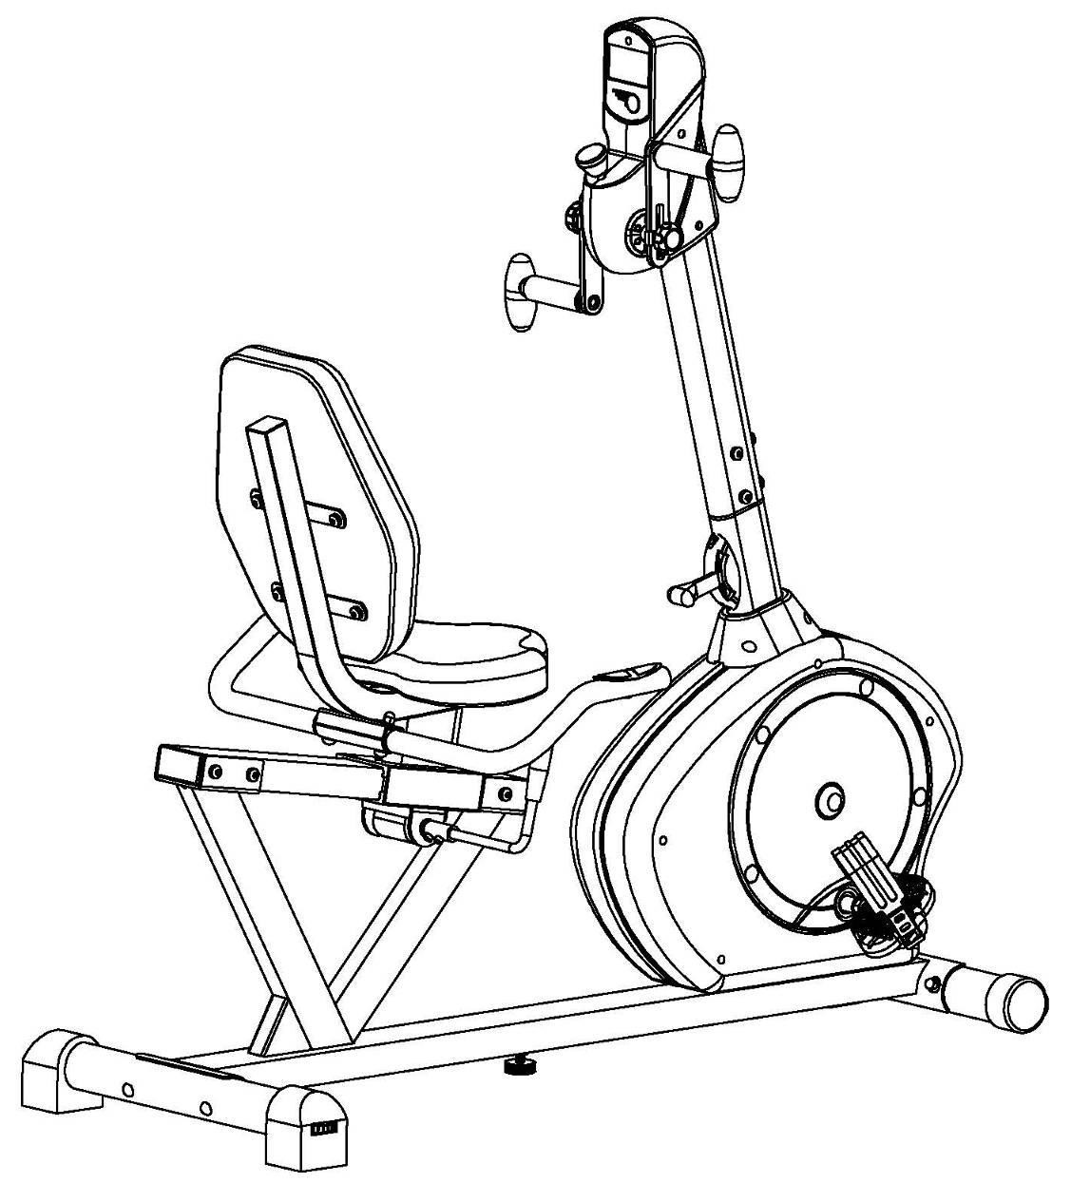
USER MANUAL

IMPORTANT! Please retain owner’s manual for maintenance and adjustment instructions. Your satisfaction is very important to us, PLEASE DO NOT RETURN UNTIL YOU HAVE CONTACTED US: support@sunnyhealthfitness.com or 1-877-90SUNNY (877-907-8669).


IMPORTANT SAFETY INFORMATION

We thank you for choosing our product. To ensure your safety and health, please use this equipment correctly. It is important to read this entire manual before assembling and using the equipment. Safe and effective use can only be achieved if the equipment is assembled, maintained and used properly. It is your responsibility to ensure that all users of the equipment are informed of all warnings and precautions.

- Before starting any exercise program you should consult your physician to determine if you have any medical or physical conditions that could put your health and safety at risk, or prevent you from using the equipment properly. Your physician’s advice is essential if you are taking medication that affects your heart rate, blood pressure or cholesterol level.
- Be aware of your body’s signals. Incorrect or excessive exercise can damage your health. Stop exercising if you experience any of the following symptoms: pain, tightness in your chest, irregular heartbeat, shortness of breath, lightheadedness, dizziness or feelings of nausea. If you do experience any of these conditions, you should consult your physician before continuing with your exercise program.
- Keep children and pets away from the equipment. The equipment is designed for adult use only.
- Use the equipment on a solid, flat level surface with a protective cover for your floor or carpet. To ensure safety, the equipment should have at least 4 feet (1.2 M) of free space all around it.
- Ensure that all nuts and bolts are securely tightened before using the equipment. The safety of the equipment can only be maintained if it is regularly examined for damage and/or wear and tear.
- Always use the equipment as indicated. If you find any defective components while assembling or checking the equipment, or if you hear any unusual noises coming from the equipment during exercise, discontinue use of the equipment immediately and do not use until the problem has been rectified.
- Wear suitable clothing while using the equipment. Avoid wearing loose clothing that may become entangled in the equipment.
- Do not place fingers or objects into the moving parts of the equipment
- The maximum weight capacity of this unit is 350 pounds (160 KG).
- The equipment is not suitable for therapeutic use.
- Use caution when lifting and moving the equipment. Always use proper lifting technique and seek assistance if necessary.
- Your product is intended for use in cool, dry conditions. You should avoid storage in extreme cold, hot or damp areas as this may lead to corrosion and other related problems.
- This equipment is designed for indoor and home use only! It is not intended for commercial use!

EXPLODED DIAGRAM

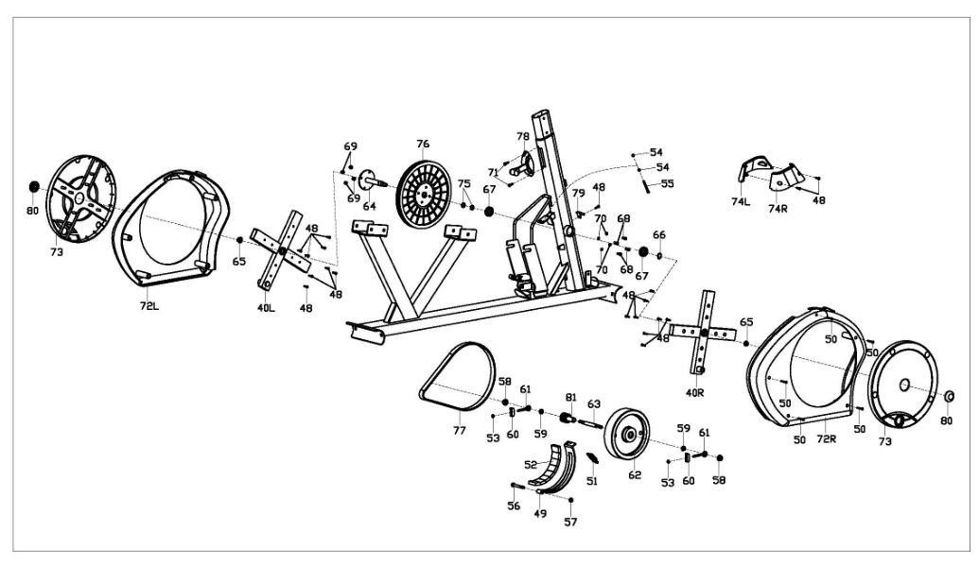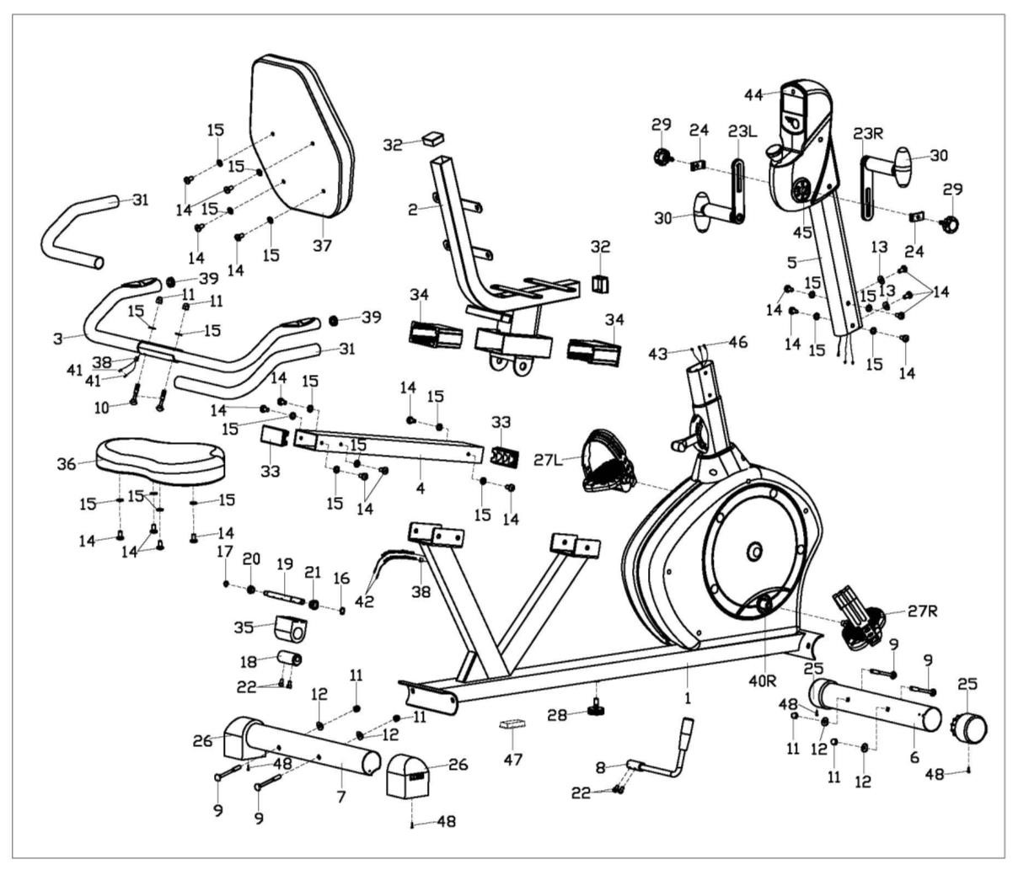

HARDWARE PACKAGE

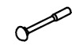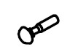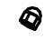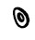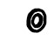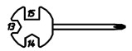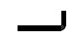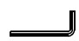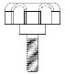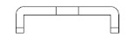

#9 M8*L73 4PCS

#10 M8*L45 2PCS

#11 M8 6PCS

#12 Ф8.2
4PCS
*2*Ф19*R30

#15 D8*1.5*Ф16 2PCS

#24

2
PCS

#29

2
PCS

#
82

S13
-
14
-
15
1PC

#
83

S5
1
PC

#
84

S6

1
PC

Ordering Replacement Parts (U.S. and Canadian Customers only)
Please provide the following information in order for us to accurately identify the part(s) needed:
- The model number (found on cover of manual)
- The product name (found on cover of manual)
- The part number found on the “EXPLODED DIAGRAM” and “PARTS LIST” (found near the front of the manual)

Please contact us at support@sunnyhealthfitness.com or 1- 877 – 90SUNNY (877-907-8669).

PARTS LIST

No. | Description | Spec. | Qty. |  | No. | Description | Spec. | Qty.
1 | Main Frame |  | 1 |  | 43 | Sensor Wire |  | 1
2 | Seat Tube |  | 1 |  | 44 | Computer |  | 1
3 | Handlebar |  | 1 |  | 45 | Connecting Axle |  | 1
4 | Slide Rail |  | 1 |  | 46 | Pulse Sensor Wire 2 |  | 2
5 | Handlebar Post |  | 1 |  | 47 | Square Plug | 60*30*1.5 | 1
6 | Front Stabilizer |  | 1 |  | 48 | Cross Pan Head  Self-Drilling Screw | ST4.2*18 | 23
7 | Rear Stabilizer |  | 1 |  | 49 | Magnet Board Connection |  | 1
8 | Adjustment Handle |  | 1 |  | 50 | Cross Pan Head  Self-Drilling Screw | ST4.2*30 | 5
9 | Square Neck Bolt | M8*L73 | 4 |  | 51 | Spring |  | 1
10 | Square Neck Bolt | M8*L45 | 2 |  | 52 | Magnet |  | 8
11 | Ball Cap Nut | M8 | 6 |  | 53 | Nut | M6 | 2
12 | Arc Washer | Ф8.2*2*Ф19*R30 | 4 |  | 54 | Nut | M5 | 2
13 | Arc Washer | d8*R20 | 2 |  | 55 | Hex Bolt | M5*60 | 1
14 | Hex Pan Head Screw | M8*16 | 20 |  | 56 | Hex Bolt | M8*L60*120 | 1
15 | Washer | D8*1.5*Ф16 | 20 |  | 57 | Nylon Nut | M8 | 1
16 | Spring Stop Collar | D12 | 1 |  | 58 | Flange Nut | M10*1 | 2
17 | Spring Stop Collar | D10 | 1 |  | 59 | Cone Thin Nut | M10*1*H5 | 2
18 | Eccentric Gear |  | 1 |  | 60 | Adjustable U Washer |  | 2
19 | Axle |  | 1 |  | 61 | Adjustable Screw |  | 2
20 | Small Alloy Bushing |  | 1 |  | 62 | Fly Wheel |  | 1
21 | Big Alloy Bushing |  | 1 |  | 63 | Fly Wheel Axle |  | 1
22 | Hex Socket Cap Screw | M6*10 | 4 |  | 64 | Middle Axle |  | 1
23L/R | Rotating Handle |  | 1pr. |  | 65 | Flange Nut | M10*1.25 | 2
24 | U Shape Board |  | 2 |  | 66 | Spring Shield |  | 1
25 | Wheeled End Cap |  | 2 |  | 67 | Bearing | 6003RZ | 2
26 | End Cap |  | 2 |  | 68 | Hex Socket Head Cap Screw | M6*15 | 4
27L/R | Pedal |  | 1pr. |  | 69 | Nylon Nut | M6 | 4
28 | Adjustable Pad |  | 1. |  | 70 | Spring Washer | D6 | 4
29 | Knob |  | 2 |  | 71 | Cross Pan Head Screw | M5*12 | 2
30 | Oval Handle |  | 2 |  | 72L/R | Belt Cover |  | 1pr.
31 | Foam Grip |  | 2 |  | 73 | Disc |  | 2
32 | Square Plug | 38*38*1.5 | 2 |  | 74L/R | Front Tube Cover |  | 1pr.
33 | Square Plug | 80*40*2 | 2 |  | 75 | Central Axle Spacer |  | 2
34 | Bushing |  | 2 |  | 76 | Big Belt Pulley |  | 1
35 | Upper Holder Block |  | 1 |  | 77 | Belt |  | 1
36 | Seat |  | 1 |  | 78 | Tension Controller |  | 1
37 | Backrest |  | 1 |  | 79 | Sensor |  | 1
38 | Guide Line Hole Plug |  | 2 |  | 80 | Nut Cap |  | 2
39 | Round Tube Plug |  | 2 |  | 81 | Small Belt Pulley |  | 1
40L/R | Crank |  | 1pr. |  | 82 | Spanner | S13-14-15 | 1
41 | Pulse Wire |  | 2 |  | 83 | Allen Wrench | S5 | 1
42 | Pulse Sensor Wire 1 |  | 2 |  | 84 | Allen Wrench | S6 | 1

ASSEMBLY INSTRUCTIONS
We value your experience using Sunny Health and Fitness products. For assistance with parts or troubleshooting, please contact us at support@sunnyhealthfitness.com or 1-877-90SUNNY (877-907-8669).

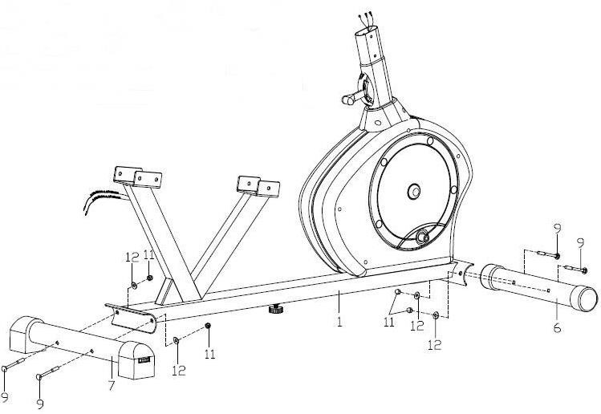
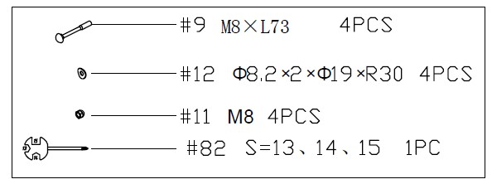
STEP 1

Attach the Front Stabilizer (No. 6) and the Rear Stabilizer (No. 7) to the Main Frame (No. 1) with the 4 Square Neck Bolts (No. 9), 4 Arc Washers (No. 12) and 4 Ball Cap Nuts (No. 11) using Spanner (No. 82).

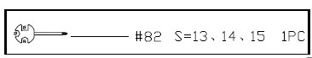
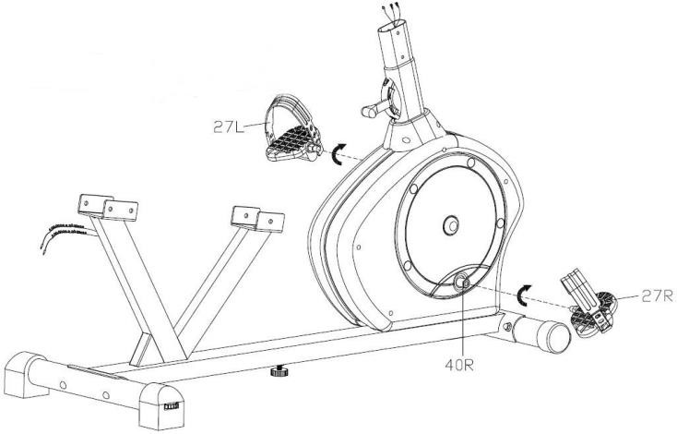

STEP 2
Attach the Pedals (No. 27L/R) to the
Crank (No. 40L/R) using the Spanner
(No. 82).

NOTE: Make sure to attach Right Pedal (No. 27R), marked (R), to the Right Crank (No. 40R) and should be tightened clockwise. Attach the Left Pedal (No. 27L), marked (L), to the Left Crank (No.40L). It should be tightened counter-clockwise. Attaching the Pedal (No. 27L/R) to the wrong Crank (No. 40L/R) or turning it the wrong direction can damage the Crank (No. 40L/R).

We value your experience using Sunny Health and Fitness products. For assistance with parts or troubleshooting, please contact us at support@sunnyhealthfitness.com or 1-877-90SUNNY (877-907-8669).

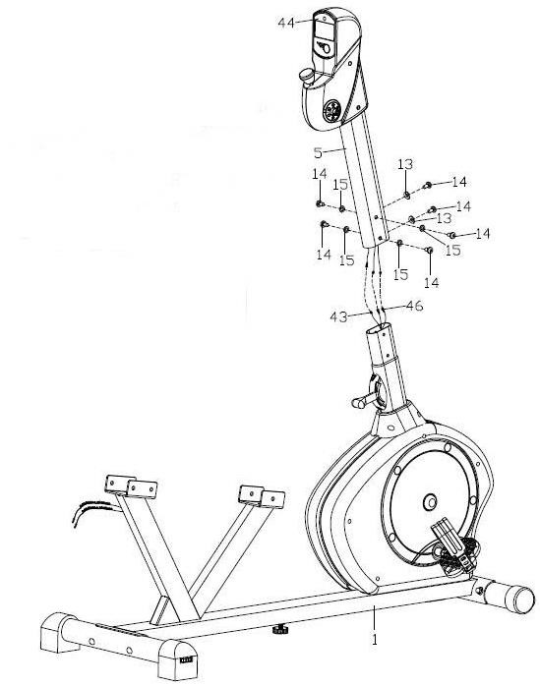
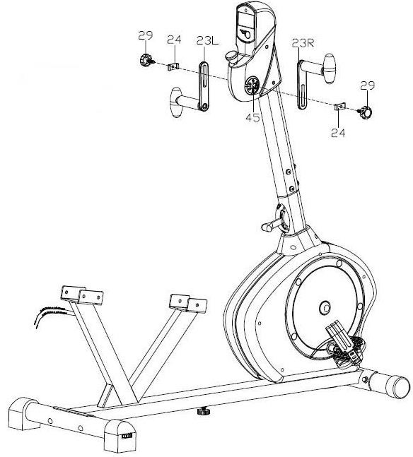
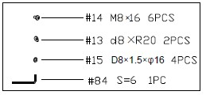
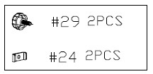
STEP 3

First, remove the preassembled 6 Hex Pan Head Screws (No. 14), 2 Arc Washers (No. 13) and 4 Washers (No. 15) from the Main Frame (No. 1) using Allen Wrench (No. 84) . Then connect the 2 Pulse Sensor Wires 2 (No. 46) and Sensor Wire (No. 43) with the wires of the Computer (No. 44). Then attach the Handlebar Post (No. 5) to the Main Frame (No. 1) with the 6 Hex Pan Head Screws (No. 14), 2 Arc Washers (No. 13) and 4 Washers (No. 15) that were just removed. Tighten and secure with Allen Wrench (No.
84).

STEP 4
Attach the Rotating Handles (No. 23L/R) to the Connecting Axle (No. 45) with 2 Knobs (No. 29) and 2 U Shape Boards (No. 24).

Note: You can adjust the position of the Rotating Handles (No. 23L/R) by loosening the Knob (No. 29), moving the Rotating Handles (No. 23L/R) to desired position, and then tightening the Knob (No. 29).

We value your experience using Sunny Health and Fitness products. For assistance with parts or troubleshooting, please contact us at support@sunnyhealthfitness.com or 1-877-90SUNNY (877-907-8669).

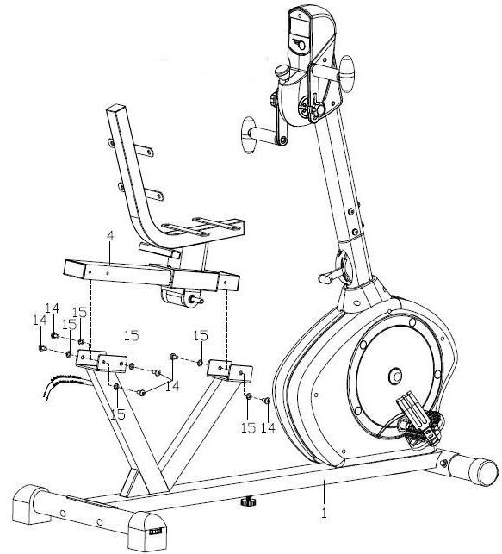
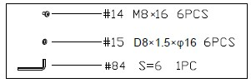
STEP 5

First, remove the preassembled 6 Hex Pan Head Screws (No. 14) and 6 Washers (No. 15) from the Slide Rail (No. 4) using Allen Wrench (No. 84). Then attach the Slide Rail (No. 4) to the Main Frame (No. 1) with 6 Hex Pan Head Screws (No. 14) and 6
Washers (No. 15) that were just removed. Tighten and secure with Allen Wrench (No. 84).

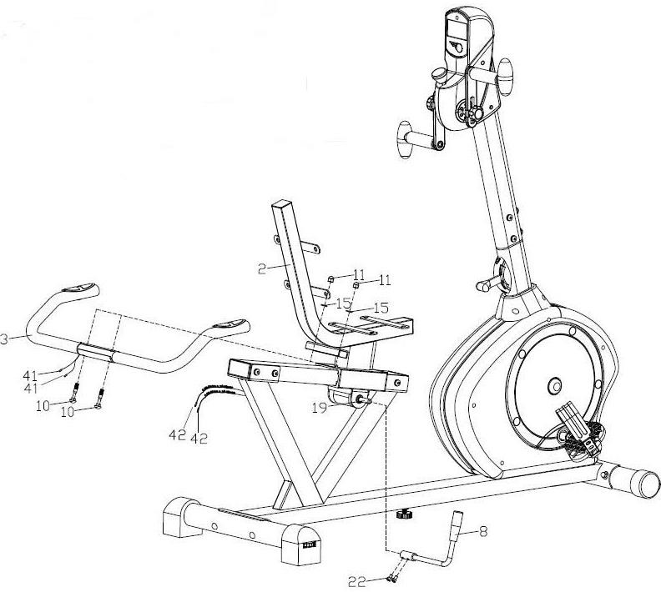
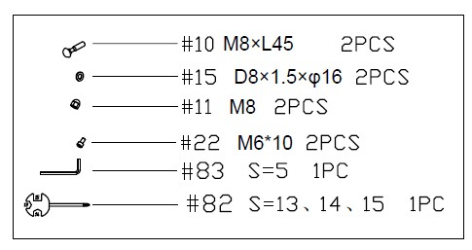

STEP 6
First, remove the preassembled 2 Hex Socket Cap Screws (No. 22) from the Axle (No. 19). Then attach the Adjustment Handle (No. 8) to the Axle (No. 19), and secure tightly with the 2 Hex Socket Cap Screws (No. 22) that were just removed. Tighten and secure with Allen Wrench (No. 83). Make sure the Adjustment Handle
(No. 8) is pointing up.

Set the Handlebar (No. 3) onto the Seat Tube (No. 2), and secure tightly with the 2 Square Neck Bolts (No. 10), 2 Washers (No. 15) and 2 Ball Cap Nuts (No. 11) using Spanner (No. 82). Connect the 2 Pulse Wires (No. 41) with the 2 Pulse Sensor Wires 1 (No.
42).

We value your experience using Sunny Health and Fitness products. For assistance with parts or troubleshooting, please contact us at support@sunnyhealthfitness.com or 1-877-90SUNNY (877-907-8669).

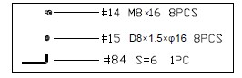
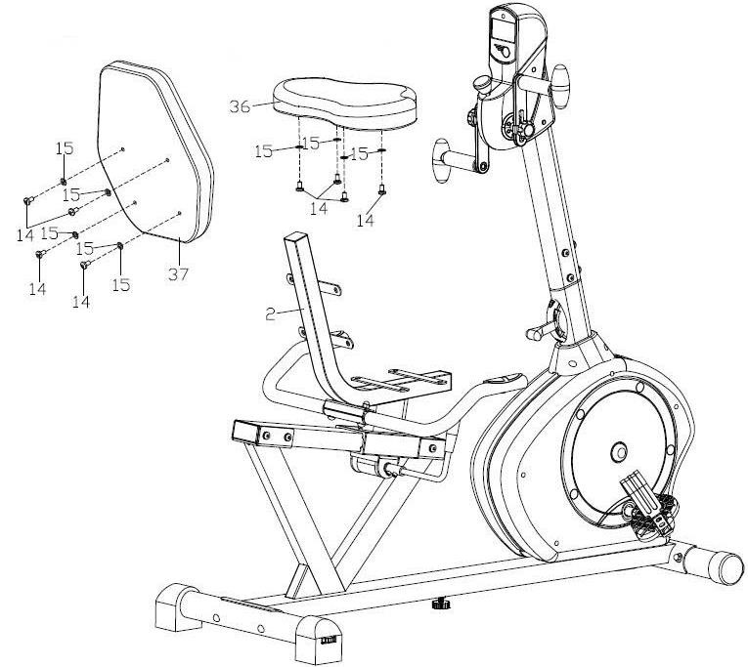
STEP 7

Remove the preassembled 4 Hex Pan Head Screws (No. 14) and 4 Washers (No. 15) from the Backrest (No. 37) using Allen Wrench (No. 84). Then attach the Backrest (No. 37) to the Seat Tube (No. 2) tightly with 4 Hex Pan Head Screws (No. 14) and 4 Washers (No. 15) that were just removed. Tighten and secure with Allen Wrench (No. 84) .

Remove the preassembled 4 Hex Pan Head Screws (No. 14) and 4 Washers (No. 15) from the Seat (No. 36) using Allen Wrench (No. 84). Then attach the Seat (No. 36) to the Seat Tube (No. 2) tightly with 4 Hex Pan Head Screws (No. 14) and 4 Washers (No. 15) that were just removed. Tighten and secure with Allen Wrench (No. 84).

Assembly is now complete!

ADJUSTMENT GUIDE
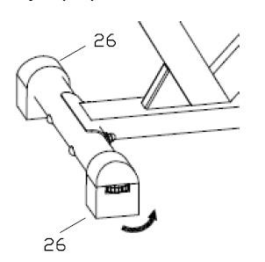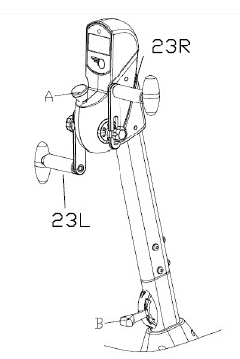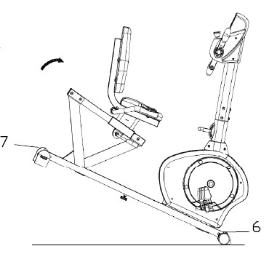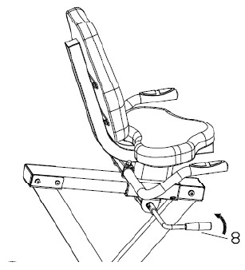

13

ADJUSTING T
HE
SEAT

POSITION

To move the

S
eat

(
No.
36)

forward or backward
while seated on the bike, pull the
Adjustment
Handle (
No.
8)

towards you. Move the
S
eat

36)
No.
(
. Push the
Adjustment Handle (
No.
8)

forward to secure.

ADJUSTING

THE LEVEL

If at any point the bike does not feel level,
you can adjust the dials located on the
side of the rear
End Caps (
No.
26)
.

ADJUSTING THE TENSION

To adjust the tension of the
Rotating Handles (
No.
23
)
L/R
,

turn the
Tension Knob A

in front of the meter. Turn
clockwise

(+)
to increase the tension,
counterclockwise

(
-
)
to

decrease the
tension.

To adjust the tension of the bike, move the
Tension Switch B
.
is the lowest tension. 8 is the highest tension.
1

MOVING THE BIKE

Lift the bike by the
Rear Stabilizer (
No.
7)

until the
wheels on the
Front Stabilizer (
No.
6)

touch the floor.
You can now

move the bike to your desired location with
ease.

36

EXERCISE COMPUTER

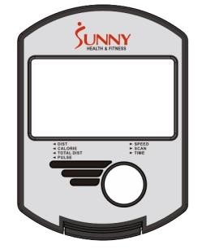
MODE: Press to select function.
Press and hold for 2 seconds to reset all values except TOTAL DIST.

FUNCTIONS AND OPERATIONS:
- SCAN: Press MODE button until “▼” appears at SCAN Position. Computer will rotate through all the 6 functions: Time, Speed, Distance, Calorie, Total Distance, and Pulse. Each function will display for 6 seconds.
- TIME: Counts the total time from exercise start to end.
- SPEED: Displays current speed.
- DIST: Count the distance from exercise start to end.
- CALORIES (CAL): Counts the total calories from exercise start to the end.
- TOTAL DIST (ODO): Counts the total distance after installing the batteries.
- PULSE: Press MODE button until “▼” appears at PULSE. Before measuring your pulse rate, place both your palms on the contact pads and the computer will show your current heartbeat rate in beats per minute (BPM) after 3~4 seconds.
Remark: During the process of pulse measurement, the measurement value may be higher than virtual pulse rate during the first 2~3 seconds, then it will return to normal level.
To ensure testing accuracy, it is suggested that user test pulse while not pedaling. The measurement value cannot be regarded as the basis for medical treatment.
- AUTO ON/OFF & AUTO START/STOP: Without any signal for 4 minutes, the power will turn off automatically.

BATTERY
If there is a problem with the display, try replacing the batteries. When changing the batteries, change both of them. Do not mix battery types. Do not mix old and new batteries. Dispose of batteries according to your state and local guidelines.

SPECIFICATIONS

FUNCTION | Auto Scan | Every 6 seconds
FUNCTION | Running Time | 00:00 ~ 99:59 (Minute: Second)
FUNCTION | Current Speed | Max is 99.9 MILE/H
FUNCTION | Trip Distance | 0.0 ~ 99.99 MILE
FUNCTION | Calories | 0.0 ~ 999.9 Kcal
FUNCTION | Total Distance | 0.0 ~ 999.9 MILE
FUNCTION | Pulse Rate | 40-240 BPM
 | Battery Type | 2 pcs of SIZE-AA and UM3
O | perating Temperature | 0℃ ~ +40℃ (32℉~ 104℉)
 | Storage Temperature | -10℃ ~ +60℃ (14℉~ 140℉)

Version 1.10



