

MAGNETIC ROWING MACHINE
SF-RW5515
USER MANUAL

IMPORTANT! Please retain owner’s manual for maintenance and adjustment instructions. Your satisfaction is very important to us, PLEASE DO NOT RETURN UNTIL YOU HAVE CONTACTED US: support@sunnyhealthfitness.com or 1- 877 - 90SUNNY (877-907-8669).

IMPORTANT SAFETY INFORMATION

We thank you for choosing our product. To ensure your safety and health, please use this equipment correctly. It is important to read this entire manual before assembling and using the equipment. Safe and effective use can only be achieved if the equipment is assembled, maintained, and used properly. It is your responsibility to ensure that all users of the equipment are informed of all warnings and precautions.

- Before starting any exercise program, you should consult your physician to determine if you have any medical or physical conditions that could put your health and safety at risk or prevent you from using the equipment properly. Your physician’s advice is essential if you are taking medication that affects your heart rate, blood pressure, or cholesterol level.
- Be aware of your body’s signals. Incorrect or excessive exercise can damage your health. Stop exercising if you experience any of the following symptoms: pain, tightness in your chest, irregular heartbeat, shortness of breath, lightheadedness, dizziness, or feelings of nausea. If you do experience any of these conditions, you should consult your physician before continuing with your exercise program.
- Keep children and pets away from the equipment. The equipment is designed for adult use only.
- Use the equipment on a solid, flat level surface with a protective cover for your floor or carpet. To ensure safety, the equipment should have at least 2 feet (60 CM) of free space all around it.
- Ensure that all nuts and bolts are securely tightened before using the equipment. The safety of the equipment can only be maintained if it is regularly examined for damage and/or wear and tear.
- Always use the equipment as indicated. If you find any defective components while assembling or checking the equipment, or if you hear any unusual noises coming from the equipment during exercise, discontinue use of the equipment immediately and do not use until the problem has been rectified.
- Wear suitable clothing while using the equipment. Avoid wearing loose clothing that may become entangled in the equipment.
- Do not place fingers or objects into the moving parts of the equipment.
- The maximum weight capacity of this unit is 250 pounds (110KG).
- The equipment is not suitable for therapeutic use.
- To avoid bodily injury and/or damage to the product or property, proper lifting and moving are required.
- Your product is intended for use in cool and dry conditions. You should avoid storage in extreme cold, hot or damp areas as this may lead to corrosion and other related problems.
- This equipment is designed for indoor and home use only; it is not intended for commercial use.

EXPLODED DIAGRAM

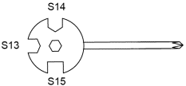
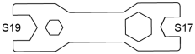
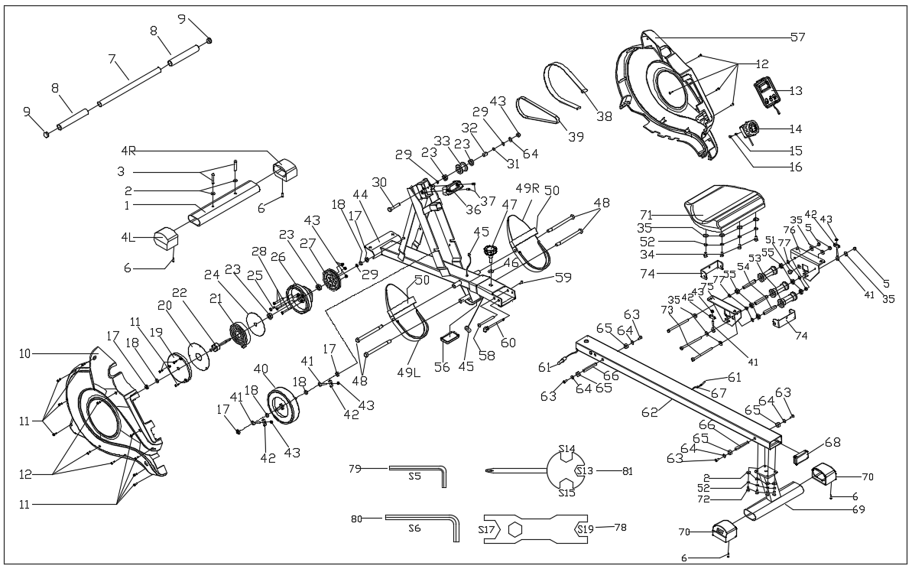
78
81

No. | Description | Spec. | Qty |  | No. | Description | Spec. | Qty
1 | Front Stabilizer |  | 1 |  | 42 | Adjusting U Seat | 30*10*1.5 | 4
2 | Washer | d8*Φ16*1.5 | 6 |  | 43 | Nut | M6*H6*S10 | 8
3 | Screw | M8*55*20*S6 | 2 |  | 44 | Main Frame |  | 1
4L/R | End Cap |  | 2 |  | 45 | Trunk Wire 1 |  | 1
5 | Nut | M8*H7.5*S13 | 3 |  | 46 | Washer | d12*Φ24*2 | 1
6 | Screw | ST4.2*25*Φ10.5 | 4 |  | 47 | Knob | M12 | 1
7 | Handlebar |  | 1 |  | 48 | Bolt | M12*Φ12.5*160*S19 | 4
8 | Foam Grip | Φ26*3*215 | 2 |  | 49L/R | Pedal L/R |  | 2
9 | End Cap | Φ28*15 | 2 |  | 50 | Pedal Strap |  | 2
10 | Left Belt Cover |  | 1 |  | 51 | Magnet | Φ15*7 | 1
11 | Screw | ST4.2*19*Φ8 | 11 |  | 52 | Spring Washer | d8 | 8
12 | Screw | ST4.2*16*Φ8 | 7 |  | 53 | Wheel | Φ40*92 | 3
13 | Computer |  | 1 |  | 54 | Casing Pipe for Idler Wheel | Φ13*Φ8*78 | 3
14 | Tension Control Knob |  | 1 |  | 55 | Bearing | 608Z | 6
15 | Washer | D5 | 1 |  | 56 | Rubber Pad |  | 1
16 | Screw | M5 | 1 |  | 57 | Right Belt Cover |  | 1
17 | Nut | M10*1*H8*S15 | 4 |  | 58 | Bolt | Φ10*95*M6*25 | 1
18 | Nut | M10*1*H5*S17 | 4 |  | 59 | Screw | M6*16*S5 | 1
19 | Cover for Mesh Belt Wheel | Φ149*14 | 1 |  | 60 | Pull Pin | Φ8*100*105 | 1
20 | Outer PC Board |  | 1 |  | 61 | Sensor Wire |  | 1
21 | Volute Spring |  | 1 |  | 62 | Sliding Rail |  | 1
22 | Axle for Mesh Belt Wheel |  | 1 |  | 63 | Screw | M6*16*Φ12 | 4
23 | Bearing | 6000-ZZ | 4 |  | 64 | Washer | d6*Φ12*1 | 5
24 | PC Board |  | 1 |  | 65 | Limit Mat | Φ33*Φ8*13 | 4
25 | Bolt | M5*45*Φ4.8 | 1 |  | 66 | Limit Axle | Φ12*80*M6 | 2
26 | Mesh Belt Wheel | Φ145 | 1 |  | 67 | Grommet | Φ16*15*Φ5 | 1
27 | Belt Wheel | Φ104 | 1 |  | 68 | End Cap | J80*40*18 | 1
28 | Bolt | M6*55*S10 | 3 |  | 69 | Rear Support |  | 1
29 | Circlip | d10 | 3 |  | 70 | End Cap |  | 2
30 | Bolt | M6*55*15*S10 | 1 |  | 71 | Seat | DDPU986 | 1
31 | Wave Washer | Φ13.5*Φ10.2*0.4 | 1 |  | 72 | Screw | M8*20*S6 | 4
32 | Spacer | Φ10*Φ6.1*40 | 1 |  | 73 | Bolt | M8*125*15*S14 | 3
33 | Mesh Belt Pulley | Φ45*35 | 1 |  | 74 | U Shape Bracket |  | 2
34 | Screw | M8*16*S6 | 4 |  | 75 | Left Seat Supporting Board |  | 1
35 | Washer | d8*Φ20*1.5 | 10 |  | 76 | Right Seat Supporting Board |  | 1
36 | Handlebar Seat |  | 1 |  | 77 | Spacer | d8*Φ15*4 | 6
37 | Screw | M5*10*Φ10 | 2 |  | 78 | Spanner | S17-19 | 1
38 | Mesh Belt | t1.5*22*2270 | 1 |  | 79 | Allen Wrench | S5 | 1
39 | Belt | 6PJ250 | 1 |  | 80 | Allen Wrench | S6 | 1
40 | Inertial Wheel | Φ176 | 1 |  | 81 | Spanner | S13-14-15 | 1
41 | Adjusting Screw | M6*40*Φ10*2.5 | 4
PARTS LIST
HARDWARE PACKAGE
#63 M6*16*Φ12 1PC PC11PC
#2 d8*Φ16*1.5 6PCS

#64 d6*Φ12*1 1PC
#3 M8*55*20*S6 2PCS
#46 d12*Φ24*2 1PC
#65 Φ33*Φ8*13 1PC
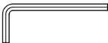
.
S5
#79
#78
#47 M12 1PC
#72 M8*20*S6 4PCS
#66 Φ12*80*M6 1PC
#59 M6*16*S5 1PC
#58 Φ10*95*M6*25 1PC
#52 d8 4PCS
#48 M12*Φ12.5*160*S19 4PCS
#60 Φ8*100*105 1PC
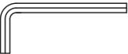
#80
#81
S6
Ordering Replacement Parts (U.S. and Canadian Customers only)
Please provide the following information in order for us to accurately identify the part(s) needed:
- The model number (found on cover of manual)
- The product name (found on cover of manual)
- The part number found on the “EXPLODED DIAGRAM” and “PARTS LIST” (found near the front of the manual)

Please contact us at support@sunnyhealthfitness.com or 1- 877 - 90SUNNY (877-907-8669).

ASSEMBLY INSTRUCTIONS

We value your experience using Sunny Health and Fitness products. For assistance with parts or troubleshooting, please contact us at support@sunnyhealthfitness.com or 1-877-90SUNNY (877-907-8669).
STEP 1:

Attach Front Stabilizer (No. 1) to Main Frame (No. 44) using 2 Screws (No. 3) and 2 Washers (No. 2). Tighten and secure with Allen Wrench (No. 80).
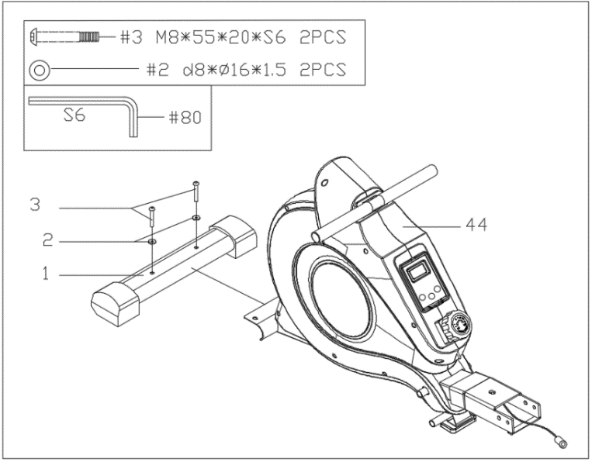

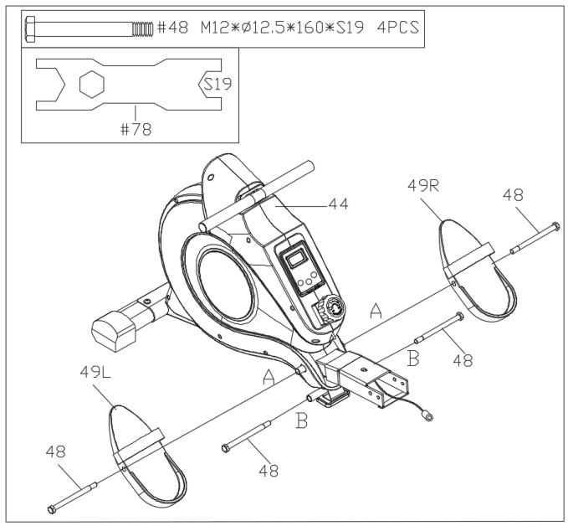
#78
S19
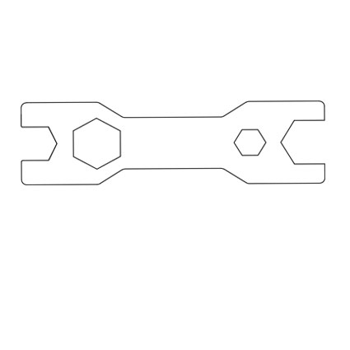
STEP 2:

Attach the 2 Bolts (No. 48) into the bottom hole in position B of Main Frame (No. 44) with Spanner (No. 78).

Insert the 2 Bolts (No. 48) into the upper hole in position A of the Main Frame (No. 44) through the Pedals (No. 49L/R). Tighten with Spanner (No. 78).

NOTE: The Pedals (No. 49L/R) should rest on Bolts (No. 48) that are in position B.

We value your experience using Sunny Health and Fitness products. For assistance with parts or troubleshooting, please contact us at support@sunnyhealthfitness.com or 1-877-90SUNNY (877-907-8669).
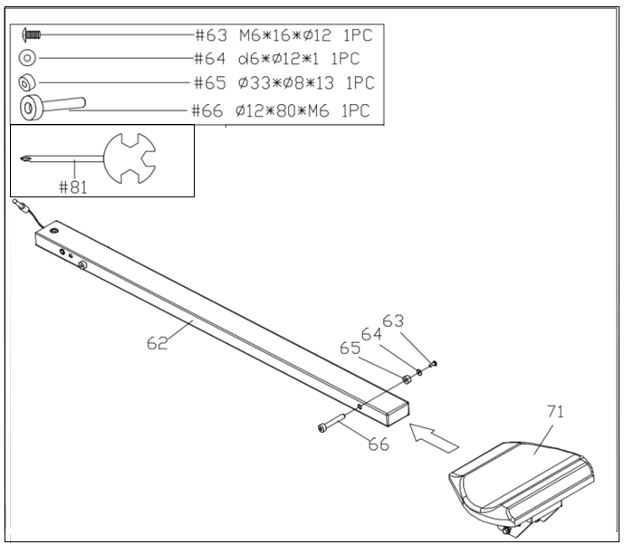
STEP 3:

Insert the Seat (No. 71) onto Sliding Rail (No. 62).

Insert the Limit Axle (No. 66) into the hole on the back of the Sliding Rail (No. 62).
Attach the Limit Mat (No. 65) onto the Limit Axle (No. 66) using 1 Screw (No. 63) and 1 Washer (No. 64), then tighten with Spanner (No. 81).

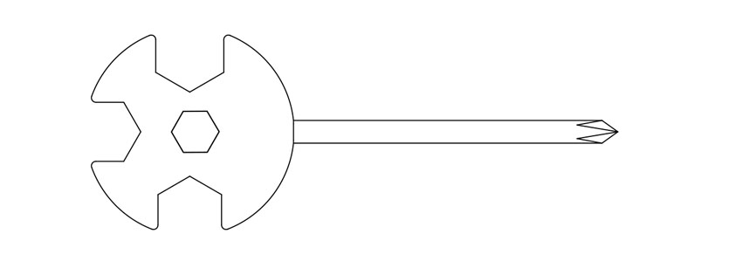
#81

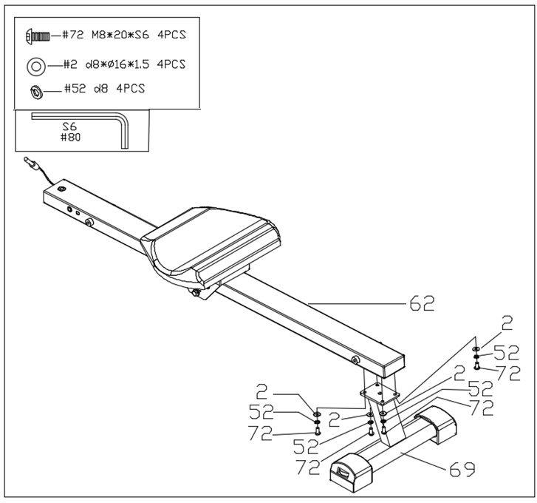
STEP 4:

Attach Sliding Rail (No. 62) onto Rear Support (No. 69) using 4 Screws (No. 72), 4 Spring Washers (No. 52), and 4 Washers (No. 2). Tighten and secure with Allen Wrench (No. 80).

STEP 5:

Connect Trunk Wire 1 (No. 45) with Sensor Wire (No. 61).

Attach the Sliding Rail (No. 62) to Main Frame (No. 44) using 1 Bolt (No. 58) and 1 Screw (No. 59). Tighten and secure with Allen Wrench (No. 79) and Allen Wrench (No. 80).

Next, attach the top of the Sliding Rail (No. 62) to the Main Frame (No. 44) using 1 Knob (No. 47) and 1 Washer (No. 46), then insert Pull Pin (No. 60).

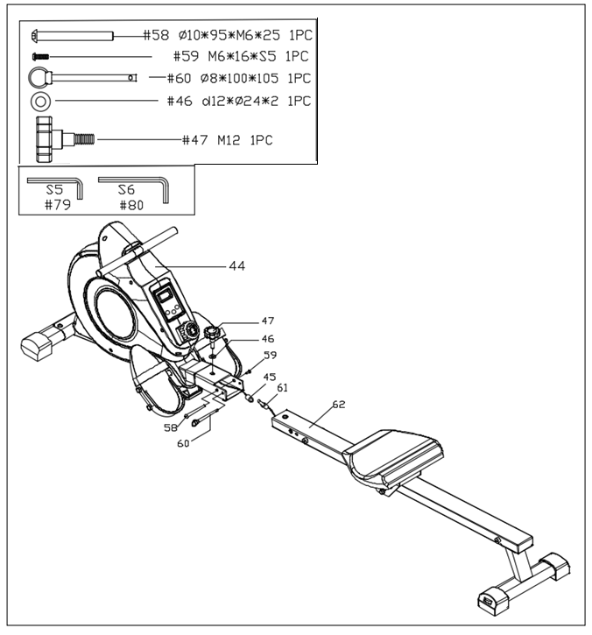

We value your experience using Sunny Health and Fitness products. For assistance with parts or troubleshooting, please contact us at support@sunnyhealthfitness.com or 1-877-90SUNNY (877-907-8669).
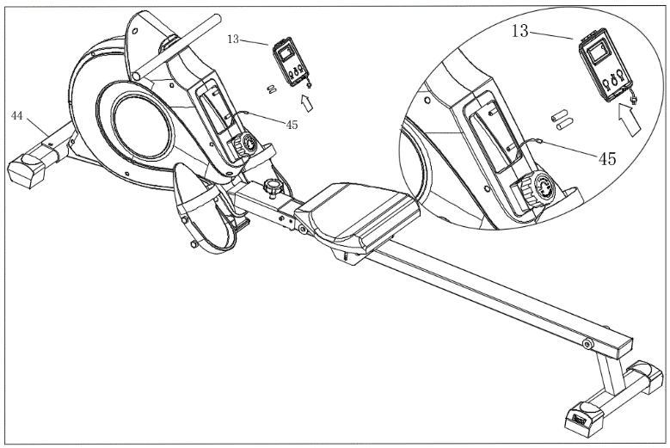
STEP 6:
Take out 2 AAA batteries from the plastic bag with the manual. Press the buckle on the bottom of Computer (No. 13) upward, then remove Computer (No. 13) from Main Frame (No. 44).
Disconnect Trunk Wire 1 (No. 45) and the link wire of Computer (No. 13). Install the 2 AAA batteries into the back of Computer (No. 13).

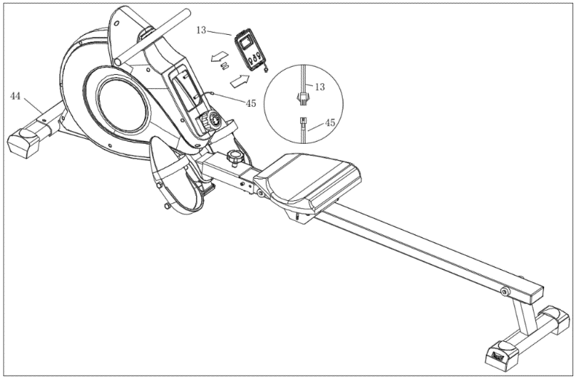
STEP 7:
Connect Trunk Wire 1 (No. 45) with the link wire of Computer (No. 13) and press the buckle on the bottom of Computer (No. 13), then put Computer (No. 13) back onto the Main Frame (No. 44). Push the Computer (No. 13) downwards to fit in position.

The assembly is complete!

ADJUSTMENTS & USAGE GUIDE

CAUTION! Moving parts, such as the seat, can cut and crush. Keep hands clear of the sliding rail during use!

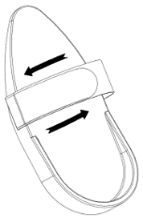 | PEDAL STRAP ADJUSTMENT  The pedal strap is adjustable and can be personalized to fit the user’s foot size.
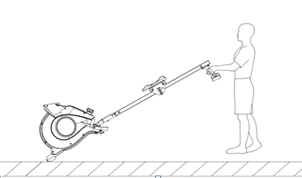  69 | MOVING THE ROWER  To move the rower, lift up the Rear Support (No. 69) until the transportation wheels on the front stabilizer touch the ground. With the wheels on the ground, you can transport the rower to the desired location with ease.
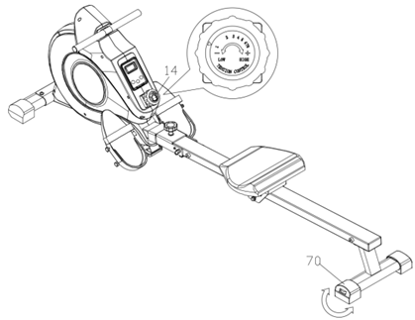 | ADJUSTING THE BALANCE AND RESISTANCE  Adjust the End Caps (No. 70) on the Rear Support (No. 69) of the rower if the rower is unbalanced during use.  Rotate the Tension Control Knob (No. 14) clockwise to increase the level of resistance. Rotate the Tension Control Knob (No. 14) counter-clockwise to decrease the level of resistance.  Tension levels are set at Level 1 being the lowest and Level 8 being the highest.
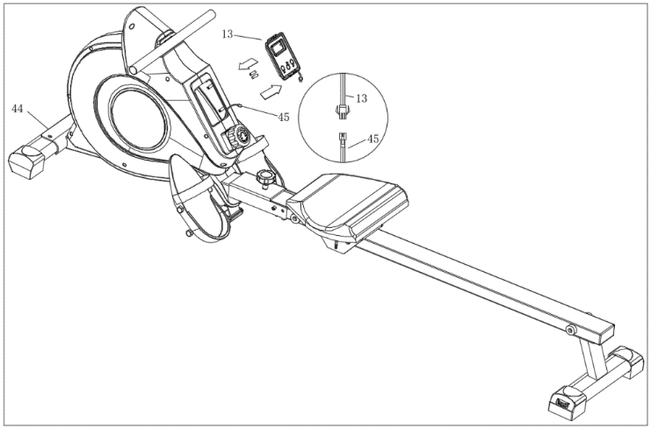 | REPLACE THE BATTERIES  Two AAA batteries are included in Computer (No. 13). To replace the batteries, remove Computer (No. 13) from Main Frame (No. 44), and disconnect the Trunk Wire 1 (No. 45) and the link wire of Computer (No. 13). Replace both batteries. Do not mix battery types and do not mix old and new batteries.  After the replacement, connect Trunk Wire 1 (No. 45) with the link wire of Computer (No. 13) and put Computer (No. 13) back onto the Main Frame (No. 44). Dispose of batteries according to your state and local rules.
STORAGE GUIDE

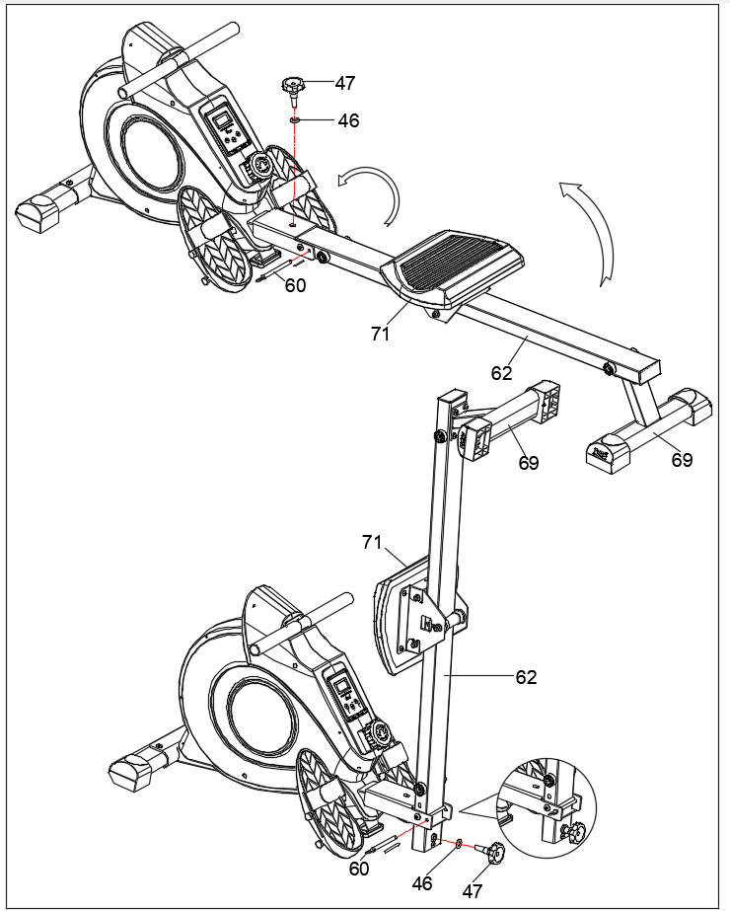
CAUTION!
The Seat (No. 71) will glide down when folding the Sliding Rail (No. 62)!
Figure B
When not in use, you can save space by folding the Sliding Rail (No. 62).

- Disassemble Knob (No. 47) and Washer (No. 46) and pull out the Pull Pin (No. 60). Fold the sliding rail to vertical angle (Figure A).
SAFETY NOTE: the seat will glide down when folding the sliding rail.

- Reinsert Pull Pin (No. 60) into the hole on the main frame, then tighten Knob (No. 47) and Washer (No. 46) to Sliding Rail (No. 62). (Figure B)

CAUTION!
Use caution when you vertically fold the Sliding Rail (No. 62) as your head may touch the Rear Support (No. 69).
Figure A

EXERCISE COMPUTER

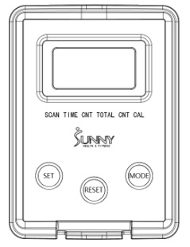
FUNCTION KEYS:

MODE: To select your specification mode and/or turn on computer.
SET: To set a value of Time, Count, or Calories (when not in Scan mode).
RESET: Press to reset Time, Count, or Calories. Press and hold for about 3 seconds to reset all values, expect Total Count.

FUNCTIONS AND OPERATIONS:
AUTO ON/OFF: The power will turn off automatically once there is no signal for 4 minutes. The computer will reactivate once the machine is put into motion or when a computer button is pressed.
SCAN: Press MODE button until SCAN appears. The computer will rotate through the four functions in the following order: TIME, COUNT, TOTAL COUNT, and CALORIES. Each function will be held for 6 seconds.
TIME: Counts the total time elapsed during your current workout.
COUNT: Counts the number of rowing strokes from your current workout.
TOTAL COUNT: Counts the total amount of strokes from the first use.
CAL: Counts the total calories burned from current workout.

COUNTDOWN:
You can set the value of Time, Count or Calories to countdown.
  - Press MODE to select a function. Make sure you are not in SCAN mode.
  - Press SET to select a value you want. You can press RESET to clear the value.
  - When the display stops flashing, start rowing and the machine will start to countdown.

BATTERY: This computer uses two AAA batteries. If the display appears incorrectly or becomes difficult to read, please install new batteries. Always change both batteries at the same time. Do not mix battery types and do not mix old and new batteries. Dispose of batteries according to your state and regional guidelines.

SPECIFICATIONS
FUNCTIONS | SCAN | Every 6 seconds
FUNCTIONS | TIME | 0:00~99:59 (Minute: Second)
FUNCTIONS | COUNT | 0~9999 Count
FUNCTIONS | CALORIES | 0.0~9999 Kcal
FUNCTIONS | TOTAL COUNT | 0~9999 Count
BATTERY TYPE |  | (2) Two AAA or UM-4
OPERATING TEMPERATURE |  | 0°C ~ 40°C
STORAGE TEMPERATURE |  | -10°C ~ 60°C

Version 5.5



