

Sustainable Aquatics
110 W. Old Andrew Johnson Highway
Phone: (865) 262-0507 Jefferson City, Tennessee 37760 Fax: (865) 262-0498
November 2018
Rotifer Batch Culture Rearing Guide
Using Amplifeed Replete and Rotifer Cysts
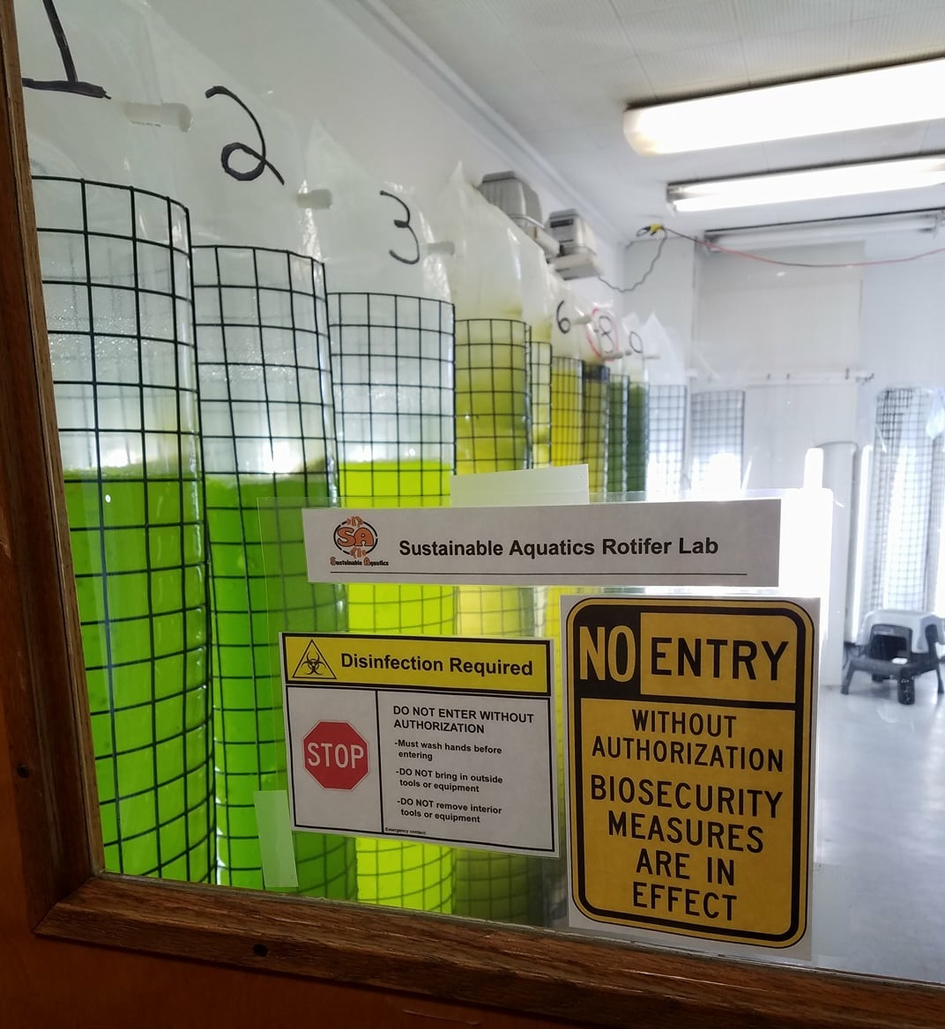
Rationale:

Rotifers are a small (150 - 300µm) zooplankton critical for the first-feeding and early-feeding of many species of fish and invertebrates (Hoff & Snell 2004, Wallace & Snell 2010, Snell et al. 2018). Rotifers primarily eat phytoplankton (single-celled algae). They require clean, well oxygenated water, consistent temperature, and quality food in sufficient quantities to keep them reproducing rapidly. The following protocol for growing rotifers centers on starting-up PhotoBioReactors (PBRs) to bloom microalgae and then inoculating the reactors by adding rotifers, which will consume the algae and then require supplemental feeding with Amplifeed Replete. The reactors are then harvested so the rotifers can be used for feeding and to inoculate subsequent reactor cultures.
Figure 1: Dedicated Rotifer Production Lab

The following is a general guide for reactor setup, inoculation, feeding, and harvest. Adjustments may need to be made depending upon rotifer and algae species/strains, reactor configuration, and culture conditions.

Starting a PBR:

Day 1:
*Set-up reactor cage in-front of LED light and place 125 L plastic bag into reactor (See Figure 2).
*Attach one airline to the bottom of each side of the bag and secure with a zip-tie or Velcro strap. Each bag will have 2 airlines (Figure 3).
*Using filtered seawater, fill reactor through a small hole created in the top of the bag (the “fill port” – Figure 4).
*Add algae nutrients through the fill port (Figure 5).
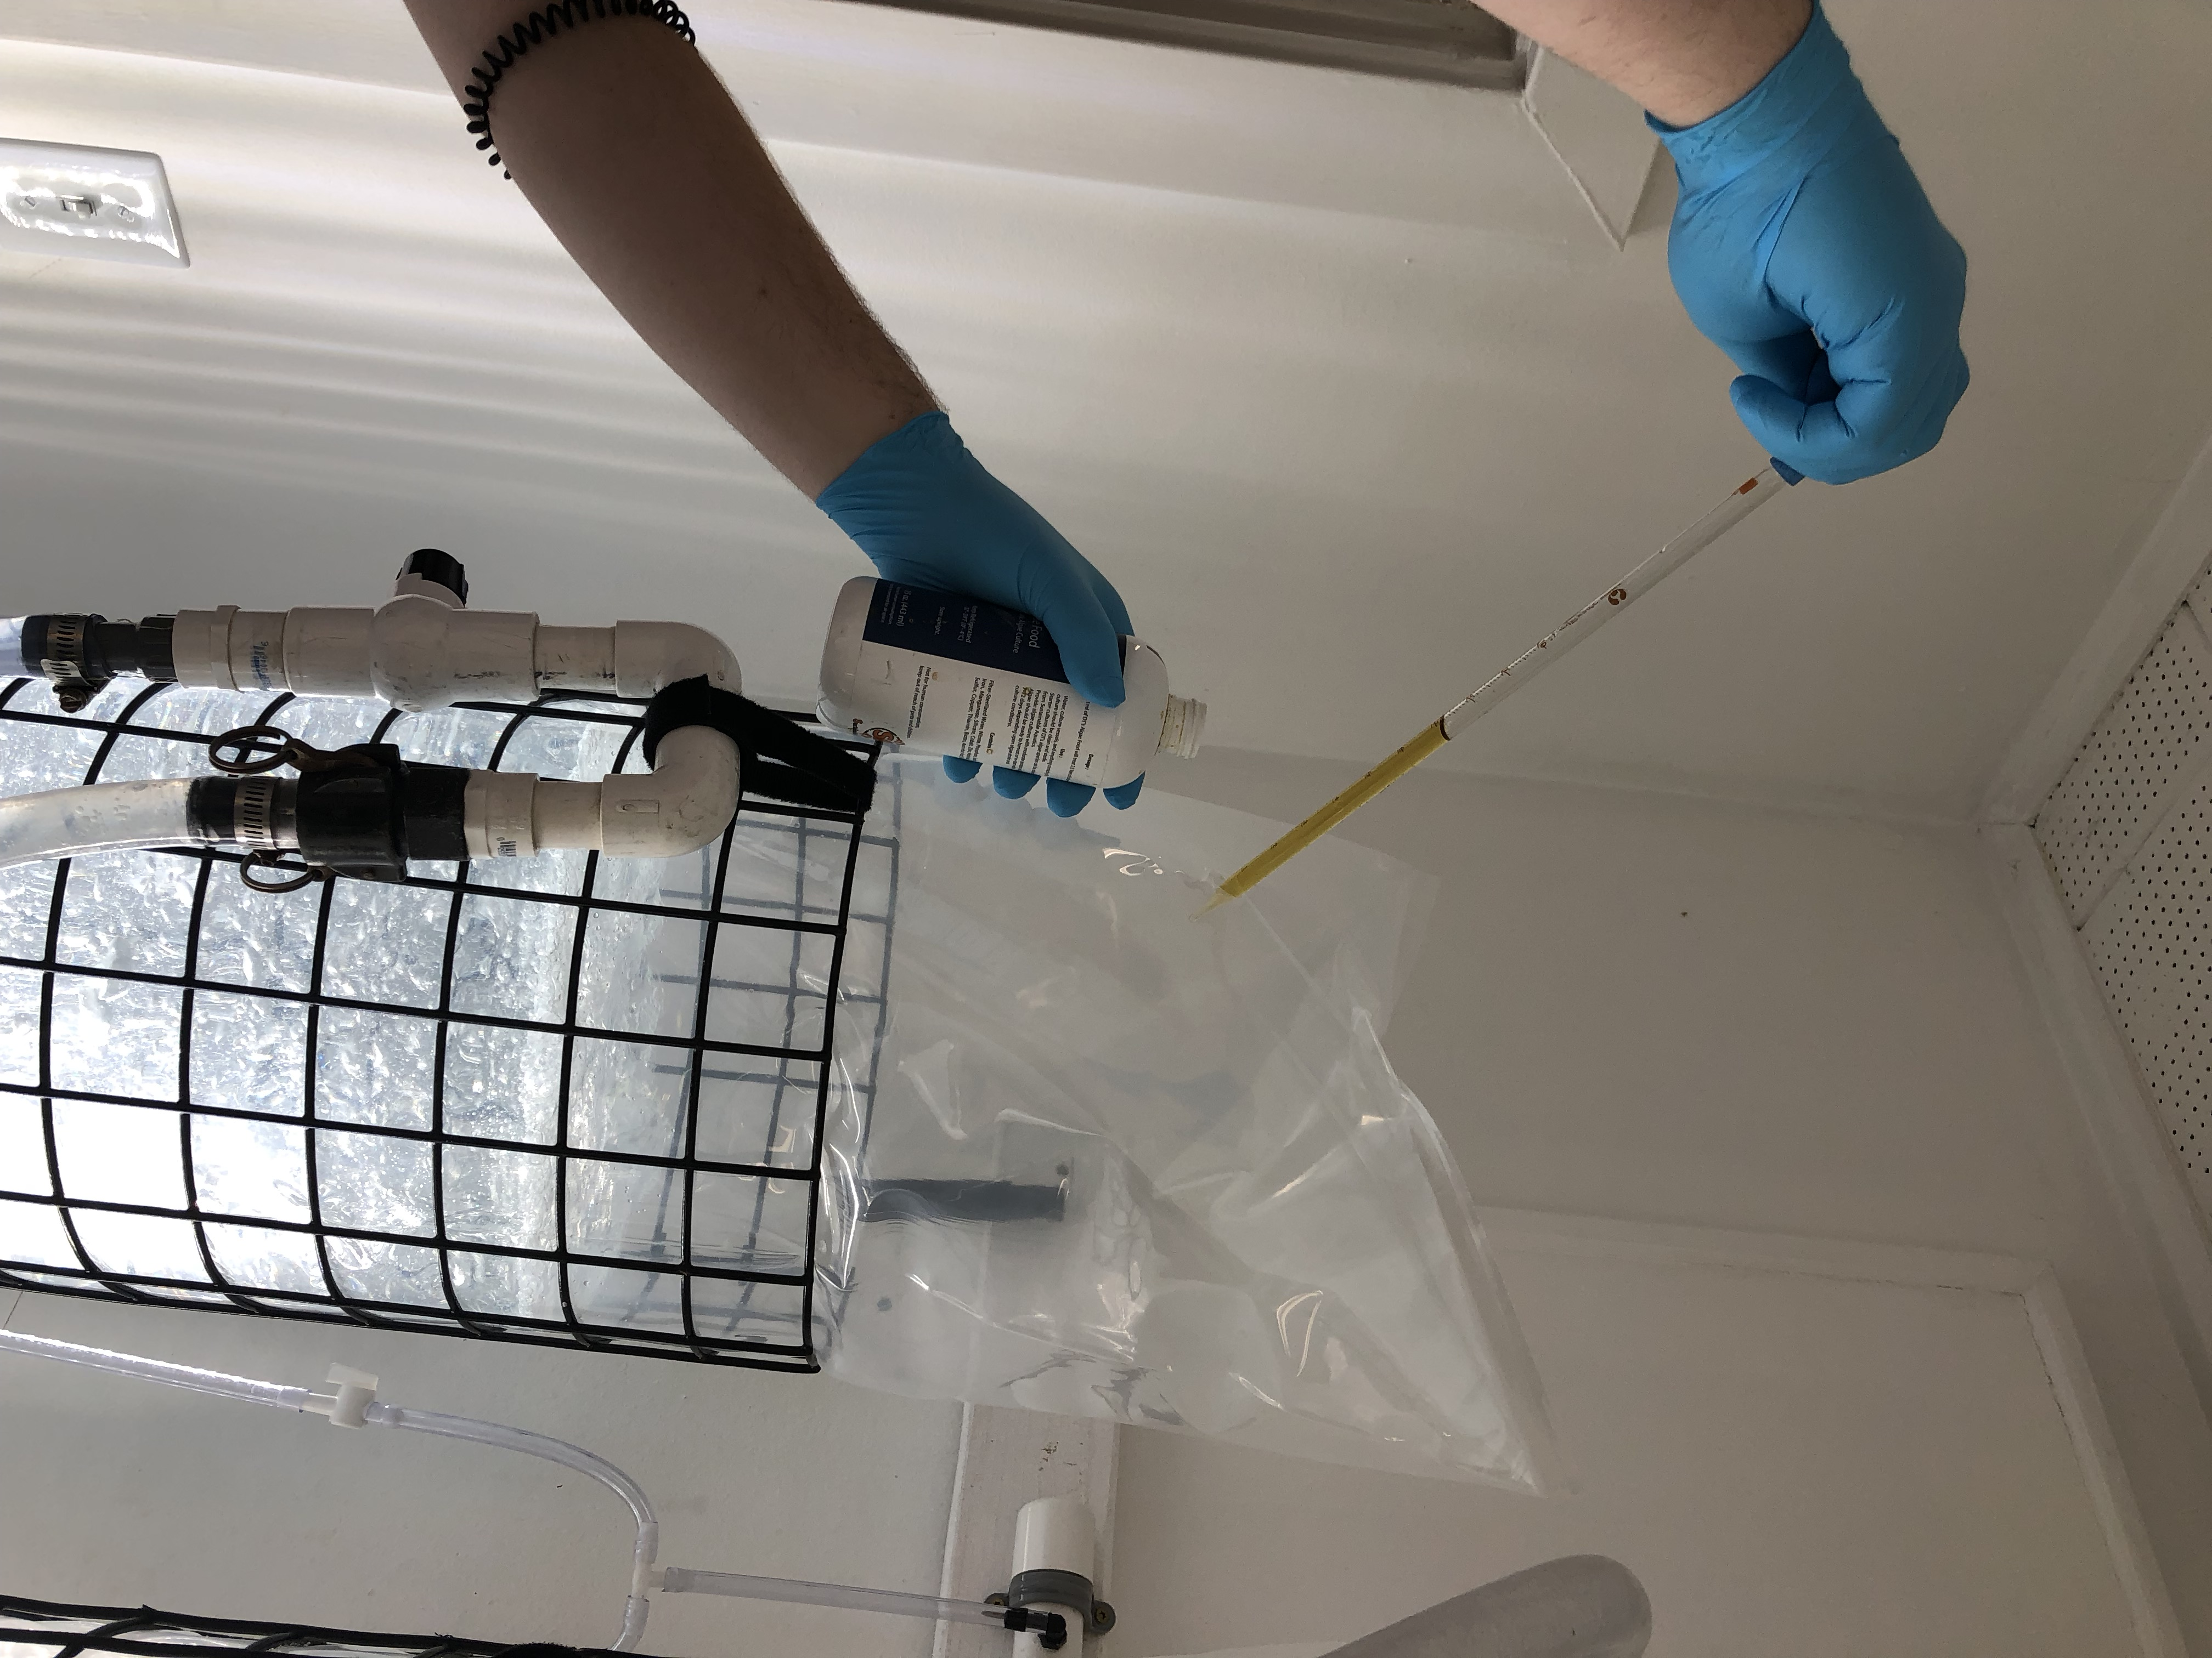
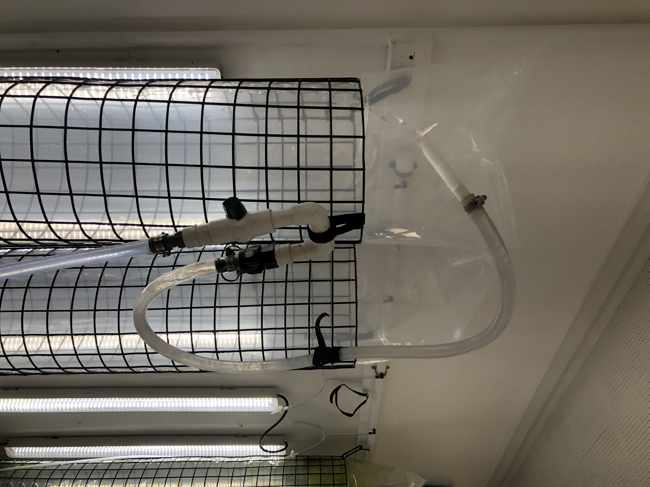
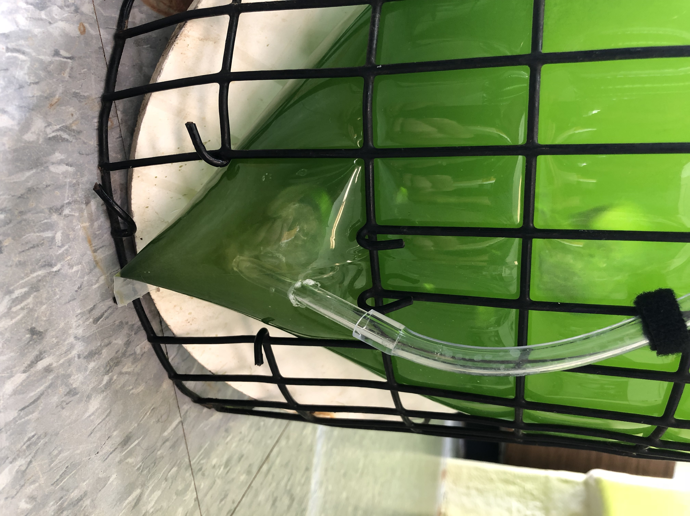
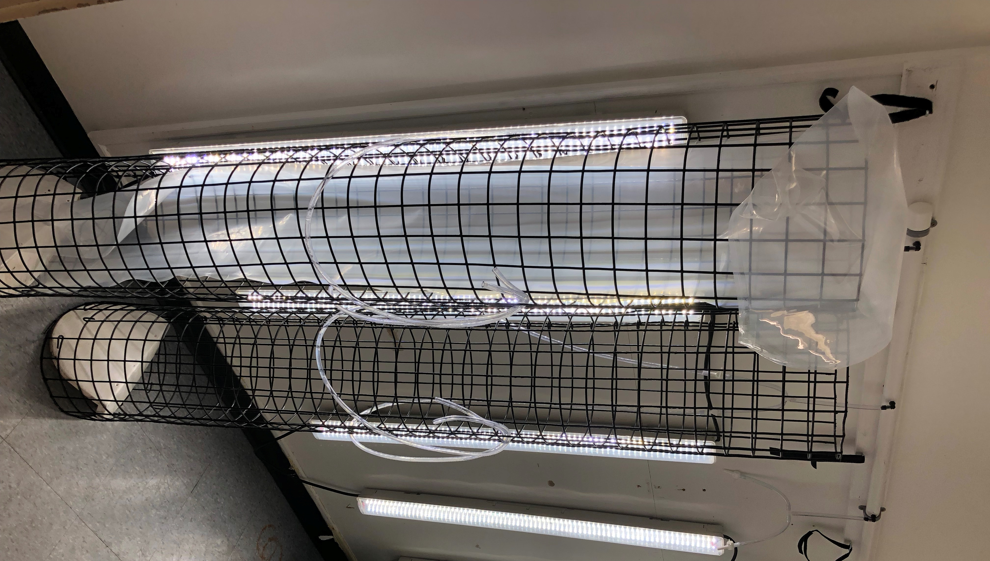
*Add one 1.5-liter bottle of phytoplankton starter culture to the bag through the fill port (Figure 6).
Figure 5: Adding Nutrients
Figure 4: Filling the Reactor
Figure 2: Airline Detail (notice Velcro strap at top)
Figure 2: Reactor Cage with LED Light and Plastic Bag
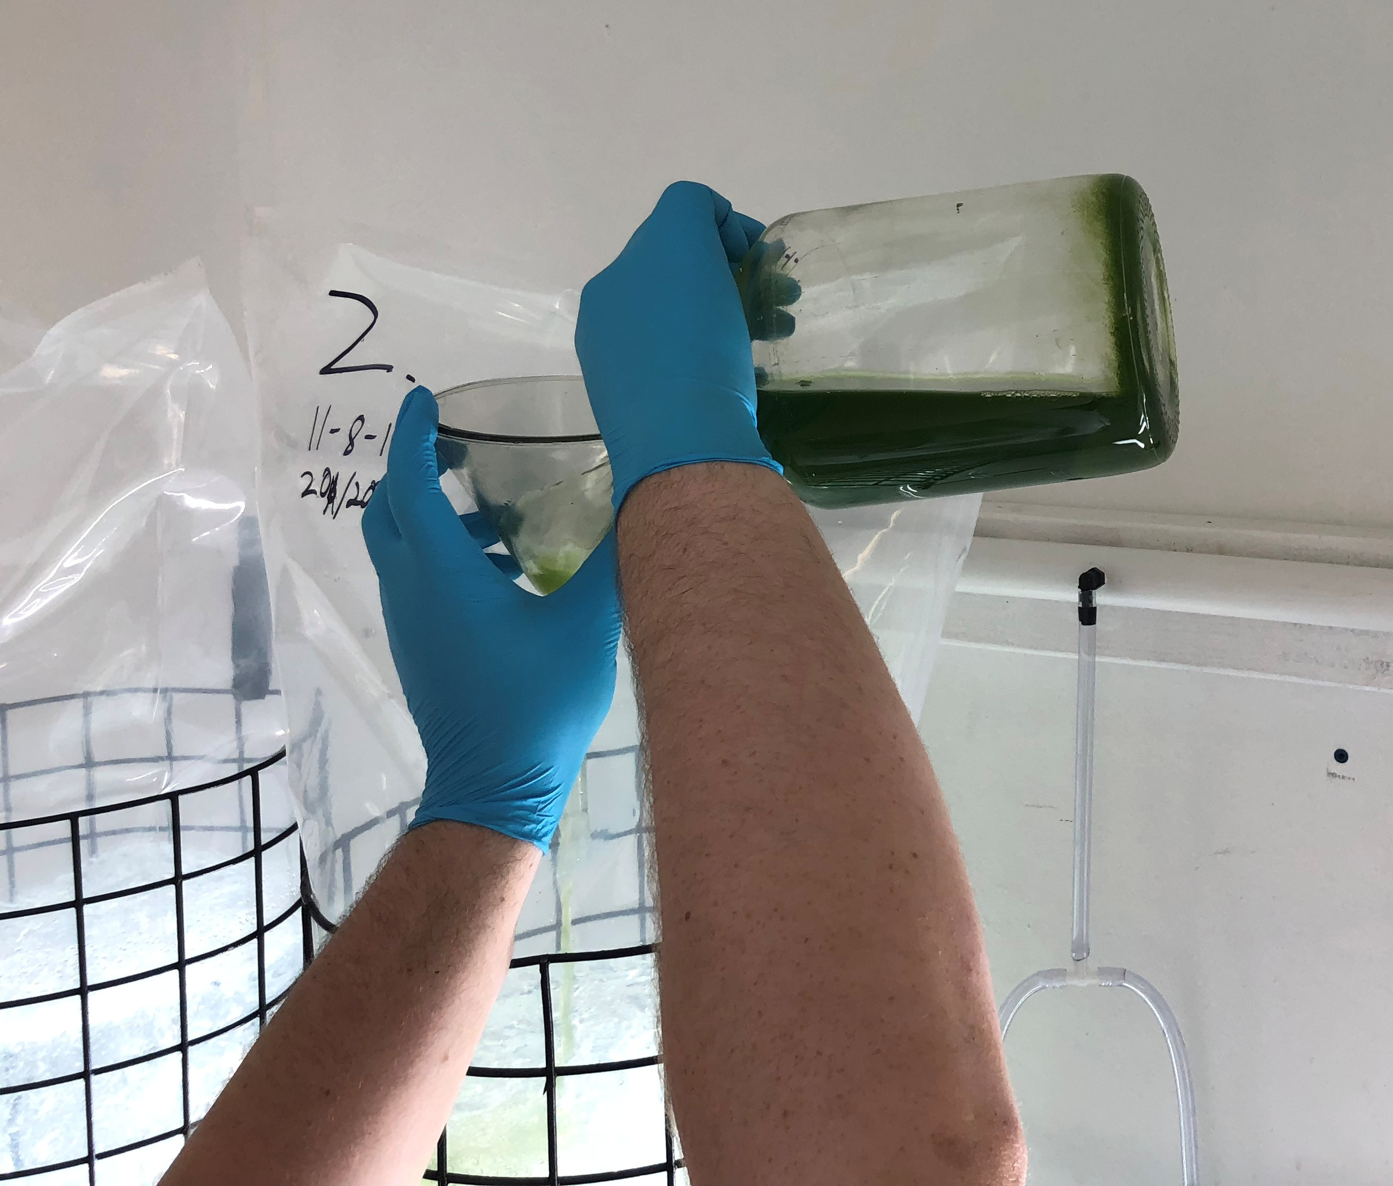
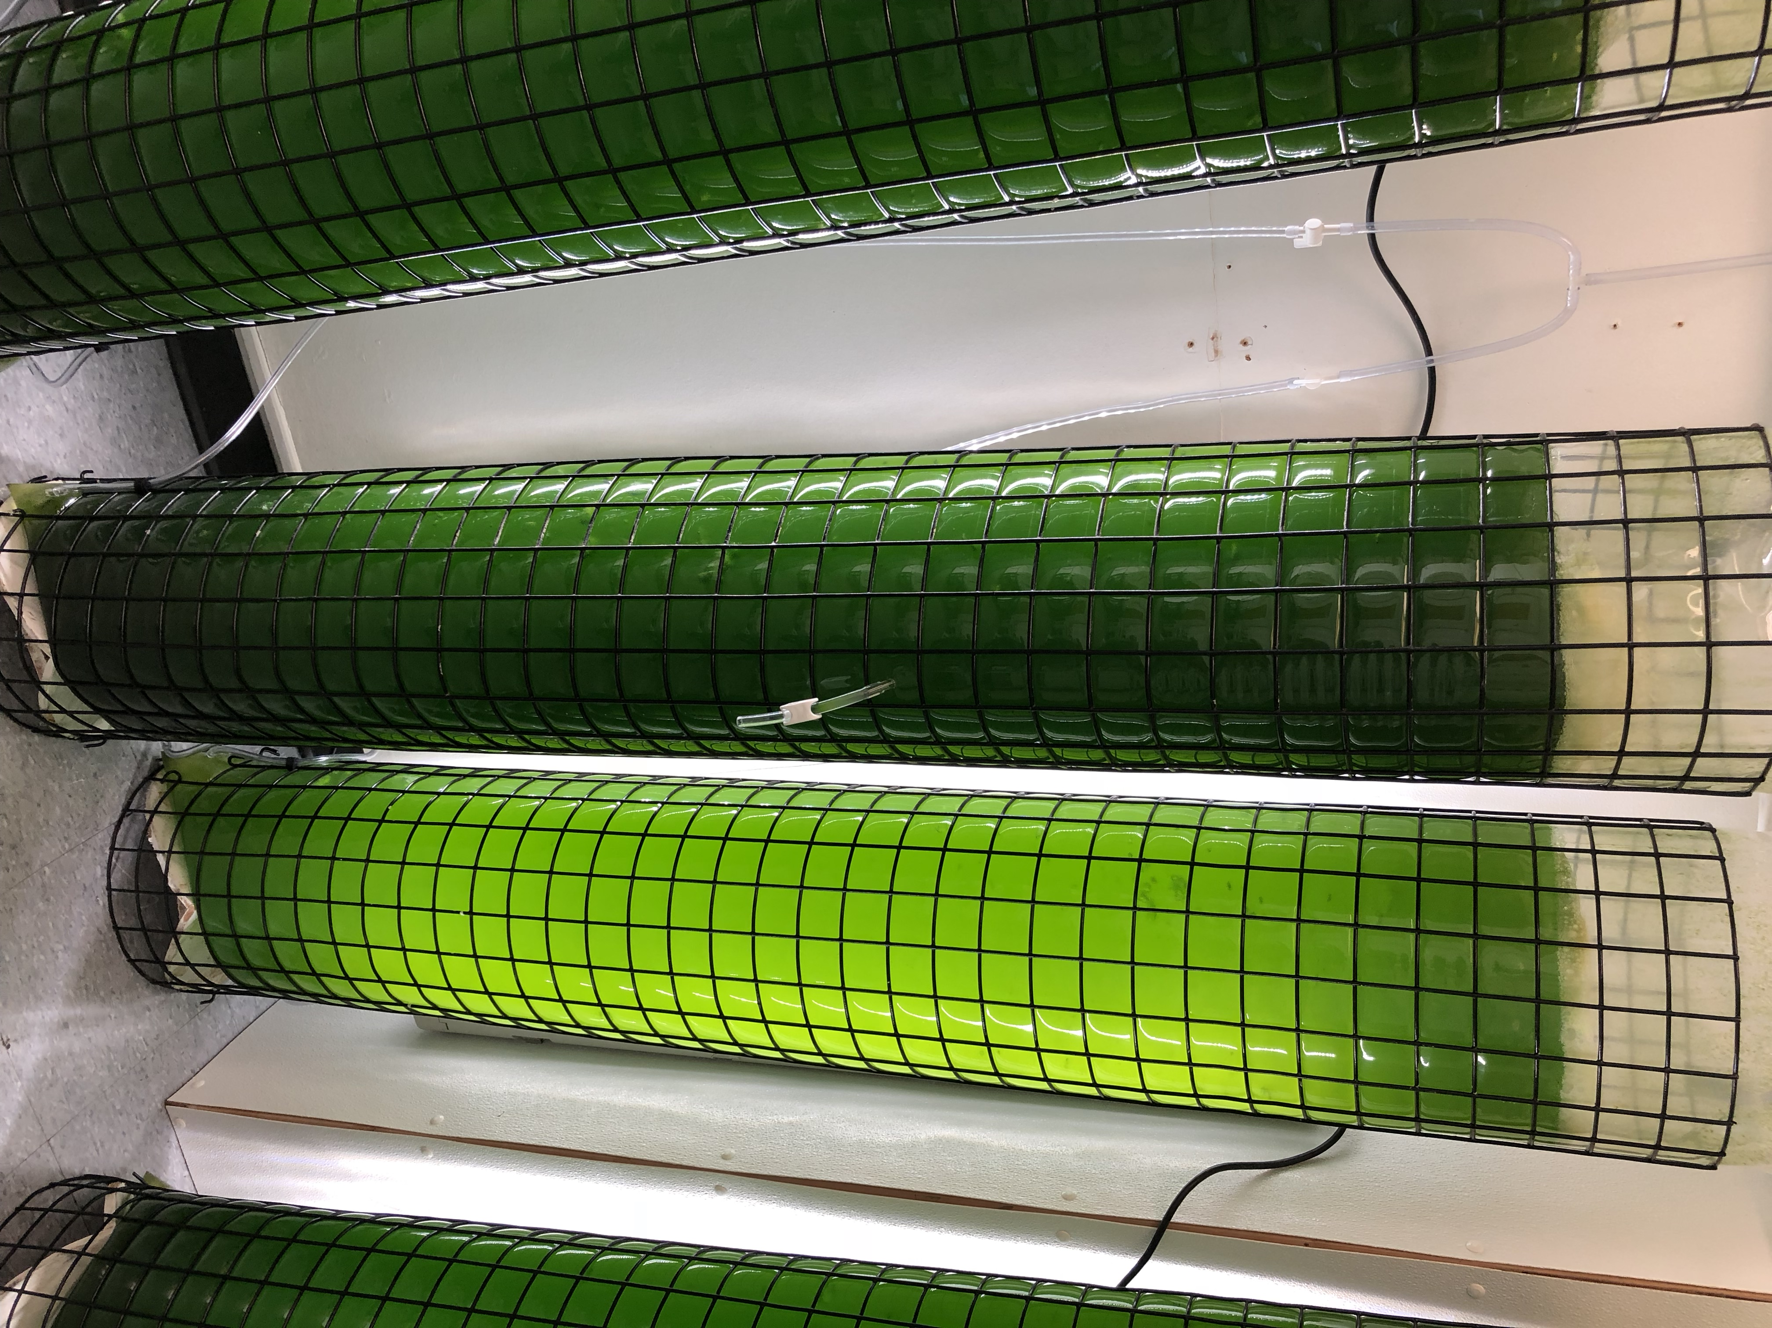
Day 2-6:
*Allow algae to bloom for 5 days. During this time the bag will become a dark green color (Figure 7). If the bag does not darken or changes to a different color, the bag should be discarded and restarted.

Day 7:
Figure 6: Inoculation of Reactor with Algae
*Add approximately 0.5 million clean, filtered and rinsed rotifers (Figure 8) to the bag through the fill port.
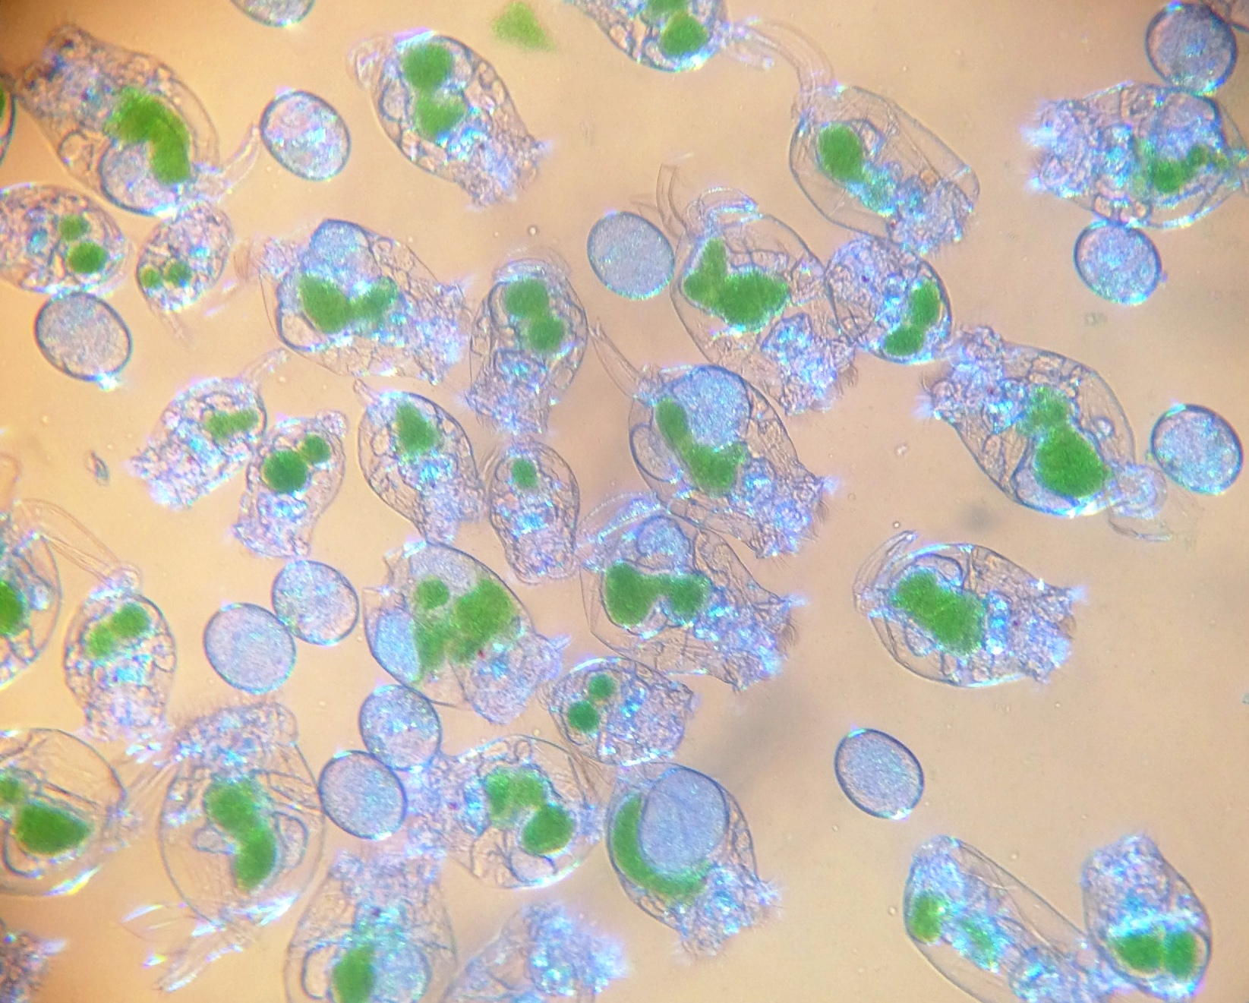
*The bag can also be inoculated with about 10 mg of dried rotifer cysts (Figure 9). Each cyst hatches into a female who begins rapid asexual reproduction. The scale-up time for starting from cysts is generally 2-3 days longer, but the advantage is that you can be confident of the purity of the rotifer species and that it is free from contamination.
Figure 7: Dark green bag on left (notice sampling port in center of bag)

Day 11-13:
*Rotifers reproduce rapidly upon introduction, doubling or more every 24 hours at 25°C.
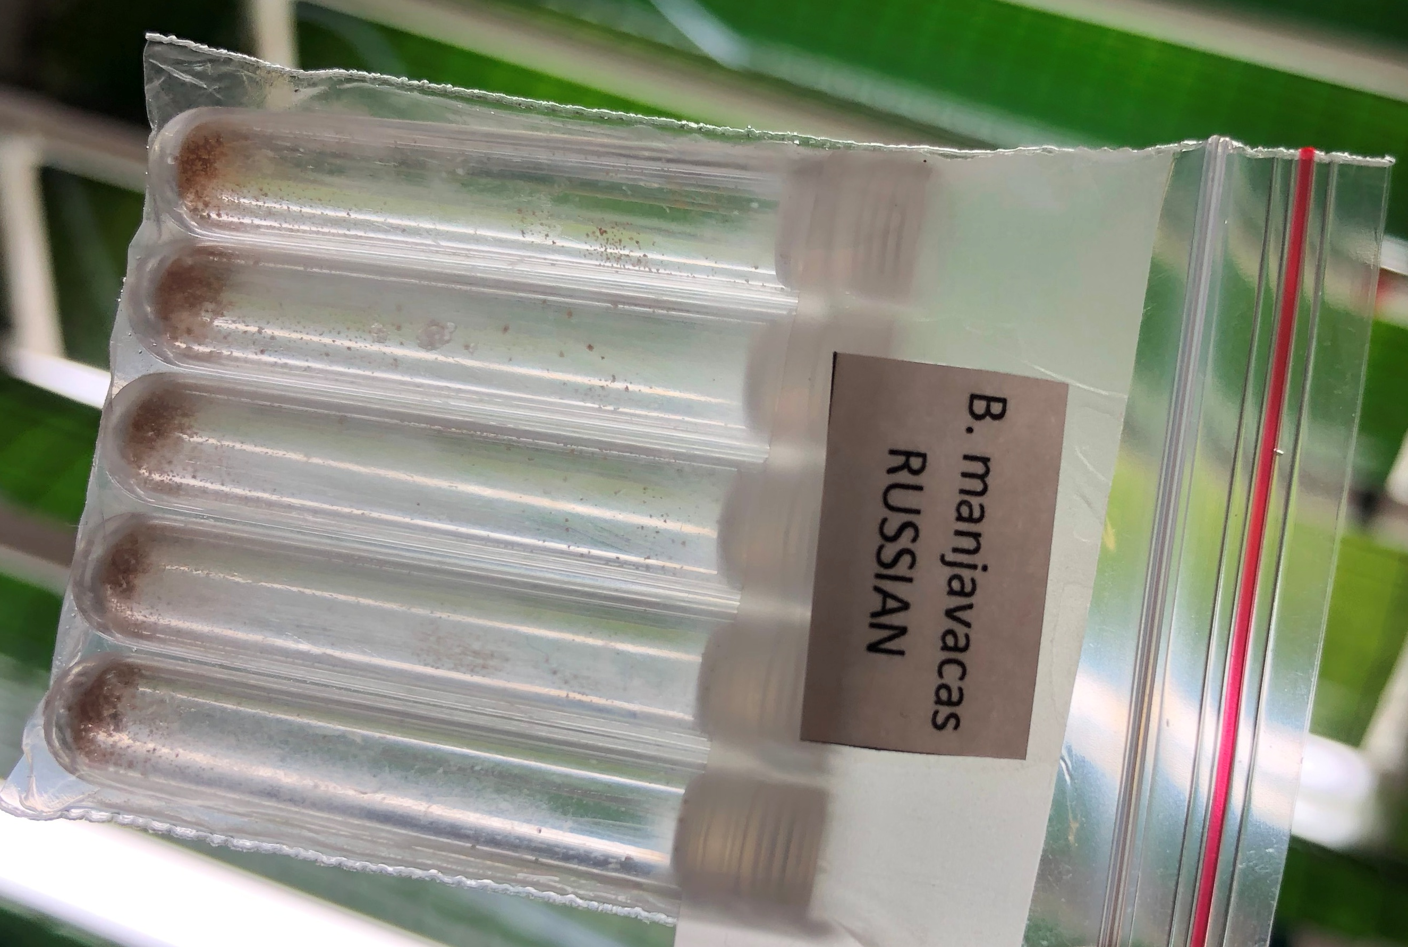
*Using the sampling port, take a 1mL sample daily and count under a microscope with about 10X magnification to assess rotifer health and population density in the reactor. A healthy rotifer population increases in density daily and has many egg-bearing females who swim vigorously (~1 mm/sec).
Figure 8: Live Rotifer Culture
*At this time, it will be necessary to introduce additional food to the bag: Twice daily (morning and evening) add 0.5g Amplifeed Replete per million rotifers

Day 14:
*Perform a health check and density count, followed by addition of Amplifeed Replete
*Harvest reactor by filtering the entire reactor volume through a 50-70 um size mesh.
*Rinse rotifers and re-suspend in clean seawater and feed-out to larval tanks
*Remove bag from reactor and discard. Prepare a new reactor for reset (Beginning again with “Day 1”).
Figure 9: Tubes Containing Dried Rotifer Cysts

Literature Cited:

Hoff, F.H. and T.W. Snell. 2004. Plankton Culture Manual. 6th edition, Florida Aqua Farms, Dade City, Florida.

Snell TW, RK Johnston, AB Matthews. 2018. Utilizing Brachionus biodiversity in marine finfish larviculture. Hydrobiologia, DOI 10.1007/s10750-018-3776-8.

Wallace, R.L. & T.W. Snell. 2010. Rotifera. In: Ecology and Systematics of North American Freshwater Invertebrates. Thorp, J.H. and A.P. Covich (eds.), Academic Press, NY.
Third edition.

