Sykik Rider CBR5.0
User Manual
Thank you for choosing SYKIK. The all new CBR5.0 is a dual camera system to record your bike’s front and back view simultaneously for your safety and pleasure. Please read this manual for user instructions. For more information, please visit: www.SYKIK.com.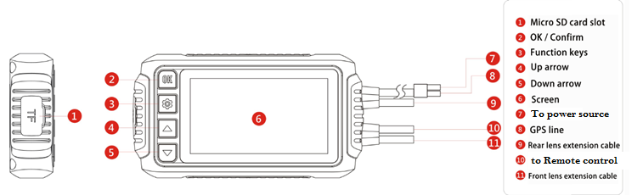

Multi function remote(optional)
Pair of Bullet cameras and extension cables
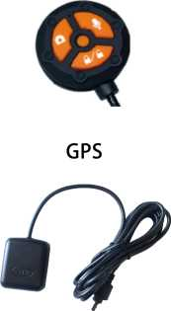
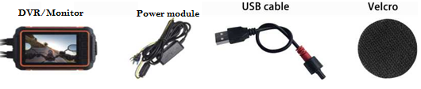
(optional)
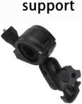
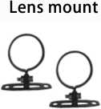
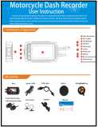

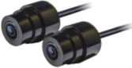

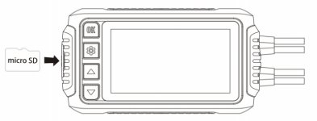
1.Before use, please insert the micro SD memory card with contact face up. Please use a type 10 or faster card.

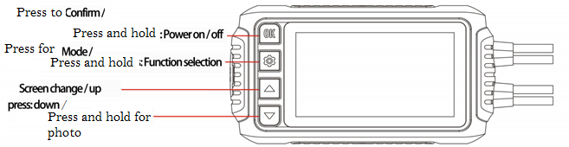
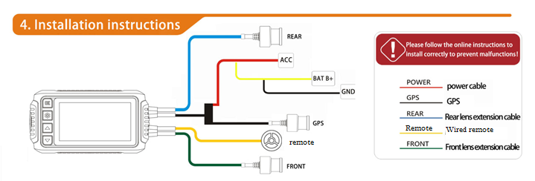
Before installing the system, please connect cameras to the DVR and run the system using a power bank or USB power outlet, using the supplied USB cord. Make sure the unit turns on and camera views are visible on the screen.

- Locate the location you would like to install the DVR with the display. Can be installed on the handle bar using included mount, or under your seat or bag using provided Velcro.
- Locate desired location to install the front and back cameras. Note, you can install the cameras in any angle since the cameras can rotate inside the camera brackets. Also the supplied brackets can tilt within a large degree for your convenience. Install the camera mounts, using the already placed adhesive. You can also use screws or zip ties to install these mounts. Place the cameras in the brackets and run the camera wires to the DVR location.
- Connect the power module to power source as illustrated above. Red wire should be connected to ignition, accessory port, fuse box or other regulated power. The yellow and black, to battery ports, positive and negative respectively. Please note, most new motorcycles and power sports offer regulated USB power outlets. You may power the system via USB using supplied power cord instead of using the power module.
- Connect the camera and power module to the DVR. Make sure to connect the front and back cameras to the correct input of the DVR as illustrated. Please note color coding on the connection interfaces. DONOT force the connections, they should slide right in once you have the groves aliened.

Optional Accessories
1.GPS : It is recommended to place the GPS antenna in open air for better reception.
2.Multi Function Remote: Should be placed close to your reach.

2. Wire rod: Install the wire rod at each position of the locomotive in sequence according to the wiring method on the right. (Avoid the electric panel and avoid interference)

- Power supply: positive (red wire) ACC is connected to "lock switch" and
negative (black wire) is connected to battery negative.
4-wire control: one end is connected to the left or right side of the handle of the faucet, and is attached to the faucet with a Velcro(lt is recommended to put it in a place where it is not easy to touch the water), and the other end is connected to the host BMW connector (MIC).
5. Lens: Lock the lens ring and lens mount on the front and rear positions (front: below the faucet or above the swash plate, rear: rear protruding position). Tighten with tapping screws. Please note that the FRONT lens is the front lens and the REAR lens is the rear lens. When installing the lens, please place the lens towards the middle to avoid direct light from affecting the image quality.
Manual file lock:
1- In the video recording mode, press the [Lock Button]. A lock symbol appears at the top of the screen, with the LED light. Please delete the locked files once no longer needed to open space for longer recording
2- Capture an Image: Press the Camera button to take a photo
3- Recording: Press the speaker button to turn on / off the radio


Light | Description
1 second slow flash | Recording status
Flashes quickly | Lock
Long bright | Standby

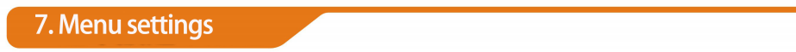
Features | Option | Preset options
Flame out video time | Off/1 min / 3 min / 5 min / 10 min | 5 min
Recording File | 1 min/2 min /3min | 1min
Touch-tone | Off/On | On
volume | 1 ~ 10 | 5
recording | Off/On | On
Clock settings | yyyy-mm-dd-hh-mm-ss
Language | English/Simplified Chinese/Traditional Chinese | English
Flickerfrequency | 50Hz/60Hz | 60 Hz
Screensaver | Off/1 min/3 min | 1 min
Gear sensitivity | Off/High/ Medium / Low | Medium
GPS status | Icon
Time zone selection | GMT/GMT-01:00 〜GMT-12:00- GMT+13:00 | GMT+08:00
WIFI | Off/on | On
System reset | Yes/no
Fomnatcard | Yes/no
Software version | xxxxxxxxx
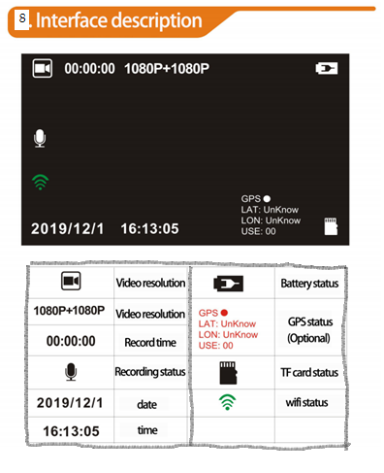
This system can connect wirelessly to your mobile phone or tablet via Wi-Fi offered within the system. To connect to your mobile phone or tablet:
1. Download the APP using the QR code below.
2. Open the APP with your phone next to the system.
3.In available Wi-Fi, look for: CBR5.0 and connect using password:12345678


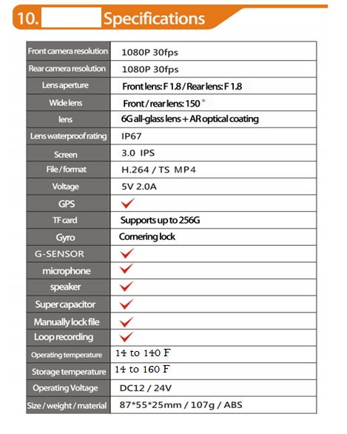

Sykik Limited Warranty
Congratulations, you have made an excellent choice of this quality product. Our commitment to quality also includes our customer service and product service. Please contact us at www.sykik.com if any questions or comments. Should you contrary to expectations, experience defects due to manufacturing faults, SYKIK will provide you with a warranty against defects as follows:

Warranty
The product is guaranteed to be free from defects in workmanship and parts for a period of 360 days from the date of your purchase. Defects that occur within this warranty period, under normal use and care, will be repaired, replaced by a new or refurbished equivalent value at our discretion.

Proof of purchase
This warranty is valid for the original purchase and is not transferable. Please keep your purchase invoice or receipt as the best proof of purchase and proof of date on which the purchase was made.

Extend of Warranty
This warranty is limited to defects in workmanship or parts. All defective products or parts will be repaired, replaced by a new or refurbished equivalent value at our discretion.
This warranty does not cover
1- Batteries, rechargeable batteries or any other consumable parts or items.
2- Normal wear and tear to the product or part.
3- Any defects caused by an accident, misuse, improper installation or operation, lack of reasonable care, unauthorized modification, loss of parts, tampering or attempted repair by a person not authorized by manufacturer.
4- Any product that has been used for purposes other than domestic consumer use.
5- Any damage caused by improper power input or improper cable connection

To make a claim
Simply send the defective unit, or part, along with copy of your invoice and description of problem to:

SYKIK Warranty Works
4722 Worth Street
Los Angeles, CA 90063

When making a return, please make sure the product is properly packaged to ensure will not be damaged during transit.

Shipping Charges
If your product is purchased within 180 days, Sykik Warranty center will ship the unit back to you at no charge. For warranty periods of over 180 days, SYKIK Warranty center will not accept any shipping charges.

