

SRTP300 Instruction Manual
Wireless tire pressure and temperature monitoring system
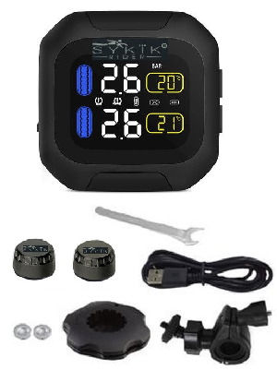
What is in the box
In the box you will find the following:
Waterproof main unit with multi-color display
Set of tire sensors
Set of luck-nuts
Luck-nut tool
Handlebar mount
USB charging cord
Battery changing tool
Instruction manual

Installation of external sensor
- Screw on the luck-nut to the metal tire stem.
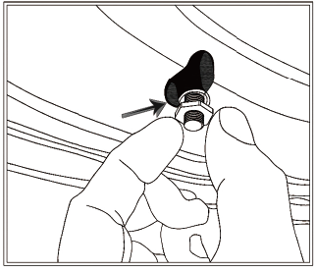
- Place the sensor on the stem and tighten it.
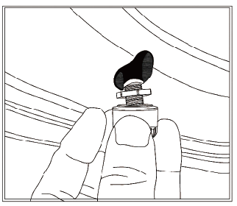
- Tighten the lock-nut counter clockwise, to hold the sensor
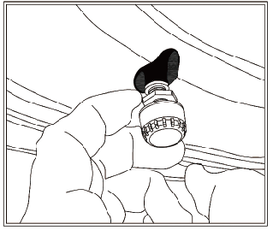
- Using the provided luck-nut tool, tighten the luck-nut counter clockwise
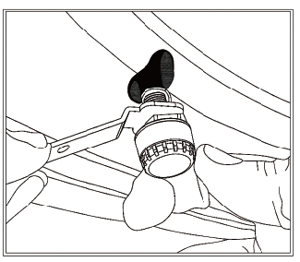
Turning the unit on or off:
Press and hold “＜” for 3s to 6s to turn the monitor on or off.
Display icons:
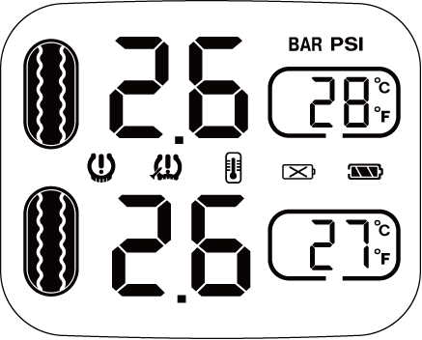
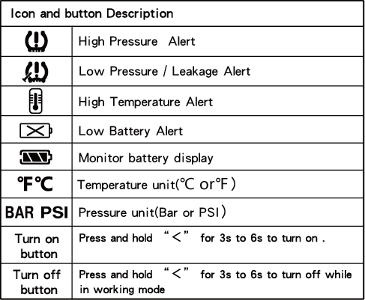

Function
Default settings
High pressure 44 PSI (3.0 Bar)
Low pressure 29 PSI (2.0 BAR) 65℃
High temperature 149℉ (65℃)

High Pressure Alert:
When the pressure of any tire is higher than the pre-defined value (44 PSI), the high pressure icon will flash with an audible alarm.
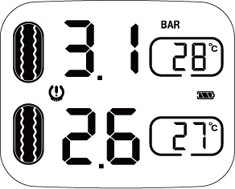

Low Pressure Alert:
When the pressure of any tire is lower than the pre-defined value (29 PSI), the low pressure icon will flash with an audible alarm.

High Temperature Alert:
When the temperature of any tire is higher than the pre-defined value (149℉), the high temperature icon will flash with an audible alarm.
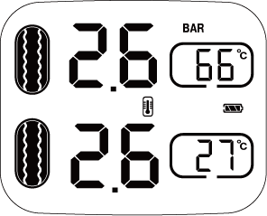
Fast Leakage Alert:
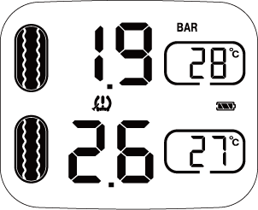
When front sensor detects tire leak, low pressure value and leak icon will flash with an audible alarm.

Sensor Low Battery Alert:
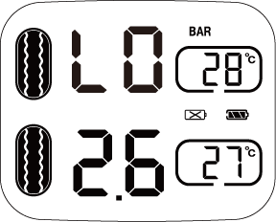
When the sensor battery is low, the low battery icon of corresponding tire will flash with an audible alarm.

Parameter setting
- Maximum pressure alarm value can be set as high as 87PSI (6 BAR).
- Maximum pressure range can be displayed 99 PSI (up to 8 BAR).
High Pressure Setting:
- Press and hold SET button to enter settings.
- Press ＜ to choose "high pressure HI" as below,
- Press SET button to setup high pressure alarm value.
- Press＜ to adjust the value desired
- Press SET to save.
- Press and hold SET button about 3s to save and exit to standby.
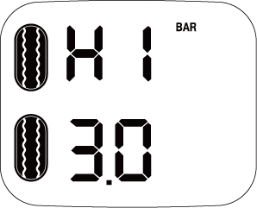
Low Pressure Setting:
- Press and hold SET button to setup
- Press ＜ to choose "low pressure LO" as below,
- Press SET button to setup low pressure alarm value.
- Press ＜ to adjust the value desired
- Press SET to save.
- Press and hold SET button about 3s to save and exit..
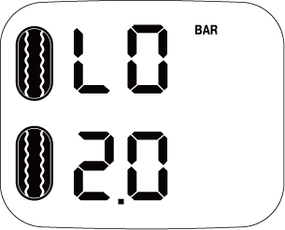

High Temperature Setting:
- Press and hold SET button to setup page
- Press ＜ to choose "high temperature HI" as below
- Press SET button to setup high temperature alarm.
- Press ＜ to adjust the value desired
- Press SET to exit. Finally press and hold SET button about 3s to save and exit to standby.
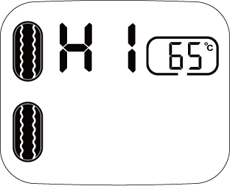
Pairing Sensors:
- Press SET button five times continuously to enter pairing mode, as bellow
- Press ＜ to choose the tire you wish to pair. Pairing tire will start to flash
- For External sensors: Tighten the sensor For Internal sensors : Inflate the tire
- The monitor will look for the sensor and displays the pressure and temperature.
- press and hold SET about 3s to save and exit to standby.
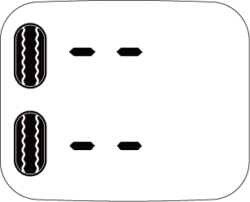

Pressure Unit Setting:
- Press and hold SET button to enter set up.
- Press ＜ to choose "BAR PSI" as below
- Press SET to setup pressure unit.
- Press ＜ to choose the pressure unit you desire
- Press SET to saves.
- Press and hold SET button about 3s to save and exit.
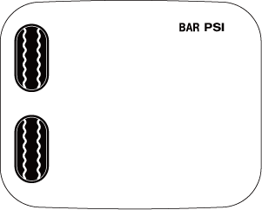

Temperature Unit Setting:
- Press and hold SET button to enter set up.
- Press ＜ to choose "℃℉"as below,
- Press SET to setup temperature unit.
- Press ＜ to choose the temperature unit you wish.
- Press SET to exit setup .
- Press and hold SET button for 3s to save and exit.
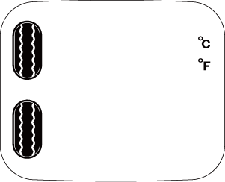

Replace battery of external sensor
Caution：Sensor battery has been installed before delivery. Please do not disassemble unless the battery has to be replaced.
- Remove the safety gasket.
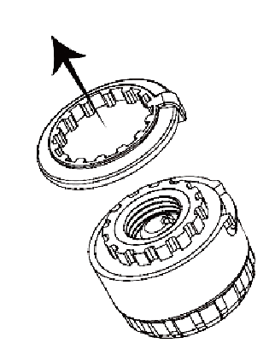

2. Place the sensor into the battery changing tool.
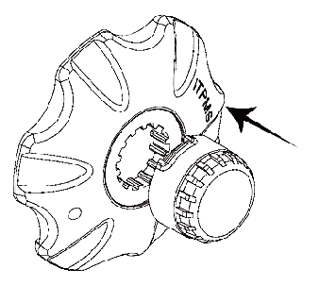

- Use battery changing tool to unscrew the sensor case.
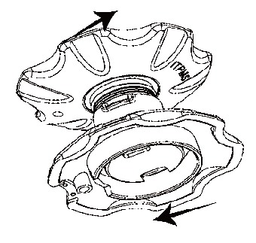

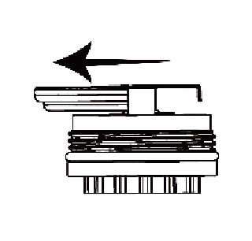
- Remove the battery and replace with a fresh battery.

- Use the battery changing tool to close the sensor
- Replace the safety gasket.
- 