INSTRUCTIONS FOR INSTALLATION AND USE OF THE 9x12 TELESCOPING
EASEL (Item # 134.12T)
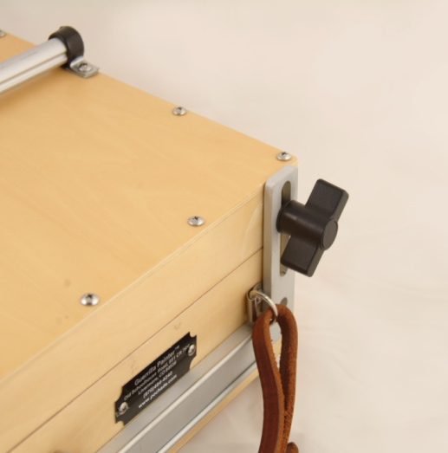
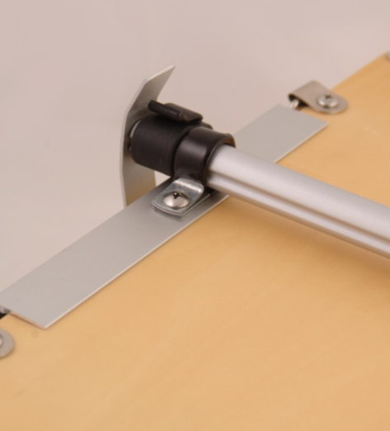
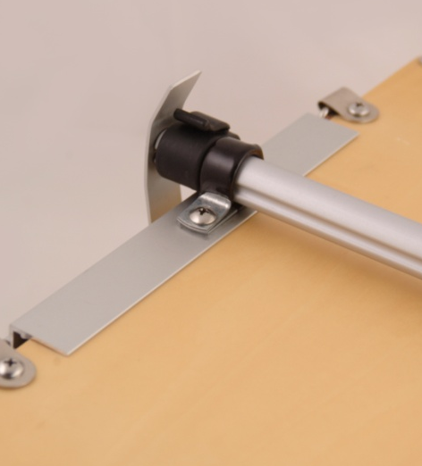
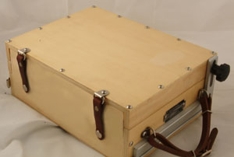
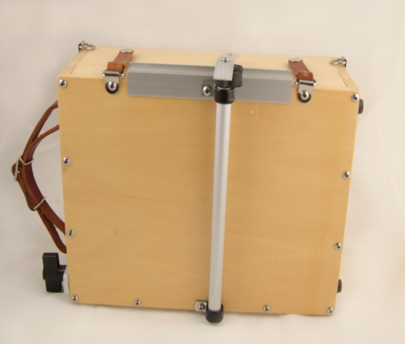
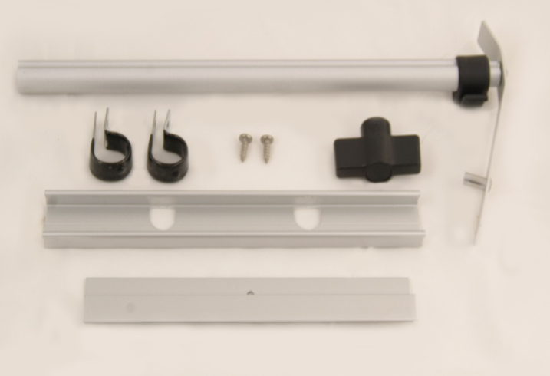
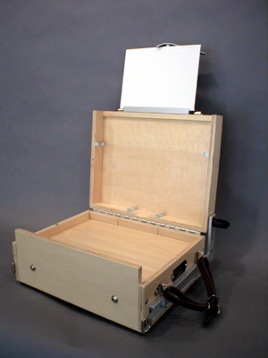
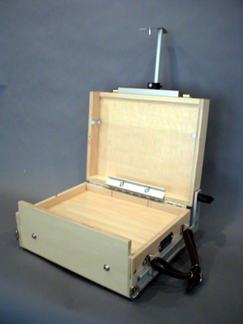
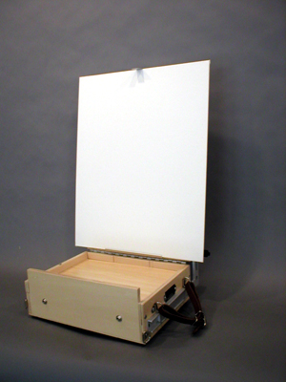
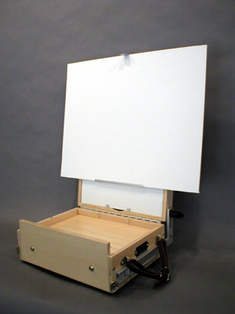
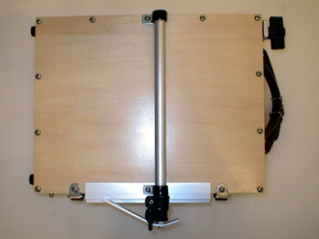
(OVER)
5
Use 2nd screw at other end.
4
Attach screw here.
3
3. Position the Upper Panel Shelf as shown with the hole over the screw hole in the lid as shown.

4. Place the Telescoping Assembly and the Vinyl-Coated Clamps as shown and attach with the screws provided. Do not over tighten the screws.

5. Replace the Adjusting Knob (and bolt, if necessary) located on the L-shaped bracket on the side of your Guerrilla Box with the Heavy-Duty Wing Knob as shown. This will allow you to make sure the lid is firmly tightened when using large panels or canvases.
1. Remove the two center screws from the long edges of the Guerrilla Box lid as shown using a Phillips head screwdriver.
2. Place the Vinyl-Coated Clamps on the Telescoping Assembly with one at the head and one at the base.
1
Place clamp here.
2
Place clamp here.
INSTALLATION
E
D
C
B
A
MATERIAL CONTENTS

A. 1 Telescoping Assembly
B. 2 Vinyl-Coated Clamps & 2 Screws
C. 1 Upper Panel Shelf (with one hole)
D. 1 Removable Lower Panel/Canvas Shelf (with two holes)
E. 1 Heavy-Duty Wing Knob

© 2015
Guerrilla Painter LLC
1-970-493-0217
www.guerrillapainter.com
USE
The Telescoping Easel adjusts easily up and down using the adjusting knob on the Telescoping Assembly. The Top Panel Holder can be rotated to use either the short or long end as needed (as shown below).
CAUTION – When using the Telescoping Easel and large canvases, make sure that your box and tripod are well secured. We recommend our Guerrilla Field Tripod Kit (Item No. 305K) or equivalent, with legs adjusted to their broadest stance and used with our Tripod Stone Bag (Item No. 306 sold separately and included in the Tripod Kit). A wind-induced crash, with the added leverage of a large painting, could damage the Telescoping Easel, your Guerrilla Box, your painting—or all three.
1. For panels up to 10" tall: You may use the Telescoping Easel to paint on smaller panels up to 10" tall using the Upper Panel Shelf (1a) as shown. Use the short end of the Top Panel Holder (1b) when painting on smaller panels held in this position.

2. For panels or canvases up to 20" tall: Use the Removable Lower Panel/Canvas Shelf (2a) when painting on larger panels or canvases up to 20" tall. Place the panel brackets through the holes in the metal shelf. The shelf will hang at a 45° angle and your panel/canvas will rest on the lower lip of this shelf outside of the frame of the box lid. Use the long end of the Top Panel Holder (2b) when painting on larger panels or canvases held in this position.

3. For panels up to 16" tall: Or you may use the Telescoping Easel and the Slip-In Easel (3a) (Item No. 133.12 sold separately) in combination for panels up to 16" tall as shown. Use the long end of the Top Panel Holder (3b) when painting on larger panels or canvases held in this position.

4. When not in use, store the Telescoping Easel as shown.
3 a
1 a
3 b
1 b
2 b
2 a
2 b
2 a
4

