

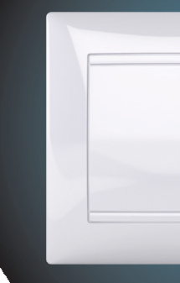


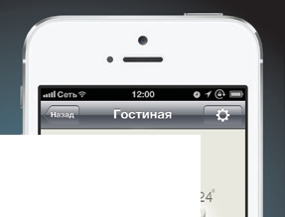

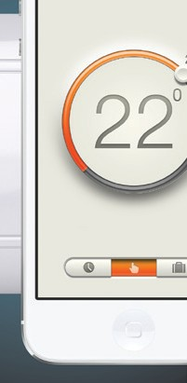
Mobile Comfort System

Technical Certificate. User Manual
Thermostat MCS 300

CONTENTS:
Introduction 3
- Control and indication 8
- Installation guide 9
Floor temperature sensor installation 9
Thermostat mounting 11
Thermostat installation 13
- Technical specification 16
- Your safety 17
- Warranty obligations 18
Warranty Certificate 19

РЭА.00065.01П(ИП)

РОСС RU.AB87.B03861

Good for printing 16.07.2013.

INTRODUCTION

Thermostat MCS 300 is a brand new Wi-Fi device, which will make your life even more warm, cozy and comfortable. MCS 300 is designed to control indoor electric heating systems (heating mats, film heaters or heating cable sections). Thermostat automatically maintains a preset temperature of the heated surface using readings from the floor temperature sensor (included in the delivery set).
Remote control is carried out directly by the Wi-Fi network of the smartphone or through the router.
There is a possibility of connecting several (from 1 to 32) thermostats MCS 300 to your home network.
Thermostat MCS 300 is mounted into the wall in close proximity from the installation wire of the heating cable (fig. 3).
Installation of a thermostat of other series or producers instead of used thermostats may be allowed. The parameters of the used temperature sensor must match the sensor parameters of the thermostat MCS 300.

To begin the thermostat operation it is required to perform a few simple procedures:

- Install thermostat MCS 300 as described in the installation guide below.

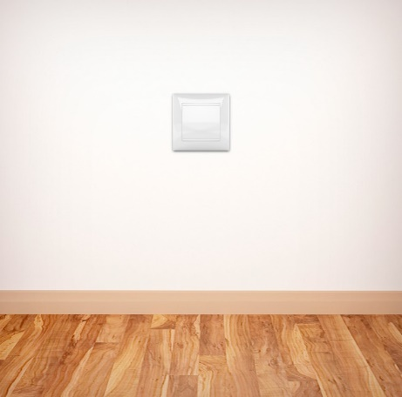

- Download the free app for your iPhone in AppStore by
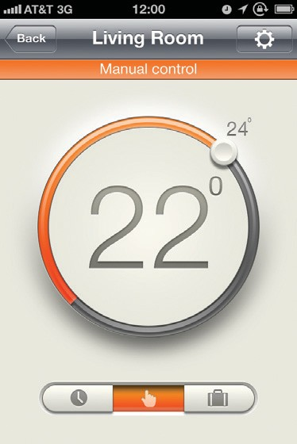
entering MCS 300 in search. You may also find a reference to this app on the website www.ses-pro.ru or on the QR code, printed in the end of the manual on its cover.

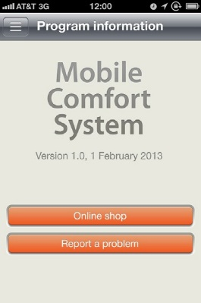

- Connect the MCS 300 thermostat to your home Wi-Fi* network by
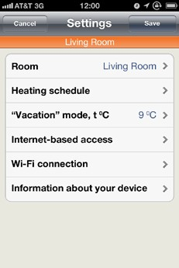
WPS or manually.

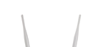
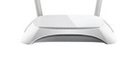

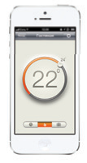
Smartphone MCS thermostat

Wi-Fi router
for remote access via Internet

* — If you do not have a Wi-Fi router, you can control the thermostat MCS 300 directly. In that case the thermostat acts as an access point. Control would be possible only with one thermostat at a time.

Thermostat is ready for operation. By running the application you will have full access to your warm floor system. You may set operation modes, heating temperature, change all settings of your thermostat.
You can download the detailed manual on thermostat operation on our website http://www.ses-pro.ru/production/wi-fi-thermostats/mcs-300.

Delivery set of the thermostat MCS 300 includes:
- Thermostat MCS 300 1 pcs.
- Remote floor temperature sensor TST02 1 pcs.
- Technical Certificate, Installation Manual 1 pcs.
- Packing box 1 pcs.


Fig. 1. Outside view of MCS 300 thermostat

CONTROLS AND INDICATION 1

The front cover does not have any LED signals or buttons (see fig. 1). If the cover is open, as it is shown on fig. 6, there are LED signals and control buttons under it (see fig. 2).

- «green» — indication of the power supply and presence of Wi-Fi connection
- «red» — indication of heating turned on and sensor failure
- «default» — thermostat switch ON/OFF, control of the modes of the network connection
- «WPS» — setting WPS connection.

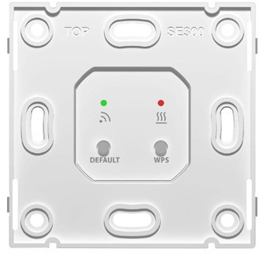
1

3
2

4

Fig. 2. Thermostat MCS 300 with opened front cover

8 Controls and indication

INSTALLATION GUIDE 2

Installation of the floor temperature sensor
Mounting the floor temperature sensor is carried out at the stage of the heating element installation. The floor temperature sensor should be placed inside the corrugated tube (see fig. 3), the end of the tube should be closed with sealing blank cover to prevent concrete mixture or tile adhesive glue penetration at the warm floor system installation. The corrugated tube with the sensor inside should be placed at the same level as the heating cable, between the loops at equal distances from them. The other end of the corrugated tube with the sensor installation wire inside should be laid in the prepared groove (chase) in the floor and lead to the installation place of the thermostat or the junction box. Excess of the tube and connection wire should be cut as applicable.

De-energize the wiring system before you connect the thermostat or disconnect it to check or replace.
A qualified electrician is to perform the electrical connections and power networking.
The warranty does not cover any thermostat defects caused by inadequate installation.
IMPORTANT Please read this manual carefully before you start operation.

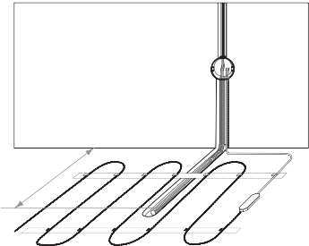

Fig 3. Thermostat and heating cable section installation
50–60 cm

Tools and materials necessary for installation:
- Corrugated plastic tube with the diameter at least 16 mm (length
of the tube depends on the place where the module will be installed);
- Standard plastic junction box;
- Flat blade and crosshead screwdrivers;
- Phase indicator to locate voltage wire.

Thermostat mounting
Preparation of electrical connections
Install junction box or terminal box. Approach the power line cables, installation wires of the heating mat or section and floor t emperature sensor installation wire to the junction box. Apply voltage to the power line cable, determine phase and neutral cores by the phase indicator and mark them accordingly.

Disconnect supply voltage. Please carry out all connecting procedures only under disconnected power supply. Connect all wires to the device screw terminals.

If you have a two-conductor supply network (without an earthing conductor), connection diagram is presented on fig. 4. The cold lead screen wire of the heating section is connected to the neutral (N) conductor of the power network, to terminal 5.

If you have a three-conductor supply network (with a separate earthing conductor), the connection diagram is presented on fig. 5. The cold lead screen wire of the heating section is connected to the earthing conductor of the power network via an external screw terminal (included in the delivery kit).

temperature sensor
N L
220VAC

temperature sensor
N L
220VAC

Single-core heating cable

Double-core heating cable

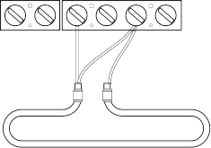
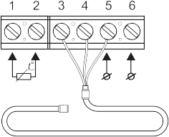
Fig. 4. Connection diagram of heating section and mats to two-conductor power network

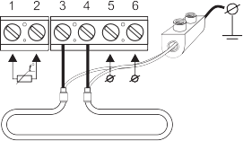
network earthing conductor
network earthing conductor

temperature sensor

N L
220VAC
external
screw terminal

temperature sensor

N L
220VAC
external
screw terminal

Single-core heating cable
Double-core heating cable

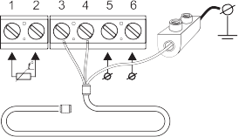
Fig. 5. Connection diagram of heating sections and mats to three-conductor power network

Thermostat installation

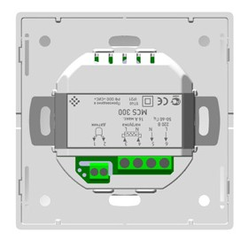
The thermostat needs to be disassembled before installation. Remove the front cover of the device. To do so, unlock the cover by inserting a flat blade screwdriver into the locking grooves located on both sides of the front cover (fig. 6). Remove the cover (fig. 7).

Locking groove

Locking groove

Locking groove

Fig. 6. Front cover removing

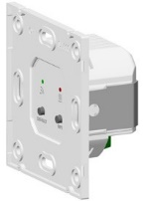
Fig. 7. Thermostat without cover

Mount the device into the junction box and fix it with at least two screws located along its horizontal axis (fig. 8).
Assembly of the thermostat is carried out in reverse order. Carefully install the front cover of the thermostat back to its place, pressing by hand till both clamps click. Make sure that the front cover is securely fixed.

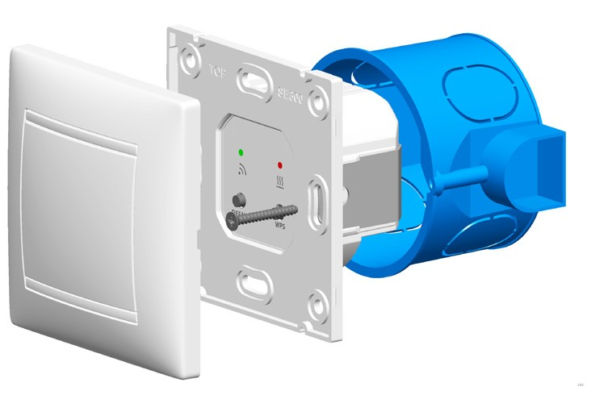
Front cover

ТЕХНИЧЕСКИЕ ХАРАКТЕРИСТИКИ
Fixing clamp

Fixing clamp
Junction box

Fig. 8. Assembly/disassembly diagram of thermostat

Thermostat MCS 300 has a removable frame. If it is necessary you may remove it and install the thermostat into the junction box without the frame. You may also use standard stopper plugs of some manufacturers of electric equipment. They may be installed instead of the MCS 300 frame and attached to the terminal box by screws.
To remove the frame of the device press the four fixing clamps, located on the upper and bottom sides of the thermostat, with the flat blade screwdriver (fig. 9) pulling the frame out.

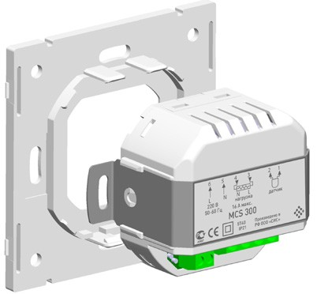
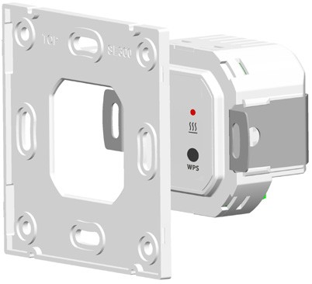
Clamps

Clamps

Fig. 9. Dismantling the removable frame

TECHNICAL SPECIFICATIONS 3

THERMOSTAT MCS 300
Supply voltage | 220 V
Maximum load current | 16 А
Power consumption | 2 W
Weight | 100 g
Dimensions | 83×83×48 mm
Store settings term at disconnected power supply | 12 months
IP rating | IP21
Protection degree | II
Floor temperature sensor | TST02
Sensor installation wire length | 2 m
Operating temperature | from +5 °С to +40 °C
Permissible relative air humidity | 80 %
Maintained temperature range | от +5 °С до +45 °C,
Factory preset temperature of executive module | +28 °C

16 Technical specifications

YOUR SAFETY 4

All operations for installation and connection of the thermostat must be carried out by a qualified electrician who has carefuly studied this manual!
Do not attempt to carry out the procedures on installation and repair of the thermostat without disconnecting the power supply.
Do not attempt to make any changes in the design of the thermostat. Do not expose the thermostat to mechanicals impacts (shocks, falls
and etc.).
Do not expose the thermostat to water.
Do not expose any parts of the thermostat to any liquids containing acids, alkalis, oils and etc.

Use dry, soft pieces of clothes to clean the thermostat.
While operating and maintaining it is necessary to follow the require- ments of GOST 12.3.019-80, “Regulations for Operation of Consumer Elec- trical Installations” and “Safety Rules for Operation of Customers’ Electric Installations”.

Breach of any stated requirements may result in the failure of the thermostat. In this case the warranty obligations are not supported.

Your safety 17

WARRANTY OBLIGATIONS 5

Manufacturer guarantees compliance of the Thermostat quality to the requirements of Technical Specification TU 3428-711-68134775-2012 assuming that the transportation rules and installation and operation in- structions are followed.

The warranty period is 2 years from the date of sale.
Within the warranty period the Buyer has the right to get the product repaired or replaced if defects are found to be occurring due to the manufacturer’s fault provided instructions on installation and operation are followed.
The warranty does not cover any mechanical damage of the thermostats or defects caused by inadequate installation, connection or operation of the product.
To get warranty obligation fulfilled, it is obligatory to submit a filled out warranty certificate indicating the name of the product, the name of the place where the product was bought, the name of the Seller, bearing the Seller’s stamp, an authorized person's signature and the Buyer’s signature.

Claims
Upon emergency due to a fault within the guarantee period the customer should immediately submit a claim to the service center of the Manufacturer or his authorized regional representatives.
18 Warranty obligations

WARRANTY CERTIFICATE

Thermostat MCS 300,

Date of manufacture Has passed acceptance tests and is declared
acceptable for service.

QCD stamp Seller Date of sale Seller’s stamp

Manufacturer:

I-WARM ELECTRIC HEATING (SHENZHEN) CO. LTD.
4/F South, Office Building, Dacheng Industrial Park, Jihua Road East, Buji, Shenzhen, China, 518112
Warranty certificate 19

