Getting started
• Remove the product from the packaging. • Please retain all packaging after you have checked and counted all the parts and contents against the list.

In the Box

Bluetooth USB 3.5mm Instruction
Headphone Charging Auxiliary Manual Cable Cable

Key Features
- Soft leather padding around the headphones allows for a comfortable fit. • Stream music via Bluetooth connectivity. Perfect for iPhone, iPad, Android TM , Windows smartphones, tablets, computers and more. • Built-in controls for answering calls, play/pause track, forward/back and volume. • Crystal clear noise reduction technology helps reduce noise and echo.
- USB rechargeable battery for upto 15 hours of talk time or music playback. • Built-in Aux jack enabling use even after the battery dies. • Built-in microphone for hands free calls.

Safety Instructions
- Keep the unit away from heat sources, direct sunlight, humidity, water and any other liquids.
- Do not operate the unit if it has been exposed to water, moisture or any other liquids to prevent against electric shock, explosion and/or injury to yourself and damage to the unit.
- Do not use the unit if it has been dropped or damaged in any way.
- Repairs to electrical equipment should only be performed by a qualified electrician. Improper repairs may place the user at serious risk.
- Do not use the unit with wet hands.
- Do not put objects into any of the openings.
- Keep the unit free from dust, lint etc.
- Do not use this unit for anything other than its intended use.
- Keep the unit out of reach of children.
- Do not use the handset at excessive volume levels, as damage to hearing may occur.
2
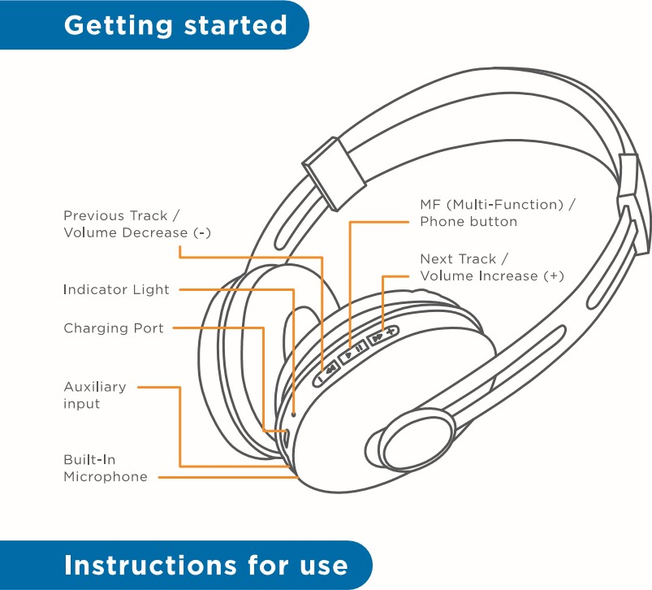
Charging Instructions
- The Bluetooth Headphone comes with a built-in rechargeable battery. Before using it for the first time we recommend you charge the battery fully. Only use the supplied USB Cord to charge the Bluetooth Headphones. Please charge for approximately 5 hours.
- Connect the USB charging cable to a computer USB
3
port and the Micro USB plug to the charging port of the device. The Indicator Light turns Red while the device is charging. It takes about 5 hours for the headphones to charge fully. Indicator Light turns blue, when the battery is fully charged.
Turning on/off the device
- Press and hold the MF button for 4 seconds to turn ON/OFF the device.
Pairing the device with Bluetooth devices (phone or music device)
- Press and hold the MF button for 4 seconds to turn on the headphones. This will prompt an indication tone, and the indicator light will flash red and blue alternatively. Place the Bluetooth Headphones and Bluetooth source device (phone or music device) close to each other so that they are no more than I meter apart.


- Activate the Bluetooth function on your Bluetooth device (phone or music device). Please refer to the manufacturer's manual for instructions on enabling Bluetooth on your device.
- Once you have activated Bluetooth on your device, select the pairing name "MSD thump 500" from the list of available Bluetooth devices.
4
- If required, enter the password '0000' to confirm pairing.
- Once paired successfully, another indication tone will be heard and the indicator light will flash blue.
- You're now ready to stream wireless music to your
headphones.
- If pairing is unsuccessful, turn off the device first and then re-pair following the above steps.
- Once you have paired the Bluetooth Headphones with a device, the Headphones will remember this device and will pair automatically when the device's Bluetooth is activated and in range. You do not need to re-pair any previously connected devices.
- The Bluetooth Headphones will attempt to automatically connect to the last device it was paired with when switched on. If you want to pair it with a new device, please follow the steps outlined above.
- Once the Bluetooth Headphones are paired with your device the music will transmit through the Bluetooth Headphones. Please refer to your device user manual for further information.
5
Function Summary
Listening to Music
- Once the Headphones are paired with your device you can stream music wirelessly through the Bluetooth Headphone. Should you encounter any problems while
streaming please refer your device user manual for further information.
Function Operation Button
Increase Volume | Playing music | Long press the + button to increase the volume
Decrease Volume | Playing music | Long press the - button to decrease the volume
Pause | Playing music | Short press the MF button to pause the music
 | Pausing | Short press the MF button to restart the music
Previous track | Playing music | Short press on the button to return to the previous track
Next track | Playing music | Short press on the button to skip to the next track
(Note: An indication tone will alert you when the volume is adjusted to minimum level.)
6

urbn
connect to disconnect
To know more about URBN visit our website
www.urbnworld.com
To connect with us for assistance please contact us on support@urbnworld.com or 1800 22 2468.
To stay tuned with our launches and deals, follow us at
urbnworld urbnworld
M S DHONI
EDITION

Answer a call | Incoming call | Press the Phone button once to answer an incoming call
Reject a call | Incoming call | Press and hold the Phone button for 2 seconds
End a call | Incoming call | After your phone conversation, short press the Phone button
Increase volume | During a call | A long press on the + button once will increase the volume
Decrease volume | During a call | A long press on the - button once will decrease the volume
Redial last number | Standby mode and connected to a device. | Short press the Phone button twice
Red Light on | Charging
Blue Light on | Charging Completed
LED Indicator | Status of the BT Headphone
Indicator Light flashes blue and red alternatively. | pairing Mode
Speaker Driver  Rated Output  Frequency Response  Signal-to-noise Ratio  Distortion | 40 mm  10mW x 2  20Hz-20KHz  >70dB
Battery Life (Play Time)  Battery Charging Time  Battery Charging Voltage Battery Capacity  Built-ln Mic | Up to 15 Hours 5 Hours  300mAh  Yes
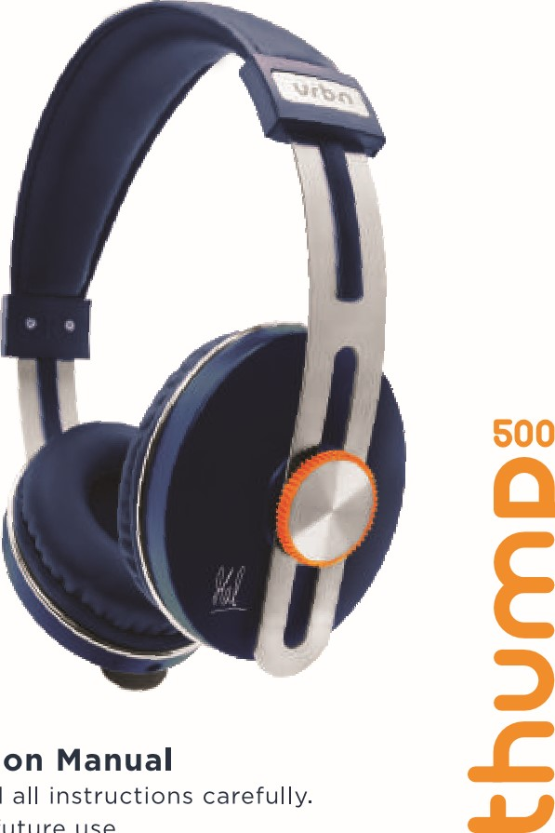
Headphone. • Do not use it outdoors in wet or in damp surroundings. may cause permanent damage to it. WARRANTY DISCLAMERS: This warranty is in lieu of all
Instruction
Please
read
Retain
for
future
use.
of devices used.)
warranties expressed or implied and no representative
Indicator Light Charging of the BT Headphone n case the device doesn't function properly, send it or person is authorized to assume for manufacturer any Care and Maintenance to the store you bought it from. The staff will help you Warranty other liability in connection with sale of our products.
address the problem.
WARRANTY PERFORMANCE: During the above one (1)
Read the following recommendations before using the This manufacturer's product warranty extends to the year warranty period, a product with defect will be
Bluetooth Headphones. Following these you will beoriginal consumer purchaser of the product. Neither able to enjoy the product for many years. Specifications the retailer nor any other company involved in the sale either repaired or replaced with a reconditioned comparable model (at manufacturer's option). The or promotion of this product is a co-warrantor of this
- repaired or replacement product will be in warranty for Do not expose the Bluetooth Headphones to liquid, manufacturer warranty.
moisture or humidity to avoid the product's internal Dimensions 175 (L) *185 (H) *70 (D) mm the balance of the warranty period or thirty (30) days circuit being affected. Weight 169g WARRANTY DURATION: All the materials and which ever is longer.
workmanship are warranted to the original consumer
Making a call with the Bluetooth Headphone in | Indicator Light | Do's and Don'ts | • Do not let the device fall on the floor. The internal | Bluetooth Transmission Range Upto 10 Meters | which have been altered or modified or, to damaged | urbn | Wireless
Bluetooth mode |  |  | circuit might get damaged. | Bluetooth Compliant 4.2 | products or parts thereof which have had the serial |  | On-Ear
 | Please refer to the below tables for a list of the | • Do not play music at excessive levels. Damage to |  | Pairing Name MSD thump 500 | number removed, altered, defaced or rendered illegible. | connect to disconnect | Headphones
Function Operation Button | Indicator Light status while using the Bluetooth | hearing and/or equipment may result. | • Do not attempt to disassemble the headphones as it | (Note: Battery life and charging time may vary based on usage and types
Listening to Music using AUX-In Mode • Do not use abrasive cleaning solvents to clean thepurchaser for a period of one (I) year from the original WARRANTY LIMIT: The maximum liability of the company shall not exceed the actual purchase price I. Insert the 3.5mm auxiliary cable (provided) to the device.purchase date.
paid by the purchaser.
•
Aux input of the Headphone. And, the other end of the Do not expose the device to extremely high or lowWARRANTY COVERAGE: This product is warranted
Please Note cable connects to the audio device (such as computer / temperature as this will shorten the life of the device,against defective materials or workmanship. This SERVICE AND REPAIR: If the service is required for the
- Not all mobile phones support all the functions listed above. Please refer to tablet etc.). destroy the battery or distort certain plastic parts.if the product has been damaged by product, the purchaser should contact Acetron
warranty is void
your mobile phone's user manual for further information.Enterprise Pvt Ltd Customer Service at support@ace-
- Functions and indication tones may vary depending on your mobile phone. 2. Select your song at the source device and play.accident, in shipment, unreasonable use, misuse,
- tron.in or by calling 1800 22 2468.
Do not dispose the device in a fire as it will result inneglect, improper service, commercial use, repairs by
(Note: Using this Aux-in mode, you do not need to turn on the Headphones, an explosion.unauthorized personnel or other causes not arising out
Disputes if any shall be subject to Mumbai Jurisdiction
and you need to control the volume increase/decrease, play/pause,of the defects in material or workmanship. This • only. next/previous track through your source device only.) Do not expose the device to any sharp objects as thiswarranty is effective only if the product is purchased will cause scratches and damage.and operated in INDIA, and does not extend to any units which have been used in violation of written
7 8 9 10 11 12

