
F

REQUEST FOR DISBURSEMENT
RFD SYSTEM USER MANUAL

TABLE OF CONTENTS

Chapter Page #
- PaperSave and Disbursements Overview 3
- PaperSave Web Workflow 8
- New Vendor Request 13
- Request for Disbursement (RFD) 18
- Purchase Order (PO) – Creation and Payment 26
- Request for Disbursement (RFD) Review and Approval 29
- Correction of Rejected Items 33
- Reports 33

Chapter 1 – PaperSave and Disbursements Overview
- Systems used for Disbursement Processing
  - General Ledger – FENXT by Blackbaud
  - RFD System by PaperSave
- RFD System Capabilities
  - All activity is processed on-line (including approvals).
  - For payments that do not have an invoice number (i.e. personal reimbursements and KFS/Banner reimbursements) PaperSave will, through a series of prompts, gather all required information and formulate invoice numbers to be consistent with the Foundation’s preferred method.
  - All backup documentation is scanned by the requestor and attached to the request prior to submitting.
  - The PaperSave workflow has been designed to require primary signatory approval for RFDs over the $10K threshold ($5K for Foundation expenses).
  - The PaperSave workflow is used to send requests to the Provost and/or President’s office for electronic approval.
  - Comments, where appropriate, can be attached to the RFD as it passes through the workflow. This includes returning the RFD to the preparer or approver when additional information is required but has not been received.
- Processing Notes
  - Payments for Foundation budget programs and University direct payment may not be done within the same RFD.
    - Example: Reimbursement to a Development Officer
      - Mileage being charged to Foundation budget
      - Donor lunch being paid from a dean’s fund is a University direct payment
  - Only one invoice may be entered on an RFD.
- System Access is obtained through the following link: https://249303.cloud.papersave.com
  - Sign-on credentials are dependent on employing entity
    - University employees – Opening the link should bring you directly to the PaperSave system
    - Foundation employees – will receive the following and will need to click on the link for their account to open the system.
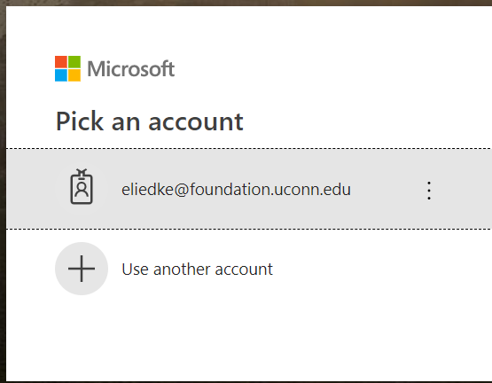

  - There are a limited number of “parking spaces” so if you are not able to get in, all the licenses may be in use and you should be able to wait a short period of time and try again.
  - The three pieces of the system used for Disbursement Processing are:
    - PaperSave Web Workflow (4th item down on the menu)
    - PaperSave Workflow Forms (11th item down on the menu)
    - Workflow Items I Reviewed (in the Published Reports Section)
  - The following is a partial sample of the PaperSave menu: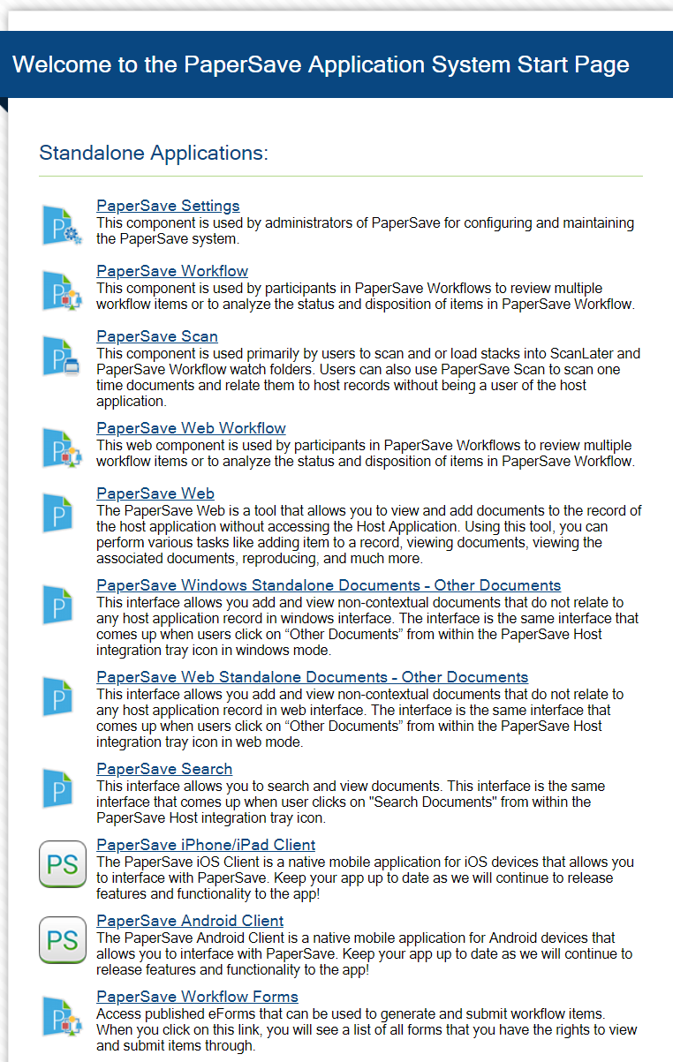

- Role Definitions: The following are roles and definitions that will be used throughout the training and the RFD system:
  - Requestor – Individual who will initiate or has initiated an RFD, PO, Vendor Maintenance and/or New Vendor Request
  - Alternate Signatory – Individual who is authorized to approve an RFD.
    - University Alternates may approve an RFD up to the amount of $10K
    - Foundation Alternates (called Budget Manager ) may approve an RFD up to the amount of $5K
  - Primary Signatory – Individual who is authorized to approve RFDs. The primary signatory approval is required for items over the above amounts.
    - University Primary Signatories are required to approve expenses in excess of $10K. University primary signatories may approve their own expenditures and RFDs for events where they were in attendance.
    - Foundation Primaries (called Senior Budget Manager) must approve expenses in excess of $5K. Foundation Senior Budget Managers may not approve their own expenses or for events where they were in attendance.
  - Provost Office Designee – Individual in the Provost’s Office who is authorized and designated to approve RFDs as required.
  - President Office Designee – Individual in the President’s Office who is authorized and designated to approve RFDs as required through the Foundation Disbursement Policy
  - Disbursement Team – Any member of the Disbursement team who may review/approve RFDs, New Vendors and Vendor updates
  - Senior Disbursement Coordinator – Individuals within the Disbursement team who may be asked to perform a second review of an RFD, New Vendor or Vendor Maintenance
- Disbursement Documentation that may be found through the Supplemental Documents button on the New RFD and New Vendor forms include:
  - Blank W-9
  - Foundation Disbursement Policy
  - Foundation Disbursement Policy Supplement
  - Travel and Entertainment (T&E) form – There may be two forms due to changing mileage rates; in most cases the most recent should be selected
  - Mileage calculation form – There may be two forms due to changing mileage rates; in most cases the most recent should be selected
  - Foundation Event Pre-Approval Form
  - PaperSave User Manual
To open a PDF file from the list of available forms
  - Check the box to the left of the form, and
  - Click the Open Selected icon in the toolbar
To open an Excel file from the list of available forms
  - Check the box to the left of the form, and
  - Click the Save icon in the toolbar

Chapter 2 - PaperSave Web Workflow
Description: The Web Workflow is used for actions on Requests for Disbursement (RFDs), Purchase Orders (POs) and New Vendor Submissions that have been generated.
Separate workflows exist for RFDs/POs and New Vendor requests.

The user only has access to items that they own in the workflow. There is an option to filter items by step but unless there are many items this is not recommended.

The workflow steps and actions available are dependent on security settings created for an individual’s assigned roles. These actions will be described as appropriate within this manual.

When an item moves from one step to the next, an e-mail is sent to the individual responsible for taking the next action step. A daily e-mail is sent to owners until all items have been either rejected or moved to the next step in the workflow.

Workflow Steps (RFD Processing): The following table identifies the workflow steps and provides some notes regarding the next steps in the process for RFD and Purchase Order processing.
Step | Owner | Notes
PO Pending Receipts | Requestor | After creation, a Purchase Order will remain in this step until the goods/services are received and the PO is converted to an RFD.
Vendor Maintenance | Disbursements | This step indicates that there are changes to the vendor that were submitted with the RFD.
Vendor Correction | Requestor | An issue with creating a new vendor or updating existing vendor information, as reviewed by the Disbursement team, is sent back to the requestor for correction.
Signatory Review | Alternate or Primary Signatory | RFD is pending review and action by appropriate signatory.

Signatory Rejection | Requestor | An issue exists within the RFD causing the signatory to reject it. After the item is corrected it is returned to the Signatory Review step.
Provost Review | Provost Office Designee | RFD is pending review and action by Provost office.
Provost Rejection | Requestor | An issue exists within the RFD causing the Provost to reject it. After the item is corrected it is returned to the Signatory Review Step.
President Review | President Office Designee | RFD is pending review and action by the President’s office.
President Rejection | Requestor | An issue exists within the RFD causing the President to reject it. After the item is corrected it is returned to the Signatory Review Step.
Final Review | Disbursements Team | Item is in queue to be reviewed by a member of the Disbursement team.
Senior Review | Senior Disbursement Coordinator or Director | Item is in queue to be reviewed by a senior member of the Disbursement team.
Entered | Disbursement Team | The item has been processed to Financial Edge through the auto-entry process.
Invoice Update | Disbursement Team | The item has been processed to Financial Edge through the auto-entry process but requires additional action prior to payment being made (by the Disbursement team).
Payment Pending | Disbursement Team | The item has been processed and approved in FE and is awaiting payment processing to be completed.
Payment Notification |  | The item has been paid and notification is being sent to requestor (if requested)
Workflow Steps (New Vendor Processing): The following table identifies the workflow steps and provides some notes regarding the next steps in the process for New Vendors.

Step | Owner | Notes
Vendor Review | Disbursement Team | All new vendors are reviewed prior to being established in Financial Edge.
Vendor Submission Issues | Requestor | There is information missing or incorrect in the request that requires correction prior to Disbursements setting the vendor up in Financial Edge.
Vendor Rejection | Requestor | The vendor will not be established in Financial Edge. Discussions with the requestor and/or notes on the request explain the reason for the rejection.
Entered | Disbursements | The vendor has been established in Financial Edge  Note: After a vendor has been established, it will be available in PaperSave the next business day.

Out of Office Note
When a requestor and/or approver will be out of the office, this tool will enable the items to be sent to another appropriate individual for continued processing. The out of office notification is processed through the PaperSave Web Workflow option from the main screen.

To set the out of office notification within the workflow, on the “Options” tab select “Workflow User Options” as displayed below:

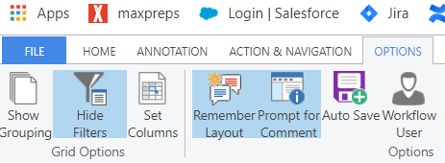

After selecting the Workflow User Options, a grid will appear requesting information:

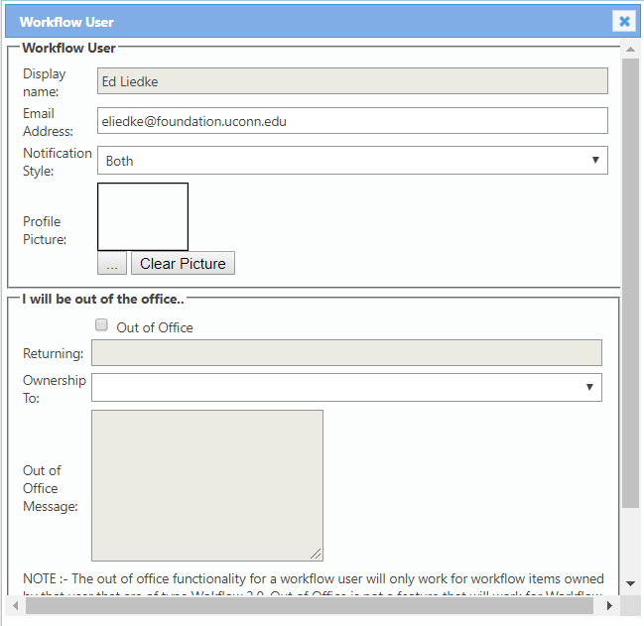

To complete the out of office activity:
- Click the button for “out of office”
- Enter the anticipated return date
- Select, from the drop-down menu, the individual who will provide coverage during the absence. This person must be an authorized approver at the same level or higher.
  - If an Alternate Signatory is placing the message, the replacement must be an alternate signatory within the same school/college/unit or the Primary Signatory from that school/college/unit.
  - If the Primary signatory is placing the message, the replacement must be the Provost designee or the President designee depending where the school/college/unit reports to.
- At the bottom of the screen (not shown above, click the “update” button).

Chapter 3 - New Vendor Request
Description: The new vendor request form is accessed through the PaperSave Workflow Forms. After opening the workflow forms screen, select the item for “New Vendor Request” from the menu as displayed below.
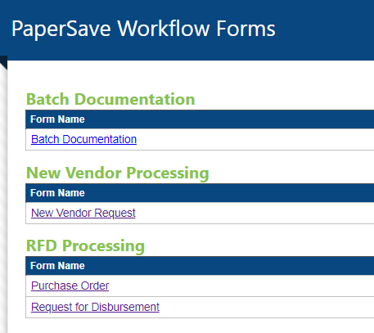

Form Sample
The following is a sample of the form to be completed.
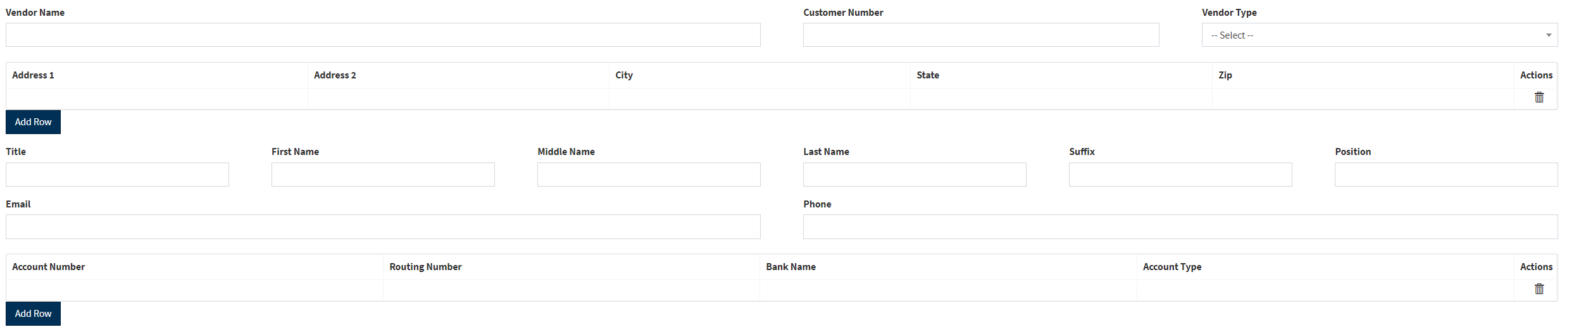

Form Completion
The following table will describe valid entries and identify those fields that are required vs. optional.
Name | Required/Optional | Description/Entry
Vendor Name | Required | Enter the legal name of the vendor.
Customer Number | Optional | If the vendor has provided a customer number, this may be entered here. This would be our ID with the vendor.
Vendor Type | Required | Select the most appropriate type from the drop-down menu.  Note: Some vendor types may make other fields required.
Address 1 | Required | Enter the vendor’s mailing address including city, state and zip code.
“Add Row” | Optional | If there is a separate address to send payments to, this address may be added by selecting this box and opening another address row.
Title | Optional | If the vendor is a business and there is a contact person at the vendor their title may be entered.
First Name | Optional | If the vendor is a business and there is a contact person at the vendor, their first name should be entered.
Middle Name | Optional | If the vendor is a business and there is a contact person at the vendor, their middle name may be entered.
Last Name | Optional | If the vendor is a business and there is a contact person at the vendor, their last name should be added.
Suffix | Optional | If the vendor is a business and there is a contact person at the vendor, their suffix may be entered.
Position | Optional | If the vendor is a business and there is a contact person at the vendor, their position (i.e. President) may be entered.
Email | Optional | The vendor’s e-mail address, if known, should be entered.
Phone | Optional | The vendor’s phone number, if known, should be entered.
Account Number |  | If the vendor is a University or Foundation employee, all payments will be made through Electronic Funds Transfer (EFT), so this field is required.  If the vendor is not an employee and prefers payment through EFT, this field may be completed.
Routing Number |  | If the vendor is a University or Foundation employee, all payments will be made through Electronic Funds Transfer (EFT), so this field will be required.  If the vendor is not an employee and prefers payment through EFT, this field may be completed.  Note: PS will verify the Routing Number as a valid bank ID. Invalid numbers will be rejected.
Bank Name |  | If the vendor is a University or Foundation employee, all payments will be made through Electronic Funds Transfer (EFT), so this field will be required.  If the vendor is not an employee and prefers payment through EFT, this field may be completed.
Account Type |  | Note: This is a drop-down menu containing choices for checking, savings or other.  If the vendor is a University or Foundation employee, all payments will be made through Electronic Funds Transfer (EFT), so this field will be required.  If the vendor is not an employee and prefers payment through EFT, this field may be completed.
Add Row | Optional | In the unlikely event a vendor provides two accounts for EFT payment, this may be selected and a row for additional banking information will be added.

Additional Documents
Additional documents are to be attached to the new vendor request form by utilizing the attachment icon (paperclip) on the form.

W-9: This form is used to identify tax ID information and the type of vendor (individual vs. corporation) for potential tax reporting. This form is required for all vendors except employees and students. A blank W-9 form may be found in the supplemental documents within the PaperSave system.

Insurance Certificate: This form is used to verify that the vendor has insurance in place if there are potential liability issues. If the vendor is providing certain services to the University and/or the Foundation an insurance certificate is required. Services that require an insurance certificate are those that could:
- have a negative impact on an individual while participating in an event,
- could negatively impact a physical structure,
- or who could potentially be negatively impacted while performing that service.
Examples of vendors where an insurance certificate is required would be (but are not limited to):
- Caterers
- Transportation (buses)
- Construction
- Repairs/maintenance (painters, lawn care, plumbers etc.)

Form Submission
After completing all the information, select the “submit” button at the top of the page. If the form is not ready to be submitted, it can be saved by clicking the save icon at the top of the page. A message will be returned indicating the form has been submitted successfully.
Once the vendor has been created in Financial Edge it may be selected for RFD and/or PO creation. This setup will generally occur within the next business day.
A member of the Disbursement Team may reach out with questions prior to setting up the vendor.

Chapter 4 - Request for Disbursement
Description: A Request for Disbursement (RFD) is a document that is used to identify information required for the Foundation Disbursement Team to remit payment to a vendor for applicable charges. The Foundation Disbursement Policy and the Supplemental Policy documents what expenses may be paid and how those payments are made.

RFD Form is accessed through the PaperSave Workflow Forms. After opening the workflow forms screen, select the item for “Request for Disbursement” from the menu as displayed below.
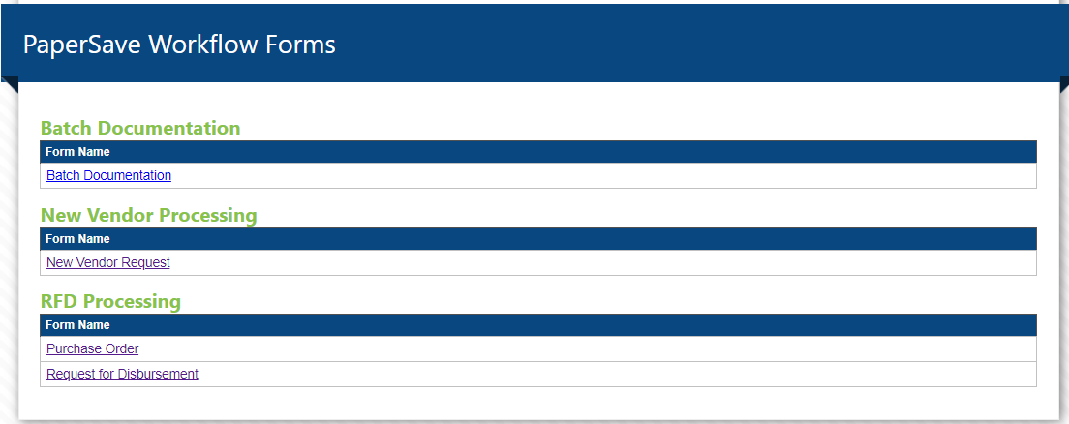

Creation of an RFD: The RFD form, for ease of training has been broken down into sections and is described below.
Vendor Selection and Information
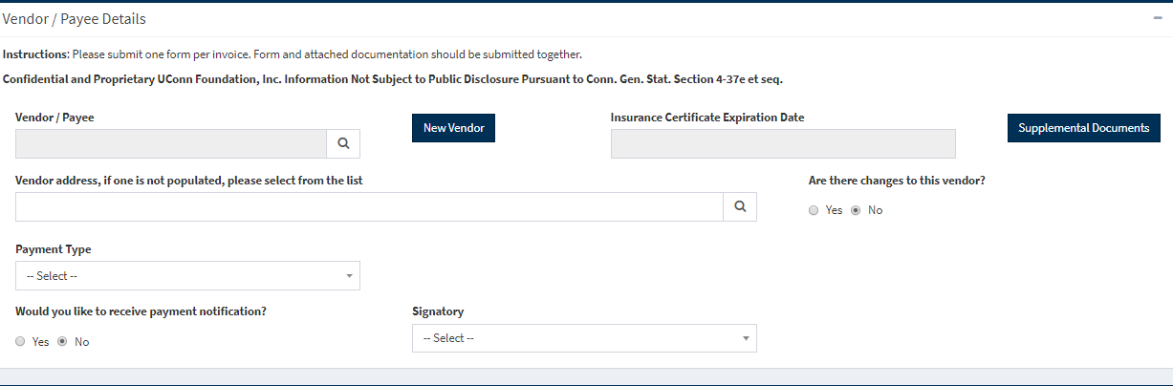

- Vendor/Payee
  - A search is performed to select the vendor/payee.
  - To initiate the search, click on the magnifying glass icon.
  - See below for sample and notes
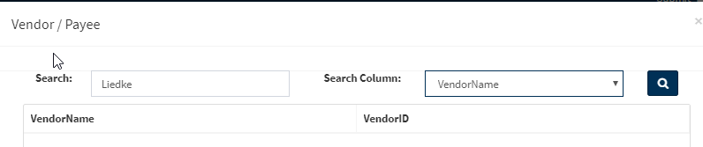
- Type the vendor name (or a portion of the name) in the search box.
- Use the drop-down in the search column to identify whether the search should be on the Vendor Name or Vendor ID.
  - Vendor IDs have been carried over from the MIP system that was previously used.
  - New vendor IDs in Financial Edge (FE) are a system generated number.
- A list of matches will be displayed;
  - Double-click the vendor to be selected.
  - The vendor information will be populated, and the following information will be displayed:
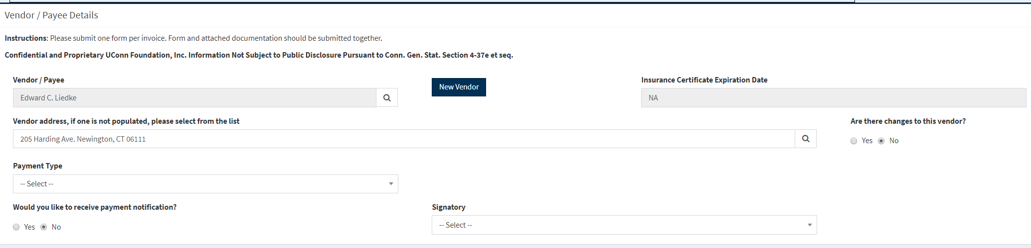
    - Insurance Certificate Expiration Date:
      - If the field indicates NA, no action is needed.
      - If the expiration date is in the future and/or after the date of the event, no action is needed.
      - If the expiration date is in the past or is before the event, you must obtain a new certificate from the vendor.
    - Vendor Address:
      - If the address field is blank and highlighted in red, click the magnifying glass and select the appropriate address from the list. A percent (%) sign in the search field is required for the search.
    - Are there changes to this vendor?
      - Default will be no.
      - If there are changes, click the yes button and enter changes as appropriate.
    - Payment Type: The drop-down menu will provide 3 options to select from:
      - Foundation: To be used when paying Foundation budgetary expenses. This selection will normally be used only by Foundation employees.
      - University Direct Pay: To be used when paying a vendor directly using Foundation accounts on behalf of the University.
      - University Reimbursement: To be used when the request is to reimburse the University or Health Center and the payee is UConn or UConn Health Center. If this button is selected, boxes for KFS and Banner numbers will be displayed.
        - If the RFD is reimbursing the University enter the appropriate KFS number.
        - If the RFD is reimbursing UConn Health Center enter the appropriate Banner number (with the preceding F or G).
    - Would you like to receive payment notification? – No is default but can change to yes if desired.
    - Signatory – Select the appropriate signatory from the drop-down menu. The drop-down should be all approved signatories for your unit.
Payment and Account/Program Details
The first part of this section will be used to build the invoice number.
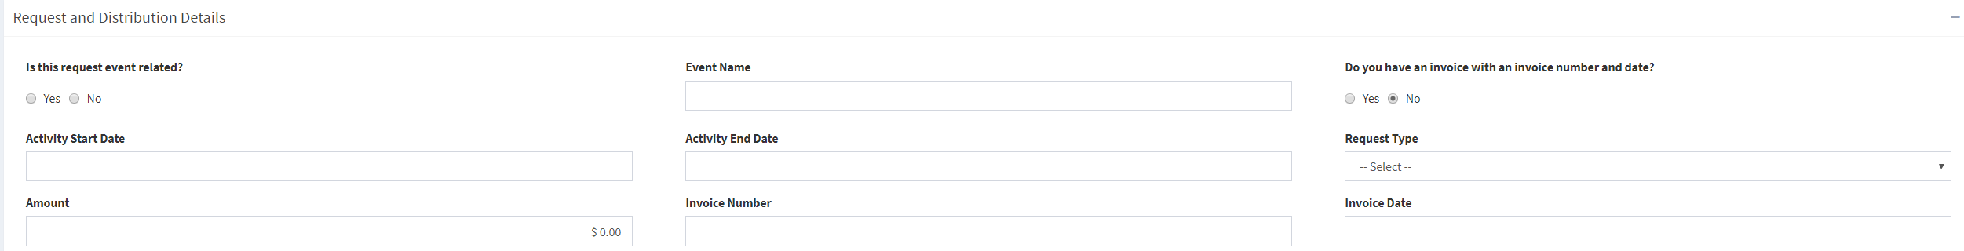
- Is this request event related (used when there is no invoice)?
  - Check the Yes button if this is for an event and there is no invoice number for payment and the payment is being made directly to a vendor.
Note: If an individual is being reimbursed for mileage, supplies or payment for the event do not click the yes button and do not enter an event name.
  - Check the No button if there is an invoice number present
- Event Name
  - If Yes button was selected, enter the name of the event in the box.
  - If the No button was selected, the box is to be left blank.
- Do you have an invoice with an invoice number and date?
  - Check the Yes or No button.
  - An invoice or bill is generated by a vendor to define the payment due. An invoice is characterized by an invoice number an invoice date (and usually an invoice due date).
  - Examples of items that are NOT invoices are:
    - Printed receipt from a restaurant,
    - Printed receipt from a parking garage
    - Printed receipt from a gas pump
- Activity Start Date (used when there is no invoice):
  - Enter the date of the first transaction or item to be paid/reimbursed.
  - This will generally be used for personal reimbursements and University KFS/Banner reimbursements.
- Activity End Date (used when there is no invoice):
  - Enter the date of the last transaction or item to be paid/reimbursed.
  - This will generally be used for personal reimbursements and University KFS/Banner reimbursements.
  - If the RFD is for an event, the start and end dates may be the same.
- Request Type – Select from the drop-down menu
  - Services – Select this when paying a vendor who is performing services such as printing, catering etc. or is supplying goods such as paper products, cleaning supplies, etc.
  - Reimbursement – Select this when reimbursing an individual (traveler) or an entity (University or UConn Health).
- Amount – Enter the total amount to be paid.
- Invoice Number - Enter the invoice number as displayed on the invoice.
  - If there is an invoice (yes to item 3 above), enter the invoice number.
  - If there is not an invoice (no to item 3 above) the system should auto-generate an invoice number.
    - The invoice number will be generated based on the information provided above.
- Invoice Date
  - If there is an invoice (yes to item 3 above), enter the invoice date.
  - If there is not an invoice (no to item 3 above) the system should auto-generate an invoice date.
    - The invoice date will be generated based on the information provided above.
Note: If some fields have been completed and then changed, the invoice number that was generated may be incorrect. In this case, it may be best to close the item without saving and start the RFD over again.
- Enter the invoice description in general terms including date ranges with the following examples:
  - Reimbursing E Liedke travel 030119 – 031519
  - Reimbursing KFS 123456 030119 – 031519
  - Oozeball posters 031419
  - Donor Lunch with J Smith 040119
Note: There is a 60-character limit to the description. You should be prompted with a warning to change the description if it is too long. If all information related to the item does not fit in the description, please include that information on a separate piece of paper as part of the documentation.
Account and Program Identification is entered through completing a grid. Multiple rows may be added to capture all appropriate information. The following is a sample of the grid with field explanations.
- Debit Account - Enter the hyphenated 7-digit account code to identify the types of expenses that are to be paid.
  - A Search can be performed by clicking on the magnifying glass. It is best to use the search function to ensure the correct number is used. The search may be performed by the GL Number or Description by utilizing the drop-down in the “Search Column”. The default is GL number.
  - There may be multiple pages of account numbers depending on the search being performed. Review all options prior to selecting the account code you prefer.
  - Foundation budget expenses must utilize the account number that begins with 100-XXXX.
  - Payments from University programs (University Direct Pay or University reimbursement) must utilize the account number that begins with 200-XXXX.
- Debit Account Description will auto-populate based on the Debit Account selected.
- Program – Enter the 5-digit program number to be used for the payment. A search can be performed like the account search described above.
- Program Description will auto-populate based on the Program selected.
- Amount – Enter the amount to be paid from this account code/program.
- Credit Amount – This is to record funds owed from previous payments. This is a somewhat rare occurrence.
  - Only one of the “Amount” or “Credit Amount” boxes may be populated on each line, not both. Most entries made will be to the “amount” box and the credit amount will be left to default to $0.
  - See below for entry of a credit line.
- Item Description – Enter information in this box specific to the Account/Program codes and amount that is entered.
Note: There is a 50-character limit to the description. You should be prompted with a warning to change the description if it is too long. If all information related to the item does not fit in the description, please include that information on a separate piece of paper as part of the documentation.

- Grouping Code
  - This was formerly called “Project Code” and is not used in most cases.
  - The appropriate Project Code may be found using the standard search procedures as previously outlined in this document.
- Employee ID must be entered if the payment is a reimbursement to UConn or UConn Health for salaries and/or paying for club memberships. The system will preface the number with EE- for auto-entry into the FE system.
Note: If salaries for multiple positions are being reimbursed each position must be entered as a separate row.
- Student ID must be entered if the payment is for a scholarship or an award.
Note: If multiple scholarships are being paid, each scholarship/award must be entered as a separate row
Note: Scholarships are normally paid through the Enrollment Planning Management office scholarships disbursement form, not the RFD system.
- Add row – If additional accounts and/or programs are needed or multiple rows for individual salaries and/or scholarships, selecting this button will provide an additional row for the information. You may add as many rows as needed to complete the RFD.
Note: It is the requestor’s responsibility to identify the appropriate account codes to be used in generating the payment. Separate distribution lines must be entered for each type of expense (salaries, services etc.) that are to be paid.

- Distribution Total – This field will be systematically calculated based on the information entered in the account/program grid. This field must match the invoice amount entered earlier in this process. The form will not allow submission if these two fields are out of balance.
Are any expenses related to a personal guest of an employee?
Note: This is only used when there are guests of employees present and the payment type is University Direct Pay. If the event is for employees only, this grid is not required and the “no” button should be selected.
- If the No button is selected, the above grid will not appear, and no further action is necessary.
- If the Yes button is selected, the above grid will appear and must be completed with the following information:
  - Employee First Name,
  - Employee Last Name,
  - Guest First Name,
  - Guest Last Name.
- If there are multiple guests, click the “Add Row” button as many times as necessary to record all employees and their guests.
- If there are guests of employees entered in this section, the RFD will need to be approved by the President’s office. If a unit reports to the Provost office, their approval is required by the University prior to submission to the President’s office.
- The appropriate school/college/unit signatory must approve the document and send it to the Provost or President as part of their approval.
Completion and Submission

The above section appears in the top right corner of the form.
- - This save button can be used to save the form if it is not ready for submission or to create templates for common expenses.
- - This “Open Saved Form” button can be used to open forms that have been saved for later submission or as templates. Using this button will only result in forms that you have created and saved.
-  - The “Attach Files” button is used to attach all back-up to the RFD. Attaching files within PaperSave is done in the same manner as attaching documents to an e-mail.
Note: All documentation must be attached to the RFD prior to submission. RFDs with incomplete information and/or documentation may be returned for correction/additional documents.
-  - The “Submit” button is used when all information is complete, and all appropriate documents are attached.
  - A final check of the document will occur, and warnings will appear for any missing information.
  - If all information is complete and validated, the form will be sent to the signatory identified in the first section of the form.
  - For items that require Provost and/or President signature (primarily potential compensation) it would be appropriate to remind the signatory of this requirement.
Credit Line on Invoice
A credit line on an invoice is a rare occurrence but requires special handling when it does occur. The primary example of a credit line occurs with printing companies who require a pre-payment of postage prior to completing a mailing. When the final invoice is generated, there may be a credit for unused postage that reduce the amount of the invoice.

Example:
- Printing Plus required $500 postage prior to mailing
- Printing and mailing are complete but only $450 in postage was used. Invoice shows:
  - Printing costs: 700.00
  - Unused postage: -50.00
  - Net due on invoice: 650.00

PaperSave Entries
- Invoice Total: 700
- First transaction line:
  - Debit account code: 100-5270 or 200-5270 (Printing and Publications)
  - Amount: $700.00
- Second transaction line:
  - Debit account code: 100-5285 or 200-5285 (Postage)
  - Amount: $0.00 (must enter this zero amount)
  - Credit amount: $50.00

The Disbursement Team will edit the invoice when the item is passed through Auto-Entry to the general ledger system.
Chapter 5 - Purchase Order
Description: A Purchase Order (PO) is a contract between the issuing organization and the vendor with specific terms and conditions. Use of a purchase order is committing the Foundation to payment for goods and/or services upon receipt. The Terms and Conditions of the PO are a required piece and must be sent to the vendor along with the PO form.

Note: A purchase order may not be the most appropriate document to use. University employees must follow University guidelines as they pertain to PSAs, Purchase Orders and contracts. Foundation employees must follow the guidance of the Foundation’s legal team. A contract (including a PSA) may have terms that contradict those within a PO therefore if there is a contract a PO is not an appropriate form.

Purchase Order Form is accessed through the PaperSave Workflow Forms. After opening the workflow forms screen, select the item for “Purchase Order” from the menu as displayed below.
Creating a PO
The PO is created with most information being like that of an RFD. Differences will be identified and explained within this section.

- Vendor selection and information is the same as the steps used to create an RFD.
- PO Number will be systematically generated upon submission of the form.
- Purchase and Distribution Details:
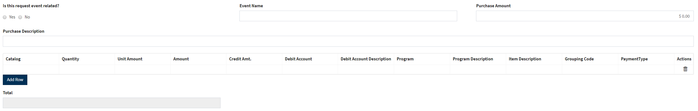
- The grid for the goods/services is like that of an RFD with the following additional information:
  - Catalog Number – Used to identify product being purchased. N/A may be applicable in some circumstances (i.e. catering).
  - Quantity – Used to identify the number of items being purchased.
  - Unit Amount – Used to identify the cost per item being purchased.
  - Amount – This is calculated based on quantity and unit amount entered.
  - The remaining fields (account, description program etc.) are completed the same as an RFD.
- If additional rows are needed, the “add row” button is selected and will result in display of additional rows for completion.
- Total – This field, like an RFD, will be calculated based on the distribution rows that are entered.
- Terms & Conditions – These are the Foundation’s terms and conditions for the PO. These terms and conditions must be submitted to the vendor with the PO by the individual creating the PO.
  - There are signature lines at the bottom for the submitter and the vendor to sign. These are optional and are dependent on vendor requirements.
- After completing all appropriate information, click the submit button.

Printing a PO

It is the requestor’s responsibility to print and submit the PO to the vendor. The following are the steps used to print a Purchase Order.
- Click the “Submit” button to finalize the document (as noted above).
  - A message will appear indicating the item was submitted successfully.
- Go to the PaperSave Web Workflow and click on the appropriate item.
  - To locate the item quicker, use the filter to identify “POs pending receipt” (in the RFD Processing Workflow).
- Select the “save” button and the Purchase Order will open to a PDF document that may be printed and sent to the vendor.

Converting a PO to an RFD
The following steps are used to convert a Purchase Order into a Request for Disbursement after the appropriate receipt has been received:
- Locate and select the appropriate item from the PaperSave Web Workflow.
- Select the button to “Edit Form” in the toolbar.

- Select the Button indicating the PO is ready for disbursement request.
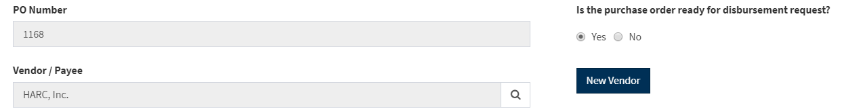
- Complete form to include all RFD fields that were not available when the PO was created.
- Edit distribution as appropriate (if applicable).
- Save the form by selecting the “save form” button in the upper left corner.
- Attach appropriate backup documentation using the following steps:
  - Select the item by clicking in the box.
  - Select “Action & Navigation” tab on the menu tabs at the top of the page
  - Select “Add Pages From File” icon on the menu bar
  - Select documents to attach
  - Select “Home” tab on the menu tabs
  - Select “Save Changes” button on menu
- Submit the form for signatory review by using the following steps
  - Select the item by clicking in the box
  - Select the approve button on the menu

Chapter 6 - Request for Disbursement (RFD) Review and Approval
Description: All Requests for Disbursements (RFDs) must have proper approval prior to the disbursement being made. The level of approval that is required is different between the University and the Foundation. These will be identified within this section. An approval on an RFD indicates the following requirements have been met for the item (excerpted from the Foundation’s Disbursement Policy:
- Expenditures must be reasonable and have a legitimate business purpose;
- Expenditures must be supportive of the University’s and/or Foundation’s mission and programs;
- Expenditures must be in conformity with the purposes and restrictions of the fund from which disbursement is requested, and such conformity must be evident based on documents provided;
- Expenditures must be substantiated and supported with appropriate documentation including invoices and/or detailed receipts in accordance with the Foundation Disbursement Policy;
- Expenditures must be approved by the primary or alternate signatory of the fund from which disbursement is requested;
- Sufficient funds must be available in the Foundation and/or University restricted and/or endowment account (for endowment accounts, the current year’s spending allocation is considered when determining if sufficient funds are available);
- Expenditures must comply with state and federal laws;
- Expenditures must be consistent with the University Board of Trustee’s Policies Regarding Transactions with the University of Connecticut Foundation, Inc. approved September 23, 2003 as it may be amended (Expenditures for Foundation operations are exempt from this requirement); and
- Expenditures must comply with other Foundation policies.

University/Health Center Approvals
- Alternate signatories as approved by the University President may approve disbursements up to and including the amount of $10,000.
- Primary signatories as approved by the University President may approve all disbursements but must approve disbursements over the amount of $10,000.
- Primary signatories may approve disbursements for their own expenses and/or for events they attend without any additional approvals.
- The University President’s office must approve any disbursement where a guest (spouse, significant other or family member) is present at an event except where the guest is defined as a bona fide volunteer through the University.
  - When the unit (school/college) reports to the Provost, the President’s office prefers the Provost Office approve these expenses prior to the President Office’s approval

Foundation Approval
- Budget managers, as approved by the Foundation President, may approve disbursements up to and including the amount of $5,000
- Senior Managers (President, Senior Vice President of Finance and Administration, Senior Vice President for Development, Vice President of Alumni Relations and Vice President of Principal Gifts) may approve any disbursements for their area of responsibility but must approve any disbursements over the amount of $5,000.
- Disbursements that exceed the amount of $20,000 must have two approvals,
  - One or both the President or Senior Vice President of Finance and Administration, and (in the case of 1)
  - The Senior Manager responsible for the budget the disbursement is being paid for

Workflow
All Approvals will be done on-line utilizing the PaperSave Web Workflow option from the PaperSave main menu. An e-mail will be received each morning to indicate that items have been submitted for approval. Items may be accessed and reviewed from the PaperSave Web Workflow prior to receiving the e-mail.

When creating an RFD, the individual is asked to identify the signatory the form should be sent to for approval. The signatories are selected from a drop-down menu customized to show only those who are authorized to approve the funds they have access to.

If the amount of the RFD exceeds the approval amount of the individual selected (alternate approver or budget manager) an error message is generated indicating they must re-select the approver due to the limits.

When items require President and/or Provost approval, the requestor may want to inform the approver of this requirement. The PaperSave system does not have a mechanism to require this, it is a manual process.

RFD Review
All RFds and the attached documentation are reviewed through PaperSave Web Workflow. To select an item for review, select the item by clicking the box to the far left of the grid. After reviewing the RFD and the documentation to ensure it meets the requirements discussed earlier in this document the following actions may be selected using one of the buttons in the tool bar:

Button | Resulting Action | Notes
Edit Form | RFD form is displayed and may be edited as needed. | Edits may include changing account or program number or adding additional scanned documents. The approver may perform these actions, or they may reject the item back to the preparer for their action.
Approve   | Item is sent to Disbursement team for review & processing. | This step may be performed by the signatory, Provost office and/or President’s office.
Reject   | Item is returned to requestor for correction. | Comments are required to indicate why the item is being rejected for correction.
Provost   | Item is sent to Provost office for review and action. | The comment box may be used by the approver to indicate the reason for Provost office review (i.e. guests of employees present at event).
President  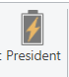 | Item is sent to President Office for review and action. | The comment box may be used to indicate the reason for the President office review (i.e. guests of employees present at event).

Chapter 7 – Correction of Rejected Items
Description: Items may be rejected for several different reasons that may include incorrect vendor, incorrect account codes/programs or missing documentation. The originator of the item will receive an e-mail indicating items have been rejected. The user may click on the Web Review hyper-link (top left corner) or go directly through the PaperSave Web Workflow option from the main menu. The steps needed to correct these errors will be described below.

Note: Corrective actions should be taken rather than entering a new RFD to retain initial information, workflow and comments.

Missing or Incomplete Documentation
- Select the item to review by checking the box to the extreme left of the item in the workflow.
- On the toolbar, select the menu for “Action & Navigation”.
- From the resulting menu, select the option for “Add Pages from File”
- After completing the attachment process, return to the “Home” tab on the toolbar.
- Click the “Corrected” button. This will send the item back to the initial signatory that had been selected for their approval.
Incorrect Vendor and/or Account Code/Program Information
- Select the item to review by checking the box to the extreme left of the item in the workflow.
- Select “Edit Form” from the toolbar.
- Edit as necessary. The edits may consist of:
  - Changing the vendor name through a vendor search.
  - Adding (or deleting) rows of account code/program information
  - Editing account/code/program information
- Click the “Save Form” after completion/
- Click the “Corrected” button.
  - This will send the item back to the initial signatory that had been selected for their approval.

Chapter 8 – Reports
The “Published Reports” section is towards the bottom of the main screen. The one report that may be useful is the item titled “Workflow Items I Reviewed”
To access the report, click on the link.
Note: You may be asked to enter your log-in credentials.

Report Parameters
The following is a sample of the screen that report where parameters may be entered.

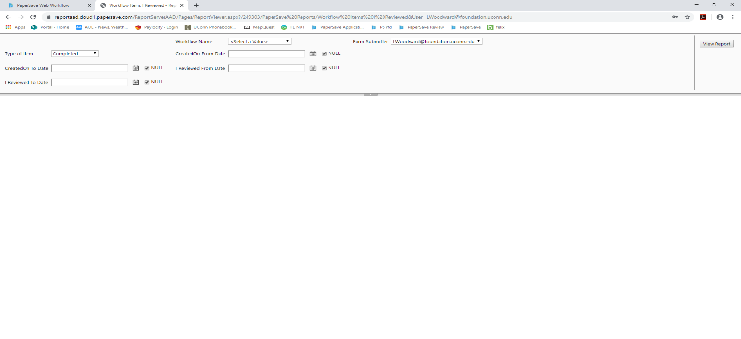
The following table describes the parameters and valid entries:
Parameter | Valid Entries | Notes
Workflow Name | RFD Processing  New Vendor Processing
Type of Item | All  Completed  In Process
Created on From Date | Beginning of period for inquiry | You must uncheck the “null” box
Created on To Date | Beginning of period for inquiry | You must uncheck the “null” box
I Reviewed From Date | Beginning of period for inquiry | You must uncheck the “null” box
I Reviewed To Date | Beginning of period for inquiry | You must uncheck the “null” box

Note: You may only enter dates in the created from/to or I reviewed from/to fields, not both.
After entering the parameter information, click the “Review Report” button in the top right-hand corner of the screen. You may leave all dates empty to receive a full list of items since system inception.

Results Sample:
The Following is a sample of the results that will be displayed for a query without any dates entered.

