Environmental Data Products
  - Users’ Manual
December, 2014

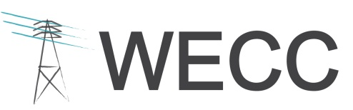
155 North 400 West, Suite 200
Salt Lake City, Utah 84103-1114

Contents
1. Overview of Manual Contents 1
2. Role of the Environmental Data Task Force 2
3. Environmental Risk Classification Data Layer 3
Development of the Environmental Data Layer 3
Potential Uses of the Environmental Data Layer 6
Limitations of the Environmental Data Layer 7
Future Updates and Improvements to the Environmental Data Layer 9
Updates to the Environmental Data Layer during the 2013-2014 Review Cycle 9
4. WECC Environmental Data Viewer v2.0 10
Application Data Contents 11
Using the Environmental Data Viewer 12
Notes for Using the Environmental Data Layer GIS Data on Your Own Machine 12

Overview of Manual Contents
The Western Electricity Coordinating Council (WECC), through the work of its Environmental Data Task Force (EDTF), has developed a number of data products that are available for use in transmission planning. This document (referred to here as the “Manual”) describes two of WECC’s primary environmental data products:
- The Environmental Risk Classification Data Layer (referred to here as the “Environmental Data Layer”) is a geospatial representation of planning-level risks to the development and expansion of the Western Interconnection electrical network based on environmental features of the landscape. This Manual details the process used to create the Environmental Data Layer, its potential uses and limitations, and recent and planned updates.
Click here to access the WECC Environmental Data Viewer and the Environmental Data Layer.
- The Environmental Data Viewer v2.0 (referred to here as the “Environmental Data Viewer”) allows interested publics to access and interact with this data through an Internet browser. Proceeding sections of this Manual describe the contents of the Environmental Data Viewer.
For the convenience of stakeholders interested in downloading and using the Environmental Data Layer directly in their own geographic information system (GIS) software, this Manual also provides suggestions on understanding and working with the Environmental Data Layer.
Several detailed attachments appended to this Manual provide background information on the development of WECC’s environmental data products:
- Attachment A – Preferred Data Set Inventory lists the various discrete data sources from which the Area Types and Environmental Data Layer were assembled. The list of Preferred Data is a subset of all the environmental data reviewed by WECC during the process of identifying the most appropriate data to inform regional transmission planning. For a complete list of all environmental data reviewed by WECC, please see the Data Inventory Spreadsheet available on WECC’s website.
- Attachment B – Methodology for Assembling the Environmental Data Layer describes the geoprocessing procedures used to create the Environmental Data Layer.
- Attachment C – Environmental and Cultural Area Type Summary describes the discrete Area Types that comprise the Environmental Data Layer.
- Attachment D – Environmental Data Viewer v2.0: Quick Start Guide provides instructions to acquaint users with the application’s functions and capabilities.
- Attachment E – Cultural Resources Data Analysis Approach explains the process currently under review by WECC to represent risk to transmission development from cultural features on the landscape using data from State Historic Preservation Offices and federal agencies.
- Attachment F – Ocean and Coastal Data and Area Types provides a list of environmental features WECC recommends for assessing planning level risk to subsea electrical cable development (NOTE: Attachment E is anticipated for release in early 2015, pending approval by the Scenario Planning Steering Group).
This Manual is subject to revision as WECC identifies new Preferred Data Sets and refines Area Type risk classifications.

Role of the Environmental Data Task Force
WECC’s Scenario Planning Steering Group (SPSG) formed the EDTF in June 2010 to develop recommendations on the type, quality, and sources of data on land, wildlife, cultural, historical, archaeological, and water resources (i.e., environmental resources), and exploring ways to synthesize and incorporate that data into WECC’s study cases and 10-year and long-term planning models. The EDTF provides recommendations to the SPSG for their review and consideration.
The EDTF’s work benefits WECC and its stakeholders in the identification and use of environmental and cultural data in the following ways:
- WECC’s preferred environmental data sets (referred to here as “Preferred Data Sets”) provide access to current (updated on a biennial basis) data for use in planning.
- WECC applies a classification system to the Preferred Data Sets to create an Environmental Data Layer for the Western Interconnection, which identifies planning-level risks to the development of the Western Interconnection electrical network based on environmental features of the landscape.
These data products facilitate knowledge transfer within planning organizations and are currently in use within WECC and outside of WECC by industry, regulators, and other stakeholders. The Environmental Data Layer is available to view and download from the Environmental Data Viewer.

Environmental Risk Classification Data Layer
The Environmental Data Layer is a single GIS layer that identifies planning-level risk to transmission development based on environmental sensitivities and constraints, as defined by four risk categories:
Category 1 | Least Risk of Environmental or Cultural Resource Sensitivities and Constraints: Areas with minimal identified environmental or cultural resource constraints and/or with existing land uses or designations that are compatible with or encourage transmission development. These areas would present few or minimal environmental and cultural mitigation requirements and are least likely to result in project delays.
Category 2 | Low to Moderate Risk of Environmental or Cultural Resource Sensitivities and Constraints: Areas where development may encounter one or more environmental or cultural resource sensitivity areas or constraints that would require low to moderate permit complexity or mitigation costs. This category also includes areas in the Protected Areas Database of the United States (PAD-US) dataset that have an unknown land use designation or degree of restriction to transmission development.
Category 3 | High Risk of Environmental or Cultural Resource Sensitivities and Constraints: Transmission development is likely to encounter one or more environmental or cultural resource sensitivities or constraints that would substantially increase permitting complexity and could result in project delays and high mitigation costs.
Category 4 | Areas Presently Precluded by Law or Regulation: Areas where transmission development is presently precluded by federal, state, or provincial law, policy, or regulation, as well as areas where development would represent a “fatal flaw” likely to preclude successful project completion (e.g., identified Native American Traditional Cultural Properties and sacred sites).

Development of the Environmental Data Layer
Development of the Environmental Data Layer began with the identification, acquisition, and review of environmental geospatial data sets published by governmental, non-governmental, and proprietary entities and covering various geographies within the Western Interconnection. Preferred Data Sets, those data sets that were deemed suitable for use in landscape-scale transmission planning through a WECC review process, were then geoprocessed using ESRI ArcGIS software to create unique “Area Types.” Area Types represent discrete lands with similar environmental features and risk classifications. Attachment A and Attachment C contain complete lists of Preferred Data Sets and Area Types, respectively. Attachment B summarizes the geoprocessing steps used to transform the Preferred Data Sets into Area Types that may be viewed/downloaded as GIS data.
The complete assemblage of Area Types was grouped to form a single layer for each of the four risk categories. These four layers were then overlaid to form a single Environmental Data Layer for the Western Interconnection. Figure 1 provides a graphic representation of the Environmental Data Layer development process.
Because the Environmental Data Layer is built from multiple GIS data sets, many locations across the Western Interconnection are overlapped by two or more data sets that represent different Area Types. In these areas of overlap, the Area Type with the highest risk category supersedes the lower risk category. The exception to this rule is that the two Risk Category 1 Area Types, which represent transmission rights-of-way/corridors (i.e., Areas Following Existing Linear Corridor and Designated Federal Energy Corridors), supersede risk categories 2 and 3. Figure 2 contains an illustrative example of how overlapping Area Types are processed in the Environmental Data Layer. In this example, a Wilderness Area polygon (Risk Category 4) in one Area Type overlaps polygons representing Critical Habitat (Risk Category 3) and National Historic Trail (Risk Category 2) Area Types; therefore, the output for the Environmental Data Layer will represent the area of overlap as Risk Category 4, Wilderness Area. Similarly, the area of overlap between the Critical Habitat polygon and the National Historic Trail polygon will be represented as Risk Category 3, Critical Habitat. Note that the polygon representing a Designated Federal Energy Corridor (Risk Category 1) supersedes risk categories 2 and 3, but not risk Risk Category 4.

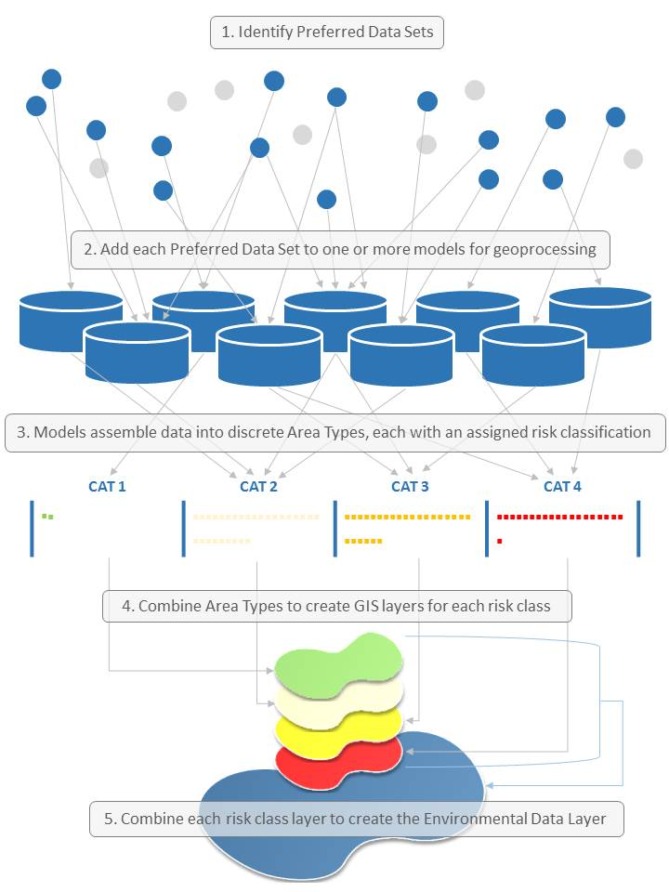
Figure 1. Environmental Data Layer Development Process
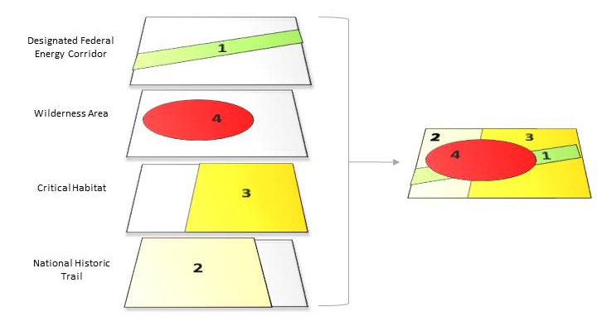
Figure 2. Identifying Risk Classification Category for overlapping polygons
In addition to the complete ranked (overlapped) information, the Environmental Data Layer allows a user to explore the pre-overlap risk category (1, 2, 3, and 4) for any given parcel of land. Using this feature of the data layer, stakeholders can explore all the different Area Types that overlay a given location.
The Environmental Data Layer is updated on a biennial basis. The biennial process involves updates to existing Preferred Data Sets, the incorporation of new Area Types and new data as preferred, and the removal of Area Types and data that are no longer suitable for use in light of changing regulatory or resource conditions.

Potential Uses of the Environmental Data Layer
The Environmental Data Layer, contributing source data sets, and analysis methods described in this Manual may be used in various capacities, and by various users, throughout the regional transmission expansion planning process. In particular, the following three types of applications are anticipated or have already been attempted.

Input to WECC’s Long Term Planning Tools
A version of the Environmental Data Layer, and its contributing source data files, was used in WECC’s Long Term Planning Tool (LTPT). Geospatial data are one of several types of information that serve as input to that tool. Please see the EDTF Input for 2013 Transmission Plan document located here for additional information on how the environmental data has been considered in the LTPT.

Input to the EDTF’s Comparison Process
The EDTF has developed a Process for Using Environmental and Cultural Information to Compare Transmission Alternatives (referred to as the “Comparison Process”) to inform decision-makers of the relative environmental and cultural risks of transmissions alternatives. The Comparison Process is based on three criteria: (1) an environmental risk score, (2) stakeholder involvement, and (3) alternative description. The “environmental risk score” for each transmission alternative may be calculated using the Environmental Data Layer to evaluate the miles of each risk category crossed by transmission alternatives and/or the proportion of the alternatives that crosses Area Types within each risk category.

Use by Non-WECC Organizations
It is possible that the Environmental Data Layer and associated risk classification system, Preferred Data Sets, and the analysis methods described in this document may be useful for organizations outside of WECC (e.g., government agencies, non-governmental organizations, and project proponents such as utility companies and transmission developers). These parties may find value in the following:
- Attachment A of this Manual contains a complete list of the EDTF-developed Area Types. A stakeholder-approved land classification system reduces ambiguity and guesswork on the part of the transmission project sponsors and other organizations interested in evaluating projects at early stages of development (i.e., pre-siting level of analysis).
- Attachment C of this Manual contains a complete list of the Preferred Data Sets. Though subject to change over time as new data become available, these data sets have all undergone a stakeholder-driven screening process and may provide a valuable resource to organizations interested in identifying data for planning-level reviews of transmission alternatives and facilities.

Limitations of the Environmental Data Layer
The Environmental Data Layer represents WECC’s best available information on environmental risks to siting transmission. Although every effort was made to ensure consistency and accuracy of the information, the Environmental Data Layer contains a number of placeholders and unresolved issues that WECC may attempt to address in future versions. The major unresolved issues are described below.

Risk Category 2/3 – Native Land Allotments and American Indian/Native American Reservations
To date, WECC has received limited input from U.S. tribes on the appropriate risk categories to assign to reservations and other tribal territories. WECC has classified these areas as Risk Category 2 or 3 pending confirmation from these governments; however, because the Environmental Data Layer requires a discrete risk classification, these areas are represented as Risk Category 2 in data available through the Environmental Data Viewer. WECC is committed to continuing outreach to tribal governments to clarify the appropriate categorization of their lands.

Canadian Lands
WECC has limited information regarding environmental and cultural sensitivities in portions of Canada. To avoid over- or under-representing the risk associated with areas where no environmental or cultural data is available, these areas have not been assigned a risk category value in the Environmental Data Layer. WECC continues to work with its Canadian members and stakeholders, including the First Nations, to address these data gaps and assign appropriate risk categories to currently unassigned lands areas.

Cultural Data
While WECC has been successful in identifying and classifying risk for certain nationally-designated features that represent cultural resources (e.g., certain National Monuments), they have not succeeded to date in developing a single Environmental Data Layer that incorporates the risk from environmental features with the risk from cultural resource site locations available in State Historic Preservation Offices and federal agency databases. To address this issue, WECC has developed a separate, distinct system for addressing risk to transmission development from cultural sites. Attachment E describes that system.

Section 368 Corridors
Section 368 Corridors were designated in the 2005 Energy Policy Act to help identify suitable locations for energy facility development on federal lands across the western U.S. While WECC included these corridors as the lowest risk (Category 1) Area Types in previous versions of the Environmental Data Layer, a recent lawsuit from environmental groups and resulting settlement means that some of these corridors may change. Pending publication of a revised Section 368 Corridor GIS layer from the U.S. federal government, corridors that were remanded for additional review in the settlement agreement have been removed from the Environmental Data Layer.

Visual Resource Data
WECC and the EDTF continue to explore methods to include visual sensitivity (visual resources) in the Environmental Data Layer. WECC will continue ongoing coordination with the Bureau of Land Management and other land management agencies to create a comprehensive data set that may address this issue.

Planning versus Siting Level Data
The data sets identified in the Data Inventory Spreadsheet that were used to construct the Environmental Data Layer were evaluated for their usefulness in the Regional Transmission Expansion Planning process; siting level analyses, while they may employ some of the same data sets, will also use other, project-level data sets more appropriate to such analyses. Even data that is used in both the Regional Transmission Expansion Planning and siting level analyses will require additional review and consideration. For example, while both WECC and a siting level analysis may use data from the National Conservation Easement Database, their interpretation of that data may differ. In the Environmental Data Layer, conservation easements have been classified as either Risk Category 2 or 3, indicating a high to moderate risk to transmission. However, transmission developers may find during the siting process that development is precluded on some conservation easements. Because of the scale at which the Regional Transmission Expansion Planning process operates, it is not possible or appropriate to determine where these precluded conservation easements may occur.

Future Updates and Improvements to the Environmental Data Layer
Data is dynamic; therefore, ongoing updates and refinements to the Preferred Data Sets listed in Attachment C are necessary to ensure the best available information is used. To maintain this data inventory, an Environmental Data Update and Review Process document listing an ongoing protocol to review and validate data sets has been developed and implemented to collect new and updated data from transmission stakeholders during a biennial data “open season.”
WECC is committed to refining the risk classification system based on emerging issues, changing circumstances, and stakeholder-recommended updates to the environmental and cultural data set catalog.

Updates to the Environmental Data Layer during the 2013-2014 Review Cycle
Based on information received from stakeholders and members of the EDTF, WECC made several revisions to the Environmental Data Layer during the 2013-2014 data collection open season and biennial update process. Of the more than 60 GIS models used to create the layer, 29 were updated due to new and revised Preferred Data Sets. In addition, WECC added several new GIS models in 2014 as a result of new Area Types approved by the SPSG in 2013 and 2014. In addition to routine updates to individual Preferred Data Sets, the primary substantive changes to the 2014 Environmental Data Layer were:
- Revised – WECC refined classification of some environmental features in Canada, based on reviews by Canadian stakeholder in 2013 and 2014.
- Revised – WECC revised its GIS modeling approach so that in areas where Risk Category 4 Area Types intersect Risk Category 1 Area Types, the area would be classified as Risk Category 4. This change was made based on stakeholder feedback that placing new transmission in an existing linear right-of-way in a Risk Category 4 Area Type could be as difficult as developing a new right-of-way. Previously, Risk Category 1 Area Types overrode all other risk categories.
- New Area Types – WECC worked with the Bureau of Land Management to collect data on right-of-way management on Bureau of Land Management lands; these data were used to create several new Area Types that better reflect restrictions and opportunities for transmission.
- New Area Types – WECC created new Area Types for State Scenic Highways/Byways and Railroads.
WECC completed the 2014 Environmental Data Layer in June 2014.

WECC Environmental Data Viewer v2.0
In 2013, WECC and its stakeholders identified an interest in making the Environmental Data Layer and other data products more widely accessible; in response, WECC developed its Environmental Data Viewer. Prior to the publication of the Environmental Data Viewer, WECC stakeholders identified several barriers to the use of WECC’s data products, including the cost associated with individually downloading and processing the data sets that make up the EDTF’s Preferred Data Sets to create their own version of the Environmental Data Layer, as well as the variation in versions of the data layers built by individual stakeholders. The WECC Environmental Data Viewer tool solves these issues by providing stakeholders a single, easily accessible location to view and download the Environmental Data Layer.

Application Data Contents
The Environmental Data Viewer displays the following content:
Environmental Data Layer | A single data layer that compiles Risk Categories 1, 2, 3, and 4 (with the most restrictive risk category visible in areas where Categories overlap, with the exception of Risk Category 1) for the Western Interconnection.
Basemaps | Options to display a variety of basemaps, such as aerial imagery, topography, and street maps.
Informational Layers  (data publisher) | A selection of data layers intended to compliment and provide additional context for the Environmental Data Layer:  - Highways (ESRI)  - Railroads (ESRI)  - Section 368 West-wide Energy Corridors (Bureau of Land Management)  - Existing Transmission Facilities (Platts, a division of McGraw Hill Financial)  - Wildlife Species Conservation Status or Federal Listing Status (NatureServe)  - Jurisdictional Land Ownership (United States Geological Survey)  - Crucial Habitat Rank (Western Governors’ Association)  - ANTICIPATED IN 2015 - Ocean and Coastal Environmental Data Layer (WECC)
Hyperlinks | Hyperlinks to related WECC and EDTF Products:  - Download site for both the complete Environmental Data Layer and individual Risk Category 1, 2, 3, and 4 data layers  - Links to the WECC Environmental Data Viewer v2.0: Quick Start Guide  - EDTF foundational documents, including the Data Quality Protocol
Note: Individual Preferred Data Sets used to develop the Environmental Data Layer are not available for viewing or download directly from the application.

Using the Environmental Data Viewer
The Environmental Data Viewer provides a basic user interface accessible to anyone with an Internet connection and a supported browser. Attachment D - WECC Environmental Data Viewer v2.0: Quick Start Guide provides a simple how-to guide for using its functions and capabilities.

Notes for Using the Environmental Data Layer GIS Data on Your Own Machine
The following sections contain tips for users who choose to download and use the Environmental Data Layer directly in their own GIS system software.

Understanding the Environmental Data Layer Structure
The Environmental Data Layer is structured to allow users to view the attributes associated with a selected polygon. The data contains multiple attribute columns named “CAT1”, “CAT2”, “CAT3”, and “CAT4” which reflect the four risk categories (e.g., CAT1 = Risk Category 1). If an attribute (Area Type) appears in a particular column, then the attribute has that risk category. For example, if the column starts with “CAT3” then the risk category associated with that attribute is Risk Category 3. In addition, the data contains a column “Risk_Class” that identifies the risk category for a particular polygon and a “CBITYPE” column that identifies the original land description for the area from the Conservation Biology Institute’s Protected Area Database (CBI-PAD), a seamless land classification data set that covers the entire U.S.
In areas of overlap, the hierarchy of the four Risk Categories are displayed as follows:
- A value of Risk Category 3 over-rides a value of Risk Category 2
- A value of Risk Category 1 over-rides a value of Risk Category 3 or a value of Risk Category 2
- A value of Risk Category 4 over-rides all other values
The Environmental Data Layer contains all attributes used to develop the final ranked risk coverage, including those lower risk categories that are superseded by an overlapping higher risk category. Using the data layer, users can therefore select a polygon and identify all Risk Category attributes and all potential Area Types for that location.

The Western Interconnection is one of two major alternative current power grids in North America. It encompasses a geographic area that extends from Canada to Mexico and includes the provinces of Alberta and British Columbia, the northern portion of Baja California, Mexico, and all or portions of the 14 western states between. Please see the WECC Transmission Planning documents for additional information.

