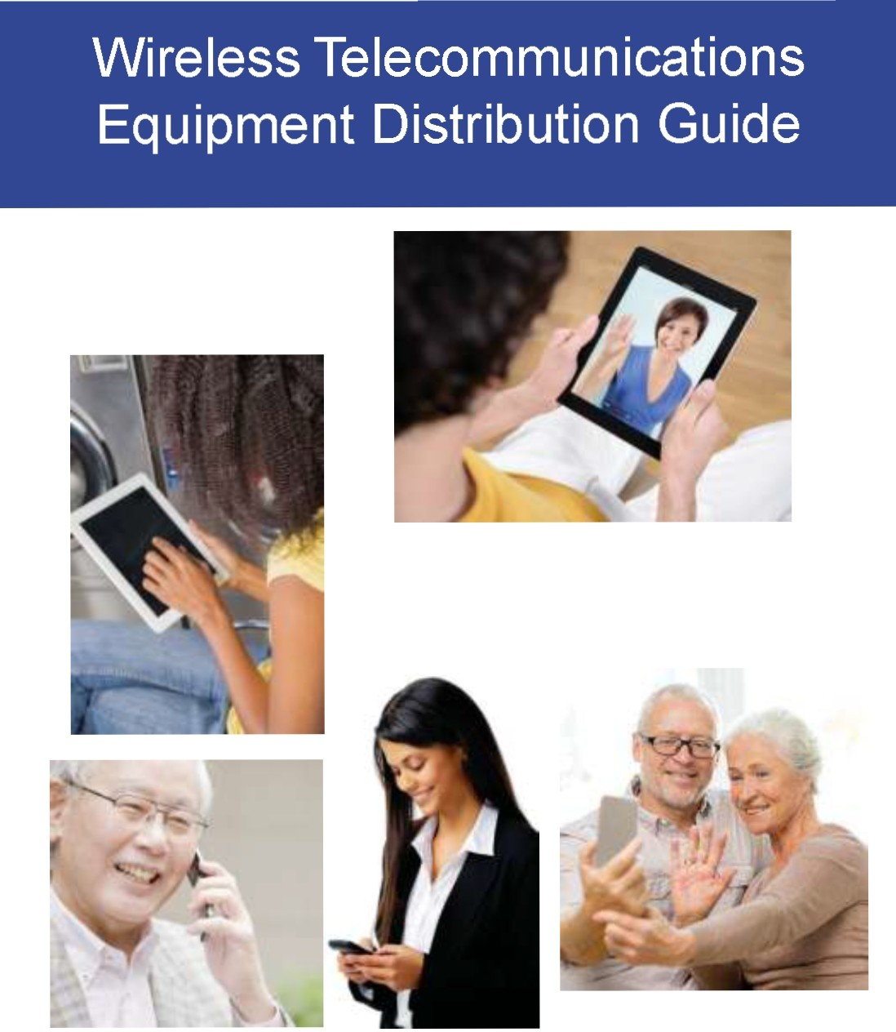

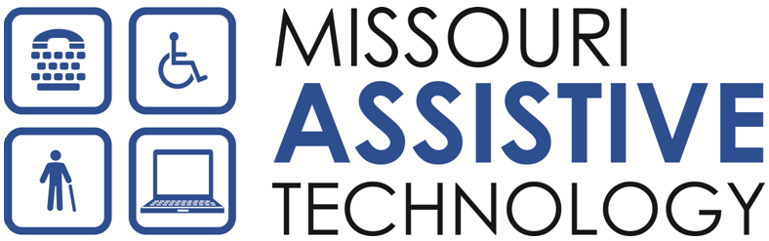

Missouri Assistive Technology
Telecommunications Access Program (TAP)

The mission of Missouri Assistive Technology (MoAT) is to increase access to Assistive Technology (AT)
for Missourians with all types of disabilities, of all ages.

The Telecommunications Access Program (TAP) is an integral program of MoAT. The TAP provides adaptive equipment for individuals who have difficulties with telecommunications (telephone and internet) because of a disability.

This TAP Wireless Pilot Program provides participants, age 18 and above, with wireless telecommunication devices. Participants will be required to share their feedback about how the equipment meets their telecommunication needs.

This guide provides information on the wireless equipment available, and the terms and conditions for anyone wanting to participate. For more information, including an application form, you can go to the TAP Wireless Pilot webpage at: http://www.at.mo.gov/TAPwireless.html

Missouri Assistive Technology

1501 NW Jefferson Street • Blue Springs, MO 64015

Voice: (800) 647-8557 (in-state only) or (816) 655-6700
TTY: (800) 647-8558 (in-state only) or (816) 655-6711

http://www.at.mo.gov/TAPwireless.html

Table of Contents

Types of Equipment Available .................................................... 4

Cell Phones ..........................................................................................5

Smartphones ........................................................................................7

Tablets ...........................................................................................................9

Accessories ........................................................................................10

Hearing Aid Compatibility ...................................................................12

Apps Guide ............................................................................... 13

Wireless Pilot Terms & Conditions .......................................... 15

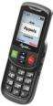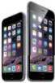Types of Equipment Available

Cell Phones (Page 5)  • Jitterbug Flip  (Order from TAP for Telephone program) | 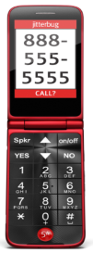  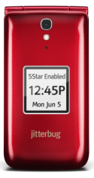
Smartphones (Page 7)  • Jitterbug Smart 2  • iPhone®  • iPhone® Plus | 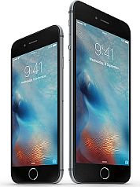  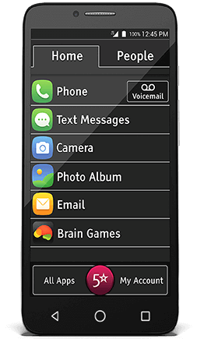  
Tablets (Page 9)  • iPad®  • iPad mini™ | 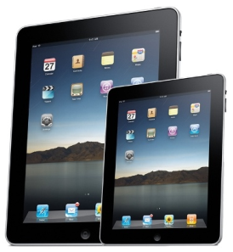
Accessories (Page 10)  Accessories can enhance your existing phone or tablet by providing wireless connections between devices.  • Bluetooth® neckloops  • Cell phone amplifiers  • Signaling devices | 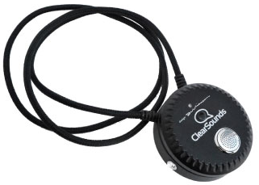

Cell Phones
Suggested for: Mild to Moderate
Hearing Loss, Low Vision. User
Friendly.

Jitterbug® Flip (TAP for Telephone)
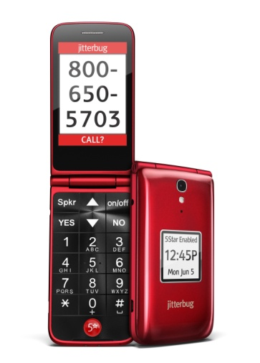
Requires Service from GreatCall®.

Telecom Activities
- Phone calls
- Text
- Access relay services

Product Features
• Basic flip phone
• Simple interface
• Large buttons
• Large screen
• Large font
• “Yes” and “No” buttons for easy navigation.
• Hearing aid capability M4 AND T4 ratings (see page 11)
• Amplification up to 25 decibels
• Access and call contacts with voice dial
• Dedicated button access to health and safety experts
• Camera
• Reading magnifier
• Bluetooth
• Red color only

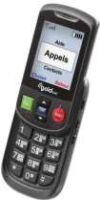Cell Phones
Suggested for: Low Vision
and Blind. User Friendly.

Odin Mobile VI®
Requires service from Odin Mobile, AT&T, or T-Mobile

Telecom Activities
- Phone Calls
- Text
- Access relay services

Product Features
• Basic slide phone
• Simple Interface
• Talking features for all functions –
dialing, caller ID, contacts, text message drafts, incoming text messages, amount of battery charge left, signal strength
• Choose male or female voice
• Adjust speech speed
• Large font
• Simple Interface
• Display contrast options – black on white or white on black
• Hearing aid compatible M3 AND T3 ratings (see page 11).
• No increased amplification beyond volume control.
• Phone color is black

Smartphones
Suggested for: Mild to Moderate
Hearing Loss,Low Vision. User
Friendly.

Jitterbug® Smart 2
Requires Service AND Data Plan from GreatCall®.

Telecom Activities
- Phone calls
- Text
- E-mail
- Browse the Internet
- Access relay services
- Access Android apps

Product Features
• Large 5.5” touch screen
• 16 GB
• Simplified menu with large letters
• Full size on-screen keyboard
• Hearing aid capability M4 AND T4 ratings (see Page 11)
• No added amplification beyond volume control
• Built-in Health and Safety apps
• Camera
• Android Phone
• Bluetooth
• MicroSD slot
• Black color only (case is Blue)

Smartphones
Suggested for: Deaf, Hard of Hearing,
Blind, Low Vision, and Speech Impaired

iPhone® and iPhone® Plus
Requires carrier to be on the AT&T,
T-Mobile, Verizon, or Sprint Network. Must have or get both a service plan AND a
data package from the carrier*

Telecom Activities
- Phone calls
- Text (iMessage)
- E-mail
- Browse the Internet
- Access relay services
- Video calls (FaceTime®)

Product Features
• iPhone® 7 Display Screen Size: 5.44 inches (diagonal)
• iPhone® 7 Plus Display Screen Size: 5.5 inches (diagonal)
• 64 GB
• VoiceOver and other built-in accessibility features
• Apps will be pre-loaded based on the disability
• Hearing Aid Compatibility: M3 AND T4 (see page 11)
• Front and back camera
• Space gray/black color only

* Note: Requires user to select your service network before MoAT orders your iPhone®.

Tablets
Suggested for: Deaf, Hard of Hearing,
Blind, LowVision, Speech Impaired

iPad® and iPad mini™ Wi-Fi only
(Requires access to Wi-Fi)

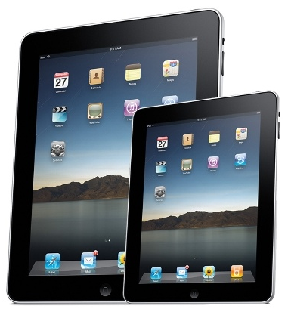

Telecom Activities
- E-mail
- Text (iMessage)
- Browse the Internet
- Access relay services
- Video Calls (FaceTime®)

Product Features
• 64 GB
• Wi-Fi Only
• iPad® Screen Size: 9.7 inch (diagonal)
• iPad® Mini Screen Size: 7.9 inch (diagonal)
• VoiceOver and other built-in accessibility features
• Apps will be pre-loaded based on the disability
• Front and back camera
• Space gray/black color only

Accessories
Neckloop, Bluetooth® Neckloop, Interface
Box, Cell Phone Ampliﬁer, Visual Signaler

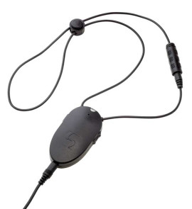
Neckloop
For individuals with a telecoil in their hearing aid or CI, the neckloop will send sound directly to the hearing aid(s) from the device. A built-in mi­
crophone is available on select neckloop models which allows for both listening and speaking through the neckloop.

• For use with Smartphones and Tablets.
• Can be used with headphones for individuals without hearing aids.

Bluetooth® Neckloop
Same neckloop principles as noted above, with the added benefit of a wireless connection between the neckloop and device.

• For use with Smartphones and Tablets which are equipped with Bluetooth®.
• Can be used with headphones for individuals without hearing aids.

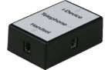Interface Box (Speech)
A customized interface box which provides a connection between an iPad or iPad mini™ and
a traditional corded home telephone. This allows
a user to make and receive calls using their iPad and a speech generating app.

• For persons with speech impairments who
use a speech (voice output) app or VoiceOver with their iPad or
iPad mini™.
• DOES NOT work on CORDLESS or Trimline® phones.

Accessories
Neckloop, Bluetooth® Neckloop,
Interface Box,Cell Phone Ampliﬁer, Visual Signaler

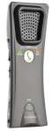Cell Phone Ampliﬁer
By pairing the cell phone amplifier to a Bluetooth® capable cellular
or smartphone, users can enjoy increased volume that best suits their hearing.

• Great for people who already have a cell phone and just have difficulty hearing what is said on the phone.
• Amplifies up to 40 decibels.
• Cell phone must have Bluetooth® capability.
• Will work with or without hearing aids.
• Will work with t-coils.
• Can also be used as a loud speakerphone.

Visual Signaler
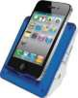Great for individuals who already have a cell phone but have
difficulty hearing it ring. Phone must be resting in Signaler to operate.
• Provides an additional visual alert for the
Deaf and Hard of Hearing.
• Signals users to texts, incoming Phone calls, Skype™ or
FaceTime® calls.
• Offers signaling beyond the accessibility
features of the iPhone® which only alerts users to incoming calls.
• The signaler will only work on cell phones that have vibration notification.

Hearing Aid Compatibility M & T Ratings: M-Ratings: Wireless devices rated M3 or M4 meet FCC requirements and are likely to generate less interference to hearing devices than mobile devices that are not labeled. M4 is the better/higher of the two ratings. M-ratings refer to enabling acoustic coupling with hearing aids that do not operate in telecoil mode.

T-Ratings: Wireless devices rated T3 or T4 meet FCC requirements and are likely to generate less interference to hearing devices than mobile devices that are not labeled. T4 is the better/higher of the two ratings. T-ratings refer to enabling inductive coupling with hearing aids operating in telecoil mode.

Wireless devices with a “M” or “T” rating of 1 or 2 or which only have a “M” or “T”
rating do not meet hearing aid compatibility for wireless devices.

Apps Guide
The following are examples of Apps that may be
installed on your iPhone®, iPad® or iPad mini™:
 | Icon | App Name | Deaf/Hard of  Hearing | Blind | Low  Vision | Speech  Impaired
 |  | Convo Mobile | X
 |  | Purple P3  Mobile – | X
 |  | Sorenson  nTouch – | X
 |  | ZVRS/Z5  Mobile – | X
 |  | Sprint Mobile IP | X
 |  | Hamilton Captel | X
 |  | Wireless  Captel by | X
 |  | ClearCaptions | X
 |  | Engag  e by E­ | X
 |  | Nixle –  Emergency Text | X
 |  | Advanced 911 –  Text 911 | X | X | X | X
 |  | Airwatch –  Device | X | X | X | X
 |  | Skype | X | X | X | X
 |  | FEMA | X | X | X | X
 |  | Red Cross | X | X | X | X
 |  | TWC – The  Weather Channel | X | X | X | X
 |  | YouTube –  App for Training | X | X | X | X

Apps Guide
The following are examples of Apps that may be
installed on your iPhone®, iPad® or iPad mini™:

Icon | App Name | Deaf/Hard of  Hearing | Blind | Low  Vision | Speech  Impaired
 | BARD Mobile |  | X | X
 | Claro PDF –  for Writing on |  | X | X
 | EyeNote –  Money |  | X | X
 | Fleksy –  Alternative |  | X | X
 | HeyTell –  Voice Messenger |  | X | X
 | Prizmo –  Scan and Read |  | X | X
 | QR Reader |  | X | X
 | TapTapSee (100  pics) |  | X | X
 | Big Browser |  |  | X
 | ZoomApp |  |  | X
 | Zoom Contacts |  |  | X
Option of ONE of the following:
 | Proloquo4Text |  |  |  |  
 | Proloquo2Go |  |  |  |  
 | TouchChat HD |  |  |  |  
 | Compas  s by |  |  |  |  

Wireless Pilot Terms & Conditions You are being provided with a wireless device through the Missouri Assistive Technology (MoAT) Wireless Equipment Pilot. Please review the following terms and conditions you have agreed to when applying for this device:

• Accepting this device means that you agree to promptly respond to surveys and/or provide other information to MoAT staff when you are contacted. Typically surveys will be e-mailed from the following e-mail address: MoTapWireless@gmail.com. This feedback will help us learn more about how the device is helping you with your telecommunications needs.
Distribution & Ownership
• Upon approval, the device will be shipped to your home.
• You cannot sell, trade, or give away equipment.
• If you plan to move out of Missouri, you should first contact
Missouri Assistive Technology.
• If your disability changes, MoAT will allow you to exchange your equipment for telecommunications equipment that meets your needs.
Usage
You are responsible for properly using and maintaining the equipment. Any unauthorized modifications will result in confiscation of the equipment, and ineligibility to obtain TAP devices in the future;

• If your equipment is broken or damaged through misuse or negligence, you are financially responsible for costs related to repairing or replacing the equipment.
• You will maintain the device in the protective case in which it was delivered.
• You will keep all packaging, boxes, manuals, cords & accessories that are issued with the device as well as the protective wrapping and packing materials.
• You will not attempt to “jailbreak” (reformat) the operating system of an iDevice or Jitterbug Touch device.
• If your device has fire damage or is stolen, you are responsible to provide MoAT with a copy of the police or fire department report.

Set-Up And Maintenance
You are responsible for setting up your equipment including obtaining any needed service plan or data package.

• For iPads, Minis and iPhones, you may receive telecom apps to download on the iDevice. These will come in the form of a “Push” notification and will be sent to you by Teltex at the request of Missouri Assistive Technology. You must accept and download these telecom apps.
• You may not remove the telecom apps from your device.
• If you select an iDevice, do not take it to the Apple Store for repairs or service. You can be charged by Apple for repairs or service if you take your device to them. If you are charged, you are responsible for paying the costs. Similarly if you are a Wireless User and you send your device to the manufacturer, you will be held responsible for the repairs and or replacement of the device.

If you experience any problems with your equipment:
• First contact Teltex Technical Support at 1-888-515-8120 and identify yourself as a participant in the Missouri wireless pilot project.
• Or e-mail Teltex at ios@teltex.com.

Teltex Customer Service is available
Monday through Friday, 8am to 5pm Central Time NOTE: Teltex CANNOT make house calls.

DO NOT TAKE THE Wireless Device or iDevice to the manufacturer or Apple
Store!

Please contact our office if you have any questions about these terms and conditions.

Missouri Assistive Technology 1501
NW Jefferson St
Blue Springs, MO 64015 (816)
655-6700
MoTapWireless@gmail.com

How to Contact
Teltex, Inc:

Voice/TTY: (888) 515-8120

Toll Free Monday – Friday 8am – 5pm CST E-Mail: ios@teltex.com Website: www.iaccessibility.com
Information is available 24/7/365
in American Sign Language, spoken English with Closed Captions
and written English.

Missouri Assistive Technology

Teltex - Always Hear for You TM

