STUDIO ENERGY 2
USER MANUAL

Table of Contents
Safety Information 4
Introduction 7
Call Functions 7
Notifications Bar 9
Contacts 11
Messaging 14
Bluetooth & Wi-Fi 15
Opera Browser 18
Gmail 19
Play Store 21
Camera 22
Gallery 23
Music 25
FM Radio 27
Sound Recorder 29
File Manager 30
Calendar 31
Alarm Clock 32
Settings 33
Storage 39
Troubleshooting 40

Safety Information
Please carefully read the terms below:
Use Safely
Do not use the phone in situations where it might cause danger.
Transportation Safety
Please observe all transportation laws and regulations.
Please drive with both hands on the wheel.
PLEASE DRIVE RESPONSIBLY - DO NOT TEXT AND DRIVE
Hospital Safety
Please follow hospital rules and limitations.
Please turn off your mobile phone when near medical instruments.
Airport Safety
Remember to follow all airport and flight safety regulations.
Chemical Warning
Do not use your mobile phone around fuels or chemicals.
Temperature Warning
Do not subject your phone to extreme temperature conditions.
Water Hazard
Your phone is not waterproof. Keep your phone away from water or liquid to avoid damage.
Emergency Calls
Make sure your mobile phone is switched on and in a service area. In home screen, tap the phone key and dial the emergency number.
Accessories and Batteries
Use only Blu authorized batteries and accessories.
Information Backup
Remember to keep a written record of all important information.
Battery Safety and Precautions
- For better performance and longer battery life, it is recommended that you charge the battery fully before using the mobile phone for the first time.
- The optimum performance of a new battery is typically achieved after two or three complete charge cycles. Note: Keep in mind that continuous overcharging will affect long term battery life.
- While charging, keep the mobile phone out the reach of children.
- Store the battery in a cool and dry place away from direct sunlight and water.
- Do not expose batteries to extreme temperatures (below -8°C (18°F) or above 43°C (110°F).
- Immediately stop using the battery if it produces an odor, cracks and leaks, overheats, distorts or has any other type of physical damage.
- Avoid using the charger near or around liquids. If the charger comes in contact with water or any liquids, immediately unplug it from the outlet to reduce the risk of overheating, charger malfunction, electric shock or fire.

Hazardous Waste – Battery Disposal

Warning: Do not throw away batteries with uncontrolled daily waste.
The marking in this manual indicates that the batteries in this product should not be disposed of with household trash at the end of its working life. If the batteries are not disposed of properly, the substances included can cause harm to human health and the environment. Please follow Country, State, County, and City environmental laws and guidelines for proper waste disposal.

Cleaning and Maintenance
- Avoid using the handset and accessories in excessively moist areas to avoid malfunction.
- Use a soft, dry cloth to clean the handset, battery and charger.
- Do not use alcohol, thinner, benzene or any other solvent to clean the handset.

Introduction
Power On and Off
On - Please ensure the SIM card has been properly inserted into the phone. Long press the Power key to switch the phone on.
Off - In standby mode, long press on Power key until an options menu appears. Select Power Off in the menu to power off the phone.

Call Functions
At the dialing interface, enter the phone number and then click the dial key. If you need to dial an extension, you may click the dial pad icon to open the interface and enter the number of the extension. You may also press and hold the 0 key to add a (+) sign when adding an international dialing prefix.
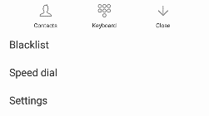
The dial menu option
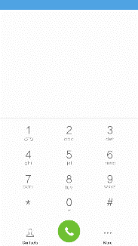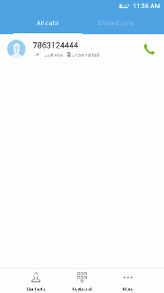
To maintain organized, the call log has Recent Calls and Contact set up in quick tabs.

Call Logs
Every telephone number called and received will be saved in the phones call log. All numbers in the call log can be dialed by clicking the dial icon on the screen, by clicking on the contact tile in the speed dial tab, or by clicking on the contact and selecting call back in the recent tab. When the number appears on the list, click it to view details. To delete a call from the call history, press the menu key and select delete. You may remove one or multiple calls.
Call Options
There are different options that can be used in the call log and dialing interface. You may press the menu key while in the general dialing interface and adjust call settings, enter call history, clear your frequently dialed numbers, and add a new contact.

Notifications Bar
The notification bar is located on the top of the screen which contains useful and important information regarding your phone and the applications that are installed.

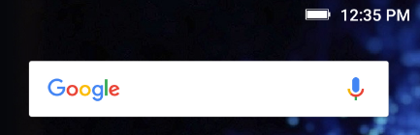

On the notification bar, several icons will appear such as signal bar, battery indicator, data indicator, Bluetooth and Wi-Fi. You may slide the notification bar down with your finger to display any pending notifications or actions.
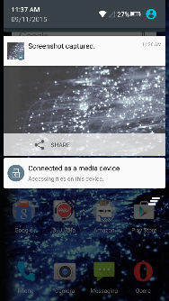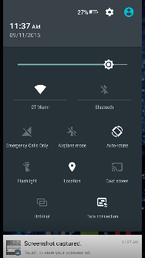
Quick Notification Settings
Pending Notifications and Applications
Clear notification button
Quick Settings menu buttons
Notification Settings
The notification settings window provides shortcuts to different phone settings for quick access. Click on any of the shortcut notification icons to power on or off.
Note: To clear notifications, drag down the notification bar and click the clear notification icon on the lower right hand part of the notification screen (3 horizontal lines as shown in the figure). The quick notification settings menu is accessed by dragging down the notification bar completely. Some settings include Wi-Fi, Bluetooth, Location, Airplane mode, and Flashlight.

Contacts
Enter: Click on the applications menu and select contacts.
- The default display is the phone contacts and SIM card contacts.
- The contacts are organized alphabetically by default.
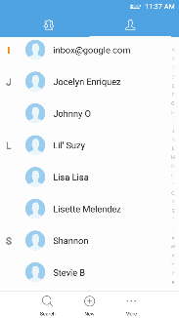
Add Contact
Note: Saving your contacts to your Google account facilitates both storage and synchronization with multiple entries across different handsets and tablets. When syncing your Gmail with a new phone, all your stored Google contacts are automatically synced with the new phone.
Search
Click the Search icon to enter the contact search interface. Any numbers or letters associated with any of the contacts saved in the list will be shown in the search results.
Add New Contact
- Click the add contact icon (+) to add contact icon in the bottom.
- Select to save your contacts to your Google account, the phone or the SIM card.
- You may enter different contact details which include adding a picture, name, telephone number, group, address, and email among other options.
- Click to save contact.
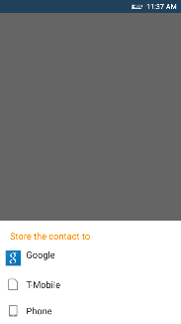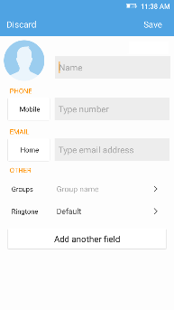
Contact information entry field
Note: You may add individual contacts to any of the home screens by entering the contacts menu, clicking on the specific contact, pressing menu, and then selecting the ‘Place on home screen’ option. You can also share contacts via MMS, Gmail, Bluetooth, and other share options within the same settings menu.
Delete Contact
- Click on the Contacts icon to enter the phonebook.
- Click the menu key to access the Contacts menu.
- Click on Delete Contact and scroll to select which contact(s) you wish to delete.
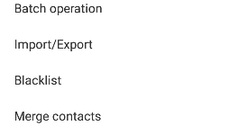
Import / Export Contacts
The phone allows you to import and export contacts to synchronize information between different storage types that include the SIM card, Gmail account and your phone.
To import or export contacts:
1. Press the Contacts icon to enter the phonebook.
2. Press the menu key and select Import / Export
3. Select the source you want to copy the contacts from. Once selected click next and select the destination where you want the contact to be copied to then select the desired contacts to be copied.

Messaging
You may use this function to exchange text messages and multimedia messages with your family and friends. The messages to and from the same contact or phone number will be saved into a single conversation so you may see the entire message history conveniently.
Add Recipient
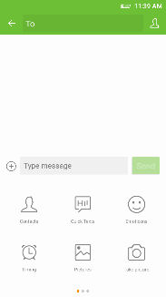
Attachment options
Text message entry field

Send an SMS
Application Menu » Messaging » New message (or shortcut icon)
- Click the contact icon to enter text message recipient
- Compose Text Message and click Send

Send an MMS
When creating message, the default message style is SMS. The message will automatically convert to MMS when adding an attachment or when surpassing 10 pages of SMS messages.
- Click the attachment icon in the messaging interface.
- Click to add attachments and create an MMS message

Bluetooth & Wi-Fi
Bluetooth is a short-range wireless communications technology that devices can use to exchange information and connect to different types of devices which include headsets and other devices.

Power on Bluetooth
Settings » Bluetooth and select to power on Bluetooth.
- The Bluetooth icon will appear in the notification bar. The Bluetooth will then start to scan for all devices within its range and will start display all available devices.
- Once the scan is complete, all the devices found will display in a list under available devices. Once the device has been identified, click on it to connect.
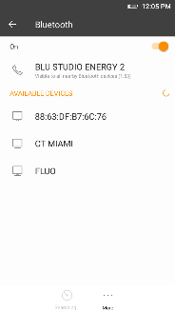
Note: The maximum detecting time of the phone is 2 minutes
List of available Bluetooth devices

Power on Wi-Fi
Settings » Wi-Fi and select to power on Wi-Fi
- Click on the desired Wi-Fi network to be connected.
Note: Unsecured networks can be connected to directly - secured networks require a password or credentials prior to connection.
To display advanced options, click on the available option tab.
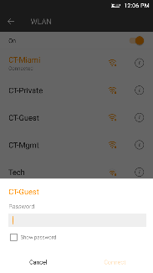
The network connection screen displays the password field

Opera Browser
Menu Functions Settings
App Layout
• This option changes the layout of the browser
New Tabs
• This option adds additional tabs
Clear Browsing Data
• This option clears any data stored
Off Road Images
• Check to select between different image qualities
Browser Options
History
Displays recent web pages
Speed Dial
Displays bookmarks and frequently accessed pages
Discover
Displays top stories and recent news

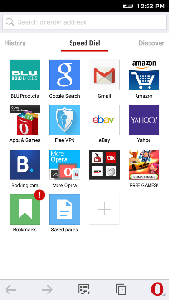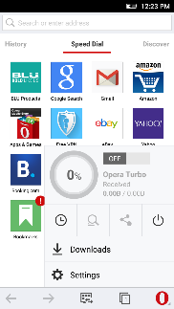
Click menu to access the Opera internet browser options

Gmail
Gmail is Google’s free email service. To access the Gmail program, click the applications menu and click on the Gmail icon and either sign in with your existing account or follow the instructions to create a new account.

Note: In order to keep accounts streamlined with Google services, your Gmail account user name and password will be used for some Google programs which include: Google Play Store, Google Drive, Google Photos, Google +, Google Calendar, and Google Wallet.

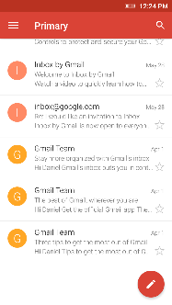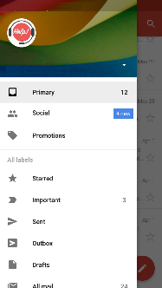
The Gmail inbox is separated by default in three different categories.

These categories include primary inbox, social inbox where all your Facebook, Twitter, and social media emails are separated to and your Promotions inbox where all your commercial emails are separated.

You may adjust these categories in Gmail settings

Play Store
Google Play allows you to download music, movies, and games directly to your device.
To access the Google Play Store, click on the applications menu and then the Play Store icon.
Note: You will need to log in to your Google account when configuring the phone or entering the Play Store for the first time.

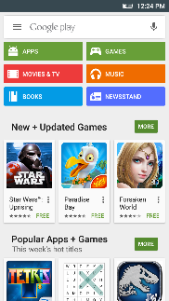
Search and select between different Play Store categories

Camera
Prior to use: It is suggested that you insert SD card before using the camera or video camera. All photos or videos taken by the phone should be typically stored in the memory card for storage of large capacity images and videos.

Open Camera
Click the Applications Menu » Camera
- Switch to video mode if you want to record videos.
Note: You may place a camera shortcut icon on any of the screens

Take Pictures
Aim the object that the picture will be taken.
- Press the Shutter button on the screen to capture image.
- After taking the picture, the file will be saved in the cameras gallery folder.
- You can view the photos by clicking the preview box button.

You may adjust various settings for the camera by pressing Menu while in the camera interface. When in the standard camera mode, you can switch to video to record or click the gallery preview box.
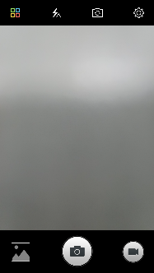
Camera Options
Select between Camera & Video

Gallery
Open Images
Click on the Applications Menu then click on the Gallery icon.

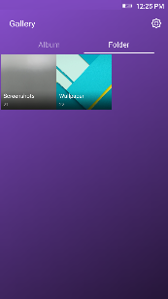
Pictures and videos are stored in separate albums or folders

Share Pictures
You may share pictures by sending them through different types of installed applications. You may also send pictures through the MMS message function by attaching a picture and also via Bluetooth.
Adjust Image
Press Menu and select edit to adjust images. You may select from different effects that may include: Vintage, Black and White, Instant, Latte, Litho, X-Process, Crop, Rotate, Mirror, Straighten, Vignette, Contrast, Exposure, Auto color, Shadows, and Vibrancy among other options.

Crop Pictures
Click menu and crop to adjust the size of the picture. Once the picture appears, pinch your fingers in or out to adjust the size. To keep proportion, hold down any of the four corners of the image and adjust.

Music
Open Music
Click on the Music icon to open the Music Player
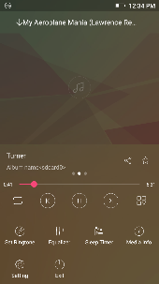
Track Controls
Song Status
Search Music
You may choose to search for music from media folder through artist name, song name, album name. The following formats are available: AMR, MIDI, MP3, WAV, and OGG.

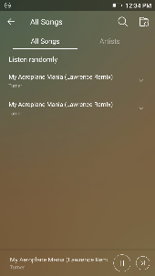
You may also save, play, and organize music through playlists

You may search music from Artist or Song

Set Music Player in the Background
Click on the Home key to move the Music Player to the background. You will see an icon on the status bar indicating that the music player is active.
Music icon while the music player is in the background
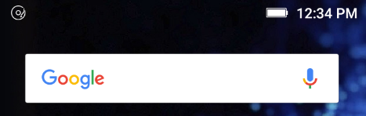

FM Radio
FM Radio
Through this function, you may listen to FM radio on the device. The FM radio uses the wired headphones as an antenna in order to receive signal. Before using this function, connect the original equipment headphones that came with the phone.

Open FM radio
Press the FM Radio icon to open the application.
Click to scan FM channels automatically then click to add any of your favorite radio stations.
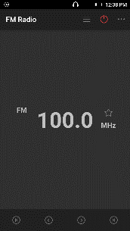
Scan
Radio Options

FM Radio as Background
Click on the Home key to move the FM Radio to the background.

Favorite Channels
Click on the Star to add to Favorite Channels. You may also click on the Channel List to browse through added stations.

Sound Recorder
You may send any recorded audio via the File Manager by selecting any of the default share options which include Bluetooth, MMS, Google Drive and Gmail.
Record
- Keep the phone’s microphone near the sound source.
- Click the record button to record the audio and click the stop button to end the recording.
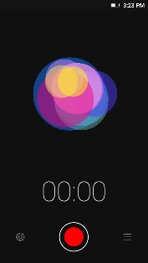
Recording Controls
Recording Time
It is suggested that you save all your recordings in your SD card for maximum storage capacity.
Please ensure the SD card is installed for extended storage space.

File Manager
The file manager allows you to search and organize your stored phone files conveniently and efficiently through one program.
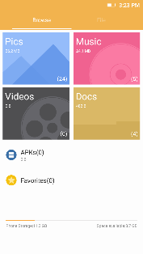
Scroll and search through the File Manager for stored phone files.

You may also search or add new folders from the File Manager interface

Calendar
The calendar helps keep track of your life’s most important moments in one application.
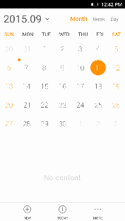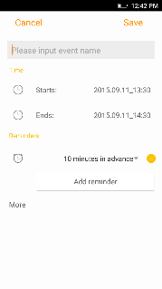
Long press the specific day or hour you wish to enter a new event to. Click Edit to enter specific details.

Enter Calendar information that ranges from Name, Location, Date among other options

Alarm Clock
Click on the Clock icon then click the alarm tab to enter the alarm clock interface.
This option allows you to add and edit alarms.
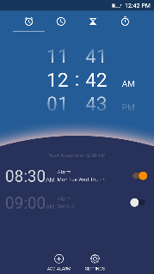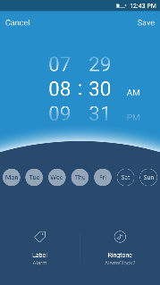
Click to add, edit or delete alarms

Then click on the specific hour and minute to set the alarm.

Settings
Wireless & Networks
 Airplane Mode
- Turn on Airplane Mode.
Note: When in flight mode, all network connections will turn off automatically.
 Mobile Networks
- Mobile Data Connection settings (APN, Preferred Networks)
 Wi-Fi
- Settings » Wi-Fi to power on. When on, the Wi-Fi will automatically search for available networks. Any unsecured network can be used directly and any secured network requires a password or credentials prior to connection
 Bluetooth
- Power on Bluetooth. Once on, Bluetooth will automatically scan for any nearby open devices
- Click to connect device
 HotKnot
- Transfer data wirelessly from one phone to another
 More Wireless & Networks
- Tethering, Portable Hotspot, VPN
- Airplane Mode
Note: Airplane mode will turn off all network connections automatically.
Basic Settings
 Date & Time
- Date and Time adjustment.
- Select Date Format - There are 3 kinds of formats you can choose from: Month-Day-Year, Day-Month-Year and Year-Month-Day.
 Sound & Vibration
This option sets the phone ring tone settings for receiving calls and notifications. Some of the settings include:
- Vibrate, volume, ring tones, ring tones notification, dial touchpad, and haptic feedback and tones
 Notification Center
- Manage alert and update notifications for installed applications
 Display
- Brightness, Wallpaper, Sleep, Daydream, Font Size, and Rotation
 Security
Set up basic screen locks: Use slide, pattern, PIN or password to lock the screen.
- Pattern: The initial set up will include simple unlock instructions and examples. Click to continue the security pattern step. Note: You can add additional pattern security at power on.
- PIN: Enter a PIN number to unlock the screen
- Password: Use a password to unlock the screen
Note: You may stop this security feature at any time.
Set up SIM card PIN lock
- SIM card PIN (Personal Identification Number) is used to prevent unauthorized use of SIM card.
To change a blocked PIN code, you will need to unlock the SIM lock then go to the Change Password screen. The phone will automatically prompt you enter the old PIN code and ask to enter a new PIN code twice. The phone will then prompt you that the change was successful. If you enter the PIN incorrectly three times, the SIM and PIN codes will be automatically locked.
You will need the PUK code to unlock the phone which is available through your service provider. If you enter the PUK code incorrectly 10 times, the SIM card will be permanently locked. Please see your service provider for a new SIM card
- Unknown Sources – Allow installation of apps from unknown sources
 Location
- High Accuracy – Use Wi-Fi and Mobile Networks to determine location.
- Battery Saving – Use Mobile Networks to determine location.
- Device Only – Use GPS to determine your location.
 Power Management
- View general power consumption information.
Operation
 Smart Gestures
- Set Smart Gesture configuration. Click on the gesture and follow the on-screen instructions.
Suspend Option
- Sets a quick access button on the home screen. You may long the press the button to hide it in notification bar.
Hardware
 LED Light
- Set LED light reminders.
 Storage
- View phone memory usage information and set default write disk.
System
Scheduled power on & off
- Set the phone to automatically turn on or off at a specific time.
 Language & Input
- Language – Change the language of the phone
- Personal Dictionary - Add or delete words to the custom dictionary keyboard,
- Spell checker, voice typing, text-to-speech, Google voice typing.
 Backup & Reset
- Backup Data – Will back up all application data, WLAN passwords, and other settings to Google's servers
- Restore to Factory Settings – Restores phone and erases all stored data completely.
Accounts
- Add and manage accounts (IMAP, POP3, Corporate, and application accounts)
 Apps
- Manage Applications - Manage and delete installed applications
- Running Applications- Press the Stop button to terminate any of the applications from the running apps list and clear any RAM usage.
 Accessibility
- Power button ends call, auto rotate screen, Talk Back, speak passwords and large text
 Printing
- You may print files via Cloud Ready printers
(Please check Google Cloud Print website for printer compatibility information)
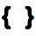 Developer Options
If the phone does not display Developer options, press build number seven (7) times in the about phone tab.
- The developer option gives access to USB Debugging and other developer tools.
Others
 About Device
- Phone information status and firmware updates

Storage
Connect the phone with the USB cable provided. Once connected, a connection interface will appear. In the connection mode interface, select one of the available options to transfer files to your computer.
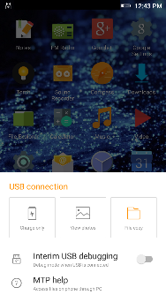
You may select to transfer files through File Copy. For pictures or images, select View Photo

Troubleshooting
Below is a list of common problems that may occur when using your mobile phone. Try these easy troubleshooting steps to resolve any type of issues you may encounter.
The phone does not power on
- Press and hold the power key until the startup sequence appears on the display.
- Check the battery level and ensure there is sufficient charge.
The phone does not respond after several minutes
- Remove and insert the battery – If the phone has an internal battery, please press and hold the power button.
The phone powers off by itself
- Check if the screen lock of the phone is enabled.
- Check if the phone needs to be charged.
The battery won’t charge
- Check if the battery is already fully charged.
- Make sure that the battery is inserted correctly.
- Ensure that the battery being used is a BLU approved battery.
- Double check if the charger connector is properly connected to the phone.
Note: Connect charger only after the battery has been inserted.

The standby time is too short
- Please keep in mind that standby time relates directly to phone usage (Internet, Text, Voice Calls, Maps, etc.).
- Batteries typically have to be replaced after a year of use.
The phone cannot connect to the network (Voice or Data)
- Verify if you have active service with your service provider.
- Contact your local network service provider and verify if you are within its network coverage area.
The phone displays a SIM Error
- Make sure the SIM is properly inserted and in its intended slot.
- Make sure that the SIM card is not damaged or scratched.
The PIN code was entered incorrectly three times
- The SIM card will lock and you will need to enter the PUK code (PIN Unlock Code). Please contact your local service provider to obtain the PUK.
I cannot make calls
- Make sure that the number you dialed is correct and the dial key has been pressed.
- Use the full national area code when dialing out of your area or when abroad, use country-specific international access codes.
I cannot receive calls
- Make sure that your phone is connected to a network.

The caller ID does not display on incoming calls
- Contact your local network service provider and verify you have the caller ID feature enabled on your account or verify if the caller may have blocked his number from appearing.
The caller cannot leave a voicemail message
- Contact your local network service provider and verify if the voicemail service is active on your account or check if the network is busy.
The phone does not connect to the internet
- Ensure with your service provider that your account has the appropriate internet/data plan enabled.
- Ensure internet APN settings are configured (Carrier dependent).
Text Messages cannot be Sent / Received
- Ensure text messaging is enabled with your service provider.
- Ensure APN settings are configured (Carrier dependent).
The information provided in this user manual is subject to change without notice and BLU Products reserves the right to modify the manual at any given time. BLU Products has made every effort to ensure that this user manual is accurate and disclaims responsibility and liability for any inaccuracies or omissions.

